|  |  |  |  |
| --- | --- | --- | --- |
|  |  | |  |
|  | Infinite Technologies, Inc.  2140 E. Bidwell  Folsom Ca 95630 | |  |
|  | Software Test Description | |  |
|  |  | |  |
|  | CDRL #A005 | |  |
|  |  |
|  | **16 September 2015** | |  |
|  | This document describes the test preparations, test cases and test procedures to be used to perform qualification testing for the WTS release. | |  |

Contents

1.0 Scope 3

1.1 Identification 3

1.2 System Overview 3

1.3 Document Overview 3

2. Referenced documents 3

3. Test preparations 3

4. Test descriptions 3

4.1 Accessing the Test Descriptions 3

4.2 CVT File Layout 4

4.2.1 TAB 1 - Index 4

4.2.2 TAB 2 - Test Participants 5

4.2.3 TAB 3 - Schedule 5

4.2.4 TAB 4 – CVT Master 6

4.2.5 TAB 5 – Requirements Traceability Matrix (RTM) 6

4.2.6 TAB 6 – Progress Matrix 7

4.2.7 Test Case (TC XXX) 7

4.2.8 Comments Tab 9

4.3 Evaluating Test Results 9

4.4 Submitting test results 9

5.0 Requirements Traceability 9

6.0 Notes 10

Acronyms and Abbreviations 10

# 1.0 Scope

1.1 Identification: The Software Test Description provides test cases to be used to perform qualification testing for a WTS® Release.

1.2 SYSTEM Overview: WTS® is ITI’s internal workload tracking web-based application that is used by ITI resources to view, track and prioritize workload.

1.3 Document Overview: The purpose of this document is to describe how to use the WTS® Customer Validation Test (CVT) documents.

# 2. Referenced documents

All referenced documents are accessible via the “CVT” link available from the WTS® menu bar. Referenced documents include:

* Customer Validation Test (CVT) Procedures
* Software Test Plan
* CVT Appendix
* Requirements Traceability Matrix

# 3. Test preparations

Test preparations are described in the Software Test Plan and CVT Process Guide.

# 4. Test descriptions

Unless otherwise specified, the CVT files are stored in a multi-tabbed Excel Workbook.

## 4.1 Accessing the Test Descriptions

All Customer Validation Tests are accessible via the “CVT” link available from the menu bar in WTS®. To access the CVTs, click on the “CVT” link in the tool bar, navigate to the appropriate release and find the link labeled “CV Test File” or, if applicable, “Other Tests.” When selecting the CV Test File, you will be prompted to open an Excel workbook.

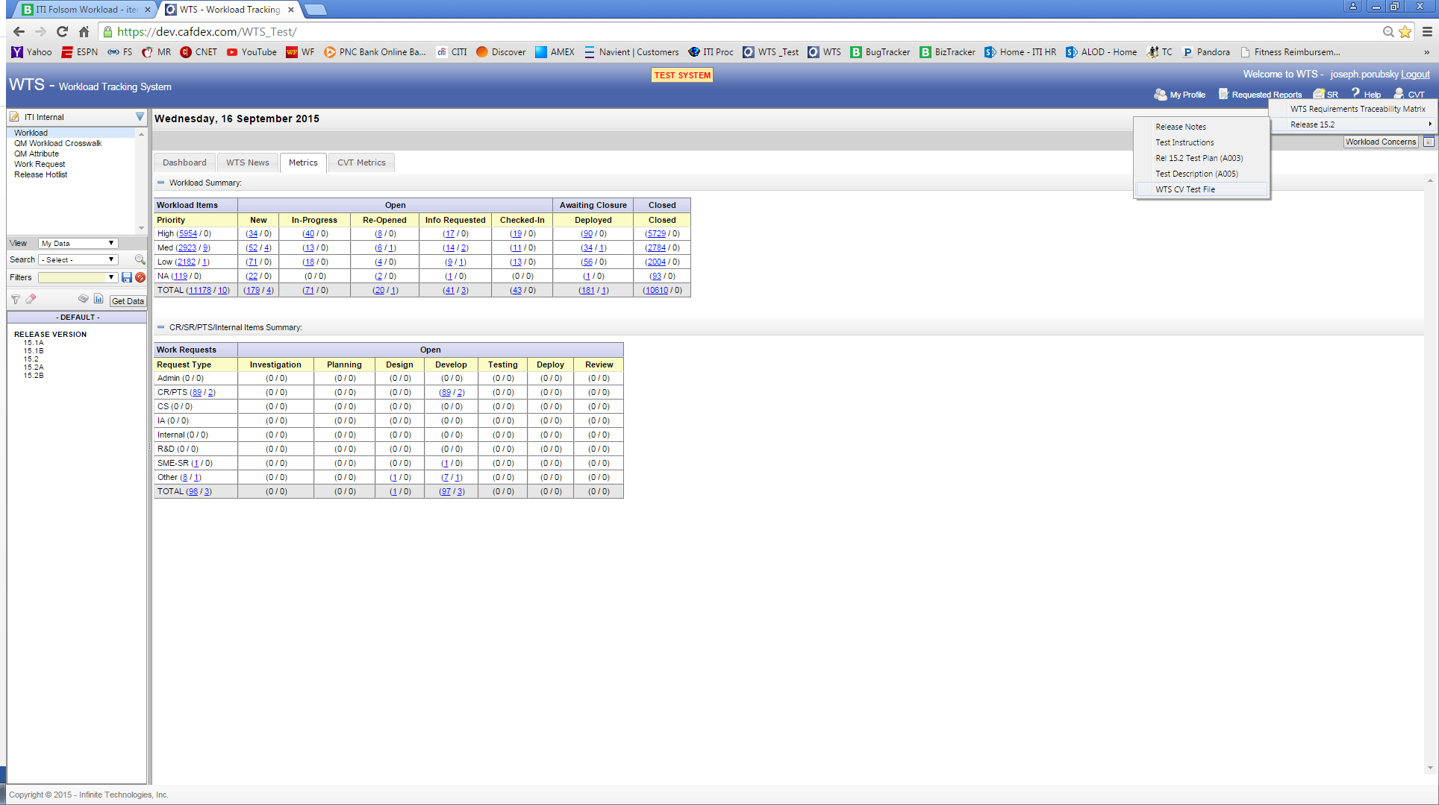

Figure - CVT Menu

## 4.2 CVT File Layout

### 4.2.1 TAB 1 - Index

The first tab within the file contains document information including:

* Index to related tabs within the file
* “ABOUT” section which includes the web application being tested as well as the WTS® release number.
* Relevant definitions

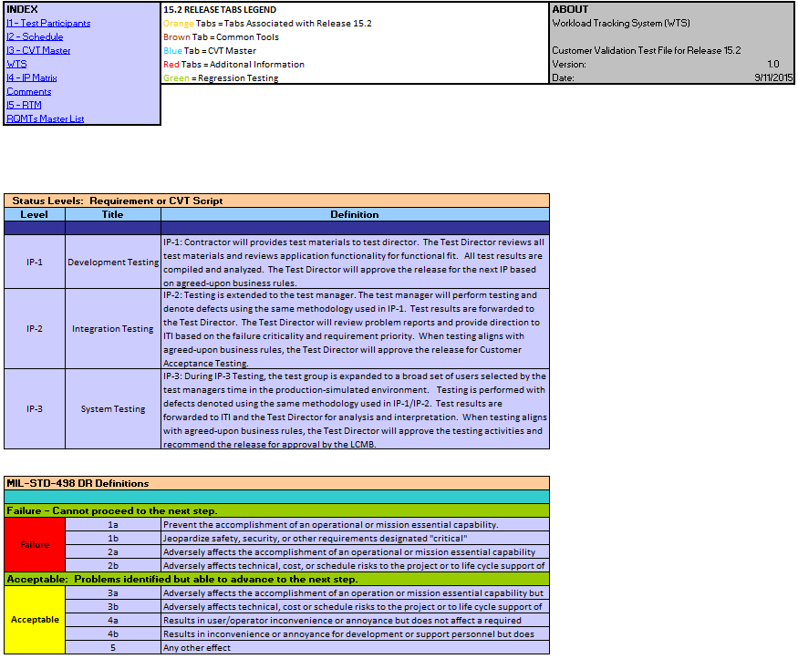

Figure - Index

### 4.2.2 TAB 2 - Test Participants

This tab provides contact information for both government and contractor test participants.

### 4.2.3 TAB 3 - Schedule

This tab provides the proposed schedule along with the actual schedule.

### 4.2.4 TAB 4 – Requirements Traceability Matrix (RTM)

The Requirements Traceability Matrix (RTM) associates functional requirements with the change requests and identifies tests to be conducted to satisfy functional testing.

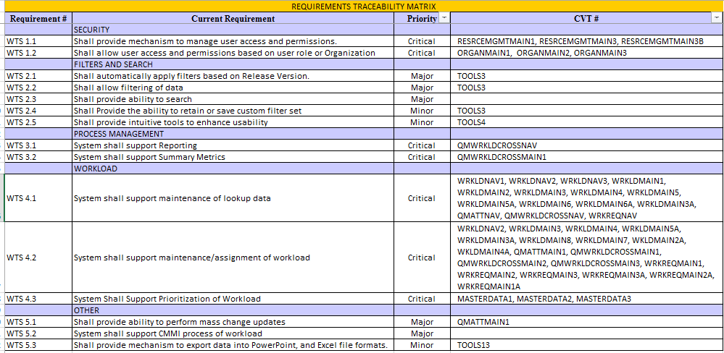

Figure 4 - Requirements Traceability Matrix

### 4.2.5 TAB 5 – CVT Master

The “CVT Master” contains a list of all Test Cases and Test Procedures to be performed to satisfy test requirements for the release. This document summarizes test status and results captured within the pursuant tabs which contain the test cases. The information is centrally aggregated to facilitate management and reporting of the tests.

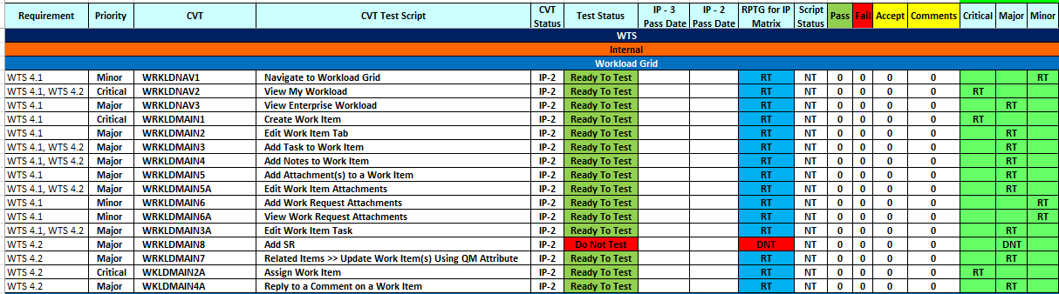

Figure - CVT Master

### 4.2.6 TAB 6 – Progress Matrix

The Progress Matrix is the management tool used to summarize and report the results of testing. This matrix plots the count of CVTs by status (Pass, Acceptable, Fail, Ready to Test, and Do Not Test) and by priority of the CVT (Critical, Major, Minor).

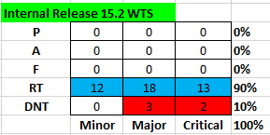

Figure - Progress Matrix

### 4.2.7 Test Case (TC XXX)

Test Cases are provided on individual tabs within the workbook.

#### 4.2.7.1 TEST Case Header

The header of each test case contains the following information:

1. Test Unique Identifier – This generally contains the CR number.
2. Test Case Preparation or Prerequisites – Typically, this will identify steps that need to be performed prior to executing the test or role restrictions.
3. Test Case Description/Objective - This statement summarizes what the test is to accomplish.
4. Expected Test Results – This identifies for the tester what a good test will look like.
5. If applicable, this section will also identify testing Assumptions or Constraints or specify input criteria.

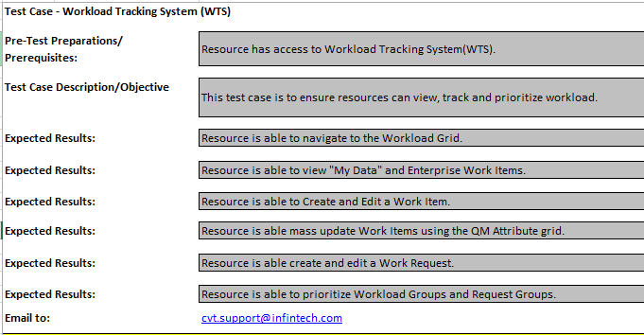

Figure - Test Case Header

#### 4.2.7.2 EXECUTING a Test Case

Test Cases are provided on individual tabs within the workbook. Each test case will consist of one or more Test Scripts (a.k.a. Test Procedures) which will provide the tester with step by step instructions on how to execute the functionality.

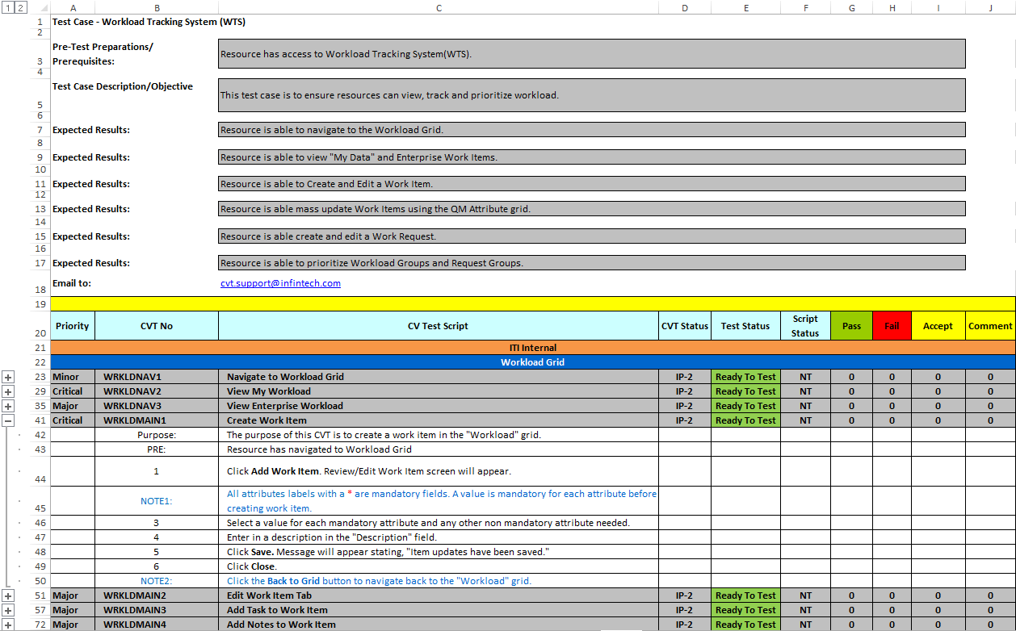

Figure – Sample Test Case

Referencing the figure above, the test scripts will include the following information (from left to right):

* 1. Priority – The priority (Critical, Major, Minor) is derived from the priority of the functional requirement(s) it supports.
  2. CVT Number – An assigned number used to manage CVT Scripts
  3. CVT Title – A descriptor to identify functionality supported
  4. CVT Status – Identifies test status (IP-1, IP-2, IP-3)
  5. Test Status – Identifies if the test script is ready to test or not ready to test. Testers should only execute tests that are in a “Ready to Test” Status.
  6. Script Status – This is a calculated value based on results entered at a step by step level as described below.
  7. Pass – A count of the number of steps within the CV Test Script that had a “Pass” status
  8. Fail – A count of the number of steps within the CV Test Script that had a “Work Stoppage”
  9. Acceptable - A count of the number of steps within the CV Test Script that in which the tester(s) reported a concern. The concern did not halt testing, the tester could continue to the next step.
  10. Comment – A count of the number of comments provided by the tester for the test script

To access the test script steps, click on the [+] symbol.

Once opened, the test should follow the step by step instructions provided, documenting results as follows:

1. Record successful completion of steps in the “Pass” column.
2. If you are unable to complete a step, record it in the “Fail” column.
3. All other instances should be recorded in the “Accept” column.
4. A comment should be provided for all items that do not pass.

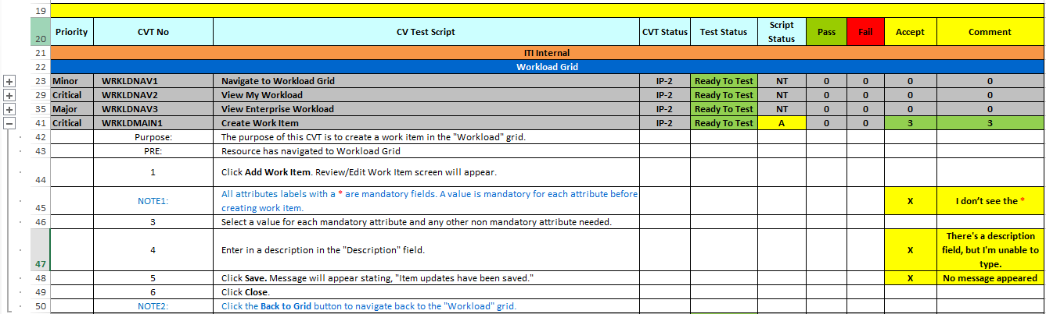

### 4.2.8 Comments Tab

The comments tab is a repository of test comments reported during test execution. Filtering capabilities are available for analysis.

## 4.3 Evaluating Test Results

The Excel file containing the tests for the web application will automatically summarize findings. As described above, the CVT Master file contains a list of all test cases included within the file. The test cases are assigned a pass or fail status as follows:

Fail (F) – A work stoppage was encountered while attempting to complete the steps in the test case.

Acceptable (A) – The tester encountered a problem or an area for improvement but was able to progress to the next step in the test case.

Pass (P) – The tester completed steps satisfactorily and did not encounter any work stoppages or other areas for improvement.

## 4.4 Submitting test results

To submit test results, save the file and send to the test director and [cvt.support@infintech.com](mailto:cvt.support@infintech.com) to review and compile results.

As described in the CVT Process Guide, business rules determine progression to the subsequent IP phase.

# 5.0 Requirements Traceability

Requirements Traceability is described in section 4.2.5 above.

# 6.0 Notes

N/A

## Acronyms and Abbreviations

A – Acceptable

CVT – Customer Validation Test/ Testing

DNT – Do Not Test

F – Fail

IP – In Progress, generally denotes a phase of testing

NT – Not Tested

P – Pass

RT – Ready to Test

RTM – Requirements Traceability Matrix

TC – Test Case

WTS – Workload Tracking System