Sean Gregory
CART 263
April 25th 2026

Project 2 Artist Statement

Screen Captures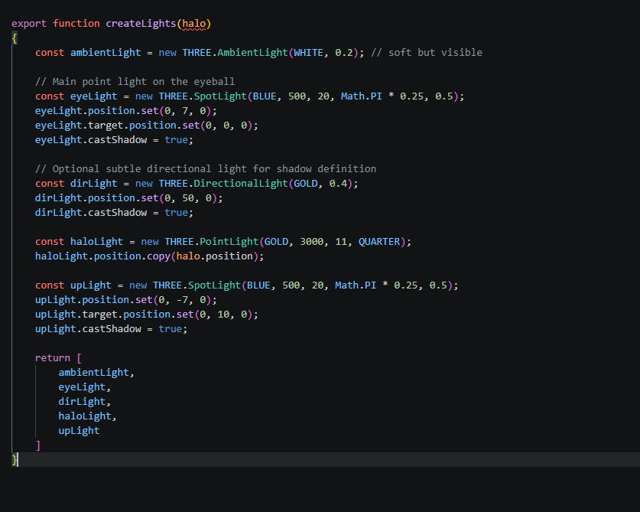
Figure 1: Making the lights operate without using too much computation power
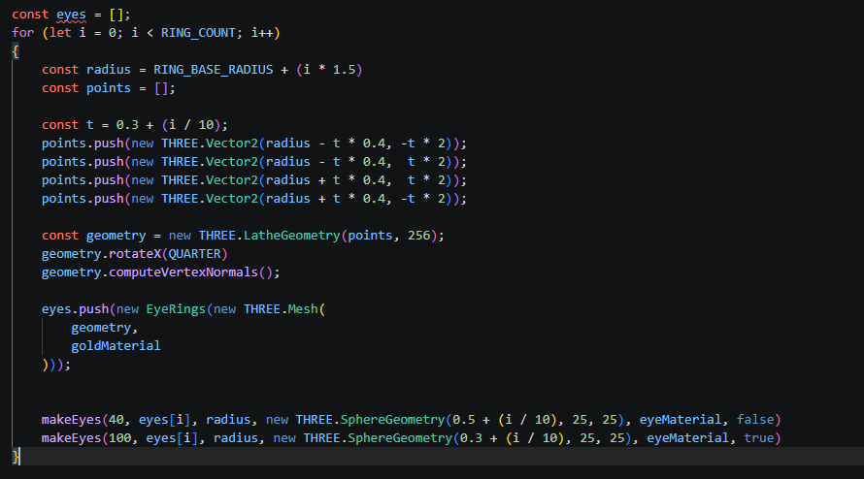
Figure 2: The beautiful ring system I made
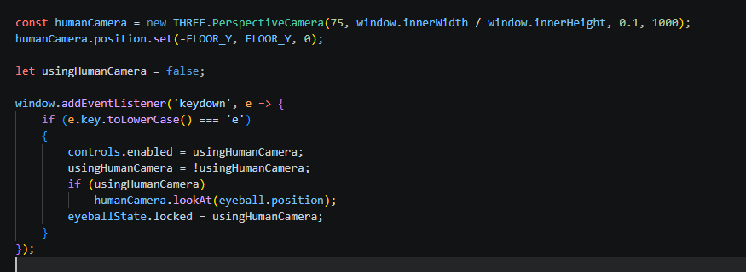
Figure 3: How I made the switch between human view and god view
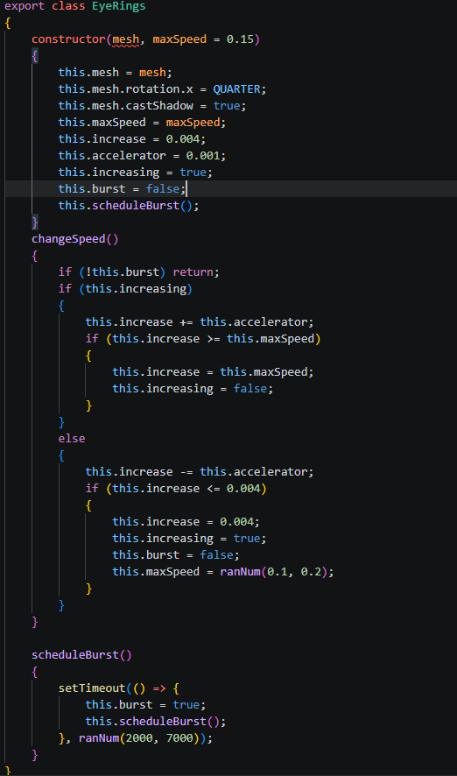
Figure 4: EyeRing class, that houses the way to make them speed and slow down
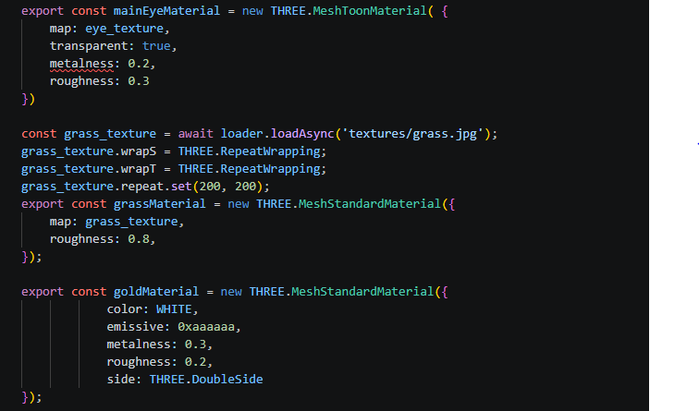
Figure 5: Me putting all the materials into one neat function to be exported

Intentions, Strategies, and interesting code.
This project explores the idea of encountering something beyond human comprehension, inspired by descriptions of biblically accurate angels. Rather than presenting angels in their common humanized form, the intention was to depict them as vast, abstract, and unsettling entities—closer to incomprehensible forces than familiar beings. The experience focuses on scale and perception: the user is not meant to observe the angel as a whole, but instead to feel dwarfed by it, only ever catching fragments of its existence at a time.
The project emphasizes the relationship between visibility and awareness. Much like the original texts that describe angels as overwhelming and terrifying, the entity in this environment exists partially outside immediate perception. Its immense size and fragmented visibility create the impression that it has always been present, whether noticed or not. This approach shifts the experience from simply “seeing” a creature to realizing one is already being observed by something far larger.
From a technical perspective, the project was developed as an interactive web experience using JavaScript and WebGL-based rendering. The environment and entity were constructed using procedural and modular techniques, allowing for dynamic positioning and scaling of components. Timing systems and randomized intervals were used to trigger appearances and behaviors, creating an unpredictable rhythm that prevents the experience from feeling scripted. The implementation focuses on lightweight performance while maintaining a sense of depth and atmosphere through motion, opacity, and spatial composition.
An interesting code snippet, I found, is the EyeRings class, which controls the 4 rings that encircle the Ophanim:
import { ranNum, QUARTER } from "./constants.js";

export class EyeRings
{
constructor(mesh, maxSpeed = 0.15)
{
this.mesh = mesh;
this.mesh.rotation.x = QUARTER;
this.mesh.castShadow = true;
this.maxSpeed = maxSpeed;
this.increase = 0.004;
this.accelerator = 0.001;
this.increasing = true;
this.burst = false;
this.scheduleBurst();
}
changeSpeed()
{
if (!this.burst) return;
if (this.increasing)
{
this.increase += this.accelerator;
if (this.increase >= this.maxSpeed)
{
this.increase = this.maxSpeed;
this.increasing = false;
}
}
else
{
this.increase -= this.accelerator;
if (this.increase <= 0.004)
{
this.increase = 0.004;
this.increasing = true;
this.burst = false;
this.maxSpeed = ranNum(0.1, 0.2);
}
}
}

scheduleBurst()
{
setTimeout(() => {
this.burst = true;
this.scheduleBurst();
}, ranNum(2000, 7000));
}
}
With this code, I condensed the code I wanted, that being it speeding up and slowing back down, perfectly, by gicing it its ideal rotation and a maxSpeed that could be modified. As well, I gave it the ability to schedule its burst, which would make a new instance ready to be released within the timeframe right after one happened. changeSpeed, which is called every frame in animate(), will return immediately if this.burst is false, so I don’t need more brackets around it, and it’s a simple logic of incrementally increasing the speed until it hits the max speed you want, before turning around and decreasing in a fade-in-out fashion, before it finally hits the lowest speed, and makes this.burst false, thus preventing it from going overboard. It’s condensed logic into less than 50 lines.

References & Inspiration
One major influence is Bloodborne, particularly its depiction of the Amygdala creatures. These entities are often invisible or unnoticed until the player gains the ability to perceive them, reinforcing the idea that something enormous can exist just outside awareness. The way these creatures cling to architecture and tower over environments directly informed the approach to scale and partial visibility in this project.
Another key inspiration is the artwork of Hieronymus Bosch. Bosch’s surreal and often disturbing compositions depict religious imagery in a way that feels chaotic, symbolic, and overwhelming. His work rejects clean, idealized representations in favor of dense, layered visuals that suggest meanings beyond immediate understanding. This influence is reflected in the fragmented and abstract construction of the angel figure, as well as the intention to evoke unease rather than clarity.

