V1
There is gender differences noted between males and females. For math scores, the males Q1, median, and Q3 scores were higher than the females. The females also had more outliers below Q1. Both males and females had achieved max scores for math. For reading, the females Q1, median, and Q3 scores were higher than the males. The females still had more outliers below Q1 for reading. Both males and females achieved max scores for reading. Overall, the males achieved higher scores in math while females achieved higher scores in reading.
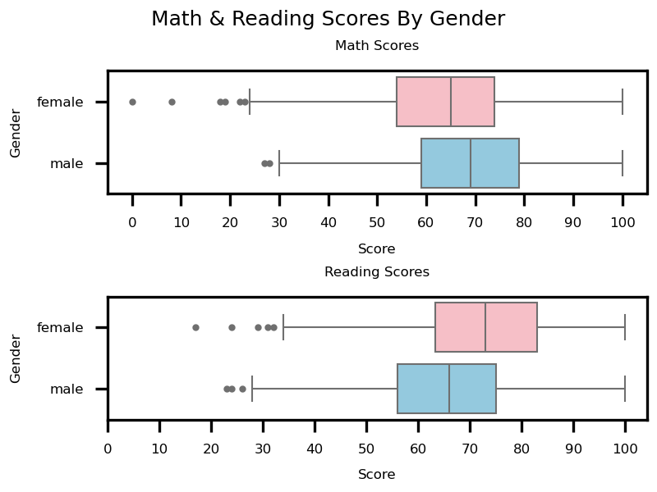
V2
There is a clear difference in the scores between the students that completed a test prep course vs the ones that did not take one. For the students that completed the course, Q1, median, and Q3 scores are all higher than the other students. Both groups did have students achieving. Scores above Q3 and even max scores. The minimum for the students that did not take a prep course is lower than those who did. The no prep course group also had more outliers below the min that the prep course completed group. Based on the box plots, we can say that on average, the prep course did help with achieving higher scores. I would like to see additional data for students that partially completed the prep course vs those who did not take it at all.
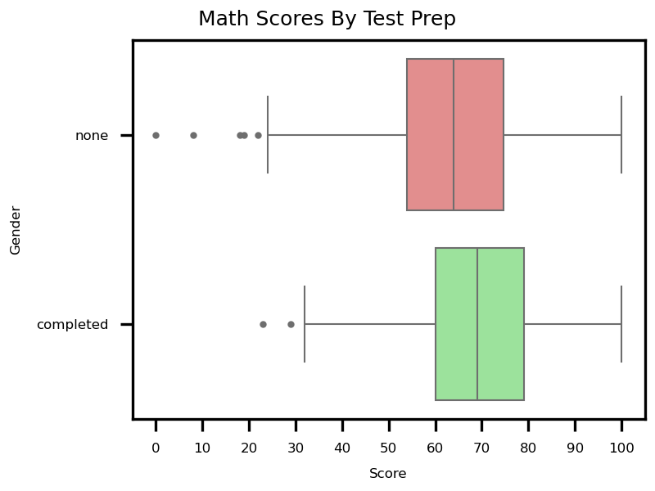
V3
Lunch type does show a relation to outcomes. The students in the free/reduced lunch category on average had lower test scores compared to the students in the standard lunch category. The average score per subject in each category remained the same in both lunch categories. In both lunch categories the students scored lowest in math and highest in reading. The average by subject remains similar but the free/reduced lunch category showed lower scores across all subjects indicating that the lunch type does affect test scores.
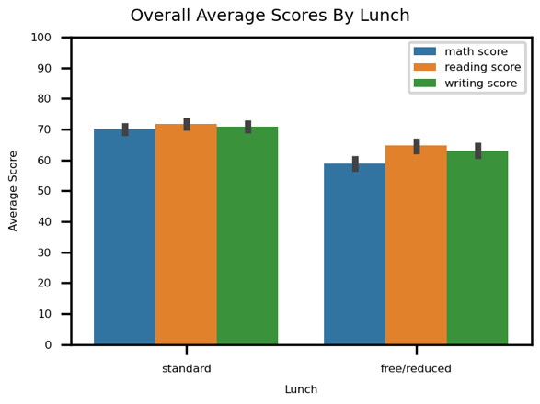
V4
The scores for the three subjects math, reading, and writing show strong positive correlations to each other. The reading and writing scores showed the strongest correlation at 0.95. The math and writing, and math and reading scores showed slightly lower correlation to each other at 0.8 and 0.82 respectively. These results do make sense because reading and writing tend to relate to each other. Math does not strongly relate to reading or writing. The results are consistent with real world logic.
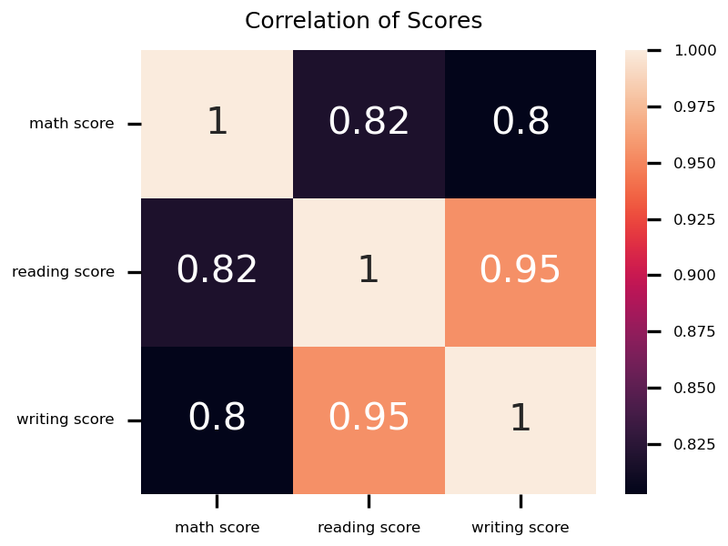
V5
Math and reading scores are strongly correlated. The math-reading correlation slopes for the two test prep groups are very similar. There is a slightly less correlation for the completed test prep group. From the scatter points we can see that the test prep completed group has better overall scores compared to the none test prep group. The confidence interval shaded region for each line overlaps the other line so we can say that the correlations are relatively similar. The test preparation course completion likely did not have an impact on the correlation between math and reading scores.
