**Project Four**

Test Cases

|  |  |  |  |
| --- | --- | --- | --- |
| **Input** | **Expected Output** | **Actual Output** | **Pass?** |
| **-**Press **Insert** with Id: 1, Sean Hamilton, Computer Science in the input fields.  -Press **Find** with Id as 1.  -Press **Delete** with Id as 1. | -Successfully added!  -Student Name: Sean Hamilton, Student Major: Computer Science, Student GPA: 4.0.  -Successfully Removed! | -Successfully added!  -Student Name: Sean Hamilton, Student Major: Computer Science, Student GPA: 4.0.  -Successfully Removed! | Yes |
| -Press **Insert** with an Id field as text.  -Press **Insert** with a name text field missing.  -Press **Insert** with a major text field missing.  -Press I**nsert** with an ID that already exists. | -Id field must be an Integer that is 1 or greater.  -Name and/or Major text areas cannot be blank!  -Name and/or Major text areas cannot be blank!  -Entry ID exists in Database! | -Id field must be an Integer that is 1 or greater.  -Name and/or Major text areas cannot be blank!  -Name and/or Major text areas cannot be blank!  -Entry ID exists in Database! | Yes |
| **-**Press **Insert** with Id: 1, Sean, CS in the input fields.  -Press **Delete** when an entry Id does not exist.  -Press **Find** when an entry Id does not exist.  -Press **Update** with Id that exists. Enter Course Grade B. Enter Credits 3.  -Press **Update** with Id that exists. Enter Course Grade C. Enter Credits 6.  -Press **Update** with Id that exists. Enter Course Grade A. Enter Credits 3.  -Press **Find** on entry id 1. | -Successfully added!  -Entry ID Does not exist in Database!  -Entry ID Does not exist in Database!  -Course Successful Added!  -Course Successful Added!  -Course Successful Added!  -Student Name: Sean, Student Major: CS, Student GPA: 2.75 | -Successfully added!  -Entry ID Does not exist in Database!  -Entry ID Does not exist in Database!  -Course Successful Added!  -Course Successful Added!  -Course Successful Added!  -Student Name: Sean, Student Major: CS, Student GPA: 2.75 | Yes |

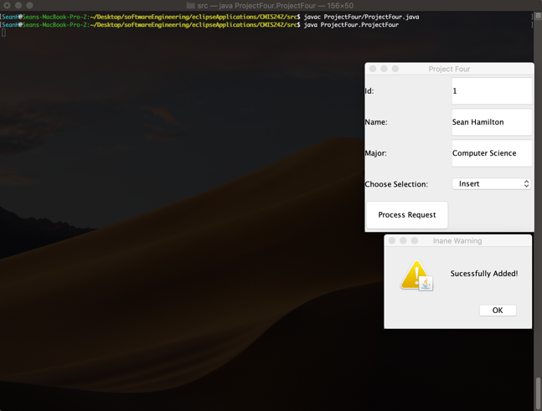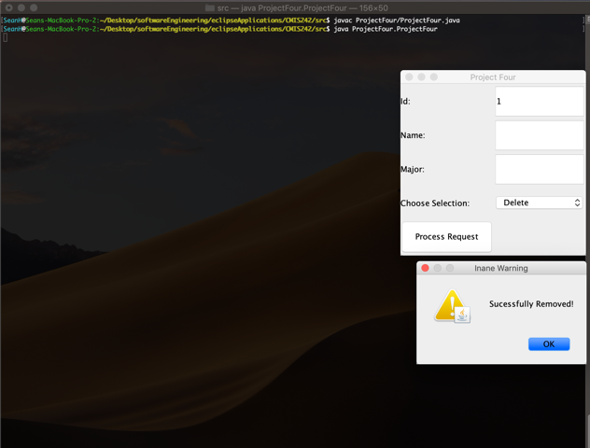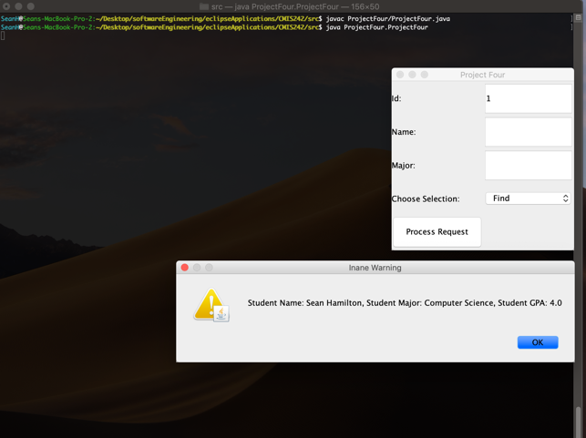

Compiling and running of class. Also test case 1 prompts

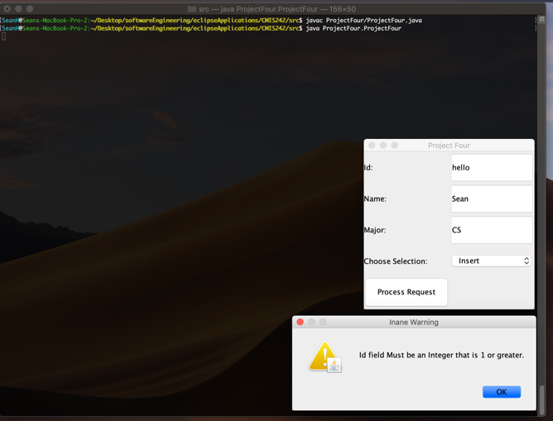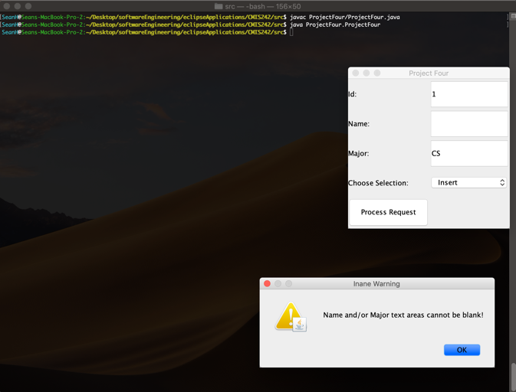

Compiling and running of class. Also test case 2 prompts

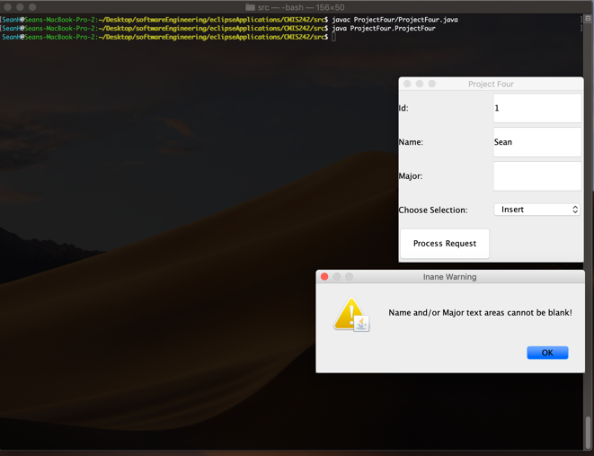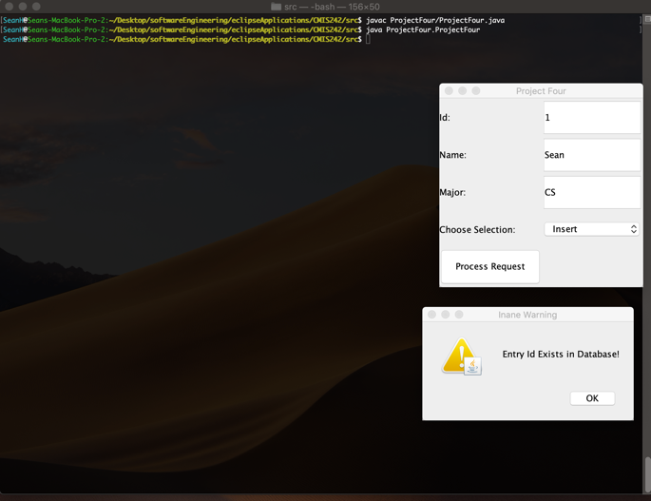

Compiling and running of class. Also test case 3 prompts

