**Project One**

Test Cases

|  |  |  |  |
| --- | --- | --- | --- |
| **Input** | **Expected Output** | **Actual Output** | **Pass?** |
| *employeeTestOne.txt which contains:*  2014 Employee Hamilton,Sean 9000  2014 Executive Ziegler,Abigail 25000 49  2015 Salesman Hill,Ramad 2200 200000 | ***2014 Employee Report***  Employee Name: Sean Hamilton, Employee Monthly Salary: $9,000.00  Employee Classification: Employee  Sean Hamilton Annual Salary: $108,000.00  ------  Employee Name: Abigail Ziegler, Employee Monthly Salary: $25,000.00, Employee Stock Price: $49.00  Employee Classification: Executive  Abigail Ziegler Annual Salary: $300,000.00  ------  Average of all 2014 Annual Salaries: $204,000.00  ***2015 Employee Report***  Employee Name: Ramad Hill, Employee Monthly Salary: $2,200.00, Employee Annual Sales: $200,000.00  Employee Classification: Salesman  Ramad Hill Annual Salary: $30,400.00  ------  Average of all 2015 Annual Salaries: $30,400.00 | ***2014 Employee Report***  Employee Name: Sean Hamilton, Employee Monthly Salary: $9,000.00  Employee Classification: Employee  Sean Hamilton Annual Salary: $108,000.00  ------  Employee Name: Abigail Ziegler, Employee Monthly Salary: $25,000.00, Employee Stock Price: $49.00  Employee Classification: Executive  Abigail Ziegler Annual Salary: $300,000.00  ------  Average of all 2014 Annual Salaries: $204,000.00  ***2015 Employee Report***  Employee Name: Ramad Hill, Employee Monthly Salary: $2,200.00, Employee Annual Sales: $200,000.00  Employee Classification: Salesman  Ramad Hill Annual Salary: $30,400.00  ------  Average of all 2015 Annual Salaries: $30,400.00 | Yes |
| *employeeTestTwo.txt which contains:*  2015 Executive Smith,John 5500.00 59  2015 Employee Johnson,Jimmy 550  2014 Salesman Gonzalez,Speedy 1500 250000  2014 Executive Ziegler,Abigail 25000 49  2015 Salesman Hill,Ramad 2200.00 200000 | ***2014 Employee Report***  Employee Name: Speedy Gonzalez, Employee Monthly Salary: $1,500.00, Employee Annual Sales: $250,000.00  Employee Classification: Salesman  Speedy Gonzalez Annual Salary: $23,000.00  ------  Employee Name: Abigail Ziegler, Employee Monthly Salary: $25,000.00, Employee Stock Price: $49.00  Employee Classification: Executive  Abigail Ziegler Annual Salary: $300,000.00  ------  Average of all 2014 Annual Salaries: $161,500.00  ***2015 Employee Report***  Employee Name: John Smith, Employee Monthly Salary: $5,500.00, Employee Stock Price: $59.00  Employee Classification: Executive  John Smith Annual Salary: $96,000.00  ------  Employee Name: Jimmy Johnson, Employee Monthly Salary: $550.00  Employee Classification: Employee  Jimmy Johnson Annual Salary: $6,600.00  ------  Employee Name: Ramad Hill, Employee Monthly Salary: $2,200.00, Employee Annual Sales: $200,000.00  Employee Classification: Salesman  Ramad Hill Annual Salary: $30,400.00  ------  Average of all 2015 Annual Salaries: $44,333.33 | ***2014 Employee Report***  Employee Name: Speedy Gonzalez, Employee Monthly Salary: $1,500.00, Employee Annual Sales: $250,000.00  Employee Classification: Salesman  Speedy Gonzalez Annual Salary: $23,000.00  ------  Employee Name: Abigail Ziegler, Employee Monthly Salary: $25,000.00, Employee Stock Price: $49.00  Employee Classification: Executive  Abigail Ziegler Annual Salary: $300,000.00  ------  Average of all 2014 Annual Salaries: $161,500.00  ***2015 Employee Report***  Employee Name: John Smith, Employee Monthly Salary: $5,500.00, Employee Stock Price: $59.00  Employee Classification: Executive  John Smith Annual Salary: $96,000.00  ------  Employee Name: Jimmy Johnson, Employee Monthly Salary: $550.00  Employee Classification: Employee  Jimmy Johnson Annual Salary: $6,600.00  ------  Employee Name: Ramad Hill, Employee Monthly Salary: $2,200.00, Employee Annual Sales: $200,000.00  Employee Classification: Salesman  Ramad Hill Annual Salary: $30,400.00  ------  Average of all 2015 Annual Salaries: $44,333.33 | Yes |
| *employeeTestTwo.txt which contains:*  2015 Executive Carter,Jimmy 5001.00 51.00  2014 Salesman Blump,Ronald 800.00 25000.00  2015 Employee Regular,Dan 400  2014 Executive Mcdonald,Jonald 2000 95.00 | ***2014 Employee Report***  Employee Name: Ronald Blump, Employee Monthly Salary: $800.00, Employee Annual Sales: $25,000.00  Employee Classification: Salesman  Ronald Blump Annual Salary: $10,100.00  ------  Employee Name: Jonald Mcdonald, Employee Monthly Salary: $2,000.00, Employee Stock Price: $95.00  Employee Classification: Executive  Jonald Mcdonald Annual Salary: $54,000.00  ------  Average of all 2014 Annual Salaries: $32,050.00  ***2015 Employee Report***  Employee Name: Jimmy Carter, Employee Monthly Salary: $5,001.00, Employee Stock Price: $51.00  Employee Classification: Executive  Jimmy Carter Annual Salary: $90,012.00  ------  Employee Name: Dan Regular, Employee Monthly Salary: $400.00  Employee Classification: Employee  Dan Regular Annual Salary: $4,800.00  ------  Average of all 2015 Annual Salaries: $47,406.00 | ***2014 Employee Report***  Employee Name: Ronald Blump, Employee Monthly Salary: $800.00, Employee Annual Sales: $25,000.00  Employee Classification: Salesman  Ronald Blump Annual Salary: $10,100.00  ------  Employee Name: Jonald Mcdonald, Employee Monthly Salary: $2,000.00, Employee Stock Price: $95.00  Employee Classification: Executive  Jonald Mcdonald Annual Salary: $54,000.00  ------  Average of all 2014 Annual Salaries: $32,050.00  ***2015 Employee Report***  Employee Name: Jimmy Carter, Employee Monthly Salary: $5,001.00, Employee Stock Price: $51.00  Employee Classification: Executive  Jimmy Carter Annual Salary: $90,012.00  ------  Employee Name: Dan Regular, Employee Monthly Salary: $400.00  Employee Classification: Employee  Dan Regular Annual Salary: $4,800.00  ------  Average of all 2015 Annual Salaries: $47,406.00 | Yes |

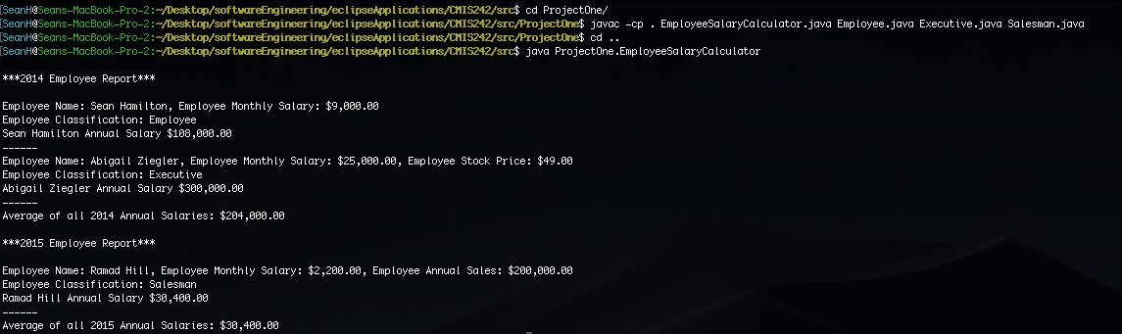

**Test Case One**

Compiling of all classes and passing test case two

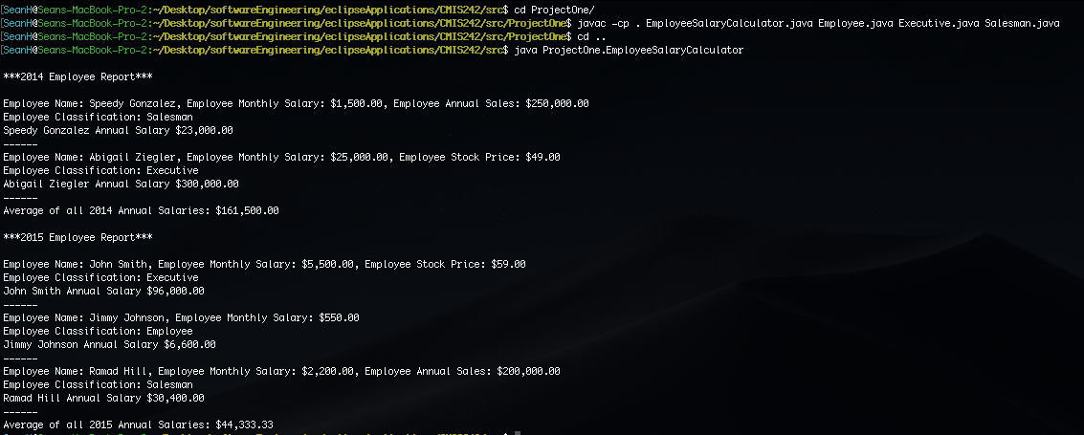

**Test Case Two:**

Compiling of all classes and passing test case two.

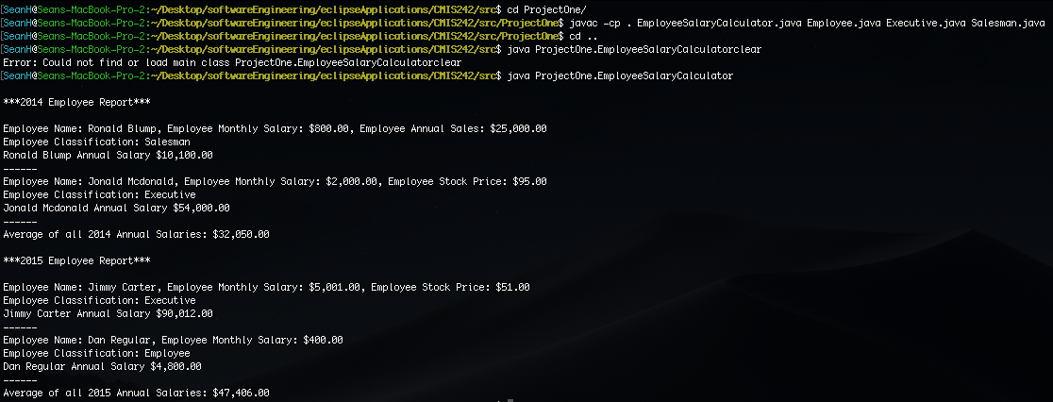

**Test Case Three:**

Compiling of all classes and passing test case three.