**Project Three**

Test Cases

|  |  |  |  |
| --- | --- | --- | --- |
| **Input** | **Expected Output** | **Actual Output** | **Pass?** |
| N=25 | **Iterative Result:** 1311738121  **Iterative Efficiency:**  25  **Recursive Result:** 1311738121  **Recursive Efficiency:**  242785 | **Iterative Result:** 1311738121  **Iterative Efficiency:**  25  **Recursive Result:** 1311738121  **Recursive Efficiency:**  242785 | Yes |
| N=9 | **Iterative Result:**985  **Iterative Efficiency:**9  **Recursive Result:** 985  **Recursive Efficiency:**109 | **Iterative Result:**985  **Iterative Efficiency:**9  **Recursive Result:** 985  **Recursive Efficiency:**109 | Yes |
| N=hello | **Iterative Result:** Must be an Integer.  **Iterative Efficiency:** Must be an Integer.  **Recursive Result:** Must be an Integer.  **Recursive Efficiency:** Must be an Integer. | **Iterative Result:** Must be an Integer.  **Iterative Efficiency:** Must be an Integer.  **Recursive Result:** Must be an Integer.  **Recursive Efficiency:** Must be an Integer. | Yes |

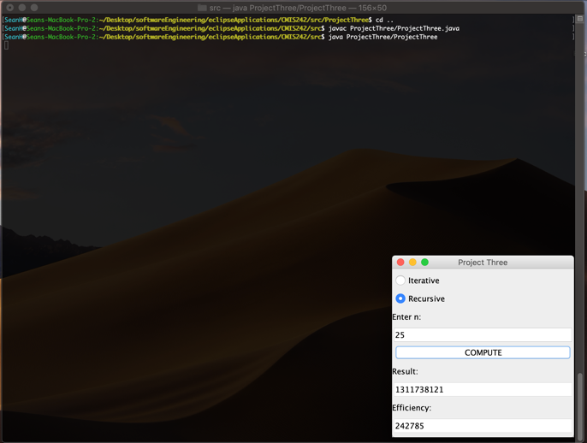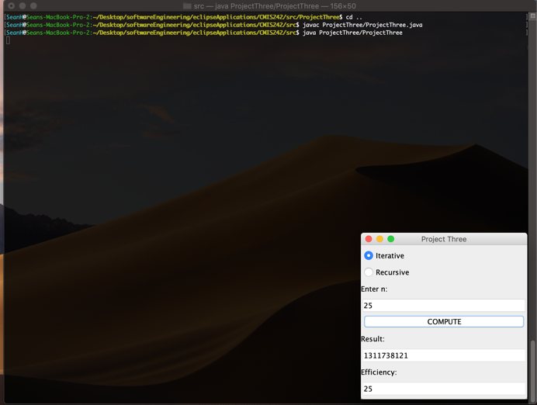

Compiling and running of test case 1.

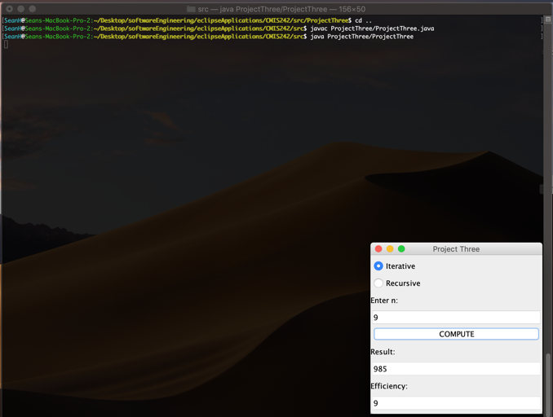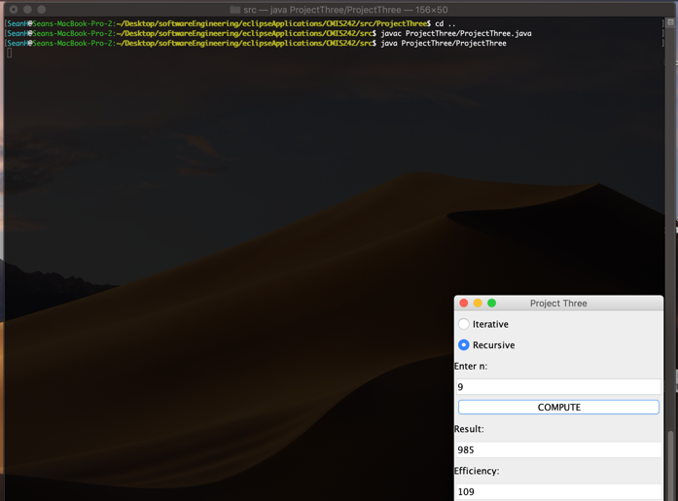

Compiling and running of test case 2.

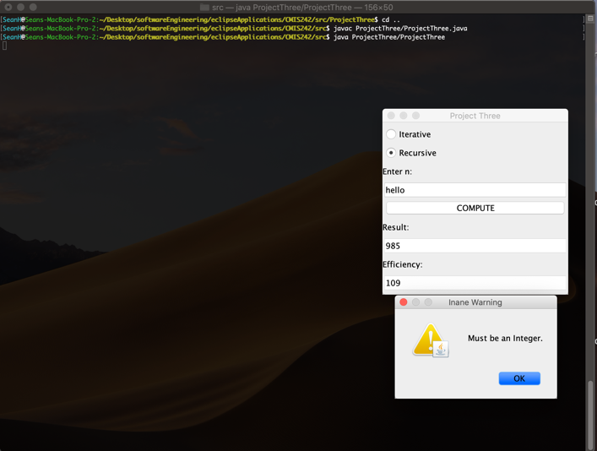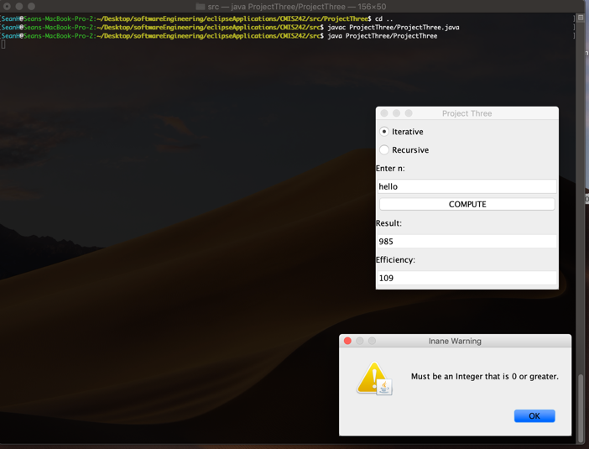

Compiling and running of test case 3.

Explanation of Results

This graph shows the results of running the solution iteratively versus recursively for the values of n 0-10. The results are conclusive that the iterative solution is more efficient and becomes even more efficient as the value of n increases. The iterative solution has a time complexity of O(1) and the recursive solution is o(n^2). For most scenarios it would be safe to assume that the iterative solution to this sequence should be used over the recursive solution.