**Project Two**

Test Cases

|  |  |  |  |
| --- | --- | --- | --- |
| **Input** | **Expected Output** | **Actual Output** | **Pass?** |
| *CheckingAccount = $200.00*  SavingsAccount = $2000.00  **-Press** withdraw from checkings for $20.00.  -**Press** withdraw from checkings for $40.00.  -**Press** withdraw from savings for $20.00.  -**Press** withdraw from savings for $40.00.  -**Press** withdraw from savings for $20.00. | -Withdraw from checkings has succeeded. New Balance: $180.00  - Withdraw from checkings has succeeded. New Balance: $140.00  -Withdraw from savings has succeeded. New Balance: $1,980.00.  - Withdraw from savings has succeeded. New Balance: $1,940.00.  - Withdraw from savings has succeeded. New Balance: $1,918.50. | -Withdraw from checkings has succeeded. New Balance: $180.00  - Withdraw from checkings has succeeded. New Balance: $140.00  -Withdraw from savings has succeeded. New Balance: $1,980.00.  - Withdraw from savings has succeeded. New Balance: $1,940.00.  - Withdraw from savings has succeeded. New Balance: $1,918.50. | Yes |
| CheckingAccount = $500.00  SavingsAccount = $500.00  -**Press** withdraw from checkings for $600.00  -**Press** withdraw from savings for $700.00  -**Press** withdraw from savings for ‘ABC’  -**Press** deposit from checking for ‘ABC’  -**Press** transfer to from savings to checkings for $5000.00. | -Sorry, you do not have the necessary funds to complete that transaction.  -Sorry, you do not have the necessary funds to complete that transaction.  -Must be a number.  -Must be a number.  -Sorry, you do not have the necessary funds to complete that transaction. | -Sorry, you do not have the necessary funds to complete that transaction.  -Sorry, you do not have the necessary funds to complete that transaction.  - Must be a number.  -Must be a number.  -Sorry, you do not have the necessary funds to complete that transaction. | Yes |
| CheckingAccount = $1000.00  SavingsAccount = $800.00  -**Press** withdraw from checking for 18.00.  -**Press** balance for checking.  -**Press** transfer $200.00 from savings to checkings. **Press** Balance for checkings.  -**Press** Deposit for savings for 1000.00 | -Must be a multiple of $20.  -$1,000.00  -$1,200.00  -Deposit to savings has succeeded. New Balance: $1,600.00 | -Must be a multiple of $20.  -$1,000.00  -$1,200.00  -Deposit to savings has succeeded. New Balance: $1,600.00 | Yes |

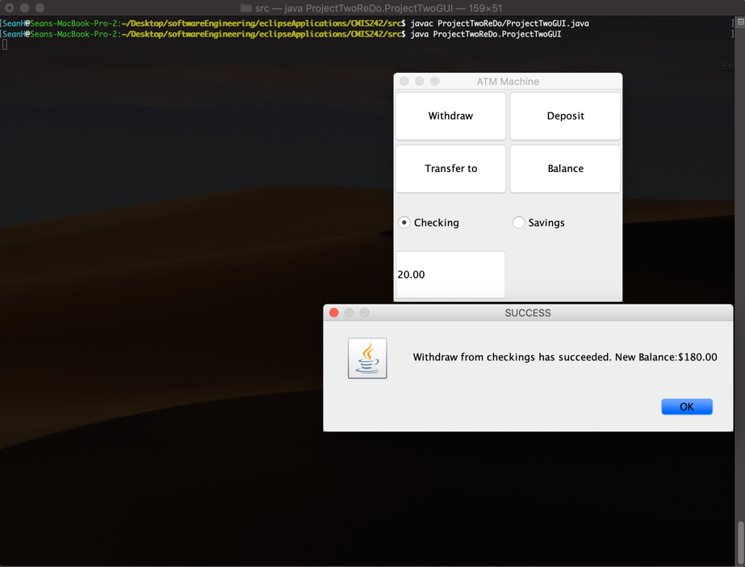

Compiling and running of class. Also test case 1 prompts

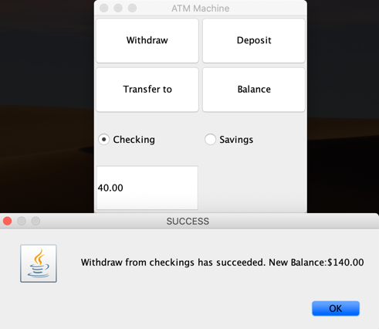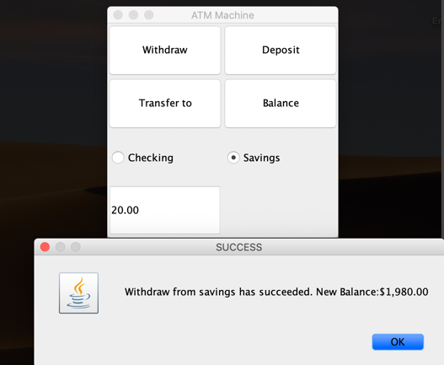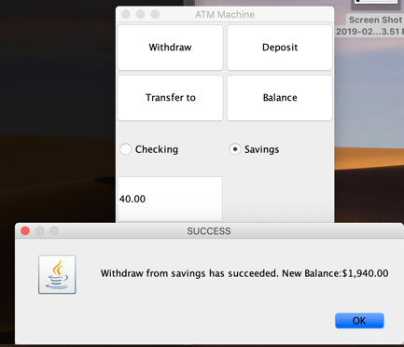

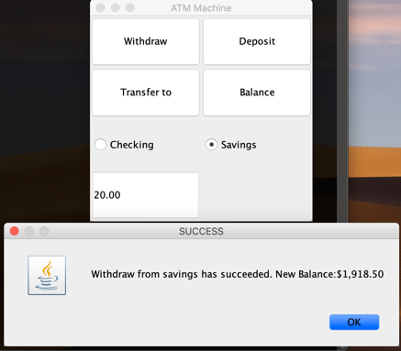

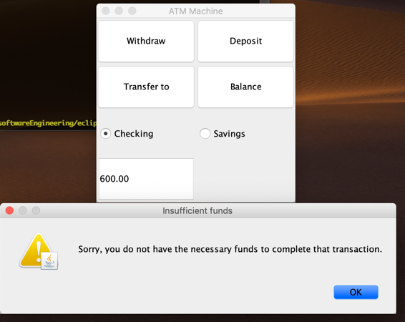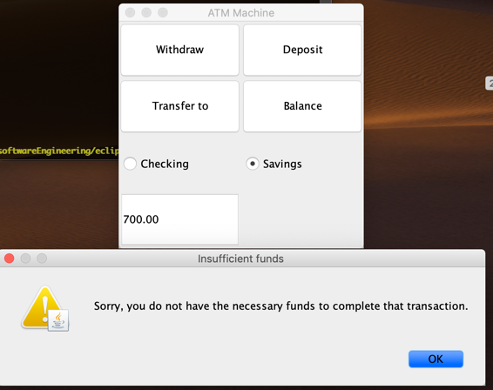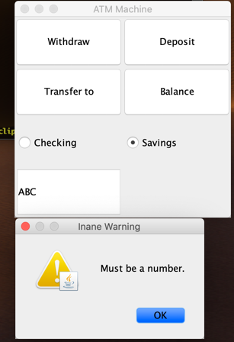

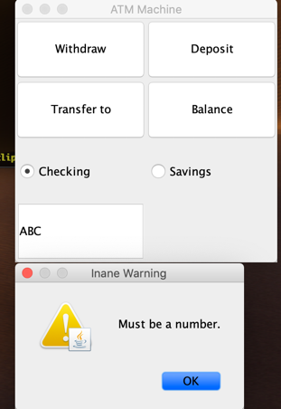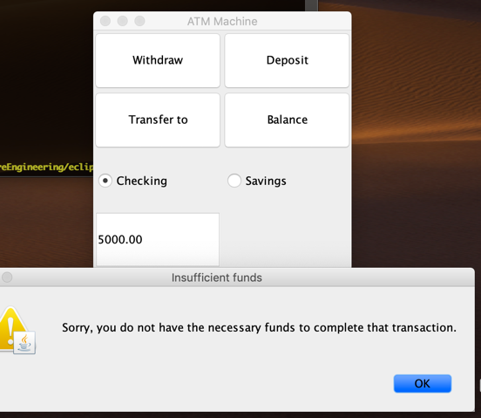

Test 2 return prompts.

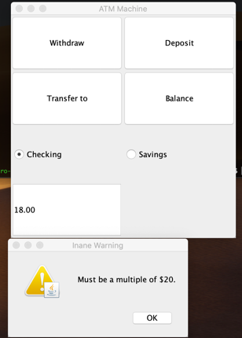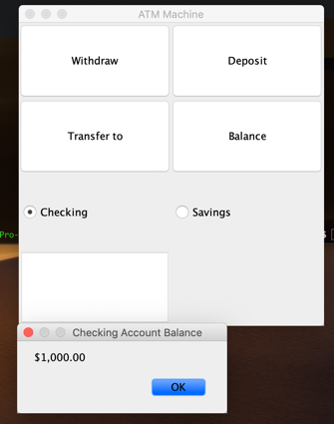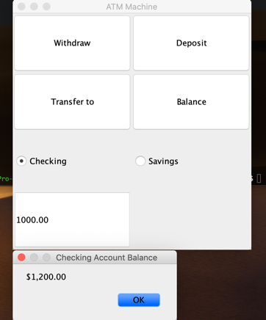

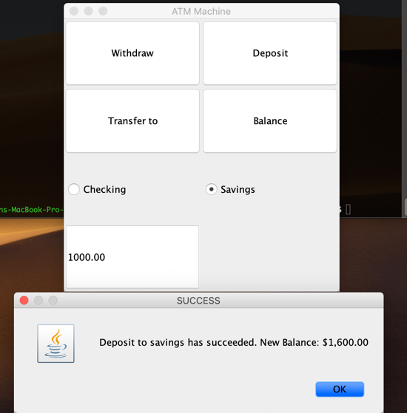

Test 3 Return prompts.