Trends in smooth cordgress biomass in the Virginia Coast Reserve

# 1 Introduction

## 1.1 Introduction

### 1.1.1 Introduction

#### 1.1.1.1 Introduction

**bold**  
*italics*  
this is a superscript  
this is a subscripts

# 2 Methods

We can easily write pretty mathematical formulas. For example, a simple linear model is given by

$$y_{i}=βx_{i}+ϵ_{i} \text{where} N∼(0,σ^{2})$$

$y_{i}$ is the response variable.

The model formula for the GAM was

mean_transect_biomass ~ s(year) +  
 s(year, habitat_type, bs = "fs") +  
 s(year, site, bs = "fs")

Here’s a random number: 1.43

# 3 Results

Results from the GAM showed that there was a significant non-linear trend in *S. alterniflora* biomass density through time (P = 0).

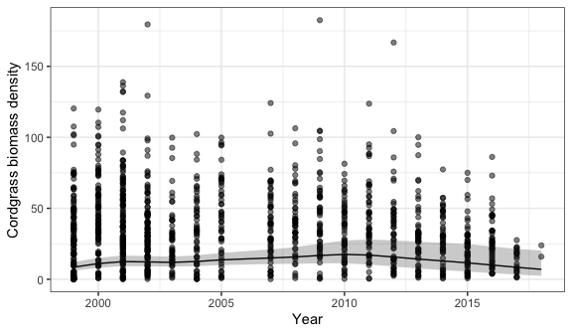

Figure 3.1: *S. alterniflora* trends in the VCR.

We used the GAMM formulation from 1.

We found a trend blah blah (Fig. 3.1).

1. Pedersen, E. J., Miller, D. L., Simpson, G. L. & Ross, N. Hierarchical generalized additive models in ecology: An introduction with mgcv. *PeerJ* **7**, e6876 (2019).