**Visual C# – Lab V**

Design Time Run Time

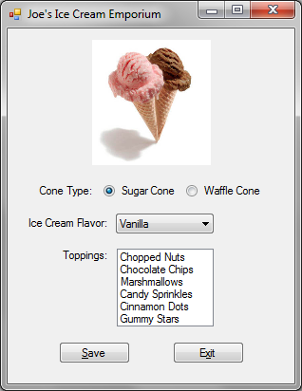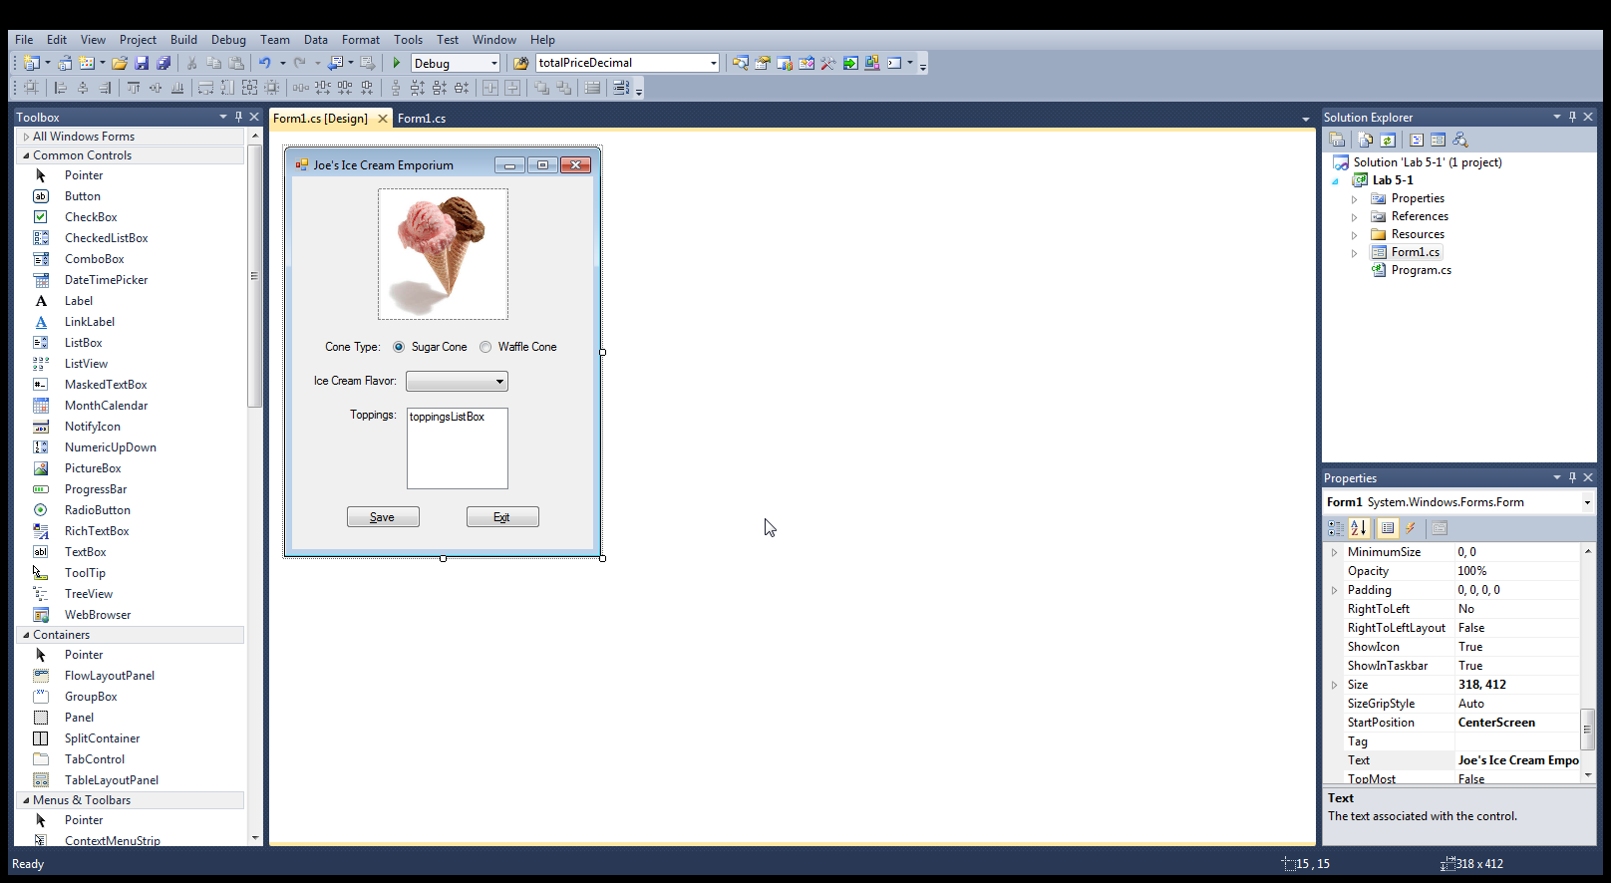

**You are to create the data-entry form shown above. Include all of the following in your project:**

* Using a project name of **Lab 5**-**1**, create a form as shown in the diagrams above. This project also requires the creation of two input text files (described below). The program will also create an output text file.
* The two input files used by the program are to be named Flavors.txt and Toppings.txt. Both of these files should be created using Notepad and then placed in the bin\Debug subfolder of the project folder. The contents of these two files will be read during the form’s Load event and the data will be processed by the program as described below. The data contents of these two files are shown on the next page.
* The picture box at the top of the form should contain an image file depicting ice cream of some kind. Just do a quick Web search to locate an appropriate image online that you can download and use.
* When the program runs, the Sugar Cone radio button should be selected as the default cone type.
* The ice cream flavor combo box should have its DropDownStyle property set to DropDownList. (This restricts the user selections to only those items included in the list.) After the program loads the ice cream flavors from the Flavors.txt input file (see below), make Vanilla the default selected flavor.
* The toppings list box should have its SelectionMode property set to MultiSimple. (This allows the user to select more than one item in the list.) The program is to load the toppings into the list from the Toppings.txt input file (see below). No toppings should be selected when the program starts up.
* The two buttons, Save and Exit, should have Access Keys defined for them as shown in the diagrams above.
* When the Save button is clicked, the program should write each order to an external text file named Orders.txt. This file should be located in the bin\Debug subfolder of the project folder. Each order should be appended to the end of this file so that a record of all orders placed is maintained. The date the order was placed should also be included in the data saved to file for each order. (See Visual C# – Lab IV for the code used to retrieve the current system date). Each order should be separated from the previous order by a blank line in the file. An example of this file’s contents after two orders is shown on the next page. After saving each order to file, the program should return the form to its original state and send the focus to the Sugar Cone radio button.
* When the Exit button is clicked, the Close method should be used to end the program.
* The contents of the two input files, and an example of the contents of the output file after using the program for two orders are shown below:

The contents of the **Flavors.txt** file should be, with one flavor per line:

**Vanilla**

**Chocolate**

**Strawberry**

**Butter Pecan**

**Rocky Road**

**Pistachio**

The contents of the **Toppings.txt** file should be, with one topping per line:

**Chopped Nuts**

**Chocolate Chips**

**Marshmallows**

**Candy Sprinkles**

**Cinnamon Dots**

**Gummy Stars**

**04/05/2017**

**Sugar Cone**

**Butter Pecan**

**Chocolate Chips**

**Marshmallows**

**Cinnamon Dots**

**04/05/2017**

**Waffle Cone**

**Strawberry**

**Chopped Nuts**

**Candy Sprinkles**