Name: ________________________
MATH 101 – MID-TERM (CH 1 – 4)
Finite Mathematics

Part I – Multiple choice – Circle the best answer (one mark each).

- In the given diagram, PQ ⊥ QR, PS = 5, and PQ = 4. The length of PR is closest to
(a) 6.4 (b) 11.7 (c) 7.1
(d) 8.9 (e) 12.1
P
R
S
Q
- If 2^{x} + 3^{y} = 43, where x and y are integers, then the value of x + y is
(a) 5 (b) 9 (c) 7 (d) 8 (e) 6
- If 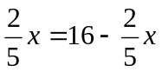, then 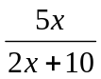 equals
(a) 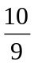 (b) 0 (c) 2 (d) 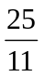 (e) 
- The value of (12.5 x 10⁻³) x (8 x 10¹¹¹) is equal to the value of
(a) 1¹¹⁰ (b) 1000¹⁰⁸ (c) 10³⁹ (d) 10¹¹⁰ (e) 100 x 10⁻³³³
- A baseball team won 50 of its first 75 games. The team still has 45 games to play. For the team to win 60% of its games over the entire season, the number of remaining games that it must win is
(a) 30 (b) 10 (c) 24 (d) 22 (e) 45
- A bag contains 5 yellow marbles, 10 red marbles, and 15 white marbles. If one marble is selected at random, the probability that it is yellow is
(a) (b)  (c)  (d) 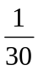 (e)
- The number of positive integers between  and 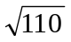 is
(a) 50 (b) 7 (c) 6 (d) 9 (e) 10
- 3² x 3³ x 3⁴ is equal to
(a) 3⁹ (b) 27⁹ (c) 27²⁴ (d) 9⁹ (e) 3²⁴
- If 60% of a number is 42, what is 50% of the same number?
(a) 40 (b) 30 (c) 25 (d) 28 (e) 35
- (1)¹⁰ + (-1)⁸ + (-1)⁷ + (1)⁵ equals
(a) 1 (b) 4 (c) 16 (d) 0 (e) 2

Part II – Written Portion – Show all you work. Marks as indicated.

- Simplify each expression (one mark each).
(a) 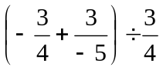 (b) 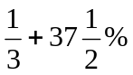
(c) 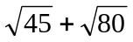 (d) 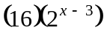
(e) 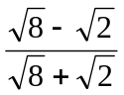 (f) 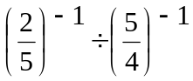
(g) (-3x²)² (2x⁻³) (h) 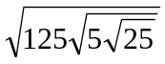
- Solve for x (two marks each)
(a) 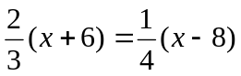 (b) 3x² + 13x – 10 = 0
(c) 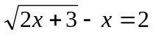 (d) 4^{x-2} = 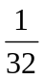
- Part III – Problems (4 marks each)

- Eight thousand dollars ($8,000.00) is invested at 6% p.a. compounded on a monthly basis.
(a) How much is this investment worth in 5 years? Hint: S = P (1 + 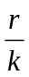)^{kt}
(b) What is the effective rate of return in one year? (two decimal places)
- The supply and demand function for sugar is given below.
(a) At what price will the supply equal the demand?
(b) At what price will no sugar be purchased?
(c) If you want to give the sugar away, what is the maximum you can get rid of? ________
Supply Function:

Demand Function:
P = 1.8 Q_{s} – 0.6

P = -2.0 Q_{d} + 3.2
- Find the maximum profit possible, given the profit function f (x, y) = 15x + 10y with the constraints below. Graph the feasible region.
(a) 6x + 3y ≤ 60
(b) 2x + 4y ≤ 44
- You decide to set up a small business selling coffee to students on campus. It costs $600 for start up, and a further 50 cents per cup in operating costs. You are able to sell each cup of coffee for $1.50.
(a) What is your cost function? Assume a linear cost function.
(b) How many cups do you need to sell to break even?

