Name:

Math 101 - Problem Survey Test Time: 1 hour
Form B

Problems: Show your work. 5 marks each

1. A 10 year bond was purchased for $1000.00. It paid a rate of 8% per annum compounded monthly. How much was the bond worth in 10 years. Hint: 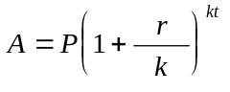

2. If f(x) = x² + x - 2

i) Find: f(2) - f(1)

ii) Find f(h + 1) - f(h)

3. A cyclist rode 410 km in five days. Each day he traveled 15 km more than he rode the previous day.

i) What distance did he travel the first day?

ii) If he continued to travel in this fashion, how far would he travel the next 5 days?

4. You wish to construct a pen adjacent to a barn. You have 30 meters of fencing available. What should the dimensions of your pen enclosure be in order to maximize the area, and what is the maximum area?

i) Write the length of the pen in terms of “x”

x x
ii) Write the area as a function of “x”.

y

iii) For what value of x is the area maximized?

iv) What is the maximum area?

5. A spinner is spun two times. The color where it stops is recorded each time.

i) What is the probability of landing in the blue area on both spins?

Red Blue
180° 120°

60°
Green
ii) What is the probability of landing on blue at least once during two spins.

iii) Given that it landed on the blue area during the first spin, what is the probability it will land on the
blue on the second spin?

6. i) Find the area of an equilateral triangle. Each side equals 10 cm.

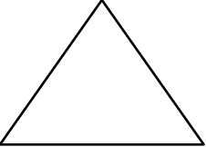

ii) Find the area of the shaded portion. ABCD is a square with two inscribed semi-circles as shown.
The radius of each semi-circle is 5 cm. Hint: A = πR²

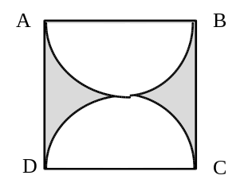

7. A rectangular lawn measures 40 m by 30 m. A strip “x” meters wide is cut along one side and across the end. (refer to diagram). If one-third of the lawn’s area is cut, determine the width to two decimal places. Hint: 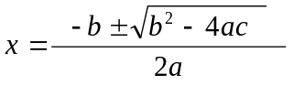
30

x
40

x
8. A circle with radius 20 is in quadrant I and another circle with radius 5 is in quadrant III. Both circles are tangent to the x and y axis.

i) Show a sketch.

ii) Determine the distance between the centers of the circles.

9. A line parallel to 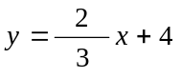 passes through (1, -3) y
i) sketch both lines

x

ii) Determine the equation of the line parallel to

- The price of a commodity is determined by the number of units sold. "x" is the number of units sold, and p = -2x + 30 is the price charged.

- Write a function for revenue in terms of "x". Hint: Let R + p · x.

- What price should be charged to maximize revenue?

- What is the maximum revenue?

- In a certain lake, the light intensity under water is reduced by 5% for every meter below the surface of the water.

- What is the intensity 20 meters below the surface?

- At what depth will the intensity be 50% of the intensity on the surface?

- Use Law of Logarithms to solve each equation below.

i) 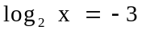

- log 8 + log 2 = log x

- 500 = e^{0.08t}

iv) log x² = 4(log x)²

