Name:

FORM A Time: 60 min.
Survey Exam - MATH 101
Trinity Western University

Part I General Knowledge - 2 marks each. Circle the best choice.

1. The value of 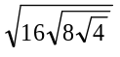

a) 16 b) 8 c) 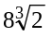 d) 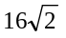 e) 64

2. The value of 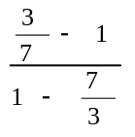 is

a) 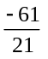 b) c) -1 d) 1 e)

3. On each application of killer weed spray, 80% of the weeds are killed. On a test plot there are 275 weeds. After a plot has been sprayed twice, the number of weeds remaining is:

a) 74 b) 176 c) 44 d) 11 e) 115

4. Two circles have diameters 5 and 15 respectively, the ratio of their areas is: A = πR²

a) 1:9 b) 1:4 c) 1:3 d) 1:2 e) none of these

5. If 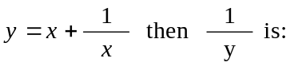
a) 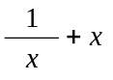 b_ 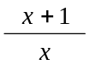 c) 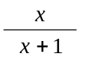 d) 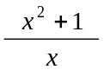 e) 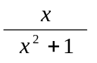

6. In an isosceles 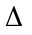 ABC, angle BAC is 90° and AD is perpendicular to BC.
If AC = BC = 2 what is the value of AD?
a) 1 b) 2 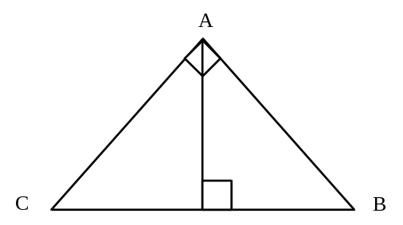

- 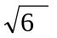 d) 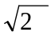 e) none of these

7. Simplify 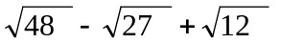

a) 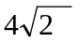 b) 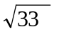 c) 3 d) 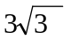 e) 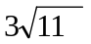

8. Tara had an average of 56 marks on her first 7 exams. To obtain an average of 60 marks on 8 exams, her mark on the eighth exam must be

a) 64 b) 72 c) 80 d) 84 e) 88

9. The value of 4(2¹⁹⁹²) is equal to the value of:

a) 4¹⁹⁹⁴ b) 8¹⁹⁹² c) 2¹⁹⁹⁴ d) 2³⁹⁸⁴ e) ³⁹⁸⁴

10. 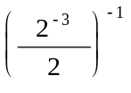 is equivalent to:

a) 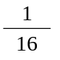 b) 4 c) 16 d) -16 e) 16⁻¹

11. Which of the following represents 0.00079 in scientific notation?

a) 7.9 x 10⁻⁴ b) 79 x 10⁻⁶ c) 7.9 x 10⁴ d) 79 x 10⁵ e) none of these

12. Simplify 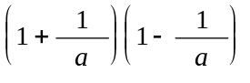

a) a² - a b) 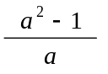 c) 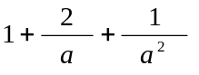 d) 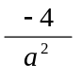 e) none of these

13. The slope of the line 3x + 2y + 7 = 0 is

a) 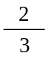 b) 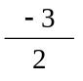 c) 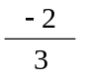 d) 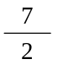 e) 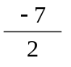

14. Solve for y only: 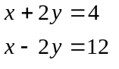

a) -2 b) -4 c) 4 d) 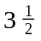 e) 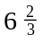
15. Where does the line 2y + 7x - 17 = 0 intersect the y axis?

a) 17 b) -17 c) 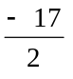 d) 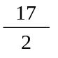 e)

16. Give the complete solution set for x³ + 5x² + 6x = 0

a) 1, -6

b) -2, -3

c) 0, -2, -3

d) 0, 1, -6

e) none of these

17. (a - 3b)² equals

a) a² - 9b² b) a² + 9b² c) a² - 6ab + 9b² d) a² + 6ab + -9b² e) none of these

18. Solve 3 - x ≤ 6 + 2x

a) x ≥ -1 d) 0 ≤ x ≤ 1

b) x ≤ -1 e) x < 1

c) x ≥ 1

19. Find f(0) if f(x) = 2^{x}

a) 1 b) 0 c) 2 d) x e) none of these

20. If 2% of a number is 8, then the number is

a) 0.16 b) 4 c) 16 d) 400 e) 800
Part II: Circle the best answer (4 marks each -- avoid guessing -- one mark for each unanswered
question.

1. When 3²² is divided by 5 the remainder is

a) 0 b) 1 c) 2 d) 3 e) 4

2. The number of integer values of n which satisfy the inequality 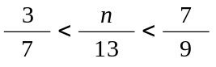

a) 9 b) 4 c) 5 d) 6 e) 7

3. The area of a triangle whose vertices are (2,0), (2,3), and (1,5) is:

a) 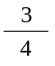 b) 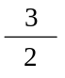 c) d) 2 e) 3
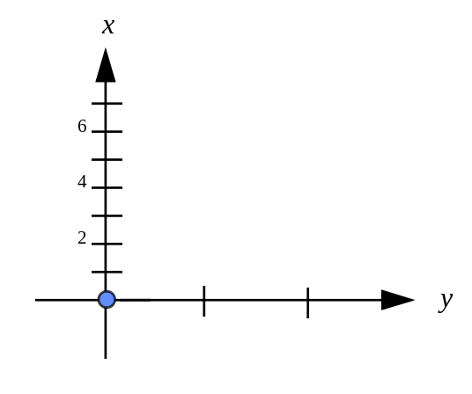

4. A square of side 2n + 1 has another square of side 2n inside it. The are between the two square is

a) 2n + 1 b) 4 c) 4n + 1 d) 4n + 2 e) 1

5. A jar is filled with a mixtures of water and vinegar in the ratio of 2:1. Another jar, with twice the volume, is filled with a mixture of water and vinegar in the ratio of 3:1. If the contents of both jars are emptied into a third container, then the ratio of water to vinegar is

a) 8:3 b) 5:2 c) 5:1 d) 6:1 e) 13:5

6. When the hands of a clock indicate the time as 9:20, then the measure of the obtuse angle formed by the hands, in degrees is

a) 150 b) 155 c) 160 d) 165 e) more than 165.

7. Which of the following could be the equation of the function whose graph is shown?

a) x + y = 6 b) y = x² c) y² = x d) xy = 8 e) none of these
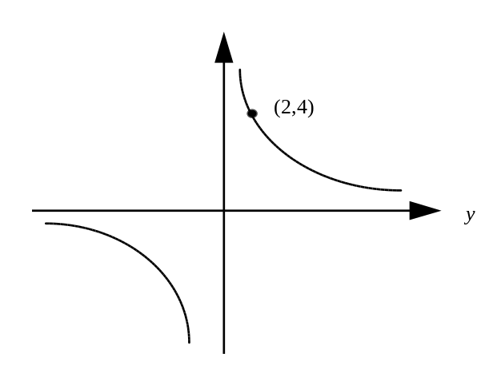

8. Solve x² - 4x - 3 = 0 Hint: use the quadratic formula 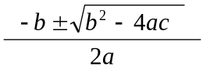

a) 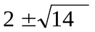 b) 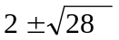 c) 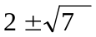 d) 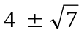

e) none of these

9. If there are 3 white and 9 red marbles in a bag, what is the probability that two marbles drawn at random without replacement will be white?

a) 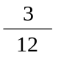 b) 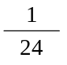 c) 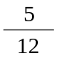 d) 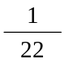 e) none of these

10. If 10% of a doctor’s patients have hearing problems and 30% have seeing problems and 5% have both hearing and seeing problems, how many of the patients have neither hearing or seeing problems.

a) 60% b) 40% c) 65% d) 45% e) 55%

