Bioplastics and Biodegradable polymers: Problem or Solution?
Christine Gerig
#218436
NATS 490
Dr. Sean Ho
12/03/2009

The LORD God took the man and put him in the Garden of Eden to work it and take care of it.
-Genesis 2:15-
Table of Contents
Contents Page(s)
Introduction 3
Introduction to Plastics 3-4
Plastic Waste 4
Plastic Degradation 4-5
Biodegradable plastics 5
Bioplastics 6
Gentically Modified organism discussion 9
Reduce, Reuse and Recycle 10-11
Conclusion 11
Bibliography 12

Word Count: 4, 146
The LORD God took the man and put him in the Garden of Eden to work it and take care of it.
-Genesis 2:15-
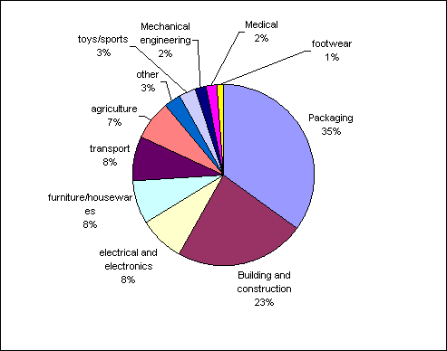
The “Landfill Crisis” of the late 1980’s to the mid 1990’s birthed a realization that humans were creating mountains of problematic waste which were having a detrimental effect on the environment⁸. Plastics are a common commodity in society and as a result have also become a common source of pollution, comprising 30% of all waste in landfills¹. The recalcitrant nature of plastics to degredation is a very large problem as it shortens the lifespan of landfills and is considered the worst waste issue present today³. The push to be ‘green’ as global warming has with urgency been acknolwedged by politians and evironementalists has created a new market of opportunities for eco-friendly products which would reduce waste. With ingenuity, manufacterors have created both biodegradable polymers and bioplastics hoping that they can reduce the amount of waste in landfills. Since their inception, biodegradable polymers and bioplastics have been praised as the solution to the current materialism of society; however, the promotion of waste, the extensive requirements of proper waste management, a radical change in human behaviour, and genetically modified crops as starting materials make these plastics no solution but rather a very big problem.
Figure 1: Plastic usage¹⁶
Within the past century, plastics have invaded the manufacturing sector and due to their broad range of properties have found use within almost every industry around the world⁴. In the 1950’s plastic consumption was around 5 million tonnes whereas today it stands around 100 million¹⁶. In Figure 1, it is obvious that plastic consumption has left no area untouched as it is used within the medical, construction, household, and transport sectors to name just a few. Plastics are prevalent within society because they are relatively inexpensive to make, have extreme durability, and are very versatile allowing them serve a variety of functions³.
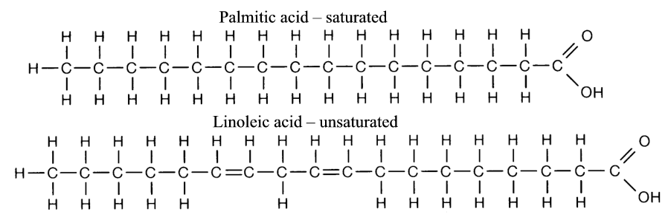
God was extremely creative when He made the earth not only in the macroscopic, but also on an atomic level as long linkages of carbon and hydrogens provide a very strong backbone within molecules called a polymer⁹. A polymer as seen in the picture below is an unmodified linkage of carbon and hydrogen atoms. When this backbone is heated, or added to with different fillers, plasticizers or functional groups its properties can change dramatically⁹. The product of such modification is called a plastic and their physicality’s can be as different as the glass window of a vehicle or the rubber elastics commonly used to tie back hair. The potential within simple combinations of atoms which God provided humans in Creation is extensive. Due to the ability of plastics to be tailored to meet specific needs with regards to properties, they have become a favourite within the manufacturing sector⁸; however, due to extensive use, a great amount of waste has also developed. Waste is not necessarily problematic; however, due to the long hydrocarbon backbones present within the plastics, microorganisms cannot digest the plastics and thus they do not decompose³. Most plastics are made for durability and strength in order to maintain maximum functionality and thus are resistant to chemicals, water and impact which contribute to their inability to degrade.
Figure 2: Polymer chain
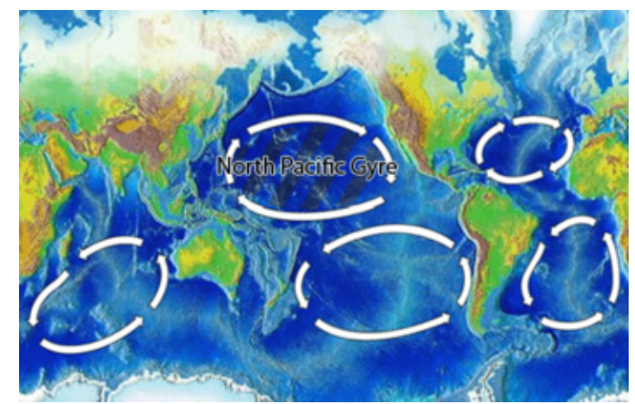
The inability of plastics to degrade has had life threatening results and continues to be damage the environment. 35-40% of plastic consumption is used for packaging and the population of the earth has increased, so has plastic consumption, leading to a substantial increase of plastic waste produced over the past century. Alongside the issue of plastics low susceptibility to degradation, plastic waste is not being disposed of properly and so is ending up in the oceans and landfills rather than in the recycling bins³. The great pacific garbage patch is a gyre or a circling of ocean currents which has led to the trapping of garage and debris from all over the world into an area between North America and Europe¹⁵. The majority of that garbage is plastic. There is six times as much plastic as there is plankton within certain areas of this gyre producing grave results¹⁵. Marine life and birds mistake the plastic for food and devour it, filling their stomach; however, it does not degrade so they remain ‘full’ and yet do not acquire any nutrients¹⁵. The animals are susceptible to die from either the toxins within the plastic that are released or from starvation¹. Pollution is not only seen at sea, but also on land as plastics are not recycled and end up in landfills, slowly releasing toxins which are released into the air or the stomachs of scavenging animals⁴. Landfills can also leak, contaminating ground water and the eco systems which they uphold. Another option in disposal is the burning of waste, yet this is extremely harmful both for humans and the environment as the toxins which are released can cause cancer and asthma⁴. If incomplete combustion occurs, which is where there is not sufficient oxygen for the reaction to occur, carbon monoxide and water are produced. Both carbon monoxide and water are very damaging greenhouse gases and will inevitably aid in the reduction of the ozone layer and thus global warming¹.
Figure 3: North Pacific Gyre¹⁵
Innovation within plastic manufacturing has lead tailoring plastics to fit the desires of society; however, the waste produced is not being efficiently disposed of and thus is detrimental the environment. With the knowledge and brain God gave humans in the Garden of Eden comes a responsibility to take care of the earth as seen in Genesis 2:15. God created the carbon and hydrogen atoms that fit together just perfectly to form the amazing and useful plastics seen today. Yet with this knowledge comes responsibility to act as stewards of the earth. It is irresponsible to make plastics and then ignore what damage is done by them. A farmer does not build a barn which he knows will damage his crops or animals and yet this is what society is doing with plastics. Plastics can still serve to be beneficial within the economy; however, there must be resources set aside to deal with the waste which is produced to ensure it is not damaging the earth, or its inhabitants.
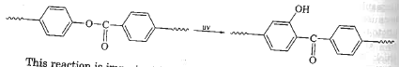
Efforts to reduce the effect plastic waste has on the environment have surfaced in the production of bioplastics and biodegradable polymers. In the process of modifying the hydrocarbon backbone in the synthesis of a plastic, if “weak links” which facilitate its degradation into fragments such as those capable of undergoing photodegradation or hydrolysis are added then it has become a biodegradable polymer³. The reason it is biodegradable after such insertions is because under certain conditions such as exposure to sunlight or water the weak links will decompose and the chain that was once too big for digestion is now much smaller and microorganism can then digest the fragments⁹. An example of such a polymer is seen in Figure 4. The addition of the ester functional group, or the C-O-C group serves as the ’weak link’, within this plastic which when exposed to UV light undergoes a structural change which promotes its degradation¹⁹. Biodegradable polymers are still made from petroleum just like their unmodified counterparts; however they have weak links which facilitate degradation. Bioplastics on the other hand are much different than biodegradable polymers since they contain little to no petroleum, but rather are synthesized out of biomass sources such as starch or vegetable oil². The sustainability and biodegradability of such bioplastics is seen as very environmentally friendly and as a great solution to the plastic waste problems which are detrimental to ecosystems and marine life.
Figure 4: Polystyrene ester copolymer degradation due to UV light.¹⁹
Manufacturers have been selling biodegradable polymers under a ‘green’ label promoting their friendliness towards the environment and yet scientifically these products have not earned such a label⁸. With a shift to promote eco- friendliness, false advertising has become common in the consumers market⁵. There are three major labels associated with plastics regarding their environmental impact which are: degradable, biodegradable and compostable⁶. Degradable simply implies that at some point in time, an irreversible change in structure will occur thus changing the properties of the plastic⁵. The biodegradable label is similar; however, the change in structure is due to the work of microorganisms such as fungi or algae breaking the chain down⁶. The last label is compostable and is by far the most honest and eco friendly. Compostable labels can only be placed on objects if the product will degrade into carbon dioxide, water and inorganic compounds at a rate consistent with other compostable materials such as a piece of thick construction paper⁵. The problem with such labels is they lead the consumer to believe that a product is not harmful to the environment even when it is. Degradable labels convince the buyer that breakdown will ensue at some point; however, there is no time limit for such a label and as such the plastic could degrade in a million years, yet it is still degradable⁴. Biodegradable polymers are beneficial since their breakdown is facilitated by microorganisms; however, again the product does not have to undergo such a process in a specific amount of time, it just has to undergo such a method of degradation⁶. Another vital issue takes place as the structure of the plastic is lost, a monomer or toxins which were once held in place are released into the environment¹. Simply put, the faster the product degrades the faster the toxins are released into the environment and cause damage. Compostable specifications do require the plastic to breakdown within a certain time frame, yet this still does not specify or limit the toxins which may be released⁵. Such labelling confuses the consumer and because the label sounds green and environmentally friendly, individuals are more likely to litter the waste rather than dispose of it appropriately as they think it will just break down in a few days with no harm done. In Exodus 20:16 the Lord commands that one not bear false witness against his neighbour. The promotion of environmentally friendly plastics shows responsibility and care for the earth, the promotion of materialism under a mask of stewardship is bearing false witness. There need to be improvements in labelled requirements and certification standards for biodegradable and bioplastic products⁶ so that consumers are not being deceived.

Biodegradable polymers are deceiving in both functionality and ability. Due to the weak links inserted into polymers to facilitate their degradation, biodegradable plastics are used for one use products such as packaging and food containers which have a specific shelf life and then are thrown into the garbage⁹. The idea is that the plastics will begin to degrade shortly after thrown into the garbage. Not only is such timing difficult, but it entails the consumption of exponentially more petroleum as products can no longer be recycled but must be thrown away⁴. Biodegradable polymers cannot be recycled since they have ‘weak links’ which if mixed with regular plastics will ruin their properties and the batch of recycled plastic is rendered useless⁷. This means the only option for the disposal of biodegradable polymers is into landfills, unless they are labelled as compostable. The deceiving part about biodegradable plastics is that they will only degrade under optimal conditions of oxygen, water and sunlight¹. Such stringent conditions are not present within landfills and as a result the plastic breaks down anaerobically and produces methane, one of the most destructive green house gases known⁷. The efficiency of biodegradable plastics is limited and the efforts of consumers to ‘go green’ are being manipulated. Biodegradable plastics do not seem to fit a stewardship mentality in caring for the earth as they are not economical, resourceful or effective.
Fig 5: Oil drill in the sunset¹³
Furthermore, it seems foolish to be using limited resources of petroleum fuel to simply make things easier to throw away. In the 2007 World Energy Outlooks, the International Energy Agency reported that, "World oil resources ... are judged to be sufficient to meet the projected growth in demand to 2030,"; however, it fails to mention what will happen after 2030¹². When referring to oil supply and reservoirs the term ‘ peak oil’ is used and it means that there will be a ‘peak oil’ period where maximum oil extraction will occur which will be followed by a significant and unprecedented decline in oil production¹³. The year 2030 is slated as this ‘peak oil’ period. In Matthew 6:25 Jesus tells us to not worry about tomorrow, for tomorrow will worry about itself. In the wake of limited petroleum resources, there is no need for worry, but rather a stewardship mentality which promotes the conservation and diligent use of what one does have. Oil is not a renewable resource and as such should not be wasted on creating one time use plastics, when durable plastics could be synthesized and reused.
Bioplastics are praised because they are synthesized with renewable resources; however, the use of food for waste is irresponsible and dishonouring to God. The idea that biomass sources are sustainable and relieve the need for the limited oil sources³ seems admirable, yet around the world around 30 000 people die of starvation a day¹⁷! In James 1:27 it states, “Pure and undefiled religion is this, to look after orphans and widows in their distress and to keep oneself polluted from the world.” ¹⁹ Although consumerism calls for convenience, one must try to avoid such; ’convenience’ when it is at the expensive of the orphans and widows who are starving all around the world. Matthew 25 recounts the Lord taking to people at the gate of heaven where they claim they never saw Jesus sick, or hungry or in need of clothing. His reply is, 'I tell you the truth. Anything you refused to do for any of my people here, you refused to do for me.' The inaction done when using biomass sources to create more waste rather than food to feed the hungry is neglecting God’s children and in doing so neglecting Him. There is absolutely no way to justify the use of food sources to feed the materialism of society rather than the physically starving of this world.
The question regarding the mutation of God’s creation through genetic modification as honouring, safe and wise has been a source of controversy in bioplastics production. The majority of bioplastics are synthesized from genetically modified organisms (GMO’s) and although this could be a topic all on its own, a few points will suffice. Some have the opinion that when God created the earth and said “ it was good” it implies that should be no need for GMO’s. In this view, God created the earth and all within it is in order that humans could live and sustain themselves. He provided food, clothing, entertainment, relationship and the tools for habitation and living. God has provided and the responsibility to sustain and preserve the earth has been left to humans¹⁰. The issue lies in the need to mutate His creation¹⁰ if He did indeed give us all that we need for life. Has society come to a point in which creation has to be modified and mutated in order to sustain life or, again, is it more a matter of convenience?
The largest issue with genetically modified organisms and bioplastics is uncertainty. When foreign genetic material is introduced into plant systems, the modified product may seem safe; however, when this modified species is placed in the wild and cross contamination occurs with wild species, the resulting gene patterns are simply left to chance and the results may be deadly¹⁰. Bt or bacillus thuringiensis is a bacteria which is toxic to such creatures such as corn borers and has been used by farmers to control such pests. Advances in technology have led to a genetically modified corn crop where Bt has been genetically implanted into the DNA of corn in order to make them resistant to such nuisances¹¹. When used in the powered form by farmers as a pesticide, there had never been fear of pests gaining resistance since the quantities were quite small. However, Bt corn has this toxic bacteria all throughout the plant, in the stock, leaves, and even pollen. Not only can the pollen be transferred to a wild corn and thus control is breached, but the very toxins within the plant are at such high quantities and when the plant decomposes it will release such toxins possibly leading to pests gaining a resistance to it.¹¹ GMO’s produce health and safety concerns for humans, other crops and the environment. If GMO crops are established a chief concern is their control and recapture, as it can be extremely difficult and no one knows for certain what mutant species may arise¹⁰. If the modification of organisms is essential to life and survival on earth it is imperative that appropriate control and recapture methods be in place in order to secure the treasures which nature already has and what God has entrusted to us. Furthermore, long term testing should also be used to test possible outcomes of certain mutations to ensure that preservation of God’s Creation is undertaken and nothing is left to chance.
There is a world where bioplastics and biodegradable polymers would work; however, the altruistic nature of such a place is unrealistic for the fast paced and convenience based society we live in. If biodegradable polymers were produced en mass, there would need to be extensive decomposition waste sites⁴. The plastics would have to be sorted into like kinds, since different plastics have different conditions for degradation, and then each with its own kind would need to be exposed to the exact amount of sunlight, moisture, humidity and oxygen that was needed for its degradation³. Furthermore, microbes would then need to be introduced into the systems to finish the process. These buildings would have to continually turn and aerate the decomposing matter and would require extensive man power to run⁵. In order for this type of process to work, individuals, and society at large would have to have a very large mental shift, as it would require, composting all compostable material, recycling specified plastics and putting all garbage into the waste receptacles. Recycling facilities would also require a large overhaul as sorting would be essential to the success of the plant⁷. If cross contamination of plastics occurred, whole batches of recyclable material would be ruined². Furthermore, after the sorting is done, different plastics require different recycling methods especially biodegradable polymers with ‘weak links’⁷. This would require people to actually compost, recycle and dispose appropriate materials into landfills, and this is the biggest issue of all: human behaviour.
In the fast paced and technologically advanced society today, convenience seems to top the list of priorities for consumers, especially with regards to going green. There has been a shift in the mentality of society over the past decade to be eco-friendly and along such a desire comes the desire for green and convenience. Recycling is inconvenient. Compositing is inconvenient. Buying biodegradable or bioplastics is effortless and makes individuals feel as though they are doing their part to help save the earth. False advertising of products as green and the inability of products to biodegrade when labelled as such is a disappointment to consumers. Yet with all this said bioplastics and biodegradable polymers would only work if each individual took responsibility and composted, recycled and disposed of garbage appropriately in the first place. However, if this shift did happen, then there would be no need to have biodegradable polymers or bioplastics because there would not be a waste problem! China in the year 2000 saw only 20-30% of plastic waste go to landfills, 10% was recycled and the other 60-70% was littered or dumped⁴. Humans are both the problem and the solution.


Reduce, reuse and recycle. The thought behind the hierarchy of waste management has been around since the 1940’s where woman collected used tires and scrap metal since resources were low during the war¹⁴. This very same motto applies today as there is a drastic need for human behaviour to shift from convenience to responsibility. First, if the amount of resources used in the generation of plastics could be reduced, then whatever resources we do have will go farther. Reduction of waste can go a long way especially if plastic items are made durable so that they can be reused. If every plastic bottle could be used twice rather than just once, the resources need to make plastic bottles would be cut in half⁷. Such a minor change can have huge benefits. Furthermore, once a plastic does come to the end of its life, if it can be recycled, this would reduce the amount of virgin material actually needed for reprocessing. It requires twice as much energy to incinerate plastic than it does to recycle it, not to mention the fumes and greenhouses gases that can be omitted during the burning process⁹. It is understandable that changing public opinion is difficult; however, this is where government incentives could play a role. If municipalities created recycling or compositing sites which were convenient for community members, and even provided payment for their waste; in a society where convenience and money are motivator’s, reduction in pollution is likely. As a start to care for the earth and preserve it, the three R’s seem to be an obvious and effective step towards stewardship.
Figure 6: Reduce Reuse Recycle¹⁴
Biodegradable polymers and bioplastics create more waste than they eliminate. Their degradation occurs only under stringent conditions of which would require new waste management and recycling systems which are both costly and their effectiveness is still only proportional to the diligence of the consumer². Biodegradable polymers and bioplastics currently sit in landfills and produce damaging methane gas while using up tonnes of precious resources every year². These ‘green’ plastics are not conducive to the lazy society we live within. The very idea that extra food would be produced for the sole purpose of creating waste while people starve is shameful and materialistic. This promotion of consumerism and a lack of diligence and care for the resources that God has bestowed upon us in no way reflects a stewardship mentality. The Bible calls us to be good stewards and through reduction of waste through recycling and reuse, food resources can allocated to feed the hungry rather than waste. Creating more durable plastics reduces the need for non-renewable resources such as petroleum and decreases waste production. It is these ideals which will help us fulfill and honour God’s mandate to care for the very Earth he entrusted to us.
Bibliography
1. Biodegradable Plastics - Developments and Environmental Impacts. Nolan-ITU Pty Ltd and ExcelPlas Australia. Report prepared for Australia Department of Environment and Water Resources. October 2002. <http://www.environment.gov.au/settlements/publications/waste/degradables/biodegra
dable/index.html >
2. Greer, D. (2006). Plastics from Plants, not Petroleum. BioCycle , 31-35.
3. Ishigaki, e. a. (2004). The degradability of biodegradable plastics in aerobic and anaerobic waste landfill model reactors. Chemosphere , 225-233.
4. Ren, X. (2003). Biodegradable plastics: a solution or a challenge? Journal of Cleaner Production , 27-40.
5. Davis, Georgina et al. (2005). An Evaluation of Degradable Polyethylene (PE) Sacks In Open Windrow Composting. 50-59

6. Riggle, David. (1998). Moving towards consensus of degradable Plastics. Biocycle, accessed at
<http://www.bpiworld.org/Files/Article/Artzu9gsH.pdf>

7. Song, G. D. (2006). Biodegradable packaging based on raw materials from crops and their impact on waste management. Industrial Crops and Products , 147–161.

8. (2000). Biodegradable Polymers: A Review. Environment and Plastics Industrial Council.
9. Azapagic, Adisa, Alan Emsley and Ian Hamerton. Polymers, the Environment and Sustainable Development. West Sussex: John Wiley and Sons, 2003.
10. Wibberley, E.J. (2003) “Integration Towards Ethical Agriculture: Challenges, principles and practice in international perspective”, in Biblical Holism and Agriculture.
11. Bacillus Thuringiensis. <http://en.wikipedia.org/wiki/Bacillus_thuringiensis> Accessed on March 9. 2008
12. World Energy Outlook 2007. <http://www.iea.org/Textbase/npsum/WEO2007SUM.pdf> pgs 5-10. Accessed on March 10.2009
13. Peak Oil. <http://en.wikipedia.org/wiki/Peak_oil>. Accessed on March 10.2009
14. Picture. <http://www.omrealtygroup.com/site/epage/55666_684.htm> Accessed on March 10.2009
15. Great Pacific Garbage Patch. <http://en.wikipedia.org/wiki/Great_Pacific_Garbage_Patch>. Accessed on March 11.2009
16. Biodegradable Plastics. <http://en.wikipedia.org/wiki/Biodegradable_Platsics>. Accessed on March 11.2009
17. Wiki Answers. <http://wiki.answers.com/Q/How_many_people_starve_to_death_each_year_worldwide> Accessed on March 11.2009
18. James.<www.biblegateway.com> Accessed on March 11.2009
19. Billingham, N.C. "Degradation." Kroschwitz, Jacqueline. Encyclopedia of Polymer Science and Technology. Hoboken: John Wiley & Sons Inc, 2003. 1-48.

