Shell Game Software Requirements Document

Andrew Chell
Clayton Weme
Joy Roodnick
1. Shell Game

1.1 Shell Game System Architecture

The shell game is where the player will begin their game and will function as the base of operations for the player throughout the entire game. The shell game will display the player’s current progress via status bars in the top left corner of the screen. Progress is determined by three factors: sales, cost of production per unit, and price at which a product can be sold. The status bars will display these factors above the main menu in the lobby. These three factors combine to determine the player's profit and ultimate success in the game.

The goal of the game is to optimize this formula which will be displayed in the menu accessible in the shell game. The shell game will contain corridors corresponding to each mini game and what part of the formula can be manipulated by playing that particular mini game. Each corridor will have an adviser to help the player complete that minigame. There will be six minigames, two for each part of the formula. If a player fails to complete the minigame a turn will be used up which will subtract from the players eventual success in the form of reduced net profit.

The game is divided into levels or scenarios that differ from city to city. When the player completes the level he continues on to the next city. Each scenario has a part of the formula that needs to be optimized by completing the corresponding mini game. So for each city a different aspect of the formula will need to be improved. For instance, in New York the players task maybe to reduce the cost of dye production, but when he gets to Boston the task will be different. The shell game will essentially remain the same from city to city. All that will be changing is the part of the formula you have to work on in each city and the difficulty level of the minigames.

Figure one is a simple diagram detailing relation of the basic components of the shell game.

Note: The design team has still not specified the role that competition will play in the overall game or if there will be a need for competition.
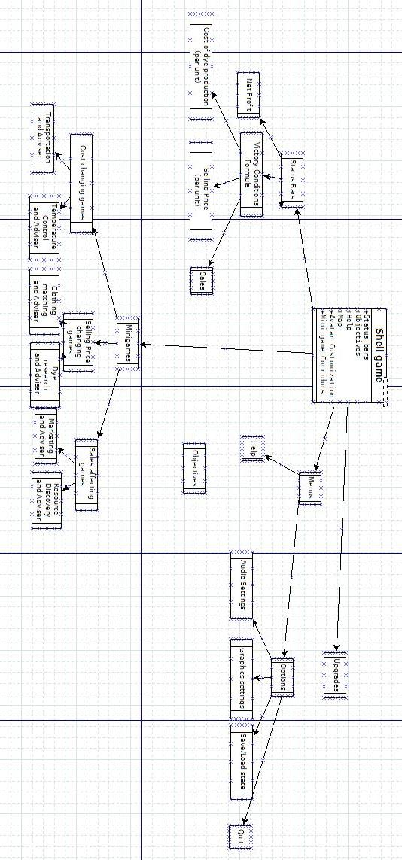

1.1.1 Subcomponents (In Alphabetical Order)

Avatar – A picture of what the players avatar currently looks like. Will be displayed in the left hand side menu in accordance with the design document.

Help – This button in the main menu should give instruction on how to navigate around the shell game, as well as control configurations and hints for each minigame.

Lobby – The lobby is essentially the UI of the shell game. This is where the player will return after every mini game, and this is where the player will find the main menu (located on the left side of the screen and access to all available mini games. Status bars tracking the user's progress will also be found here just above the menu.

Map – Will display a map of which city the user is in and the other cities in the game. Accessed via the menu on the left side of the screen.

Mini Game corridors – Will appear as doors in the shell game. Each door should clearly specify which mini game it leads too. Corridors will be accessed by clicking the doors in the lobby.

Objectives – This button found in the main menu should display the victory conditions as well as display the players overall progress through the game.

Options – The options menu should contain settings for: audio configuration (including sound effects and music volume adjustors), Save/load game state, graphics settings, quit game. Options menu should be accessible through a button on the left hand side of the lobby.

Status Bars – While in the lobby, the player should be able to view: the current cost of production, the price at which he can sell his product, and the overall sales.

Upgrades – Menu for purchasing upgrades to optimize formula. Should be accessible in the menu bar located in the lobby on the left side of the screen.

1.2 GUI Design
Before the main shell display there will be a screen for the player to select their character’s features such as: gender, hairstyle and hair-colour, eye colour, clothing and name. Then choose the name of their company and enter the main shell screen. The GUI will basically be a view of the player’s factory with a sidebar and info along the top. The sidebar has various options. These options will be in a sidebar on the left side of the screen. They will show: the date, scenario goals, completion percentage of the goals, time remaining to complete the goals, cost per unit, price per unit, total sales, current profit rate, total profits, and menu button. The view of the factory has your office and 6 – depending on the number of mini-games implemented – departments corresponding to each mini-game. The avatar will walk around the factory guided by mouse clicks. We will need images/animations from the art team of the avatar walking as well as background sprites. When the player enters a department, (optional zoom to show only that department) they may start playing the mini-game or talk to an advisor who gives information about the player’s progress with respect to that mini-game. The player leaves the shell screen to play the mini-game and when finished, appears back in the same room/department where they started the mini-game. The advisor speaks again and tells how successful the player was and the end result affecting the overall progress.

1.3 Requirements
1.3.1 Functional Requirements

First will be a screen for the player to select their character, where the player can select: gender, hairstyle and hair-colour, eye colour, clothing and name of their character. Then they will choose the name of their company and the main shell screen will come up. There will be status bars to show the player’s progress. These status bars will show: the date (game/historical date), the goals for the city and which are completed. They will also show: the percentage of goal completion, and the time remaining to finish the goals. In addition, the status bars will show the: cost per unit, price per unit, total sales, current profit rate, total profits. Last but not least, a menu button will be included where the player can: save/load, quit and view high scores. The avatar will have to be animated by mouse clicks and we will need images from the art team. And we will need background music from the sound team. We will also need an advisor for each mini-game who will update the player on the progress of that mini-game and after playing will inform the player how successful they were and what the effect on the shell will be. Mini-games can be played in any order. The goals as listed previously in the sidebar will be for each scenario/level/city. These will be of the form: increase profits to x, raise x amount of dollars, or reduce costs to x dollars per unit– where x will be defined by the writing team. Each scenario gets progressively more difficult to complete – the writing team will define difficulty.

1.3.2 Non-Functional Requirements:

Every time a mini-game is played, a turn will be used up. There are a certain amount of turns to complete each level. Each turn is an amount of time in history. The player’s overall statistics are updated each time a mini-game is played. Mini-games are independent of each other, and only affect the shell game statistics. By playing the mini-games, player can accomplish goals. When player accomplishes all goals for that scenario, they move on to the next city. The player beats the game when all scenarios are completed and is given a score relating to how effective they were when running their company.

1.4 Objects and Data
The shell game will consist of four different objects that with house the data for the game. The bulk of the data will be held in the game object of the ShellGame class as it will hold all of the data for the cities as well. Two items will be represented as integers but will be enumerations. As python has no enumerations built in, the values for the enumeration will attributes of an object and only reference through this object (never as integers). Each element of the walls list will consists of an integer and two strings. The integer is the score and the two strings are the name of the company and the name of the player. The move method of the player will move the player one square closer to the goal. It will return true if the player has reached the target (or cannot get any closer).

Name | Type/Return Type | Decription
game | ShellGame
highscores | 2-dimension list | contains highscore data
currentPlayer | player
walls | 2-dimension list of booleans | determines where the player can walk
Attributes of
ShellGame
minigames | List of Minigames
current city | integer | index in cities that the player is currently in
cities | list of cities
time | integer | time since the start of the city
help | string | displayed when the player looks at the  help menu
Methods of shellGame
changeCity | boolean | moves the player to a new city (return false  if no more cities to move to)
win | None | called when the player meets the  objective in the last city
save | boolean | Saves the current game (returns true  if successful)
Attributes of Player
name | string
cost | float
price | float
totalprofit | float
colour | pygame.Color
x | integer | position of the player in pixels
y | integer | position of the player in pixels
targetX | integer | location the player in moving to
targetY | integer | location the player in moving to
Methods of Player
move | boolean | moves the player 1 step closer to the target
inRoom | integer | return which room the player is in
Attributes of City
name | string
objective | integer | what the objective for the city is
currentGoal | integer* | what the goal of the city is about ie  profit or cost or capital
Methods of City
isObjectiveMet | boolean | tests whether or not the objective  for the city is met
Attributes of
Minigame
advisor | string | what the advisor says before you have  completed the mingame
currentEffect | integer* | what the minigame affects
Methods of Minigame
play | None | starts the minigames

*currentGoal and currentEffect are enumerations and should never be accessed as integers
1.4.1 Object Diagram
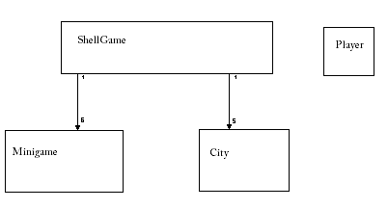

1.4.2 Database Design

The database will consist of two tables, one to keep all of the saved games and one to keep the high-scores. The columns of the database are described below.

Saved Games
playerName  companyName | string  string
cost | float
price | float
totalprofit | float
rColour | integer
gColour | integer
bColour | integer
city | integer
Highscores
name | string
score | integer

1.5 States
There are essentially four states the shell games can have. The player can be in a minigame, walking, waiting or waiting in a room. The difference between the last two is that the second one will display the message from the advisor in the room.
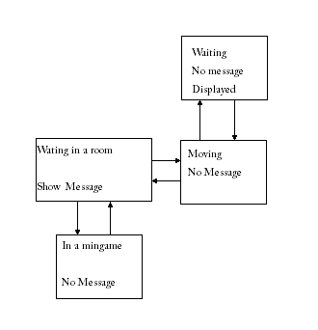
1.6 Testing
1.6.1 Shell Game Testing
The shell game will be tested by testing all methods and functions with appropriate test cases before implementing them into the shell game. When the shell game is completed, then stress testing can begin. The shell game testing will be as automated as possible. When another team member adds a component to the shell game, it must be tested before and after integration.

1.6.2 Testing for Integration
For the shell game to work correctly, it must be integrated correctly with all of the minigames. The player must be able to enter each of the minigames correctly. This means the game must not crash or freeze when the player enters a minigame. This involves the player walking into the mingame room and indicating they want to start the game. Once the game has started, the normal activity of the shell game should be suspended while the minigame is running. That is, you should not be allowed to move your player or access the shell game menus while a minigame is running. Once the minigame is finished, the player must be returned correctly to the shell game and be able to move and access menus again. Whenever the player completes a minigame (whether pass or fail) the time must be added to the elapsed time (it must be greater than when they started). If the minigame is a success the appropriate variable must be adjusted and the display should be updated for it. All the different effects with varying amount should be tested. The shell game upon returning must also correctly decide if the objective for the city has been reached (you should not be a city for which the objective has been completed). If it has the player must successfully be moved to the new city (without crashing or freezing). The player must have the ability to move and enter minigames in the new city. If there are no remaining cities (they have all been completed) the end of the game needs to be run. The final score must be correctly calculated and if high enough added to the high-scores. For testing the high-scores, if the new score is not added to the high-scores it must be lower than all of the existing high-scores. If it is added, it must be lower than the scores above it and higher than the ones below it.

1.7 Preliminary Indication of Resources

Breaking down into sections we have to animate the avatar that moves with mouse clicks. One person will do this, and they will need images from the art team of the avatar walking from all view positions. This will take approximately five hours. One person will create the sidebar with all the buttons, taking images from the art team and info from the writing team. This will take approximately 8 hours, taking into consideration possible communication delay with the other teams about details. Another person will be given the overall map, add the sidebar to the background, and add the avatar. They will need the background image from the art team and background music from the music team. This will take approximately five hours.

Appendix: Priority of Mini-games
Based on the recommendations made by the design team, we would choose to do the Dye research game (mini-game 1) next followed by the Gathering game (mini-game 3). Then if there is still time, we would do the Fashion game (6), followed by the Marketing game (5), followed by the Transportation game (4). Lastly, if there is still more time, we would complete the final mini-game, the Espionage game (7).

