109學年度第一學期「通訊原理」Ans#1

Date:11/05/2020

1. 每題2分，共30分

a) Ans: 

b) Ans: 

c) Ans: 

d) Ans: 

e) Ans: 

f) Ans: 

g) Ans: 

h) Ans: 

i) Ans: 

j) Ans:

k) Ans: 

l) Ans: 

m) Ans: 1

n) Ans: 

o) Ans: 

2. 每題10分，共20分

(a)



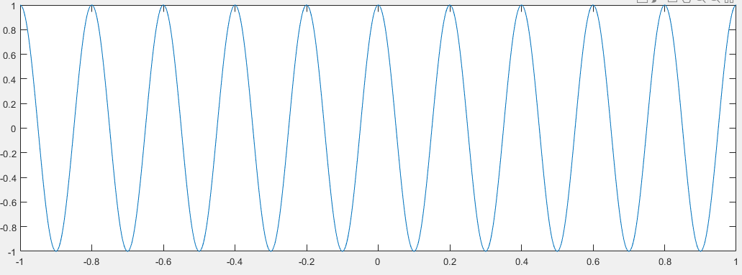

 

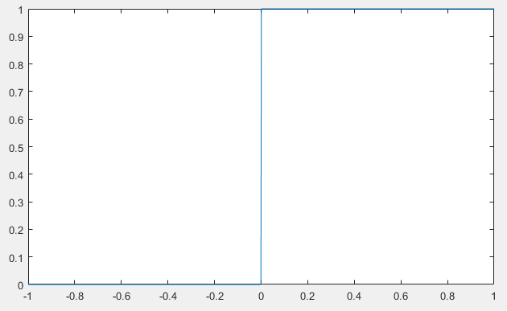 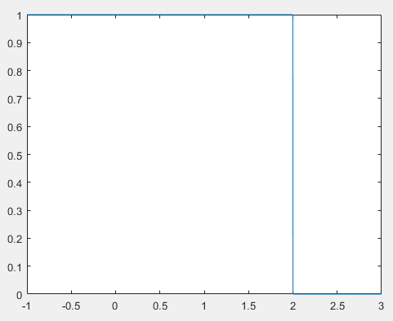



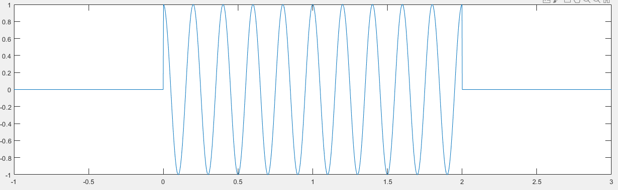

This is a cosine burst nonzero between 0 and 2 seconds.

Its power is $P≜\lim_{T→∞}{\frac{1}{2T}\int_{-T}^{T}{{\left|\left(t\right)\right|}^{2}dt=0}}$.

Its energy is . It is an energy signal.

2.

(b)

 

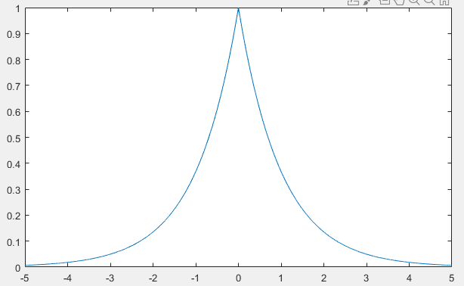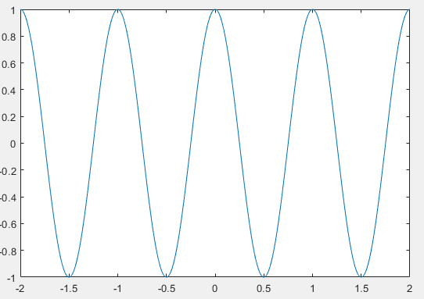



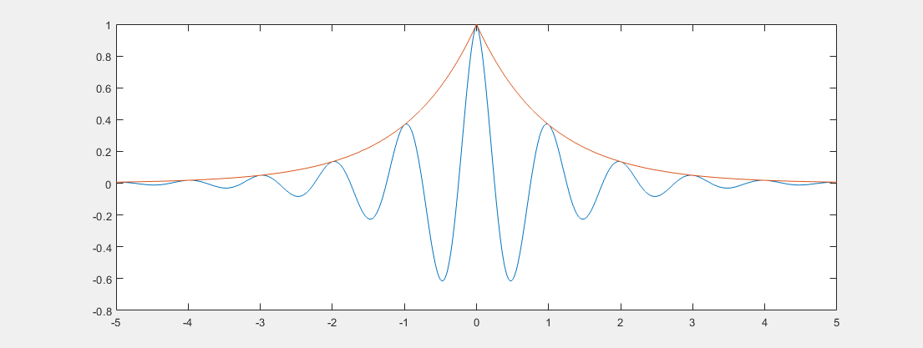

Its power is $P≜\lim_{T→∞}{\frac{1}{2T}\int_{-T}^{T}{{\left|\left(t\right)\right|}^{2}dt=0}}$.

Using evenness of the integrand, its energy is

 (\*)

Next, we compute the two integration terms on the right of (\*). First,

 (\*\*)

Then,



 (\*\*\*)

Finally, by substituting (\*\*\*) and (\*\*) into (\*), we have



3. 共10分



4. 共10分



5. 每題5分，共20分

The autocorrelation function must be (1) even, (2) have an absolute maximum at  and (3) have a Fourier transform that is real and nonnegative.

1. Legitimate. All properties satisfied.



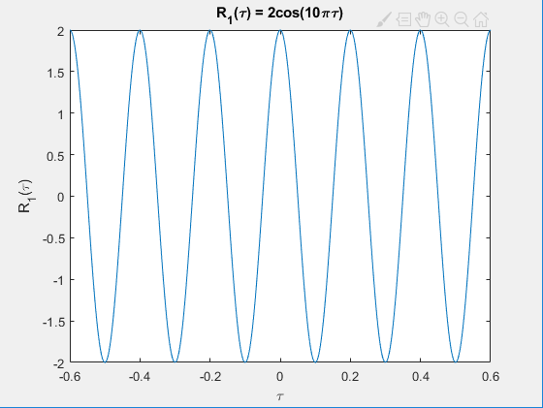

1. Legitimate. All properties satisfied.



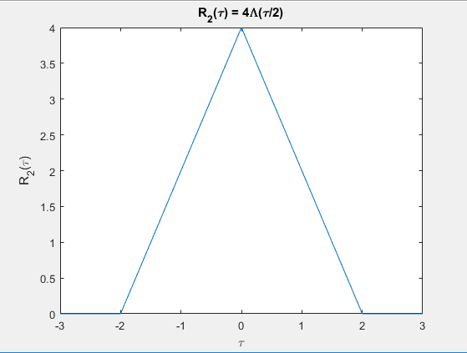

1. Illegitimate. Property (3) not satisfied

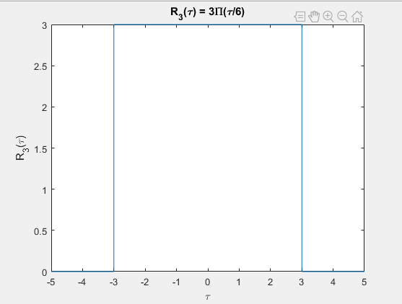

1. Illegitimate. None of properties satisfied.



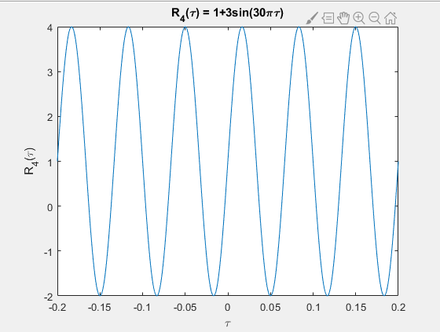

6. 共10分

 

