**Simple Image Album**

The *Simple Image Album* application displays a photo album. Your challenge is first to display the images as thumbnails. Then, when the user clicks a thumbnail, your application will display the full-size image in a separate window.

This means that you will have to add a click handler to each PictureBox control,

but fortunately you can use the same handler for all the buttons.

Form with image thumbnails

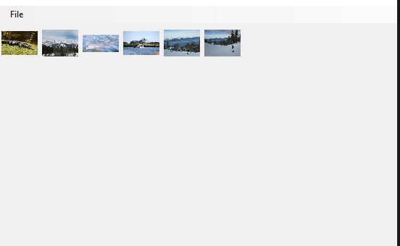

Form with image opened

