**Accounts Dictionary**

Create an application that lists accounts from a Dictionary object. Create an Account class that contains an ID, name, and balance. Display the accounts in a ListBox. If the user enters new values, she or he can click on the *Add* button

to add a new account to the dictionary. Or if the user clicks the *Replace* button, she

or he can replace a dictionary item. Use exception handlers to catch errors caused by invalid input values, or an attempt to add a duplicate Account ID to the dictionary.

Used can add new account

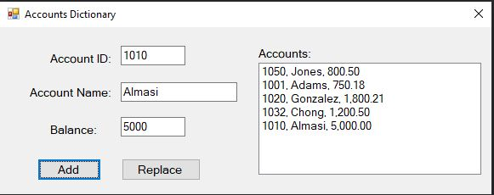

User can replace/edit existing account

