**Cruise Selection Wizard**

Selecting a cruise vacation can be tricky. We all have different preferences when it comes to details like the location of the cruise, the size of the ship, the average age of the passengers, and so on.

Your job is to make this selection process easier. Create a wizard application that named Cruise that contains properties that represent the characteristics of a single cruise. Use the following: (1) size of ship, (2) geographical region, (3) formal versus informal attire, and (4) average passenger age. Next, create a class that contains a strongly typed List Of Cruise object. Use the constructor of this class to fill the list with cruise information.

***User Interface***

Ask the user for the relative importance of each cruise criterion

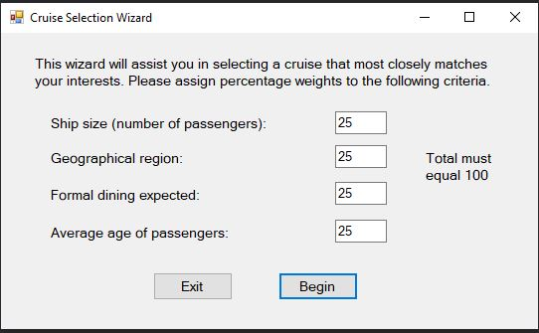

Next, ask the user for his or her individual preferences for each of the criteria. For example, the user is asks for the ideal ship size;

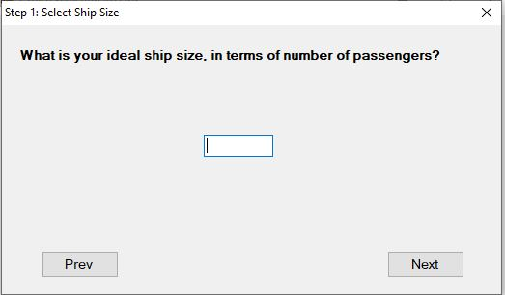

Next the user is asked for an ideal geographical region;

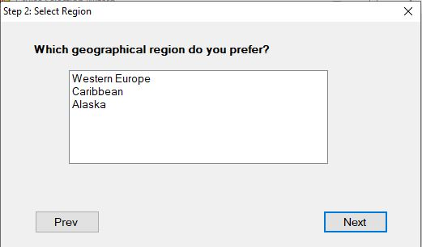

Then ask about formal vs informal preference for the meals.

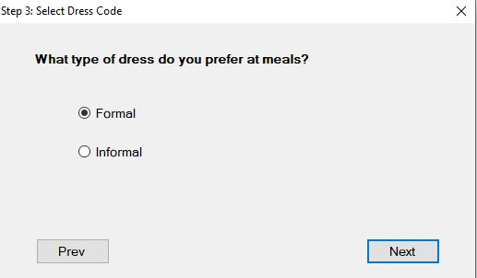

Then the user is asked about the average age of the passengers with whom they would prefer to sail.

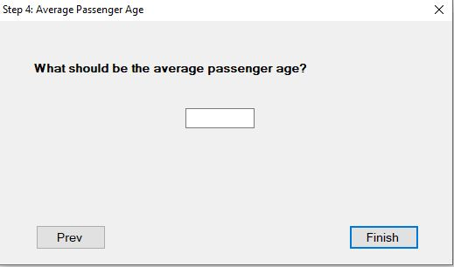

And then the user is shown a list of cruises, with a percentage next to each that shows the percentage similarity of the cruise to the user’s preferred criteria. The user can select different radio buttons to filter the display so it shows cruises that meet various thresholds.

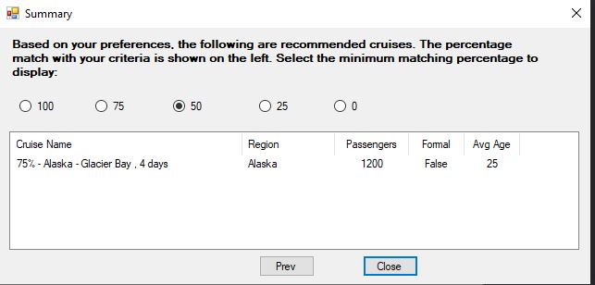

Selected other minimum matching percentages to display

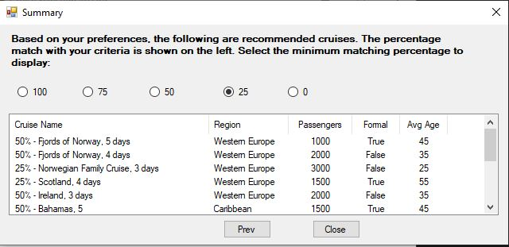

Use weighted criteria to help find the cruises that best match the user’s preferences. Here is an example of the types of variables we used in our solution program:

NumPassengersWt Single - Number of passengers

RegionWt Single - Geographical region

FormalWt Single - Formal attire expected?

AverageAgeWt Single - Average passenger age

The algorithm for determining the percentage match of a cruise to the user’s preferences must take into account the percentages the user assigned to the individual criteria. Let’s call these percentages pc1, pc2, pc3, and pc4. The user’s actual preferences can be called r1, r2, r3, and r4. For each cruise, let’s say that it has characteristics c1, c2, c3, and c4.

We will call **tp** the *total percentage match value* for this cruise:

*tp = 0*

*if c1 = r1 then tp = tp + pc1*

*if c2 = r2 then tp = tp + pc2*

*if c3 = r3 then tp = tp + pc3*

*if c4 = r4 then tp = tp + pc4*

Let’s use an example, and the following table. Suppose the user has assigned the following values to the four preferences:

|  |  |  |
| --- | --- | --- |
| **Preference** | **User’s Prefered Value** | **Percentage Weight for Each Preference** |
| Size of ship (r1) | 1500 | Pc1 = .25 |
| Geographical region (r2) | Alaska | Pc2 = .45 |
| Formal vs Informal (r3) | Informal | Pc3 = .20 |
| Average Age (r4) | 45 | Pc4 = .10 |

This sample user seems mainly concerned with the geographical region (45 percent) and the size of the ship (25 percent). We’ll say that the ship size matches if it is within 500 feet of the user’s preferred value. The age matches if it is within five years of the user’s preferred age for the passengers.

Next, let’s look at a couple of sample cruises: Cruise X holds 1,700 passengers, goes to Alaska, emphasizes formal wear, and has an average passenger age of 55. Its percentage match is 70 percent:

**.25 + .45 + 0 + 0 = .70**

Cruise Y holds 2,500 passengers, goes to the Caribbean, emphasizes informal wear, and has an average passenger age of 45. Its percentage match is only 30 percent:

**0 + 0 + .20 + .10 = .30**

Based on these two sample cruise evaluations, this user would be advised to select Cruise X because it has a higher percentage match value. But another user might place more emphasis on different criteria and produce a different set of percentages.

***Suggested Classes***

Cruise class—contains information about a single cruise, which in turn contains the following properties:

NumPassengers Integer - number of passengers

Region String - geographical region

Formal Boolean - formal attire expected?

AverageAge Single - average passenger age

CruiseCollection class - contains a List Of Cruise object, a constructor, and a read-only property that returns the list of available cruises.