**Repair Shop**

Create CRUD application that manages repair shop’s customer list and repair appointments. User should be able to view, add, edit, and delete customer and appointment.

**Filter Appointments by Customer**

In the Appointments form, add a combo box to the toolbar containing a list of customers. When the user selects customer, restrict the list of appointments to those that match the selected customer.

**Add New Customer**

Create a form that lets the user input a new customer. The CustId column in the database is not autogenerated, so you might want to use a query to get the list of IDs, find the highest one, and create a new ID that is larger. Do not permit any of the customer fields to be blank. Do not permit the new customer’s phone number to be the same as an existing customer’s phone number.

**Modify Customer**

Modify the Home Repair Services application as follows. Create a form that lets the user modify an existing customer’s name and phone number. Do not permit the customer ID field to be modified. When the user clicks a button to save their changes, the form must call an Update method in the Customers class, which in turn calls the TableAdapter’s Update method.

NOTES:

Implement Adding and Modifying Appointment in the same manner as described for Customers.

Allow deletion of customers and appointments directly from their respective Data Grid Views.

Main Form only contains menus to View or add customers/appointments

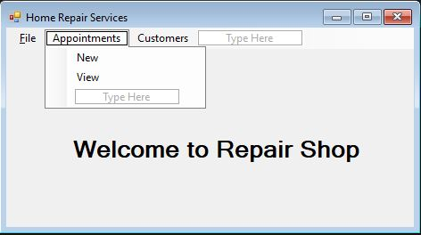

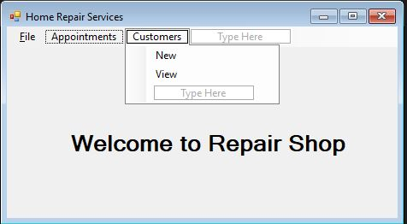

Viewing all customers form – using a data grid view. User can select row and clicks Edit Selected to open Modify Customer form.

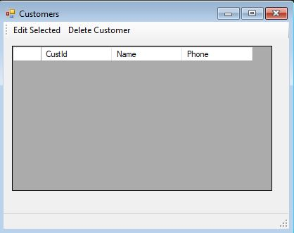

Adding Customer form – Note there is no ID field. This will be added automatically by database

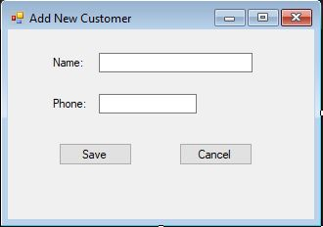

Modify Customer form – contains label for ID. All information will be displayed in the text boxes. User can modify the record and save the modified record in the database

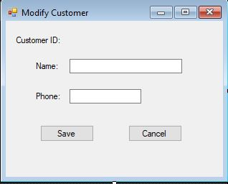

Viewing Appointments form. All information is displayed in Data Grid View. Form allows to display all appointments (clicking All button) or filter appointments by customer (selected from a drop down). User can select a record and clicks Edit to open the record for editing in Edit form

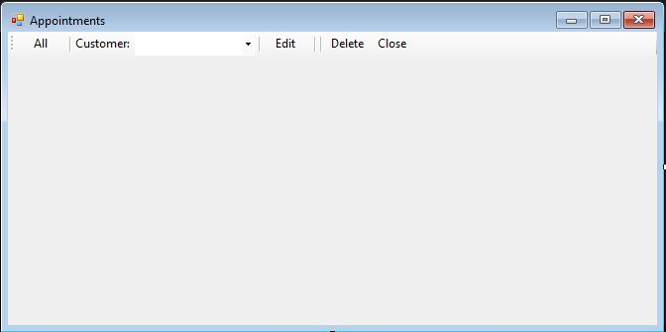

New Appointment/Modify Appointment forms – the forms are the same. Except the Modify appointment form will have all fields pre-filled with current record, ready for the user to modify them, while New Appointment form will have all fields blank and ready for the user to enter. We will use two separate forms.

