Isolated DC/DC Power Supply Design Summary

**Name: Candice Loo**

**Date Created: 1/2/19**

**Last Updated: 1/24/19**

# Duty Cycle and Transformer Ratio

By looking at the inductor voltage waveforms in one period and given that the average inductor voltage is $V_{L}=0V$, we see that the positive and negative areas must be equivalent.

$$D\left(\frac{N_{2}}{N_{1}}V_{in}-V_{o}\right)=\left(1-D\right)V_{o}$$

$$\frac{V_{o}}{V_{in}}=\frac{N_{2}}{N_{1}}D$$

By substituting the conditions of a full bridge converter into the buck section of [1], the optimal turns ratio for the transformer can be found. While I am uncertain about the intricacies as to why the paper chooses $D_{min}=.35$ and $D_{max}=.48$, we will use double these values to translate it to a full bridge converter.

$$D_{min}\frac{V_{in}}{V_{o}}≤\frac{N_{1}}{N_{2}}≤D_{max}\frac{V_{in}}{V_{o}}$$

$$0.9899≤\frac{N_{1}}{N_{2}}≤1.358$$

We choose the transformer ratio to be the approximate average of either extremes of the optimal values.

$$\frac{N_{1}}{N_{2}}=1.174$$

$$D=\frac{N_{1}}{N_{2}}\frac{V_{o}}{V_{in}}=.415$$

# Component Calculation

The full bridge converter is derived from the buck converter, so we should be able to find the inductor and capacitor in the same way, but with the transformer ratio in mind.

$$L=\frac{D\left(\frac{N_{2}}{N_{1}}V_{in}-V_{o}\right)}{f_{s}∆i_{L}}=2.60mH$$

$$C=\frac{∆i_{L}}{8f_{s}∆V_{o}}=1.54μF$$

$$R=\frac{V_{o}}{I_{o}}=6Ω$$

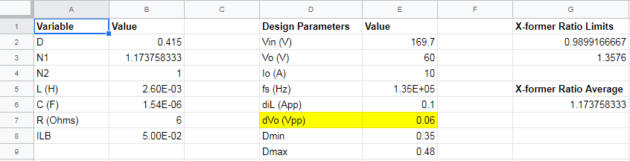

*Figure 2.1. Summary of parameters and results*

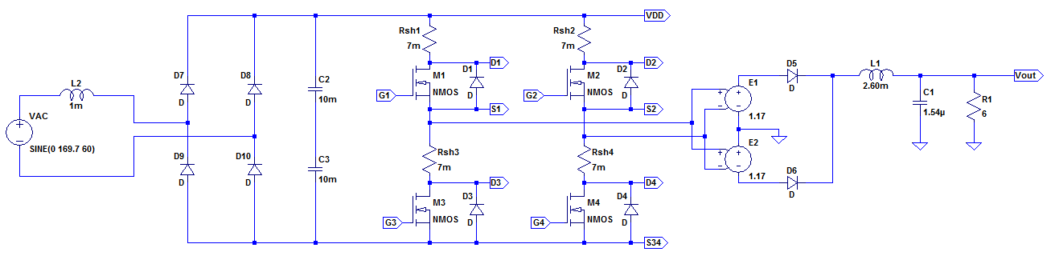

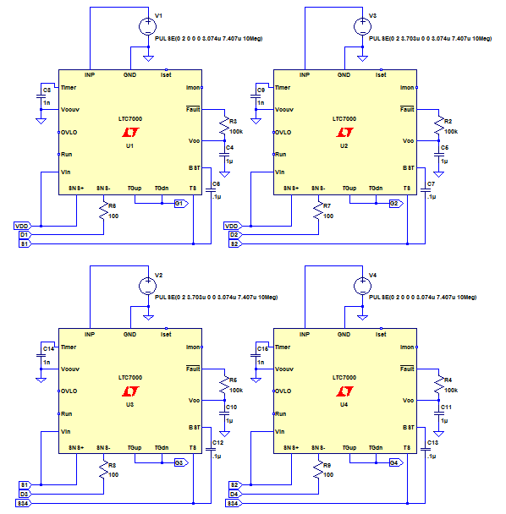

*Figure 2.2. Circuit schematic for the isolated full bridge converter*

# Simulation in LTspice

The simulation results appear in figure 3.1. Simulation in progress, as some debugging of the control circuit is required.

[Insert image of waveforms here]

*Figure 3.1. LTspice waveforms for the output voltage, inductor current, secondary voltage, switch current, and diode current*

Table 3.1. Summary of simulation results

|  |  |  |
| --- | --- | --- |
|  | **Theoretical Values** | **Simulation Values** |
| $$V_{o} (V)$$ | 5 | 3.2053203 |
| $$I_{L} (A)$$ | 75 | 48.079405 |
| $$V_{S1,on} (V)$$ | 6.071 | 3.663737 |
| $$I_{T3,peak} (A)$$ | 2.719 | 1.7823839 |
| $$∆V_{o} (V_{pp})$$ | .1 | 0.1300602 |
| $$∆i_{L} (A)$$ | 2.25 | 3.663737 |

$$V_{S1,on}=\frac{N_{2}}{N_{1}}V_{in}$$

$$I_{T3,peak}=i_{L,peak}*\frac{N_{2}}{N_{1}}$$

$$∆V_{o}=.02V_{o}$$

$$∆i_{L}=.03I_{L}$$

# Current Step-Up

When performing current step-up, we see that the current does not quite reach its expected value due to losses in the transformer. There is also a voltage dip because the inductor wants to maintain or smoothly transition its current.

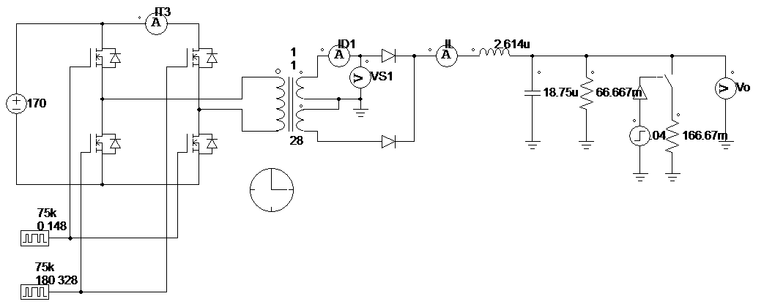  
*Figure 4.1. Circuit schematic for current step up and step down*

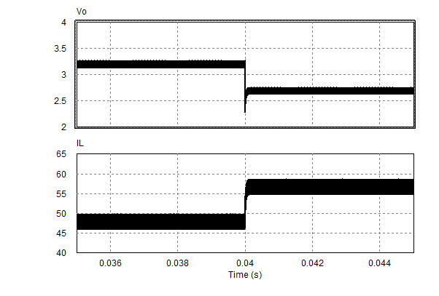

*Figure 4.2. Current step-up waveforms*

# Current Step-Down

In current stepdown, we observe the same losses as in current step-up, but the voltage spikes because the inductor wants to maintain its current.

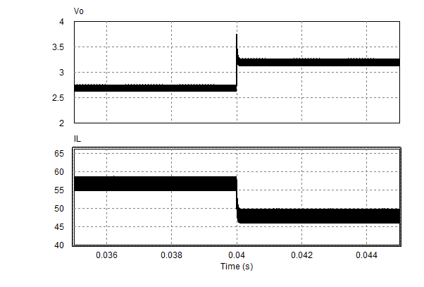

*Figure 4.2. Current step-down waveforms*

# Boundary Current

$$I_{LB}=I_{oB}=\frac{D\left(\frac{N_{2}}{N_{1}}V_{in}-V_{o}\right)}{2f_{s}L}=50mA$$

# References

[1] L. Rubino, B. Guida, P. Marino and A. Cavallo, "On the selection of optimal turns ratio for transformers in isolated DC/DC boost full bridge converter," SPEEDAM 2010, Pisa, 2010, pp. 39-43.