Hw9 Report
SetList.h compile:
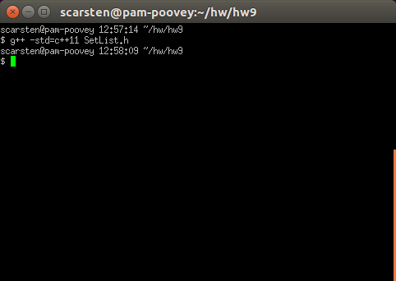
MapArray.h compile:
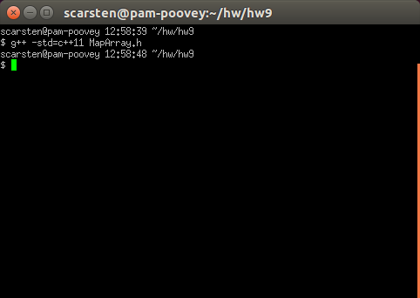

main.cpp compile:
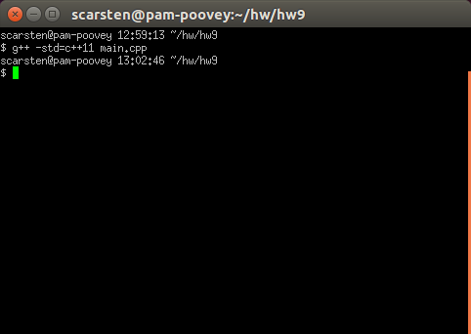
main.cpp run:
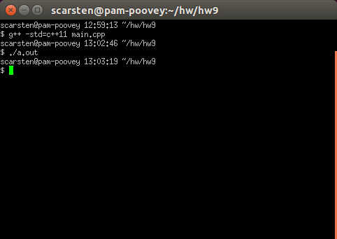

frequency.txt file:
abacus 1
abbreviations 1
abstract 2
abstracted 2
abstraction 1
accredited 1
acknowledges 1
act 1
action 1
actionscript 1
activities 1
actual 1
ad 1
ada 1
adacore 1
adaptations 1
add 1
addition 1
addresses 1
adopted 1
affects 1
air 1
al-jazari 1
algebra 1
algorithms 4
allow 1
allowed 5
allows 1
along 1
also 2
although 1
analogous 1
analysis 1
analytical 2
ancient 2
another 1
antikythera 1
application 2
applications 2
architecture 1
areas 2
arithmetic 1
around 2
art 1
artifacts 1
assembly 6
automata 1
automate 1
babbage 1
basic 1
bc 2
became 2
become 1
becoming 1
beginning 1
bernoulli 1
besides 1
beyond 2
binary 1
build 1
building 1
built 1
c 3
calculate 1
calculating 1
calculation 1
calculations 2
calculator 1
calculators 1
calculus 1
calendars 1
call 1
called 1
cams 1
card 3
cards 8
career 2
cases 1
certification 1
challenges 1
changes 1
charles 1
china 1
circa 1
clearance 1
cloth 1
cobol 1
code 6
coding 2
cognitive 1
combines 1
commercial 1
commonly 1
community 1
company 1
compiler 1
complicated 1
computation 1
computational 1
compute 1
computer 11
computers 3
computing 2
conceive 1
conception 1
condition 1
configuration 1
considerably 1
considered 2
consistent 1
consumption 1
control 4
convenient 1
converted 1
core 1
corrections 1
correctness 1
cost 1
countries 3
covers 1
craft 1
crafted 1
created 1
criteria 1
critical 1
cultures 1
cycle 1
data 4
dates 1
debatable 1
debate 3
debugging 1
decisions 1
defined 1
derived 1
design 1
develop 1
developed 7
developing 1
development 5
device 2
devices 2
devising 1
different 10
differs 1
directly 2
discarded 1
discipline 4
domain 1
dozens 1
drive 1
drum 2
drummer 1
due 1
early 1
easier 1
easily 1
easy 1
economic 1
editors 1
efficient 2
efficiently 1
eg 4
elementary 1
elements 1
employed 1
engine 5
engineer 1
engineering 4
engineers 1
enough 1
entered 1
entering 3
entirely 1
entities 1
environments 1
era 2
error 2
europe 1
even 1
every 1
evolvable 2
executable 1
exhaustion 1
existed 1
expertise 1
expressed 1
extent 2
fact 1
faster 1
final 1
find 1
first 4
follow 1
force 1
form 3
formal 1
format 1
forms 1
formula 2
formulation 1
fortran 3
found 1
foundation 2
founded 1
functional 1
fundamental 1
gears 1
general 3
generating 1
geometry 1
giant 1
given 1
goal 1
good 1
governmentally 1
greater 1
greece 1
habitual 1
hardware 2
haskell 1
herman 1
high 2
high-level 3
higher 1
history 1
hole 1
holes 1
hollerith 2
however 2
human 2
humans 1
hypothesis 1
ibm 3
idea 1
ie 1
illegal 1
implementation 5
importing 1
impractical 1
include 3
including 3
increase 1
increasing 1
increasingly 2
incur 1
india 1
industry 1
inexpensive 1
influences 1
initial 1
input 1
instead 1
institution 1
instruction 2
instructions 7
instruments 2
intent 1
invented 5
invention 1
inventions 1
involves 1
jacquard 3
japan 1
java 1
javascript 1
jobs 1
joseph 1
just 1
keypunch 1
knowledge 1
known 2
kurdish 1
labor 1
language 16
languages 11
larger 1
late 2
later 3
leads 1
leaps 1
learn 1
led 1
less 3
let 1
level 2
levers 1
license 1
licensed 1
licensing 1
likely 1
linguistics 1
list 1
lists 1
little 1
locations 1
logic 1
loom 3
looms 1
lovelace 1
low-level 1
lower 1
lunar-to-solar 1
machine 10
machines 4
made 3
maintaining 1
making 1
management 1
manner 1
many 5
marie 1
mathematician 1
maximum 1
may 2
meant 1
measured 1
mechanical 2
mechanism 2
mechanisms 1
mechanized 1
media 1
medieval 1
medium 1
memory 1
method 1
metonic 1
might 2
model 1
modern 4
mostly 1
much 3
musical 1
mutual 1
name 1
nature 1
necessary 1
need 1
neumann 1
new 1
notation 3
number 2
numbers 2
numerical 2
objective-c 1
objects 1
occasionally 1
often 4
olympiads 1
one 4
oneself 1
ongoing 2
operated 1
operating 1
operation 2
operations 3
opportunities 1
opposed 1
order 1
organize 1
original 2
output 2
outsourcing 1
overhead 1
painstakingly 1
panel 1
panels 1
paper 3
part 1
particular 2
particularly 2
parts 1
pass 1
past 1
pasteboard 1
pattern 2
patterns 3
pegs 1
percussion 1
perfectly 1
perform 1
performing 1
perl 1
phase 1
php 1
physically 1
placed 1
playing 1
plugboard 1
popular 2
possibility 1
postulates 1
power 1
practical 1
practices 1
predetermined 1
prior 1
problem 2
process 6
processing 3
produce 2
producing 1
profession 1
professional 1
professions 1
program 6
programmable 2
programmed 1
programmer 4
programmers 5
programming 24
programs 10
progressed 1
prone 1
punch 1
punched 7
punching 1
purpose 1
python 1
read 1
readable 1
rebuilt 1
record 2
recording 1
referred 1
regarded 1
regulated 1
related 1
relations 1
relatively 1
replace 1
represented 1
representing 2
require 1
required 1
requirements 1
requires 1
reserved 1
resources 1
rhythms 1
ruby 1
s 3
sapirwhorf 1
science 2
scientist 1
security 1
see 1
seemed 1
self-governed 1
sequence 3
sequentially 1
series 1
services 1
sets 2
settled 1
several 1
shortened 1
sizes 1
small 1
smalltalk 1
software 9
solution 1
solving 1
sometimes 1
sorter 1
source 5
speaker 1
speakers 1
special 1
specialized 1
specific 2
specified 1
specify 2
specifying 1
speed 2
spoken 1
sql 1
standardized 1
stands 1
states 2
still 3
storage 1
stored 1
strict 1
subject 1
subjects 1
sumeria 1
surrounding 1
susceptible 1
symbolic 1
symbols 1
synthesis 1
system 2
systems 1
tabulating 1
tabulator 2
takes 1
tape 2
target 1
task 2
tasks 1
technical 1
techniques 1
term 2
terminals 1
terms 2
testing 1
tests 1
text 3
theorized 1
things 1
thought 2
thoughts 1
three 1
thus 2
time 2
total 1
tracked 1
translates 1
translation 1
trials 1
trigger 1
turn 1
two 1
type 1
typically 1
typing 1
underlying 1
understanding 1
unit 2
united 2
upon 1
use 5
used 3
uses 2
using 5
usually 4
utilizing 1
various 2
vary 1
verification 1
visual 1
vital 1
von 1
wage 1
way 1
weaves 1
weaving 1
well 1
whether 1
whole 1
whose 2
widely-used 1
will 1
within 1
without 2
wooden 1
world 3
worlds 1
write 1
writing 3
written 1
wrote 1
x 3
y 1
yield 1

