Multi-Agent Frameworks for Automated Machine Learning Model Evaluation and Improvement
A Literature Review and Practical Implementation Guide
Hack Days — Touchbase
April 2026
Prepared by: Sean Lewis
Research Assistance: Claude (Anthropic)

Table of Contents

1. Abstract
This paper reviews fourteen research publications spanning prompting strategies, multi-agent architectures, ensemble methods, evaluation frameworks, explainability, and statistical inference to propose a practical multi-agent framework for automated machine learning model evaluation and improvement. The framework targets a specific use case: given a pre-built scikit-learn classification or regression model and a pre-existing dataset, the system deploys collaborating LLM agents to iteratively improve cross-validated out-of-sample performance. Drawing on Chain-of-Thought prompting, Plan-and-Solve decomposition, ReAct-style reasoning-acting loops, Mixture-of-Agents synthesis, and LLM-as-a-Judge evaluation, we propose a four-agent architecture—Planning, Execution, Evaluation, and Critic—orchestrated through an iterative refinement cycle. The paper provides concrete implementation recommendations for a Hack Week sprint, including tech stack selection (LangGraph, CrewAI, or direct API), integration points with MLflow and Optuna, and a complete output specification encompassing HTML reports, SHAP diagnostics, GitHub pull requests, and unit test coverage. Our goal is to introduce multi-agent frameworks to the broader Data Science team in an approachable format with a reusable template that can scale to accommodate structured and unstructured evaluation heuristics from diverse stakeholders.

2. Introduction
The emergence of large language models (LLMs) as capable reasoning engines has opened new possibilities for automating the iterative, expertise-intensive process of machine learning model development. Traditional model improvement workflows require a data scientist to hypothesize feature transformations, select hyperparameters, evaluate performance metrics, interpret diagnostic plots, and iterate—a cycle that can take days or weeks for complex problems. Multi-agent frameworks, where specialized LLM agents collaborate on different aspects of this workflow, offer a promising path toward accelerating this process while maintaining interpretability and human oversight.
This paper addresses a concrete challenge: how to design and implement a multi-agent system that improves cross-validated out-of-sample performance for scikit-learn models, given specific data and a baseline model. The system must accept human-generated ideas for testing, execute model training and evaluation, and produce comprehensive outputs including performance metrics, diagnostic visualizations, code changes, and explanatory reports. Critically, the framework must be simple enough to implement during a five-day Hack Week while being extensible enough to accommodate diverse heuristic requirements from multiple stakeholders.
We review fourteen papers that collectively inform the design of this framework, organized into five thematic categories: (1) prompting strategies that enable agent reasoning, (2) multi-agent architectures and ensemble methods, (3) evaluation and benchmarking frameworks, (4) explainability for agentic systems, and (5) statistical and causal foundations for rigorous model assessment. For each paper, we extract the techniques most relevant to our use case and map them to specific components of the proposed framework.

3. Literature Review

3.1 Prompting Strategies for Agent Reasoning

3.1.1 Chain-of-Thought Prompting
Wei et al. (2022) introduced chain-of-thought (CoT) prompting, demonstrating that augmenting few-shot exemplars with intermediate reasoning steps enables LLMs to solve complex multi-step problems. On GSM8K math word problems, PaLM-540B with just eight CoT exemplars improved from 33% to 57% accuracy, surpassing finetuned GPT-3. The key insight is that CoT allows models to allocate additional computation to problems requiring more reasoning steps—a form of adaptive computation that is particularly valuable for our framework’s Planning Agent, which must decompose complex model improvement strategies into executable steps.
Importantly, Wei et al. found that CoT reasoning is an emergent ability tied to model scale—models below 100B parameters showed minimal benefit. This finding directly informs our tech stack decision: the framework should use frontier-class models (GPT-4, Claude, Gemini) rather than smaller open-source alternatives for the planning and reasoning components.

3.1.2 Plan-and-Solve Prompting
Wang et al. (2023) extended CoT with Plan-and-Solve (PS) prompting, which addresses three critical failure modes: calculation errors, missing reasoning steps, and semantic misunderstandings. PS prompting instructs the LLM to first devise a plan, then carry it out with explicit attention to calculation accuracy and variable tracking. On GSM8K, PS reduced calculation errors from 25% to 7% and missing-step errors from 25% to 12%.
For our Evaluator Framework, PS prompting is directly applicable to the Planning Agent’s strategy formulation. When a human provides an idea for testing (e.g., ‘try adding polynomial features to the top 5 predictors’), the Planning Agent should decompose this into a structured plan: identify the top 5 predictors by importance, generate polynomial features, retrain the model, evaluate cross-validated performance, and compare against the baseline. The explicit planning phase reduces the risk of the agent missing critical steps or making implementation errors.

3.1.3 ReAct: Synergizing Reasoning and Acting
Yao et al. (2023) introduced ReAct, which interleaves reasoning traces (thoughts) with task-specific actions (tool calls) in a continuous loop. On HotpotQA, ReAct with self-consistency achieved 86.6% accuracy compared to 80.8% for CoT alone. On interactive benchmarks like ALFWorld (71% success) and WebShop (59% success), the framework dramatically outperformed acting-only baselines.
ReAct’s Thought→Action→Observation loop maps directly onto our Execution Agent’s workflow. The agent reasons about which model modification to try (Thought), executes the code change and model training (Action), observes the cross-validated performance results (Observation), and reasons about next steps. This interleaved approach provides interpretability—the reasoning trace is human-readable—and supports human-in-the-loop correction when the agent’s reasoning goes off track.

3.1.4 Self-Consistency
Wang et al. (2023) proposed self-consistency, a ‘sample-and-marginalize’ approach that generates diverse reasoning paths via temperature sampling and selects the most consistent answer through majority voting. On GSM8K, self-consistency improved accuracy from 56.5% (greedy decode) to 78.7%—a 22-point gain without any model retraining.
For our framework, self-consistency applies at two levels. First, the Critic Agent can use self-consistency to validate the Evaluation Agent’s conclusions: by sampling multiple independent assessments of model performance and checking for consensus, we reduce the risk of a single flawed evaluation driving incorrect decisions. Second, the Planning Agent can generate multiple candidate strategies and select the most promising through consistency-weighted voting, mirroring the ensemble approach that Star-Agents applies to data generation.

3.2 Multi-Agent Architectures and Ensemble Methods

3.2.1 Mixture-of-Agents
Wang et al. (2024) proposed Mixture-of-Agents (MoA), a layered architecture where each layer contains multiple LLM agents that all see outputs from the previous layer. Using only open-source models (Qwen1.5-110B, Wizard8x22B, Llama3-70B-Instruct, Mistral-8x22B), MoA achieved 65.1% on AlpacaEval 2.0—surpassing GPT-4 Omni’s 57.5%. The key technical insight is that LLMs demonstrate ‘collaborativeness’: they generate higher-quality responses when provided outputs from other models, even less capable ones.
MoA’s architecture directly informs our framework’s synthesis layer. Rather than having a single LLM evaluate model performance, we can structure our Evaluation Agent as a MoA layer where multiple evaluation perspectives (metric-focused, diagnostic-focused, code-quality-focused) are synthesized into a unified assessment. The iterative refinement property of MoA—where each layer improves upon the previous—mirrors our overall improvement loop where each cycle of Planning→Execution→Evaluation→Critique produces incrementally better models.

3.2.2 Ensemble LLMs: A Survey
Mienye and Swart provide a comprehensive taxonomy of ensemble techniques for LLMs, covering stacking, bagging, boosting, voting, knowledge distillation, Mixture-of-Experts (MoE), and hybrid multi-agent ensembles. Their key classification distinguishes model-level ensembles (aggregating diverse architectures), parameter-level ensembles (multiple variants of the same architecture), and task-specific approaches.
For our framework, the most relevant ensemble strategies are: (1) Voting ensembles for the Critic Agent’s consensus mechanism, where multiple evaluation perspectives vote on whether a model improvement is genuine; (2) Mixture-of-Experts routing for the Orchestrator, which must decide which agent to invoke based on the current state of the improvement cycle; and (3) Stacking for the synthesis layer, where a meta-learner combines the outputs of Planning, Execution, and Evaluation agents into a final recommendation. The survey also highlights the critical tension between ensemble diversity (more diverse models improve robustness) and computational cost—a tension directly relevant to our resource-constrained Hack Week context.

3.2.3 Star-Agents: Automatic Data Optimization
Zhou et al. (NeurIPS 2024) proposed Star-Agents, which uses multi-agent collaboration to optimize instruction-tuning data quality. The framework pairs different LLMs to rewrite instructions and responses, evaluates quality using a dual-model strategy (IFD metric combining smaller and larger model assessments), and evolves the agent pairings over iterations. Star-Agents achieved a 12% average performance improvement on MT-bench and 40% improvement on form-specific tasks.
Star-Agents’ evolutionary agent-pair sampling mechanism is particularly relevant to our framework. Rather than using fixed agent configurations, we can adaptively evolve which combinations of prompting strategies, model types, and evaluation criteria produce the best improvements. The Instruction Memory Bank concept translates to our framework as a curated repository of successful model improvement strategies that the Planning Agent can draw upon across iterations.

3.3 Evaluation and Benchmarking Frameworks

3.3.1 LLM-as-a-Judge
Zheng et al. (2023) proposed using strong LLMs as judges to evaluate other LLMs, demonstrating that GPT-4 can match human judges with 80% agreement. They introduced MT-Bench (80 multi-turn questions across 8 categories) and Chatbot Arena (crowdsourced battle platform with 30K+ votes). Critically, they identified systematic biases: position bias (favoring the first answer), verbosity bias (preferring longer responses), self-enhancement bias (models favoring their own outputs), and limited math/reasoning capability.
For our Evaluator Framework, LLM-as-a-Judge directly applies to the Evaluation Agent’s assessment of model improvements. However, the identified biases require mitigation. We recommend: (1) using position-swapped evaluations where the baseline and improved model results are presented in alternating orders; (2) requiring the judge to reference specific metrics rather than relying on general impressions; and (3) using chain-of-thought prompting for the judge to make its reasoning explicit and auditable.

3.3.2 MLAgentBench: Benchmarking LLM Research Agents
The MLAgentBench paper evaluates AI research agents performing 15 diverse ML tasks spanning NLP, computer vision, time series, and tabular data. GPT-4 agents achieved nearly 90% success on well-established tasks but only 0–30% on complex tasks like Kaggle Challenges. Key failure modes include hallucination, debugging difficulties, token length constraints, and poor planning.
These findings directly calibrate our expectations for the Hack Week framework. We should: (1) scope the framework to well-established tasks (scikit-learn classification/regression with standard preprocessing) where agent success rates are highest; (2) implement a Research Log mechanism for maintaining context across long agent sessions; (3) use hierarchical actions that break complex operations into smaller, verifiable steps; and (4) design explicit guardrails against hallucination, such as requiring the agent to execute code and observe actual results rather than predicting outcomes.

3.3.3 HypoGenIC: Hypothesis Generation with LLMs
Zhou et al. proposed HypoGenIC, which uses an Upper Confidence Bound (UCB)-inspired algorithm to generate and evaluate hypotheses. The framework iteratively generates hypotheses from labeled data, evaluates them against training examples, and refines the hypothesis bank by focusing on incorrectly predicted examples. On synthetic tasks, HypoGenIC matched or exceeded supervised learning baselines while producing interpretable, transferable hypotheses.
HypoGenIC’s approach maps directly onto our Planning Agent’s strategy generation. Rather than generating model improvement ideas randomly, the agent can use UCB-inspired exploration-exploitation: initially explore diverse strategies (feature engineering, hyperparameter tuning, ensemble methods), then exploit the most promising direction while maintaining some exploration budget. The iterative refinement through wrong-example analysis parallels our framework’s focus on diagnosing model weaknesses through SHAP analysis and error pattern identification.

3.4 Explainability in Agentic Systems
Chaduvula et al. provide a critical distinction between explainability for static predictors and agentic AI systems. Traditional methods like SHAP and LIME produce attribution-based explanations tied to single predictions, but agentic systems require trajectory-level explanations that account for action sequences, tool interactions, and state evolution. Their rubric-based evaluation found that state tracking inconsistency is 2.7x more prevalent in failed agent runs and reduces success probability by 49%.
For our framework, this paper informs two design decisions. First, the Diagnostics output must include not only traditional model explainability (SHAP, PDP, feature importance) but also agent trajectory explanations documenting why the agent made specific decisions during the improvement process. Second, the framework should implement state tracking mechanisms that maintain consistency across the multi-agent pipeline—a lesson reinforced by the finding that trajectory degradation is the primary failure mode for complex multi-step tasks.

3.5 Domain Applications: Agentic AI for Hypothesis Testing
Saichandran et al. deployed a multi-agentic AI system for hypothesis testing in Alzheimer’s disease research, processing 48,876 participants from the NACC database. Their five-agent architecture—Data Preparation, Planning, Scientist, Critic, and Summarization—provides a validated template for domain-specific multi-agent systems. The system verified 42.0±2.8 hypotheses out of 100, with an 85.2% non-testable classification rate in negative controls, demonstrating reliable discrimination between testable and non-testable hypotheses.
This architecture closely parallels our proposed framework. Their Planning Agent maps to our Planning Agent, the Scientist Agent maps to our Execution Agent, the Critic Agent maps directly, and the Summarization Agent maps to our output generation pipeline. Their iterative loop structure—outer loop for planning, inner loop for execution with critic feedback—validates our proposed multi-loop architecture. The YAML-based configuration management and structured JSON logging provide a practical template for experiment reproducibility.

3.6 Statistical and Causal Foundations

3.6.1 Computer Age Statistical Inference
Efron and Hastie’s comprehensive treatment of statistical inference provides the methodological foundation for rigorous model evaluation. Three techniques are particularly relevant to our framework: (1) Bootstrap methods for assessing uncertainty in cross-validated performance estimates, enabling the framework to distinguish genuine improvements from noise; (2) Large-scale hypothesis testing with false discovery rate controls for evaluating multiple model configurations simultaneously; and (3) Cross-validation theory for understanding when cross-validated estimates are reliable versus when they may be biased by feature selection or hyperparameter tuning conducted on the same data.

3.6.2 Causal Inference with Structural Causal Models
Pearl’s work on causal inference with non-manipulable variables provides a theoretical foundation for interpreting model improvement results. When the Evaluation Agent assesses whether a particular feature engineering step improved performance, it must distinguish between genuine causal improvement and spurious correlation. Pearl’s do-calculus framework offers a principled approach: rather than asking ‘did performance improve after adding feature X?’ (observational), we should ask ‘would performance improve if we intervened to add feature X?’ (interventional). In practice, this translates to requiring controlled experiments where the only variable changed is the proposed modification, with all other pipeline components held constant.

4. Proposed Framework Design
Drawing on the techniques and architectures reviewed above, we propose a four-agent multi-agent framework with a Mixture-of-Agents synthesis layer, orchestrated through an iterative improvement cycle with human-in-the-loop feedback. This section details each component of the framework and maps it to the supporting literature.

4.1 Architecture Overview
Figure 1 presents the high-level architecture of the proposed Evaluator Framework. The system consists of four specialized agents—Planning, Execution, Evaluation, and Critic—coordinated by an Orchestrator Agent that manages the iterative improvement loop. Human inputs (ideas, heuristics, feedback) enter through the Orchestrator, and outputs (reports, models, diagnostics) are generated after each improvement cycle.
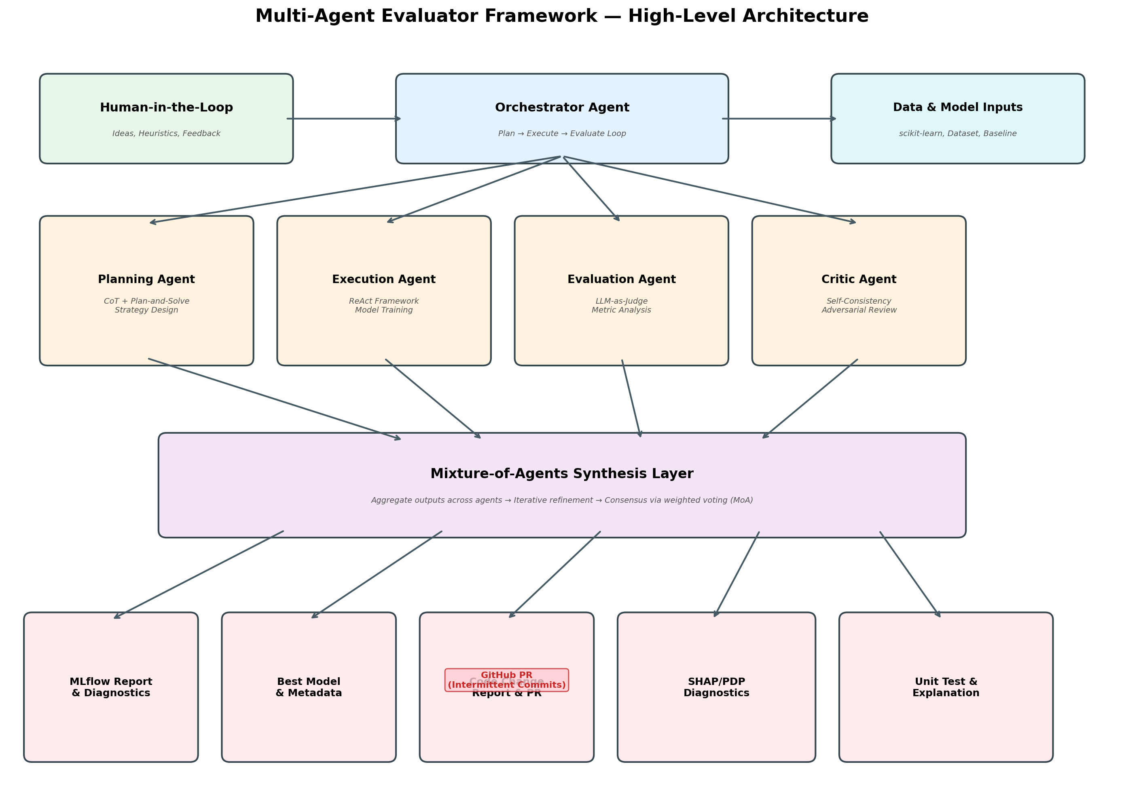
Figure 1: High-Level Multi-Agent Evaluator Framework Architecture

4.2 Agent Roles and Responsibilities

4.2.1 Orchestrator Agent
The Orchestrator manages the overall improvement cycle, routing tasks to specialized agents and maintaining global state. It implements a Mixture-of-Experts routing strategy (informed by the Ensemble LLMs Survey) to select which agent to invoke based on the current phase. The Orchestrator maintains a Research Log (per MLAgentBench) that tracks all decisions, results, and reasoning traces for reproducibility.

4.2.2 Planning Agent
The Planning Agent translates human ideas and performance diagnostics into executable model improvement strategies. It uses Plan-and-Solve prompting to decompose high-level ideas into step-by-step plans, with Chain-of-Thought reasoning for complex strategy formulation. When generating candidate strategies, it applies HypoGenIC’s UCB-inspired exploration-exploitation balance to manage the breadth of strategies explored versus depth of refinement.

4.2.3 Execution Agent
The Execution Agent implements the plans produced by the Planning Agent by generating and executing Python code against the scikit-learn pipeline. It operates in a ReAct loop: reasoning about the current step (Thought), executing code (Action), observing the results including errors and metrics (Observation), and deciding next steps. The agent interfaces with the existing codebase’s cross-validation functions and performance metrics, pointing to pre-existing functions rather than writing metric code from scratch.

4.2.4 Evaluation Agent
The Evaluation Agent assesses model performance using both quantitative metrics and qualitative analysis. It implements LLM-as-a-Judge evaluation with bias mitigation (position swapping, metric-grounded reasoning, CoT-prompted justification). For quantitative evaluation, it applies bootstrap confidence intervals (per CASI) to determine whether improvements are statistically significant. The agent generates structured evaluation reports including cross-validated performance, feature importance rankings, and diagnostic flags.

4.2.5 Critic Agent
The Critic Agent provides adversarial review of both the improvement strategies and the evaluation results. It uses self-consistency to validate conclusions: sampling multiple independent assessments and checking for consensus. When the Critic identifies issues—such as potential data leakage, overfitting to validation sets, or unjustified feature selections—it returns the process to the Planning Agent with specific feedback. This debate-style interaction between Evaluation and Critic agents mirrors the adversarial approaches surveyed in the Ensemble LLMs literature.

4.3 Agent Interaction and Iterative Refinement
Figure 2 illustrates the iterative flow through the four agents. Each cycle begins with the Planning Agent formulating a strategy, proceeds through Execution and Evaluation, and concludes with the Critic’s assessment. If performance has improved and the Critic approves, the system generates outputs. If not, the cycle re-enters the Planning phase with feedback from the Critic and updated performance diagnostics.
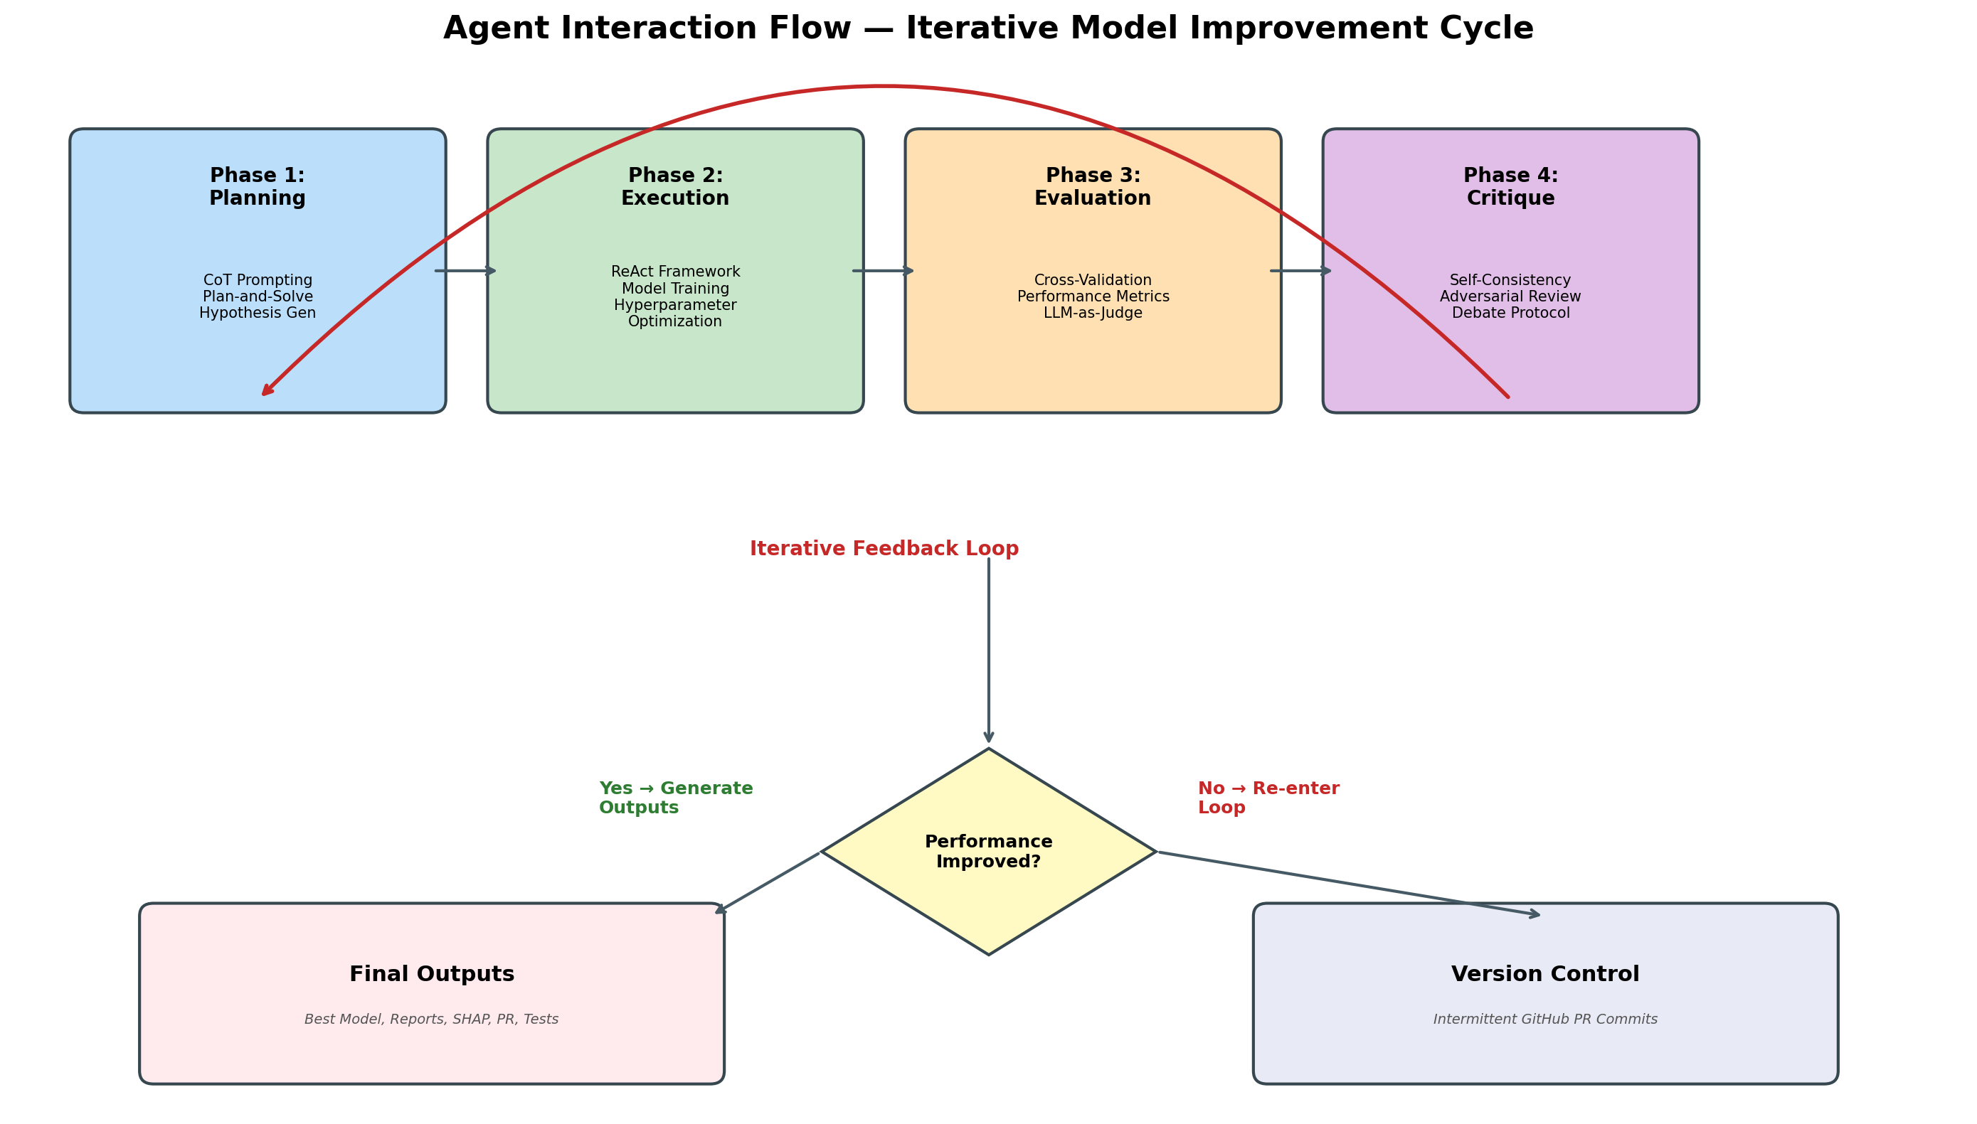
Figure 2: Agent Interaction Flow — Iterative Model Improvement Cycle

4.4 Prompting Strategy
Each agent uses a tailored prompting strategy drawn from the reviewed literature:
Agent | Primary Strategy | Application
Planning | Plan-and-Solve + CoT | Decompose improvement ideas into structured, step-by-step execution plans
Execution | ReAct | Interleave reasoning with code execution and result observation
Evaluation | LLM-as-Judge + CoT | Assess improvements with bias-mitigated, metric-grounded evaluation
Critic | Self-Consistency + Debate | Validate conclusions through diverse sampling and adversarial challenge
Orchestrator | MoE Routing | Select and sequence agent invocations based on current improvement phase
Table 1: Agent Prompting Strategies

4.5 Human-in-the-Loop Integration
The framework supports human-in-the-loop interaction at three points: (1) Strategy Input — the human provides initial ideas for model improvement, such as specific hyperparameter ranges, feature engineering approaches, or model architectures to explore; (2) Mid-Cycle Review — after each improvement cycle, the human can review the agent’s reasoning trace (enabled by ReAct’s interpretable Thought→Action→Observation format) and course-correct if the agent is pursuing unproductive strategies; and (3) Final Approval — the human reviews the final model, diagnostics, and code changes before the system generates the GitHub PR.

4.6 Version Control and CI/CD Integration
The framework makes intermittent GitHub PR commits throughout the improvement process, following the brainstorm specification that the agent ‘should make PR commits intermittently throughout the process to avoid generating a single, massive monolithic PR.’ Each commit corresponds to a completed improvement cycle and includes: the code changes made by the Execution Agent, the performance metrics from the Evaluation Agent, and a commit message generated by the Orchestrator summarizing the changes and their rationale. The Code Change Report output provides a human-readable guide detailing what the reviewer needs to double-check in each commit.

5. Implementation Recommendations

5.1 Tech Stack Selection
The brainstorm identified three categories of implementation options: wrapper frameworks (LangGraph, CrewAI) and direct API access (OpenAI, Google Gemini, Anthropic). Based on our literature review and the Hack Week constraints, we recommend the following evaluation criteria and assessment:
Criterion | LangGraph | CrewAI | Direct API | Recommendation
Setup Complexity | Medium | Low | Low-Medium | CrewAI or Direct
Agent Orchestration | Excellent (graph-based) | Good (role-based) | Manual | LangGraph
Iterative Loops | Native support | Configurable | Custom code | LangGraph
Code Execution | Via tools | Via tools | Custom sandbox | Any
MoA Support | Natural fit | Possible | Manual | LangGraph
Learning Curve | Steep | Gentle | Moderate | CrewAI
Hack Week Fit | Good if familiar | Best for quick start | Maximum flexibility | CrewAI for v1
Table 2: Tech Stack Comparison for Hack Week Implementation
Our primary recommendation is CrewAI for the initial Hack Week prototype due to its gentle learning curve and role-based agent definition that maps naturally to our four-agent architecture. For teams already familiar with LangGraph, its native graph-based orchestration and loop support make it the superior long-term choice. Direct API access offers maximum flexibility and is recommended if credit constraints are a concern, since wrapper frameworks add token overhead from their system prompts and coordination messages.

5.2 Integration with scikit-learn and MLflow
The Execution Agent interfaces with the existing scikit-learn pipeline through a sandboxed Python execution environment. Model code and pipelines must be pre-built (per the brainstorm specification), so the agent’s role is to modify hyperparameters, feature engineering steps, and model selection—not to write infrastructure code from scratch. Cross-validated prediction performance functions should already exist in the repository, with the agent pointing to them rather than writing metric code.
MLflow integration serves dual purposes: experiment tracking during the improvement process (logging each model variant’s parameters, metrics, and artifacts) and final output generation (the HTML Report is generated using MLflow’s artifact visualization capabilities). Optuna can be integrated for hyperparameter optimization, with its optimization history included in the diagnostics output.

5.3 Output Specification
The framework produces six categories of outputs aligned with the brainstorm specification:
Output | Contents | Implementation
HTML Report | MLflow artifact dashboard with run comparisons | MLflow autogenerated with custom summary page
Best Model | Serialized model + metadata (params, metrics, lineage) | MLflow model registry with auto-versioning
Code Change Report | Human-readable guide for PR review | Agent-generated markdown with diff annotations
Diagnostics | SHAP, PDP, interactions, Optuna history, feature importance | SHAP library + matplotlib + Optuna visualization
Metrics | Performance tables and JSON | Pandas DataFrames exported to JSON and HTML tables
Unit Tests + Explanation | Pass percentage for generated code + text summary of model choice | pytest with coverage report + LLM-generated narrative
Table 3: Output Specification

6. Literature-to-Framework Component Mapping
Figure 3 provides a visual mapping of how each reviewed paper informs specific components of the proposed framework. This mapping demonstrates that the framework design is grounded in validated research rather than ad hoc engineering decisions.
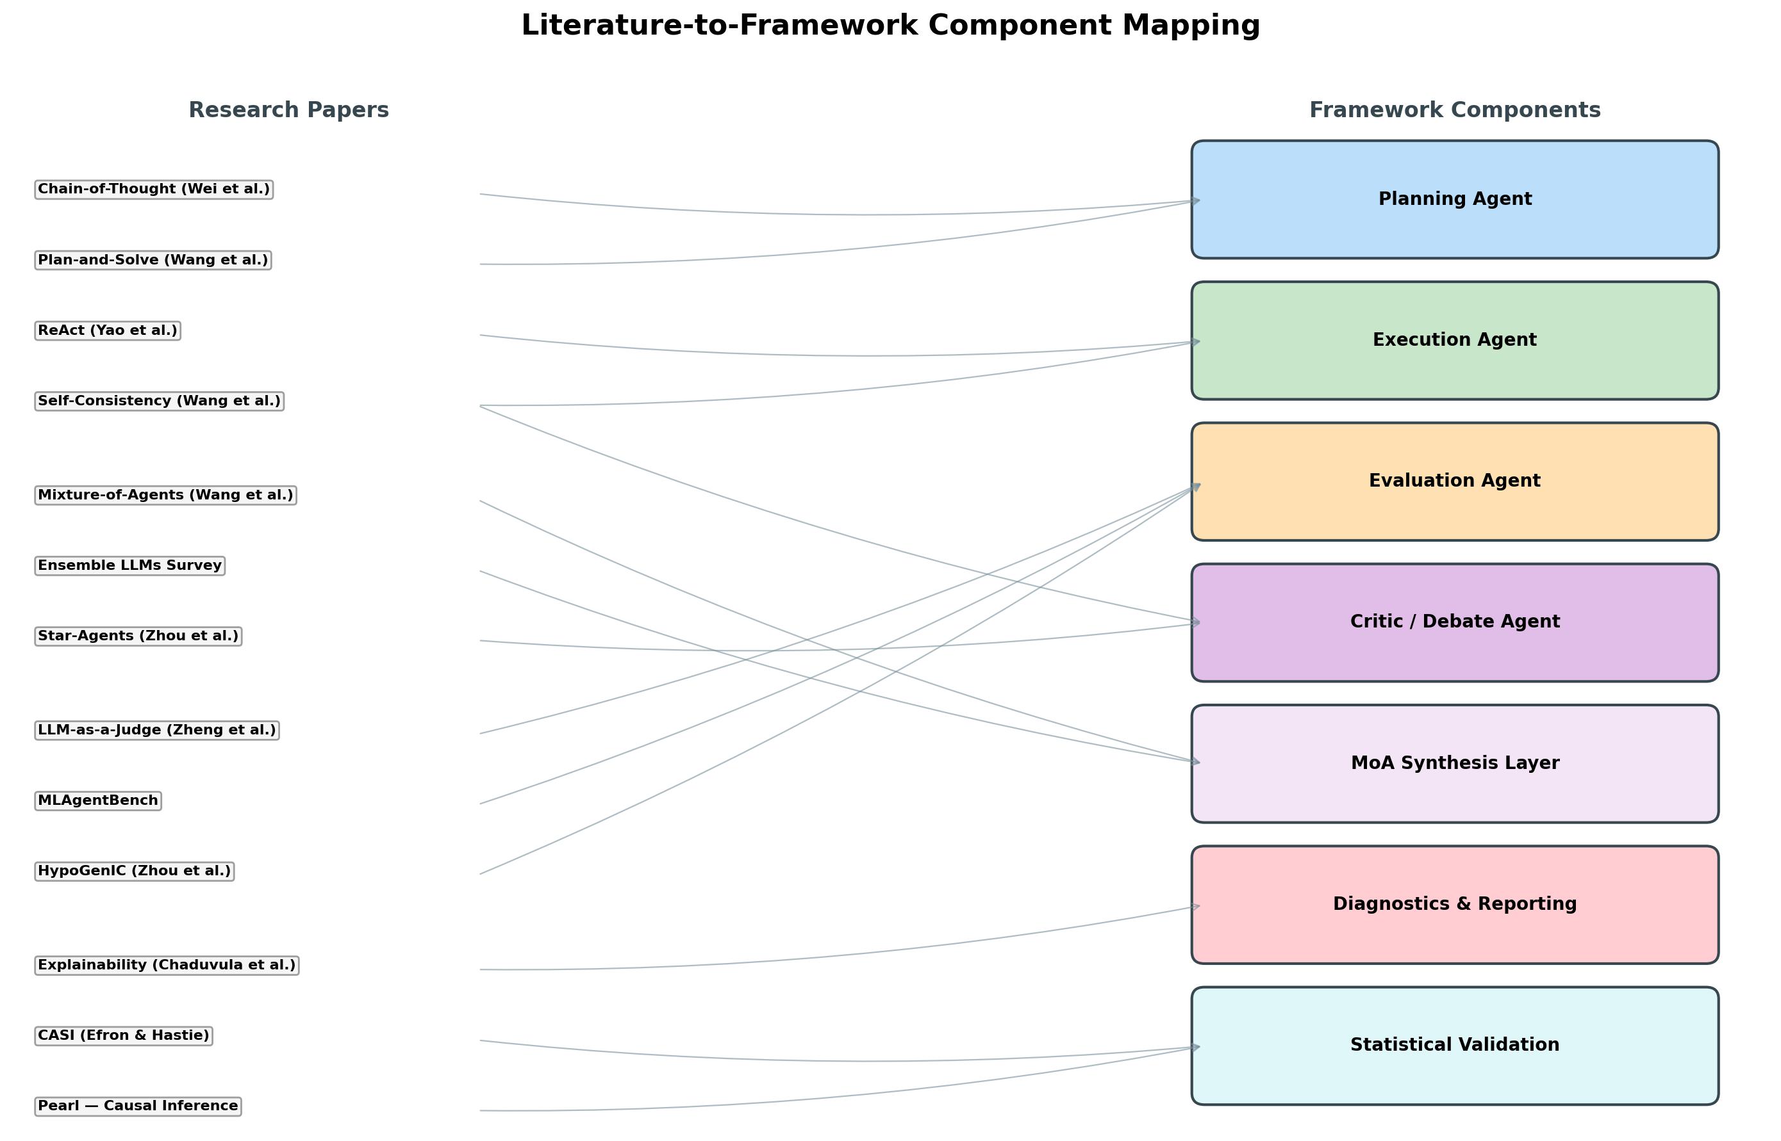
Figure 3: Literature-to-Framework Component Mapping
Paper | Framework Component | Specific Technique Applied
Chain-of-Thought (Wei et al.) | Planning Agent, Evaluation Agent | Multi-step reasoning for strategy formulation and evaluation justification
Plan-and-Solve (Wang et al.) | Planning Agent | Structured plan decomposition with attention to calculation accuracy
ReAct (Yao et al.) | Execution Agent | Thought-Action-Observation loop for code execution and model training
Self-Consistency (Wang et al.) | Critic Agent, Execution Agent | Diverse sampling with majority voting for validation
Mixture-of-Agents (Wang et al.) | MoA Synthesis Layer | Layered agent architecture with iterative refinement
Ensemble LLMs Survey | MoA Synthesis Layer, Orchestrator | Voting ensembles, MoE routing, stacking for meta-learning
Star-Agents (Zhou et al.) | Critic Agent, Orchestrator | Evolutionary agent-pair sampling, dual-model evaluation
LLM-as-a-Judge (Zheng et al.) | Evaluation Agent | Bias-mitigated LLM evaluation with position swapping
MLAgentBench | Orchestrator, All Agents | Research Log, hierarchical actions, failure mode awareness
HypoGenIC (Zhou et al.) | Planning Agent, Evaluation Agent | UCB-inspired hypothesis generation and evaluation
Explainability (Chaduvula et al.) | Diagnostics & Reporting | Trajectory-level agent explanations, rubric-based evaluation
CASI (Efron & Hastie) | Statistical Validation | Bootstrap confidence intervals, FDR controls, cross-validation theory
Pearl — Causal Inference | Statistical Validation | Interventional reasoning for model improvement attribution
Table 4: Complete Literature-to-Framework Component Mapping

7. Evaluation Framework: Three Levels of Sophistication
The brainstorm specification identifies three levels of evaluation sophistication. For the Hack Week scope, Option 1 is selected, but the framework is designed to extend to Options 2 and 3 as the system matures:

7.1 Option 1: Performance Metric Only (Hack Week Scope)
The Evaluation Agent assesses model improvement based solely on cross-validated out-of-sample performance metrics. The Critic Agent validates that improvements are statistically significant using bootstrap confidence intervals. This is the simplest and most objective evaluation criterion, suitable for the initial prototype.

7.2 Option 2: Performance Metric + Structured Output
Extends Option 1 by incorporating structured evaluation rubrics—for example, assessing whether the model satisfies domain-specific constraints (monotonicity relationships, feature interaction requirements, interpretability thresholds). This leverages the LLM-as-a-Judge framework with structured output schemas.

7.3 Option 3: Performance Metric + Structured + Unstructured
Adds unstructured evaluation criteria such as natural-language assessments of model diagnostics, SHAP plot interpretations, and stakeholder-specific heuristics. This is where diverse requirements from Dave, Nick, and Edward would be incorporated as personalized evaluation perspectives within the MoA synthesis layer.

8. Hack Week Execution Plan

8.1 Days 1–2: Research and Scoping
Complete the literature review (this paper), finalize the tech stack decision (CrewAI recommended for rapid prototyping), set up the development environment with API keys, and establish the baseline model on Jonathan’s existing project. Configure MLflow for experiment tracking and create the GitHub repository structure. Key deliverable: a working baseline with documented cross-validated performance.

8.2 Days 3–5: Testing and Execution
Day 3: Implement the Planning and Execution Agents with basic CoT and ReAct prompting. Test on Jonathan’s baseline model with 2–3 simple improvement ideas. Day 4: Add the Evaluation and Critic Agents. Implement the iterative improvement loop. Begin measuring the speed, cost, and accuracy delta versus manual model improvement. Day 5: Generate the full output suite (HTML report, diagnostics, code change report, unit tests). Conduct a comparative analysis of manual vs. agent-assisted improvement.

8.3 Daily Syncs
One hour per day around 3 PM PST / 4 PM MDT. Each sync reviews: (1) what was accomplished since the last sync, (2) key outputs and their quality, (3) blockers and credit consumption, and (4) next steps. These syncs serve dual purposes—project management and data collection for the comparative evaluation of manual vs. agent-assisted workflows.

9. Resource Management and Credit Allocation
A critical constraint identified in the brainstorm is balancing development credits, testing credits, and real work credits. We recommend a 20/50/30 split: 20% of credits for development and debugging (including prompt engineering and agent configuration), 50% for testing the framework against the baseline model, and 30% reserved for real work and demo runs. This allocation ensures that the bulk of credits are spent on the actual evaluation task rather than on infrastructure setup.
To minimize credit consumption: (1) use cheaper models (GPT-3.5, Haiku) for the Execution Agent’s code generation and the Critic’s initial screening, reserving frontier models (GPT-4, Opus, Gemini Pro) for the Planning Agent’s strategy formulation and the Evaluation Agent’s final assessment; (2) implement caching for repeated queries; (3) limit the number of improvement cycles per run (e.g., maximum 5 iterations); and (4) use GitHub Copilot for routine coding tasks, reserving API credits for the multi-agent framework itself.

10. Conclusion
This paper has reviewed fourteen research publications and synthesized their techniques into a practical multi-agent framework for automated ML model evaluation and improvement. The proposed four-agent architecture—Planning, Execution, Evaluation, and Critic—draws on Chain-of-Thought prompting for structured reasoning, Plan-and-Solve decomposition for reliable planning, ReAct loops for grounded code execution, self-consistency for robust validation, Mixture-of-Agents for multi-perspective synthesis, and LLM-as-a-Judge for scalable evaluation.
The framework is designed to be implementable within a five-day Hack Week sprint while remaining extensible to accommodate the three levels of evaluation sophistication (performance metric only, structured output, and unstructured evaluation). By grounding the design in validated research and providing concrete implementation recommendations—including tech stack selection, integration points, output specifications, and credit allocation strategies—this paper aims to make multi-agent frameworks accessible to the broader Data Science team in a reusable, template-based format.
The ultimate measure of success will be the comparative evaluation against Jonathan’s existing project: does the multi-agent framework produce measurable improvements in speed, cost, and accuracy relative to manual model development? The Hack Week will provide the first empirical answer to this question, with the framework designed to capture the data needed for rigorous evaluation.

11. References
[1] Wei, J., Wang, X., Schuurmans, D., Bosma, M., Ichter, B., Xia, F., Chi, E. H., Le, Q. V., & Zhou, D. (2022). Chain-of-Thought Prompting Elicits Reasoning in Large Language Models. NeurIPS 2022.
[2] Wang, L., Xu, W., Lan, Y., Hu, Z., Lan, Y., Lee, R. K.-W., & Lim, E.-P. (2023). Plan-and-Solve Prompting: Improving Zero-Shot Chain-of-Thought Reasoning by Large Language Models. ACL 2023.
[3] Yao, S., Zhao, J., Yu, D., Du, N., Shafran, I., Narasimhan, K., & Cao, Y. (2023). ReAct: Synergizing Reasoning and Acting in Language Models. ICLR 2023.
[4] Wang, X., Wei, J., Schuurmans, D., Le, Q., Chi, E. H. (2023). Self-Consistency Improves Chain of Thought Reasoning in Language Models. ICLR 2023.
[5] Wang, J., Wang, J., Athiwaratkun, B., Zhang, C., & Zou, J. (2024). Mixture-of-Agents Enhances Large Language Model Capabilities. Together AI / Stanford University.
[6] Mienye, I. D. & Swart, T. G. Ensemble Large Language Models: A Survey. University of Johannesburg.
[7] Zhou, H., Tang, Y., Qin, H., Yang, Y., Jin, R., Xiong, D., Han, K., & Wang, Y. (2024). Star-Agents: Automatic Data Optimization with LLM Agents for Instruction Tuning. NeurIPS 2024.
[8] Zheng, L., Chiang, W.-L., Sheng, Y., et al. (2023). Judging LLM-as-a-Judge with MT-Bench and Chatbot Arena. UC Berkeley.
[9] MLAgentBench: Benchmarking Large Language Models as AI Research Agents. Under review at ICLR 2024.
[10] Zhou, Y., Liu, H., Srivastava, T., Mei, H., & Tan, C. (2024). Hypothesis Generation with Large Language Models. University of Chicago.
[11] Chaduvula, S., Ho, J., Kim, K., Narayanan, A., Alinoori, M., Garg, M., Ramachandran, D., & Raza, S. From Features to Actions: Explainability in Traditional and Agentic AI Systems. Vector Institute.
[12] Saichandran, K. S., Elzokm, K., Guney, O. B., & Kolachalama, V. B. (2025). Agentic AI for Automated Hypothesis Testing in Alzheimer’s Disease and Related Dementias. medRxiv preprint.
[13] Efron, B. & Hastie, T. (2016/2021). Computer Age Statistical Inference: Algorithms, Evidence, and Data Science. Cambridge University Press.
[14] Pearl, J. (2018). Does Obesity Shorten Life? Or is it the Soda? On Non-manipulable Causes. Journal of Causal Inference, R-483.

