Technical Brief
Multi-Agent Framework for ML Model Evaluation
A Practical Implementation Guide for Hack Week
Hack Days — Touchbase | April 2026
Author: Sean Lewis

Contents

1. Executive Summary
This technical brief distills findings from fourteen research papers into a practical blueprint for building a multi-agent framework that automates scikit-learn model evaluation and improvement. The system uses four collaborating LLM agents—Planning, Execution, Evaluation, and Critic—to iteratively improve cross-validated out-of-sample performance given human-provided ideas and a baseline model.
Key recommendations: use CrewAI for rapid prototyping (or LangGraph if the team has prior experience), integrate with MLflow for experiment tracking and Optuna for hyperparameter optimization, and implement a ReAct-based execution loop with LLM-as-a-Judge evaluation and self-consistency validation. The framework is scoped for a five-day Hack Week sprint, starting with performance-metric-only evaluation (Option 1) and designed to extend to structured and unstructured evaluation criteria.

2. Key Techniques from the Literature
Fourteen papers inform the framework design. Here are the six most impactful techniques and where they apply:
Technique | Source Paper | What It Does | Where It’s Used
Plan-and-Solve | Wang et al. (2023) | Decomposes complex tasks into step-by-step plans, reducing errors by 70% | Planning Agent strategy formulation
ReAct Loop | Yao et al. (2023) | Interleaves reasoning with code execution and result observation | Execution Agent model training
Self-Consistency | Wang et al. (2023) | Samples diverse reasoning paths, selects via majority vote (+22pts accuracy) | Critic Agent validation
Mixture-of-Agents | Wang et al. (2024) | Layered multi-LLM synthesis that outperforms GPT-4 with open-source models | Synthesis layer for aggregating agent outputs
LLM-as-Judge | Zheng et al. (2023) | Uses LLMs to evaluate model quality with 80% human agreement | Evaluation Agent assessment
Bootstrap CI | Efron & Hastie | Statistical confidence intervals for distinguishing signal from noise | Statistical validation of improvements
Table 1: Core techniques and their application in the framework

3. Framework Architecture
The framework consists of four specialized agents coordinated by an Orchestrator through an iterative improvement loop:
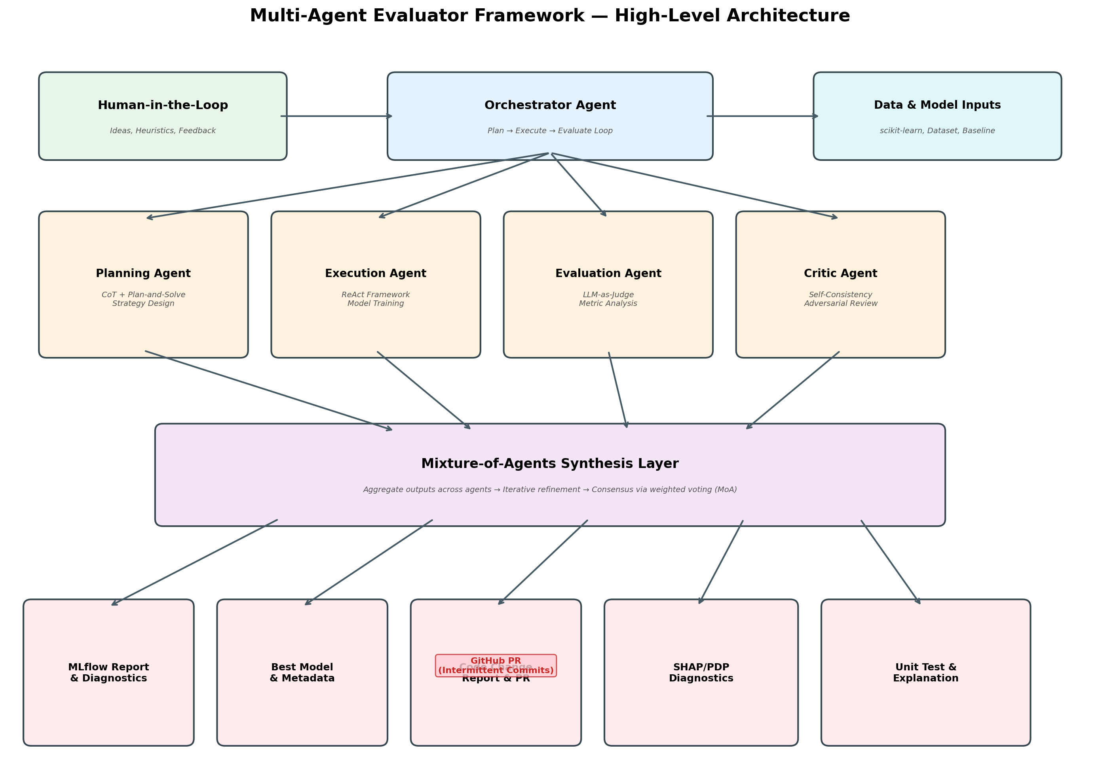
Figure 1: High-Level Multi-Agent Architecture

3.1 Agent Descriptions
Agent | Responsibility | Prompting Strategy | Recommended Model
Orchestrator | Manages improvement cycle, routes tasks, maintains Research Log | MoE Routing | GPT-4 / Claude Opus
Planning | Translates human ideas into executable strategies with step-by-step plans | Plan-and-Solve + CoT | GPT-4 / Claude Opus
Execution | Generates and runs Python code, trains models, collects results | ReAct | GPT-4 / Claude Sonnet
Evaluation | Assesses performance with metrics, diagnostics, and LLM judging | LLM-as-Judge + CoT | GPT-4 / Claude Opus
Critic | Adversarial review, validates conclusions, checks for data leakage | Self-Consistency | GPT-4 / Claude Opus
Table 2: Agent roles, prompting strategies, and model recommendations

3.2 Iterative Improvement Flow
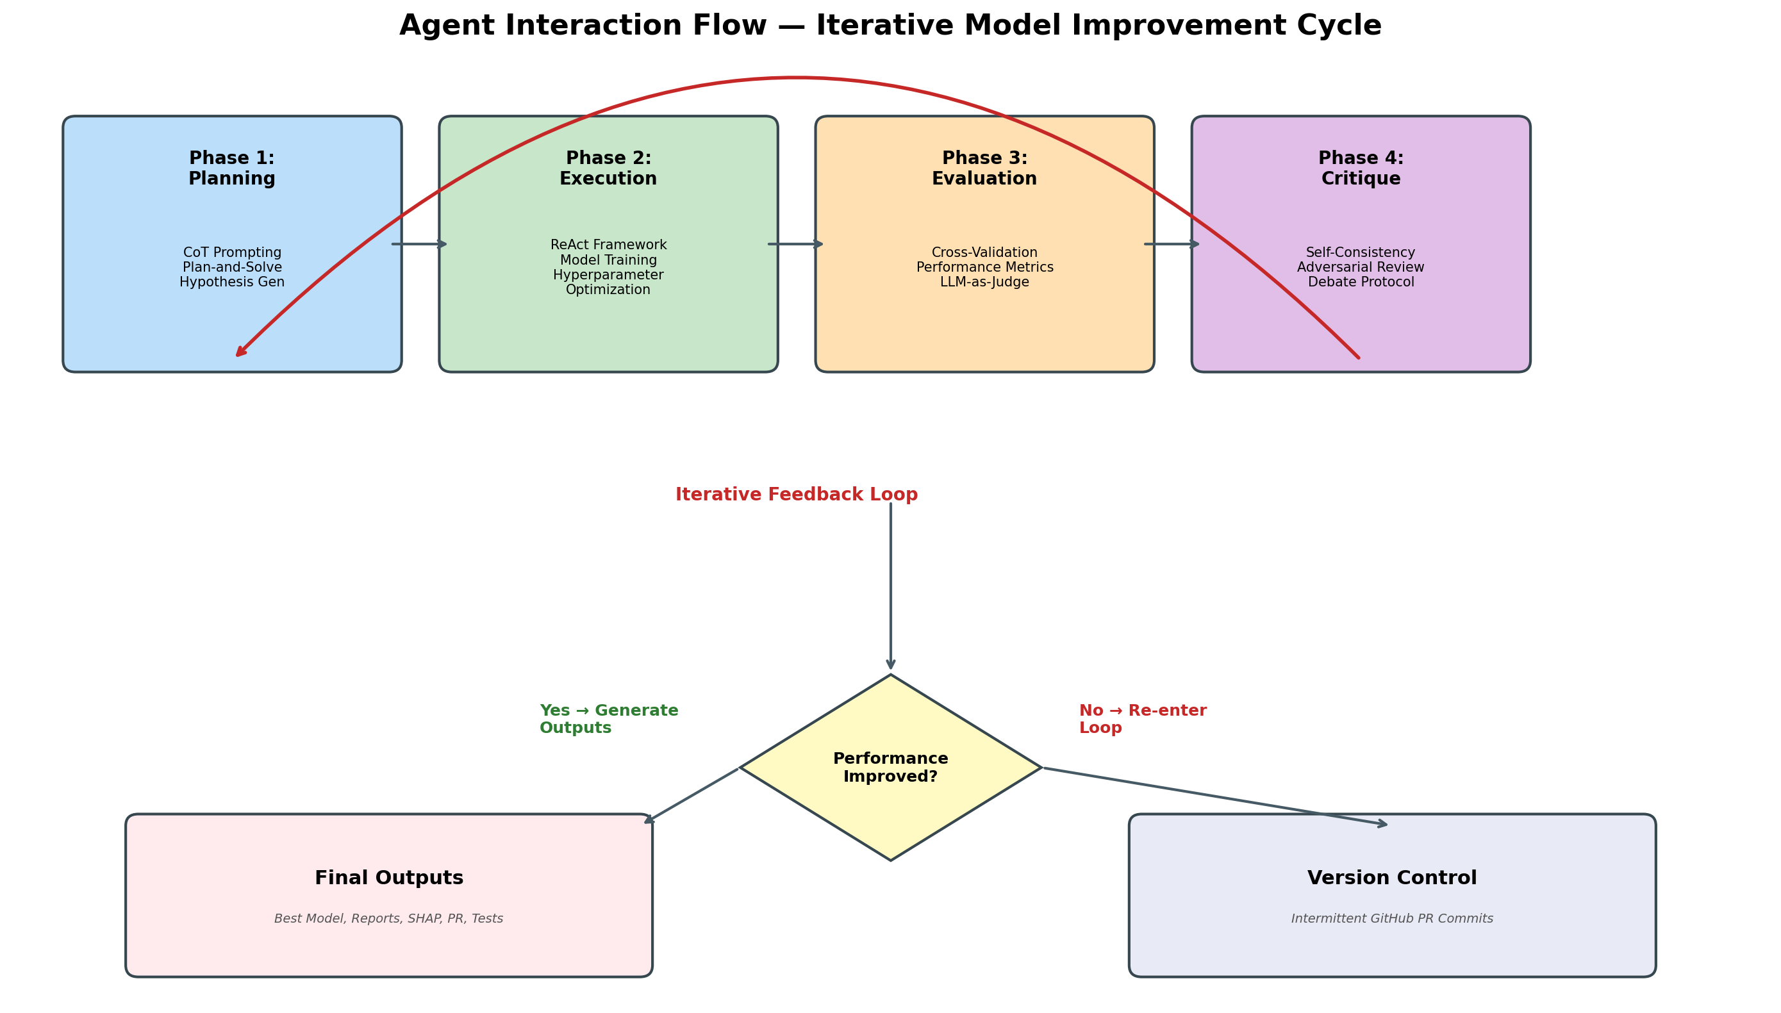
Figure 2: Iterative Model Improvement Cycle
Each improvement cycle follows four phases: (1) the Planning Agent decomposes the human’s idea into an executable strategy; (2) the Execution Agent implements the changes via a ReAct loop of Thought→Action→Observation; (3) the Evaluation Agent assesses whether performance improved using cross-validated metrics and bootstrap confidence intervals; (4) the Critic Agent validates the evaluation through self-consistency sampling and adversarial challenge. If the Critic approves, outputs are generated. If not, the cycle re-enters Planning with specific feedback.

4. Implementation Guide

4.1 Tech Stack Recommendation
Primary: CrewAI — Best fit for Hack Week due to its gentle learning curve and role-based agent definition that maps naturally to our four-agent architecture. Agents are defined declaratively with roles, goals, and backstories, making it intuitive for team members new to multi-agent frameworks.
Alternative: LangGraph — Superior for the long-term product. Its graph-based orchestration natively supports the iterative loops and conditional branching our framework requires. Recommended if any team member has prior LangGraph experience.
Fallback: Direct API — Maximum flexibility and lowest token overhead. Use if credit constraints are severe, since wrapper frameworks add system prompt and coordination overhead per call.

4.2 Integration Stack
Component | Tool | Purpose
ML Framework | scikit-learn | Pre-built model pipelines (classification / regression)
Experiment Tracking | MLflow | Log parameters, metrics, artifacts; generate HTML reports
Hyperparameter Opt. | Optuna | Bayesian optimization with visualization history
Explainability | SHAP + matplotlib | SHAP values, PDP plots, feature importance, interactions
Version Control | GitHub + PyGithub | Intermittent PR commits with agent-generated descriptions
Testing | pytest + coverage | Unit test generation and pass-rate reporting
Coding Assistant | GitHub Copilot | Routine coding tasks (save API credits for agent framework)
Table 3: Integration stack

4.3 Inputs and Outputs

System Inputs:
Model metadata (scikit-learn, classification vs. regression), pre-built model code and pipelines, pre-existing dataset, and cross-validation performance functions already in the repository.

Human Inputs:
Ideas for testing (feature engineering, hyperparameter tweaks, model architecture changes), performance function references (e.g., standard ASE function in the repo), and feedback during mid-cycle reviews.

Outputs:
Output | Details
HTML Report | MLflow-generated dashboard with run comparisons and artifact visualization
Best Model + Metadata | Serialized model with parameters, metrics, and lineage tracked in MLflow
Code Change Report | Markdown guide detailing what the human reviewer needs to check in the PR
Diagnostics | SHAP/PDP charts, interaction plots, Optuna history, feature importance (gain + split), categorical distributions
Metrics | Performance tables (HTML) and structured JSON with bootstrap confidence intervals
Unit Test Report | Pass percentage for generated/adjusted code via pytest
Results Explanation | LLM-generated narrative explaining why the final model was chosen
Table 4: Framework output specification

5. Resource and Credit Allocation
Recommended credit split: 20% development (prompt engineering, agent config), 50% testing (framework vs. baseline runs), 30% reserved (real work, demos). Cost optimization strategies:
Tiered model usage: Use cheaper models (GPT-3.5-turbo, Claude Haiku) for the Execution Agent’s code generation and Critic’s initial screening. Reserve frontier models (GPT-4, Claude Opus) for Planning and final Evaluation.
Caching: Cache LLM responses for identical queries. Many improvement strategies share common sub-steps that can be reused.
Iteration limits: Cap improvement cycles at 5 per run to prevent runaway credit consumption.
Copilot leverage: Use GitHub Copilot for boilerplate code, saving API credits for the multi-agent intelligence layer.

6. Hack Week Execution Timeline
Day | Activities | Deliverables
Day 1 | Finalize tech stack, get API keys, set up dev environment, configure MLflow | Working dev environment with API access confirmed
Day 2 | Build baseline model on Jonathan’s project, document CV performance, set up GitHub repo | Baseline model with documented cross-validated metrics
Day 3 | Implement Planning + Execution Agents, test with 2-3 simple improvement ideas | Working Plan→Execute pipeline with basic improvements
Day 4 | Add Evaluation + Critic Agents, implement iterative loop, measure speed/cost/accuracy delta | Full 4-agent loop producing measurable improvements
Day 5 | Generate full output suite, run comparative analysis, prepare demo for stakeholders | Complete outputs: report, model, PR, diagnostics, tests, explanation
Table 5: Day-by-day execution plan
Daily Syncs: 1 hour/day at 3 PM PST / 4 PM MDT. Review: accomplishments, output quality, credit consumption, blockers, and next steps.

7. Evaluation Framework: Three Levels
Option 1 (Hack Week): Performance metric only. Cross-validated OS performance assessed with bootstrap confidence intervals. Simplest, most objective.
Option 2 (Post-Hack): Performance metric + structured output. Adds domain-specific rubrics (monotonicity constraints, interpretability thresholds) evaluated via LLM-as-a-Judge.
Option 3 (Scale): Performance metric + structured + unstructured. Incorporates natural-language heuristics from Dave, Nick, and Edward as personalized evaluation perspectives in the MoA synthesis layer.

8. References
[1] Wei, J. et al. (2022). Chain-of-Thought Prompting Elicits Reasoning in Large Language Models. NeurIPS.
[2] Wang, L. et al. (2023). Plan-and-Solve Prompting. ACL.
[3] Yao, S. et al. (2023). ReAct: Synergizing Reasoning and Acting in Language Models. ICLR.
[4] Wang, X. et al. (2023). Self-Consistency Improves Chain of Thought Reasoning. ICLR.
[5] Wang, J. et al. (2024). Mixture-of-Agents Enhances Large Language Model Capabilities.
[6] Mienye, I. D. & Swart, T. G. Ensemble Large Language Models: A Survey.
[7] Zhou, H. et al. (2024). Star-Agents: Automatic Data Optimization. NeurIPS.
[8] Zheng, L. et al. (2023). Judging LLM-as-a-Judge with MT-Bench and Chatbot Arena.
[9] MLAgentBench: Benchmarking Large Language Models as AI Research Agents. ICLR (under review).
[10] Zhou, Y. et al. (2024). Hypothesis Generation with Large Language Models.
[11] Chaduvula, S. et al. Explainability in Traditional and Agentic AI Systems. Vector Institute.
[12] Saichandran, K. S. et al. (2025). Agentic AI for Automated Hypothesis Testing in ADRD. medRxiv.
[13] Efron, B. & Hastie, T. (2016/2021). Computer Age Statistical Inference. Cambridge.
[14] Pearl, J. (2018). On Non-manipulable Causes. Journal of Causal Inference.

