Linked List insertion

Linked List traversal/print

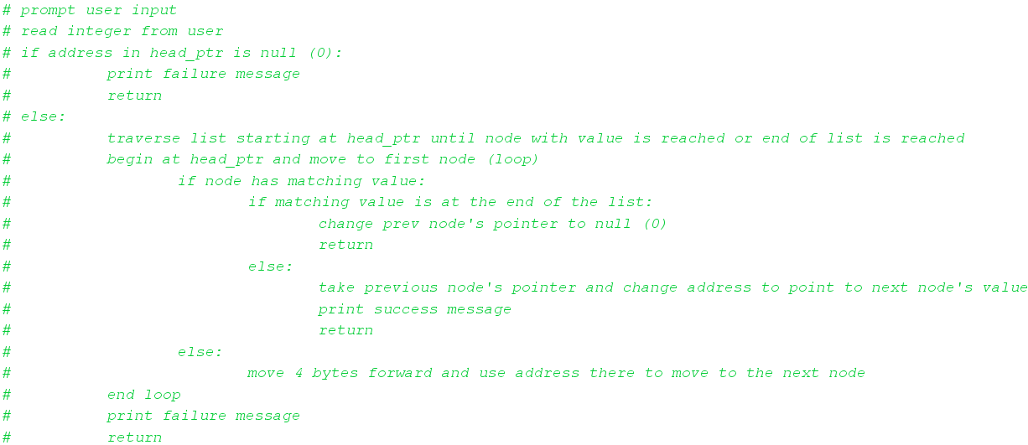Linked List deletion