**Company:** Iterum Therapeutics (ITRM) **Investment:** Long Common Equity

**Catalyst:** Read out of Phase 3 Clinical Trial **Current Price:** $3.50

Iterum (NASDAQ: ITRM) is a clinical stage pharmaceutical company developing anti-infectives to combat multi-drug resistant pathogens.

**Opportunity**

Iterum acquired an exclusive worldwide license to sulopenem and its oral prodrug sulopenem etzadroxil from Pfizer. Pfizer has done multiple Phase 1 & 2 trials on the drug in over 1,450 patients which has established a clear safety and pk/dosing profile, the 3 Phase III trials in 2H ’19 will establish efficacy.

This has the potential to be the first oral penem which would add significant value to both clinicians and payors. Iterum’s stock has fallen due to 1) very little coverage 2) post IPO sell-off & 3) no news. We view this as a very attractive entry price with limited downside risk. We are not going to go into detail on the commercial/ financial model as we believe that even under the most conservative scenario, a successful read out will merit a price over $10/share. That is currently ~2.5-3.0x the current price.

**Catalyst**

Three Phase III readouts in Q4 2019/ Q1 2020– indications for uUTI, cUTI, & cIAI.

**Two Questions to Determine Success**

1. **Will the oral dosing of sulopenem display sufficient efficacy?**

A little background on the science. Antibiotics efficacy is typically measured using a parameter called MIC (minimum inhibitory concentration). MIC is the lowest concentration of a drug that prevents visible growth of a bacteria. Antibiotics can be divided into three different pharmacokinetic/ pharmacodynamic classes: Type I, Type II, & Type III. Penem (e.g. sulopenem) antibiotics are considered Type 2 antibiotics. The PK/PD parameter to maximize efficacy for Type II antibiotics is T>MIC – ie. the ideal dosing regimen for the penem class of antibiotics maximizes the duration of exposure. IV sulopenem has demonstrated that T of ~ 5 hours is sufficient for efficacy. Since a single dose of oral sulopenem + probenecid showed a T>MIC of 3.6 hours, a BID dose (2x a day), seems very plausible to show comparable (if not better) efficacy than the IV sulopenem.

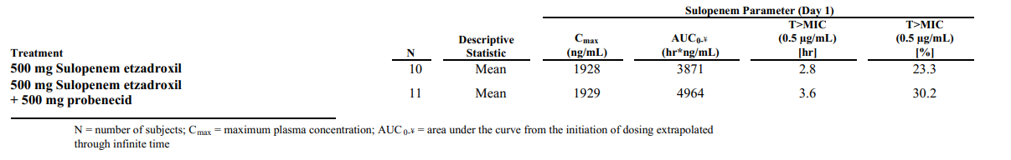**Exhibit 1:**

Source: 2018 10k

**Key Takeaway:** Note the study in figure 1 shows that probenecid increases the AUC of sulopenem by 28.2% and extends the mean time over MIC, also 28.6%.

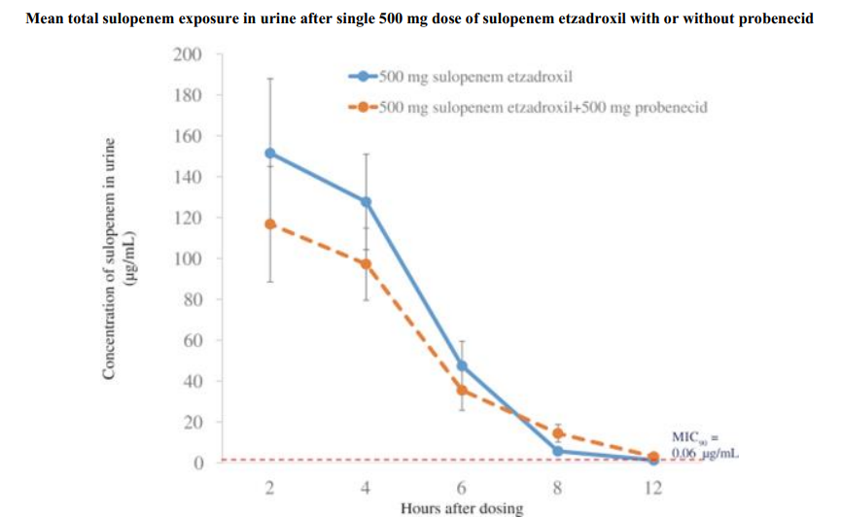**Exhibit 2:**

Source: 2018 10k

**Key Takeaway:** Peak urine concentrations are almost 2,000-fold higher than the MIC90, and a single dose will exceed the MIC90 for the entire BID dosing interval.

1. **Does sulopenem target the proper pathogen?**

While sulopenem did perform worse than some others in the penem class, it shows clear in-vitro efficacy. Note sulopenem MIC90 against major organisms associated with the indications Iterum is going after is less than 1 ug/mL (Less than 4 uG/mL tends to be the standard for efficacy).

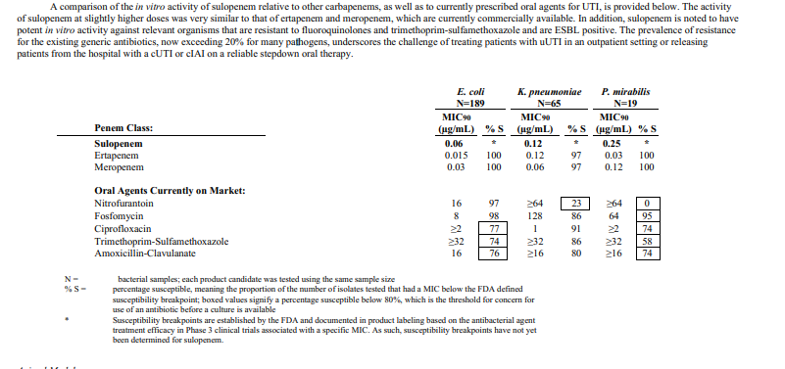**Exhibit 3:**

**Key Takeaway:** While sulopenem did perform worse than some others in the penem class, it shows clear in-vitro efficacy. In other words, while not the best, it is clearly good enough. Further note, MIC90 against major organisms associate with the indications Iterum is going after is less than 1 ug/mL (Less than 4 uG/mL tends to be the standard for efficacy).

**Safety Profile**

**Exhibit 3:**

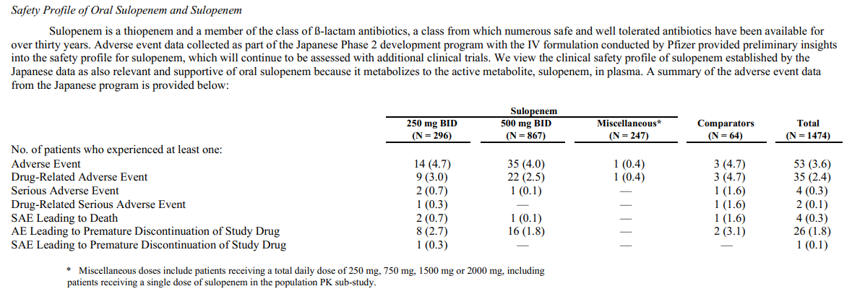

**Key Takeaway:** We don’t believe there are any safety or toxicity issues with either the IV or oral dosing of sulopenem.

**Market**

The leading indication is for Urinary Tract Infections (UTI) – will make up majority of the sales. Iterum’s differentiator is that they are developing an oral formulation for a step down from the IV – the market outside the hospital is an attractive commercial opportunity. For instance, Alan Carr at Needham thinks it is a $500M - $1B opportunity. It will compete in the market of the ~260k penem scripts per year – oral formulation provides a clear differentiator.

**Other Points of Note**

* Strong global rights & exclusivity (composition patent through 2034 (2029 + 5 yr extension)
* Iterum has 3 studies under SPA with the FDA. They are all Non-inferiority (it’s not worse than the comparator), however, superiority will help commercial success, especially for uUTI

**Risks:**

* All three, or any 3, of the Phase III trials due to read out in Q4 could fail to meet their endpoint.
* Changing dosing from 500mg 2x a day to 1g 1x per day
* Licensing Agreement with Pfizer/ Will need to issue shares

**Valuation:**

Our analysis shows that the value of the company is at least $100M if any single indication gains approval. Realistically, we think this company has a value between $300-$500M if they pass these Phas III trials.

**Conclusion:**

We believe this is an opportunity that can return multiples in the short term and could be 5x-10x in the 18-24 month range. We think the probability of success in either uUTI or cUTI is ~70%. If all three trials fail, we expect the value to be ~$25M – as determined by cash on hand – which represents a 50% decline.