CS270 Recitation 5
“More Logisim”

Goals

To understand how to design and debug combinational and sequential circuits using the Logisim logic simulator, in order to prepare for the next homework.

The Assignment

Make a subdirectory called R5 for this recitation, where all files should reside. Logisim can be found in the directory shown below, using the following command:

$ ~cs270/logisim/logisim

1) Design an AND gate with two inputs using n-type and p-type transistors. You may search on the web for the canonical design of this circuit. Verify that it works correctly by making Logisim generate the truth table. The TA will explain some of the fine points of laying down transistors in Logisim. Save the circuit into R5, export a .gif image, and paste it into the space below:

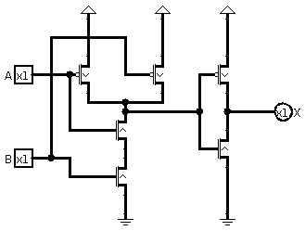
2) Design a combinational circuit for the following truth table using logic gates. Inputs are A, B, and C, and the outputs are X and Y. Use the methodology described in Section 3.3.4 of the textbook, which employs successive arrays of AND and OR gates. Design the circuit in Logisim, export a .gif image, and paste it into the space below, making sure the truth table matches:

A | B | C | X | Y
0 | 0 | 0 | 1 | 1
0 | 0 | 1 | 1 | 1
0 | 1 | 0 | 0 | 1
0 | 1 | 1 | 0 | 1
1 | 0 | 0 | 1 | 0
1 | 0 | 1 | 1 | 0
1 | 1 | 0 | 0 | 1
1 | 1 | 1 | 1 | 1

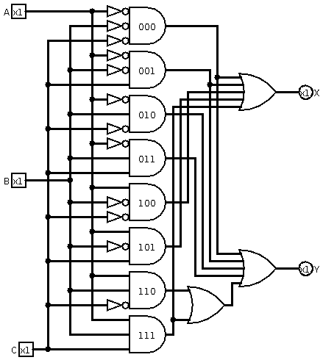
3) Redesign the combinational circuit from the previous page using boolean logic techniques to minimize the number of gates. To start, write down the minimized terms below the table. You should only need three AND gates and three OR gates.

A | B | C | X | Y
0 | 0 | 0 | 1 | 1
0 | 0 | 1 | 1 | 1
0 | 1 | 0 | 0 | 1
0 | 1 | 1 | 0 | 1
1 | 0 | 0 | 1 | 0
1 | 0 | 1 | 1 | 0
1 | 1 | 0 | 0 | 1
1 | 1 | 1 | 1 | 1

X = !A!B!C + !A!BC + A!B!C + A!BC + ABC

X = !A!B + A!B + ABC

X = !B + ABC

Y = !A!B!C + !A!BC + !AB!C + !ABC + AB!C + ABC

Y = !A + AB
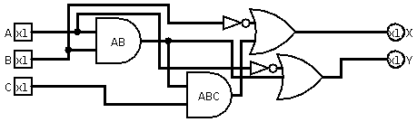
4) Design an SR flip-flop using logic gates. You may browse the web or look at the textbook for the canonical version of this circuit. Label the inputs Set and Reset, and the outputs Q and !Q. Verify that the circuit works as intended. Design the circuit in Logisim, and export a .gif image that you will paste into the space below. Generate a truth table using Logisim, does the table reflect the state of the flip-flop, or is it unable to analyze a sequential circuit?

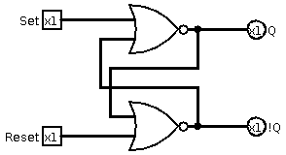
5) Submit the saved version of this document into the Recitation 5 drop box in RamCT, and get it checked off by the TA for full credit.

