Sean MacBride

**Analysis of the Proper Motion and Contrast**

**Of Carina Over Different Magnitude Limits**

In beginning the analysis of Carina, four filters on the Gaia data were implemented: a sigma cut on proper motion, a magnitude limit, a branch limit, and a semimajor axis limit. Although each of the filters was based on one class of data, all of the data associated with a star was maintained if it passed the filter. The sigma cut involved removing all-stars that did not fall within the product of a variable times the sigma of the proper motion measured by the Gaia team[1]. In this instance, 3-sigma was used. The magnitude cut involved removing all-stars that were brighter than a given magnitude. In this instance, the magnitudes were set at 19, 19.5, 20, 20.5, and 21. The branch cut involved eliminating stars that did not fall on an expected region of a color-magnitude diagram. The bounds on the branch were determined by observing a color-magnitude diagram with a 0.5 sigma cut on the proper motion, and then applying the bounds found to the data sets with a larger sigma cut and variable magnitude limits. The semimajor axis cut involved rotating the positional coordinates of the data set to calculate a semimajor axis based on the ellipticity[2] of the galaxy. All stars with semimajor axes greater than the survey area were removed from the dataset. This produced the final data sets shown below. 5 graphs in total were produced. The graphs were categorized as follows.

1. 20 Magnitude cut, 3 sigma
2. 20 Magnitude cut, 2 sigma
3. 20 Magnitude cut, 1.65 sigma
4. Proper Motion Plot - A scatter plot of the proper motion. The weighted mean of the proper motion of each set is plotted in black.
5. BP-RP vs. G-Magnitude - A scatter plot with BP-RP magnitude on the x axis and G-Magnitude on the y axis. Using a 0.5 sigma-cut, bounds on the BP-RP and G-Magnitude branch were determined. Those bounds are reflected in this plot. The magnitude cut is clearly visible in this plot.
6. Position Plot - A scatter plot with the delta x from the tangent plan projection on the x axis and delta y from the tangent plan projection on the y axis.
7. Adjusted Number Density Plot - A number density with semimajor axis length on the x-axis and density on the y axis. Using a log-log scale. Adjusted for background over the deeper range of semimajor axis values by taking the average over a range defined by observationally classifying it on the unadjusted graph. Two different binning techniques were used. Over the range where uniform stars per bin number was effective, a uniform stars per bin were used. Over the rest of the survey radius, a fixed number of bins was used.
8. Surface Density of Delta X vs. Delta Y over full range - A surface density diagram of delta-x on the x axis and delta-y on the y axis.
9. Surface Density of Delta X vs. Delta Y over small range - A surface density diagram of delta-x on the x axis and delta-y on the y axis, but over a range of (-1,1) on both the x axis and y axis.

1a.)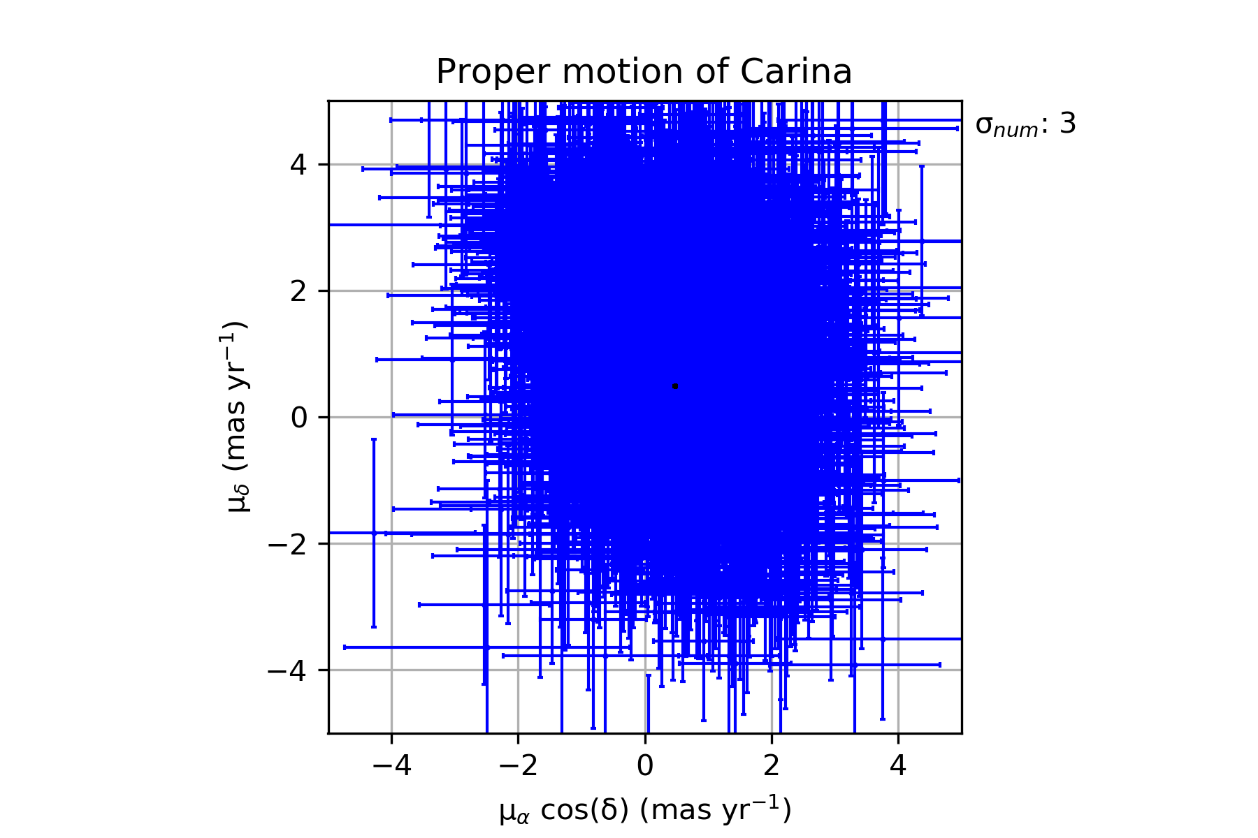

1b.)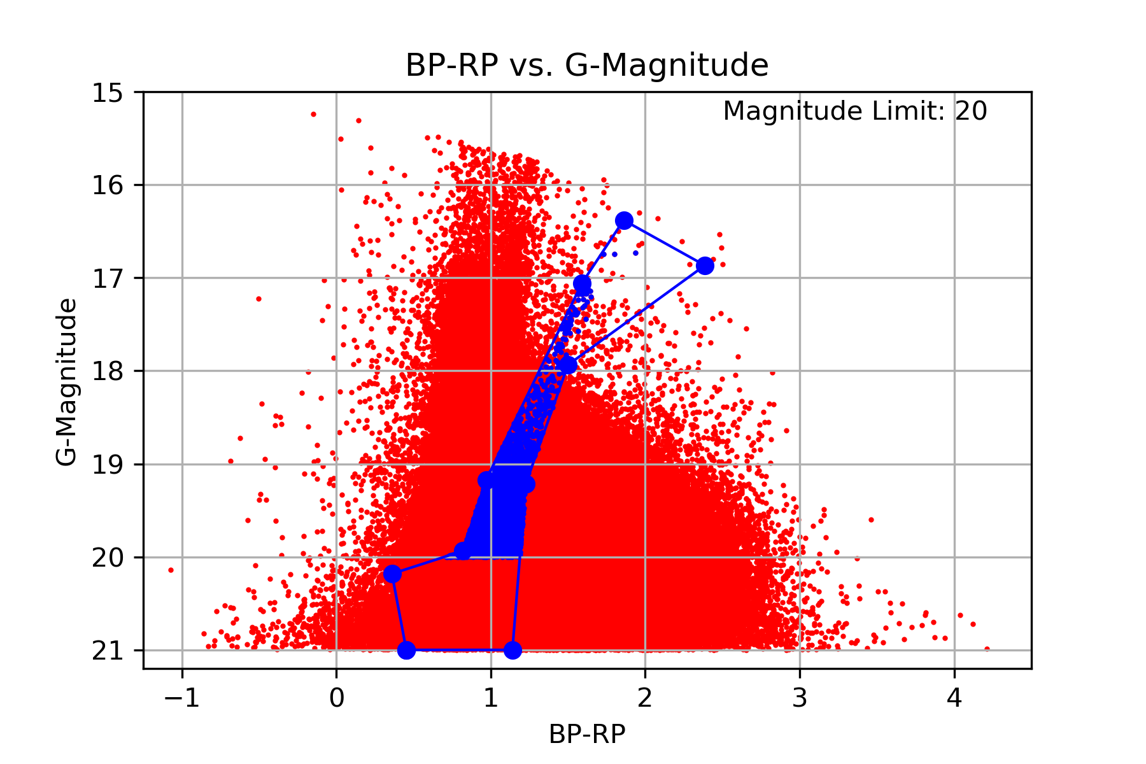

1c.)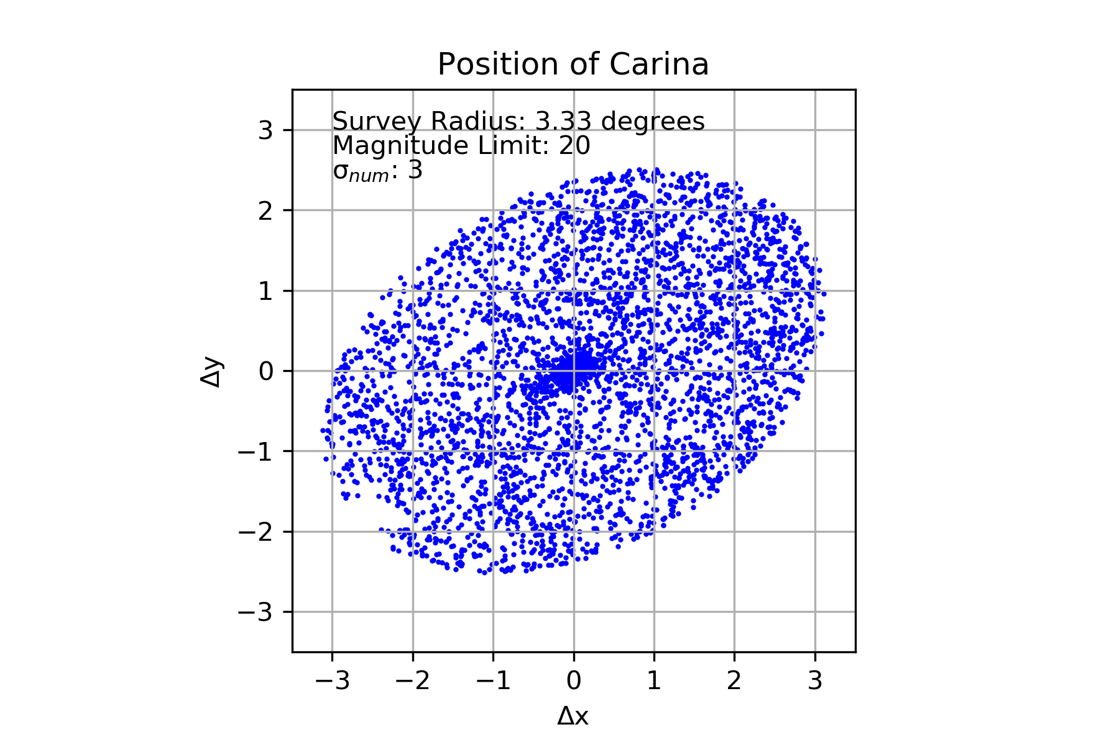

1d.)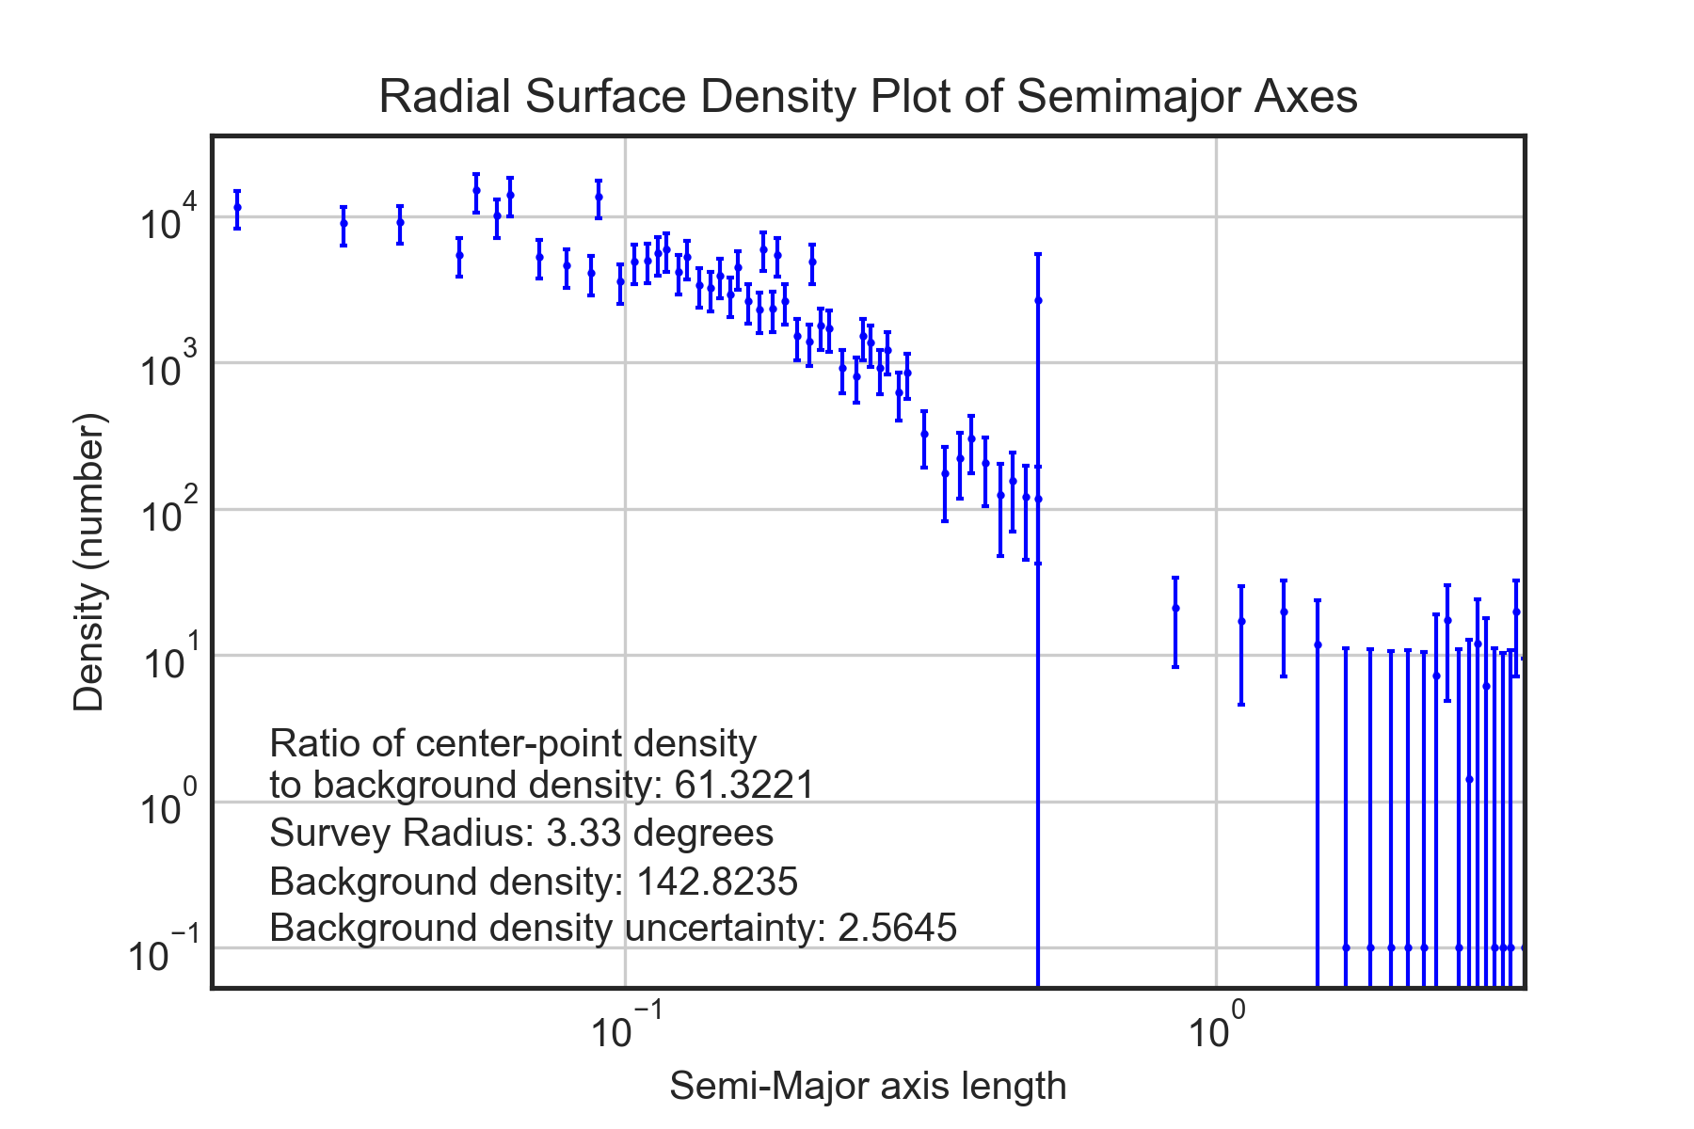

1e.)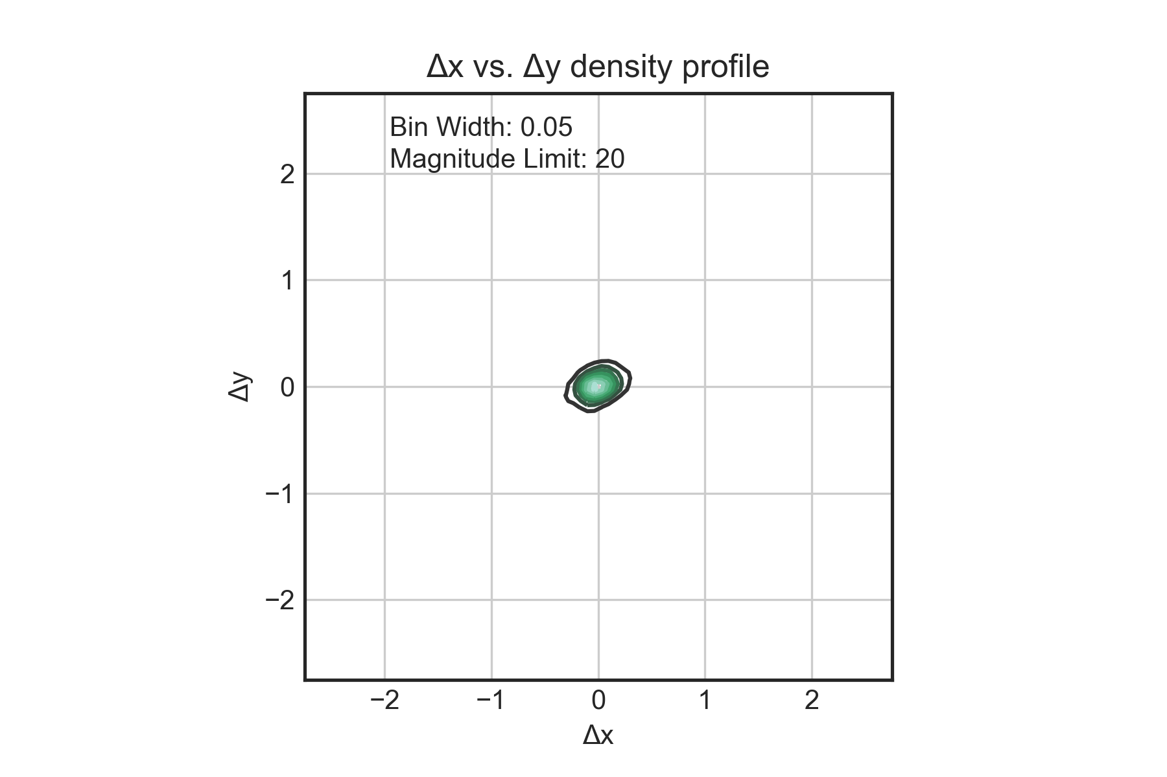

1f.)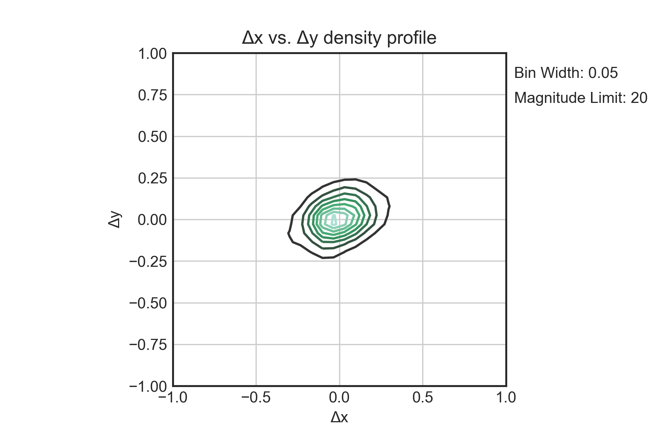

2a.)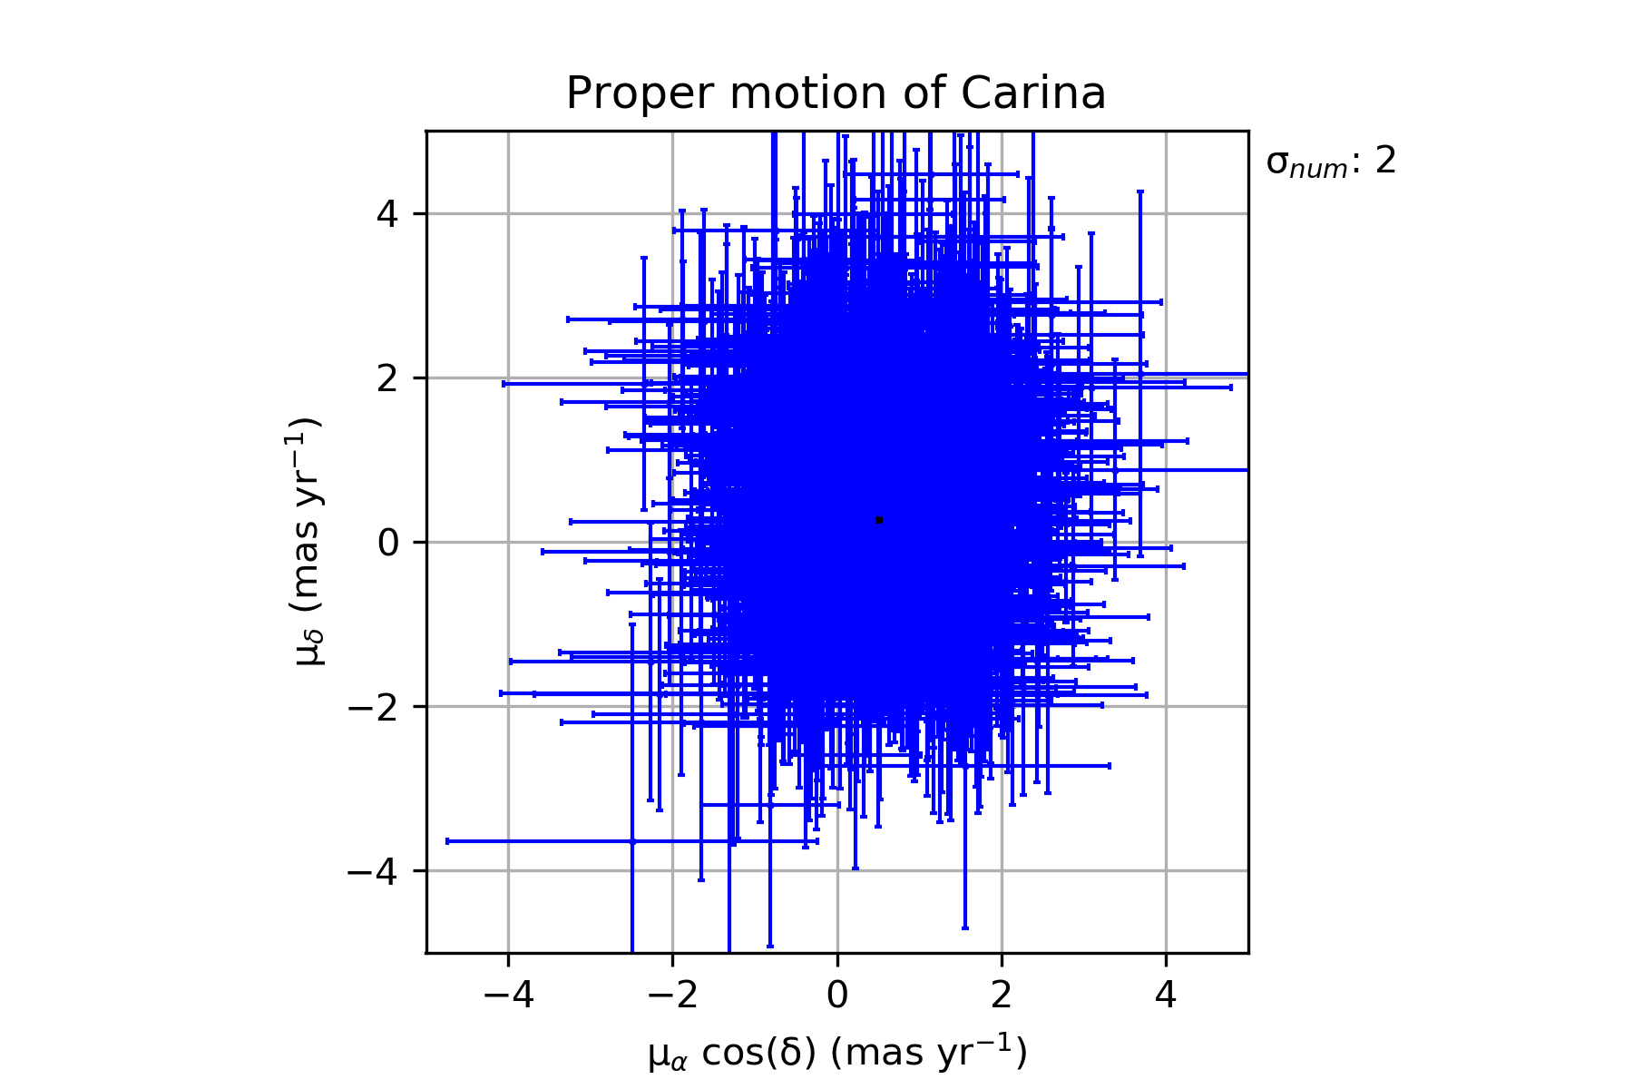

2b.)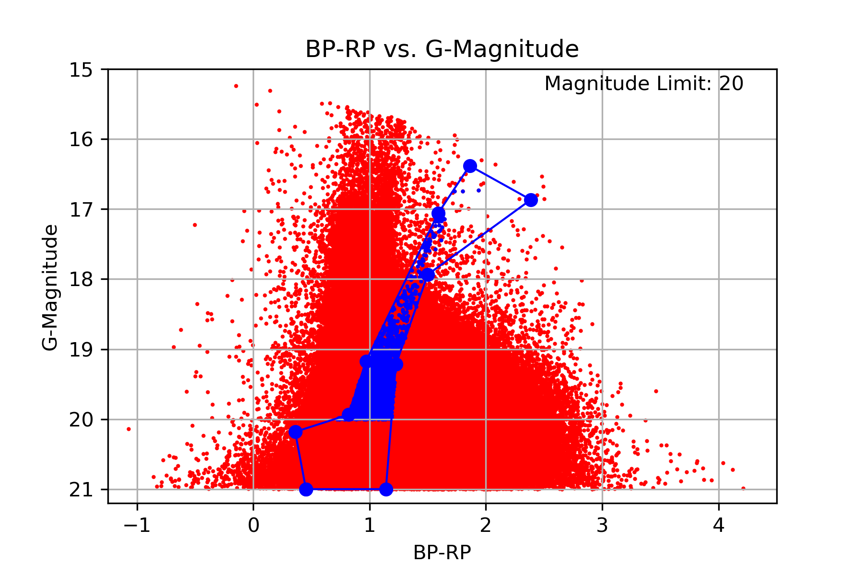

2c.)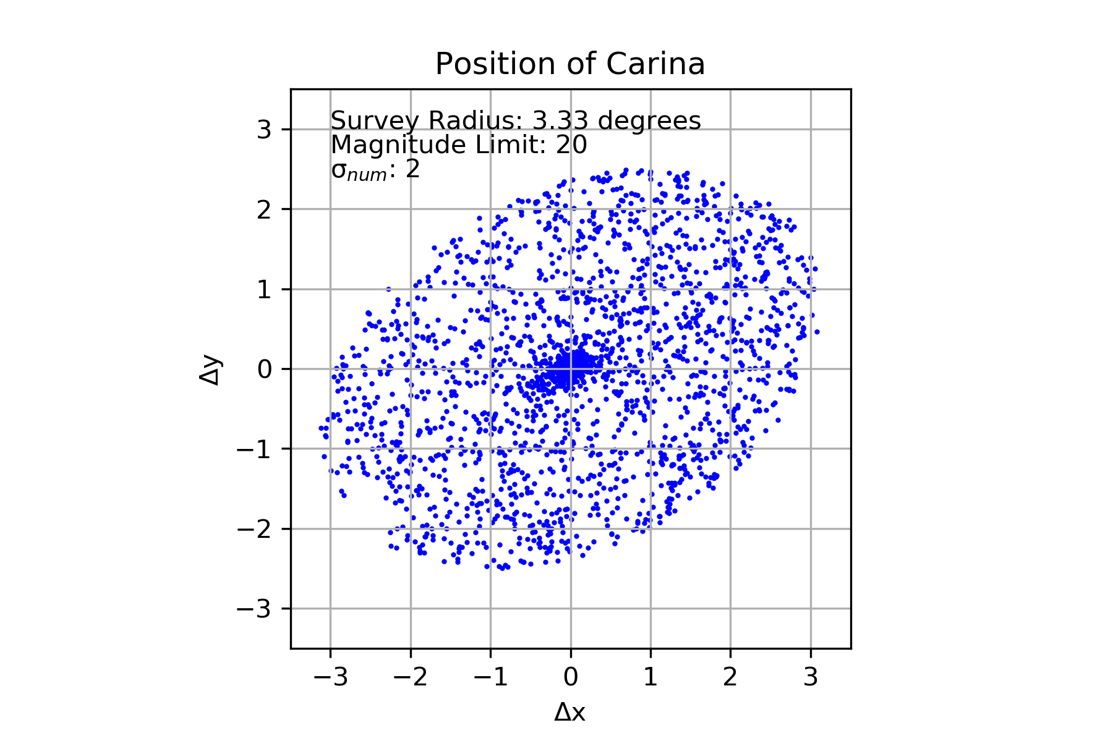

2d.)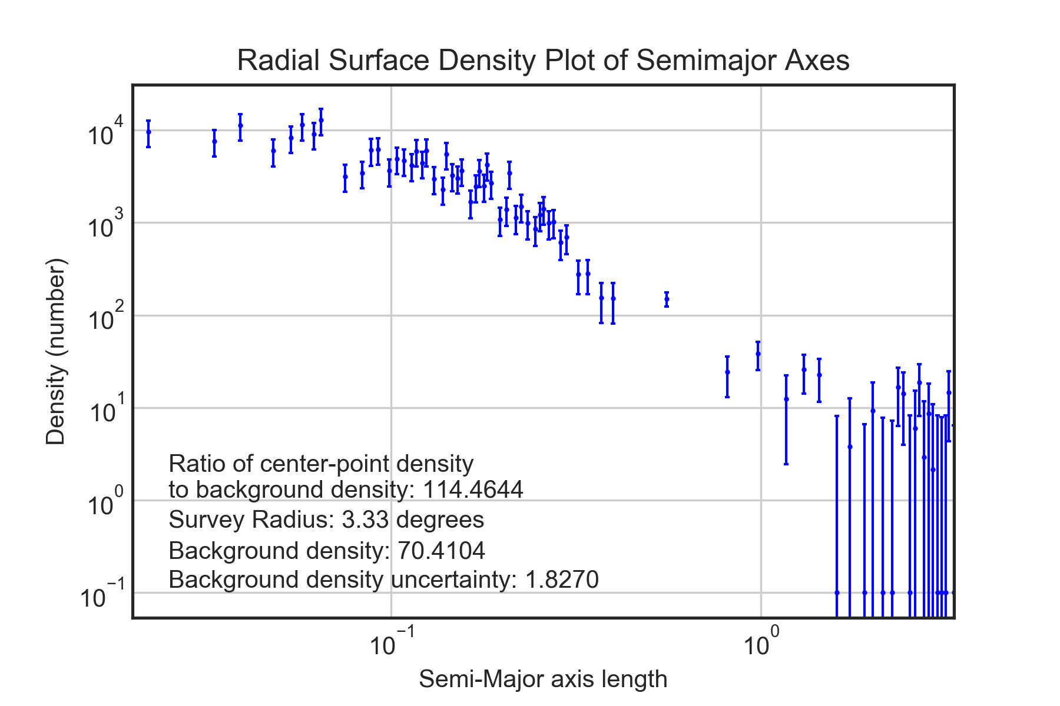

2e.)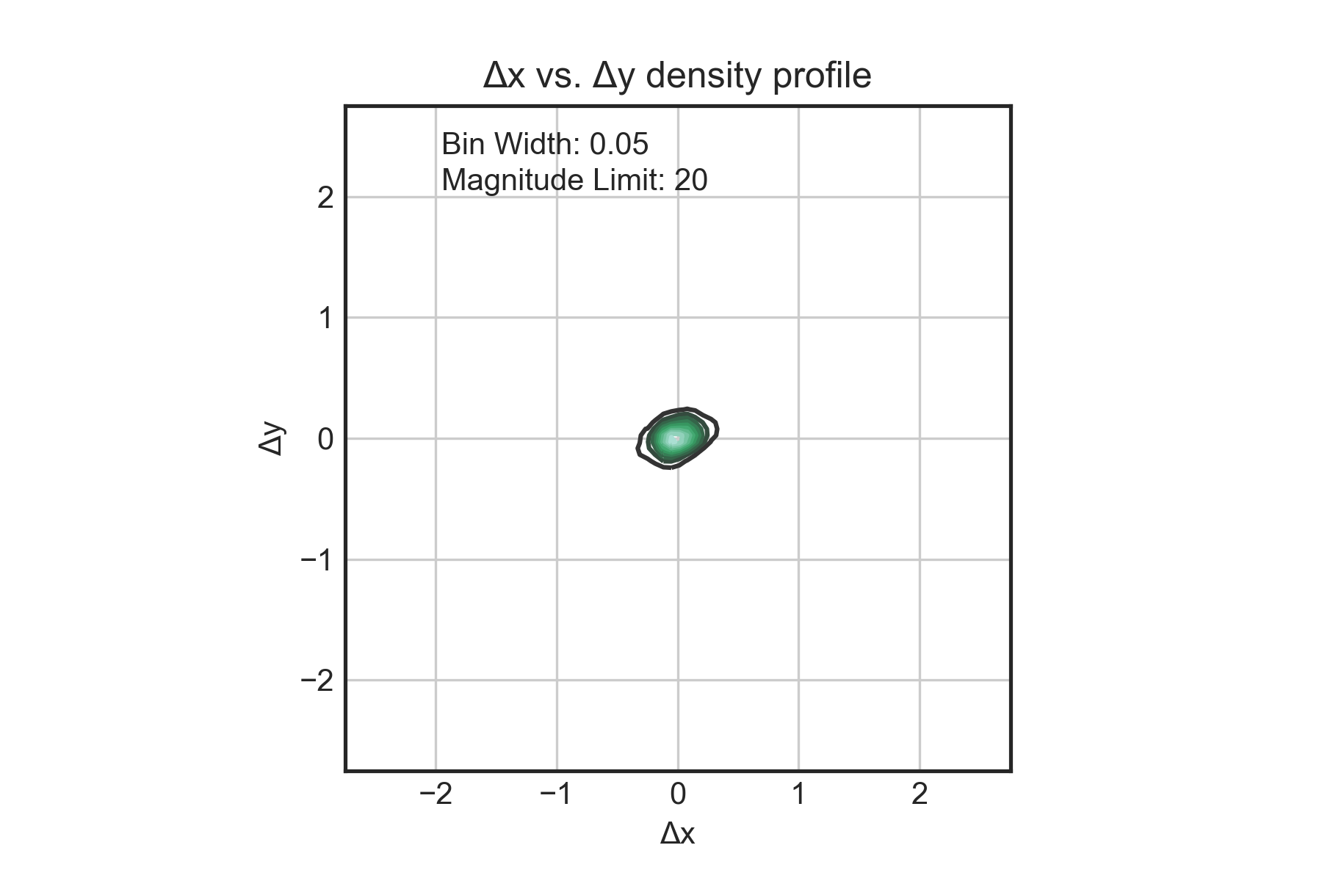

2f.)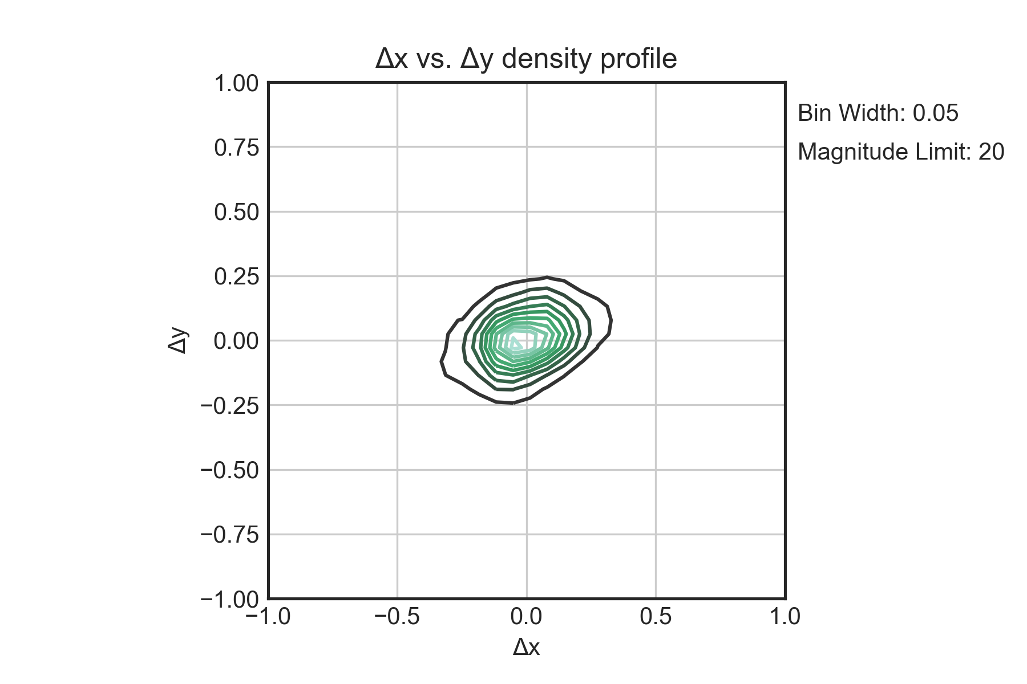

3a.)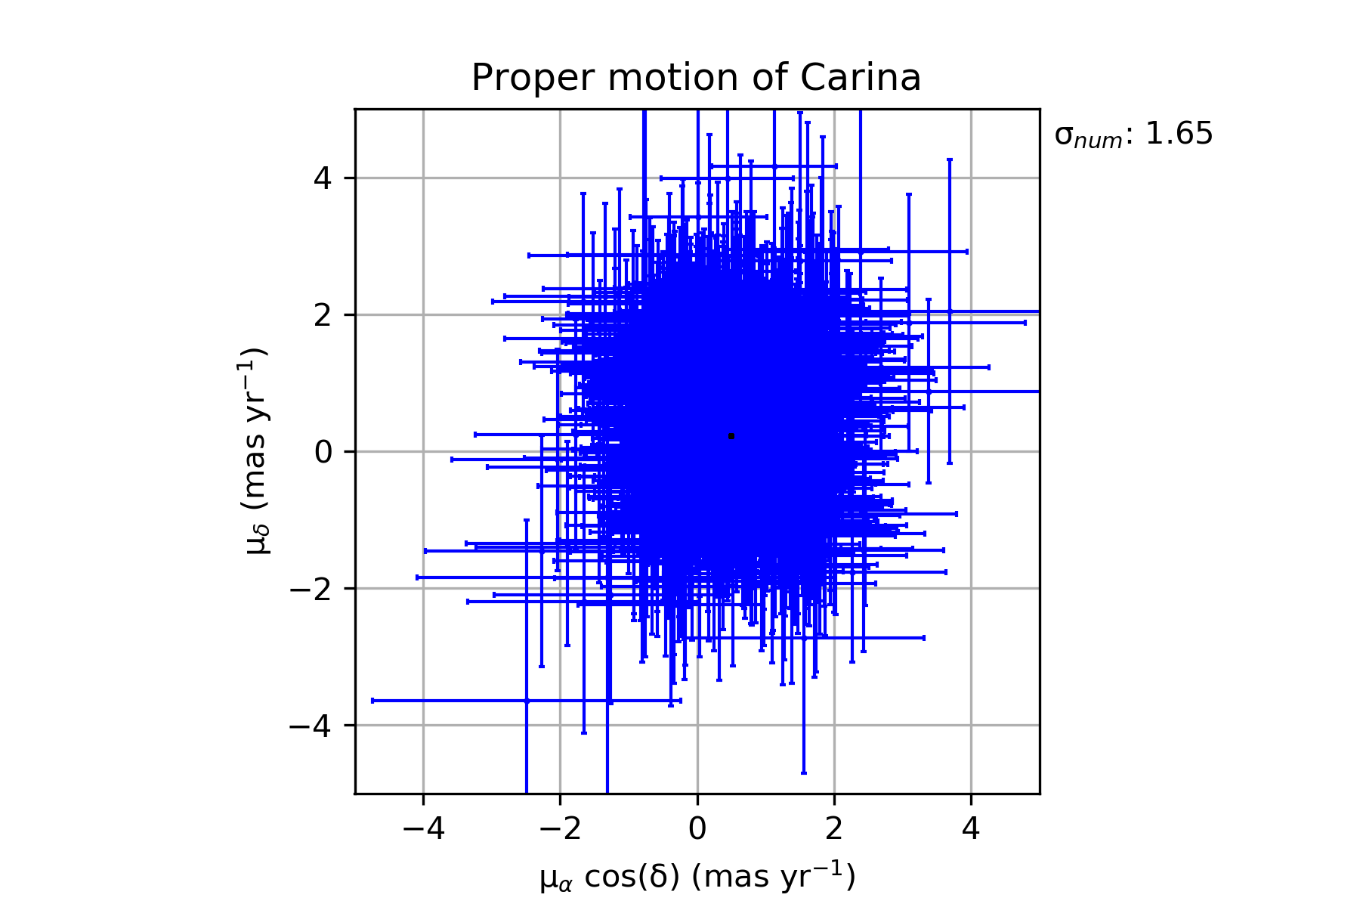

3b.)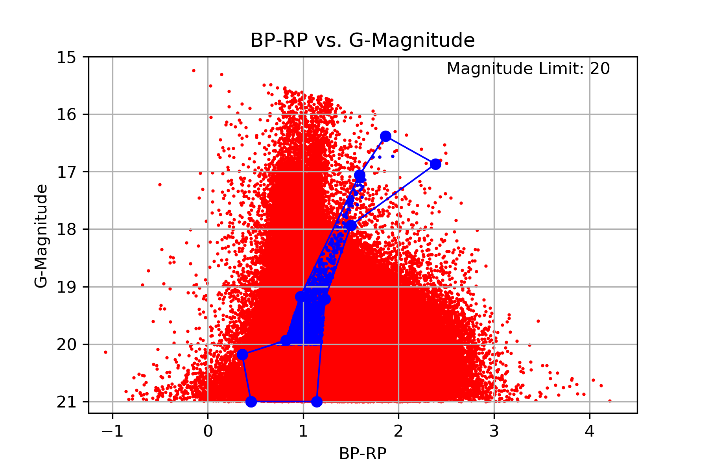

3c.)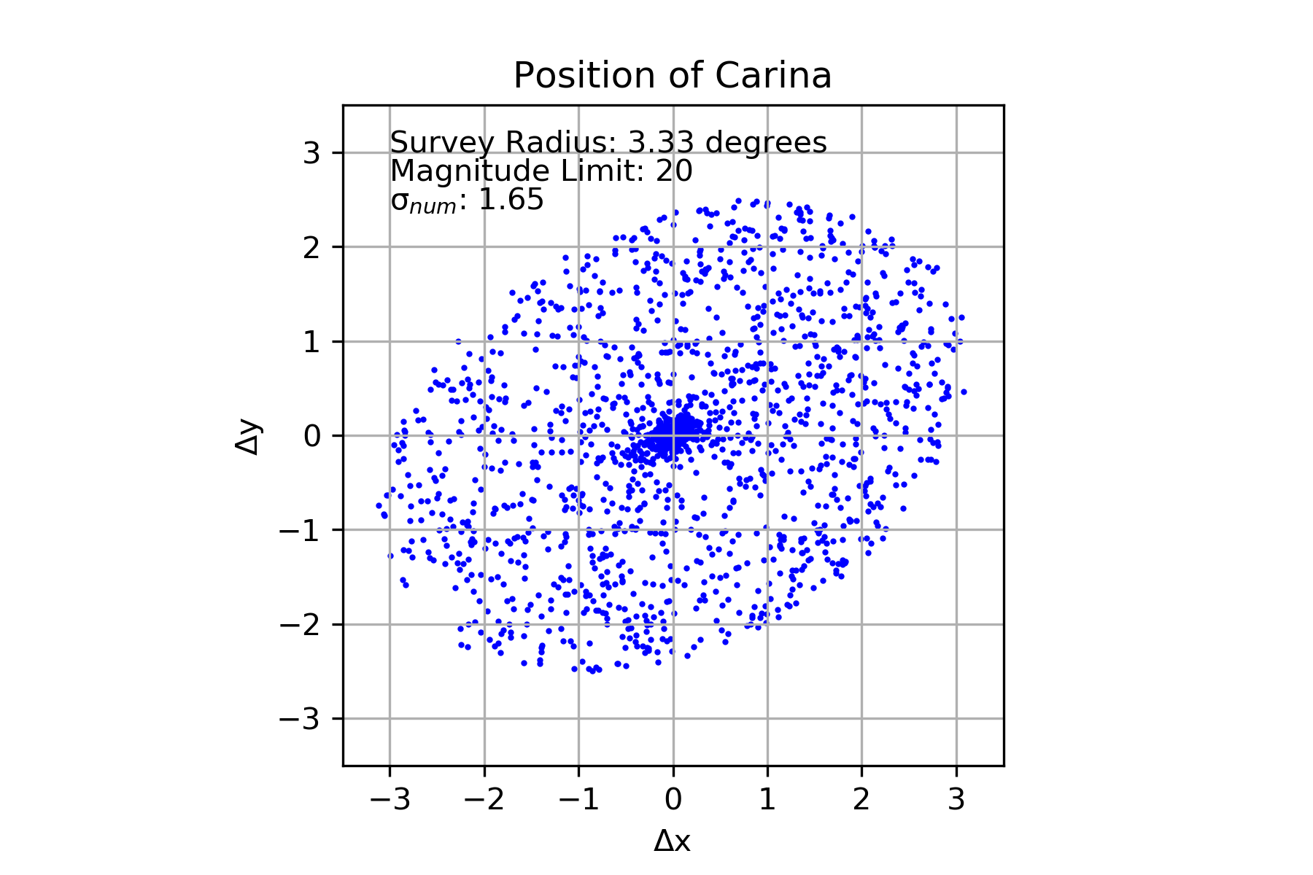

3d.)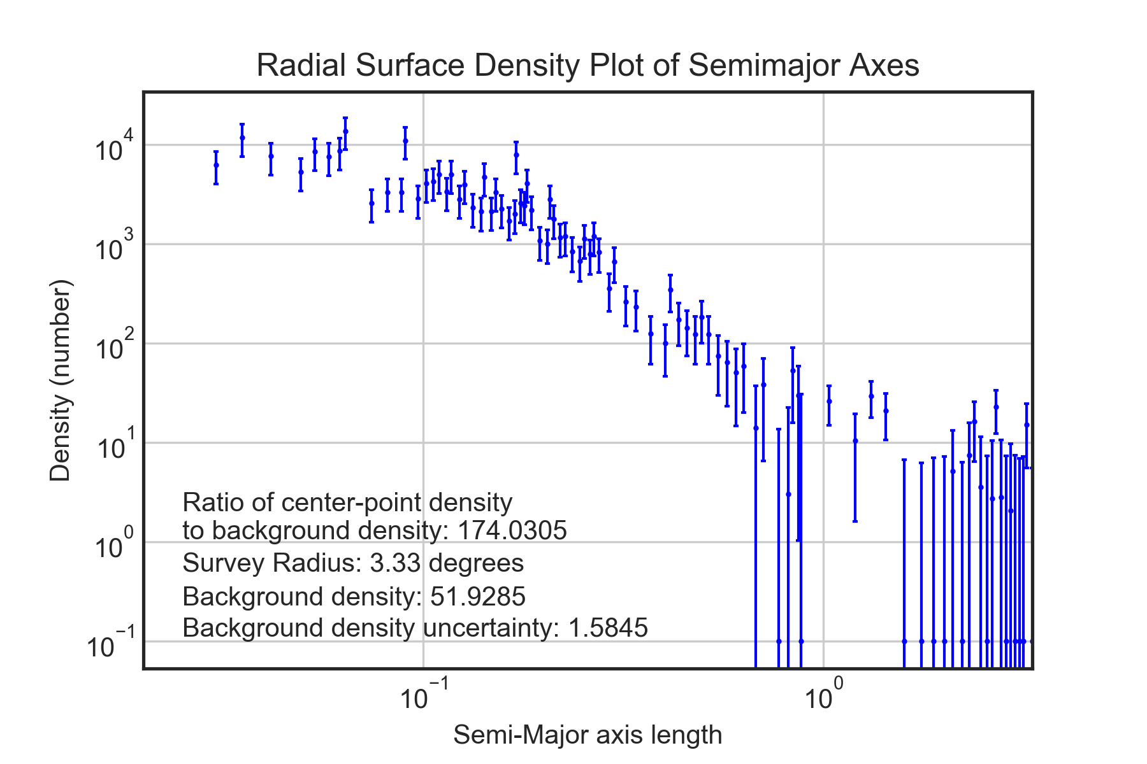

3e.)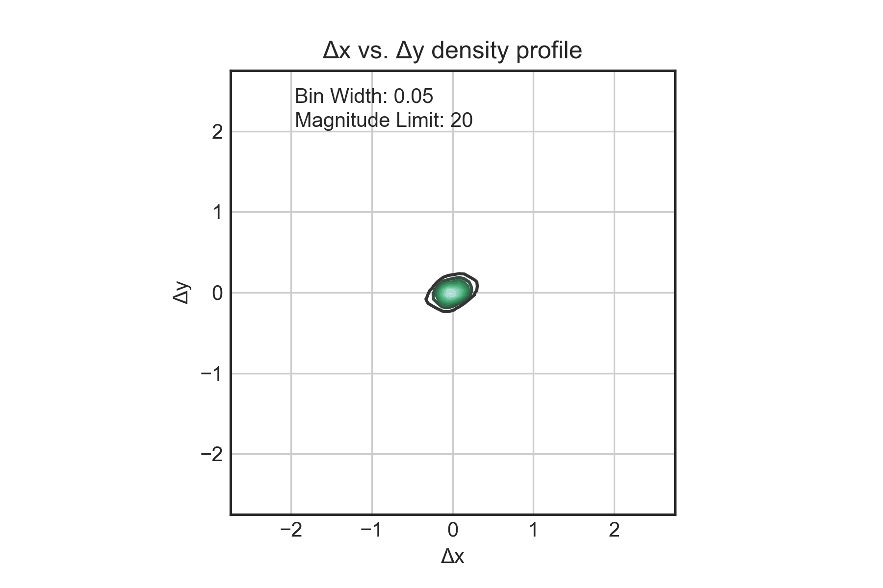

3f.)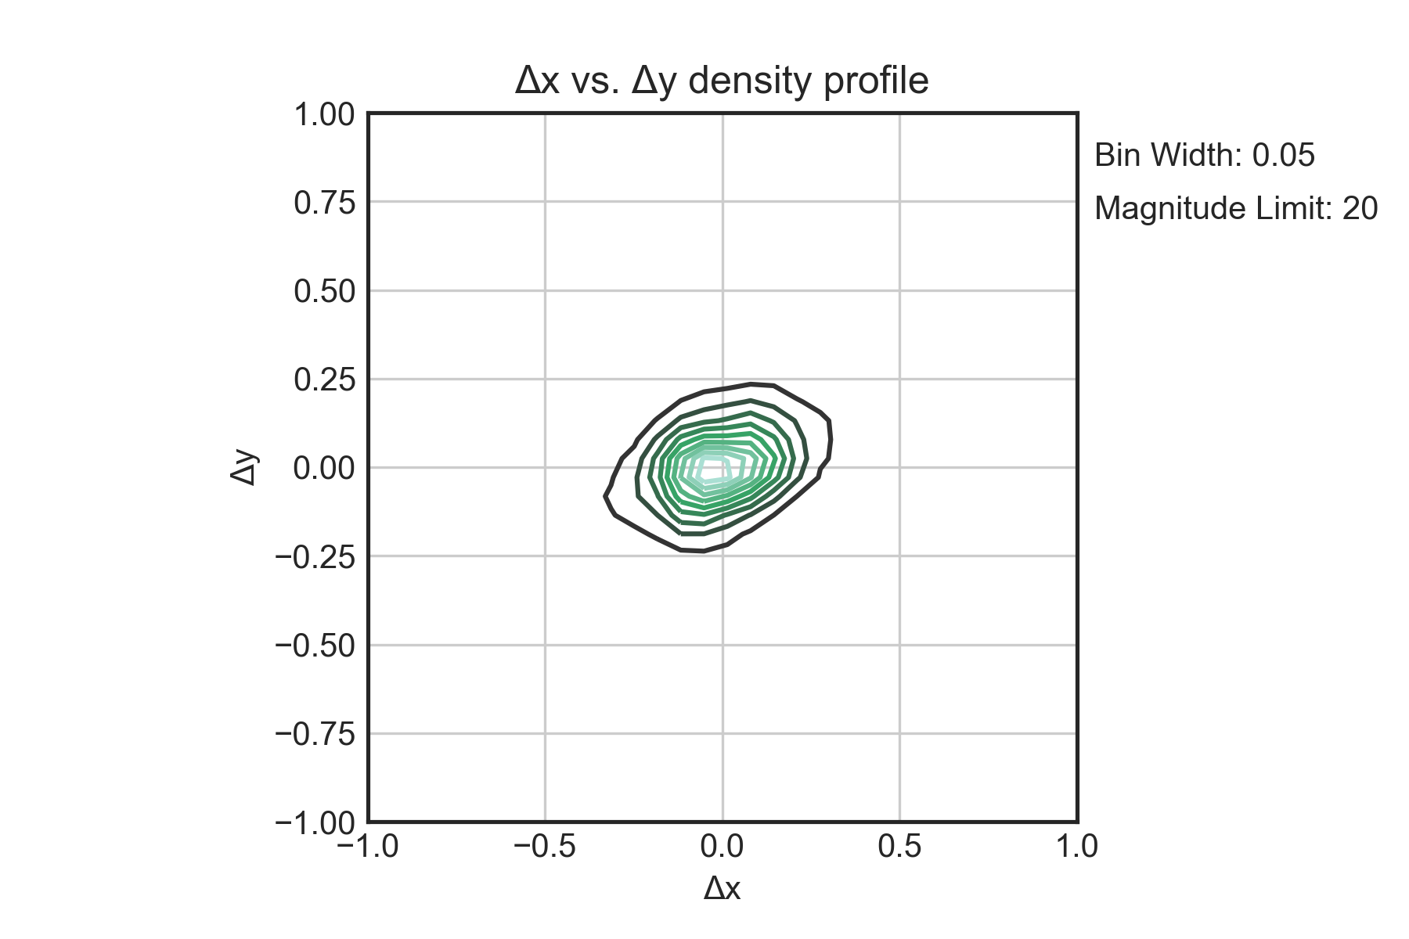

1. *Gaia* Collaboration A. A. 2018
2. McConnachie, A. W. 2012, AJ, 144, 4