Sean MacBride

**Analysis of the Proper Motion and Contrast**

**Of Carina Over Different Magnitude Limits**

In beginning the analysis of Carina, four filters on the Gaia data were implemented: a proper motion cut, a magnitude limit, a photometric selection, and a semimajor axis limit. Although each of the filters was based on one class of data, all of the data associated with a star was maintained if it passed the filter. The proper motion selection removed all stars that did not fall within a fixed multiplier of its uncertainty of the proper motion measured by the Gaia team[1]. In this instance, the multiplier was 3. The magnitude cut involved removing all-stars that were brighter than a given limiting magnitude. In this instance, the limits were set at 19, 19.5, 20, 20.5, and 21. The photometric selection eliminated stars that did not fall in the region of a color-magnitude diagram expected for Carina members. The bounds on the region were determined from the a color-magnitude diagram with a 0.5 sigma cut on the proper motion. The semimajor axis cut involved rotating the positional coordinates of the data set to calculate a semimajor axis based on the ellipticity and orientation[2] of the galaxy. All stars with semimajor axes greater than the survey area were removed from the dataset. The above selection produced 5 final data sets differing in magnitude: 1.) 19 Magnitude cut, 2.) 19.5 Magnitude cut, 3.) 20 Magnitude cut, 4.) 20.5 Magnitude cut, and 5.) 21 Magnitude cut. Shown below are the following plots for each of the five samples.

1. Proper Motion Vector Point Plot - A scatter plot of the proper motion. The weighted mean of the proper motion of each set is plotted in black.
2. BP-RP vs. G-Magnitude Color Magnitude Diagram - A plot of the Gaia BP-RP color vs. Gaia G magnitude. Using a 0.5 sigma-cut, bounds on the BP-RP and G-Magnitude branch were determined. Those bounds are reflected in this plot. The magnitude cut is clearly visible in this plot.
3. Position Plot - A scatter plot with the delta x from the tangent plan projection on the x axis and delta y from the tangent plan projection on the y axis.
4. Background Subtracted Projected Number Density Profile - A number density with semimajor axis length on the x-axis and density on the y axis. Using a log-log scale. Adjusted for background over the full range of semimajor axis values by taking the average over a range defined by observationally classifying it on the unadjusted graph. Two different binning techniques were used. Over the range where uniform stars per bin number was effective, a uniform stars per bin were used. Over the rest of the survey radius, a fixed number of bins was used.
5. Surface Density on the Tangent Plane - A surface density diagram contour diagram the tangent plane.
6. Surface Density on the Tangent Plane - A surface density diagram contour diagram the tangent plane, but over a range of (-1,1) on both the x axis and y axis.

1a.) 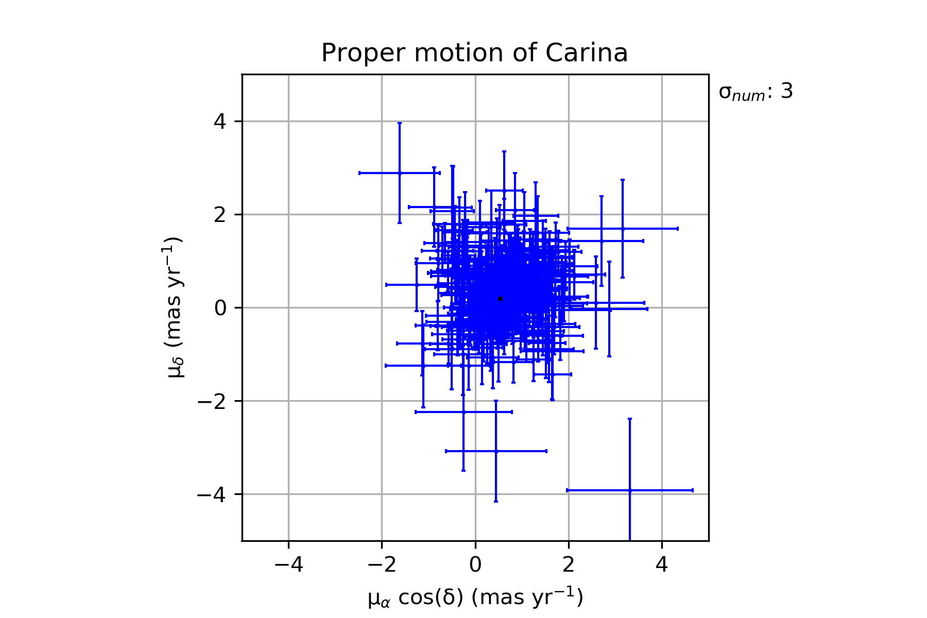

1b.)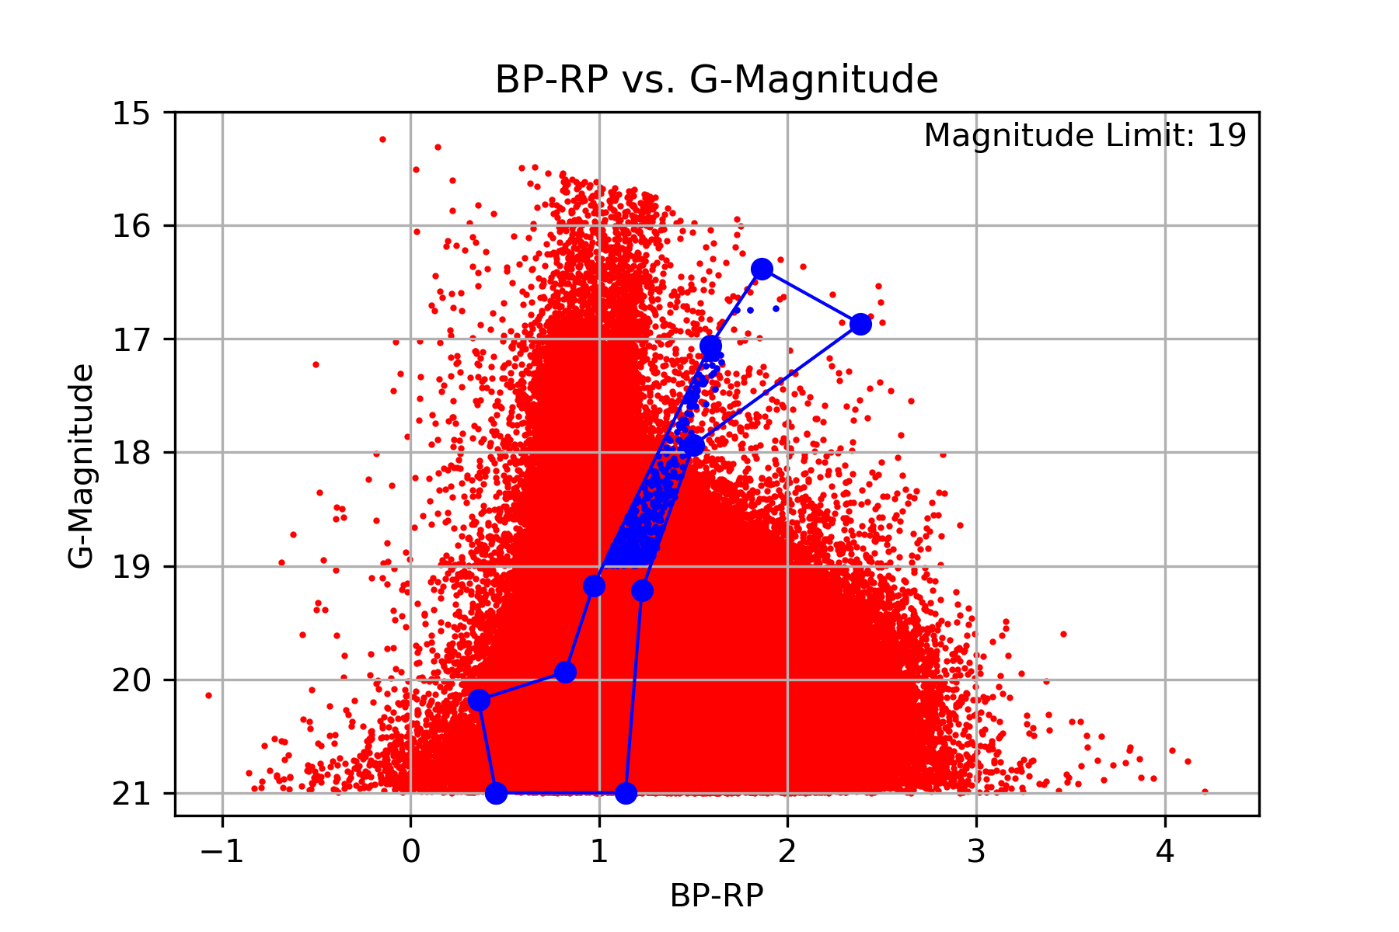

1c.)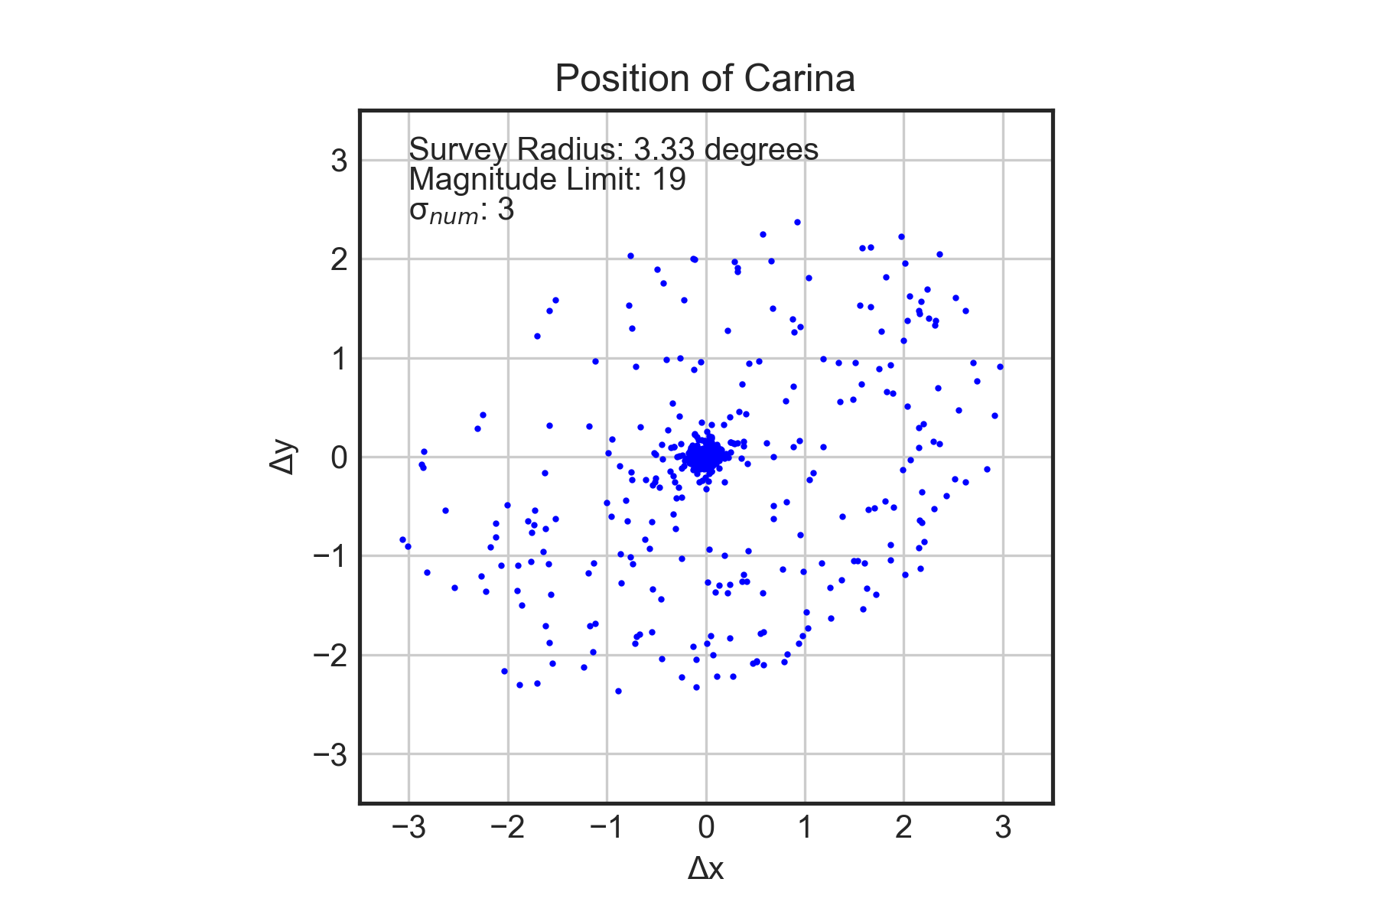

1d.)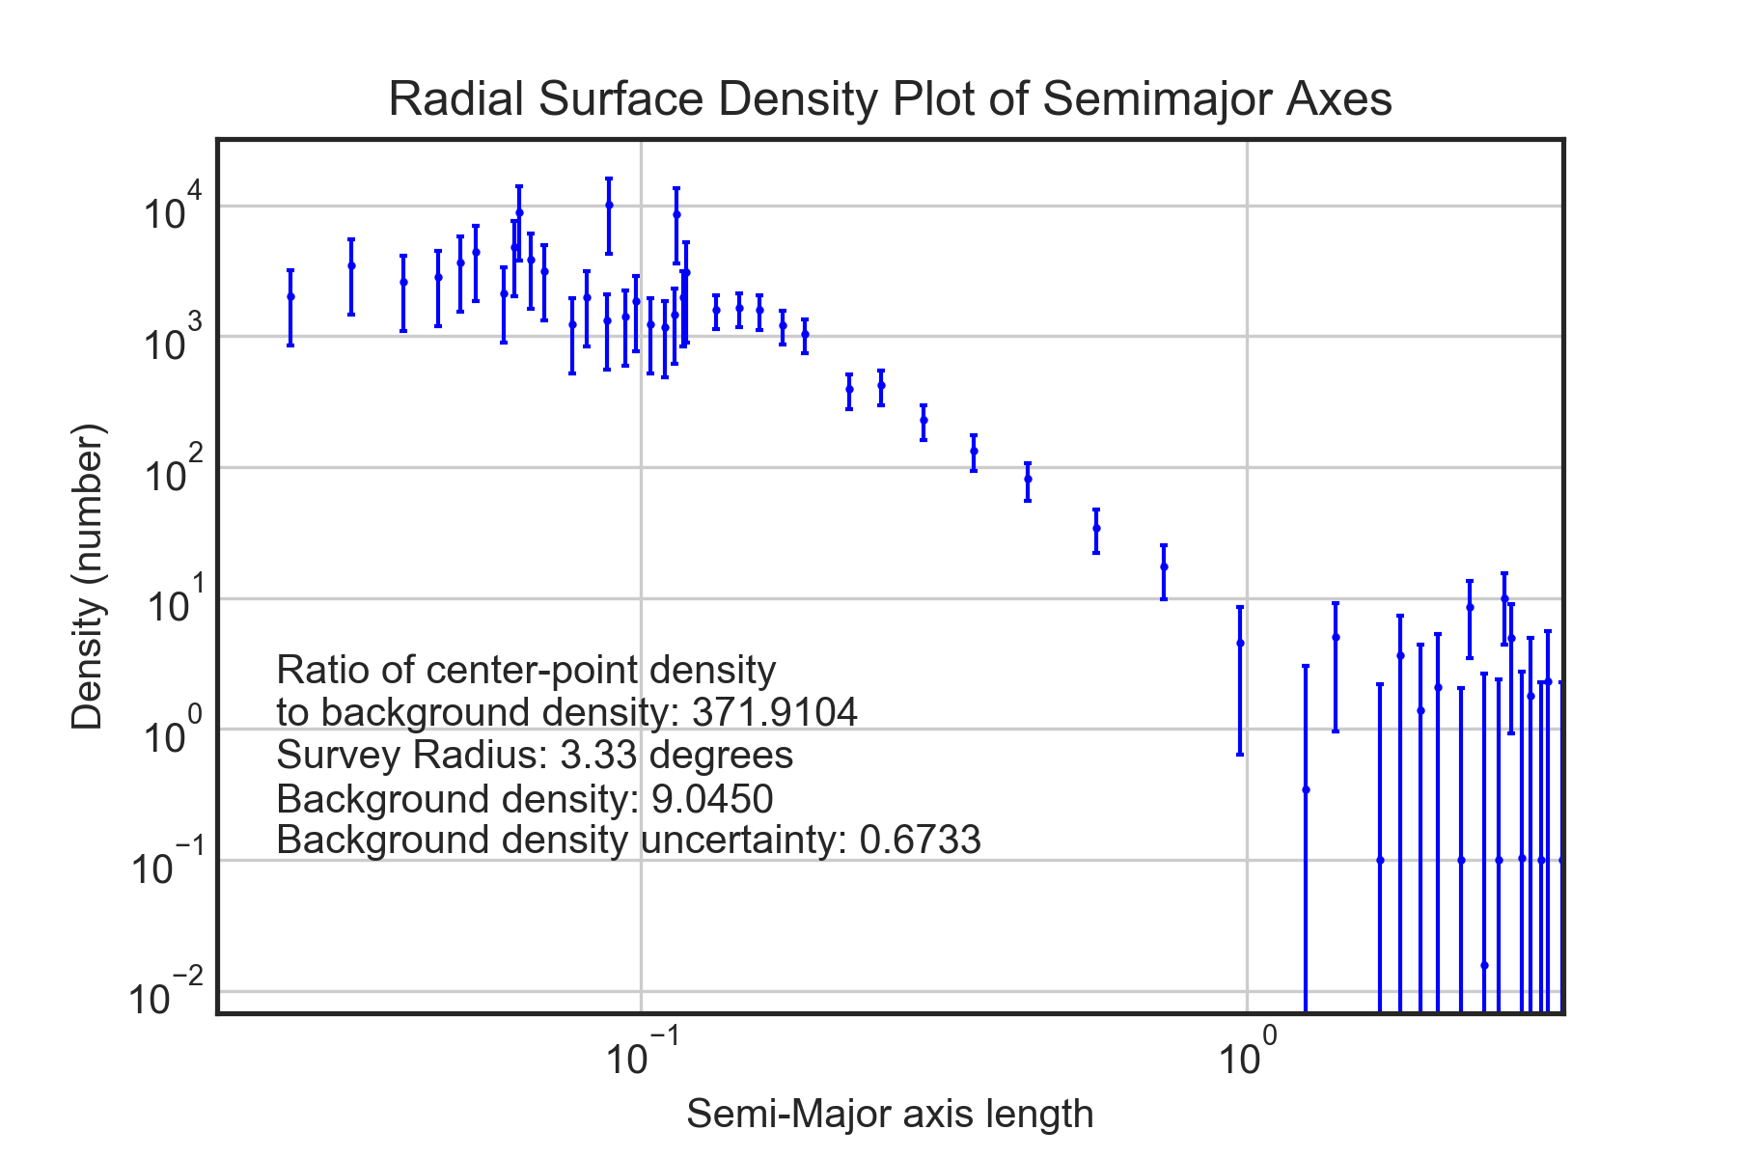

1e.)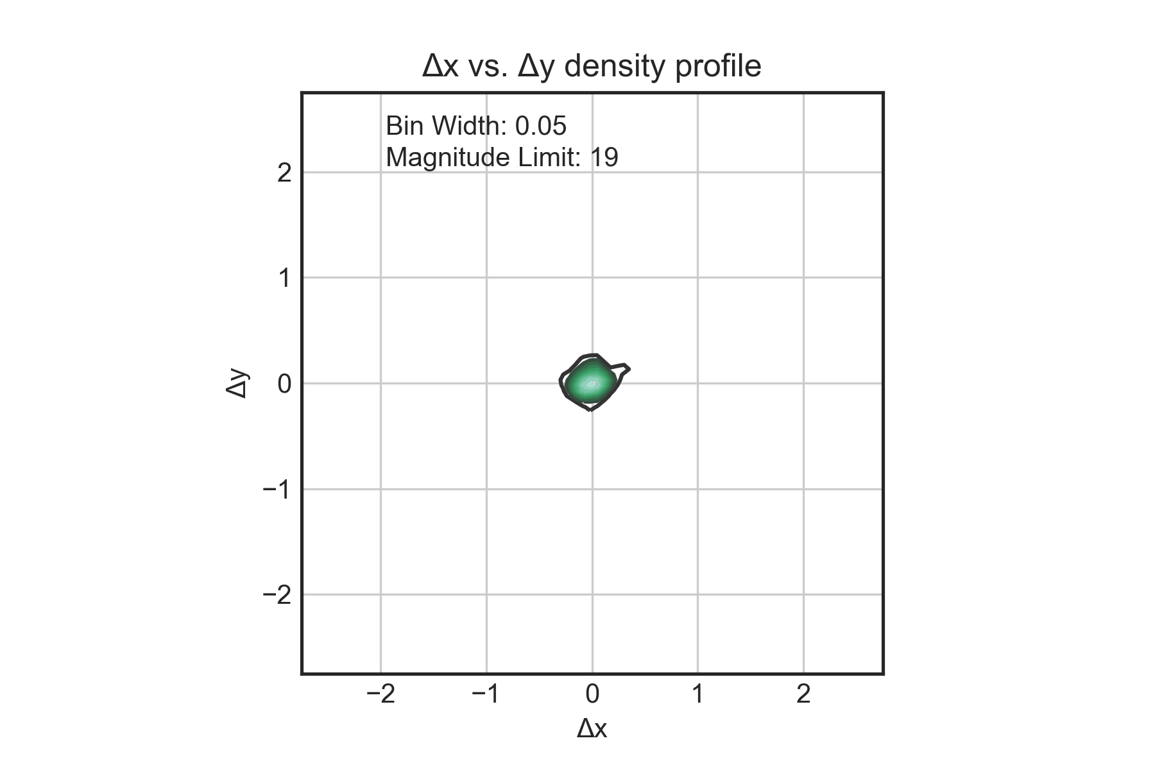

1f.)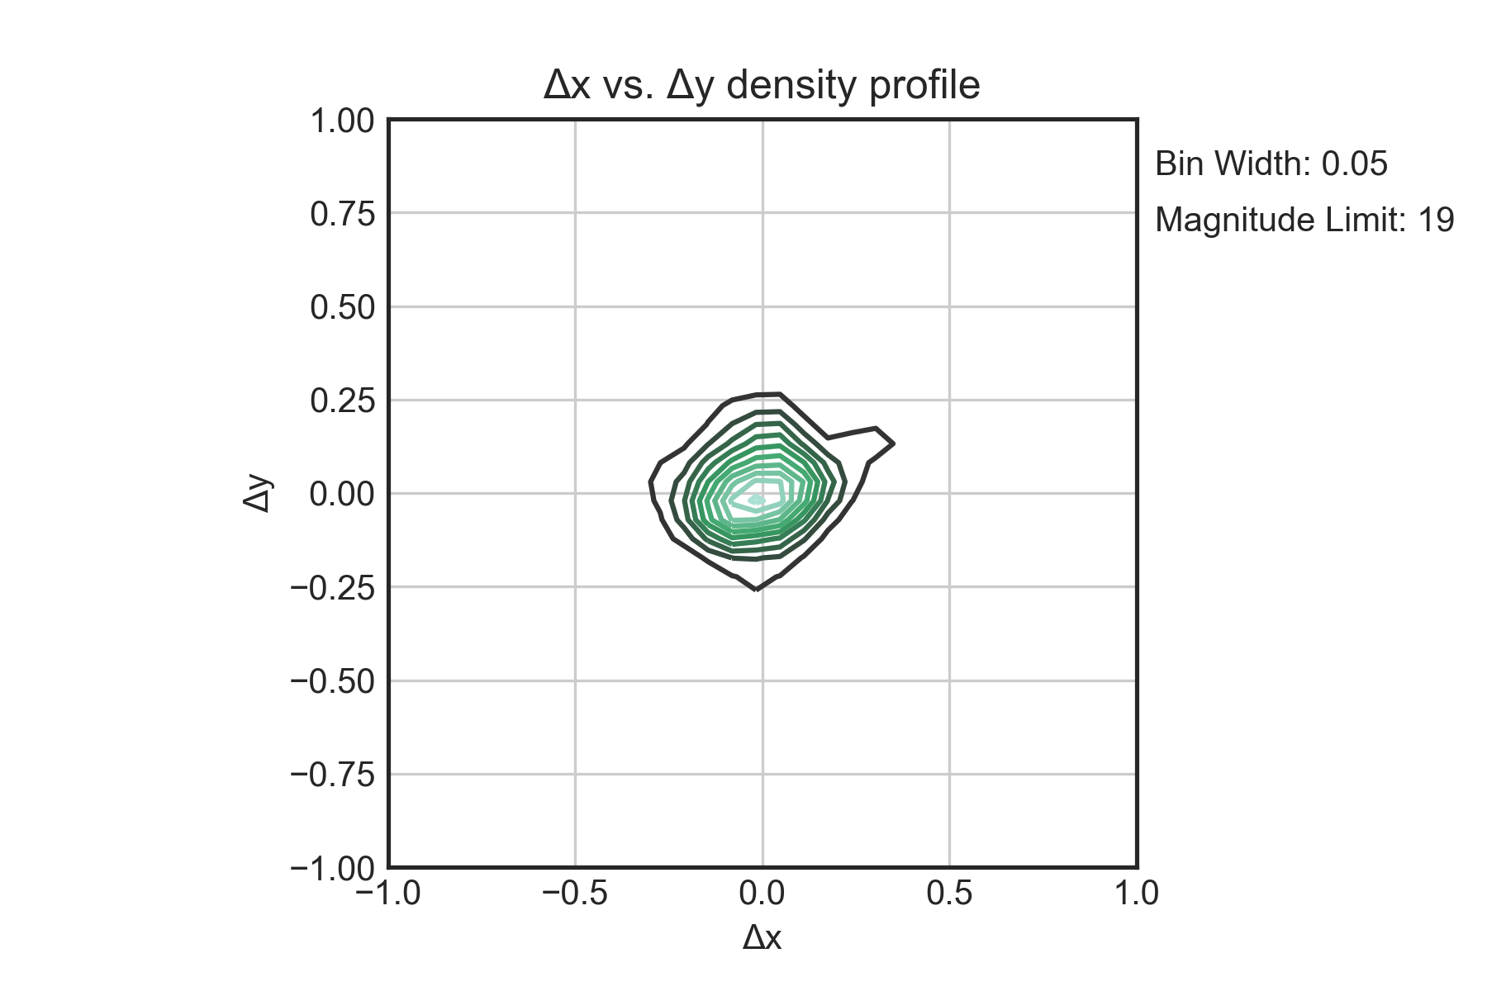

2a.)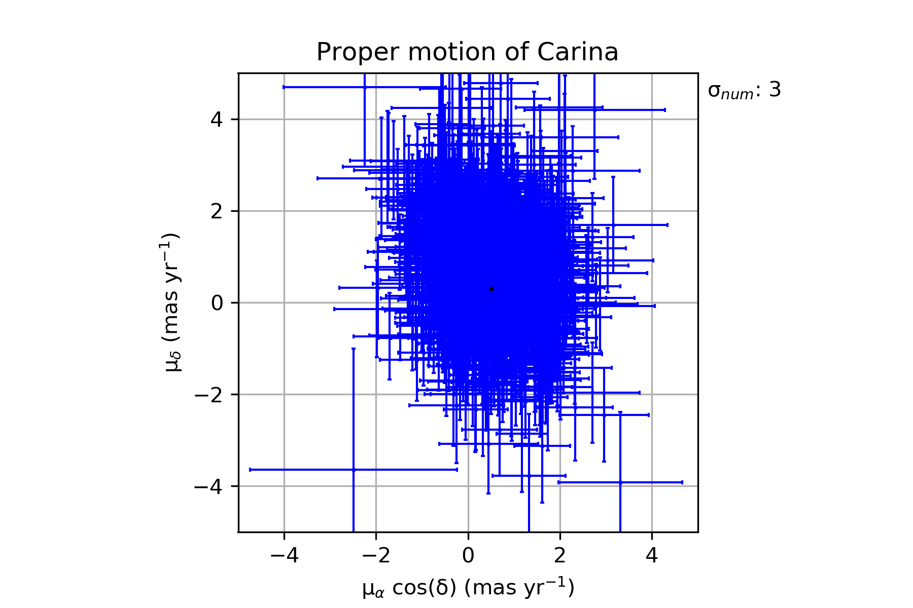

2b.)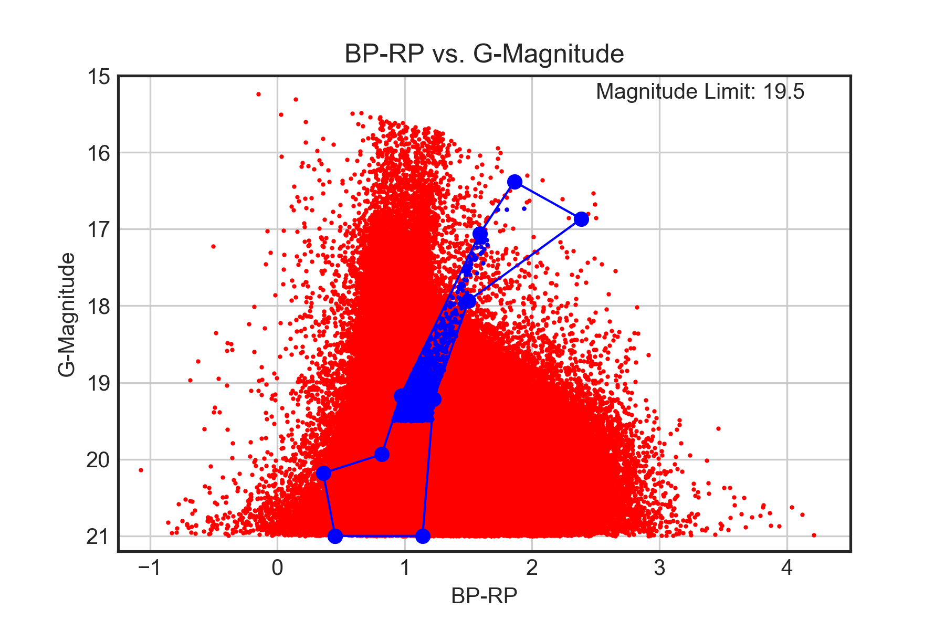

2c.)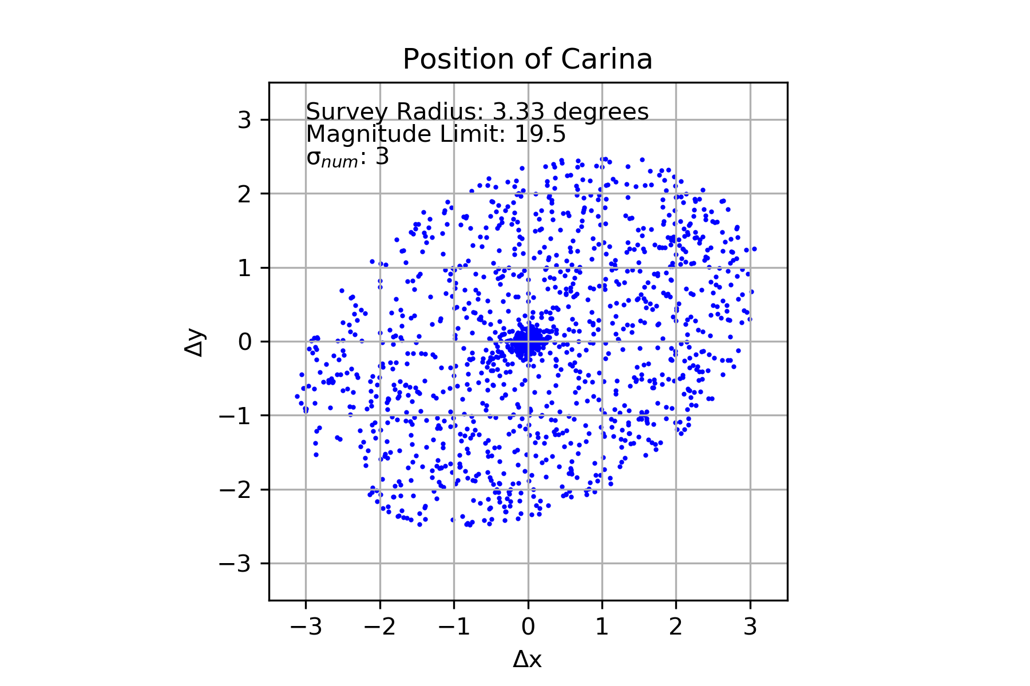

2d.)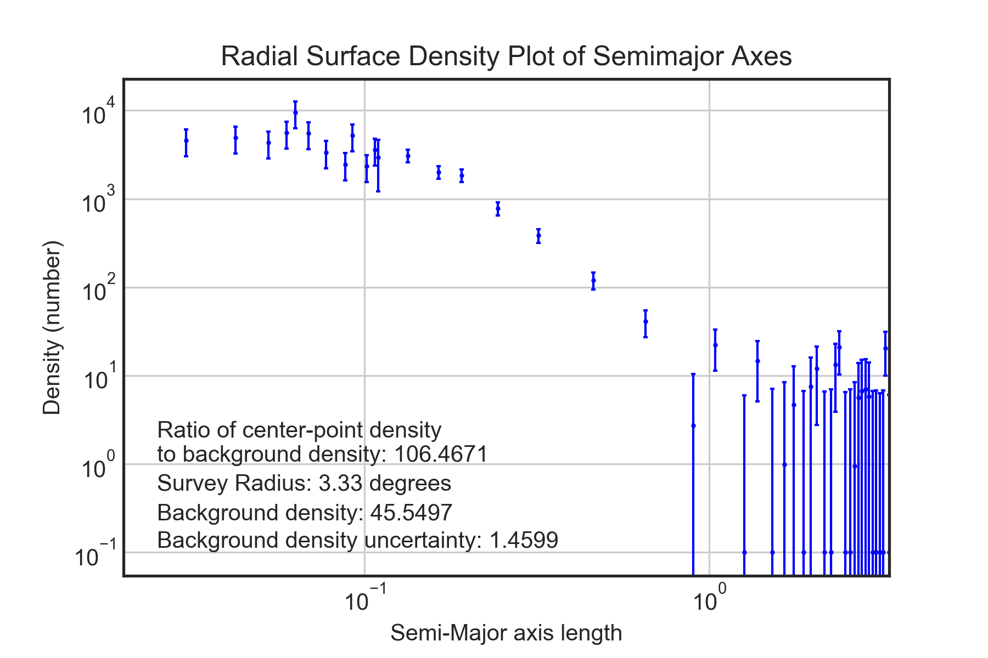

2e.)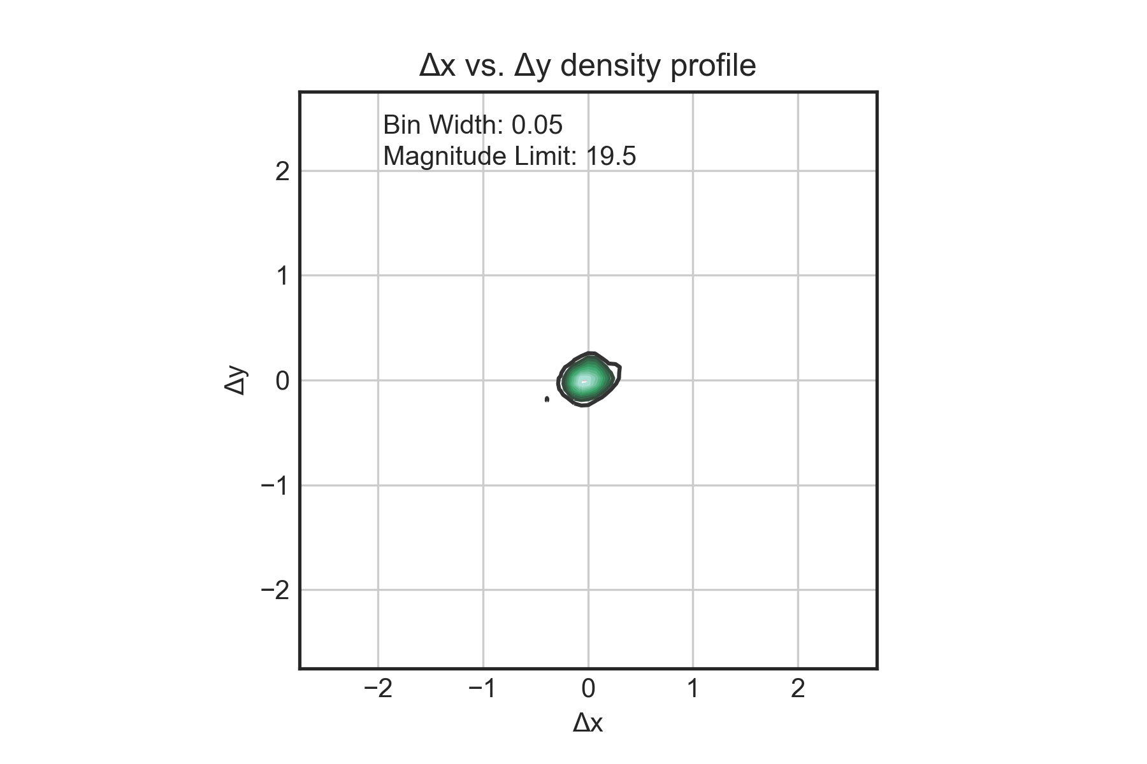

2f.)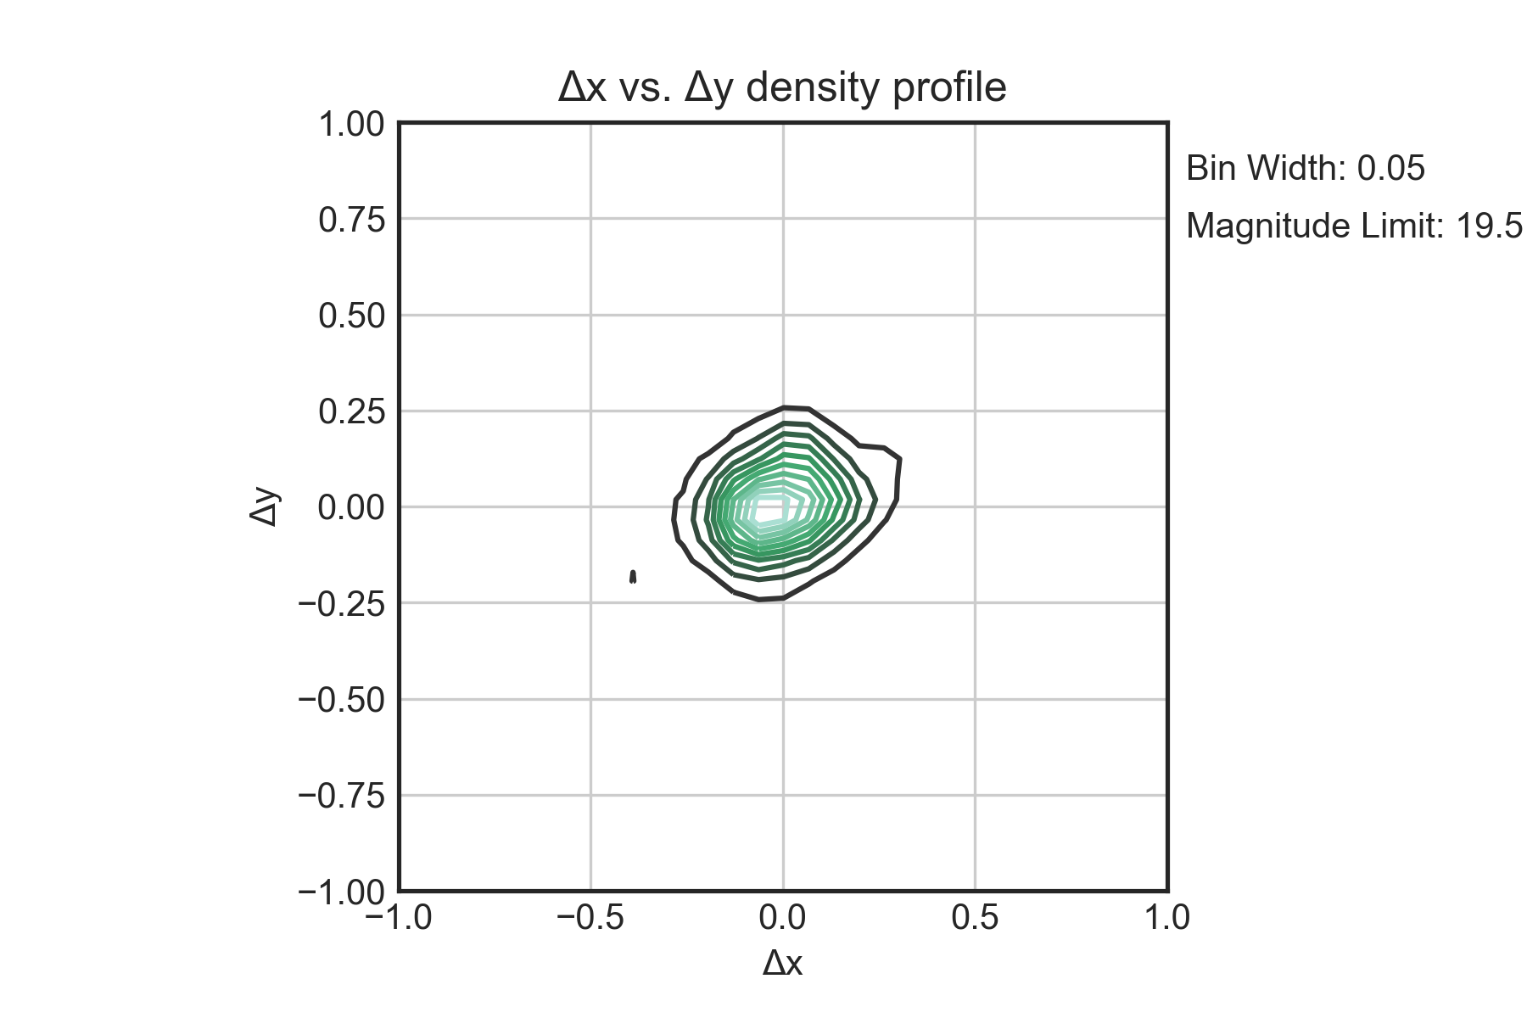

3a.)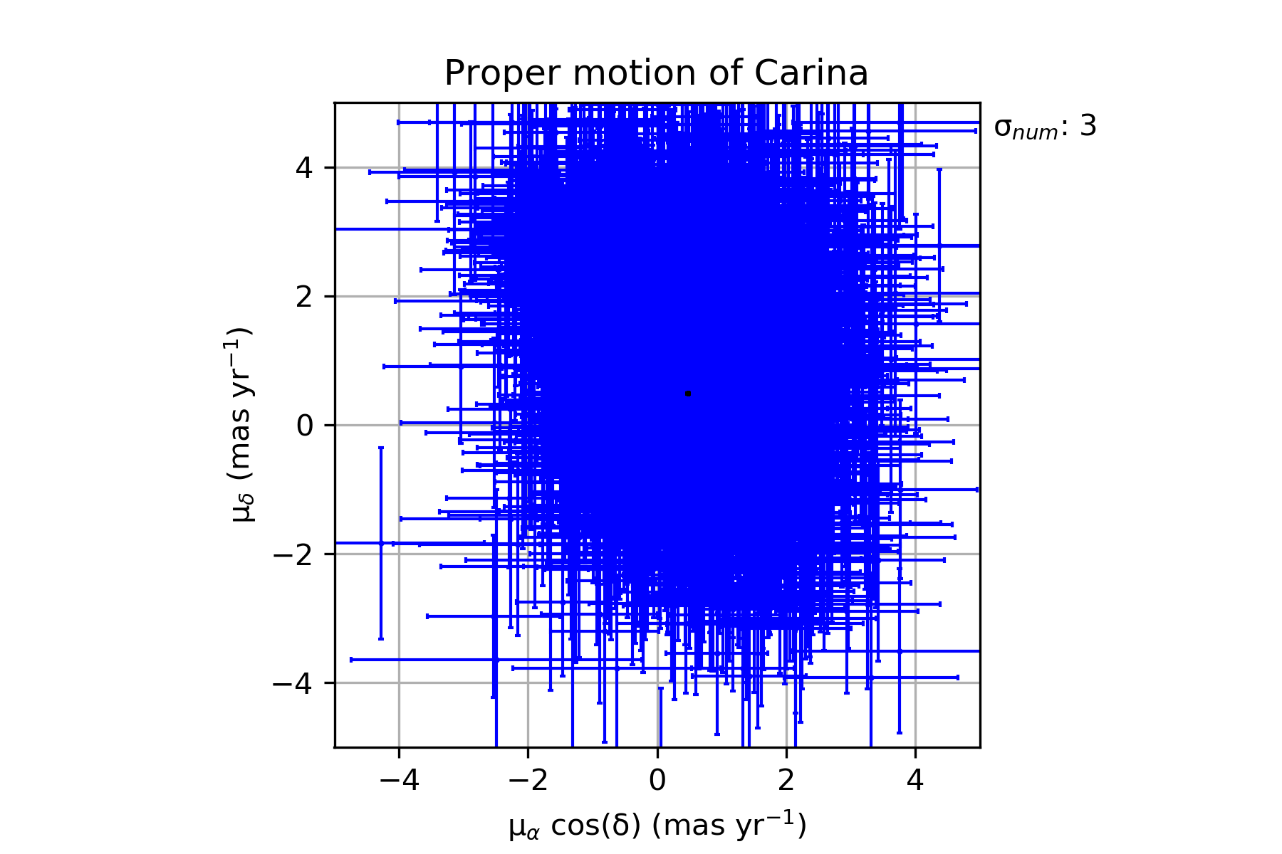

3b.)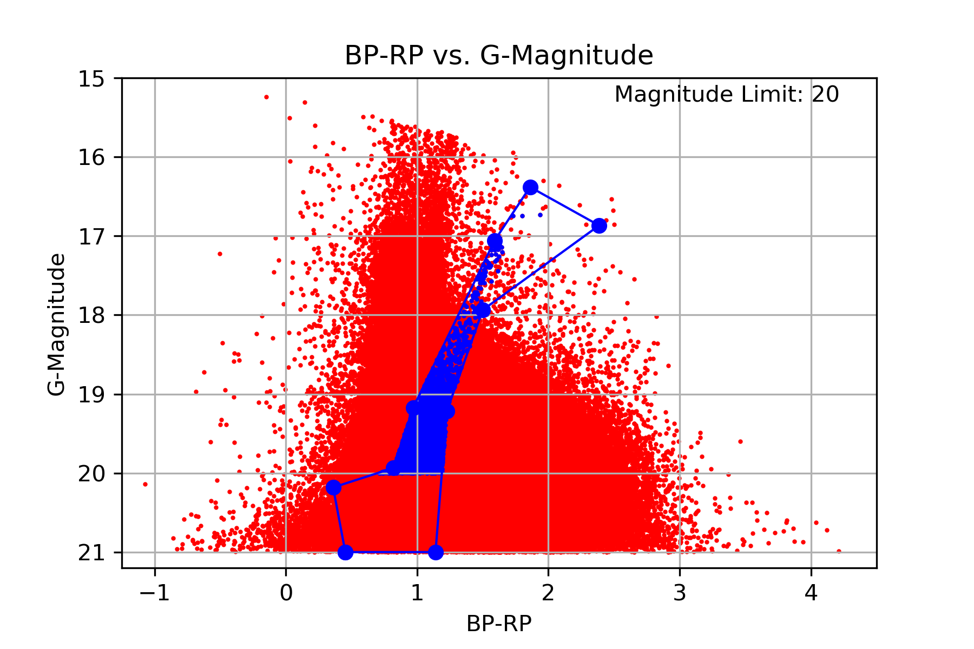

3c.)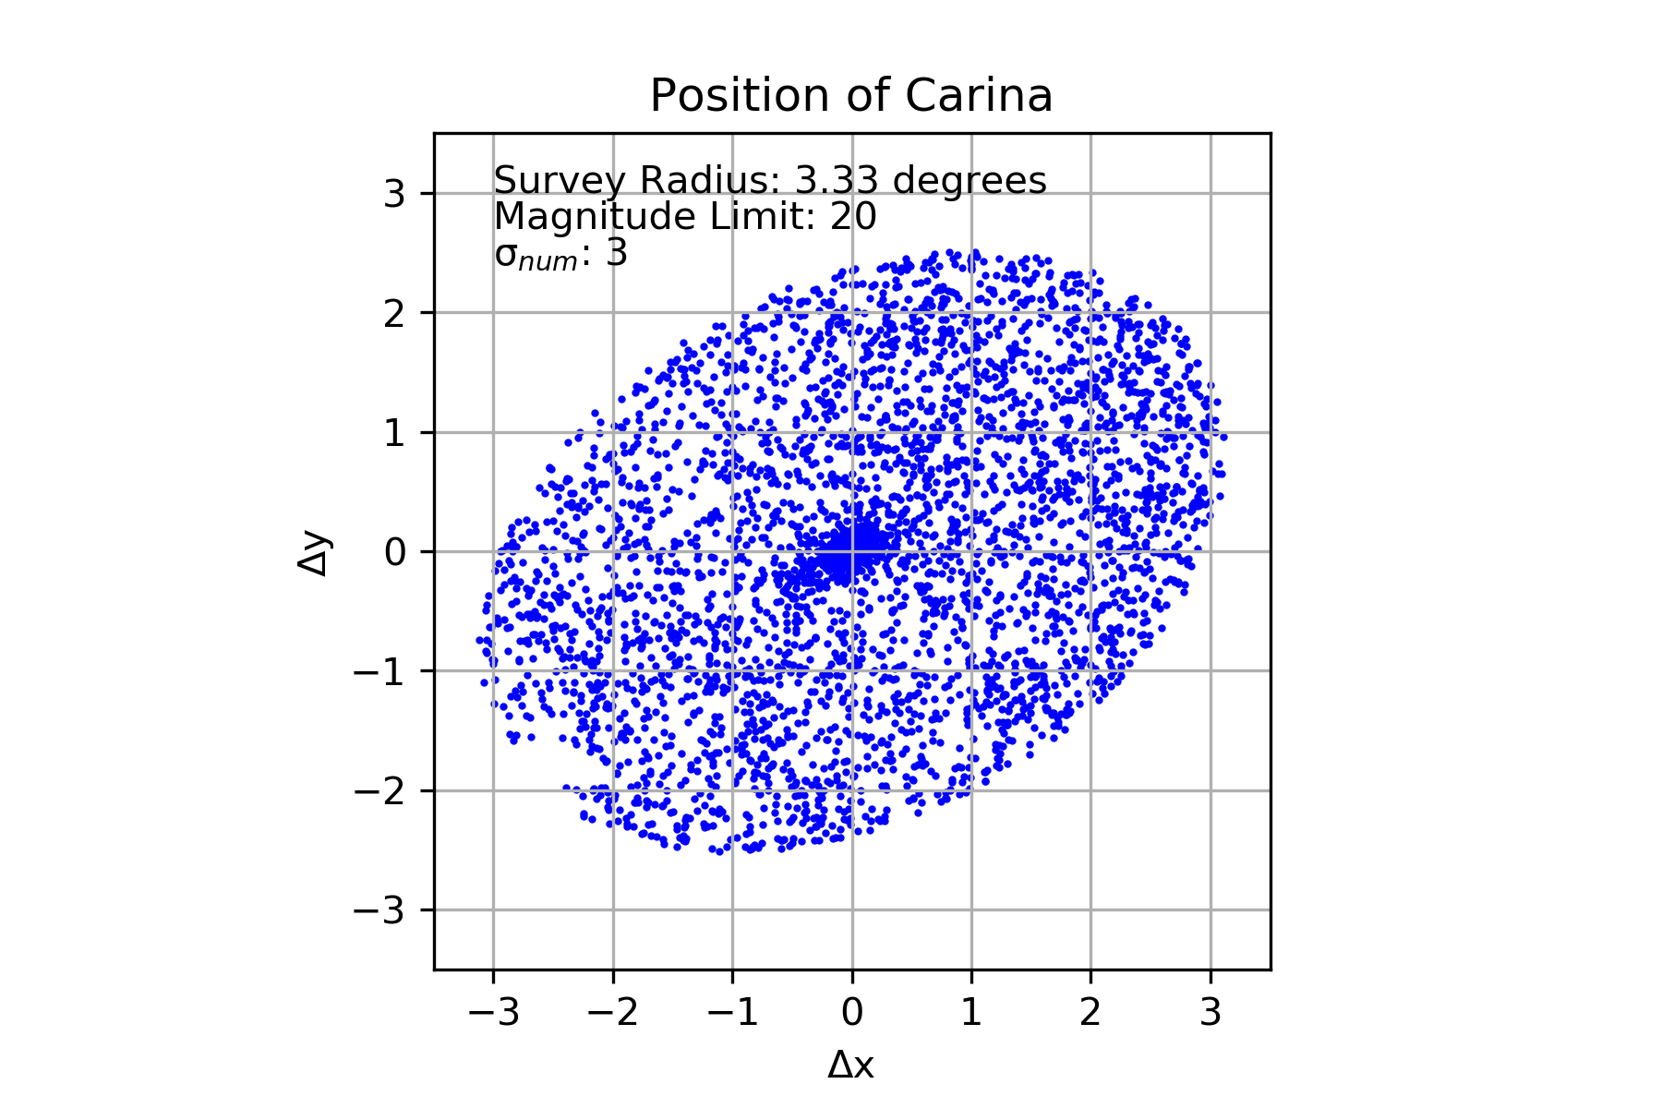

3d.)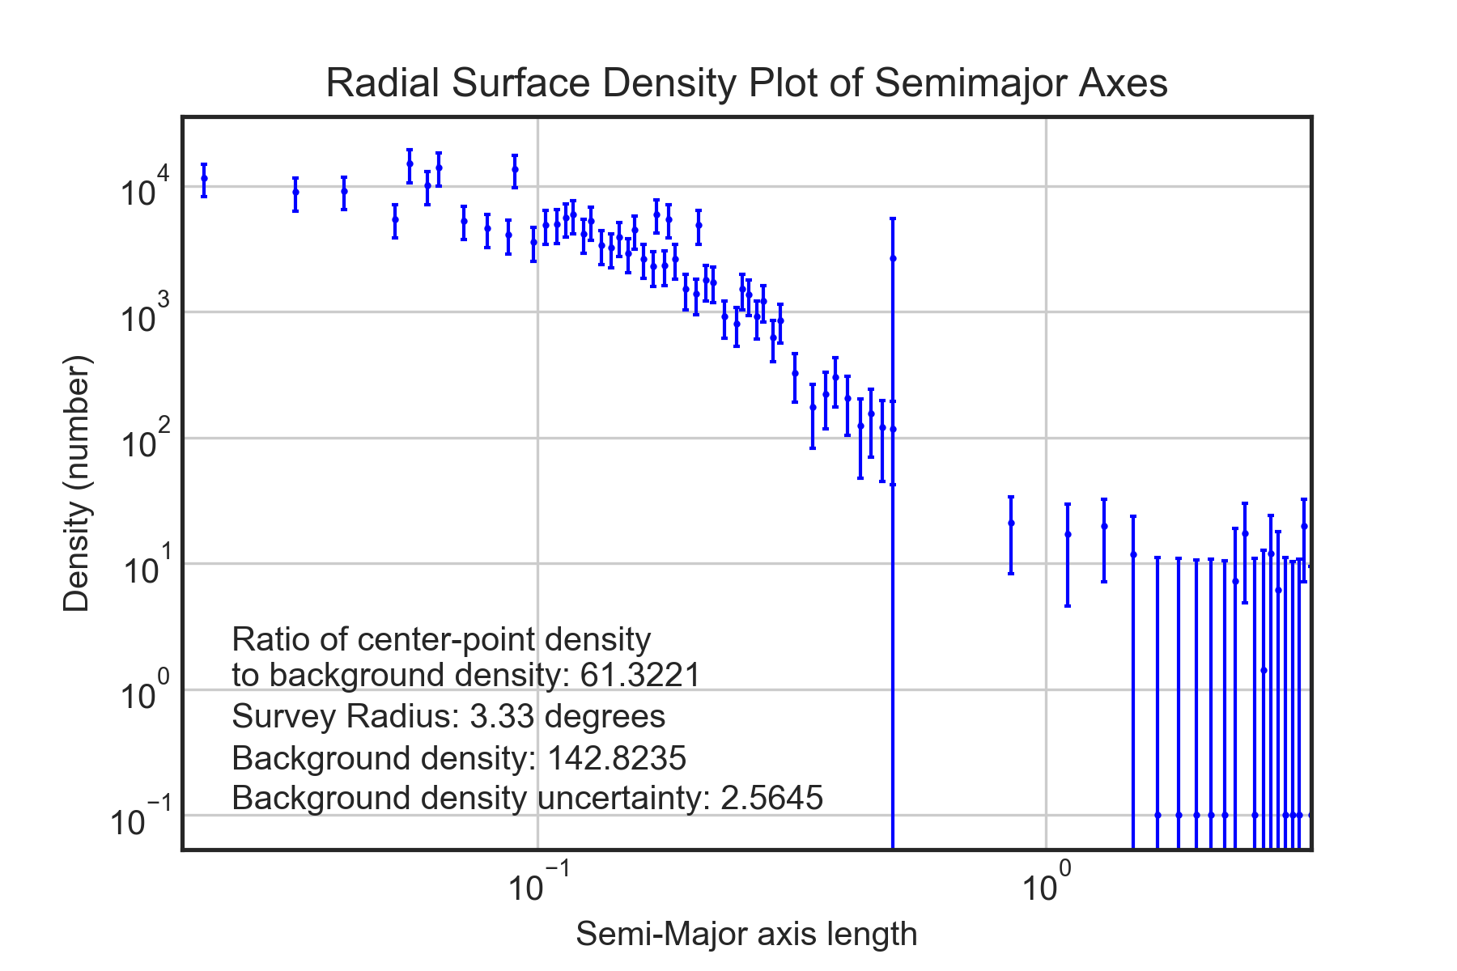

3e.)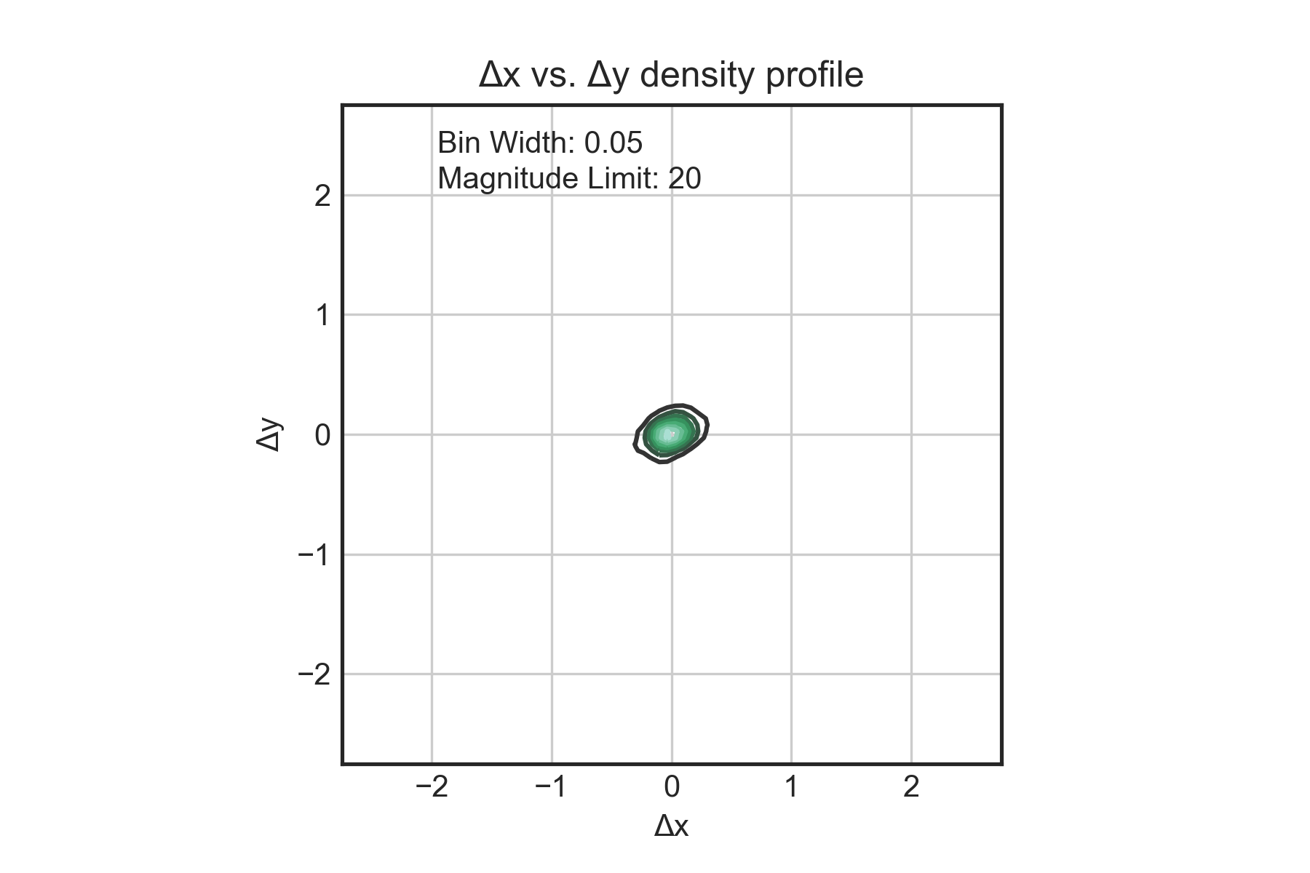

3f.)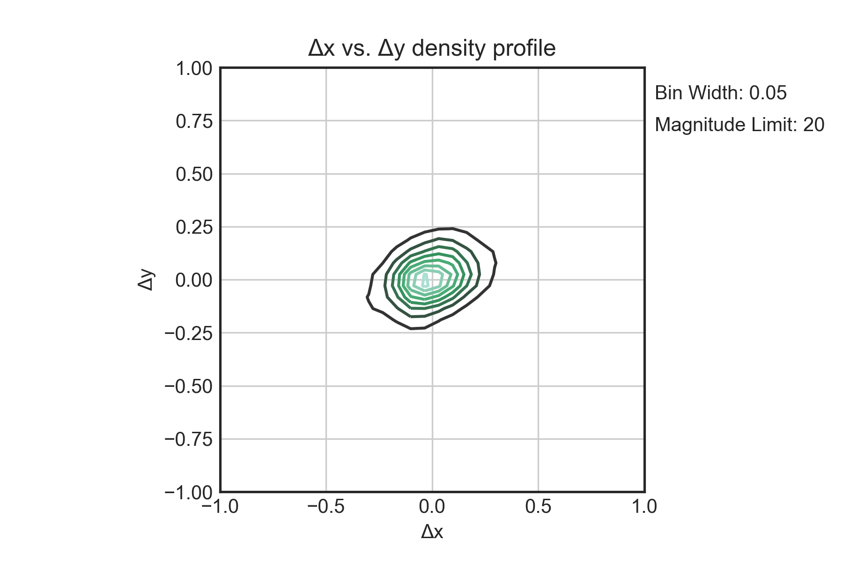

4a.)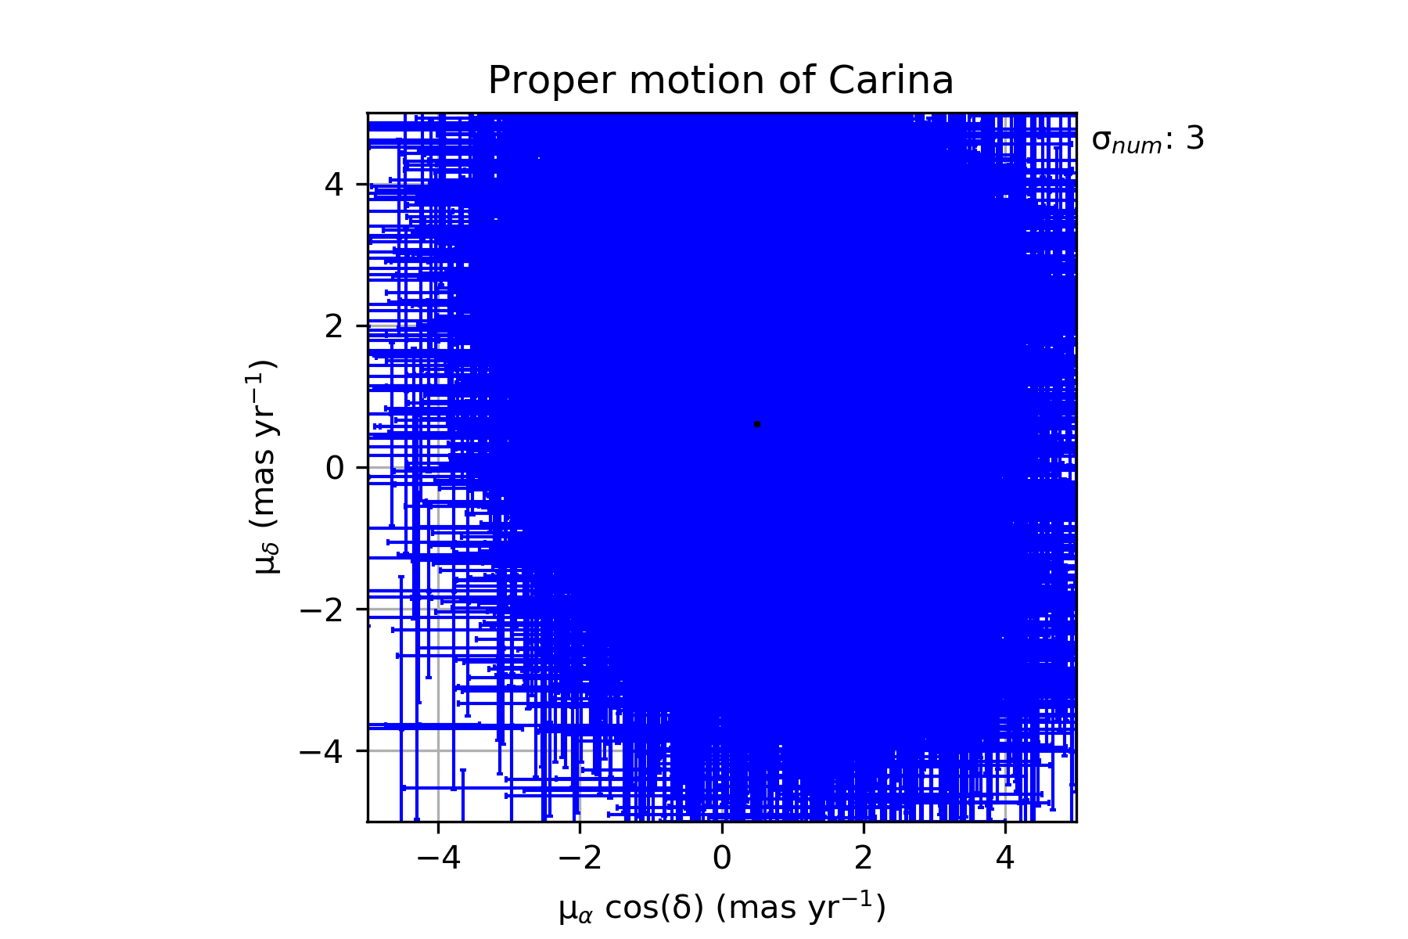

4b.)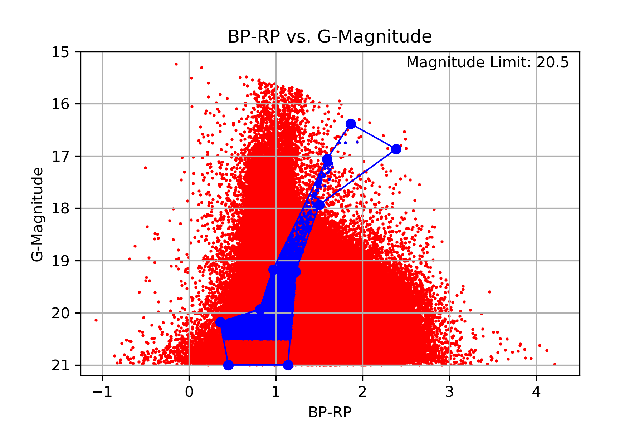

4c.)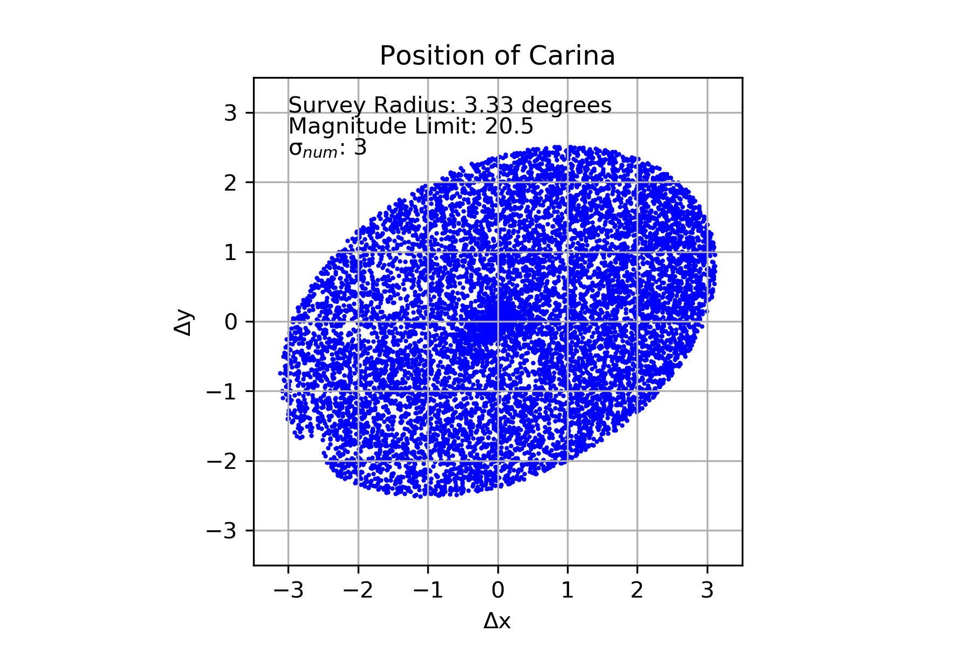

4d.)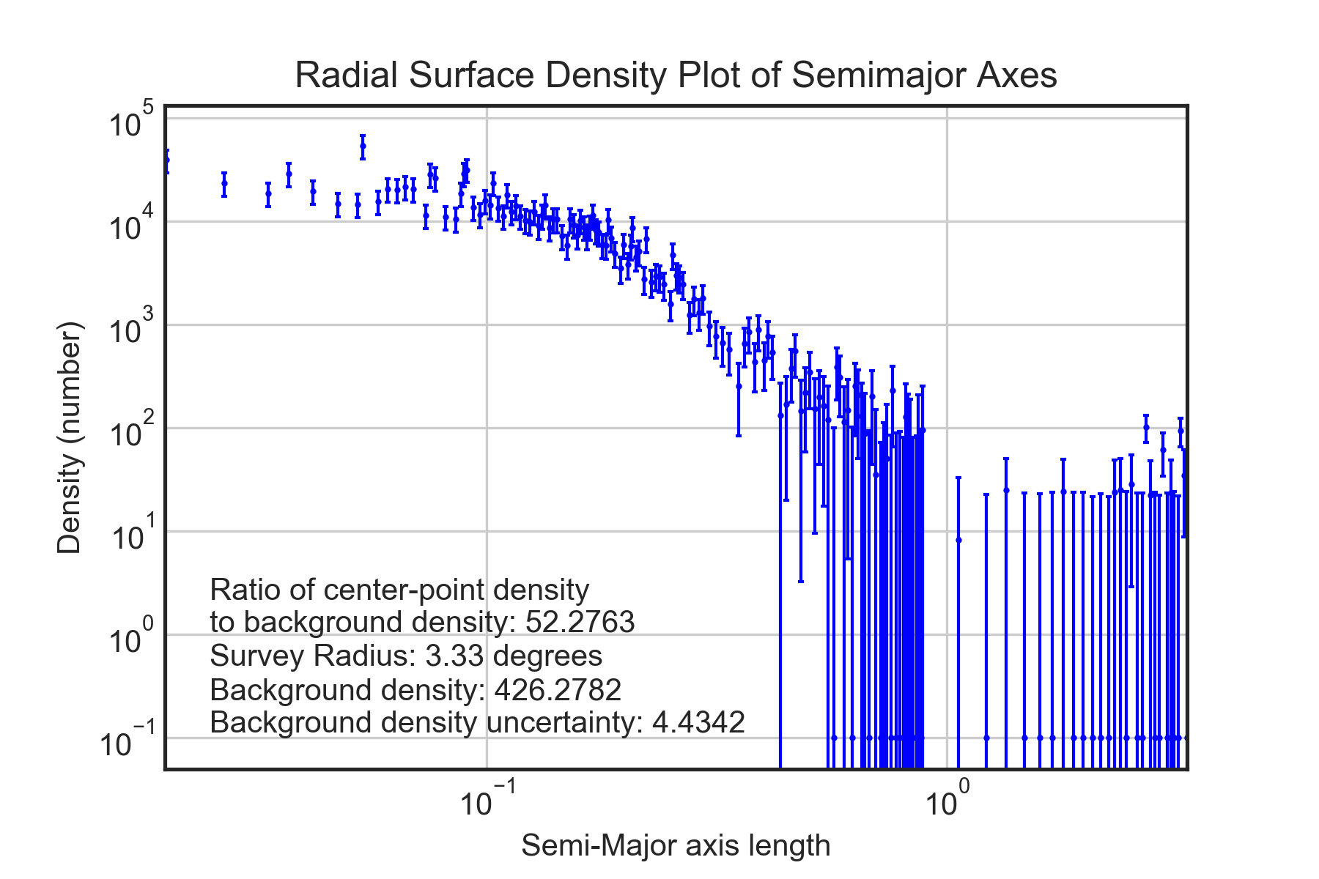

4e.)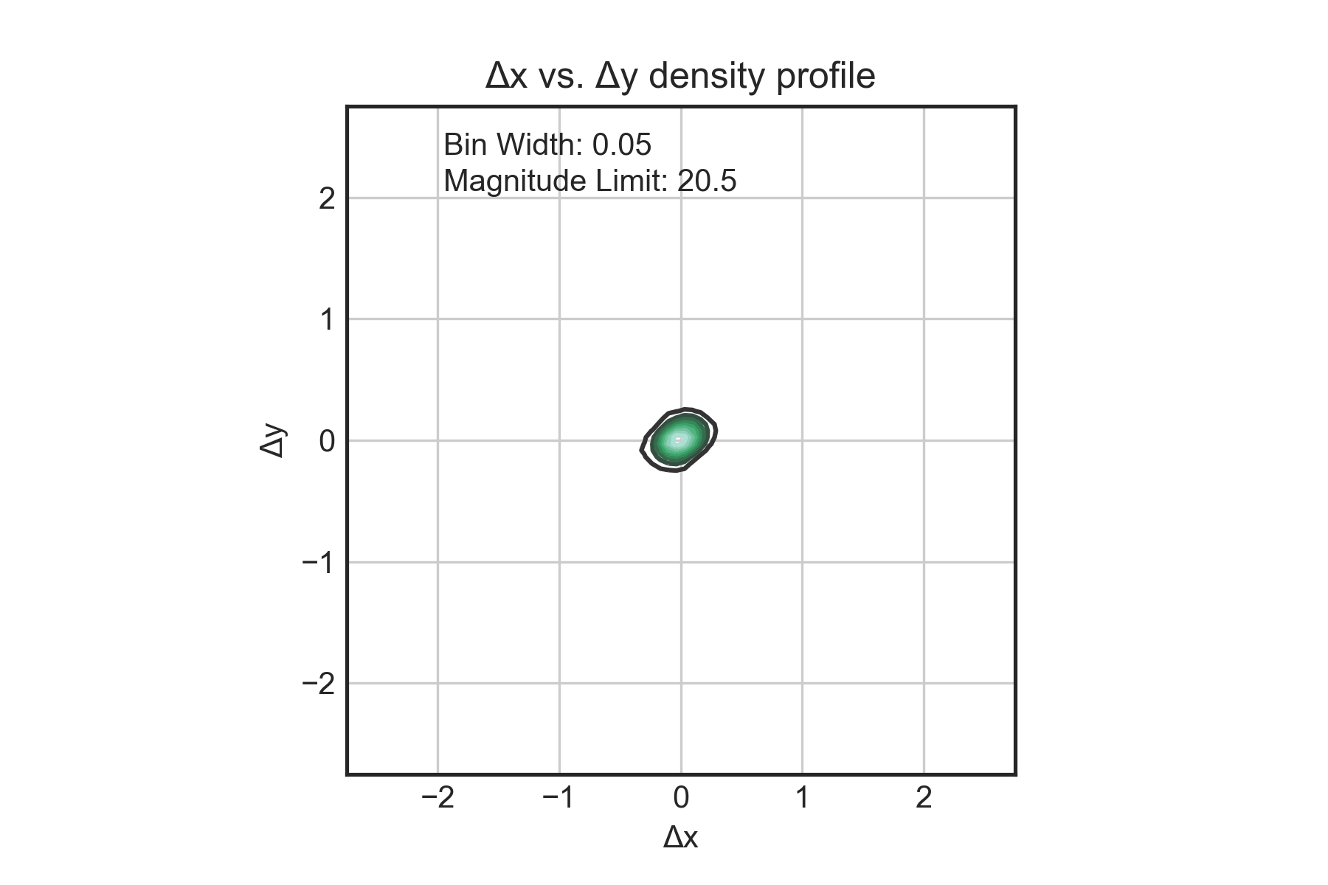

4f.)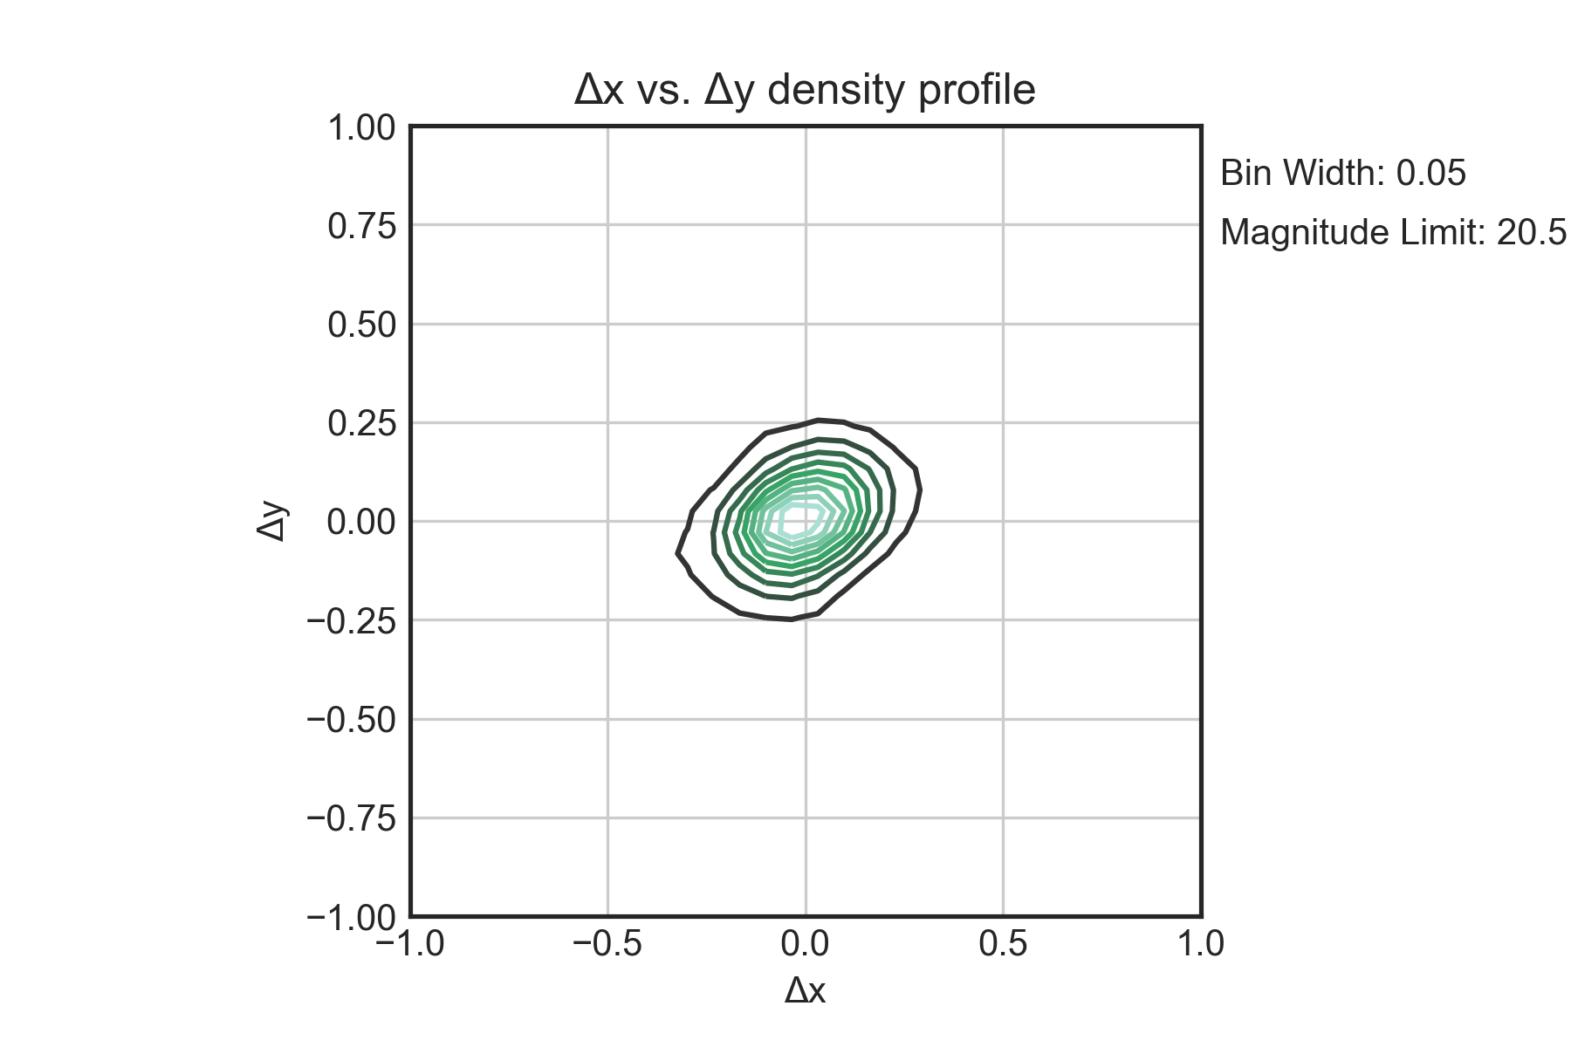

5a.)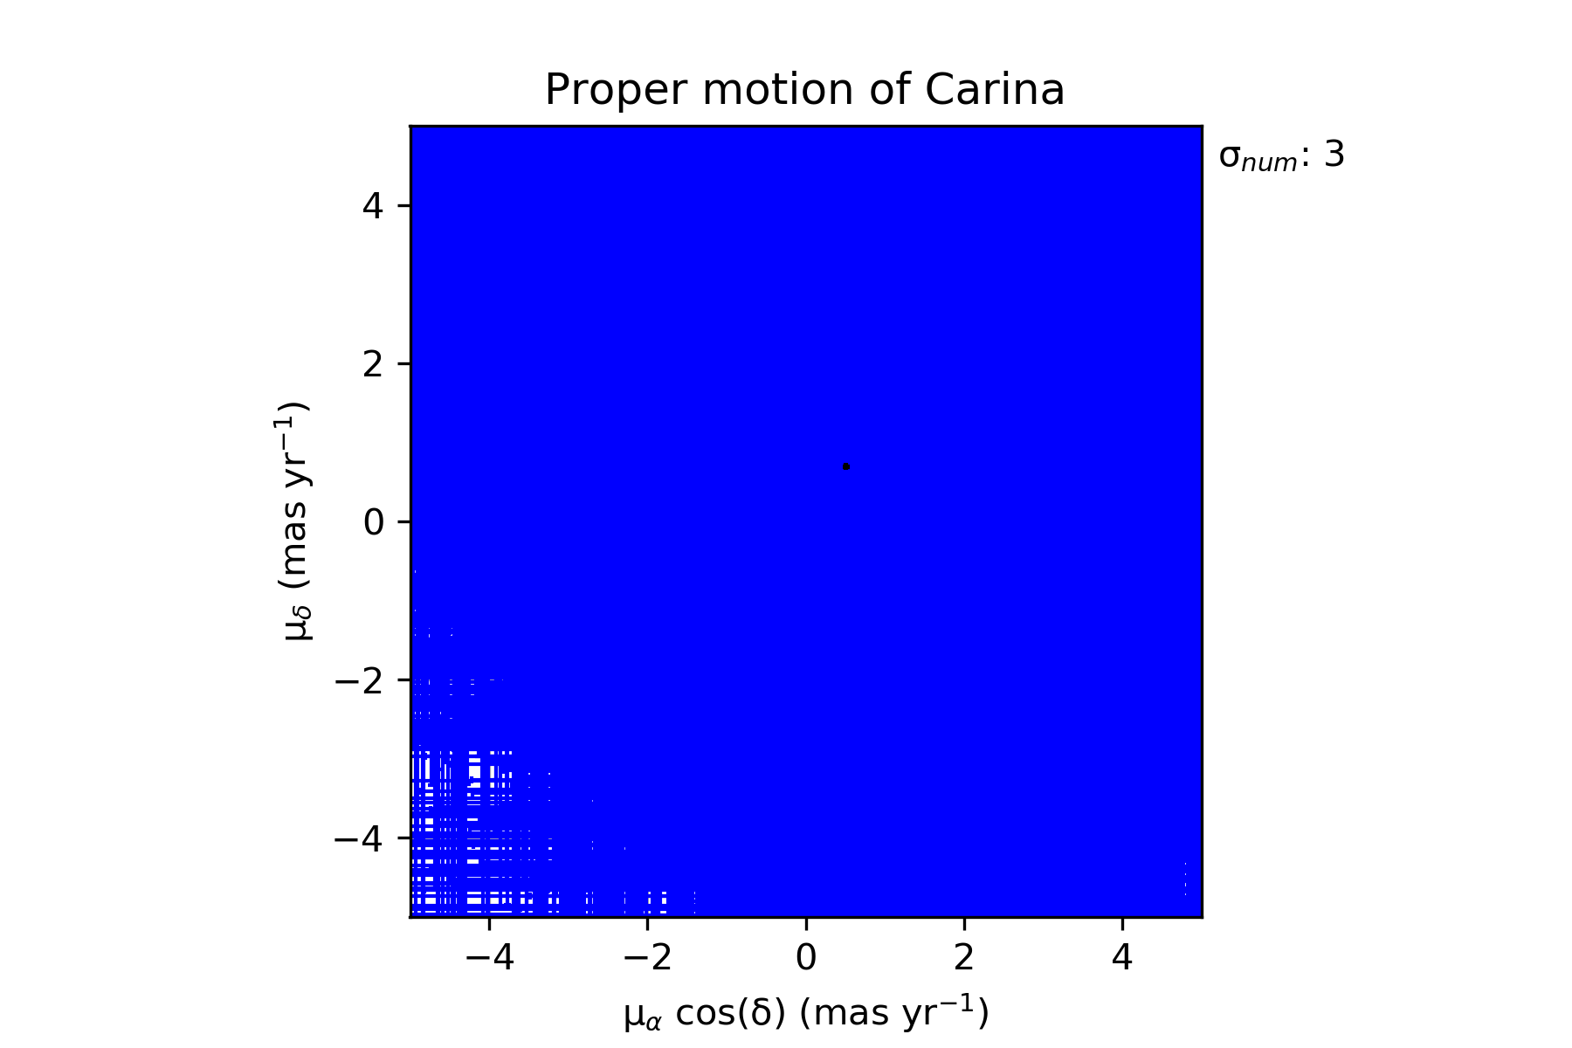

5b.)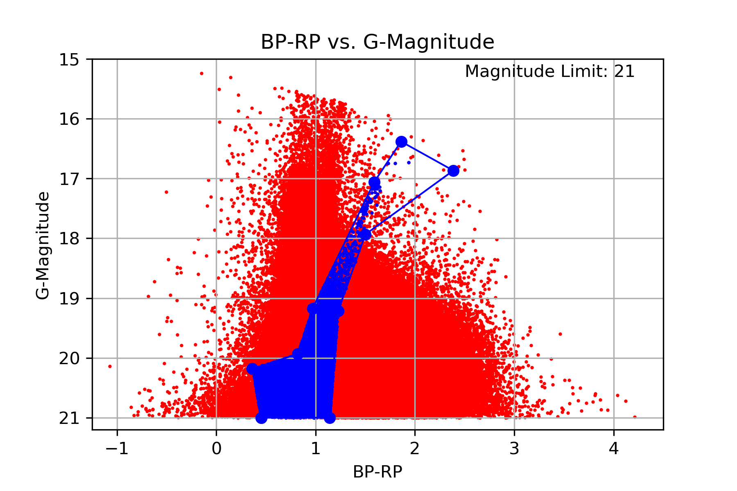

5c.)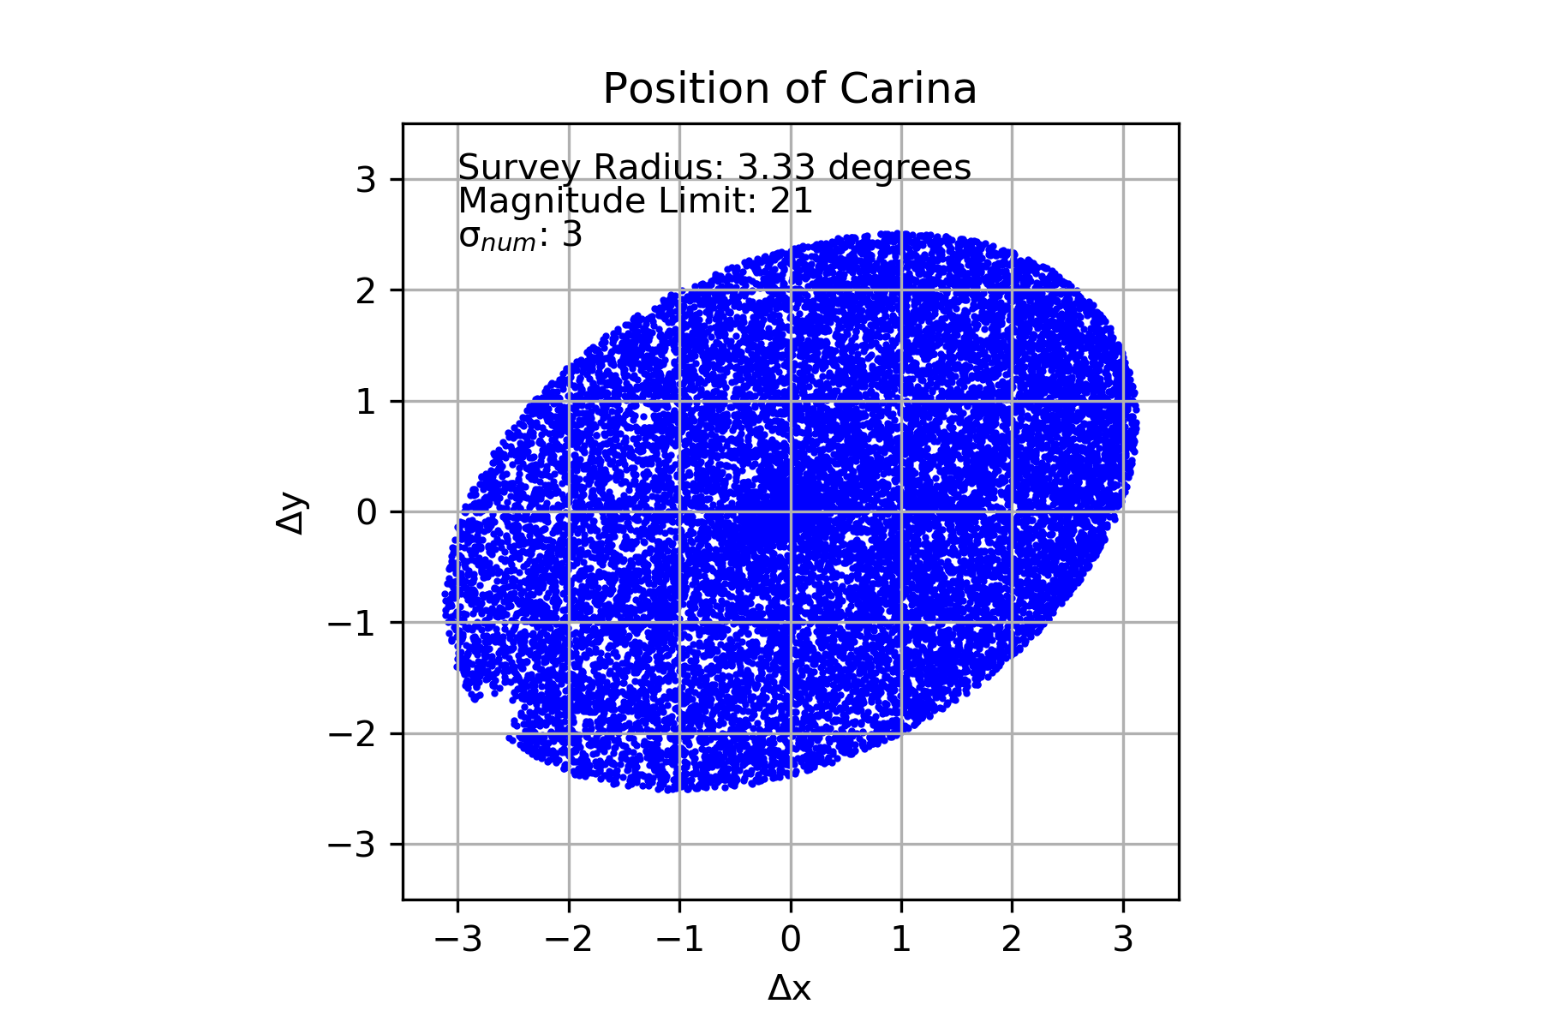

5d.)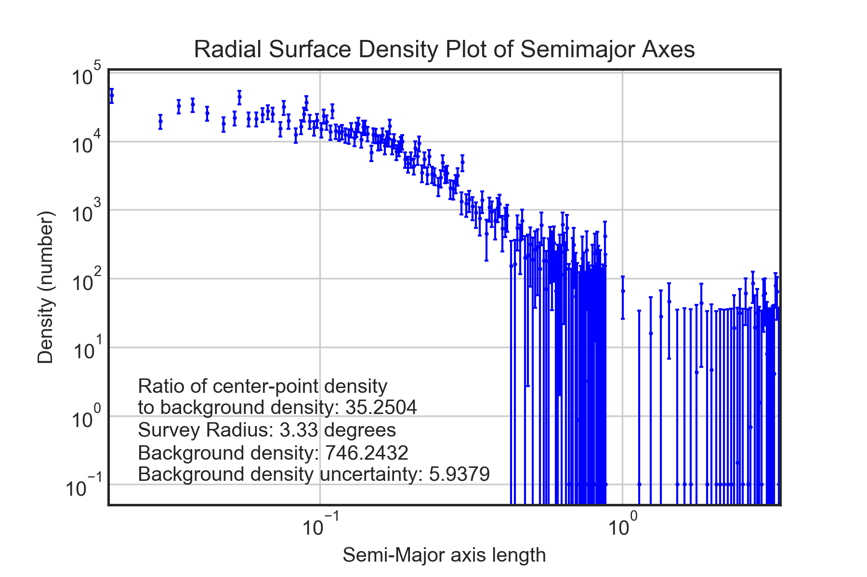

5e.)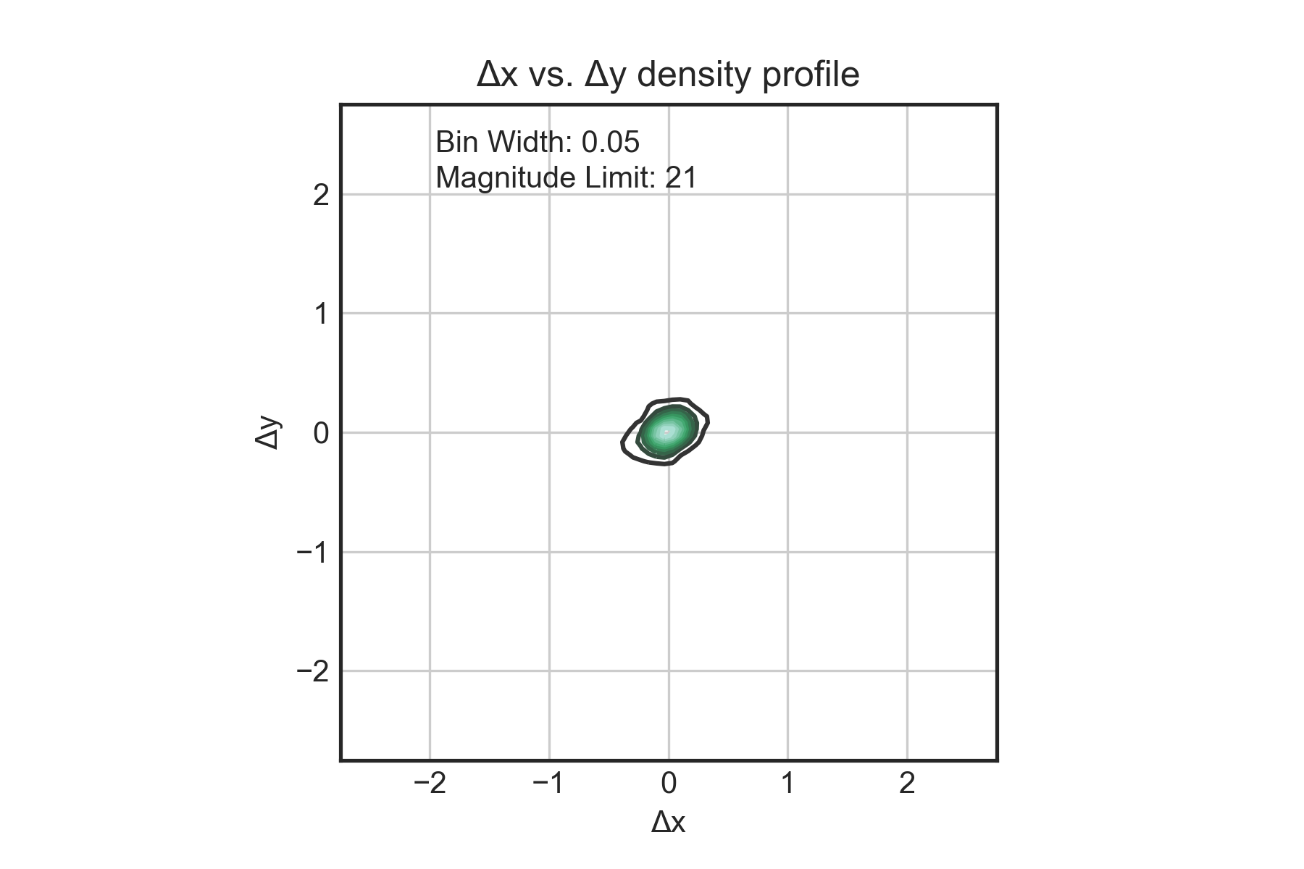

5f.)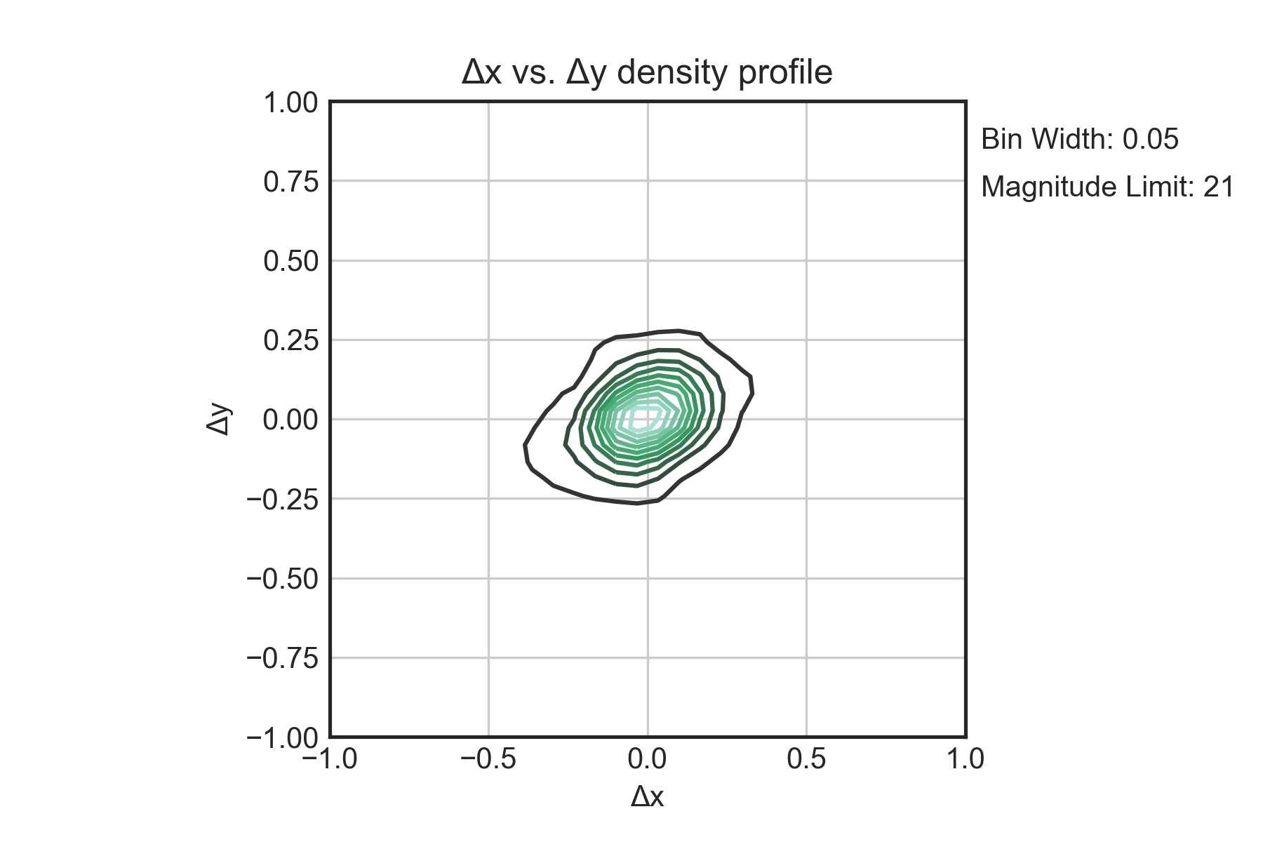

1. *Gaia* Collaboration A. A. 2018
2. McConnachie, A. W. 2012, AJ, 144, 4