public class Main{
public static void main(String[] aStrings){
// #1
String name = "SEAN Manutnithya";
System.out.println("Hello " + name);
displayP(aStrings);
displayShapeA(aStrings);
displayShapeB(aStrings);
displayC(aStrings);
tableA(aStrings);
tableB(aStrings);
System.out.print("Text length is: " + textLen(aStrings));
System.out.print("Result: " + cutText(aStrings));
findVowelIdx(aStrings);
textCompare(aStrings);
textContain(aStrings);
Student std1 = new Student(0002, "Makara", 'F', 17, 88.3, 4);
Student std2 = new Student(0001, "Tola", 'M', 15, 98.3, 3);
std1.display();
std2.display();
}
output: Hello SEAN Manutnithya
// #2
public static void displayP(String[] aStrings){
System.out.println("\n Line break");
System.out.println("\t Tabulation");
System.out.println("\' Single Quote");
System.out.println("\" Double Quote");
System.out.println("\\ \\Sign");
System.out.println("\\\\ \\\\Sign");
System.out.println("// Line command");
System.out.println("/*...*/ Block command");
System.out.println("\"\"\" \n \"\"\" text block");

}
output:

Line break
Tabulation
' Single Quote
" Double Quote
\ \Sign
\\ \\Sign
// Line command
/*...*/ Block command
"""
""" text block

// #3
public static void displayShapeA(String[] asStrings){
String str = "*";
int extraSt = 0;
for(int i = 21; i > 0;i-=2){
String repeat = str.repeat(i);
System.out.println(" ".repeat(extraSt++) + repeat);
}
}
public static void displayShapeB(String[] aStrings){
int len = 17;
int height = 10;
String str = "*";
String strLen = "\n*\t\t*";
System.out.print(str.repeat(len));
System.out.print(strLen.repeat(height));
System.out.print("\n" + str.repeat(len));
}
public static void displayC(String[] aStrings){
for(int r = 0; r < 5; r++){
for(int c = 0; c < 5 ; c++){
System.out.print(r + c + 1 + " ");
}
System.out.println();
}
}
output:
*********************
*******************
*****************
***************
*************
***********
*********
*******
*****
***
*
**************
* *
* *
* *
* *
* *
* *
* *
* *
* *
* *
**************
1 2 3 4 5
2 3 4 5 6
3 4 5 6 7
4 5 6 7 8
5 6 7 8 9

// #4
public static void tableA(String[] aStrings){
System.out.print("\t |");
for(int row=1; row<=10;row++){
System.out.print("\t" + row + "|");
}
System.out.print("\n"+"-".repeat(90) + "\n");
// System.out.println();
int len = 0;
for(int row = 1; row <= 5; row++){
for(int col = 1; col <= 10; col++){
int num = row * col;
if(num < 10 && num % 10 != 0){
len = 1;
}
if(col == 1) System.out.print("\t" + row + "|");
if(len == 1){
System.out.print("\t" + " " + num + "|");
len = 0;
}else {
System.out.print("\t" + num + "|");
}
}
System.out.println();
}
}
public static void tableB(String[] aStrings){
System.out.print("""
+-----------------+-----------+---------------------+---------+
| Country | Name | Professoin | Age |
+-----------------+-----------+---------------------+---------+
| Germany | Micheal | Computer Engineer | 19 |
+-----------------+-----------+---------------------+---------+
| England | Robert | Artist | 34 |
+-----------------+-----------+---------------------+---------+
| United Kingdom | Julia | Designer | 42 |
+-----------------+-----------+---------------------+---------+
| United State | Jo | Actor | 21 |
+-----------------+-----------+---------------------+---------+
""" );

}
output:
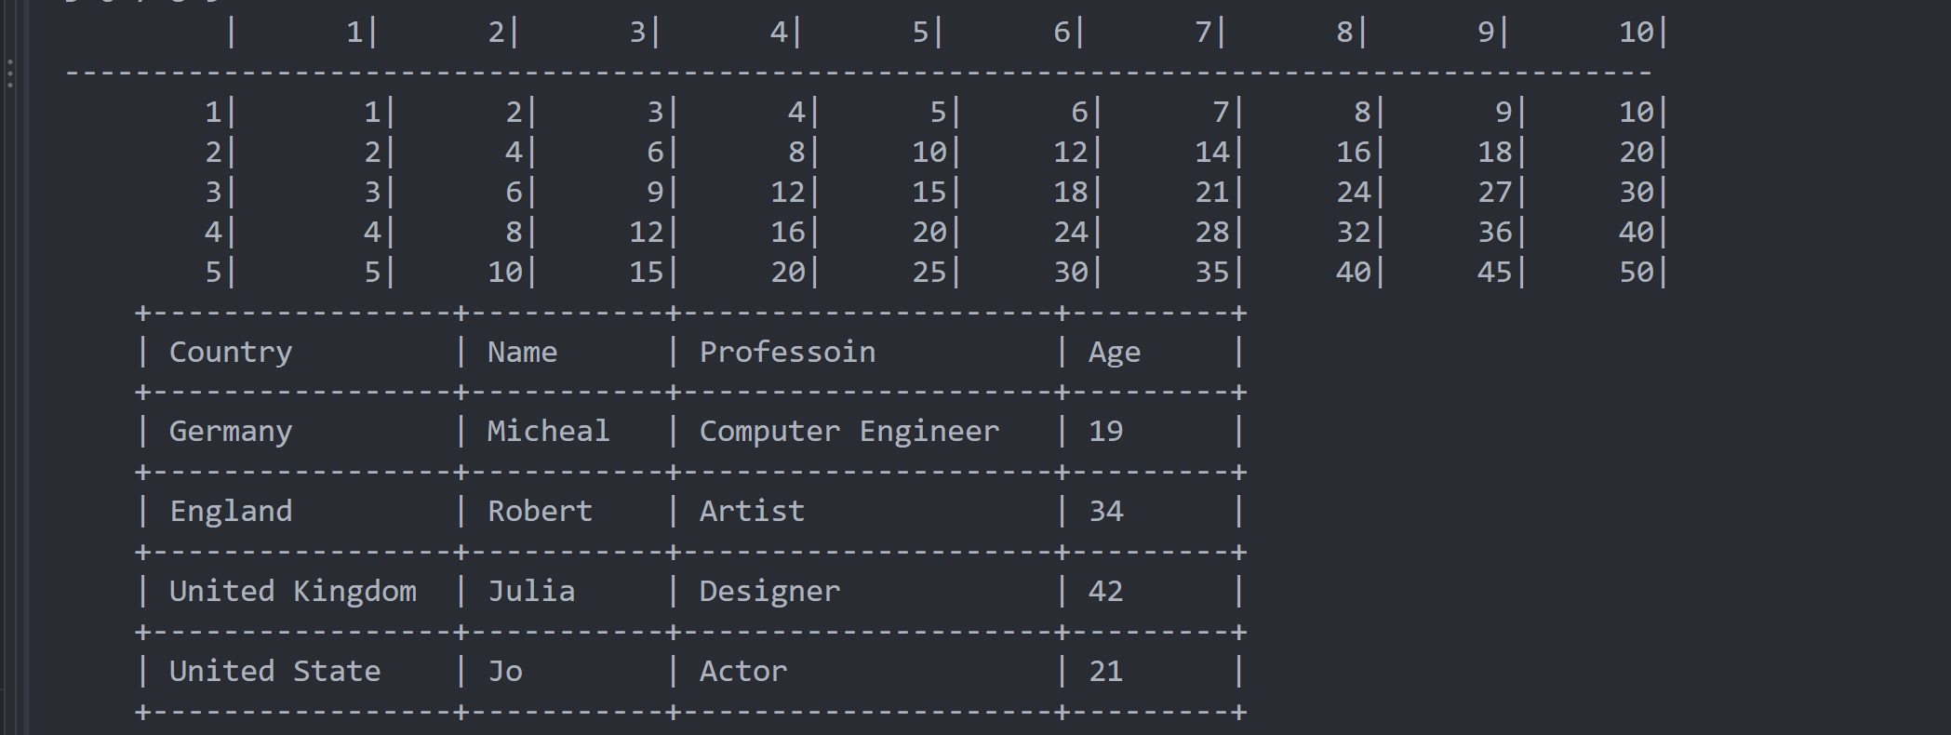
// #5
public static String textLen(String[] aStrings){
String text = "I love my Home Country";

int len = text.length();
return String.valueOf(len);
}
public static String cutText(String[] aStrings){
String text = "I love my little country";
String cutText = text.substring(7);

return cutText;
}
public static void findVowelIdx(String[] aStrings){
String text = "Hi Student!";
String vols = "aeiouAEIOU";

for(int t=0; t<text.length(); t++){
char ch = text.charAt(t);
if(vols.indexOf(ch) != -1){
System.out.println("\"" + ch + "\" is at index: " + t);
}
}
}
public static void textCompare(String[] aStrings){
String text1 = "Hi Students!";
String text2 = "Students!";
String text3 = "Hi Students!";
System.out.println("text1 is eqaul to text2: " + text1.equals(text2));
System.out.println("text1 is eqaul to text3: " + text1.equals(text3));
}
public static void textContain(String[] aStrings){
String text1 = "Hi Students!";
String text2 = "Students";
String text3 = "Teacher";
System.out.println("text1 contains text2: " + text1.contains(text2));
System.out.println("text1 contains text3: " + text1.contains(text3));
}
}
output:
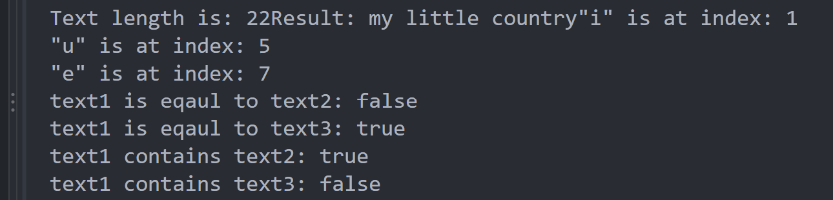
// #6
class Car{
String model;
String color;
String year;
int price;
int warenty;
}
class Employee {
String name;
String Id;
String DOB;
String dept;
String offi;
}
class BankAccount {
String name;
String password;
String accNum;
int balance;
int expense;
}
class Video{
String name;
String ext;
int length;
int resolution;
int size;
}
class Student{
int studentId;
String name;
char gender;
int age;
double score;
int year;
Student(int studentId, String name, char gender, int age, double score, int year){
this.studentId = studentId;
this.name = name;
this.gender = gender;
this.age = age;
this.score = score;
this.year = year;
}
void display(){
System.out.printf(
"""
StudentId: %d
Name: %s
Gender: %c
Age: %d
Score: %.1f
Year: %d
""",studentId,name,gender,age,score,year);
}
}
output:
