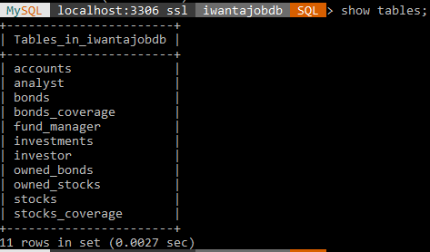

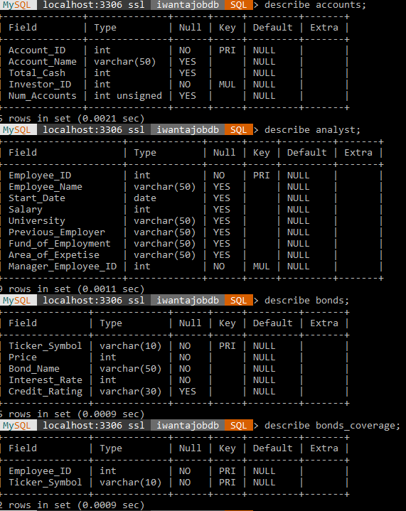

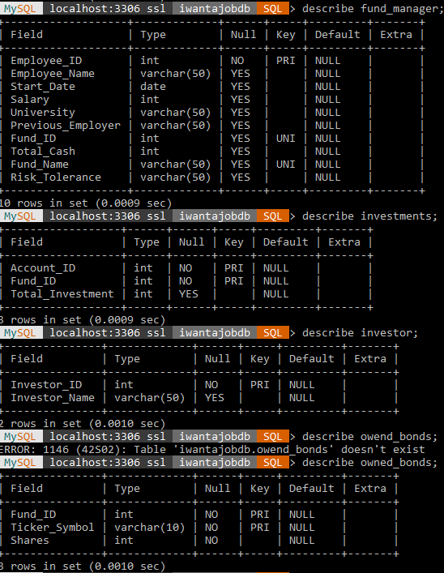

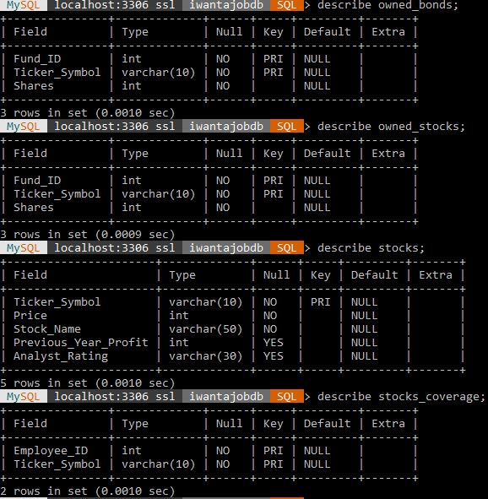

7. We are not able to insert new data into Fund_Coverage view because the data cannot be entered into the base table. A view is not actual data as it is just a representation of data. We don’t have the adequate date to populate the base database which caused our error.