# Web of Well-Being: Re-Examining PERMA and Subjective Well-Being Through Networks

# Sean H. Merritt1, Saida Heshmati1, Stewart I. Donaldson1, and Zita Oravecz2

# Claremont Graduate Univiersity1

# Penn State University2

# Author Note

#### Correspondence should be sent to Sean Merritt, Claremont Graduate University, 150 E 10th St, Claremont, CA 91711 E-mail: [sean.merritt@cgu.edu](mailto:sean.merritt@cgu.edu)

###### Abstract

#### The most central topic in positive psychology is the study of well-being. While the field has been around for 20 years, there is not much a consensus on the measurement of well-being. One such framework known as PERMA, has been criticized for not being distinct from subjective wellbeing. Previous studies examined the differences between PERMA and subjective wellbeing using traditional factor analysis methods. In this paper we propose a different approach using network analysis. With this approach we find evidence to suggest that PERMA is not only distinct from subjective wellbeing, but its components may be more theoretically important to measuring and understanding well-being.

###### Web of Well-Being: Re-Examining PERMA and Subjective Well-Being Through Networks

With the advent of Positive Psychology (M. E. Seligman & Csikszentmihalyi, 2000), the scientific investigation of Well-Being began. Consequently, various theoretical approaches to understanding and conceptualizing well-being have been proposed by positive psychologists. One recent framework was proposed by Seligman (2011) that well-being is composed of five building blocks: Positive emotions, Engagement, Relationships, Meaning, and Accomplishment (PERMA). Since this proposition, PERMA has been the center of numerous research studies Donaldson, Heshmati, Lee, & Donaldson (2020) and recently has been a central topic of debate (Goodman et al, 2018; Martin Seligman, 2018). For instance, Goodman and colleagues (2018) found PERMA was nearly identical to subjective wellbeing as measured by satisfaction with life (SWL), a single happiness question, and negative emotion question.

While Goodman et al.’s(2018) study has many strengths, there were several limitations to their conclusions that our research will address. First, Goodman et al., based their conclusions on a factor model perspective on latent variables. This approach assumes independence among factors/items loading onto the latent factor of interest. However, based on the intercorrelated nature of elements of well-being demonstrated in previous research, it is more probable that elements of well-being and items measuring them are not independent of each other and are interrelated. To address this limitation, the current study sought to use a network psychometric analysis approach to determine the probability of a “web” of well-being with elements of well-being as a woven web of elements that are correlated to each other. Network loadings are similar to factor loadings while allowing for the interpretation of how items interact with each other. Through a network approach, PERMA elements may be proven to be conceptualized more as a web of elements of well-being rather than building blocks of well-being, in which one or more elements might be identified as more influential elements in the web compared to others. This information can be used in interventions such that more central elements of the web of well-being may be targeted to increase in specific populations.

Second, Goodman and colleagues used a convenience sample collected through mTurk in which the representativeness of the sample for the intended population was not confirmed. To further confirm Goodman et al.’s (2018) investigation, this study replicated Goodman and colleagues’ work with a representative sample of the United States in terms of age, gender, and race through the use of the Prolific platform (Prolific.co). Where mTurk is a general platform to get work done at low rates, prolific is a specialized survey hosting platform that verifies and monitors participants with sophisticated checks for high quality data. Their services include representative sampling based on the demographics listed previously.

Finally, Goodman et al. (2018), only used a single question to measure happiness and negative emotion along with the SWL scale, whereas SWB is traditionally measured using SWL and the PANAS (CITE) which includes 8 positive and 8 negative emotions. In the current study, we use the SWL and PANAS scales as measures of SWB in relation to the PERMA elements using a network approach.

In conclusion, using a network perspective, in the current study we examine SWB and PERMA in a different light. Seligman (2011) called PERMA the ‘building blocks’ of wellbeing. However, the idea of building blocks has been limited by traditional latent factor models. Thinking of PERMA with factor models creates the image of physical blocks. You stack those blocks up and you get wellbeing. Looking at PERMA with a network paradigm changes the ideas of building blocks to a web of interconnected entities (or factors). Through this perspective, we understand wellbeing (more specifically PERMA) as how constructs work together to develop a well person. In this study we show how PERMA and SWB can be thought of as networks and what that means for their importance. We also show how this paradigm integrates PERMA into currently established well-being theoretical frameworks.

*RQ1*: Does Goodman et al’s findings replicate on a more representative sample?

*RQ2*: Can SWB and PERMA be represented as network models?

*RQ3*: What are the most central features of these networks? How does it compare between PERMA and SWB? Are PERMA constructs more central than SWB?

*RQ4*: Are the features of PERMA distinct from those of SWB (SWL, positive and negative emotions)?

## Method

### Participants and Procedure

Using the online sampling service prolific.co, we recruited 580 U.S. adults. Using Prolifics stratified sampling, we obtained a representative sample according to age, gender, and ethnicity matching the U.S. census. A call for participants was listed on the site where those who were interested were redirected to our survey hosted on Qualtrics. After receiving consent, participants filled out the *PERMA profiler, satisfaction with life scale, PANAS, BFI-2S, and demographics questions*. After fully completing the survey, participants were paid $1.60 for their time (approximately $9.66/ hour).

### Scales

#### SWB

To measure subjective well-being we used Diener’s (CITE) Satisfaction with Life Scale (SWL) and the Positive Affect and Negative Affect Schedule (PANAS).

#### PERMA

The PERMA profiler was used to measure PERMA. This scale contains three items for each component in PERMA. It also contains three questions on negative affect, three questions on health, a loneliness question, and a happiness question. While we asked all 23 questions we used the first 21 questions for analysis on PERMA.

#### Personality

While not used in our analysis here, we measured big five personality using the BFI-25. It is a short personality questionnaire that has been found to have high reliability and validity (CITE).

#### Demographics

We asked demographic questions to ensure generalization of results. While prolific had pre-recorded individuals age, gender, and ethnicity we gathered these to match our recorded data. we also asked about education, occupation, relationship status, religion, and number of family members living in the home.

### Analysis

The first part of our analysis used simple correlations and confirmatory factor analysis (CFA) to replicate Goodman et al.(2018). We then constructed our networks using the psychonetrics package following the tutorial as outlined in Kan, Jonge, Maas, Levine, & Epskamp (2020). Once the networks were constructed we measured the centrality of each construct using the median strength of nodes. We chose to take the median as previous studies show problems with using centrality of individual nodes [CITE] and centrality is often heavily right skewed [CITE]. Next we wanted to test for distinguished clusters we used exploratory graphical analysis (EGA). EGA is similar to exploratory factor analysis, in that it searches for the number of constructs by grouping items (Golino & Epskamp, 2017). EGA is different in that it groups items based on networks and does not assume these groupings are orthogonal.

## Results

### Table 1

Correlation table

|  |  |  |  |  |  |  |  |  |  |  |
| --- | --- | --- | --- | --- | --- | --- | --- | --- | --- | --- |
|  | 1 | 2 | 3 | 4 | 5 | 6 | 7 | 8 | 9 | 10 |
| 1. P | - |  |  |  |  |  |  |  |  |  |
| 2. E | .45*** | - |  |  |  |  |  |  |  |  |
| 3. R | .72*** | .33*** | - |  |  |  |  |  |  |  |
| 4. M | .78*** | .42*** | .63*** | - |  |  |  |  |  |  |
| 5. A | .72*** | .37*** | .62*** | .79*** | - |  |  |  |  |  |
| 6. N | -.59*** | -.20*** | -.48*** | -.54*** | -.57*** | - |  |  |  |  |
| 7. H | .59*** | .28*** | .48*** | .54*** | .58*** | -.41*** | - |  |  |  |
| 8. SWL | .69*** | .25*** | .62*** | .64*** | .62*** | -.46*** | .49*** | - |  |  |
| 9. Pos | .87*** | .41*** | .64*** | .73*** | .69*** | -.63*** | .53*** | .61*** | - |  |
| 10. Neg | -.65*** | -.28*** | -0.52*** | -.60*** | -.61*** | .77*** | -.47*** | -.50*** | -.67*** | - |

### RQ1:

Using Pearson correlations we found that all of the constructs are highly correlated (see table 1). The only exception being engagement. Where most correlations ranged between .50 and .87, engagement correlated with other constructs in the .20 to .42 range.

Using confirmatory factor analysis, we found evidence to support Goodman et al (2018) with latent correlations greater than 0.90. However, fit indices indicated only moderate fit when modeled as independent factors (see table 2).

**Table 2**

Fit Indices for CFAs

|  |  |  |  |  |  |  |  |  |
| --- | --- | --- | --- | --- | --- | --- | --- | --- |
| **Model** | df | Χ2 | p | TLI | CFI | RMSEA | AIC | BIC |
| One Factor | 487 | 1972.07 | < .001 | .91 | 0.92 | 0.07 | 54178.41 | 54498.81 |
| SWB~PERMA | 487 | 1972.07 | < .001 | .91 | 0.92 | 0.07 | 54178.41 | 54498.81 |
| SWB+P~ERMA | 486 | 1895.29 | < .001 | .92 | 0.92 | 0.07 | 54103.63 | 54428.36 |
| SWB~ERMA | 223 | 820.77 | < .001 | .94 | 0.95 | 0.07 | 41705.94 | 41935.42 |
| Independent Factors | 467 | 2486.65 | < .001 | .88 | 0.89 | 0.09 | 54732.99 | 55139.99 |
| Independent (No Hap.) | 215 | 702.81 | < .001 | .95 | 0.96 | 0.06 | 41603.98 | 41868.09 |

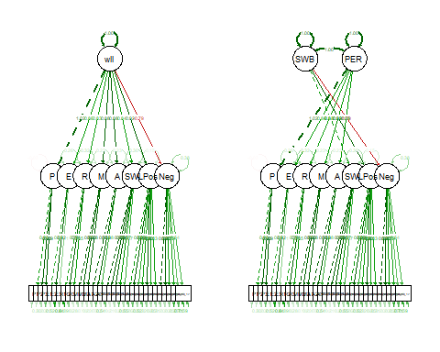

#### *Figure 1.* SEM Paths for Model 1 and 2

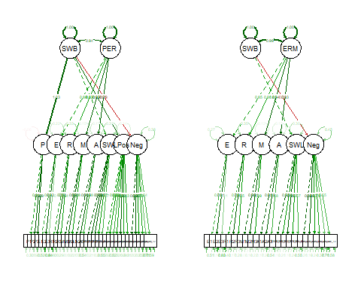

#### *Figure 2.* SEM Paths for Model 3 and 4

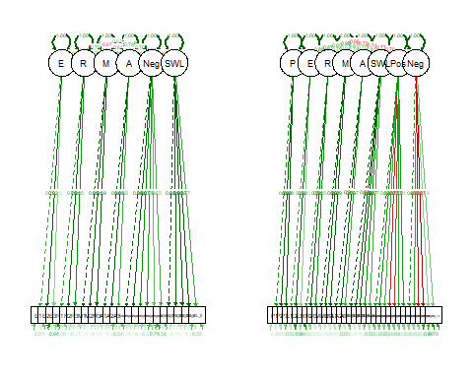

#### *Figure 3.* SEM Paths for Model 5 and 6

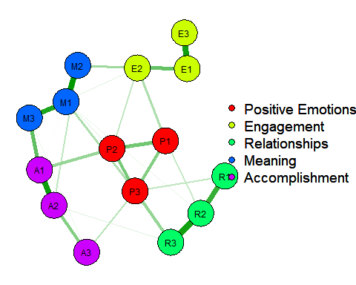

#### *Figure 4.* PERMA Network

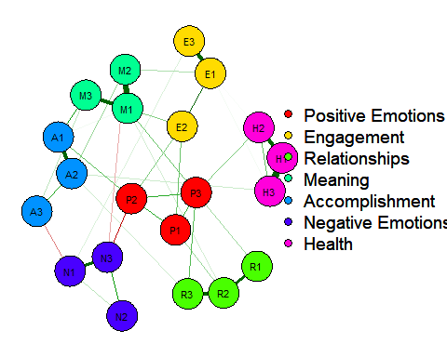

#### *Figure 5.* PERMA+NH Network

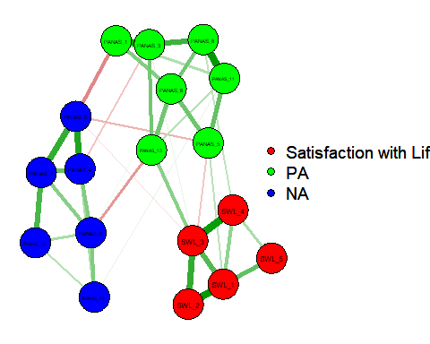

#### *Figure 6.* Subjective Well-being Network

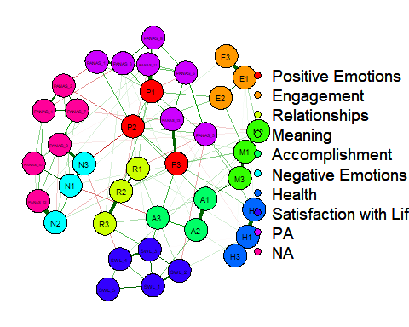

#### *Figure 7.* PERMA+NH+SWB Network

### RQ2:

Next, we modeled four different potential networks. We first constructed PERMA and SWB networks individually to first gauge how these constructs model separately. We then added negative emotions and health to PERMA (PERMA+NH) for additional insight on the impact of additional constructs. Finally, we combined PERMA+NH and SWB to see if a network perspective would find SWB and PERMA to be similar like Goodman et al. concluded. If this is the case, we should expect to see SWL, positive affect, and negative affect as the central features in these networks. We would also expect to see PERMA constructs to cluster with SWB constructs. After these models were constructed, we examined the fit indices. These are the same fit indices used for SEM and CFA models. All models had excellent fit (see table 3), showing that PERMA and SWB can be represented as network model

**Table 3**

Fit Indices for Networks

|  |  |  |  |  |  |  |  |  |
| --- | --- | --- | --- | --- | --- | --- | --- | --- |
| Model | df |  | TLI | CFI | RMSEA | AIC | BIC | EBIC |
| PERMA | 176 | 147.44 | 0.97 | 0.98 | 0.06 | 8474.73 | 8634.82 | 9111.43 |
| PERMA+NH | 170 | 364.56 | 0.95 | 0.96 | 0.06 | 11736.58 | 11958.52 | 12701.38 |
| SWB | 613 | 234.96 | 0.96 | 0.97 | 0.06 | 10041.44 | 10252.46 | 10923.03 |
| PERMA+NH+SWB | 633 | 1134.25 | 0.95 | 0.95 | 0.05 | 20825.65 | 21360.48 | 23514.66 |

### RQ3:

In network analysis, centrality is used to measure the degree of importance of a node (in this case an item) in the network. For this paper we were not concerned with the centrality of individual items, but the median centrality of constructs across items. Table 4 shows the median centrality score for each construct per model. Positive emotions (or affect) were found to be the most central in SWB, PERMA, PERMA+NH+SWB, but not the PERMA+NH network. In addition, Meaning and Accomplishment were found to be highly central across all PERMA based models and were found to be more central than SWL in the PERMANH + SWB.

We decided to examine this further using several linear regression models. We first examined three models regressed onto SWL. Model 1 consisted of positive emotions alone. This was significant with positive emotions accounting for 47% of the variance in SWL. Model 2 consisted of meaning and accomplishment. Both were significant accounting for 43% of the variance in SWL. Finally, we modeled positive emotions, meaning, and accomplishment. All were significant. We find meaning and accomplishment accounting for 4% more variance in SWL than positive emotions alone. We replicated these models for SWB but found that meaning and accomplishment do not explain any more variance in SWB than positive emotions alone. However, further examination shows that while SWB is calculated using SWL, we find that SWL only explains 3% more variance in SWB than positive emotions alone.

**Table 4**

Centrality of Factors

|  |  |  |  |
| --- | --- | --- | --- |
| Factor | Mean | Median | Model |
| P | 2.04 | **2.02** | PERMA |
| E | 1.53 | 1.79 | PERMA |
| R | 1.61 | 1.57 | PERMA |
| M | **2.10** | 1.87 | PERMA |
| A | 1.65 | 1.94 | PERMA |
| P | 1.73 | 1.65 | PERMA+NH |
| E | 1.54 | 1.64 | PERMA+NH |
| R | 1.60 | 1.53 | PERMA+NH |
| M | **1.98** | 2.02 | PERMA+NH |
| A | 1.49 | **2.04** | PERMA+NH |
| N | 0.78 | 0.80 | PERMA+NH |
| H | 1.94 | 1.82 | PERMA+NH |
| SWL | **1.76** | 1.67 | SWB |
| Pos | 1.56 | **1.80** | SWB |
| Neg | 1.33 | 1.18 | SWB |
| P | 1.93 | **2.22** | PERMA+NH+SWB |
| E | 1.48 | 1.48 | PERMA+NH+SWB |
| R | 1.58 | 1.52 | PERMA+NH+SWB |
| M | **2.05** | 1.94 | PERMA+NH+SWB |
| A | 1.49 | 1.94 | PERMA+NH+SWB |
| N | 1.38 | 1.41 | PERMA+NH+SWB |
| H | 2.00 | 1.85 | PERMA+NH+SWB |
| SWL | 1.76 | 1.49 | PERMA+NH+SWB |
| Pos | 1.68 | 1.75 | PERMA+NH+SWB |
| Neg | 1.54 | 1.67 | PERMA+NH+SWB |

### RQ4:

We then used exploratory graphical analysis (EGA) to test how items clustered together. For this part of the analysis, we only performed EGA on the PERMA+NH+SWB model as we were primarily interested in whether or not PERMA and SWB clustered together. Table 5 shows the network loadings for each item. Network loadings are similar to factor loadings with the exception that items can be loaded onto multiple groups, indicating an interaction among groups (Christensen & Golino, 2020). We found seven distinct clusters within in the network. SWL, health, relationships, and engagement clustered within their respective groups. Negative emotions (PERMA) clustered with negative affect (PANAS). Positive emotions tended to be equally clustered with positive affect and meaning and accomplishment (which were found to cluster together). These clustering groups show that PERMANH factors are distinct from the factors of SWB (with the exception of positive and negative emotions). If they were not distinct, we would expect more of PERMANH to cluster with positive or negative affect and satisfaction with life. Computing centrality with these new clusters puts meaning and accomplishment as most central, followed by positivity and health.

**Table 5**

Network Loadings

|  |  |  |  |  |  |  |  |
| --- | --- | --- | --- | --- | --- | --- | --- |
|  | 1 | 2 | 3 | 4 | 5 | 6 | 7 |
| P1 | - | .**10** | - | **.18** | - | - | - |
| P2 | - | **.13** | - | **.13** | - | - | - |
| P3 | - | **.12** | - | **.15** | - | - | - |
| E1 | - | **.14** | **.34** | - | - | - | - |
| E2 | - | **.15** | **.23** | .- | - | - | - |
| E3 | - | - | **.34** | - | - | - | - |
| R1 | - | - | - | - | - | **.29** | - |
| R2 | - | - | - | - | - | **.44** | - |
| R3 | - | - | - | - | - | **.28** | - |
| M1 | - | **.32** | - | - | - | - | - |
| M2 | - | **.25** | - | - | - | - | - |
| M3 | - | **.30** | - | - | - | - | - |
| A1 | - | **.27** | - | - | - | - | - |
| A2 | - | **.27** | - | - | - | - | - |
| A3 | - | **.11** | - | - | - | - | - |
| N1 | **.24** | - | - | - | - | - | - |
| N2 | **.24** | - | - | - | - | - | - |
| N3 | .**27** | - | - | - | - | - | - |
| H1 | - | - | - | - | - | - | **.53** |
| H2 | - | - | - | - | - | - | **.40** |
| H3 | - | - | - | - | - | - | **.48** |
| SWL_1 | - | - | - | - | **.46** | - | - |
| SWL_2 | - | - | - | - | **.32** | - | - |
| SWL_3 | - | - | - | - | **.41** | - | - |
| SWL_4 | - | - | - | - | **.29** | - | - |
| SWL_5 | - | - | - | - | **.21** | - | - |
| PANAS_1 | - | - | - | **.22** | - | - | - |
| PANAS_2 | **.29** | - | - | - | - | - | - |
| PANAS_3 | - | - | - | **.35** | - | - | - |
| PANAS_4 | **.33** | - | - | - | - | - | - |
| PANAS_5 | - | - | - | **.14** | - | - | - |
| PANAS_6 | - | - | - | **.28** | - | - | - |
| PANAS_7 | **.31** | - | - | - | - | - | - |
| PANAS_8 | - | - | - | **.38** | - | - | - |
| PANAS_9 | **.31** | - | - | - | - | - | - |
| PANAS_10 | .**21** | - | - | - | - | - | - |
| PANAS_11 | - | - | - | **.33** | - | - | - |
| PANAS_12 | **.32** | - | - | - | - | - | - |
| PANAS_13 | - | **.11** | - | **.15** | - | - | - |

**Table 6**

|  |  |  |
| --- | --- | --- |
| Clusters | Mean | Median |
| E | 1.48 | 1.48 |
| R | 1.58 | 1.52 |
| M & A | 1.77 | **1.94** |
| H | **2.00** | 1.85 |
| SWL | 1.76 | 1.49 |
| Negativity | 1.49 | 1.45 |
| Positivity | 1.76 | 1.89 |

*Centrality by New Clusters*

## Discussion

These results indicate that SWB and PERMA can be considered as a network rather than latent constructs. This provides a new way to view the “building blocks” of well-being. Rather than PERMA being blocks that stack up into a building of well-being, PERMA is a web of experiences that come together to form the means by which one feels well. Just like how a spider’s web catches insects, a PERMA web captures high quality experiences of living. Networks also allow us to look at the most central features of a construct. Which means we can distinguish features of constructs that may be more important for the development of wellbeing.

Considering that positive emotions were most central across models, we can infer that the most important part to experiencing (or at least reporting) wellbeing is experiencing high positive emotions. This does not mean that we must experience positive emotions first to have higher satisfaction with life or meaning, but that all these experiences are likely to somehow connect to positivity. On the other hand, positivity was not the most central in the PERMA+NH model. This might suggest that the more concepts we can add to PERMA, the less important positive emotions may be. However, this did not replicate in the SWB+PERMANH, this could be because SWB shares similar concepts to PERMA. Therefore, PERMA might benefit by adding additional constructs much like the PERMA+4 designed for the workplace.

When we examine the SWB + PERMANH model we see that positive emotions, meaning, accomplishment, and health were more central to the network than SWL, positive affect, or negative affect. This suggests that concepts found in PERMANH might be more theoretically important to the overall concept of well-being than SWB as we measured it here. On the other hand, relationships, engagement, and negative emotions were found to be just as central if not less central than SWB constructs, but R,E, and N were also not highly central in previous PERMA models. We also find that concepts found in PERMA+NH are distinct from SWB per EGA. Even after accounting for this clustering we found our previous results to hold up, PERMA concepts may be more central than concepts of SWB, with the exception of positivity.

Our results show that the need for PERMA resides in the framework for which we wish to look at wellbeing. If wellbeing is considered a single construct with sub factors, then SWB is the preferred way to look at it. However, if we wish to look at well-being as an interacting construct, or as some previous writers have suggested a balancing act of positive and negative emotions, then PERMA provides a more accurate lens to examine wellbeing.

Proponents of PERMA argue that while SWB is a good snapshot of someone's wellbeing, it does not provide a granular level analysis of how to improve wellbeing. It is said that PERMA can be used as a sort of diagnostics tool in which we can determine targets of interventions. However, Goodman et al., (2018) found that people high in one component of PERMA also tend to be high in another. Similarly, our findings show that PERMA constructs are highly interrelated. The network approach suggests that these high similar scores exist for a different reason, the influence of one construct on the others.  From this perspective, we don’t say that PERMA is a diagnostic tool, but a theoretical framework for planning interventions. Interventions should focus on how to properly build and reinforce all aspects of PERMA when promoting well-being.

###### References

Christensen, A. P., & Golino, H. (2020). On the equivalency of factor and network loadings. *Behavior Research Methods*, 1–18.

Donaldson, S. I., Heshmati, S., Lee, J. Y., & Donaldson, S. I. (2020). Examining building blocks of well-being beyond PERMA and self-report bias. *The Journal of Positive Psychology*, 1–8.

Golino, H. F., & Epskamp, S. (2017). Exploratory graph analysis: A new approach for estimating the number of dimensions in psychological research. *PloS One*, *12*(6), e0174035.

Goodman, F. R., Disabato, D. J., Kashdan, T. B., & Kauffman, S. B. (2018). Measuring well-being: A comparison of subjective well-being and PERMA. *The Journal of Positive Psychology*, *13*(4), 321–332.

Kan, K.-J., Jonge, H. de, Maas, H. L. van der, Levine, S. Z., & Epskamp, S. (2020). How to compare psychometric factor and network models. *Journal of Intelligence*, *8*(4), 35.

Khaw, D., & Kern, M. (2014). A cross-cultural comparison of the PERMA model of well-being. *Undergraduate Journal of Psychology at Berkeley, University of California*, *8*(1), 10–23.

Seligman, ME. (2011). Flourish: A visionary new understanding of happiness and well-being. *Policy*, *27*(3), 60–1.

Seligman, Martin. (2018). PERMA and the building blocks of well-being. *The Journal of Positive Psychology*, *13*(4), 333–335. <https://doi.org/10.1080/17439760.2018.1437466>

Seligman, M. E., & Csikszentmihalyi, M. (2000). Positive psychology: An introduction. In *Flow and the foundations of positive psychology* (pp. 279–298). Springer.