# Web of Well-Being: Re-Examining PERMA and Subjective Well-Being Through Networks

# Sean H. Merritt1, Saida Heshmati1, Stewart I. Donaldson1, and Zita Oravecz2

# Claremont Graduate Univiersity1

# Penn State University2

# Author Note

#### Correspondence should be sent to Sean Merritt, Claremont Graduate University, 150 E 10th St, Claremont, CA 91711 E-mail: [sean.merritt@cgu.edu](mailto:sean.merritt@cgu.edu)

###### Abstract

#### Words about the abstract.

###### Title for intro

With the advent of Positive Psychology (M. E. Seligman & Csikszentmihalyi (2000)), the scientific investigation of Well-Being began. Consequently, various theoretical approaches to understanding and conceptualizing well-being have been proposed by positive psychologists. One recent framework was proposed by Seligman (2011) that well-being is composed of five building blocks: Positive emotions, Engagement, Relationships, Meaning, and Accomplishment (PERMA). Since this proposition, PERMA has been the center of numerous research studies Donaldson, Heshmati, Lee, & Donaldson (2020) and recently has been a central topic of debate (Goodman et al, 2018; (, Martin Seligman, 2018). For instance, Goodman and colleagues (2018) found PERMA was nearly identical to subjective wellbeing as measured by satisfaction with life (SWL), a single happiness question, and negative emotion question.

While Goodman et al.’s(2018) study has many strengths, there were several limitations to their conclusions that our research will address. First, Goodman et al., based their conclusions on a factor model perspective on latent variables. This approach assumes independence among factors/items loading onto the latent factor of interest. However, based on the intercorrelated nature of elements of well-being demonstrated in previous research, it is more probable that elements of well-being and items measuring them are not independent of each other and are interrelated. To address this limitation, the current study sought to use a network psychometric analysis approach to determine the probability of a “web” of well-being with elements of well-being as a woven web of elements that are correlated to each other. Network loadings are similar to factor loadings while allowing for the interpretation of how items interact with each other. Through a network approach, PERMA elements may be proven to be conceptualized more as a web of elements of well-being rather than building blocks of well-being, in which one or more elements might be identified as more influential elements in the web compared to others. This information can be used in interventions such that more central elements of the web of well-being may be targeted to increase in specific populations.

Second, Goodman and colleagues used a convenience sample collected through mTurk in which the representativeness of the sample for the intended population was not confirmed. In an effort to further confirm Goodman et al.’s (2018) investigation, this study replicated Goodman and colleagues’ work with a representative sample of the United States in terms of age, gender, and race through the use of the Prolific platform (Prolific.co). Where mTurk is a general platform to get work done at low rates, prolific is a specialized survey hosting platform that verifies and monitors participants with sophisticated checks for high quality data. Their services include representative sampling based on the demographics listed previously.

Finally, Goodman et al.(2018), only used a single question to measure happiness and negative emotion along with the SWL scale, whereas SWB is traditionally measured using SWL and the PANAS (CITE) which includes 8 positive and 8 negative emotions. In the current study, we use the SWL and PANAS scales as measures of SWB in relation to the PERMA elements using a network approach.

In conclusion, using a network perspective, in the current study we examine SWB and PERMA in a different light. Seligman (2011) called PERMA the ‘building blocks’ of wellbeing. However, the idea of building blocks has been limited by traditional latent factor models. Thinking of PERMA with factor models creates the image of physical blocks. You stack those blocks up and you get wellbeing. Looking at PERMA with a network paradigm changes the ideas of building blocks to a web of interconnected entities (or factors). Through this perspective, we understand wellbeing (more specifically PERMA) as how constructs work together to develop a well person. In this study we show how PERMA and SWB can be thought of as networks and what that means for their importance. We also show how this paradigm integrates PERMA into currently established well-being theoretical frameworks.

*RQ1*: Does Goodman et al’s findings replicate on a more representative sample?

*RQ2*: Can SWB and PERMA be represented as network models?

*RQ3*: What are the most central features of these networks? How does it compare between PERMA and SWB? Are PERMA constructs more central than SWB?

*RQ4*: Are the features of PERMA distinct from those of SWB (SWL, positive and negative emotions)?

## Method

### Participants and Procedure

Using the online sampling service prolific.co, we were able to gather a U.S. representative sample based on age, gender, and ethnicity. Prolific stratifies groups according to age, gender, and ethnicity that matches percentages from the U.S. census. All participants filled out the PERMA profiler, satisfaction with life scale, PANAS, BFI-2S, and demographics. Our final sample was 580. The satisfaction with life scale and PANAS will be used to measure subjective well being.

## Results

### Descriptives

## Warning in if (class(matCorr) != "rcorr") {: the condition has length > 1 and  
## only the first element will be used

Correlation table

|  |  |  |  |  |  |  |  |  |  |  |
| --- | --- | --- | --- | --- | --- | --- | --- | --- | --- | --- |
|  | 1 | 2 | 3 | 4 | 5 | 6 | 7 | 8 | 9 | 10 |
| 1. P | - |  |  |  |  |  |  |  |  |  |
| 2. E | 0.45*** | - |  |  |  |  |  |  |  |  |
| 3. R | 0.72*** | 0.33*** | - |  |  |  |  |  |  |  |
| 4. M | 0.78*** | 0.42*** | 0.63*** | - |  |  |  |  |  |  |
| 5. A | 0.72*** | 0.37*** | 0.62*** | 0.79*** | - |  |  |  |  |  |
| 6. N | -0.59*** | -0.2*** | -0.48*** | -0.54*** | -0.57*** | - |  |  |  |  |
| 7. H | 0.59*** | 0.28*** | 0.48*** | 0.54*** | 0.58*** | -0.41*** | - |  |  |  |
| 8. SWL | 0.69*** | 0.25*** | 0.62*** | 0.64*** | 0.62*** | -0.46*** | 0.49*** | - |  |  |
| 9. Pos | 0.87*** | 0.41*** | 0.64*** | 0.73*** | 0.69*** | -0.63*** | 0.53*** | 0.61*** | - |  |
| 10. Neg | -0.65*** | -0.28*** | -0.52*** | -0.6*** | -0.61*** | 0.77*** | -0.47*** | -0.5*** | -0.67*** | - |

### RQ1:

Using confirmatory factor analysis we found evidence to support Goodman et al (2018) with latent correlations greater than 0.90 with our representative sample of participants. However, fit indices indicated only moderate fit when modeled as independent factors.

Fit Indices for CFAs

|  |  |  |  |  |  |  |  |  |
| --- | --- | --- | --- | --- | --- | --- | --- | --- |
| Model | df | $χ^{2}$ | p | TLI | CFI | RMSEA | AIC | BIC |
| One Factor | 487 | 1972.07 | 0 | 0.91 | 0.92 | 0.07 | 54178.41 | 54498.81 |
| SWB~PERMA | 487 | 1972.07 | 0 | 0.91 | 0.92 | 0.07 | 54178.41 | 54498.81 |
| SWB+P~ERMA | 486 | 1895.29 | 0 | 0.92 | 0.92 | 0.07 | 54103.63 | 54428.36 |
| SWB~ERMA | 223 | 820.77 | 0 | 0.94 | 0.95 | 0.07 | 41705.94 | 41935.42 |
| Independent Factors | 467 | 2486.65 | 0 | 0.88 | 0.89 | 0.09 | 54732.99 | 55139.99 |
| Independent Factors (No Hap.) | 215 | 702.81 | 0 | 0.95 | 0.96 | 0.06 | 41603.98 | 41868.09 |

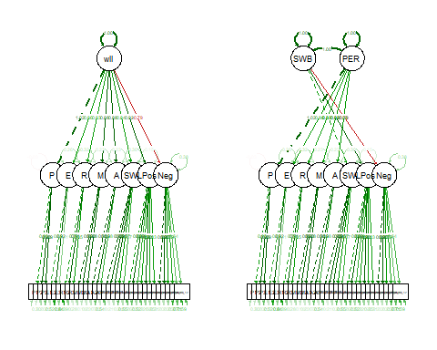

#### *Figure 1.* SEM Paths for Model 1 and 2

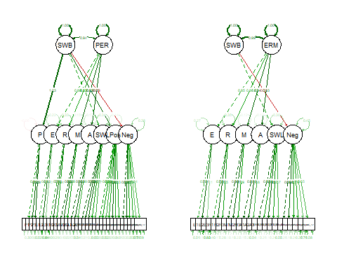

#### *Figure 2.* SEM Paths for Model 3 and 4

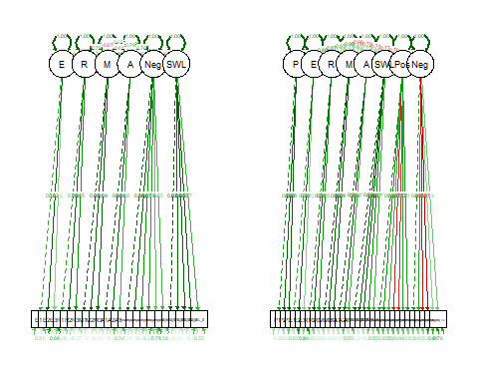

#### *Figure 3.* SEM Paths for Modle 5 and 6

### RQ2:

We then modeled PERMA and SWB networks individually to first gauge how these constructs model separately. We then added negative emotions and health for additional insight on the impact of additional constructs added to PERMA. Finally, we combined PERMA+NH and SWB to see if a network perspective would find SWB and PERMA to be similar like Goodman et al. concluded. If this is the case, we should expect to see SWL, positive affect, and negative affect as the central features in the network. We would also expect to see PERMA constructs to cluster with SWB constructs. All models had excellent fit, showing that PERMA and SWB can be represented and network models.

Fit Indices for Networks

|  |  |  |  |  |  |  |  |  |  |
| --- | --- | --- | --- | --- | --- | --- | --- | --- | --- |
| Model | df | $χ^{2}$ | p | TLI | CFI | RMSEA | AIC | BIC | EBIC |
| PERMA | 76 | 147.4371 | 1.7e-06 | 0.9726022 | 0.9801692 | 0.0578365 | 8474.727 | 8634.815 | 9111.432 |
| PERMA+NH | 170 | 364.5572 | 0.0e+00 | 0.9543544 | 0.9630488 | 0.0638184 | 11736.581 | 11958.521 | 12701.384 |
| SWB | 113 | 234.9600 | 0.0e+00 | 0.9632426 | 0.9728524 | 0.0619750 | 10041.440 | 10252.464 | 10923.031 |
| PERMA+NH+SWB | 633 | 1134.2493 | 0.0e+00 | 0.9462803 | 0.9541099 | 0.0530850 | 20825.646 | 21360.484 | 23514.658 |

## png   
## 2

#### *Figure 4.* PERMA Network

## png   
## 2

#### *Figure 5.* PERMA+NH Network

## png   
## 2

#### *Figure 6.* Subjective Well-being Network

jpeg('PERMNH+SWB_graph.jpg')  
  
qgraph::qgraph( getmatrix(nwModel_PERMA_SWB, "omega" ),   
 labels = yvars,  
 groups = list( `Positive Emotions` = which( lambda[ , 1 ] == 1 ),  
 Engagement = which( lambda[ , 2 ] == 1 ),  
 Relationships = which( lambda[ , 3 ] == 1 ),  
 Meaning = which( lambda[ , 4 ] == 1 ),   
 Accomplishment = which( lambda[ , 5 ] == 1 ),  
 `Negative Emotions` = which( lambda[ , 6 ] == 1 ),  
 Health = which( lambda[ , 7 ] == 1 ),  
 `Satisfaction with Life` = which( lambda[ , 8 ] == 1 ),  
 PA = which( lambda[ ,9 ] == 1 ),  
 `NA` = which( lambda[ ,10 ] == 1 )),  
 layout = "spring" )  
  
dev.off()

## png   
## 2

#### *Figure 7.* PERMA+NH+SWB Network

### RQ3:

In network analysis, centrality is used to measure the degree of importance of a node (in this case an item) in the network. For this paper we were not concerned with the centrality of individual items, but the median centrality of constructs across items. We chose to compare medians because centrality indices have the property of being heavily right skewed. Positive emotions (or affect) were found to be the most central in SWB, PERMA, SWB+PERMANH, but not PERMA+NH networks. In addition, Meaning and Accomplishment were found to be highly central across all PERMA based models. Meaning and Accomplishment were found to be more central than SWL in the PERMANH + SWB. Additional analysis shows that meaning and accomplishment explain 47% of the variance in SWL.

Centrality of Factors

|  |  |  |  |
| --- | --- | --- | --- |
| Factor | Mean Centrality | Median Centrality | Model |
| P | 2.0390067 | 2.0170984 | PERMA |
| E | 1.5251466 | 1.7850565 | PERMA |
| R | 1.6136079 | 1.5668929 | PERMA |
| M | 2.1001703 | 1.8665321 | PERMA |
| A | 1.6488526 | 1.9366526 | PERMA |
| P | 1.7301249 | 1.6505471 | PERMA+NH |
| E | 1.5444691 | 1.6416797 | PERMA+NH |
| R | 1.6000114 | 1.5349431 | PERMA+NH |
| M | 1.9800505 | 2.0178907 | PERMA+NH |
| A | 1.4910033 | 2.0368223 | PERMA+NH |
| N | 0.7796959 | 0.8010794 | PERMA+NH |
| H | 1.9405380 | 1.8201001 | PERMA+NH |
| SWL | 1.7560898 | 1.6730445 | SWB |
| Pos | 1.5573200 | 1.8021721 | SWB |
| Neg | 1.3306281 | 1.1773622 | SWB |
| P | 1.9278820 | 2.2238385 | PERMA+NH+SWB |
| E | 1.4779663 | 1.4826353 | PERMA+NH+SWB |
| R | 1.5778906 | 1.5202969 | PERMA+NH+SWB |
| M | 2.0541407 | 1.9426576 | PERMA+NH+SWB |
| A | 1.4918335 | 1.9382068 | PERMA+NH+SWB |
| N | 1.3781293 | 1.4062504 | PERMA+NH+SWB |
| H | 1.9962998 | 1.8528574 | PERMA+NH+SWB |
| SWL | 1.7633476 | 1.4865734 | PERMA+NH+SWB |
| Pos | 1.6826547 | 1.7531817 | PERMA+NH+SWB |
| Neg | 1.5399781 | 1.6662426 | PERMA+NH+SWB |

### RQ4:

We then used exploratory graphical analysis (EGA) to test how items clustered together. We found that SWL, health, relationships, and engagement clustered within their respective groups. Negative emotions (PERMA) clustered with negative affect (PANAS). Positive emotions tended to be equally clustered with positive affect and meaning and accomplishment (which were found to cluster together). These clustering groups show that PERMANH factors are distinct from the factors of SWB (with the exception of positive and negative emotions). If they were not distinct we would expect more of PERMANH to cluster with positive or negative affect and satisfaction with life. Computing centrality with these new clusters puts meaning and accomplishment as most central, followed by positivity and health.

## Warning in EGAnet::EGA(.): Previous versions of EGAnet (<= 0.9.8) checked  
## unidimensionality using [4;muni.method = "expand"[0m as the default

## Registered S3 method overwritten by 'GGally':  
## method from   
## +.gg ggplot2

## [1;m[4;m  
## Exploratory Graph Analysis  
## [0m[0m

## • model = glasso  
## • algorithm = walktrap  
## • correlation = cor_auto  
## • unidimensional check = leading eigenvalue

## Variables detected as ordinal: SWL_1; SWL_2; SWL_3; SWL_4; SWL_5; PANAS_1; PANAS_2; PANAS_3; PANAS_4; PANAS_5; PANAS_6; PANAS_7; PANAS_8; PANAS_9; PANAS_10; PANAS_11; PANAS_12; PANAS_13

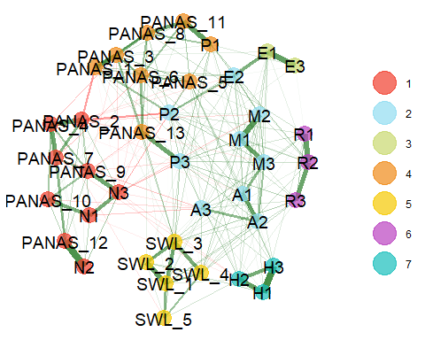

## EGA Results:  
##   
## Number of Dimensions:  
## [1] 7  
##   
## Items per Dimension:  
## items dimension  
## N1 N1 1  
## N2 N2 1  
## N3 N3 1  
## PANAS_2 PANAS_2 1  
## PANAS_4 PANAS_4 1  
## PANAS_7 PANAS_7 1  
## PANAS_9 PANAS_9 1  
## PANAS_10 PANAS_10 1  
## PANAS_12 PANAS_12 1  
## P2 P2 2  
## P3 P3 2  
## E2 E2 2  
## M1 M1 2  
## M2 M2 2  
## M3 M3 2  
## A1 A1 2  
## A2 A2 2  
## A3 A3 2  
## E1 E1 3  
## E3 E3 3  
## P1 P1 4  
## PANAS_1 PANAS_1 4  
## PANAS_3 PANAS_3 4  
## PANAS_5 PANAS_5 4  
## PANAS_6 PANAS_6 4  
## PANAS_8 PANAS_8 4  
## PANAS_11 PANAS_11 4  
## PANAS_13 PANAS_13 4  
## SWL_1 SWL_1 5  
## SWL_2 SWL_2 5  
## SWL_3 SWL_3 5  
## SWL_4 SWL_4 5  
## SWL_5 SWL_5 5  
## R1 R1 6  
## R2 R2 6  
## R3 R3 6  
## H1 H1 7  
## H2 H2 7  
## H3 H3 7

Centrality by New Clusters

|  |  |  |
| --- | --- | --- |
| clusters | Mean Centrality | Median Centrality |
| E | 1.477966 | 1.482635 |
| R | 1.577891 | 1.520297 |
| M & A | 1.772987 | 1.940432 |
| H | 1.996300 | 1.852857 |
| SWL | 1.763348 | 1.486573 |
| Negativity | 1.486028 | 1.448691 |
| Positivity | 1.756223 | 1.886350 |

## Discussion

These results indicate that SWB and PERMA can be considered as a network rather than latent constructs. This provides a new way to view the “building blocks” of well-being. Rather than PERMA being blocks that stack up into a building of well-being, PERMA is a web of experiences that come together to form the means by which one feels well. Just like how a spider’s web catches insects, a PERMA web captures high quality experiences of living. Networks also allow us to look at the most central features of a construct. Which means we can distinguish features of constructs that may be more important for the development of wellbeing.

Considering that positive emotions were most central across models, we can infer that the most important part to experiencing (or at least reporting) wellbeing is experiencing high positive emotions. This does not mean that we must experience positive emotions first to have higher satisfaction with life or meaning, but that all these experiences are likely to somehow connect to positivity. On the other hand, positivity was not the most central in the PERMA+NH model. This might suggest that the more concepts we can add to PERMA, the less important positive emotions may be. However, this did not replicate in the SWB+PERMANH, this could be because SWB shares similar concepts to PERMA. Therefore, PERMA might benefit by adding additional constructs much like the PERMA+4 designed for the workplace.

When we examine the SWB + PERMANH model we see that positive emotions, meaning, accomplishment, and health were more central to the network than SWL, positive affect, or negative affect. This suggests that concepts found in PERMANH might be more theoretically important to the overall concept of well-being than SWB as we measured it here. On the other hand, relationships, engagement, and negative emotions were found to be just as central if not less central than SWB constructs, but R,E, and N were also not highly central in previous PERMA models. We also find that concepts found in PERMA+NH are distinct from SWB per EGA. Even after accounting for this clustering we found our previous results to hold up, PERMA concepts may be more central than concepts of SWB, with the exception of positivity.

Our results show that the need for PERMA resides in the framework for which we wish to look at wellbeing. If wellbeing is considered a single construct with sub factors, then SWB is the preferred way to look at it. However, if we wish to look at well being as an interacting construct, or as some previous writers have suggested a balancing act of positive and negative emotions, then PERMA provides a more accurate lens to examine wellbeing.

###### References

Donaldson, S. I., Heshmati, S., Lee, J. Y., & Donaldson, S. I. (2020). Examining building blocks of well-being beyond PERMA and self-report bias. *The Journal of Positive Psychology*, 1–8.

Goodman, F. R., Disabato, D. J., Kashdan, T. B., & Kauffman, S. B. (2018). Measuring well-being: A comparison of subjective well-being and PERMA. *The Journal of Positive Psychology*, *13*(4), 321–332.

Khaw, D., & Kern, M. (2014). A cross-cultural comparison of the PERMA model of well-being. *Undergraduate Journal of Psychology at Berkeley, University of California*, *8*(1), 10–23.

Seligman, ME. (2011). Flourish: A visionary new understanding of happiness and well-being. *Policy*, *27*(3), 60–1.

Seligman, Martin. (2018). PERMA and the building blocks of well-being. *The Journal of Positive Psychology*, *13*(4), 333–335. <https://doi.org/10.1080/17439760.2018.1437466>

Seligman, M. E., & Csikszentmihalyi, M. (2000). Positive psychology: An introduction. In *Flow and the foundations of positive psychology* (pp. 279–298). Springer.