Compressor Performance Management - Literature Review

# Research Question

What is the best performance management method for air compressors?

# Method

To complete this review the following search engines were used:

1. Google Scholar
2. Science Direct
3. Engineering Village

Search terms used were in the form of “compressed air”, “air compressor” and “pneumatic system” together with the particular approach or method being reviewed, e.g. “air compressor fault detection neural networks”.

Papers were summarised under the main categories of:

* What was the higher goal of the method (e.g. FDD, Optimisation)?
* What method did they use?
* What type of compressor were they using?
* Are there any good leads in the references of the paper? If so make a list to follow.
* What parameters were required/used by the method?
* What faults were detected (if it was an FDD paper)?
* Are there any similarities / differences in opinion between this paper and others reviewed?

# Background

In 2012 industry consumed 2,542 Mtoe of energy globally, which represented over 28% of the 8,980 Mtoe of global final energy consumption (IEA 2012). In an Irish context, industry consumed 2.26 Mtoe of energy in 2012, representing almost 22% of Ireland’s 10.3 Mtoe of final energy consumption. Within the category of industrial energy, compressed air is recognised as an energy intensive utility, accounting for 10% of industrial electricity in the European Union (Saidur et al. 2010). Energy costs typically account for 78% of the total life cycle cost of a compressed air system (Radgen 2006). Compressed air is known colloquially in industry as the “fourth fuel”, due to the high electrical cost associated with generation. Compressed air systems are typically running at 19%% overall system efficiency (Saidur et al. 2010), due to energy losses largely due to lost heat of generation and leakages.

Compressed air is generated in industry using a wide variety of equipment types and configurations. Different types of equipment are suited to different applications in terms of volumetric and pressure requirements. The three key types of compressor installed in industry today are reciprocating, rotary, and centrifugal machines. Their suitability to different volumetric and pressure requirements is summarised in **Figure 1** (SEAI 2007).

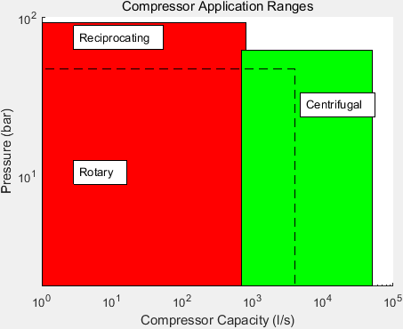

Figure 1: Typical Compressor Application Ranges

Reciprocating and rotary machines are both positive displacement type machines. They work through isolation of a quantity of air in a space which is then reduced in volume. Centrifugal machines are aerodynamic machines, which operate by imparting kinetic energy to air, which is then converted to pressure energy by stopping the moving air.

Given that compressed air represents such a dense form of energy transport, it is beneficial in terms of long and short term overall energy efficiency goals to manage their performance. Performance management is typically achieved through means such as those in **Table 1.**

|  |  |  |
| --- | --- | --- |
| Performance Management Method | Advantages | Disadvantages |
| Maintenance Contracts | Security of asset reliability | Potential for unneccesary work |
| Periodic Audits | Likely to pick up on common opportunities for improvement | Dependent on skill level of auditor |
| Sequence Controllers | Can draw on manufacturer knowledge of system operation | Initial configuration may not be maintained due to system changes |
| BMS Monitoring | Desk-based site wide monitoring capability | Dependent on skill level of BMS reviewer. Unable to pick up on sensor errors |

Table 1: Compressed Air System Performance Management Methods

As is outlined in **Table 1**, the key disadvantages of existing methods are either that they are manual and periodic in nature, or require the intervention of a human expert in compressed air systems to be effective. In the case of maintenance contracts and periodic audits, there is also the potential for unnecessary work to be carried out, as both these measures are typically carried out on a timescale basis. The intervention of a human expert also lends itself to an inefficient method of performance measurement. An expert may be particularly well versed with one type of system, but not another. The disparate range of compressed air systems can lead to an expert restricting themselves to one type of system, preventing possible lessons learned to be applied in other suitable cases.

Research is being carried out to define the future of compressed air system performance management. In this review the research considered is that of ongoing analysis of compressed air system data. This ongoing analysis may have a high level of:

1. Fault detection – monitoring system parameters to determine when the system is in fault condition
2. Fault detection and diagnosis – as for fault detection but with the capability of determining the specific cause of the fault detected
3. Prognostics – monitoring system parameters to predict the time at which a part or component of the compressed air system will no longer perform its intended function (George Vachtsevanos, Frank L. Lewis, Michael Roemer, Andrew Hess n.d.). This can allow for predictive maintenance, ensuring that maintenance is carried out before equipment becomes faulty. Predictive maintenance programs are recognised as more sophisticated than other program types (e.g. corrective, preventive, opportunistic and condition-based). In an analysis of one industrial facility (Bevilacqua & Braglia 2000), compressors were selected from various equipment types as being the type of equipment most warranting the use of a predictive maintenance program. This was decided using an Analytical Hierarchy Process approach, with different equipment types assigned a Criticality Index (CI) based on the potential consequences of failure.
4. Analytics – monitoring system parameters allow the discovery and communication of meaningful patterns which advise on possible improvements to system operation
5. Automated commissioning – automatically achieving, verifying, and documenting satisfaction of the performance of a compressed air system with the current user requirement
6. Optimisation – defining how to achieve the goal of best possible operation of a compressed air system with respect to a defined criterion, typically lowest cost of operation
7. Control – Ensuring that some undesirable condition of a compressed air system is avoided

# Current Methods

This review has categorised different methods for air compressor performance management into three distinct categories, i.e.:

1. Knowledge based (manual methods)
2. Engineering model / rule based (deterministic/quantitative methods)
3. Machine learning / data driven (probabilistic methods)

These three categories of method have different capabilities, benefits and disadvantages, as shown in **Table 3, Table 4,** and **Table 5** **.**

Table 2: Compressor Performance Management Methods

|  |  |  |  |  |  |
| --- | --- | --- | --- | --- | --- |
| ***Group*** | ***Examples*** | ***Description*** | ***Capabilities*** | ***Pros*** | ***Cons*** |
| Group 1: Knowledge Based Methods | Limit checking | Applying thresholds to key sensor values to alert site personnel when alarm level is reached | Failure Analysis Maintenance Planning Decision Support | Significant amount of human knowledge may be formally recorded | Large time commitment required for each and every implementation Difficult to transfer lessons learned to new applications |
| Physical redundancy | Installing parallel sensors in order that site personnel be notified of an error if sensor values do not match |
| Spectrum analysis | Analysis of compressor drive frequency response to alert when response drifts from normal |
| FMEA / FMECA | Analysis of site equipment to determine potential areas of failure and potential effect on other equipment |
| Fault Tree Analysis | Postulation of all potential areas of failure in equipment |
| AHP | Analysis of criticality of equipment to best allocate maintenance resources |

Table 3: Group 1 Compressor Performance Management Methods

|  |  |  |  |  |  |
| --- | --- | --- | --- | --- | --- |
| ***Group*** | ***Examples*** | ***Description*** | ***Capabilities*** | ***Pros*** | ***Cons*** |
| Group 2: Real-time performance management methods Deterministic | Kalman Filter | A Kalman filter may be created for each defined fault state in order to predict the outputs of the compressed air system, and if the prediction error of any filter is zero the system can be diagnosed as being in the relevant fault state | FDD Optimisation Performance comparison and analysis | Typically give a high level of confidence in prediction of plant variables, allowing informed decision making concerning performance improvement opportunities | Normally require a high level of modelling capability from site engineers which may be outside normal role responsibilities New modelling typically required for each performance management implementation |
| Diagnostic Observers | Using observers to form hypothesises as to how to change a model to remove deviations from expected behaviour in ordert to diagnose potential faults |
| Parity Relations | Manipulating system variables to generate fault signatures in the form of residual differences which can be used in operation to diagnose faults |
| Parameter Estimation | Creating a reference fault-free model of a system and analysing actual deviations in variables to diagnose faults, or tuning model in order to optimise the system with respect to some defined factor (e.g. cost) |
| Engineering rules | Formalising potential faults through the use of IF statements to determine when a system is in fault condition by virtue of fundamental engineering principles being broken or changed |

Table 4: Group 2 Compressor Performance Management Methods

|  |  |  |  |  |  |
| --- | --- | --- | --- | --- | --- |
| ***Group*** | ***Examples*** | ***Description*** | ***Capabilities*** | ***Pros*** | ***Cons*** |
| Group 3: Predictive performance management methods Stochastic / Probabilistic Data Mining Statistical Learning Machine Learning | Artificial neural networks | Creation of a network of elements or neurons which may determine variable values based on interconnected element's response to external inputs | FDD Predictive Maintenance Optimisation Analytics Automated Commissioning Automatic Performance Comparison and Analysis | Typically require minimal input from engineering experts Concepts are typically understandable to site engineering when input is required Lessons learned in one facility may be readily applied to new applications given relatively similar configurations of equipment | Typically require a learning period in fault-free condition Probabilistic method involves a level of risk - prediction results may not be as accurate as deterministic, engineering-based methods |
| Association rule learning | Identification of interesting relationships between variables by recognising statistically significant historical relationships |
| Bayesian networks | Creation by learning or using prior knowledge of graphical probabilistic models which give relationships between variables |
| Clustering | Grouping data readings into different groups where intragroup similarity is greater than intergroup similarity |
| Decision tree learning | Definition of the condition a system may be in based on observed variables, represented graphically using a tree structure which may be generated from past data using algorithms such as the ID3 algorithm |
| Genetic algorithms | Determining the optimum point a system can operate at, by selecting random members of a population of samples and using them as parents of successive samples, which tend toward the optimal sample |
| Reinforcement learning | As distinct from supervised and unsupervised learning techniques, this method requires feedback on whether it has correctly predicted the value of a variable and tends toward an optimum based on this feedback |
| PCA | Analysis of a population of variables to determine the population extremes in a given number of directions or components, allowing categorisation of each data point in terms of its position in each direction |
| Support vector machines | A supervised learning technique which when given a sample data set which is labelled according to which class each point belongs in, can determine the optimal plane which splits classes allowing accurate future classification of variables |

Table 5: Group 3 Performance Management Methods

## Knowledge Based Methods

Knowledge based methods are defined for the purposes of this review as those methods which attempt to formalise in code or otherwise the reasoning of a human expert. These systems represent an approach where the engineering or equipment knowledge of an expert is applied in a heuristic fashion.

These systems typically require heavy engagement from system and equipment experts at the time of deployment. This engagement may take the form of interviews and/or site visits with key personnel. The individual opinions of site personnel may vary from facility to facility, and this may prevent lessons learnt being transferred across industries.

From this review it appears that these methods are useful to a certain extent and may be deployed in a facility to ensure that if key personnel retire, valuable knowledge about a compressed air system is not lost. However the amount of time and engagement required for deployment would suggest that for rapid performance improvements in compressed air system performance, other approaches would be more suitable.

### Analytical Hierarchy Process

One such example of a knowledge based system as defined in this review is the Analytical Hierarchy Process (AHP) approach. This is a formal method discussed in detail in (Saaty 2008) to support decision making. Areas including maintenance programming of industrial equipment lend themselves to an AHP approach for decision making, as the approach assists with ensuring all possible factors influencing any decision made are considered.

The AHP method involves initially creating a hierarchy scheme for the decision to be made. An example hierarchy scheme is given in **Figure 2.**

Figure 2: Example AHP Hierarchy Scheme

The hierarchy scheme has three or more levels. The topmost level is the goal, or the question which must be answered. The intermediate level (which may include sublevels) gives the factors which will influence the decision. The final level are the choices that are available to be made for the decision.

In an AHP process, first the factors (and sub factors) are compared in terms of importance with one another. This is done using a pairwise comparison. A pairwise comparison involves comparing each option with the other options available in each group of two available. The number of comparisons available is determined as follows:

$$x= \frac{n(n-1)}{2}$$

$$x= \text{Number of Choices}$$

$$n= \text{Number of Options}$$

The factors are first compared pairwise with each other, typically on a scale between 1 and 9, where 9 significantly favours the option in question over that it is being compared to in terms of importance. A value of 1 signifies that neither is favoured, and the reciprocal of 9 signifies that the other option is significantly favoured. This generates a comparison matrix similar to that shown in **Table 6.** For example, according to the values in the table, reliability is significantly favoured in terms of importance over efficiency, whereas cost is not as important as reliability.

|  |  |  |  |
| --- | --- | --- | --- |
|  | Cost | Reliability | Efficiency |
| Cost | 1 | 1/9 | 5 |
| Reliability | 9 | 1 | 9 |
| Efficiency | 1/5 | 1/9 | 1 |

Table 6: Example AHP Pairwise Comparison Matrix

By taking the normalised eigenvector of this table as a matrix, a priority vector may be obtained. Calculating a normalised eigenvector of a matrix is outside the scope of this review, but the priority vector obtained for the matrix of Error! Reference source not found. is as follows:

$$\text{Priority Vector = }\begin{matrix}0.17 \\ 0.767 \\ 0.059\end{matrix}$$

This step is repeated for the lower level for each choices suitability at satisfying each factor. The weights obtained in the first priority vector are combined with those obtained in the second priority vector, to give an overall weight for each choice. The choice with the highest weight may then be taken as the preference with all relevant factors considered.

#### (Bevilacqua & Braglia 2000)

(Bevilacqua & Braglia 2000) presented an application of the AHP method to determine the correct maintenance strategy to use for different types of equipment in an oil refining facility, based on a limited budget. The types of maintenance strategy to choose from were:

1. Corrective maintenance
2. Preventive maintenance
3. Opportunistic maintenance
4. Condition-based maintenance
5. Predictive maintenance

The maintenance strategies given above are arranged in order of increasing cost. It had been determined previously at the test facility in question that equipment types such as air compressors warranted the extra expenditure associated with predictive maintenance. This had been determined through a FMECA process. The authors demonstrated using an AHP approach that air compressors did warrant the extra expenditure of predictive maintenance. This was based on the critical factors determined for the maintenance needs of the facility, namely:

1. Damages that could be caused by a failure in the equipment being analysed
2. Applicability of the maintenance strategy to the equipment in question
3. Added value created by employing the maintenance strategy to the equipment in question
4. Cost of implementation of the maintenance strategy

These four key factors were then split into various sub factors, and the AHP methodology applied to determine which maintenance strategy most suited each type of equipment. Site equipment was split into three distinct groups, with an example, representative machine analysed using the AHP methodology to determine the appropriate maintenance strategy.

It was found that predictive maintenance was most suited for air compressor maintenance at the facility, based on the factors described above. This highlights the criticality of air compressors as industrial utility equipment.

The AHP methodology is demonstrative of the fact that a significant amount of human expert knowledge is required to create and deploy manual knowledge based systems of the type given in this group. The advantage gained by deploying these types of systems is the formal recording of significant amounts of human knowledge, however this comes at a significant time cost, with lessons learned in one facility difficult to apply to another. Ultimately this group of methods is well suited to the role of decision support system.

## Model-Based Methods

The second category of method for compressor performance management considered in this review are model based methods. These methods are deterministic in that they employ some model which will always generate the same output for given inputs.

Model-based methods for compressor performance management may be broadly divided into two categories:

1. Analytical redundancy methods
2. Parameter estimation methods

Both of these approaches rely on generating residual patterns for diagnosis of why a compressor is not performing as expected, i.e. fault detection and diagnosis. Parameter estimation methods may be used for compressor optimisation and performance analysis.

Analytical redundancy methods are further subdivided into the following categories:

1. Kalman Filters
2. Diagnostic Observers
3. Parity (Consistency) Relations

For the purpose of fault detection and diagnosis, the difference between model-based methods and other traditional methods such as those discussed in **Section 4.1** is evident in the concept of redundancy. Where model-free methods often employ physical redundancy by comparing identical sensors in parallel to determine faults, model-based methods usually incorporate some level of analytical redundancy (Gertler 1998). This analytical redundancy compares actual sensor readings with analytically calculated values to determine when a system is in fault condition. Any differences between calculated and measured values may then be represented as residuals. These residuals may then be evaluated to diagnose the specific fault in the compressed air system. Often the analytically calculated values are generated for a variety of fault conditions, to determine the residual patterns for each fault. This process is summarised in **Figure 3.**



Figure 3: Typical Model-Based FDD Process

The analytical redundancy approaches to fault detection are summarised as follows:

1. Kalman Filters
   * A Kalman Filter can remove noise to assist in the prediction of a variable from a mathematical model. Since the prediction error of the Kalman filter will be zero in the case of no fault, the residual generated may be used as a fault detection residual. In addition, Kalman filters may be constructed for each potential fault state of a compressed air system, and if the prediction error of the filter is zero for any of the bank of filters, the fault in question may be diagnosed. Kalman filters have been used with some success to detect compressed air leakage by (Krichel & Sawodny 2011).
2. Diagnostic Observers
   * Diagnostic observers can be used to diagnose faults by analysing a deviation from expected behaviour, and forming a diagnostic hypothesis as a change to the mathematical model of the compressed air system which removes the deviation from expected behaviour (van Harmelen et al. 2008).
3. Parity (consistency) relations
   * Parity relations are a method for fault diagnosis which operate by manipulating compressed air model observables in order to generate the residuals associated with particular faults (Kabbaj et al. 2003). These residuals may then be compared with measured residuals for fault diagnosis.

Parameter estimation operates differently to analytical redundancy methods in that a reference model is first created by identifying a fault-free condition of the compressed air plant (Gertler 1998). Deviations from this reference model are then used to generate residuals, which must be individually evaluated to diagnose faults. This method is reliable in that the intervention of a human expert is typically required at the residual evaluation stage, however this adds a time cost to the method.

For the purpose of optimisation model-based methods can be used to improve a compressed air system’s performance with respect to some variable (e.g. energy efficiency). This can be achieved by analysing many potential operational scenarios through a computer model, with no risk to an installed system, before implementing a change to the physical plant’s operational characteristics. This is the method and goal which are reviewed in **Section 4.2.1** of this paper.

### (Xenos et al. 2015)

(Xenos et al. 2015) presented a paper describing a model-based optimisation of a network of air compressors in parallel. The compressors analysed were large (tens of MW) multistage centrifugal air compressors. The modelling approach taken was data-driven, in that training data was used to develop a black-box model of the air compressors.

Training data was split into a calibration step and a validation step, and a regression approach taken to determine the parameters of the model.

The values measured for input to the model were:

* ma = mass flow of air entering the compressor
* Tin = ambient temperature at compressor inlet
* pin = ambient pressure at compressor inlet
* pout = compressor discharge pressure

By taking these variables as inputs to the black-box model, the electrical power drawn by the compressor, Pel was determined for the different compressors in the compressor station.

The black-box model developed took the form of a polynomial regression model, given in

$${y^{*}}_{\left(i,t\right)}=b_{(i,0)}+ b_{(i,1)}.{x^{*}}_{\left(i,1,t\right)}+b_{(i,2)}.{x^{*}}_{\left(i,2,t\right)}+b_{(i,3)}.{x^{*}}_{\left(i,3,t\right)}+b_{(i,4)}.{x^{*}}_{\left(i,4,t\right)}+b_{(i,5)}.{x^{*^{2}}}_{\left(i,1,t\right)}+b_{(i,6)}.{x^{*^{2}}}_{\left(i,2,t\right)}+b_{(i,7)}.{x^{*^{2}}}_{\left(i,3,t\right)}+b_{(i,8)}.{x^{*^{2}}}_{\left(i,4,t\right)}+b_{(i,9)}.{x^{*}}_{\left(i,1,t\right)}{{.x}^{*}}_{\left(i,2,t\right)}+{{b_{(i,10)}.{x^{*}}_{\left(i,1,t\right)}.x}^{*}}_{(i,3,t)}+b_{(i,11)}.{x^{*}}_{\left(i,1,t\right)}.{x^{*}}_{\left(i,4,t\right)}$$

Where y*(i,t) = y(i,t) / ymaxi ; x(i,j,t) = x*(i,j,t) / xmax(i,j) are the scaled variables of the regression models of the compressors in set I, and y(i,t) = Pel(i,t). The parameters bm, m = 1,….,12 are calculated using regression methods.

In a related work (Xenos et al. 2014) the same authors developed two black box models with similar variables and the addition of the inlet guide vane angle as an input to the models. This allowed the mass flow rate of air to be predicted initially, with this predicted variable used together with the inlet guide vane angle, ambient temperature and pressure, and compressor discharge pressure to calculate the electrical power consumed by the compressor. The two approaches taken by the authors in these papers are summarised in **Figure 4** and **Figure 5.**

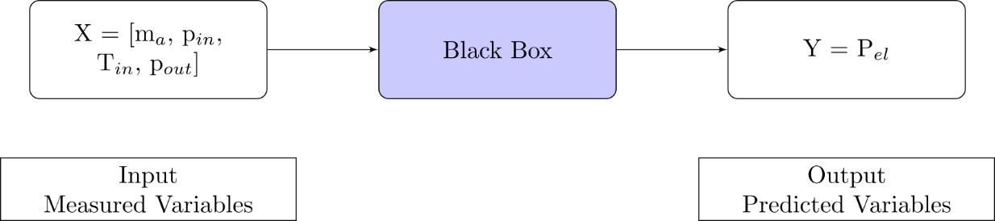

Figure 4: Black-box model for Power prediction (Xenos et al. 2015)

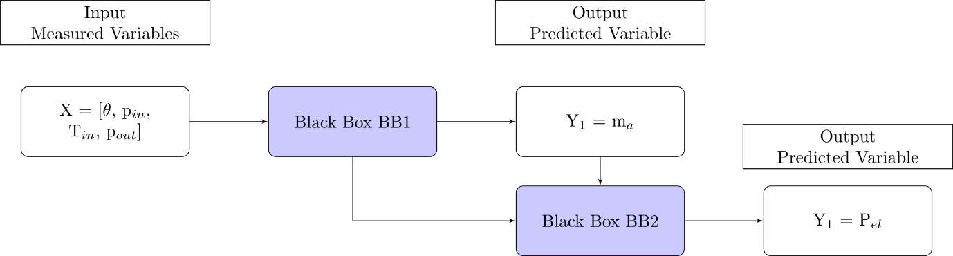

Figure 5: Alternative black-box model for Power prediction (Xenos et al. 2014)

By obtaining a mathematical model for the power drawn by the compressors in the compressor station (which are configured in parallel), the authors then attempted to optimise the plant’s operation in terms of electrical power drawn. This was achieved by minimising the power of all compressors in the station according to the following equation:

This was achieved by minimising the power of all compressors in the station according to the following equation:

$$\min_{ω^{*}} \sum_{i∊I}{P_{(el,i,t_{r})}}$$

This equation was subject to the following contraints, normalisations, mass balances and regression domain:

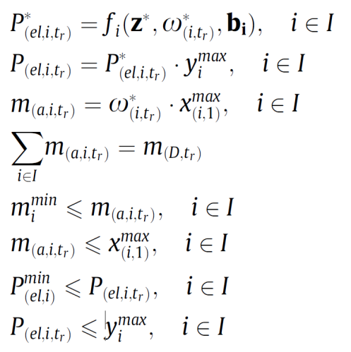

The optimisation approach was carried out by the authors in Matlab. The approach was successful in reducing the overall power consumption of the compressor station by optimally sharing the load between compressors. The optimisation approach resulted in a lower power consumption than the actual operation of the compressors, which shared the load using defined operational procedure for the test site.

## Probabilistic Methods

The final category of method for compressor performance management considered in this review is the category of probabilistic or stochastic methods. This category encompasses approaches including data mining, statistical learning and machine learning.

With these methods there is an element of probability, for example for a fault diagnosis application, there is typically a goal of identifying faults to some degree of accuracy.

Probabilistic methods have been applied in various forms to compressor performance management. Artificial Neural Networks (ANNs) have been applied for the purpose of generating a compressor’s performance map when a degradation in performance has occurred (Yu et al. 2007; Ghorbanian & Gholamrezaei 2009) and to optimise a compressor’s operating conditions (Cortés et al. 2009). ANNs, Support Vector Machines (SVMs) and Deep Belief Networks (DBNs) have both been used with success to detect valve faults in reciprocating air compressors (Cui et al. 2009; Qin et al. 2012; Verma et al. 2011; James Li & Yu 1995; Tran et al. 2014). Fault diagnosis of sensors and actuators in centrifugal compressor equipment using Principal Component Analysis (PCA) has been achieved (Zanoli et al. 2010). (Petković et al. 2012) presented a clustering method for fault detection of air compressors.

From this review an ANN based approach appears to be the most prolific method of compressor performance management in recent literature, therefore ANNs will be discussed and an example paper which applied an ANN approach will be reviewed.

### Artificial Neural Networks (ANNs)

ANNs are statistical learning models which attempt to replicate the behaviour of biological neurons in the manner in which they process information. Another name that is given to these neurons in an ANN context is perceptrons. **Figure 6** depicts a typical perceptron’s information flow.

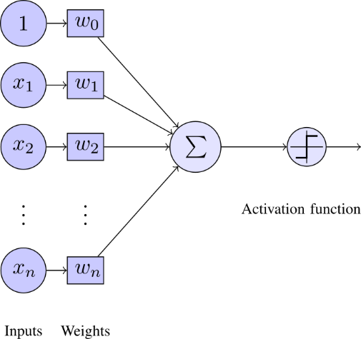

Figure 6: Perceptron Overview

As can be seen in **Figure 6**, a perceptron takes many weighted inputs, adds them together and passes the total to an activation function. The activation function then outputs a useful value depending on the sum of weighted inputs passed to it. In **Figure 6** the activation function is a step function, that is it will output 1 if the sum of the weighted inputs exceeds some threshold, and 0 otherwise. An analogy to biological neurons here would be that the perceptron will fire if the threshold is met.

**Figure 6** shows one perceptron, but an ANN is made up of many neurons or perceptrons. **Figure 7** shows a typical ANN, where there is an input layer, a hidden layer, and finally the output layer. In this example there is one hidden layer, but there can often be two or more hidden layers. Similarly there is not a restriction to one output for an ANN, there may be more than one perceptron in the output layer of the ANN. In the example, all information paths flow from the Input layer to the Output layer, which makes the network a feed forward network. There are other types of neural network which allow information to flow back in the opposite direction as well, these are known as feedback networks. Once there are more than two layers in the network (i.e. at least one hidden layer) the network is known as a multilayer perceptron network. Through the use of a training period, the correct weights may be assigned to the neurons in a network to accurately predict the outputs of a compressor system for a range of inputs.

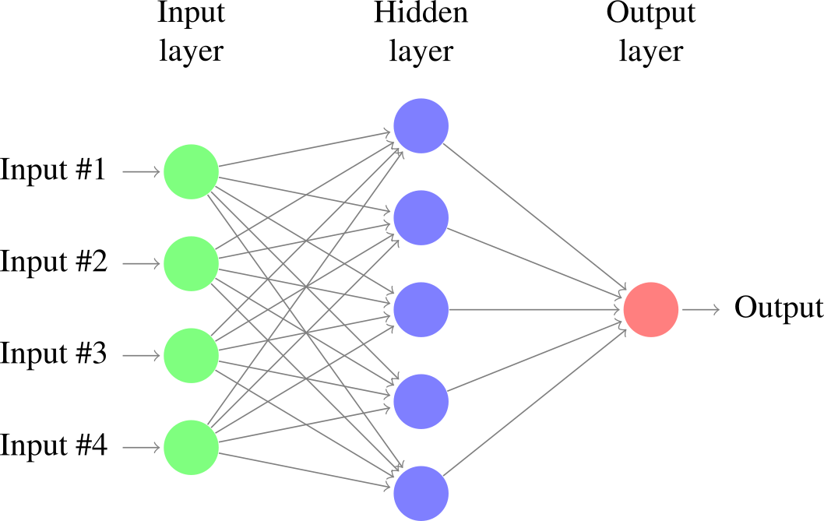

Figure 7: Typical Artifical Neural Network (ANN)

### (Ghorbanian & Gholamrezaei 2009)

In this paper different neural network model types were reviewed for accuracy in generating a gas generator’s compressor performance characteristic map. The four types reviewed were:

1. Generalised regression neural net-work (GRNN)
   * Generalised regression neural networks do not require an iterative training procedure, but rather approximate the functions between inputs from one initial training data set.
2. Modified GRNN
   * This method which was developed by the authors involved taking a GRNN and transforming the values to reduce the computational load involved in the initial training period
3. Multilayer perceptron network
   * In this paper the multilayer perceptron network involved two hidden layers, which could generate the compressor performance characteristic map when given the corrected massflow rate and rotational speed of the compressor in question.
4. Radial basis function network
   * This type of network uses radial basis functions as activation functions for each perceptron. The output of a radial basis function is dependent on the inputs distance from some origin, that is to say $Φ\left(x\right)= Φ(\left\|x\right\|)$. This ensures that the output of the activation function is symmetrical about a mean which assists in reducing computational time for a neural network.

The two types of neural network found to be most effective in reconstructing a compressor’s performance map were modified or rotated GRNN and multilayer perceptron. Rotated GRNN was found to be most accurate in terms of closest agreement of results with training data, it was limited as a method to predicting the compressor performance map within the limits of training data given to it, and i.e. it is limited to interpolation. Multilayer perceptron networks are more suited to predicting a compressor’s performance characteristic at any operational point of the compressor, i.e. it can extrapolate to outside the given experimental training data. It was determined that multilayer perceptron neural networks are the most powerful of those reviewed in reconstructing compressor performance characteristic maps.

A key accuracy measure was that the performance map of a compressor was able to be reconstructed to 92% accuracy using 50% of available training data. Also by using the output of one neural network together with one measured parameter (corrected mass flow rate of air) as the inputs of another neural network the efficiency of the compressor could be predicted to an extremely high accuracy.

The authors had the same opinion as (Yu et al. 2007) in that neural networks provide an effective means of reconstructing a compressor’s characteristic performance curve when experimental or manufacturer’s data is not available, e.g. in off-design conditions.

# Discussion and Conclusion

This review took into consideration many different options for compressor performance management methods, each of which has its own merits and disadvantages. After consideration of each methods individual attributes, it appears that the most promising current research into compressor performance management lies between the deterministic and probabilistic approaches. In particular, the data-driven regression model approach taken by (Xenos et al. 2015), the ANN approach taken by (Ghorbanian & Gholamrezaei 2009) and the DBN approach (a form of ANN) taken by (Tran et al. 2014) stand out as the state of the art for compressor optimisation and fault diagnosis. It is the intention of the author to explore these methods with a test data set from an operational compressed air station serving a small-scale pharmaceutical facility.

# Abbreviations

|  |  |
| --- | --- |
| Abbreviation | Meaning |
| AHP | Analytical Hierarchy Process |
| RCM | Reliability Centred Maintenance |
| FMEA | Failure Mode and Effect Analysis |
| FMECA | Failure Mode Effect and Criticality Analysis |
| FDD | Fault Detection and Diagnosis |
| RBM | Restricted Boltzmann Machine |
| WSM | Weighted Sum Model |
| ANN | Artificial Neural Network |
| MLP | Multi Layer Perceptron |

# References

Bevilacqua, M. & Braglia, M., 2000. The analytic hierarchy process applied to maintenance strategy selection. *Reliability Engineering & System Safety*, 70(1), pp.71–83.

Cortés, O., Urquiza, G. & Hernández, J. a., 2009. Optimization of operating conditions for compressor performance by means of neural network inverse. *Applied Energy*, 86(11), pp.2487–2493. Available at: http://dx.doi.org/10.1016/j.apenergy.2009.03.001.

Cui, H. et al., 2009. Research on fault diagnosis for reciprocating compressor valve using information entropy and SVM method. *Journal of Loss Prevention in the Process Industries*, 22(6), pp.864–867. Available at: http://dx.doi.org/10.1016/j.jlp.2009.08.012.

George Vachtsevanos, Frank L. Lewis, Michael Roemer, Andrew Hess, B.W., *Intelligent Fault Diagnosis and Prognosis for Engineering Systems*,

Gertler, J., 1998. *Fault Detection and Diagnosis in Engineering Systems*, Available at: http://books.google.com/books?id=fmPyTbbqKFIC.

Ghorbanian, K. & Gholamrezaei, M., 2009. An artificial neural network approach to compressor performance prediction. *Applied Energy*, 86(7-8), pp.1210–1221. Available at: http://dx.doi.org/10.1016/j.apenergy.2008.06.006.

Van Harmelen, F., Lifschitz, V. & Porter, B., 2008. *Handbook of Knowledge Representation*, Elsevier Science. Available at: https://books.google.ie/books?id=xwBDylHhJhYC.

IEA, 2012. International Energy Agency. *IEA*. Available at: http://www.iea.org [Accessed August 5, 2015].

James Li, C. & Yu, X., 1995. High pressure air compressor valve fault diagnosis using feedforward neural networks. *Mechanical Systems and Signal Processing*, 9(5), pp.527–536. Available at: http://www.sciencedirect.com/science/article/pii/S0888327085700404 [Accessed July 23, 2015].

Kabbaj, N. et al., 2003. Fault detection and isolation in a greenhouse using parity relations. *EFTA 2003. 2003 IEEE Conference on Emerging Technologies and Factory Automation. Proceedings (Cat. No.03TH8696)*, 2(OCTOBER).

Krichel, S. V & Sawodny, O., 2011. Analysis and optimization of compressed air networks with model-based approaches. *Pneumatica*, pp.334–341.

Petković, M. et al., 2012. On-line adaptive clustering for process monitoring and fault detection. *Expert Systems with Applications*, 39(11), pp.10226–10235.

Qin, Q. et al., 2012. A novel scheme for fault detection of reciprocating compressor valves based on basis pursuit, wave matching and support vector machine. *Measurement: Journal of the International Measurement Confederation*, 45(5), pp.897–908. Available at: http://dx.doi.org/10.1016/j.measurement.2012.02.005.

Radgen, P., 2006. Efficiency through compressed air energy audits. In *Energy Audit Conference, www. audit06. fi*.

Saaty, T.L., 2008. Decision making with the analytic hierarchy process. *International Journal of Services Sciences*, 1(1), p.83.

Saidur, R., Rahim, N.A. & Hasanuzzaman, M., 2010. A review on compressed-air energy use and energy savings. *Renewable and Sustainable Energy Reviews*, 14(4), pp.1135–1153. Available at: http://www.sciencedirect.com/science/article/pii/S1364032109002755 [Accessed March 24, 2014].

SEAI, 2007. *Compressed Air Technical Guide*, Dublin.

Tran, V.T., Althobiani, F. & Ball, A., 2014. An approach to fault diagnosis of reciprocating compressor valves using Teager-Kaiser energy operator and deep belief networks. *Expert Systems with Applications*, 41(9), pp.4113–4122. Available at: http://dx.doi.org/10.1016/j.eswa.2013.12.026.

Verma, N.K., Roy, A. & Salour, A., 2011. An optimized fault diagnosis method for reciprocating air compressors based on SVM. *Proceedings - 2011 IEEE International Conference on System Engineering and Technology, ICSET 2011*, pp.65–69.

Xenos, D.P. et al., 2015. Optimization of a network of compressors in parallel: Real Time Optimization (RTO) of compressors in chemical plants – An industrial case study. *Applied Energy*, 144, pp.51–63. Available at: http://linkinghub.elsevier.com/retrieve/pii/S0306261915000161.

Xenos, D.P. et al., 2014. Preprocessing of Raw Data for Developing Steady-State Data-Driven Models for Optimizing Compressor Stations. , (July).

Yu, Y. et al., 2007. Neural-network based analysis and prediction of a compressor’s characteristic performance map. *Applied Energy*, 84(1), pp.48–55.

Zanoli, S.M., Astolfi, G. & Barboni, L., 2010. Applications of fault diagnosis techniques for a multishaft centrifugal compressor. *18th Mediterranean Conference on Control and Automation, MED’10 - Conference Proceedings*, pp.64–69.