Compressor Performance Management - Literature Review

# Research Question

What is the best performance management method for air compressors?

# Method

To complete this review the following search engines were used:

1. Google Scholar
2. Science Direct
3. Engineering Village

Search terms used were in the form of “compressed air”, “air compressor” and “pneumatic system” together with the particular approach or method being reviewed, e.g. “air compressor fault detection neural networks”.

Papers were summarised under the main categories of:

* What was the higher goal of the method (e.g. FDD, Optimisation)?
* What method did they use?
* What type of compressor were they using?
* Are there any good leads in the references of the paper? If so make a list to follow.
* What parameters were required/used by the method?
* What faults were detected (if it was an FDD paper)?
* Are there any similarities / differences in opinion between this paper and others reviewed?

# Background

In 2012 industry consumed 2,542 Mtoe of energy globally, which represented over 28% of the 8,980 Mtoe of global final energy consumption (IEA 2012). In an Irish context, industry consumed 2.26 Mtoe of energy in 2012, representing almost 22% of Ireland’s 10.3 Mtoe of final energy consumption. Within the category of industrial energy, compressed air is recognised as an energy intensive utility, accounting for 10% of industrial electricity in the European Union (Saidur et al. 2010). Energy costs typically account for 78% of the total life cycle cost of a compressed air system (Radgen 2006). Compressed air is known colloquially in industry as the “fourth fuel”, due to the high electrical cost associated with generation. Compressed air systems are typically running at 19% overall system efficiency (Saidur et al. 2010), due to energy losses largely due to lost heat of generation and leakages.

Compressed air is generated in industry using a wide variety of equipment types and configurations. Different types of equipment are suited to different applications in terms of volumetric and pressure requirements. The three key types of compressor installed in industry today are reciprocating, rotary, and centrifugal machines. Their suitability to different volumetric and pressure requirements is summarised in **Figure 1** (SEAI 2007).

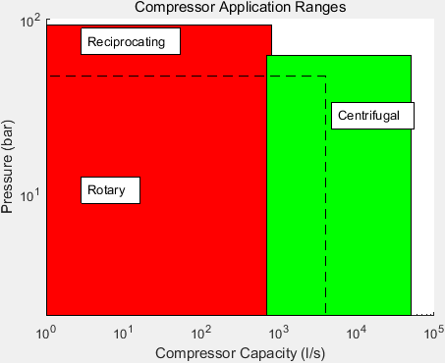

Figure : Typical Compressor Application Ranges

Reciprocating and rotary machines are both positive displacement type machines. They work through isolation of a quantity of air in a space which is then reduced in volume. Centrifugal machines are aerodynamic machines, which operate by imparting kinetic energy to air, which is then converted to pressure energy by stopping the moving air.

Given that compressed air represents such a dense form of energy transport, it is beneficial in terms of long and short term overall energy efficiency goals to manage the performance of air compressors. Performance management is typically achieved through means such as those in **Table 1.**

|  |  |  |
| --- | --- | --- |
| ***Performance Management Method*** | ***Advantages*** | ***Disadvantages*** |
| Maintenance Contracts | Security of asset reliability | Potential for unnecessary work |
| Periodic Audits | Likely to pick up on common opportunities for improvement | Dependent on skill level of auditor |
| Sequence Controllers | Can draw on manufacturer knowledge of system operation | Initial configuration may not be maintained due to system changes |
| BMS Monitoring | Desk-based site wide monitoring capability | Dependent on skill level of BMS reviewer. Unable to pick up on sensor errors |

Table : Compressed Air System Performance Management Methods

As is outlined in **Table 1**, the key disadvantages of existing methods are either that they are manual and periodic in nature, or require the intervention of a human expert in compressed air systems to be effective. In the case of maintenance contracts and periodic audits, there is also the potential for unnecessary work to be carried out, as both these measures are typically carried out on a timescale basis. The intervention of a human expert also lends itself to an inefficient method of performance measurement. An expert may be particularly well versed with one type of system, but not another. The disparate range of compressed air systems can lead to an expert restricting themselves to one type of system, preventing possible lessons learned to be applied in other suitable cases.

Research is being carried out to define the future of compressed air system performance management. In this review the research considered is that of ongoing analysis of compressed air system data. This ongoing analysis could be designated as having any of the goals outlined in **Table 2**.

The high level goals or approaches given in **Table 2** may be achieved using a variety of methods, which are discussed in **Section 0.**

|  |  |  |
| --- | --- | --- |
| ***Goal*** | ***Description*** | ***Example Work*** |
| Fault Detection and Diagnosis | Monitor system parameters to determine when system is in fault condition and the potential reasons for the identified fault | Using vibration, pressure and current signals to diagnose valve faults for a reciprocating compressor (Tran et al. 2014) |
| Prognostics | Monitoring system parameters to determine when a component of a system will no longer perform its intended function (Vachtsevanos et al. 2006) | Determining the remaining useful life of a gaseous circuit breaker based on gas pressure and ambient temperature (Catterson & Costello 2013) |
| Analytics | Monitoring system parameters to discover meaningful patterns which may advise on potential improvements to system operation | Determining abnormal appliance power consumption based on analysis of individual appliance’s acoustic noise (Pathak et al. 2015) |
| Automated Commissioning | Achieving, verifying and documenting that the performance of a system satisfies the current user requirement | Automatically carrying out the normal testing procedure for an air compressor by replicating the tasks normally carried out during commissioning (Mazid & Martin 2008) |
| Optimisation | Improving system operation or design as measured against some defined criteria | Development of a tool which delivers an optimal design for a compressed air system based on energy and life cycle costing (Friden et al. 2012) |
| Control | Managing the operation of a system in order that operating conditions remain in line with design states and undesirable states are avoided | Development of a control algorithm for fixed speed compressors that provides the pressure control capabilities of a variable speed system while limiting energy consumption (Facchinetti et al. n.d.) |

Table : Analysis Approaches for Industrial Equipment

# Current Methods

This review categorises industrial utility performance management methods into three high-level classifications, which are themselves subdivided into individual methods. These three categories are:

1. Quantitative Model Based
2. Qualitative Model Based
3. Data Based

These three categories are shown visually in **Figure 2**, which is adapted from previous works on system performance management and diagnostic approaches (Katipamula & Brambley 2005; Venkatasubramanian, Rengaswamy, Yin, et al. 2003; Venkatasubramanian, Rengaswamy & Kavuri 2003; Venkatasubramanian 2003; Gao et al. 2015a; Gao et al. 2015b).

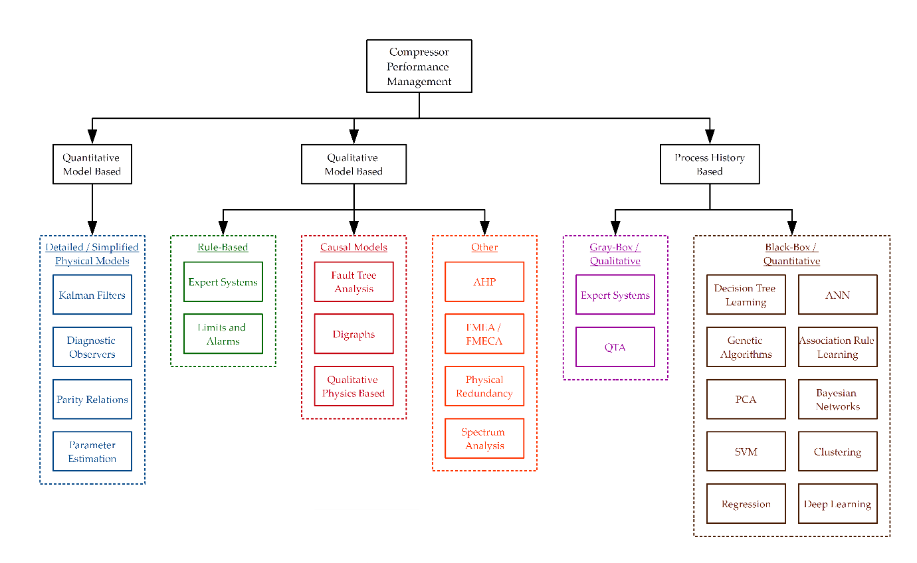

Figure : Performance Management Methods

These three categories of method have different capabilities, benefits and disadvantages, as shown in **Table 4, Table 5,** and **Table 6** **.**

|  |  |  |  |  |
| --- | --- | --- | --- | --- |
| ***Method*** | ***Description*** | ***Benefits*** | ***Disadvantages*** | ***Examples*** |
| Kalman Filters | A Kalman filter allows the combination of observed and predicted parameters to more accurately predict future parameters than with a physical model alone. It also allows for the reduction of the effects of noisy data on models. | Very accurate  Transients may be modelled | Computationally expensive  Complex to create  Typically require many inputs from system | Surge control for axial compressors (Backi et al. 2013)  Fault detection for gas turbine compressors ((Salar et al. 2010)  State estimation of a thermal power plant (Nair et al. 2011) |
| Diagnostic Observers – switch def with parity relations | Using observers to form hypotheses as to how to change a model to remove deviations from expected behaviour | Accurate isolation of individual faults possible | Observers required for each individual potential fault state | Fault detection of a steam boiler feed water preheater (Tarantino et al. 2000)  Estimation of a steam boiler’s pressure given fuel and feed water conditions (Ramezanifar et al. 2006) |
| Parity Relations – switch def with diagnostic observers | Manipulating system variables to generate fault signatures in the form of residual differences which can be used in operation to diagnose faults | Accurate isolation of individual faults possible | Fault signatures required for each individual fault state | Fault diagnosis of a wind farm using interval nonlinear parameter-varying parity equations (Blesa et al. 2014) |
| Parameter Estimation | Comparison of modelled data, normally using ordinary and partial differential equations, with measured data, with analysis of any residuals to diagnose faults | High level of confidence in modelled data | Detailed physical model required for accuracy  Difficult to isolate individual causes of faults | Optimisation of the modelling of a multistage compressor using parameter estimation to determine the surge line (Dapeng Niu et al. 2011) |

Figure : Quantitative Model Based Methods

|  |  |  |  |  |
| --- | --- | --- | --- | --- |
| ***Method*** | ***Description*** | ***Benefits*** | ***Disadvantages*** | ***Examples*** |
| Expert Systems |  |  |  | Fault diagnosis assistance using IF-THEN rules for an air compressor (Liu 2001) |
| Physical Redundancy | Installing parallel sensors in order that site personnel be notified of an error if sensor values do not match |  |  | Development of a framework for analysis of fault detection schemes based on analytical and physically redundant sensor for aircraft (Wheeler et al. 2011) |
| Analytical Hierarchy Process |  |  |  | Maintenance strategy selection for equipment at an oil refinery (Bevilacqua & Braglia 2000) |
| Spectrum Analysis | Analysis of compressor drive and vibrational frequency response to alert when response drifts from normal |  |  | Vibration analysis of reciprocating comrpessors for valve failure diagnosis (Ruilin Lin et al. 2010) |
| Fault Tree Analysis | Postulation of all potential areas of failure in equipment |  |  | Reliability assessment of an anti-surge control system for a centrifugal compressor (Ren et al. 2012) |
| FMEA / FMECA | Analysis of site equipment to determine potential areas of failure and potential effect on other equipment |  |  | Development of a compressor safety evaluation model (Zhu et al. 2013) |
| Qualitative Physics Based |  |  |  | Fault Detection for an AHU (Glass et al. 1995) |
| Digraphs |  |  |  | FDD for a typical industrial process using SDG for model decomposition (Shin et al. 2007) |
| Limits and Alarms | Implementation of user defined limits on key parameters which flag when exceeded or are not met | With correct identification of thresholds can quickly highlight issues with systems | Little diagnosis and isolation potential  Correct selection of thresholds dependent on user expertise | Incorporated into modern compressor PLCs |

Table : Qualitative Model Based Methods

|  |  |  |  |  |
| --- | --- | --- | --- | --- |
| ***Method*** | ***Description*** | ***Benefits*** | ***Disadvantages*** | ***Examples*** |
| Support Vector Machine / Relevance Vector Machine | A supervised learning technique which when given a sample data set which is labelled according to which class each point belongs in, can determine the optimal plane which splits classes allowing accurate future classification of variables |  |  | Compressed air load forecasting for large flows (Liu et al. 2013)  Fault diagnosis for reciprocating air compressor valves (Wang et al. 2010; Cui et al. 2009; Qin et al. 2012; James Li & Yu 1995)  Fault diagnosis for reciprocating air compressors (Verma et al. 2011) |
| PCA | Analysis of a population of variables to determine the population extremes in a given number of directions or components, allowing categorisation of each data point in terms of its position in each direction |  |  | Sensor fault detection, diagnosis and estimation for centrifugal chillers (Wang & Cui 2005)  Fault detection and isolation for a centrifugal compressor (Zanoli & Astolfi 2013)  Sensor and actuator fault diagnosis for a centrifugal compressor (Zanoli et al. 2010a) |
| Artificial Neural Networks |  |  |  | Valve failure detection for reciprocating compressors (Namdeo et al. 2008)  Neural network based fault diagnosis of a reciprocating compressor employing genetic algorithms for initial parameter identification (Jinru et al. 2008)  Performance prediction of a centrifugal air compressor employing artificial neural networks and genetic algorithms (Luo Fangqiong & Huang Shengzhong 2011)  Generation of a gas generator’s compressor performance characteristic map (Ghorbanian & Gholamrezaei 2009; Yu et al. 2007) |
| Genetic Algorithms | Determining the optimum point a system can operate at, by selecting random members of a population of samples and using them as parents of successive samples, which tend toward the optimal sample |  |  | Noise minimisation of a hermetic compressor (Dasilva 2004)  Neural network based fault diagnosis of a reciprocating compressor employing genetic algorithms for initial parameter identification (Jinru et al. 2008)  Performance prediction of a centrifugal air compressor employing artificial neural networks and genetic algorithms (Luo Fangqiong & Huang Shengzhong 2011)  Parameter identification for a centrifugal compressor model (Xiaogang et al. 2013) |
| Decision Tree Learning |  |  |  | Fault diagnosis for a modular production system (Demetgul 2013) |
| Deep Learning |  |  |  | Reciprocating compressor valve fault diagnosis (Tran et al. 2014) |
| Clustering | Grouping data readings into different groups where intragroup similarity is greater than intergroup similarity |  |  | Fault detection and isolation for a centrifugal compressor based on PCA and Clustering (Zanoli et al. 2010b)  Adaptive clustering for pneumatic system fault detection (Petković et al. 2012) |
| Bayesian Networks | Creation by learning or using prior knowledge of graphical probabilistic models which give relationships between variables |  |  | Fault diagnosis of a pneumatic air braking system (Lingling 2010)  Fault detection via classification of compressor variables compressed dimensionally via PCA (Liu & Chen 2009) |
| Regression |  |  |  | Optimisation of a network of comrpessors in parallel (Kopanos et al. 2015) |

|  |  |  |  |  |  |
| --- | --- | --- | --- | --- | --- |
| ***Group*** | ***Examples*** | ***Description*** | ***Capabilities*** | ***Pros*** | ***Cons*** |
| Group 1: Knowledge Based Methods | Limit checking | Applying thresholds to key sensor values to alert site personnel when alarm level is reached | Failure Analysis Maintenance Planning Decision Support | Significant amount of human knowledge may be formally recorded | Large time commitment required for each and every implementation Difficult to transfer lessons learned to new applications |
| Physical redundancy | Installing parallel sensors in order that site personnel be notified of an error if sensor values do not match |
| Spectrum analysis | Analysis of compressor drive frequency response to alert when response drifts from normal |
| FMEA / FMECA | Analysis of site equipment to determine potential areas of failure and potential effect on other equipment |
| Fault Tree Analysis | Postulation of all potential areas of failure in equipment |
| AHP | Analysis of criticality of equipment to best allocate maintenance resources |

Table : Group 1 Compressor Performance Management Methods

|  |  |  |  |  |  |
| --- | --- | --- | --- | --- | --- |
| ***Group*** | ***Examples*** | ***Description*** | ***Capabilities*** | ***Pros*** | ***Cons*** |
| Group 2: Real-time performance management methods Deterministic | Kalman Filter | A Kalman filter may be created for each defined fault state in order to predict the outputs of the compressed air system, and if the prediction error of any filter is zero the system can be diagnosed as being in the relevant fault state | FDD Optimisation Performance comparison and analysis | Typically give a high level of confidence in prediction of plant variables, allowing informed decision making concerning performance improvement opportunities | Normally require a high level of modelling capability from site engineers which may be outside normal role responsibilities New modelling typically required for each performance management implementation |
| Diagnostic Observers | Using observers to form hypothesises as to how to change a model to remove deviations from expected behaviour in order to diagnose potential faults |
| Parity Relations | Manipulating system variables to generate fault signatures in the form of residual differences which can be used in operation to diagnose faults |
| Parameter Estimation | Creating a reference fault-free model of a system and analysing actual deviations in variables to diagnose faults, or tuning model in order to optimise the system with respect to some defined factor (e.g. cost) |
| Engineering rules | Formalising potential faults through the use of IF statements to determine when a system is in fault condition by virtue of fundamental engineering principles being broken or changed |

Table : Group 2 Compressor Performance Management Methods

|  |  |  |  |  |  |
| --- | --- | --- | --- | --- | --- |
| ***Group*** | ***Examples*** | ***Description*** | ***Capabilities*** | ***Pros*** | ***Cons*** |
| Group 3: Predictive performance management methods Stochastic / Probabilistic Data Mining Statistical Learning Machine Learning | Artificial neural networks | Creation of a network of elements or neurons which may determine variable values based on interconnected element's response to external inputs | FDD Predictive Maintenance Optimisation Analytics Automated Commissioning Automatic Performance Comparison and Analysis | Typically require minimal input from engineering experts Concepts are typically understandable to site engineering when input is required Lessons learned in one facility may be readily applied to new applications given relatively similar configurations of equipment | Typically require a learning period in fault-free condition Probabilistic method involves a level of risk - prediction results may not be as accurate as deterministic, engineering-based methods |
| Association rule learning | Identification of interesting relationships between variables by recognising statistically significant historical relationships |
| Bayesian networks | Creation by learning or using prior knowledge of graphical probabilistic models which give relationships between variables |
| Clustering | Grouping data readings into different groups where intragroup similarity is greater than intergroup similarity |
| Decision tree learning | Definition of the condition a system may be in based on observed variables, represented graphically using a tree structure which may be generated from past data using algorithms such as the ID3 algorithm |
| Genetic algorithms | Determining the optimum point a system can operate at, by selecting random members of a population of samples and using them as parents of successive samples, which tend toward the optimal sample |
| Reinforcement learning | As distinct from supervised and unsupervised learning techniques, this method requires feedback on whether it has correctly predicted the value of a variable and tends toward an optimum based on this feedback |
| PCA | Analysis of a population of variables to determine the population extremes in a given number of directions or components, allowing categorisation of each data point in terms of its position in each direction |
| Support vector machines | A supervised learning technique which when given a sample data set which is labelled according to which class each point belongs in, can determine the optimal plane which splits classes allowing accurate future classification of variables |

Table : Group 3 Performance Management Methods

## Knowledge Based Methods

Knowledge based methods are defined for the purposes of this review as those methods which attempt to formalise in code or otherwise the reasoning of a human expert. These systems represent an approach where the engineering or equipment knowledge of an expert is applied in a heuristic fashion.

These systems typically require heavy engagement from system and equipment experts at the time of deployment. This engagement may take the form of interviews and/or site visits with key personnel. The individual opinions of site personnel may vary from facility to facility, and this may prevent lessons learnt being transferred across industries.

From this review it appears that these methods are useful to a certain extent and may be deployed in a facility to ensure that if key personnel retire, valuable knowledge about a compressed air system is not lost. However the amount of time and engagement required for deployment would suggest that for rapid performance improvements in compressed air system performance, other approaches would be more suitable.

### Analytical Hierarchy Process

One such example of a knowledge based system as defined in this review is the Analytical Hierarchy Process (AHP) approach. This is a formal method discussed in detail in (Saaty 2008) to support decision making. Areas including maintenance programming of industrial equipment lend themselves to an AHP approach for decision making, as the approach assists with ensuring all possible factors influencing any decision made are considered.

The AHP method involves initially creating a hierarchy scheme for the decision to be made. An example hierarchy scheme is given in **Figure 4.**

Figure : Example AHP Hierarchy Scheme

The hierarchy scheme has three or more levels. The topmost level is the goal, or the question which must be answered. The intermediate level (which may include sublevels) gives the factors which will influence the decision. The final level are the choices that are available to be made for the decision.

In an AHP process, first the factors (and sub factors) are compared in terms of importance with one another. This is done using a pairwise comparison. A pairwise comparison involves comparing each option with the other options available in each group of two available. The number of comparisons available is determined as follows:

$$x= \frac{n(n-1)}{2}$$

$$x= \text{Number of Choices}$$

$$n= \text{Number of Options}$$

The factors are first compared pairwise with each other, typically on a scale between 1 and 9, where 9 significantly favours the option in question over that it is being compared to in terms of importance. A value of 1 signifies that neither is favoured, and the reciprocal of 9 signifies that the other option is significantly favoured. This generates a comparison matrix similar to that shown in **Table 7.** For example, according to the values in the table, reliability is significantly favoured in terms of importance over efficiency, whereas cost is not as important as reliability.

|  |  |  |  |
| --- | --- | --- | --- |
|  | Cost | Reliability | Efficiency |
| Cost | 1 | 1/9 | 5 |
| Reliability | 9 | 1 | 9 |
| Efficiency | 1/5 | 1/9 | 1 |

Table : Example AHP Pairwise Comparison Matrix

By taking the normalised eigenvector of this table as a matrix, a priority vector may be obtained. Calculating a normalised eigenvector of a matrix is outside the scope of this review, but the priority vector obtained for the matrix of Error! Reference source not found. is as follows:

$$\text{Priority Vector = }\begin{matrix}0.17 \\ 0.767 \\ 0.059\end{matrix}$$

This step is repeated for the lower level for each choice’s suitability at satisfying each factor. The weights obtained in the first priority vector are combined with those obtained in the second priority vector, to give an overall weight for each choice. The choice with the highest weight may then be taken as the preference with all relevant factors considered.

#### (Bevilacqua & Braglia 2000)

(Bevilacqua & Braglia 2000) presented an application of the AHP method to determine the correct maintenance strategy to use for different types of equipment in an oil refining facility, based on a limited budget. The types of maintenance strategy to choose from were:

1. Corrective maintenance
2. Preventive maintenance
3. Opportunistic maintenance
4. Condition-based maintenance
5. Predictive maintenance

The maintenance strategies given above are arranged in order of increasing cost. It had been determined previously at the test facility in question that equipment types such as air compressors warranted the extra expenditure associated with predictive maintenance. This had been determined through a FMECA process. The authors demonstrated using an AHP approach that air compressors did warrant the extra expenditure of predictive maintenance. This was based on the critical factors determined for the maintenance needs of the facility, namely:

1. Damages that could be caused by a failure in the equipment being analysed
2. Applicability of the maintenance strategy to the equipment in question
3. Added value created by employing the maintenance strategy to the equipment in question
4. Cost of implementation of the maintenance strategy

These four key factors were then split into various sub factors, and the AHP methodology applied to determine which maintenance strategy most suited each type of equipment. Site equipment was split into three distinct groups, with an example, representative machine analysed using the AHP methodology to determine the appropriate maintenance strategy.

It was found that predictive maintenance was most suited for air compressor maintenance at the facility, based on the factors described above. This highlights the criticality of air compressors as industrial utility equipment.

The AHP methodology is demonstrative of the fact that a significant amount of human expert knowledge is required to create and deploy manual knowledge based systems of the type given in this group. The advantage gained by deploying these types of systems is the formal recording of significant amounts of human knowledge, however this comes at a significant time cost, with lessons learned in one facility difficult to apply to another. Ultimately this group of methods is well suited to the role of decision support system.

## Model-Based Methods

The second category of method for compressor performance management considered in this review are model based methods. These methods are deterministic in that they employ some model which will always generate the same output for given inputs.

Model-based methods for compressor performance management may be broadly divided into two categories:

1. Analytical redundancy methods
2. Parameter estimation methods

Both of these approaches rely on generating residual patterns for diagnosis of why a compressor is not performing as expected, i.e. fault detection and diagnosis. Parameter estimation methods may be used for compressor optimisation and performance analysis.

Analytical redundancy methods are further subdivided into the following categories:

1. Kalman Filters
2. Diagnostic Observers
3. Parity (Consistency) Relations

For the purpose of fault detection and diagnosis, the difference between model-based methods and other traditional methods such as those discussed in **Section 4.1** is evident in the concept of redundancy. Where model-free methods often employ physical redundancy by comparing identical sensors in parallel to determine faults, model-based methods usually incorporate some level of analytical redundancy (Gertler 1998). This analytical redundancy compares actual sensor readings with analytically calculated values to determine when a system is in fault condition. Any differences between calculated and measured values may then be represented as residuals. These residuals may then be evaluated to diagnose the specific fault in the compressed air system. Often the analytically calculated values are generated for a variety of fault conditions, to determine the residual patterns for each fault. This process is summarised in **Figure 5.**



Figure : Typical Model-Based FDD Process

The analytical redundancy approaches to fault detection are summarised as follows:

1. Kalman Filters
   * A Kalman Filter can remove noise to assist in the prediction of a variable from a mathematical model. Since the prediction error of the Kalman filter will be zero in the case of no fault, the residual generated may be used as a fault detection residual. In addition, Kalman filters may be constructed for each potential fault state of a compressed air system, and if the prediction error of the filter is zero for any of the bank of filters, the fault in question may be diagnosed. Kalman filters have been used with some success to detect compressed air leakage by (Krichel & Sawodny 2011).
2. Diagnostic Observers
   * Diagnostic observers can be used to diagnose faults by analysing a deviation from expected behaviour, and forming a diagnostic hypothesis as a change to the mathematical model of the compressed air system which removes the deviation from expected behaviour (van Harmelen et al. 2008).
3. Parity (consistency) relations
   * Parity relations are a method for fault diagnosis which operate by manipulating compressed air model observables in order to generate the residuals associated with particular faults (Kabbaj et al. 2003). These residuals may then be compared with measured residuals for fault diagnosis.

Parameter estimation operates differently to analytical redundancy methods in that a reference model is first created by identifying a fault-free condition of the compressed air plant (Gertler 1998). Deviations from this reference model are then used to generate residuals, which must be individually evaluated to diagnose faults. This method is reliable in that the intervention of a human expert is typically required at the residual evaluation stage, however this adds a time cost to the method.

For the purpose of optimisation model-based methods can be used to improve a compressed air system’s performance with respect to some variable (e.g. energy efficiency). This can be achieved by analysing many potential operational scenarios through a computer model, with no risk to an installed system, before implementing a change to the physical plant’s operational characteristics. This is the method and goal which are reviewed in **Section** Error! Reference source not found.of this paper.

### (Xenos et al. 2015)

(Xenos et al. 2015) presented a paper describing a model-based optimisation of a network of air compressors in parallel. The compressors analysed were large (tens of MW) multistage centrifugal air compressors. The modelling approach taken was data-driven, in that training data was used to develop a black-box model of the air compressors.

Training data was split into a calibration step and a validation step, and a regression approach taken to determine the parameters of the model.

The values measured for input to the model were:

* ma = mass flow of air entering the compressor
* Tin = ambient temperature at compressor inlet
* pin = ambient pressure at compressor inlet
* pout = compressor discharge pressure

By taking these variables as inputs to the black-box model, the electrical power drawn by the compressor, Pel was determined for the different compressors in the compressor station.

The black-box model developed took the form of a polynomial regression model, given in

$${y^{*}}_{\left(i,t\right)}=b_{(i,0)}+ b_{(i,1)}.{x^{*}}_{\left(i,1,t\right)}+b_{(i,2)}.{x^{*}}_{\left(i,2,t\right)}+b_{(i,3)}.{x^{*}}_{\left(i,3,t\right)}+b_{(i,4)}.{x^{*}}_{\left(i,4,t\right)}+b_{(i,5)}.{x^{*^{2}}}_{\left(i,1,t\right)}+b_{(i,6)}.{x^{*^{2}}}_{\left(i,2,t\right)}+b_{(i,7)}.{x^{*^{2}}}_{\left(i,3,t\right)}+b_{(i,8)}.{x^{*^{2}}}_{\left(i,4,t\right)}+b_{(i,9)}.{x^{*}}_{\left(i,1,t\right)}{{.x}^{*}}_{\left(i,2,t\right)}+{{b_{(i,10)}.{x^{*}}_{\left(i,1,t\right)}.x}^{*}}_{(i,3,t)}+b_{(i,11)}.{x^{*}}_{\left(i,1,t\right)}.{x^{*}}_{\left(i,4,t\right)}$$

Where y*(i,t) = y(i,t) / ymaxi ; x(i,j,t) = x*(i,j,t) / xmax(i,j) are the scaled variables of the regression models of the compressors in set I, and y(i,t) = Pel(i,t). The parameters bm, m = 1,….,12 are calculated using regression methods.

In a related work (Xenos et al. 2014) the same authors developed two black box models with similar variables and the addition of the inlet guide vane angle as an input to the models. This allowed the mass flow rate of air to be predicted initially, with this predicted variable used together with the inlet guide vane angle, ambient temperature and pressure, and compressor discharge pressure to calculate the electrical power consumed by the compressor. The two approaches taken by the authors in these papers are summarised in **Figure 6** and **Figure 7.**

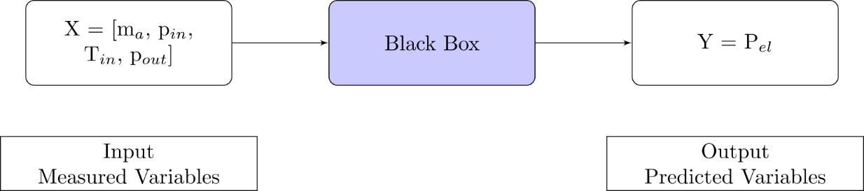

Figure : Black-box model for Power prediction (Xenos et al. 2015)

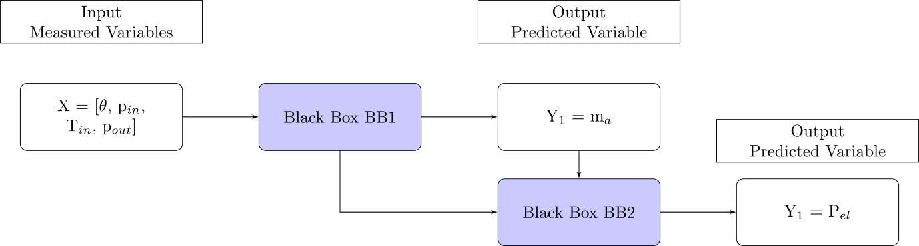

Figure : Alternative black-box model for Power prediction (Xenos et al. 2014)

By obtaining a mathematical model for the power drawn by the compressors in the compressor station (which are configured in parallel), the authors then attempted to optimise the plant’s operation in terms of electrical power drawn. This was achieved by minimising the power of all compressors in the station according to the following equation:

This was achieved by minimising the power of all compressors in the station according to the following equation:

$$\min_{ω^{*}} \sum_{i∊I}{P_{(el,i,t_{r})}}$$

This equation was subject to the following contraints, normalisations, mass balances and regression domain:

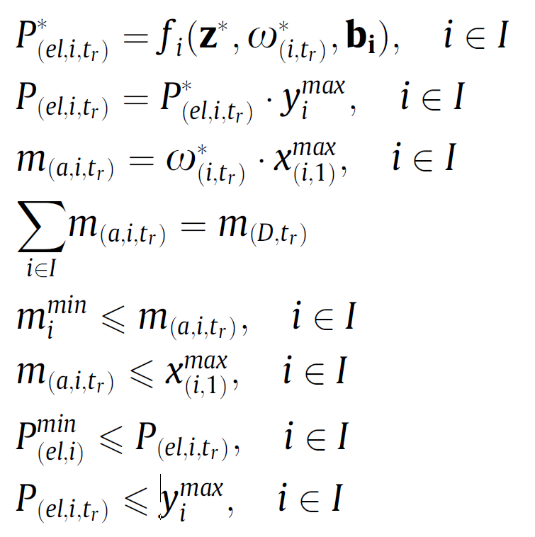

The optimisation approach was carried out by the authors in Matlab. The approach was successful in reducing the overall power consumption of the compressor station by optimally sharing the load between compressors. The optimisation approach resulted in a lower power consumption than the actual operation of the compressors, which shared the load using defined operational procedure for the test site.

## Probabilistic Methods

The final category of method for compressor performance management considered in this review is the category of probabilistic or stochastic methods. This category encompasses approaches including data mining, statistical learning and machine learning.

With these methods there is an element of probability, for example for a fault diagnosis application, there is typically a goal of identifying faults to some degree of accuracy.

Probabilistic methods have been applied in various forms to compressor performance management. Artificial Neural Networks (ANNs) have been applied for the purpose of generating a compressor’s performance map when a degradation in performance has occurred (Yu et al. 2007; Ghorbanian & Gholamrezaei 2009) and to optimise a compressor’s operating conditions (Cortés et al. 2009). ANNs, Support Vector Machines (SVMs) and Deep Belief Networks (DBNs) have both been used with success to detect valve faults in reciprocating air compressors (Cui et al. 2009; Qin et al. 2012; Verma et al. 2011; James Li & Yu 1995; Tran et al. 2014). Fault diagnosis of sensors and actuators in centrifugal compressor equipment using Principal Component Analysis (PCA) has been achieved (Zanoli et al. 2010a). (Petković et al. 2012) presented a clustering method for fault detection of air compressors.

From this review an ANN based approach appears to be the most prolific method of compressor performance management in recent literature, therefore ANNs will be discussed and an example paper which applied an ANN approach will be reviewed.

### Artificial Neural Networks (ANNs)

ANNs are statistical learning models which attempt to replicate the behaviour of biological neurons in the manner in which they process information. Another name that is given to these neurons in an ANN context is perceptrons. **Figure 8** depicts a typical perceptron’s information flow.

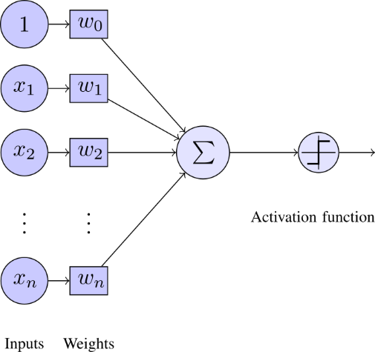

Figure : Perceptron Overview

As can be seen in **Figure 8**, a perceptron takes many weighted inputs, adds them together and passes the total to an activation function. The activation function then outputs a useful value depending on the sum of weighted inputs passed to it. In **Figure 8** the activation function is a step function, that is it will output 1 if the sum of the weighted inputs exceeds some threshold, and 0 otherwise. An analogy to biological neurons here would be that the perceptron will fire if the threshold is met.

**Figure 8** shows one perceptron, but an ANN is made up of many neurons or perceptrons. **Figure 9** shows a typical ANN, where there is an input layer, a hidden layer, and finally the output layer. In this example there is one hidden layer, but there can often be two or more hidden layers. Similarly there is not a restriction to one output for an ANN, there may be more than one perceptron in the output layer of the ANN. In the example, all information paths flow from the Input layer to the Output layer, which makes the network a feed forward network. There are other types of neural network which allow information to flow back in the opposite direction as well, these are known as feedback networks. Once there are more than two layers in the network (i.e. at least one hidden layer) the network is known as a multilayer perceptron network. Through the use of a training period, the correct weights may be assigned to the neurons in a network to accurately predict the outputs of a compressor system for a range of inputs.

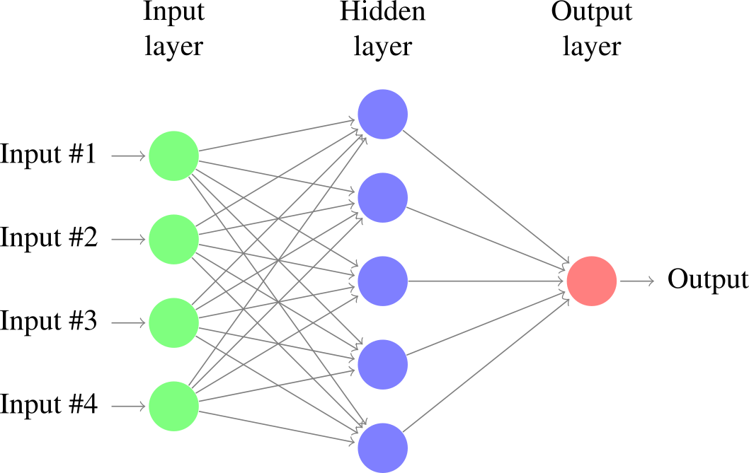

Figure : Typical Artifical Neural Network (ANN)

### (Ghorbanian & Gholamrezaei 2009)

In this paper different neural network model types were reviewed for accuracy in generating a gas generator’s compressor performance characteristic map. The four types reviewed were:

1. Generalised regression neural net-work (GRNN)
   * Generalised regression neural networks do not require an iterative training procedure, but rather approximate the functions between inputs from one initial training data set.
2. Modified GRNN
   * This method which was developed by the authors involved taking a GRNN and transforming the values to reduce the computational load involved in the initial training period
3. Multilayer perceptron network
   * In this paper the multilayer perceptron network involved two hidden layers, which could generate the compressor performance characteristic map when given the corrected massflow rate and rotational speed of the compressor in question.
4. Radial basis function network
   * This type of network uses radial basis functions as activation functions for each perceptron. The output of a radial basis function is dependent on the inputs distance from some origin, that is to say $Φ\left(x\right)= Φ(\left\|x\right\|)$. This ensures that the output of the activation function is symmetrical about a mean which assists in reducing computational time for a neural network.

The two types of neural network found to be most effective in reconstructing a compressor’s performance map were modified or rotated GRNN and multilayer perceptron. Rotated GRNN was found to be most accurate in terms of closest agreement of results with training data, it was limited as a method to predicting the compressor performance map within the limits of training data given to it, and i.e. it is limited to interpolation. Multilayer perceptron networks are more suited to predicting a compressor’s performance characteristic at any operational point of the compressor, i.e. it can extrapolate to outside the given experimental training data. It was determined that multilayer perceptron neural networks are the most powerful of those reviewed in reconstructing compressor performance characteristic maps.

A key accuracy measure was that the performance map of a compressor was able to be reconstructed to 92% accuracy using 50% of available training data. Also by using the output of one neural network together with one measured parameter (corrected mass flow rate of air) as the inputs of another neural network the efficiency of the compressor could be predicted to an extremely high accuracy.

The authors had the same opinion as (Yu et al. 2007) in that neural networks provide an effective means of reconstructing a compressor’s characteristic performance curve when experimental or manufacturer’s data is not available, e.g. in off-design conditions.

# Discussion and Conclusion

This review took into consideration many different options for compressor performance management methods, each of which has its own merits and disadvantages. After consideration of each methods individual attributes, it appears that the most promising current research into compressor performance management lies between the deterministic and probabilistic approaches. In particular, the data-driven regression model approach taken by (Xenos et al. 2015), the ANN approach taken by (Ghorbanian & Gholamrezaei 2009) and the DBN approach (a form of ANN) taken by (Tran et al. 2014) stand out as the state of the art for compressor optimisation and fault diagnosis. It is the intention of the author to explore these methods with a test data set from an operational compressed air station serving a small-scale pharmaceutical facility.

# Abbreviations

|  |  |
| --- | --- |
| Abbreviation | Meaning |
| AHP | Analytical Hierarchy Process |
| RCM | Reliability Centred Maintenance |
| FMEA | Failure Mode and Effect Analysis |
| FMECA | Failure Mode Effect and Criticality Analysis |
| FDD | Fault Detection and Diagnosis |
| RBM | Restricted Boltzmann Machine |
| WSM | Weighted Sum Model |
| ANN | Artificial Neural Network |
| MLP | Multi Layer Perceptron |

# References

Backi, C.J., Gravdahl, J.T. & Grøtli, E.I., 2013. Nonlinear observer design for a Greitzer compressor model. , pp.1457–1463.

Bevilacqua, M. & Braglia, M., 2000. The analytic hierarchy process applied to maintenance strategy selection. *Reliability Engineering & System Safety*, 70(1), pp.71–83.

Blesa, J. et al., 2014. An Interval NLPV Parity Equations Approach for Fault Detection and Isolation of a Wind Farm. *IEEE Transactions on Industrial Electronics*, 0046(c), pp.1–1. Available at: http://ieeexplore.ieee.org/articleDetails.jsp?arnumber=6998858.

Catterson, V. & Costello, J., 2013. Increasing the Adoption of Prognostic Systems for Health Management in the Power Industry. *Chemical Engineering Transactions*, 33, pp.271–276. Available at: http://www.aidic.it/cet/13/33/046.pdf.

Cortés, O., Urquiza, G. & Hernández, J. a., 2009. Optimization of operating conditions for compressor performance by means of neural network inverse. *Applied Energy*, 86(11), pp.2487–2493. Available at: http://dx.doi.org/10.1016/j.apenergy.2009.03.001.

Cui, H. et al., 2009. Research on fault diagnosis for reciprocating compressor valve using information entropy and SVM method. *Journal of Loss Prevention in the Process Industries*, 22(6), pp.864–867. Available at: http://dx.doi.org/10.1016/j.jlp.2009.08.012.

Dapeng Niu et al., 2011. Modelling of multistage centrifugal compressor. In *Proceedings of 2011 International Conference on Computer Science and Network Technology*. IEEE, pp. 1144–1147. Available at: http://ieeexplore.ieee.org/lpdocs/epic03/wrapper.htm?arnumber=6182163.

Dasilva, A.R., 2004. Controlling the radiation of hermetic compressors by means of minimization of power through discharge pipes using genetic algorithms_2004.pdf. In *International Compressor Engineering Conference*.

Demetgul, M., 2013. Fault diagnosis on production systems with support vector machine and decision trees algorithms. *The International Journal of Advanced Manufacturing Technology*, 67(9-12), pp.2183–2194. Available at: http://link.springer.com/10.1007/s00170-012-4639-5.

Facchinetti, T., Benetti, G. & Vedova, M.L. Della, Modeling and real-time control of an industrial air multi-compressor system.

Friden, H. et al., 2012. Energy and LCC Optimised Design of Compressed Air Systems: A Mixed Integer Optimisation Approach with General Applicability. *2012 UKSim 14th International Conference on Computer Modelling and Simulation*, (Lcc), pp.491–496. Available at: http://ieeexplore.ieee.org/lpdocs/epic03/wrapper.htm?arnumber=6205496.

Gao, Z., Cecati, C. & Ding, S.X., 2015a. A Survey of Fault Diagnosis and Fault-Tolerant Techniques Part I: Fault Diagnosis. *Industrial Electronics, IEEE Transactions on*, PP(99), p.1.

Gao, Z., Cecati, C. & Ding, S.X., 2015b. A Survey of Fault Diagnosis and Fault-Tolerant Techniques Part II: Fault Diagnosis with Knowledge-Based and Hybrid/Active Approaches. *Industrial Electronics, IEEE Transactions on*, PP(99), p.1.

Gertler, J., 1998. *Fault Detection and Diagnosis in Engineering Systems*, Available at: http://books.google.com/books?id=fmPyTbbqKFIC.

Ghorbanian, K. & Gholamrezaei, M., 2009. An artificial neural network approach to compressor performance prediction. *Applied Energy*, 86(7-8), pp.1210–1221. Available at: http://dx.doi.org/10.1016/j.apenergy.2008.06.006.

Glass, a S. et al., 1995. Qualitative model-based fault detection in air-handling units. *IEEE Control Systems Magazine*, 15(4), pp.11–22. Available at: http://www.scopus.com/inward/record.url?eid=2-s2.0-0029359274&partnerID=40&md5=190fc8710ebf04754f9055cc492f4691.

Van Harmelen, F., Lifschitz, V. & Porter, B., 2008. *Handbook of Knowledge Representation*, Elsevier Science. Available at: https://books.google.ie/books?id=xwBDylHhJhYC.

IEA, 2012. International Energy Agency. *IEA*. Available at: http://www.iea.org [Accessed August 5, 2015].

James Li, C. & Yu, X., 1995. High pressure air compressor valve fault diagnosis using feedforward neural networks. *Mechanical Systems and Signal Processing*, 9(5), pp.527–536. Available at: http://www.sciencedirect.com/science/article/pii/S0888327085700404 [Accessed July 23, 2015].

Jinru, L., Yibing, L. & Keguo, Y., 2008. Fault diagnosis of piston compressor based on Wavelet Neural Network and Genetic Algorithm. *2008 7th World Congress on Intelligent Control and Automation*, pp.6006–6010. Available at: http://ieeexplore.ieee.org/lpdocs/epic03/wrapper.htm?arnumber=4592852.

Kabbaj, N. et al., 2003. Fault detection and isolation in a greenhouse using parity relations. *EFTA 2003. 2003 IEEE Conference on Emerging Technologies and Factory Automation. Proceedings (Cat. No.03TH8696)*, 2(OCTOBER).

Katipamula, S. & Brambley, M., 2005. Review Article: Methods for Fault Detection, Diagnostics, and Prognostics for Building Systems—A Review, Part I. *HVAC&R Research*, 11(2), pp.169–187. Available at: http://www.tandfonline.com/doi/abs/10.1080/10789669.2005.10391133.

Kopanos, G.M. et al., 2015. Optimization of a network of compressors in parallel: Operational and maintenance planning – The air separation plant case. *Applied Energy*, 146, pp.453–470. Available at: http://linkinghub.elsevier.com/retrieve/pii/S0306261915001166.

Krichel, S. V & Sawodny, O., 2011. Analysis and optimization of compressed air networks with model-based approaches. *Pneumatica*, pp.334–341.

Lingling, H., 2010. Fault diagnosis model of the diesel locomotive air brake system based on Bayesian network. , pp.0–2.

Liu, C. et al., 2013. Large flow compressed air load forecasting based on Least Squares Support Vector Machine within the Bayesian evidence framework. *IECON Proceedings (Industrial Electronics Conference)*, (2011), pp.7886–7891.

Liu, J. & Chen, D.-S., 2009. Fault Detection and Identification Using Modified Bayesian Classification on PCA Subspace. *Industrial & Engineering Chemistry Research*, 48(6), pp.3059–3077. Available at: http://www.scopus.com/inward/record.url?eid=2-s2.0-65349135893&partnerID=tZOtx3y1.

Liu, S.-Y.S.-C., 2001. An Efficient Expert System for Air Compressor Troubleshooting. *Expert Systems*, 18(4), pp.203–214. Available at: http://doi.wiley.com/10.1111/1468-0394.00175 [Accessed April 10, 2014].

Luo Fangqiong & Huang Shengzhong, 2011. Research and Application of Wavelet Neural Network Based on the Optimization of Genetic Algorithm in Centrifugal Compressor’s Performance Prediction. *2011 Third International Conference on Measuring Technology and Mechatronics Automation*, 9, pp.1027–1030. Available at: http://ieeexplore.ieee.org/lpdocs/epic03/wrapper.htm?arnumber=5721364.

Mazid, A.M. & Martin, R., 2008. Automation of compressor test procedure using advantech data acquisition module. In *2008 10th International Conference on Control, Automation, Robotics and Vision*. IEEE, pp. 2266–2271. Available at: http://ieeexplore.ieee.org/lpdocs/epic03/wrapper.htm?arnumber=4795885.

Nair, A.T. et al., 2011. Kalman Filter Based State Estimation of a Thermal Power Plant. *2011 International Conference on Process Automation, Control and Computing*, pp.1–5. Available at: http://ieeexplore.ieee.org/xpls/abs_all.jsp?arnumber=5978971\nhttp://ieeexplore.ieee.org/lpdocs/epic03/wrapper.htm?arnumber=5978971.

Namdeo, R., Manepatil, S. & Saraswat, S., 2008. Detection of Valve Leakage in Reciprocating Compressor Using Artificial Neural Network ( Ann ). , pp.1–8.

Pathak, N., Khan, M. & Roy, N., 2015. Acoustic based appliance state identifications for fine-grained energy analytics. *IEEE International Conference on Pervasive Computing and Communications (PerCom)*, pp.63–70. Available at: http://ieeexplore.ieee.org/xpls/abs_all.jsp?arnumber=7146510.

Petković, M. et al., 2012. On-line adaptive clustering for process monitoring and fault detection. *Expert Systems with Applications*, 39(11), pp.10226–10235.

Qin, Q. et al., 2012. A novel scheme for fault detection of reciprocating compressor valves based on basis pursuit, wave matching and support vector machine. *Measurement: Journal of the International Measurement Confederation*, 45(5), pp.897–908. Available at: http://dx.doi.org/10.1016/j.measurement.2012.02.005.

Radgen, P., 2006. Efficiency through compressed air energy audits. In *Energy Audit Conference, www. audit06. fi*.

Ramezanifar, a, Afshar, a & Nikravesh, S.K.Y., 2006. State Estimation of a Boiler Using Nonlinear Observer. *Information and Control*.

Ren, Y. et al., 2012. Reliability Assessment of Anti-surge Control System in Centrifugal Compressor. *2012 Fourth International Conference on Computational and Information Sciences*, pp.1240–1243. Available at: http://ieeexplore.ieee.org/lpdocs/epic03/wrapper.htm?arnumber=6301343.

Ruilin Lin, Boyun Liu & Qi Liu, 2010. Study of the non-liner dynamic system theory for reciprocating compressor fault diagnosis. In *2010 International Conference on Computer Application and System Modeling (ICCASM 2010)*. IEEE, pp. V9–245–V9–248. Available at: http://ieeexplore.ieee.org/lpdocs/epic03/wrapper.htm?arnumber=5623041.

Saaty, T.L., 2008. Decision making with the analytic hierarchy process. *International Journal of Services Sciences*, 1(1), p.83.

Saidur, R., Rahim, N.A. & Hasanuzzaman, M., 2010. A review on compressed-air energy use and energy savings. *Renewable and Sustainable Energy Reviews*, 14(4), pp.1135–1153. Available at: http://www.sciencedirect.com/science/article/pii/S1364032109002755 [Accessed March 24, 2014].

Salar, A. et al., 2010. Improving Model-Based Gas Turbine Fault Diagnosis Using Multi-Operating Point Method. *2010 Fourth UKSim European Symposium on Computer Modeling and Simulation*, (2), pp.240–247. Available at: http://ieeexplore.ieee.org/lpdocs/epic03/wrapper.htm?arnumber=5703690.

SEAI, 2007. *Compressed Air Technical Guide*, Dublin.

Shin, B. et al., 2007. Application of fault diagnosis based on signed digraphs and PCA with linear fault boundary. *2007 International Conference on Control, Automation and Systems*, pp.984–987. Available at: http://ieeexplore.ieee.org/lpdocs/epic03/wrapper.htm?arnumber=4407067.

Tarantino, R., Szigeti, F. & Colina-Morles, E., 2000. Generalized Luenberger observer-based fault-detection filter design: An industrial application. *Control Engineering Practice*, 8(6), pp.665–671.

Tran, V.T., Althobiani, F. & Ball, A., 2014. An approach to fault diagnosis of reciprocating compressor valves using Teager-Kaiser energy operator and deep belief networks. *Expert Systems with Applications*, 41(9), pp.4113–4122. Available at: http://dx.doi.org/10.1016/j.eswa.2013.12.026.

Vachtsevanos, G. et al., 2006. *Intelligent Fault Diagnosis and Prognosis for Engineering Systems*, Hoboken, NJ, USA: John Wiley & Sons, Inc. Available at: http://doi.wiley.com/10.1002/9780470117842.

Venkatasubramanian, V., Rengaswamy, R., Yin, K., et al., 2003. A review of process fault detection and diagnosis. *Computers & Chemical Engineering*, 27(3), pp.293–311.

Venkatasubramanian, V., 2003. A review of process fault detection and diagnosis: Part III: Process history based methods. *Computers & chemical …*, 27, pp.293–311. Available at: http://www.sciencedirect.com/science/article/pii/S009813540200162X.

Venkatasubramanian, V., Rengaswamy, R. & Kavuri, S.N., 2003. A review of process fault detection and diagnosis: Part II: Qualitative models and search strategies. *Computers & Chemical Engineering*, 27(3), pp.313–326. Available at: http://www.sciencedirect.com/science/article/pii/S0098135402001618\nhttp://www.sciencedirect.com/science/article/pii/S0098135402001618/pdfft?md5=09aaf3029aa870816812fdf60c453e47&pid=1-s2.0-S0098135402001618-main.pdf.

Verma, N.K., Roy, A. & Salour, A., 2011. An optimized fault diagnosis method for reciprocating air compressors based on SVM. *Proceedings - 2011 IEEE International Conference on System Engineering and Technology, ICSET 2011*, pp.65–69.

Wang, F. et al., 2010. Fault Diagnosis for Reciprocating Air Compressor Valve Using P-V Indicator Diagram and SVM. *2010 Third International Symposium on Information Science and Engineering*, (109047), pp.255–258. Available at: http://ieeexplore.ieee.org/lpdocs/epic03/wrapper.htm?arnumber=5945097.

Wang, S. & Cui, J., 2005. Sensor-fault detection, diagnosis and estimation for centrifugal chiller systems using principal-component analysis method. *Applied Energy*, 82(3), pp.197–213. Available at: http://linkinghub.elsevier.com/retrieve/pii/S0306261904001953.

Wheeler, T.J. et al., 2011. Performance analysis of fault detection systems based on analytically redundant linear time-invariant dynamics. *Proceedings of the American Control Conference*, pp.214–219. Available at: http://www.scopus.com/inward/record.url?eid=2-s2.0-80053146995&partnerID=tZOtx3y1.

Xenos, D.P. et al., 2015. Optimization of a network of compressors in parallel: Real Time Optimization (RTO) of compressors in chemical plants – An industrial case study. *Applied Energy*, 144, pp.51–63. Available at: http://linkinghub.elsevier.com/retrieve/pii/S0306261915000161.

Xenos, D.P. et al., 2014. Preprocessing of Raw Data for Developing Steady-State Data-Driven Models for Optimizing Compressor Stations. , (July).

Xiaogang, W., Xueliang, B. & Bo, J., 2013. Adaptive genetic algorithm for parameter identification of centrifugal compressor. *2013 25th Chinese Control and Decision Conference (CCDC)*, pp.2982–2986. Available at: http://ieeexplore.ieee.org/lpdocs/epic03/wrapper.htm?arnumber=6561456.

Yu, Y. et al., 2007. Neural-network based analysis and prediction of a compressor’s characteristic performance map. *Applied Energy*, 84(1), pp.48–55.

Zanoli, S.M. & Astolfi, G., 2013. Application of a Fault Detection and Isolation System on a Rotary Machine. *International Journal of Rotating Machinery*, 2013, pp.1–11. Available at: http://www.hindawi.com/journals/ijrm/2013/189359/.

Zanoli, S.M., Astolfi, G. & Barboni, L., 2010a. Applications of fault diagnosis techniques for a multishaft centrifugal compressor. *18th Mediterranean Conference on Control and Automation, MED’10 - Conference Proceedings*, pp.64–69.

Zanoli, S.M., Astolfi, G. & Barboni, L., 2010b. FDI of process faults based on PCA and cluster analysis. *2010 Conference on Control and Fault-Tolerant Systems (SysTol)*, pp.197–202. Available at: http://ieeexplore.ieee.org/lpdocs/epic03/wrapper.htm?arnumber=5676023.

Zhu, X. et al., 2013. A quantitative comprehensive safety evaluation method for centrifugal compressors using FMEA-fuzzy operations. In *2013 2nd International Symposium on Instrumentation and Measurement, Sensor Network and Automation (IMSNA)*. IEEE, pp. 202–206. Available at: http://ieeexplore.ieee.org/lpdocs/epic03/wrapper.htm?arnumber=6743251.