Compressor Performance Assessment Rules

# Introduction

This document summarises the fundamental rules which have been identified for assessing the performance of air compressors. The rules are applicable to two-stage compressors, and have been developed with a similar methodology to APAR. The rules are in the process of being implemented in Microsoft Excel as an initial test bed, which is being developed in tandem with MATLAB functions for more stable long term usage.

# Compressor Operation

**Figure 1** shows the configuration of an Atlas Copco ZT37 VSD air compressor. This rotary tooth, two stage air compressor is representative of many machines installed in industry today of two-stage configuration. While the means of compression may differ between machines (screws, centrifugal means, etc.) the basic principle of two stages of compression with intermediate and final cooling is commonplace in industrial machines.

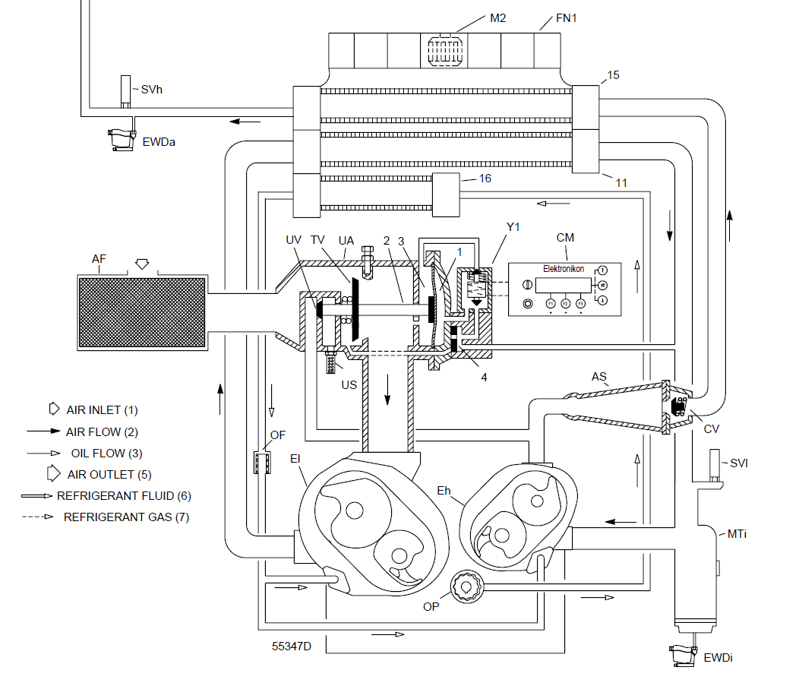

Figure 1: Atlas Copco ZT37 VSD Compressor Configuration

**Figure 2** shows a simplified line diagram version of the basic principles of operation seen in **Figure 1**. Air enters the machine and is compressed to approximately 2.5 barg in the first stage of compression, known as Element 1. Following this compression the compressed air is typically at approximately 140 °C. It is cooled by passing it through the intercooler, which is an air-cooled heat exchanger, with air passed over the exchanger by means of a fan. The compressed air then enters the second stage of compression or Element 2, and is compressed to the final delivery pressure. In the test site under analysis, this set point is 7.0 barg. Following this second stage of compression the compressed air is at approximately 75 °C. It is then passed through a final cooler, which is similar in configuration to the intercooler and is cooled using the same fan. The compressed air is then delivered at the required temperature and pressure (20 °C, 7.0 barg) to the receiver. At the test site under analysis the receiver is 1.5 m3 in capacity. The temperatures and pressures available from the test site are noted in **Figure 2,** and are summarised in **Table 1. N.B. pi (intercooler pressure) is actually on the cooling side, not the compressed air side.**

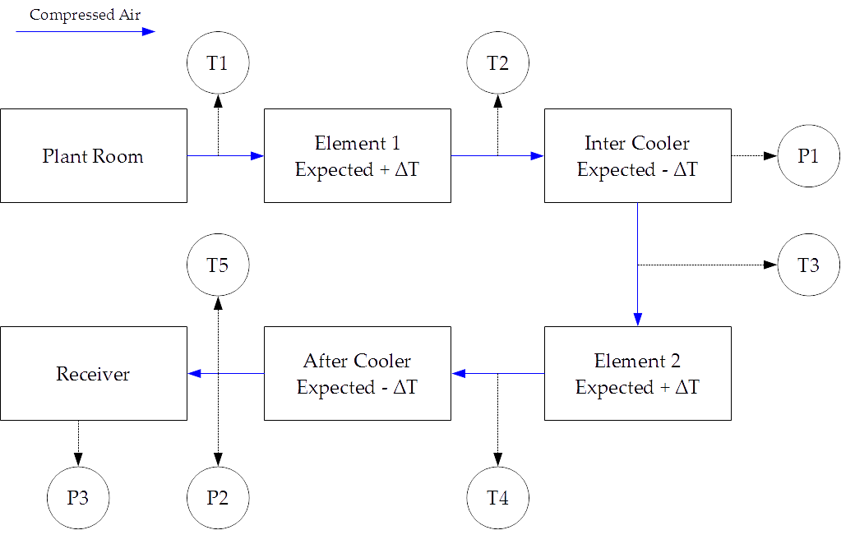

Figure 2: Fundamental Operation of Two-Stage Compressor

|  |  |
| --- | --- |
| ***Reference*** | ***Item*** |
| T1 | Plant Room Temperature |
| T2 | Element 1 Outlet Temperature |
| T3 | Element 2 Inlet Temperature |
| T4 | Element 2 Outlet Temperature |
| T5 | Final Delivery Temperature |
| P1 | Compressed Air Pressure in Intercooler |
| P2 | Compressed Air Final Delivery Pressure |
| P3 | Compressed Air Receiver Pressure |

Table 1: Test Site Available Pressures and Temperatures

The expected change in temperature of the compressed air as it passes through the four key components of the compressor under load is noted in **Figure 2.** Under normal operation the compressed air will rise in temperature as it passes through a compression stage, and decrease in temperature as it passes through a cooling stage.

# Rules

Rules have been divided into “loaded” and “unloaded” operation.

## Rules for Loaded Operation

### Rule 1

If a decrease in temperature across Element 1 is observed, then either T1, T2, or both require calibration, or Element 1 is not compressing air. This is formalised as:

if ( (T1 – T2) > 0)

Rule1 = True;

end

### Rule 2

If an increase in temperature across the intercooler is observed, then either T2, T3, or both require calibration, or the intercooler is not cooling the compressed air. This is formalised as:

if ( (T3 – T2) > 0)

Rule2 = True;

end

### Rule 3

If a decrease in temperature across Element 2 is observed, then either T3, T4, or both require calibration, or Element 2 is not compressing air. This is formalised as:

if ( (T3 – T4) > 0)

Rule3 = True;

end

### Rule 4

If an increase in temperature across the after cooler is observed, then either T4, T5, or both require calibration, or the after cooler is not cooling the compressed air. This is formalised as:

if ( (T5 – T4) > 0)

Rule4 = True;

end

### Rule 5

Threshold for plant room temperature – typically ambient temperature + 5 °C.

### Rule 6

During normal operation, the temperature of Element 1’s outlet does not exceed approx. 145 °C. This has been selected as a preliminary threshold to flag Rule 5 in the event that this temperature is exceeded. If this temperature is exceeded it is indicative of an issue with Element 1. The warning level set in the PLC of the compressor for this value is 225 °C, and so any approach toward this warning level is indicative of a fault.

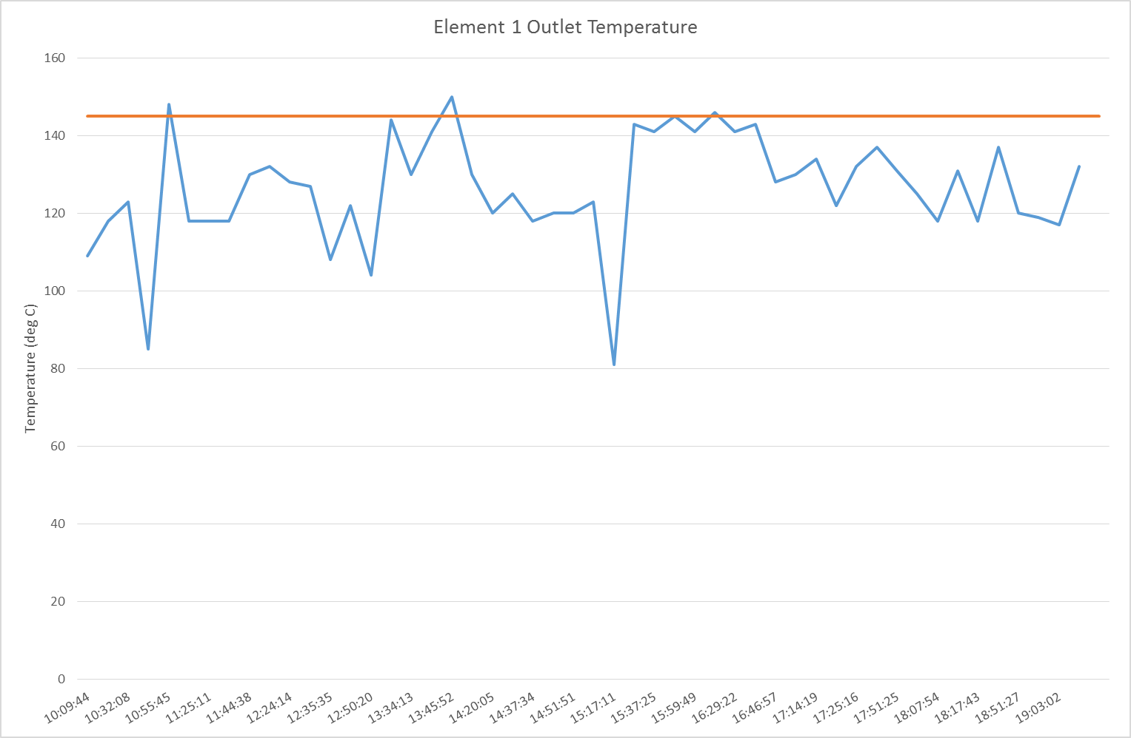

Figure 3: Element 1 Outlet Temperature

### Rule 7

As for Rule 5 for T3.

### Rule 8

As for Rule 5 for T4.

### Rule 9

As for Rule 5 for T5.

### Rule 10

Element 1 is intended to raise the pressure of the compressed air to 2.5 barg. If this is not achieved, then Element 2 will have to work harder to achieve the required final delivery pressure, which will further result in excessive cooling load on the after cooler with respect to the intercooler. This rule is formalised as:

If (P1 < (2.5 + ∊)

Rule9 = True;

End

### Rule 11

For a single compressor in isolation, if P2 continues to rise when the compressor is unloaded, then this indicates either a fault with the P2 sensor, or more likely that the load/unload valve of the compressor has failed. This is formalised as:

If ( (P2(t) – (P2(t-1)) > 0) while (Loaded = False)

Rule10 = True;

End

### Rule 12

Determine threshold for number of motor starts per hour

### Rule 13

If the oil pressure of the compressor does not rise when the compressor is loaded, this indicates a fault with the oil pump of the compressor. This is formalised as:

If ( (Poil(t) – (Poil(t-1)) <= 0) while (Loaded = True)

Rule12 = True;

End

### Rule 14 and 15

Calculate theoretical heat of compression for element 1 and element 2 pressure ratios. Apply this to dummy data for flow from CAGI data sheets. Compare theoretical temperature rise to actual temperature rise. **MAY NOT ACTUALLY BE POSSIBLE AS INTERCOOLER PRESSURE ON COMPRESSED AIR SIDE IS NOT AVAILABLE**

### Rule 16 and 17

Calculate theoretical cooling across intercooler and aftercooler using temperature of ambient and rejected cooling air, based on the air flow rate of the cooling fan. Compare this to the actual level of cooling observed in intercooler and after cooler. **MAY NOT ACTUALLY BE POSSIBLE AS INTERCOOLER PRESSURE ON COMPRESSED AIR SIDE IS NOT AVAILABLE**

## Rules for Unloaded Operation

At this stage these will be limited to similar threshold rules as Rules 5, 6,7 and 8, totalling four rules.

### Rule 18

### Rule 19

### Rule 20

### Rule 21

## Compressor Network Rules

### Rule 22

If the outlet pressure of 2 compressors connected to the same header differs by more than 0.1 barg, it is indicative that at least one of the pressure sensors requires calibration. This may be formalised as:

If (P2A – P2B) > ∊)

Rule# = True;

End

## Ideas for Rules

### Dryers

* Dew point controlled dryers very often require their probes to be recalibrated. Is there a way to automatically detect if they might need calibration? Maybe if you noticed a change in the frequency of purge cycles
* Could the rate of purge be used for flow measurement? i.e. determine how much moisture is in the ambient air, figure out how long it will take the dryer to dry out one cube of compressed air, and use that time to determine the throughput of air through the machine?

### More Ideas

1. Have similar rules as rules 1 to 4 for the airside – should see a rise in temperature for the cooling air as it goes across the cooler
2. Establish the moisture capacity of the dryer, and the moisture loading of the compressors (from ambient conditions). This combined with analysis of the puge frequency of the dryers could give an indication of the compressed air flow rate.
3. Create a metric for the purge frequency of the dryers as related to the ambient humidity of air
4. I’ve basically done a pressure decay test – this can be used to calculate the system volume and potentially the flow rate by measuring the time it took the compressor to get back up to pressure after being let down to 6 bar – basically look up how to do a pressure decay test
5. Show VSD% band times as a load duration curve – more visual
6. Look at the average loading of the compressor as a % of the max load – basically the VSD compressor is running at about 20-30% load – calculate this formally
7. Can you derive flow from the temperature rise across Element 1 or 2 knowing the pressure rise? Possibly?
8. Make sure to build in correction factors to allow for the fact that the system isn’t operating at reference conditions – ref conditions should be on the CAGI data sheet but are probably standard temperature and pressure
9. Get onto Austin O’Neill from Ingersoll Rand to look at getting a smaller compressor
10. Need a metric for current, volts, and power factor
11. Three-phase balancing between currents and voltages

# Point Naming Convention

## Sensors

|  |  |
| --- | --- |
| ***Reference*** | ***Item*** |
| T1 | Plant Room Temperature |
| T2 | Element 1 Outlet Temperature |
| T3 | Element 2 Inlet Temperature |
| T4 | Element 2 Outlet Temperature |
| T5 | Final Delivery Temperature |
| P1 | Compressed Air Pressure in Intercooler |
| P2 | Compressed Air Final Delivery Pressure |
| P3 | Compressed Air Receiver Pressure |
| N1 | Motor starts per 5 minutes |
| P10 | Oil Pressure |
| P11 | Ambient Pressure |

## Expected Levels

|  |  |  |
| --- | --- | --- |
| ***Reference*** | ***Item*** | ***Value*** |
| T6 | Plant Room Temperature | 25 |
| T7 | Element 1 Outlet Temperature | 140 |
| T8 | Element 2 Inlet Temperature | 22 |
| T9 | Element 2 Outlet Temperature | 100 |
| T10 | Final Delivery Temperature | 21 |
| P4 | Compressed Air Pressure in Intercooler | 2500 |
| P5 | Compressed Air Final Delivery Pressure | 7250 |
| P6 | Compressed Air Receiver Pressure | 7250 |
| N2 | Motor starts per 5 minutes | 1 |
| K1 | Compressor power idle | 1.5 |
| K2 | Compressor maximum power unloaded | 8.4 |

## Warning Levels (High)

|  |  |  |
| --- | --- | --- |
| ***Reference*** | ***Item*** | ***Value*** |
| T11 | Plant Room Temperature | 35 |
| T12 | Element 1 Outlet Temperature | 155 |
| T13 | Element 2 Inlet Temperature | 24 |
| T14 | Element 2 Outlet Temperature | 120 |
| T15 | Final Delivery Temperature | 21 |
| P7 | Compressed Air Pressure in Intercooler | 2600 |
| P8 | Compressed Air Final Delivery Pressure | 7510 |
| P9 | Compressed Air Receiver Pressure | 7510 |
| N3 | Motor starts per 5 minutes | 2 |

## Error Thresholds

|  |  |  |
| --- | --- | --- |
| ***Reference*** | ***Item*** | ***Value*** |
| E1 | Plant Room Temperature | 5 °C |
| E2 | Element 1 Outlet Temperature | 5 °C |
| E3 | Element 2 Inlet Temperature | 5 °C |
| E4 | Element 2 Outlet Temperature | 5 °C |
| E5 | Final Delivery Temperature | 5 °C |
| E6 | Compressed Air Pressure in Intercooler | 100 mBar |
| E7 | Compressed Air Final Delivery Pressure | 100 mBar |
| E8 | Compressed Air Receiver Pressure | 100 mBar |
| E9 | Oil Pressure | 100 mBar |