MetaJudge v0.5.5.1
Statistical Analysis Report
Preliminary — Full Item Set + Sensitivity Analysis
Models: 5 | Calibration items: 117 | Family B items: 84
Date: 2026-03-28 | Benchmark version: v0.5.5.1

1. Executive Summary
This report presents pairwise statistical comparisons across five frontier language models on the MetaJudge v0.5.5.1 benchmark, covering both confidence calibration (Family A, 117 items) and selective abstention (Family B, 84 items). All tests are non-parametric with Holm-Bonferroni correction for multiple comparisons.
Key findings: 17 of 32 tests reached statistical significance after Holm-Bonferroni correction (α = 0.05). 12 in calibration, 5 in Family B.

2. Family A: Calibration Results

2.1 Model Leaderboard
Model | n | Accuracy | Mean Brier | ECE | Overconf. Rate
DeepSeek V3.1 | 117 | 0.761 | 0.812 | 0.115 | 0.714
Gemini Flash | 117 | 0.915 | 0.920 | 0.062 | 1.000
Gemini Pro | 117 | 0.923 | 0.926 | 0.053 | 1.000
Haiku 4.5 | 117 | 0.726 | 0.784 | 0.170 | 0.594
Sonnet 4 | 117 | 0.778 | 0.817 | 0.123 | 0.808

2.2 Pairwise Statistical Comparisons
McNemar's test compares binary accuracy; paired permutation test compares mean Brier scores. Bootstrap 95% CIs quantify effect magnitude. Cohen's d measures standardized effect size.
Pair | Acc A | Acc B | McNemar p | Brier Δ | Perm p | 95% CI | Cohen's d | Sig
Haiku 4.5 vs Sonnet 4 | 0.726 | 0.778 | 0.286 | -0.033 | 0.270 | [-0.092, 0.024] | -0.10 | No
Haiku 4.5 vs DeepSeek V3.1 | 0.726 | 0.761 | 0.523 | -0.028 | 0.372 | [-0.089, 0.031] | -0.08 | No
Haiku 4.5 vs Gemini Flash | 0.726 | 0.915 | <0.001 | -0.136 | <0.001 | [-0.202, -0.072] | -0.38 | Yes***
Haiku 4.5 vs Gemini Pro | 0.726 | 0.923 | <0.001 | -0.142 | <0.001 | [-0.208, -0.077] | -0.40 | Yes***
Sonnet 4 vs DeepSeek V3.1 | 0.778 | 0.761 | 0.815 | 0.005 | 0.848 | [-0.048, 0.058] | 0.02 | No
Sonnet 4 vs Gemini Flash | 0.778 | 0.915 | <0.001 | -0.103 | <0.001 | [-0.160, -0.047] | -0.33 | Yes***
Sonnet 4 vs Gemini Pro | 0.778 | 0.923 | <0.001 | -0.109 | <0.001 | [-0.165, -0.052] | -0.35 | Yes***
DeepSeek V3.1 vs Gemini Flash | 0.761 | 0.915 | <0.001 | -0.108 | <0.001 | [-0.166, -0.054] | -0.34 | Yes***
DeepSeek V3.1 vs Gemini Pro | 0.761 | 0.923 | <0.001 | -0.115 | <0.001 | [-0.175, -0.055] | -0.34 | Yes***
Gemini Flash vs Gemini Pro | 0.915 | 0.923 | 1.000 | -0.006 | 0.762 | [-0.045, 0.034] | -0.03 | No

2.3 Calibration Reliability Diagram
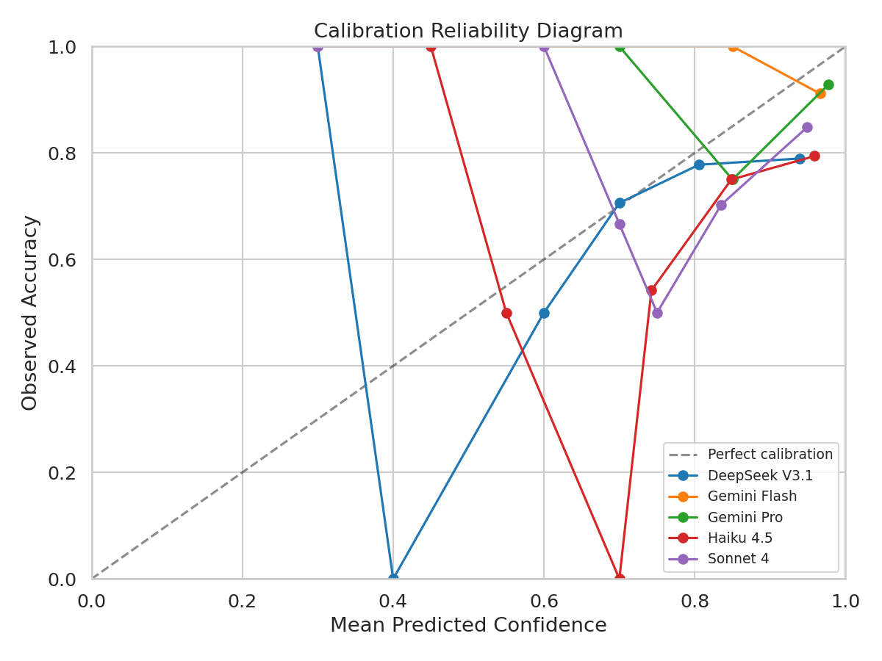

2.4 Brier Score Forest Plot
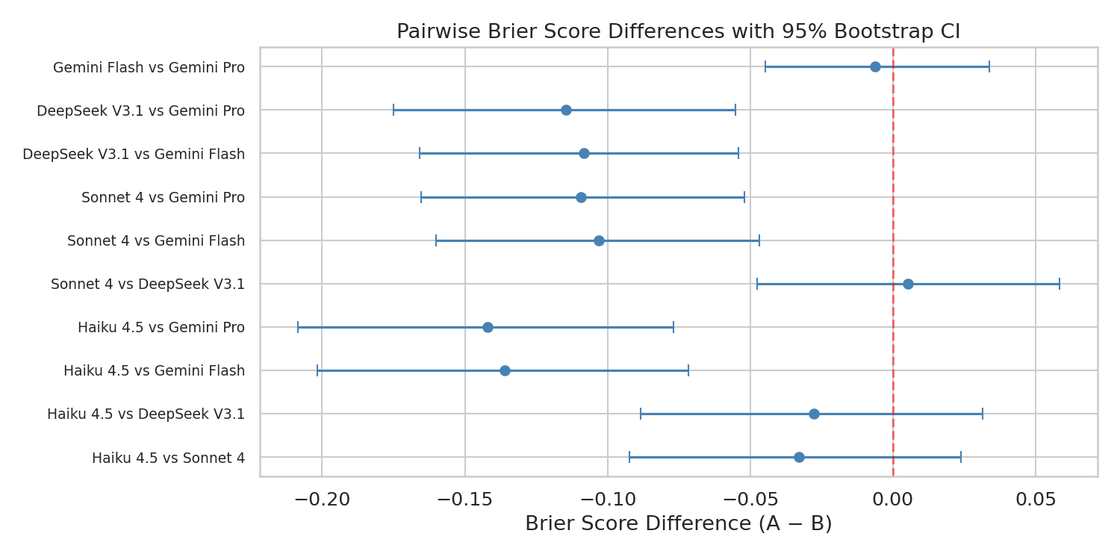

2.5 Per-Mechanism Analysis
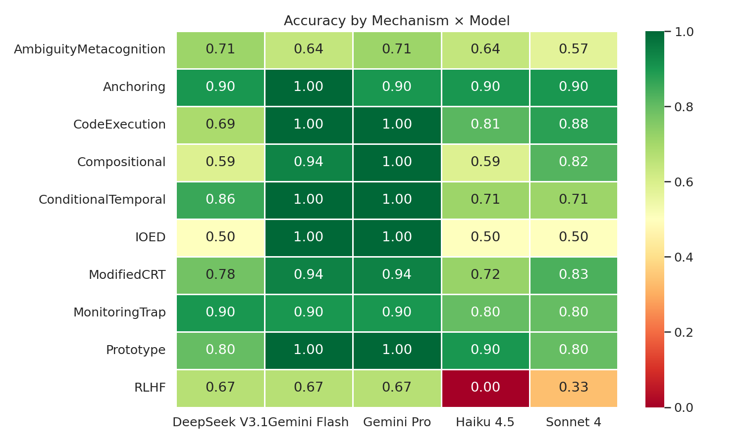

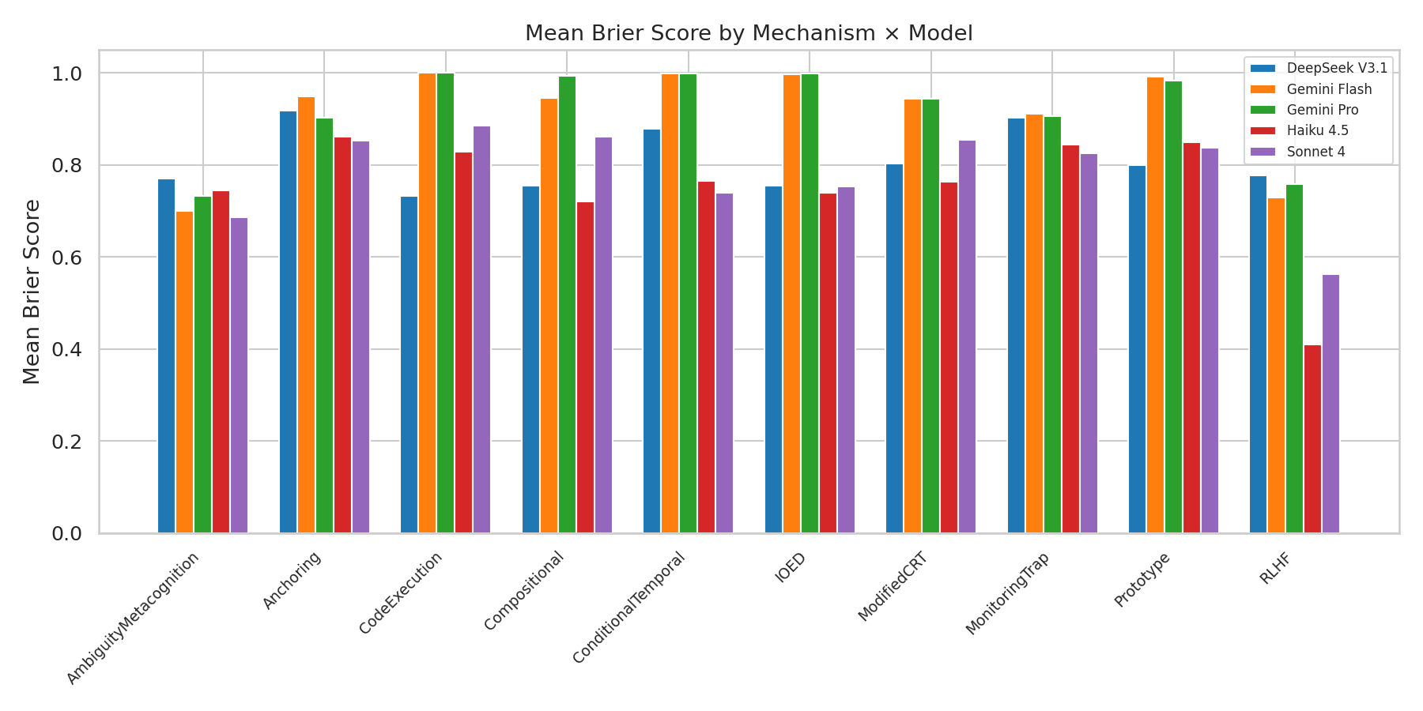
Mechanism | DeepSeek V3.1 | Gemini Flash | Gemini Pro | Haiku 4.5 | Sonnet 4 | n
AmbiguityMetacognition | 0.714 | 0.643 | 0.714 | 0.643 | 0.571 | 14
Anchoring | 0.900 | 1.000 | 0.900 | 0.900 | 0.900 | 10
CodeExecution | 0.688 | 1.000 | 1.000 | 0.812 | 0.875 | 16
Compositional | 0.588 | 0.941 | 1.000 | 0.588 | 0.824 | 17
ConditionalTemporal | 0.857 | 1.000 | 1.000 | 0.714 | 0.714 | 7 ⚠
IOED | 0.500 | 1.000 | 1.000 | 0.500 | 0.500 | 2 ⚠
ModifiedCRT | 0.778 | 0.944 | 0.944 | 0.722 | 0.833 | 18
MonitoringTrap | 0.900 | 0.900 | 0.900 | 0.800 | 0.800 | 20
Prototype | 0.800 | 1.000 | 1.000 | 0.900 | 0.800 | 10
RLHF | 0.667 | 0.667 | 0.667 | 0.000 | 0.333 | 3 ⚠
⚠ = fewer than 10 items (descriptive only)

2.6 P-value Heatmap
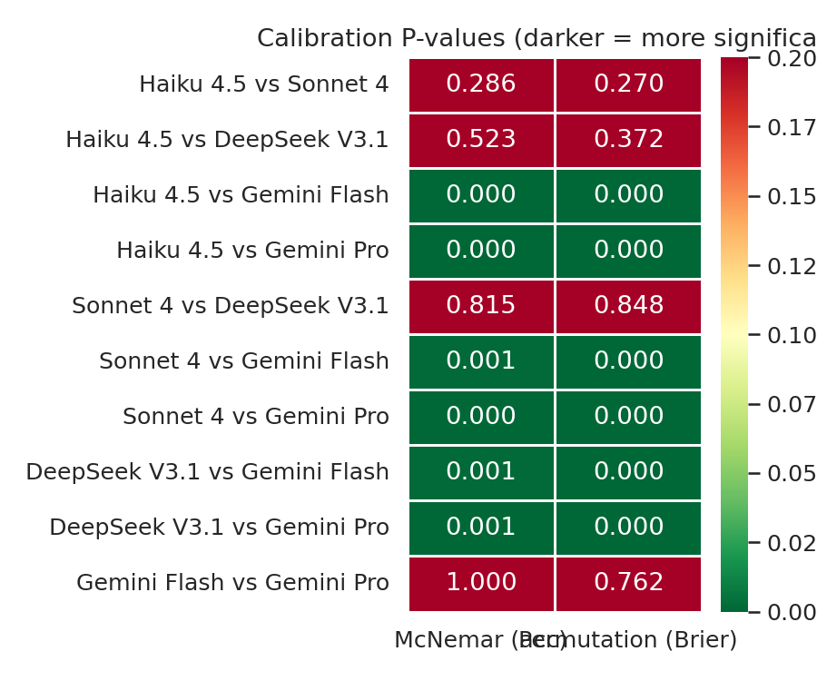

3. Family B: Selective Abstention Results

3.1 Model Leaderboard
Model | n | UWAA | Mean Utility | Action Acc | Macro F1
DeepSeek V3.1 | 84 | 0.801 | 0.601 | 0.536 | 0.587
Gemini Flash | 1 | 1.000 | 1.000 | 1.000 | 1.000
Gemini Pro | 84 | 0.869 | 0.738 | 0.643 | 0.678
Haiku 4.5 | 84 | 0.820 | 0.639 | 0.607 | 0.630
Sonnet 4 | 84 | 0.898 | 0.796 | 0.750 | 0.767
Note: Gemini Flash has only 1 Family B item and is excluded from pairwise statistical comparisons.

3.2 Pairwise Statistical Comparisons
Pair | Util A | Util B | Util Perm p | S-M p | 95% CI | Cohen's d | Sig
Haiku 4.5 vs Sonnet 4 | 0.639 | 0.796 | 0.003 | 0.004 | [-0.268, -0.056] | -0.32 | Yes**
Haiku 4.5 vs DeepSeek V3.1 | 0.639 | 0.601 | 0.580 | 0.001 | [-0.089, 0.173] | 0.06 | Yes**
Haiku 4.5 vs Gemini Pro | 0.639 | 0.738 | 0.137 | 0.407 | [-0.230, 0.026] | -0.16 | No
Sonnet 4 vs DeepSeek V3.1 | 0.796 | 0.601 | 0.001 | 0.104 | [0.077, 0.318] | 0.35 | Yes**
Sonnet 4 vs Gemini Pro | 0.796 | 0.738 | 0.265 | 0.019 | [-0.043, 0.158] | 0.12 | No
DeepSeek V3.1 vs Gemini Pro | 0.601 | 0.738 | 0.040 | 0.001 | [-0.263, -0.014] | -0.23 | Yes**

3.3 Action Distribution
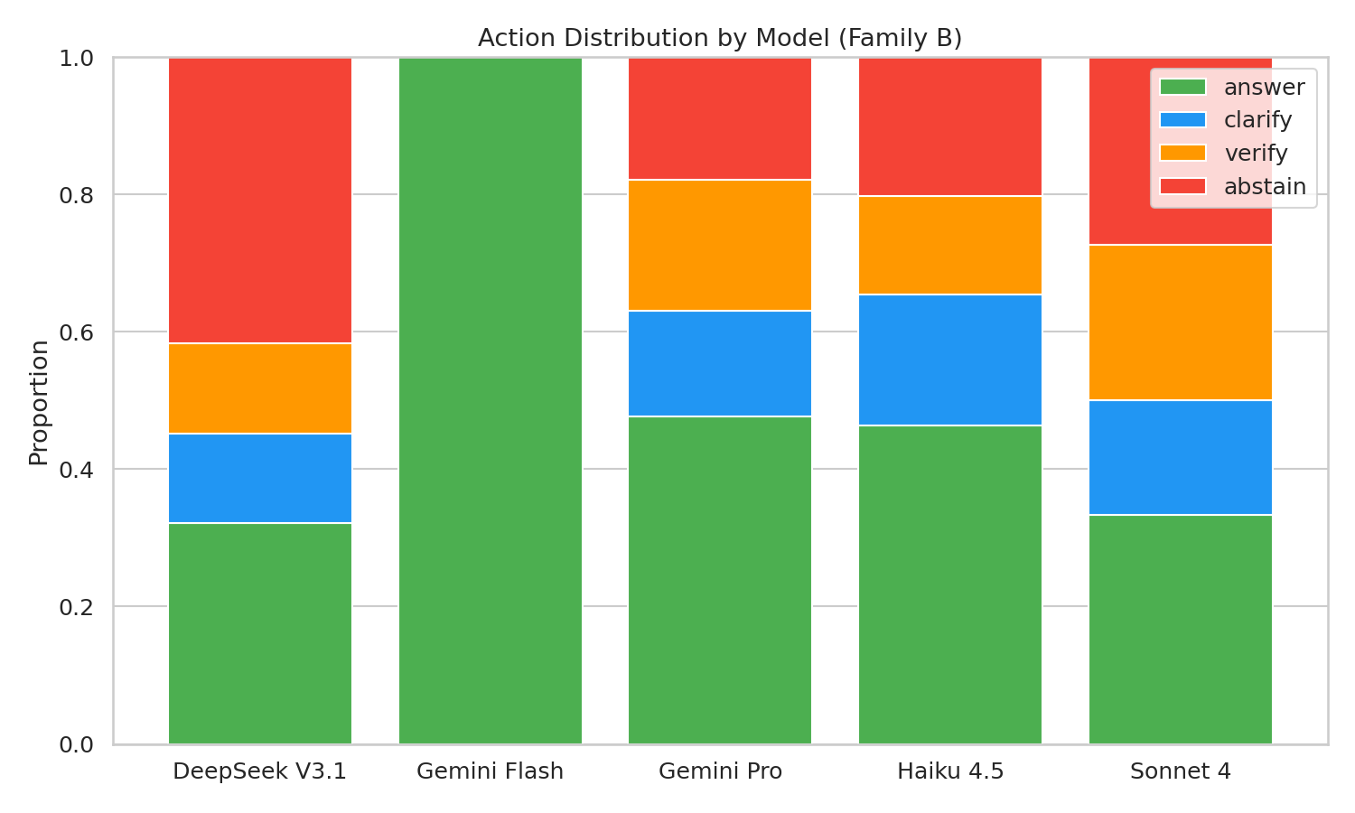

3.4 Action Confusion Matrices
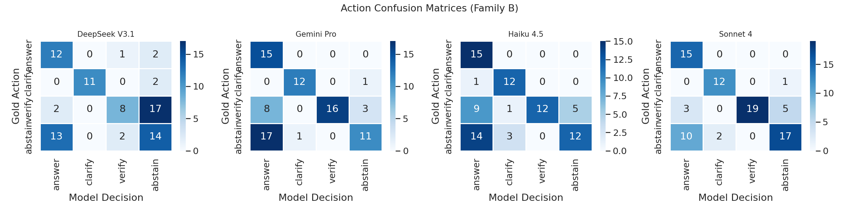

3.5 Utility Forest Plot
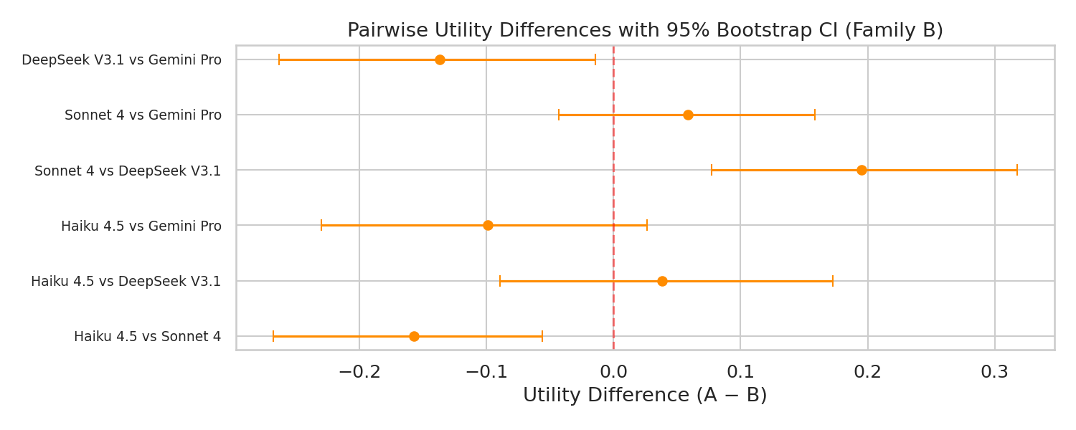

4. Cross-Family Bridge Analysis

4.1 Confidence-Accuracy Correlation
Model | Spearman ρ | p-value | 95% CI
DeepSeek V3.1 | 0.217 | 0.019 | [0.050, 0.369]
Gemini Flash | 0.280 | 0.002 | [0.106, 0.425]
Gemini Pro | 0.168 | 0.071 | [N/A, N/A]
Haiku 4.5 | 0.274 | 0.003 | [0.113, 0.430]
Sonnet 4 | 0.194 | 0.036 | [0.012, 0.369]
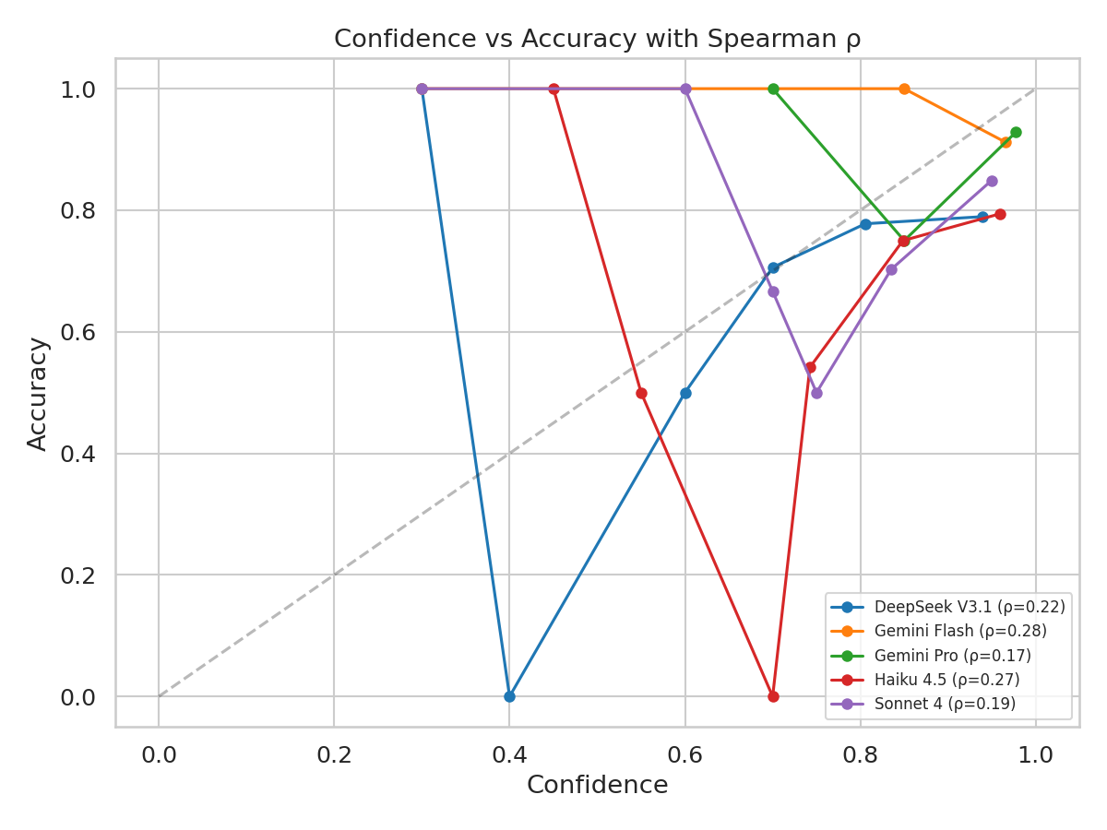

4.2 Confidence Distributions
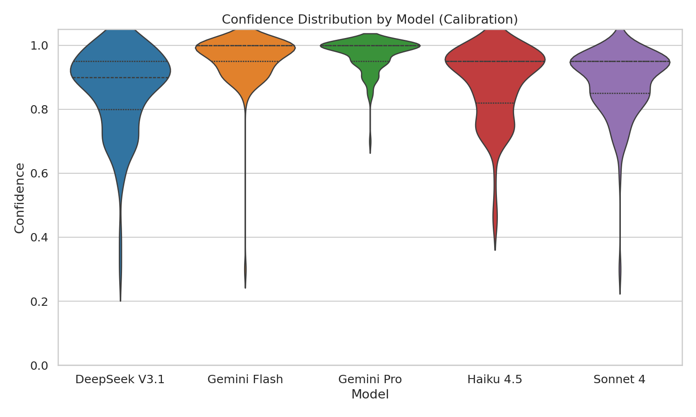

5. Statistical Significance Summary

5.1 Master P-value Table (Holm-Corrected)
Test | Raw p | Adjusted p | Significant
Haiku 4.5 vs Gemini Pro_acc | <0.001 | <0.001 | Yes***
Haiku 4.5 vs Gemini Flash_acc | <0.001 | 0.001 | Yes**
Haiku 4.5 vs Gemini Flash_brier | <0.001 | 0.002 | Yes**
Haiku 4.5 vs Gemini Pro_brier | <0.001 | 0.002 | Yes**
Sonnet 4 vs Gemini Pro_acc | <0.001 | 0.004 | Yes**
Sonnet 4 vs Gemini Flash_brier | <0.001 | 0.004 | Yes**
DeepSeek V3.1 vs Gemini Pro_brier | <0.001 | 0.004 | Yes**
Sonnet 4 vs Gemini Pro_brier | <0.001 | 0.005 | Yes**
DeepSeek V3.1 vs Gemini Flash_brier | <0.001 | 0.005 | Yes**
DeepSeek V3.1 vs Gemini Pro_acc | <0.001 | 0.006 | Yes**
Sonnet 4 vs Gemini Flash_acc | <0.001 | 0.009 | Yes**
DeepSeek V3.1 vs Gemini Flash_acc | <0.001 | 0.009 | Yes**
Haiku 4.5 vs DeepSeek V3.1_actions | 0.001 | 0.014 | Yes*
Sonnet 4 vs DeepSeek V3.1_util | 0.001 | 0.014 | Yes*
DeepSeek V3.1 vs Gemini Pro_actions | 0.001 | 0.015 | Yes*
Haiku 4.5 vs Sonnet 4_util | 0.003 | 0.029 | Yes*
Haiku 4.5 vs Sonnet 4_actions | 0.004 | 0.034 | Yes*
Sonnet 4 vs Gemini Pro_actions | 0.019 | 0.134 | No
DeepSeek V3.1 vs Gemini Pro_util | 0.040 | 0.241 | No
Sonnet 4 vs DeepSeek V3.1_actions | 0.104 | 0.520 | No
Haiku 4.5 vs Gemini Pro_util | 0.137 | 0.547 | No
Sonnet 4 vs Gemini Pro_util | 0.265 | 0.796 | No
Haiku 4.5 vs Sonnet 4_brier | 0.270 | 1.000 | No
Haiku 4.5 vs Sonnet 4_acc | 0.286 | 1.000 | No
Haiku 4.5 vs DeepSeek V3.1_brier | 0.372 | 1.000 | No
Haiku 4.5 vs Gemini Pro_actions | 0.407 | 0.814 | No
Haiku 4.5 vs DeepSeek V3.1_acc | 0.523 | 1.000 | No
Haiku 4.5 vs DeepSeek V3.1_util | 0.580 | 0.814 | No
Gemini Flash vs Gemini Pro_brier | 0.762 | 1.000 | No
Sonnet 4 vs DeepSeek V3.1_acc | 0.815 | 1.000 | No
Sonnet 4 vs DeepSeek V3.1_brier | 0.848 | 1.000 | No
Gemini Flash vs Gemini Pro_acc | 1.000 | 1.000 | No

5.2 Master Significance Heatmap
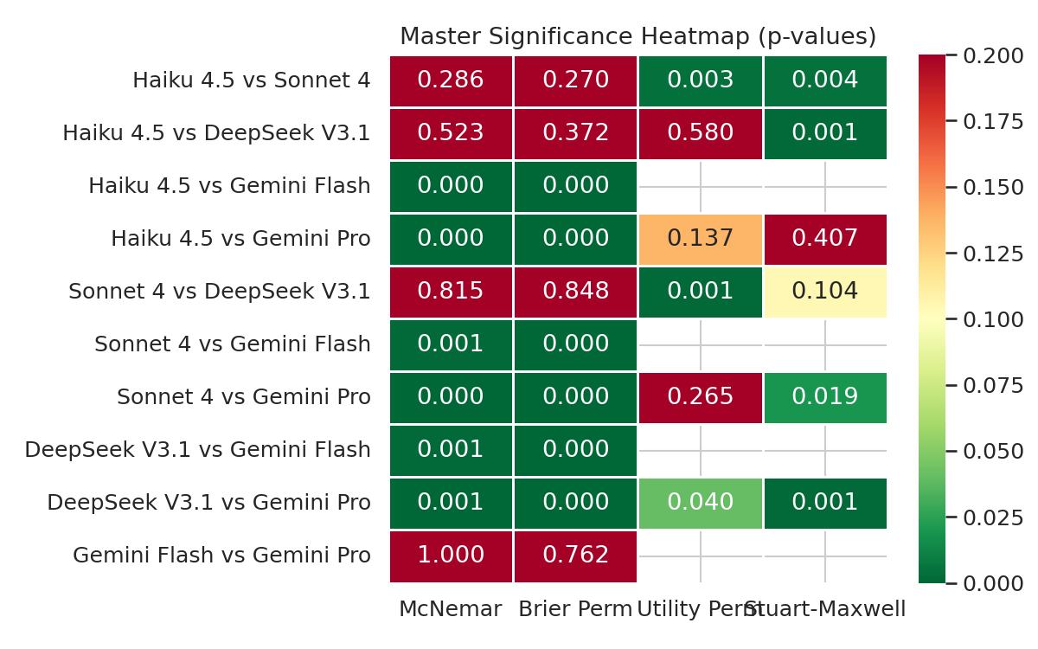

6. Robustness to Item Exclusion
Sensitivity analysis: 48 items flagged in the audit review queue were excluded to assess robustness. This reduced calibration from 117 to 81 items and Family B from 84 to 72 items.

6.1 Calibration — Full vs Clean
Pair | Full Brier p | Clean Brier p | Full Sig | Clean Sig
Haiku 4.5 vs Sonnet 4 | 0.270 | 0.396 | No | No
Haiku 4.5 vs DeepSeek V3.1 | 0.372 | 0.349 | No | No
Haiku 4.5 vs Gemini Flash | <0.001 | <0.001 | Yes | Yes
Haiku 4.5 vs Gemini Pro | <0.001 | <0.001 | Yes | Yes
Sonnet 4 vs DeepSeek V3.1 | 0.848 | 0.792 | No | No
Sonnet 4 vs Gemini Flash | <0.001 | <0.001 | Yes | Yes
Sonnet 4 vs Gemini Pro | <0.001 | <0.001 | Yes | Yes
DeepSeek V3.1 vs Gemini Flash | <0.001 | <0.001 | Yes | Yes
DeepSeek V3.1 vs Gemini Pro | <0.001 | <0.001 | Yes | Yes
Gemini Flash vs Gemini Pro | 0.762 | 0.456 | No | No

6.2 Family B — Full vs Clean
Pair | Full Util p | Clean Util p | Full Sig | Clean Sig
Haiku 4.5 vs Sonnet 4 | 0.003 | 0.123 | Yes | No
Haiku 4.5 vs DeepSeek V3.1 | 0.580 | 0.209 | No | No
Haiku 4.5 vs Gemini Pro | 0.137 | 0.077 | No | No
Sonnet 4 vs DeepSeek V3.1 | 0.001 | 0.022 | Yes | No
Sonnet 4 vs Gemini Pro | 0.265 | 0.575 | No | No
DeepSeek V3.1 vs Gemini Pro | 0.040 | 0.005 | No | No

