FUNNEL SWIPE  Maria Wendt →  Money Flow System  - Two paid-traffic sales-page architectures reverse-engineered section by section, then rebuilt with original Sean Ali / Money Flow copy.  REFERENCE GOAL  Preserve the conversion logic, not the copyrighted wording. This is a build-ready swipe file for future landing pages and Meta traffic tests. | 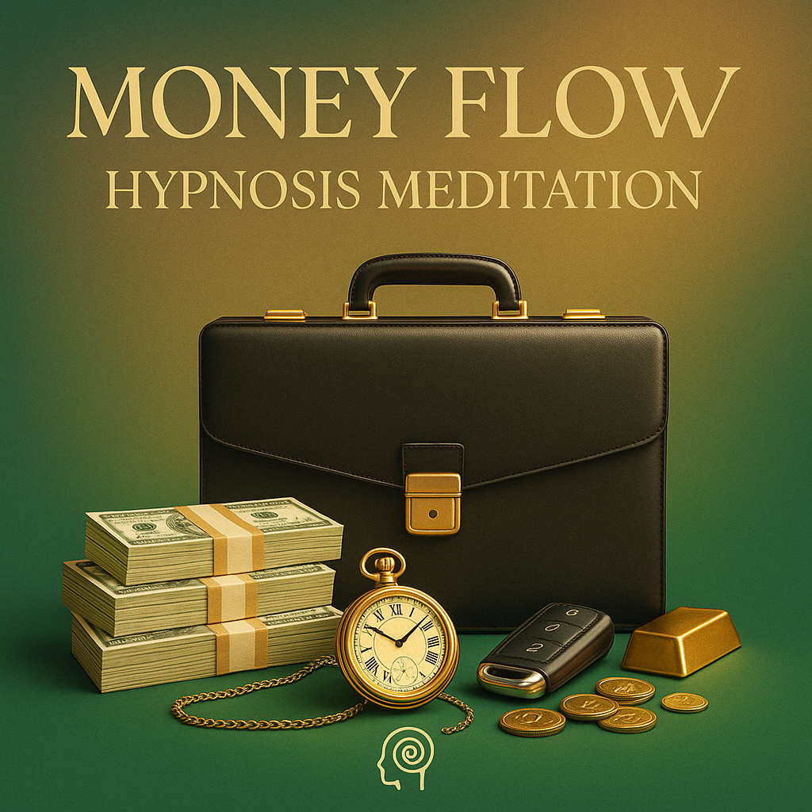  MONEY FLOW  Working front-end architecture

Copyright boundary
The source pages are third-party copyrighted works. I mapped the page order, persuasion mechanics, CTA cadence, offer logic, proof placement, and visual hierarchy, then wrote fresh Money Flow copy instead of reproducing their language line-for-line.

Source pages:
1) https://learn.coachmariawendt.com/make-money-selling-digital-products/
2) https://learn.coachmariawendt.com/instagram-bundle-8/

Executive read: what is actually working here
Highest-leverage takeaway
These pages do not win because they are visually sophisticated. They win by reducing thinking: one offer, one obvious action, plain-English benefit fragments, repeated checkout buttons, concrete price anchoring, and proof only after the visitor understands what is being sold.

Your “she is scaling Meta ads direct to pages like this” hypothesis is plausible, but the exact spend to these two URLs is not independently confirmed. What is confirmed is that Maria publicly teaches an ad → click → direct purchase model, says her team has spent millions on advertising, and describes scaling to high daily sale volume. A current third-party ad archive also shows Maria Wendt digital-product ads sending traffic to the same learn.coachmariawendt.com ecosystem. That is strong evidence for the funnel philosophy, not proof of spend on each exact URL.
PAGE 1 DNA  Single low-ticket product. Very short. Immediate CTA. Benefits before proof. Three major action moments. Price is simple and visible. Best analog for a $19 Money Flow front-end. | PAGE 2 DNA  Bundle/value-stack page. Outcomes first, then social proof, then “which item should I use?” segmentation, then item-by-item breakdown. Best analog for a multi-audio Money Flow System bundle.

What I would copy vs. what I would not copy
- COPY: the single-column, mobile-first path with almost no competing navigation.
- COPY: one concrete promise at the top, then benefits stated in short fragments rather than essay copy.
- COPY: CTA repetition before the visitor has time to mentally exit the page.
- COPY: direct checkout links instead of adding extra funnel steps for a low-ticket offer.
- COPY: bundle segmentation (“start here if you want X”) because it turns many products into a guided system.
- COPY: proof after comprehension — not a huge wall of credibility before the person understands the offer.
- TEST: low ticket price points aggressively; the simplicity of the page depends on the offer feeling low-friction.
- DO NOT COPY: unsupported income, manifestation, timing, or result claims. Your current Money Flow SOP requires verified proof and plain-language claims discipline.
- DO NOT COPY: their exact wording, testimonials, screenshots, pricing gimmicks, or personal claims.

Money Flow facts used for this swipe
I grounded the adaptation in your current Drive sources rather than remembered old copy. The active Money Flow page SOP says public copy should begin with Sean as a real person, the challenge he lived, what changed, the result he created, and the tool he now shares. It also says not to invent product details, proof, values, guarantees, or outcomes.
Working product assumptions for the two adaptations:
- Single-offer adaptation: Money Flow, current source-of-truth price $19 (was $47), positioned as a flagship money-focused hypnosis/meditation entry offer.
- Bundle adaptation: the currently verified five-session money bundle is $57 (was $135) and contains Money Flow, ATM In Your Mind, Money Magnet, Quantum Cash Manifestation, and Money Wave. In this document I use “Money Flow System” as the umbrella working name because you explicitly requested that frame. Verify the final public name before publishing.
- Sean authority/story facts used: built from scratch, discovered online business + meditation + visualization, 15+ years making money online, $25M+ in sales generated, and a location-independent life in Panama — sourced from the current Money Flow SOP.

Swipe Page 1 — compact low-ticket sales page
Source: Make Money Selling Digital Products
Observed role: short direct-response page that moves a cold visitor from “what is this?” to checkout with minimal education. The page has only a handful of persuasion jobs and repeats the purchase action instead of creating more content.
# | Block | What it does | Why it converts | Money Flow translation
1 | Bare header / no distraction | Keeps the visitor inside one conversion path. | Cold paid traffic does not need a site tour. Every extra nav option is an exit. | Use HM logo/brand only. No menu on the dedicated ad page.
2 | Product-name headline | Names the thing plainly before adding story or mechanism. | The visitor can orient instantly. No curiosity debt. | “Money Flow System” as the top line.
3 | Authority + what it is | One short credibility sentence tied directly to the offer. | Authority is attached to relevance, not dumped as biography. | Sean explains he built the practice from years using visualization, meditation and reprogramming while building his life/business.
4 | CTA #1 above fold | First immediate purchase opportunity. | Captures high-intent clickers without forcing scroll. | START MONEY FLOW — $19 working price.
5 | Benefit fragments | Several short “you get / you learn / this helps” statements. | Fast scanning on mobile; each line removes a different objection. | Guided session, simple nightly use, no long course, no complicated setup.
6 | Price restatement | Shows the price by itself, without complex pricing table. | Reduces uncertainty and keeps perceived decision size small. | Price: $19 working front-end.
7 | Ease / low-tech objection | Explains that implementation is simple. | Low-ticket buyers often fear hidden work more than price. | Digital access; headphones/quiet space optional; no special app required unless current delivery says otherwise.
8 | CTA #2 after comprehension | Second action after benefits and objections. | Catches the rational buyer after the core case is made. | YES — GIVE ME MONEY FLOW.
9 | Category / applicability line | Broadens relevance without adding a new promise. | Helps the prospect self-identify quickly. | For people already using meditation, visualization, journaling or subconscious audio — and people who want a simpler practice.
10 | CTA #3 | Another low-friction action before proof. | Prevents proof from becoming a required hurdle. | I’M READY TO START.
11 | Creator proof | Shows concrete evidence that the creator actually does the thing. | Reduces “why should I trust this person?” late in the page. | Use only current verified Sean/HM proof: product screenshots, customer reviews, business history, or sourced results.
12 | Customer proof + disclaimer | Adds social confirmation with a clear qualifier. | Lets proof work without pretending every buyer gets the same outcome. | Use verified current testimonials only. No universal money or timing claims.
13 | Footer/legal | Policies + Meta disclaimer. | Necessary for paid traffic and trust, but kept out of the sales path. | HM legal links + current Meta disclaimer + support link.

Page 1 conversion mechanics
- The page does not “warm up” for long. It asks for the sale almost immediately.
- The copy is written as short utility fragments. Each line carries one job.
- The price is not hidden behind a modal, webinar, quiz, or application.
- The CTA language is reaction-based and emotional rather than sterile “Submit” or “Checkout.”
- The proof block is late. This matters: first make the visitor understand the product, then prove the creator can deliver.
- There is no need for an elaborate mechanism section at this ticket if the product itself is intuitive.

Money Flow adaptation A — full page copy
Working use case
This is the closest analog to Maria’s short $27 page. Use it for a simple cold-traffic test to the current Money Flow entry offer. Working price below is $19 because that is the current source-of-truth price for Money Flow. If the checkout changes, update every price mention together.

HERO
MONEY FLOW SYSTEM
A simple guided audio practice I built from the same visualization, meditation and subconscious work I have used for years.

START MONEY FLOW — $19

WHAT IT GIVES THE BUYER
- One money-focused guided hypnosis / meditation session you can return to without turning it into another long course.
- A simple way to rehearse more prosperous thoughts, possibilities and decisions during quiet time or before bed.
- A repeatable mental practice for people who already believe their inner world influences how they show up in the outer world.
- Digital access so the practice can fit into a normal night instead of becoming another project to complete.
Price: $19
Plain-English objection answer
No complicated funnel. No giant curriculum. No promise that an audio magically creates money. Money Flow is a mental practice — a guided way to work with the thoughts, images and expectations you repeatedly bring into daily life.

YES — GIVE ME MONEY FLOW

SEAN AUTHORITY BLOCK
 | Why I made this  I did not start with a secret advantage. I grew up in a single-parent home in Canada and had to learn how to see a different future before I could build one. Over the years I got deep into online business, meditation, visualization and practical mental tools. Those practices became part of how I prepared my mind, made decisions and kept moving toward the life I wanted. Money Flow is one of the tools I created to make that practice simple enough to actually use.
I’M READY TO START

PROOF
INSERT VERIFIED PROOF HERE — current customer review screenshots, current buyer count, current product usage proof, or current creator/business proof only.
Recommended proof order: 1–3 short customer screenshots → one Sean authority proof block → optional “how to use it” visual. Avoid old screenshots merely because they look impressive.
FOOTER
30-day guarantee / refund language: USE CURRENT VERIFIED POLICY ONLY. • Privacy • Terms • Support • Meta disclaimer

Page 1 build specification
DESKTOP  Centered single column. Recommended 720–860 px max content width. Hero copy compact enough that product + first CTA appear without a giant scroll. CTA width 420–560 px. | MOBILE  Full-width content with 18–22 px side padding. Buttons near full width. Benefit lines 1–3 sentences max. Keep proof screenshots legible without pinch-zoom.

- No sticky bottom CTA by default — this matches your active Money Flow visual rules.
- One main product image near the hero; do not keep repeating the same mockup through the page.
- CTA every 1–2 meaningful persuasion blocks. Page 1 only needs about three main action moments.
- Use current HM brand implementation and current checkout/tracking. Do not design a new brand skin just because the swipe uses a different style.

Swipe Page 2 — bundle / value-stack sales page
Source: Instagram Bundle 8
Observed role: low-price bundle page that makes a larger catalog feel easy. It does this by grouping outcomes, repeatedly surfacing the bundle price, showing social proof, and then breaking down the individual assets one by one.
# | Block | What it does | Why it converts | Money Flow translation
1 | Outcome headline | Names the desired result before the bundle details. | The visitor buys the destination, not the file count. | Lead with “Money Flow System” + the mental practice outcome.
2 | Immediate first item / example | Shows one concrete asset right away. | Makes the bundle tangible before discussing value. | Feature Money Flow first as the anchor session.
3 | Price compression | Frames each included item as a tiny fraction of the total. | Creates a “why not?” economic reaction. | Use the verified $57 bundle / $135 anchor only if current checkout still matches.
4 | CTA #1 | Purchase button appears before deep detail. | Captures people who already understand the offer. | UNLOCK THE MONEY FLOW SYSTEM — $57.
5 | Outcome bullet list | Shows what the bundle helps the buyer do. | Turns a product list into a set of desired states/use cases. | Nightly money practice, visualization anchor, money-focused brainwave session, identity rehearsal, opportunity-awareness practice.
6 | CTA #2 | Repeats action after outcome list. | Converts after benefits, before proof. | GET THE COMPLETE SYSTEM.
7 | Scroll cue / more detail | Signals that deeper breakdown is below. | Prevents a long page from feeling random. | “Keep scrolling to see which session to use first.”
8 | Social proof intro | “People like this bundle” before showing testimonials. | Pre-frames the screenshots so they are interpreted as confirmation. | Use current verified HM reviews only.
9 | CTA #3 | Action after proof. | Turns validation into purchase momentum. | START MONEY FLOW.
10 | Authority + bundle thesis | Explains why these particular items belong together. | Stops the bundle feeling like leftover files. | Sean explains why he uses different mental tools for different moments rather than one track for everything.
11 | Outcome segmentation | Groups assets by what the buyer wants. | Reduces overwhelm and acts like a recommendation engine. | “If you want a simple nightly anchor… / if you want identity rehearsal… / if you want wordless or brainwave focus…”
12 | Item-by-item breakdown | Each included asset gets a short title, purpose, and value. | Increases perceived value without needing a long VSL. | Five verified money sessions with one clear use case each.
13 | CTA every few items | Buttons inserted inside the catalog. | Long bundle pages lose buyers unless the exit to checkout stays close. | Insert CTA after item 2–3 and again before final close.
14 | Final close | Restates simple economic and use-case logic. | The visitor ends on “what do I get and what do I do next?” | Five sessions, one money-focused practice library, digital access.
15 | Legal footer | Policies / platform disclaimer. | Keeps compliance separate from persuasion. | Current HM policies + Meta disclaimer.

Page 2 conversion mechanics
- The bundle does not merely list eight courses. It first organizes them around outcomes — “more sales” vs. “more followers.” That is the most transferable idea on the page.
- The repeated low unit price makes the bundle feel economically obvious. Your equivalent is not “$1 each” unless it is true; your equivalent is showing the verified anchor ($135) versus current bundle price ($57).
- The creator’s authority is repeated inside the sales argument, not isolated in a giant biography section.
- Each asset is described with one main job. The page avoids forcing the buyer to understand complex differences among eight products.
- The CTA appears at multiple decision points, especially after proof and after sub-groups of products.

Money Flow adaptation B — bundle page copy
Working bundle mapping
To mirror the 8-course bundle without inventing assets, this version uses the five money sessions currently verified in your source-of-truth: Money Flow, ATM In Your Mind, Money Magnet, Quantum Cash Manifestation, and Money Wave. Working price: $57; verified anchor in Drive: $135.

HERO
THE COMPLETE MONEY FLOW SYSTEM
Five money-focused audio sessions for the different moments when I want to reset, visualize, rehearse a bigger future, or simply stop feeding the same old thoughts.
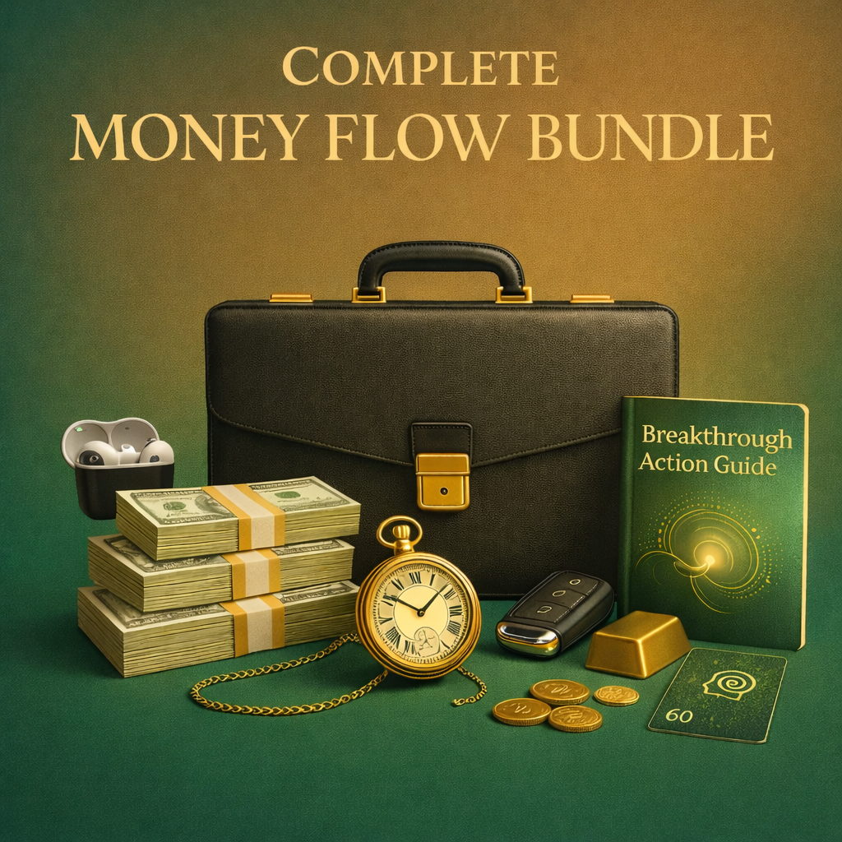
Working offer: $57 • verified anchor: $135
UNLOCK THE MONEY FLOW SYSTEM — $57

WHAT THIS BUNDLE IS FOR
- A simple money-focused audio library instead of trying to force one session to fit every mood or situation.
- A nightly or quiet-time practice for visualization, subconscious rehearsal and more intentional thinking around money and possibility.
- Different sessions for different jobs: guided hypnosis, identity rehearsal, brainwave-focused listening and momentum / opportunity awareness.
- A low-friction way to make the practice repeatable without adding another giant course to finish.
GET THE COMPLETE SYSTEM

START HERE BASED ON WHAT YOU NEED
IF YOU WANT A SIMPLE NIGHTLY ANCHOR  Start with Money Flow. This is the flagship guided money-focused hypnosis / meditation and the easiest entry point into the system. | IF YOU WANT TO REHEARSE A DIFFERENT SELF-IMAGE  Use Money Magnet or ATM In Your Mind as the sessions centered most directly on wealth-focused identity and subconscious rehearsal.

IF YOU WANT A BRAINWAVE-FOCUSED MONEY SESSION  Use Quantum Cash Manifestation or Money Wave. These are the more audio / brainwave-oriented parts of the stack. | IF YOU DO NOT KNOW WHERE TO START  Start with Money Flow for several nights, notice how you respond, then rotate into the session that matches the mental state you want to practice next.

SOCIAL PROOF
Proof placement
Insert 3–6 CURRENT verified HM customer screenshots here. Keep them short and readable. The page you are swiping places proof before the deep catalog breakdown; that is intentional because it makes the later item-by-item detail feel safer to buy.

START MONEY FLOW

WHY I USE MORE THAN ONE AUDIO
For years I have been visualizing my dream life, listening to reprogramming audios, meditating, and rehearsing the future I want in my mind. I never treated one recording like magic. Different days call for different mental work. Sometimes I want a guided reset. Sometimes I want to picture a bigger future. Sometimes I want something more passive in the background. The Money Flow System puts those different use cases in one place so the practice stays simple.
INSIDE THE SYSTEM
1. Money Flow
Flagship money-focused hypnosis / meditation. Best first session when you want one simple practice to return to.
2. ATM In Your Mind
A wealth-focused subconscious session built around rehearsing a more expansive internal money picture.
3. Money Magnet
An identity-oriented session for picturing and practicing the version of yourself who handles money, opportunity and receiving differently.
YES — I WANT THE COMPLETE SYSTEM

4. Quantum Cash Manifestation
A money-focused brainwave audio for people who like a more immersive audio-session format.
5. Money Wave
A brainwave-entrainment style session designed around momentum and noticing opportunity.
FINAL CLOSE
Five different money-focused sessions. One simple place to start. No claim that an audio replaces action, skill, work, or good decisions — just a repeatable mental practice built around the inner side of how I personally prepare myself to think and move differently.
$135 anchor → $57 working bundle price
GET THE MONEY FLOW SYSTEM — $57

Price/name/checkout must be synchronized with the current live offer before launch.

Why this page style is compatible with Meta cold traffic
This is the most important strategic part of the swipe. The pages are not trying to create maximum persuasion depth. They are trying to make a low-ticket decision feel obvious enough that the visitor can buy in the same session.
Mechanic | Why it matters | Money Flow rule
Ad continuity | The landing page should feel like the next sentence of the ad, not a new funnel. | Use the same product name, same primary desire, same visual, and same price family from ad → page.
Low cognitive load | Few sections, short copy fragments, repeated button. | Do not add a 12-part mechanism lecture to a $19 test.
Fast price discovery | Price is visible early. | Do not make a cold prospect scroll 5 screens to learn it costs $19/$57.
Direct purchase path | Buttons lead to checkout, not a maze. | Keep purchase click direct if the economics support it.
Mobile scanability | Benefits are broken into short chunks. | Use sentence fragments, bullets, and highly legible proof screenshots.
Proof without delay | Proof appears after basic offer understanding. | The visitor should know what Money Flow is before seeing testimonials.
Repeated action | CTA comes back whenever a persuasion job is finished. | Hero → after benefits → after proof → after product breakdown.

What I would test first
Test the offer assumption before polishing the page
The highest-leverage unknown is not whether the button should be green or gold. It is whether cold Meta traffic will buy Money Flow directly at the selected price with enough average order value to cover acquisition cost. Build the short page first, then let the numbers earn the right to add complexity.

- Test 1: Money Flow single at the current $19 price using the Page 1 structure.
- Test 2: Five-session money bundle at the current verified $57 price using the Page 2 structure.
- Keep the creative promise identical across both so you are testing offer architecture, not two unrelated messages.
- Primary decision metrics: landing-page view → checkout click, checkout click → purchase, CPA, AOV, refund rate, and downstream buyer value.
- Do not interpret cheap clicks as validation. The page has one job: produce buyers at economics you can scale.

Build-ready checklist for the Money Flow pages
Area | Requirement | Status
Above the fold | HM logo or minimal brand mark only; product name; one short supporting sentence; product visual; current price; purchase CTA. | ☐
Message match | Ad headline/desire and landing page headline are recognizably the same promise. | ☐
Copy | Short, plain, human. Sean story first when story is used. No abstract identity jargon before a concrete example. | ☐
Mechanism | Explain what the buyer actually does: listen, visualize, rehearse, repeat. Do not over-intellectualize it. | ☐
Images | Use real product asset and one natural Sean image. Do not repeat the same mockup everywhere. | ☐
CTA | Direct, readable, high contrast, repeated at natural decision points. No sticky CTA by default. | ☐
Price | One current price everywhere. If an anchor is used, it must match a real/current source. | ☐
Proof | Only current verified testimonials/screenshots/counts. Add qualifier where outcomes vary. | ☐
Claims | No guaranteed wealth, guaranteed manifestation, medical claims, or “listen tonight and get X tomorrow” promises. | ☐
Checkout | Current URL, working on mobile, payment options visible, no broken redirect. | ☐
Tracking | Meta pixel/CAPI/analytics and purchase event use existing current implementation. | ☐
Legal | Privacy, terms, refund/guarantee, support and Meta disclaimer. | ☐
Mobile QA | Button fits, headings wrap cleanly, proof screenshots readable, no horizontal overflow. | ☐
Speed | Compress images and avoid unnecessary scripts/embeds. Paid traffic page should feel instant. | ☐

CTA pattern bank — adapted, not copied
- START MONEY FLOW — $19
- YES — GIVE ME MONEY FLOW
- I’M READY TO START
- UNLOCK THE MONEY FLOW SYSTEM — $57
- GET THE COMPLETE SYSTEM
- YES — I WANT ALL FIVE SESSIONS
- START WITH MONEY FLOW TONIGHT
The pattern to preserve is emotional self-talk + clear action + price where useful. Do not over-write CTA buttons.

One-screen reference maps

Page 1 — short offer
01 Product name + one-sentence explanation
Keep this block compact. One persuasion job at a time.

02 Product visual
Keep this block compact. One persuasion job at a time.

03 CTA + price
Keep this block compact. One persuasion job at a time.

04 4–6 benefit fragments
Keep this block compact. One persuasion job at a time.

05 Price restatement
Keep this block compact. One persuasion job at a time.

06 Simple-use / objection answer
Keep this block compact. One persuasion job at a time.

07 CTA
Keep this block compact. One persuasion job at a time.

08 Short creator authority block
Keep this block compact. One persuasion job at a time.

09 CTA
Keep this block compact. One persuasion job at a time.

10 Verified proof
Keep this block compact. One persuasion job at a time.

11 Legal footer
Keep this block compact. One persuasion job at a time.

Page 2 — bundle
01 Outcome headline + bundle visual
The page should feel like a guided catalog, not a pile of products.

02 Price compression / anchor + CTA
The page should feel like a guided catalog, not a pile of products.

03 Outcome list
The page should feel like a guided catalog, not a pile of products.

04 CTA
The page should feel like a guided catalog, not a pile of products.

05 Scroll cue
The page should feel like a guided catalog, not a pile of products.

06 Social proof
The page should feel like a guided catalog, not a pile of products.

07 CTA
The page should feel like a guided catalog, not a pile of products.

08 Why the bundle exists
The page should feel like a guided catalog, not a pile of products.

09 Choose-your-use-case segmentation
The page should feel like a guided catalog, not a pile of products.

10 Item 1–3 breakdown
The page should feel like a guided catalog, not a pile of products.

11 CTA
The page should feel like a guided catalog, not a pile of products.

12 Item 4–5 breakdown
The page should feel like a guided catalog, not a pile of products.

13 Final price restatement + CTA
The page should feel like a guided catalog, not a pile of products.

14 Legal footer
The page should feel like a guided catalog, not a pile of products.

Sources and verification notes
Third-party funnel sources
- https://learn.coachmariawendt.com/make-money-selling-digital-products/
- https://learn.coachmariawendt.com/instagram-bundle-8/
- https://mariawendt.com/ads-course/ — evidence for Maria’s direct ad → click → purchase funnel philosophy and large paid-media usage.
- TryAtria Meta ad archive result for “Maria Wendt Official” (August 2026) — directional evidence that digital-product ads are currently active in this ecosystem; not proof of spend on the two exact swipe URLs.
Sean / Money Flow sources from connected Google Drive
- MASTER_SALES_PAGE_SOP_MONEYFLOW_CONTROL_V6_CLEAN — current sales-page shell, voice, proof and claims rules.
- Money Flow System - Webinar Offer Map — offer naming, funnel role, current pricing ladder and bundle mapping.
- MONEY PAGES tab — current Money Flow $19 entry price and verified five-session Money Mind Stack $57 / $135 anchor.
- Drive assets used: money flow.png, moneyflowbundle.png, sean beach.jpeg.
Final verification before publishing
Because product pricing and active checkout details can change faster than a reference document, verify the current live offer name, price, guarantee, checkout URL, product inclusions, proof screenshots and tracking immediately before turning this swipe into a live page.

