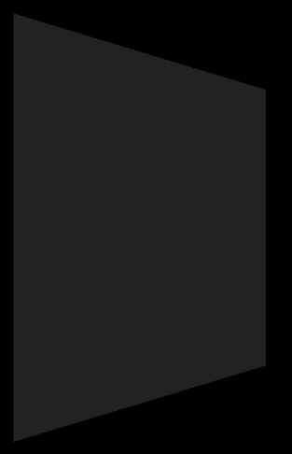COSC342 assignment 2 report – Sean Moir ID:8475230

I’ve tested the program by making single changes and new renders each time a change was made to isolate what fixed or broke the render.

Planes are a flat surface, thus to create a plane, a constant Z value is set, with X and Y being an infinite set of points over the plane with boundaries set by the scale of the plane, thus a unit plane is **X{0 -> 1}, Y{0 -> 1}, Z=0**.

To make the cube, the cube is made up of 6 planes (implemented in its own file as not to create a dependency) intersecting each other at the other’s boundaries

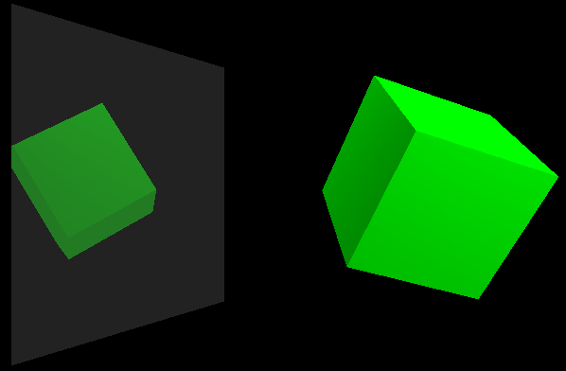

The cylinder is made up of a rounded surface, like that of a Sphere but with a constant Z co-ordinate, with two circular end cap, so for the rounded surface the equation **x^2 + y^2 - 1 = 0** is used, whereas for the round endcaps the equation **x^2 + y^2 = 1** is used.

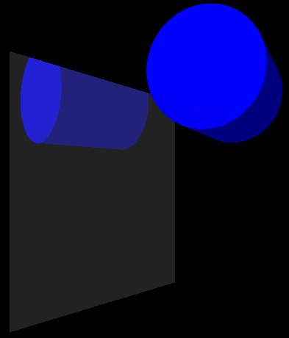

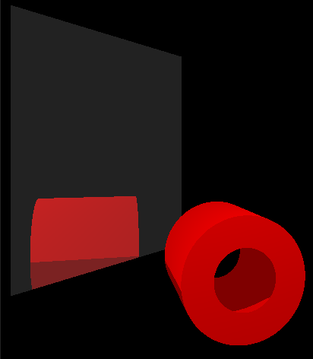The Tube is made up of the same rounded surface as the cylinder but with two of them, one having a smaller radius of the form **radius * ratio** where **0 < ratio < 1** with the same translation, thus being inside the bigger round surface, then with the end caps being two superimposed circles with differing radii by the equation **radius * ratio**, the difference of the circles being rendered, forming 2D rings with the equation (**x^2 + y^2 >= 1) AND (x^2 + y^2 <= r^2)**, where **r = ratio**.

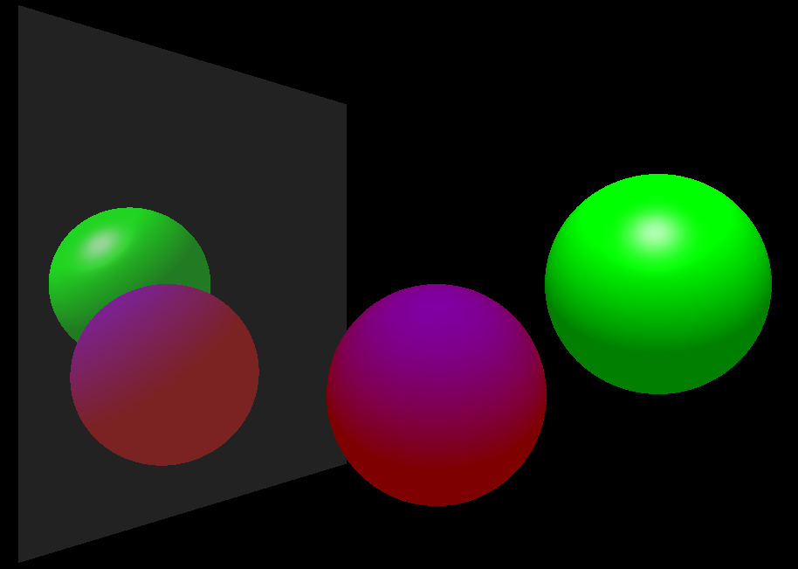For the diffuse, specular and ambient lighting I used the Phong Illumination equation as given in the lecture notes, this is done within the Scene.cpp -> computeColour() function, I tested this by hand with manual visual comparison with my sample scene that highlights specular and diffuse lighting.

I implemented shadows, by checking for an intersection with an object between the hit point and the light source. I tested this by comparing my output to the sample lighting scene.

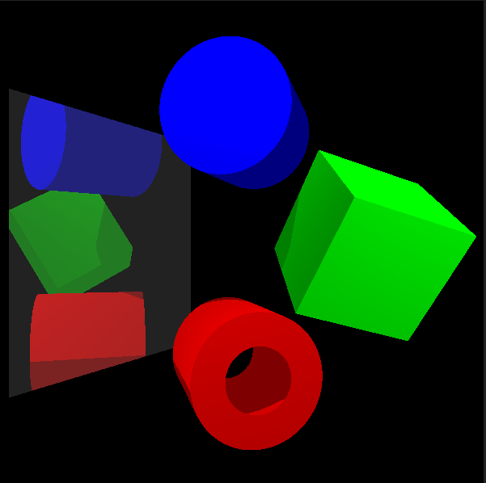

There are no known flaws in the program, the only issues encountered have been coming up with the ray-intersection equations used to render each object, I have overcome them, but they are by far the hardest part of the assignment.