In this lesson we are going to learn how numbers are represented in a computer. You might already wonder what this even means. Does a computer not know what 1, 2, or 42 are? Actually — it doesn't.
We often hear that the only thing that a computer knows is 0 and 1. But what does this actually mean? A computer is built with complex electrical circuits. The simplest circuit we can have is a single wire. Such a wire either has electricity passing through it (1) or it doesn't (0). So more precisely, a computer does not know the numbers 0 and 1, but it can distinguish between two states (on/off) of an electrical wire. So we, as humans, associate these two states with the numbers 0 and 1.
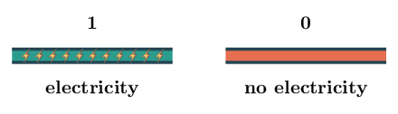
This on/off state of a single wire is called a bit. It is the smallest piece of information that a computer can store. By using more wires, we are able to represent sequences of bits. With two wires, we get a set of four possible states:
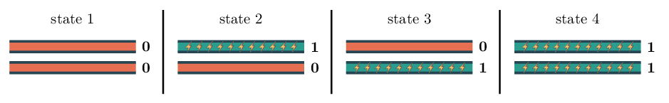
Every bit that we add doubles the number of possible states. With one bit we have two states, with two bits we have four states, with three bits we have eight states and so on. In general, with n bits we have:
n times2×2×…×2=2n states
As we can see, the number of states grows quite quickly as the complexity of the circuit increases. With 20 wires, we can already represent over one million states (1,048,576 to be precise)!
Before we move on, let's see how many states can be represented using 32 bits.
Instructions

- Using the ** python operator, compute 232, the number of states that 32 bits can be on.
- Print the result to the screen using the print() built-in function.
In order to understand the number system used by computers, it is best to first understand the decimal number system which we use everyday. It is called decimal or base 10 because we use ten digits to represent numbers: 0, 1, 2, 3, 4, 5, 6, 7, 8 and 9.
In the decimal number system, each digit has a different value depending on its position. For example, in a number like 234, the 2 represents the hundreds digit, the 3 the tenths digit and the 4 the units digit. What this means is that if we multiply the hundreds digit by 100, the tenths digit by 10 and the units digit by 1 we get the same number:
2×100+3×10+4×1=200+30+4=234
In a similar manner, 31497 can be written as:
3×10000+1×1000+4×100+9×10+7×1=30000+1000+400+90+7=31497
Starting with the rightmost digit (units digit), every time we move one digit to the left, the weight of that digit is multiplied by 10:
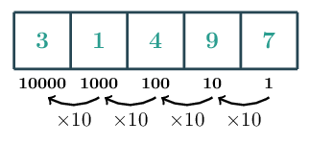
Let's number the positions from right to left, starting at 0. Then the units digit is at position 0, the tenths digit at position 1 and so on:
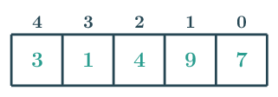
We can then easily write the multiplier of a digit in function of its position in the number. For example, since at each step we multiply by 10, the digit at position 3 has weight 10×10×10=103=1000, the digit at position 1 has weight 10=101. Remember that a positive number to the power 0 is equal to 1 so, this also works for the digit at position 0 which has weight 1=100.
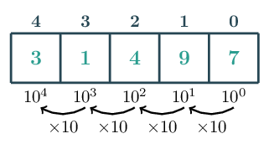
We can generalize and say that the digit at position k has weight 10k. The value of a digit is equal to that digit times its weight. For example, in the number 2534 the value of digit 2 is 2×103=2000 and the value of digit 3 is 3×101=30.
Instructions

Consider the number 645231.
- Assign to a variable named weight_digit_2 the weight of digit 2 in the number 645231.
- Using the value of weight_digit_2, assign to a variable named value_digit_2 the value of digit 2 in the number 645231.
- Assign to a variable named weight_digit_5 the weight of digit 5 in the number 645231.
- Using the value of weight_digit_5, assign to a variable named value_digit_5 the value of digit 5 in the number 645231.
The binary number system works very similarly to the decimal number system, except instead of having ten digits, we only have two: 0 and 1.
Some numbers in base 10 also only use the digits 1 and 0, for example, the number one hundred and one is written 101 in base 10. In order to avoid the confusion between numbers in the binary system and numbers in the decimal system that only contains digits 0 and 1, we usually write the numbers in base 2 between parenthesis and append a 2 as a subscript on the right of the number. So we will write (101)2 to represent a number in base two whose digits are 1, 0 and 1.
Humans are only good at counting in base 10. Since our first days in school, we have used the decimal system to count and do mathematics. For this reason, it is important to be able to translate a number in base 2 to number in base 10 that we can easily understand.
It turns out that the way to do so is very similar to the way base 10 works. Remember that we said that the number 234 in base 10 can also be thought of as:
(2×102)+(3×101)+(4×100)=(2×100)+(3×10)+(4×1)=234
To convert a number in base 2 to base 10, we do exactly the same but using powers of 2 rather than powers of 10. In this way, the number (101)2 represents the number decimal number 5:
(101)2=(1×22)+(0×21)+(1×20)=(1×4)+(0×2)+(1×1)=4+0+1=5
If we number the digits as we did before — that is, from the right to the left and starting at 0 — we can get the weight of each digit in base 2 by multiplying it by 2 every time we move one digit to the right. Therefore, the first few weights are 1, 2, 4, 8, 16, 32, ...
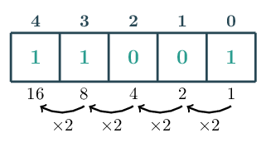
We have just learned that the binary system works very similarly to the decimal system except that:
- We use only the digits 0 and 1 to write the numbers
- The weights of the numbers are powers of 2 rather than powers of 10
Instructions

- Convert the value of (11001)2 to base 10. Assign the result to decimal_1.
- Convert the value of (1110)2 to base 10. Assign the result to decimal_2.
- Print the values of decimal_1 and decimal_2.
On the previous screen, we learned how to convert a number in base 2 to a number in base 10. We did it by hand, but Python actually has a function to do it for us. We can use the int() built-in function like so:
decimal = int('11001', 2)
print(decimal)
Copy
25
Copy
The first argument is a string object whose characters are the digits of the number that we want to convert. The second argument is 2 to instruct Python that the string represents a number in base 2.
On the first screen, we saw that a computer can only represent sequences of zeros and ones. For this reason, the binary number system is very well suited to represent numbers in the computer.
But in order to be able to use the binary number system to represent decimal numbers inside a computer we need to make sure that every integer in base 10 can be represented in base 2. Fortunately this is the case! We are not going to prove this as it goes out of the scope of what we are trying to teach in this lesson.
Here are the numbers 0 through 7 in binary:
decimal | binary
0 | 0
1 | 1
2 | 10
3 | 11
4 | 100
5 | 101
6 | 110
7 | 111
We have learned in the first screen that with n bits we can represent 2n different states (or values). This matches what we have just learned. The above table uses 3 bits, so we expect to be able to represent 23=8 values. In this particular instance, these 8 values are the decimal numbers 0, 1, 2, 3, 4, 5, 6, and 7.
In Python, we can use the built-in function bin() to convert any decimal number into a binary. The result of the function will be a string containing the binary representation of the input number. Python uses a slightly different notation to show that a number is in base 2. It will prefix the number with 0b:
bin(25)
Copy
'0b11001'
Copy
The binary representation of 25 is (11001)2. Python represents it as 0b11001. You should think as the 0b as Python way of representing the ( )2 notation.
Instructions

- Convert the number 12345 to base 2 using the bin() function. Assign the result to bin_1.
- Convert the number 1337 to base 2 using the bin() function. Assign the result to bin_2.
- Print the values of bin_1 and bin_2.
So far, we have looked at numbers in base 10 which is the one that we use in our day to day life and the base 2 which makes it possible to represent numbers with only two digits making it specially suited for representing numbers inside a computer.
However, we saw that both those bases work very similarly. The only thing that changed was:
- The set of available digits
- The base when computing the decimal values of numbers
The following table highlights these differences and similarities:
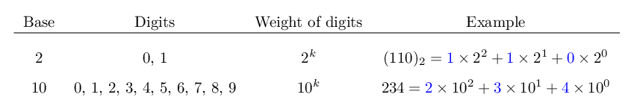
Looking at this, we might ask, what happens if instead of using 2 or 10, we use another number, say 8? Actually nothing prevents us from doing so! This is known as the octal number system. In this particular instance the numbers will have digits 0, 1, 2, 3, 4, 5, 6, 7 and the weights of the numbers will be powers of 8: 1=80, 8=81, 64=82, ...
We will use the notation ( )8 to specify that this number is a number in base 8. So (435)8 represents a number with digits 4, 3, and 5 in base 8. The value it corresponds to in base 10 is computed in the same way but using powers of 8:
(435)8=4×82+3×81+5×80=4×64+3×8+5×1=285
In general, when working in base b, we denote the numbers using the notation ( )b and compute the base 10 value of a given number by using weights that are powers of b. We can add a more general entry to the table above for representing how base b works:
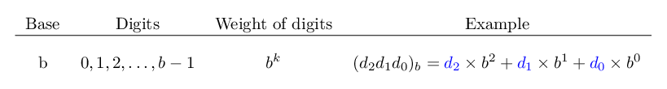
In Python we can convert a number represented in base b to base 10 (decimal) by using the int() function and passing the base value b as the second argument:
decimal = int('435', 8)
print(decimal)
Copy
285
Copy
There is unfortunately no built-in function to convert a number from base 10 to any given base b.
Instructions

- Convert the base 8 number (435)8 to base 10. Assign the result to a variable named base_8_to_10.
- Convert the base 7 number (10)7 to base 10. Assign the result to a variable named base_7_to_10.
From what we have discussed in the previous screen, you may be wondering:
- What happens if b=1? Because in this case, we only have the digit 0 available.
- What happens if b>10? We only have 10 digits available, 0, 1, 2, ..., 9. So how do we represent numbers in a base that requires more then 10 digits?
Let's answer both these questions starting with the first one. If b=1, then we only have the digit 0 available. Therefore, the only number that we can represent in this case is the number 0 itself. This makes it of little interest and therefore is considered an invalid base.
For the second question, the solution is to use other symbols to represent the digits. The convention is to use English alphabet letters a, b, ..., z. So a is used to represent the digit with decimal value 10, b for 11 and so on.
For example, in base 16 we have 16 digits: 0, 1, ..., 9, a, b, c, d, e and f. To compute the decimal value of a base 16 number we do the same as before while keeping in mind that a has value 10, b has value 11 up to f who has value 15.
(b5)16=b×161+5×160=11×16+5×1=181
There are 26 letters in the English alphabet meaning that, together with the 10 digits, we have a total of 36 symbols. So the maximum base that we can represent in this way is 36. In theory we could choose any other symbols for going further than 36. In practice this turns out to not have a lot of useful applications. If we look at the Python documentation of the int() function we see that it indeed supports bases 2 to 36.
Base 16 is often called hexadecimal and is used quite a lot. We mentioned in the previous screen that Python does not have any built-in function for converting numbers in base 10 to another given base. However, hexadecimal is important enough that Python has a built-in hex() function for converting base 10 to base 16.
hex(181)
Copy
'0xb5'
Copy
As you can see, Python prefixed the result with 0x to indicate that the string represents a hexadecimal number. You can think of 0x as being Python's equivalent of our ( )16 notation.
Don't be confused if you see these letters used in uppercase (like B5 rather than b5); they still represent the same thing. Also, when using Python to convert from hexadecimal to decimal, it accepts all notations:
print(int('b5', 16))
print(int('B5', 16))
print(int('0xb5', 16))
Copy
181
181
181
Copy
Instructions

- Use the hex() function to convert the decimal number 3501 to hexadecimal. Assign the result to a variable named hex_3501.
- Use the int() function to convert the hexadecimal number F to decimal. Assign the result to a variable named decimal_F.
We have learned that base 2 is important because it provided a way to represent numbers in a computer. Base 10 is important for obvious reasons since it is what we, as humans, naturally use.
But why do we care about hexadecimal? The main reason is that it makes more compact sequences of bits (zeros and ones). A group of four bits is called a nibble. Recall that from the first screen that with 4 bits we can represents 24=16 values. More precisely we can represent the numbers from 0 to 15.
On the previous screen we learned that one hexadecimal digit can also represent any value from 0 to 15. Therefore, with hexadecimal, we can represent a nibble with a single character! This is very compact! Once you get used to the hexadecimal notation, in certain contexts it makes it more readable than using base 10.
decimal | binary (nibble) | hexadecimal
0 | 0000 | 0
1 | 0001 | 1
2 | 0010 | 2
3 | 0011 | 3
4 | 0100 | 4
5 | 0101 | 5
6 | 0110 | 6
7 | 0111 | 7
8 | 1000 | 8
9 | 1001 | 9
10 | 1010 | a
11 | 1011 | b
12 | 1100 | c
13 | 1101 | d
14 | 1110 | e
15 | 1111 | f
Perhaps more importantly, a group of eight bits is called a byte. Sequences of eight bits can be used to represent numbers from 0 to 255. There are a lot of things in a computer that are represented with a few bytes. Hexadecimal provides a concise notation in those cases because it only require two digits to represent a byte (each digit represents four bits so two digits represent eight bits).
Let's see an example of such a representation with colors. Note that you do not need to understand how colors work to understand the remainder of this material, this is just to give an example application of hexadecimal.
In the RGB color system, colors are represented by three values between 0 and 255, each one indicating how much red, green, and blue there is in the color. You probably have seen these kind of sliders to select a color:
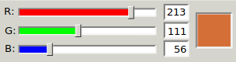
One way to represent the selected color is a tuple (213, 111, 56). In hexadecimal we can represent it more concisely as d56f38. The d5 represents 213, 6f represents 111 and 38 represents 56.
Let's confirm this using Python.
Instructions

- Convert the number 213 to hexadecimal. Assign the result to a variable named red_hex.
- Convert the number 111 to hexadecimal. Assign the result to a variable named green_hex.
- Convert the number 56 to hexadecimal. Assign the result to a variable named blue_hex.
Another base that is used frequently is base 8. We mentioned in a previous example that it is named octal. Its digits are 0, 1, 2, 3, 4, 5, 6 and 7.
Sequences of bits are often used to represent groups of options. This is done by assigning one bit per option with the meaning that the option is selected if the bit is one and unselected otherwise.
A common set of options that appears in a computer are file system permissions. You will learn more about these in the command line interface lessons. For now, our goal is simply to illustrate one use of octal.
A file has three kinds of permissions that need to be set of a given user:
- Can the user read the file?
- Can the user write on that file?
- Can the user execute that file?
We can easily represent the permissions of a file using a sequence of three bits. The leftmost bit is used to represent whether the user can read, the middle bit is used to the write permissions, and the remaining one for to specify whether the user can execute the file. For example, the sequence 101 would mean that the user can read and execute the file:
read | write | execute
1 | 0 | 1
We already learned that there are a total of 2n different sequences of n bits. Therefore, there are 23=8 possible configurations of a user's permission on a file. We can easily represent those using a single digit in octal as shown in the following table:
read | write | execute | octal representation
0 | 0 | 0 | 0
0 | 0 | 1 | 1
0 | 1 | 0 | 2
0 | 1 | 1 | 3
1 | 0 | 0 | 4
1 | 0 | 1 | 5
1 | 1 | 0 | 6
1 | 1 | 1 | 7
Just like for hexadecimal, Python has a build-in function oct for converting decimal numbers into octal. Python will prefix the result with the character 0o to indicate that it represents an octal number.
oct(8)
Copy
0o10
Copy
Instructions

- Use the oct() function to convert the decimal number 999 into octal. Assign the result to a variable named octal_999.
- Confirm that the result by using the int() function to convert octal_999 back to decimal. Assign the result to a variable named original.

