In the previous course, we explored the basics of working with data using the Python programming language. In this course, we'll continue our Python journey and focus on strings, object-oriented programming, dates and times, and many other concepts that are essential for programming in Python.
In the first course, the data we worked with didn't have many quirks — all the values were in a consistent format. Data with a consistent format is often described as "clean." As data engineers, much of the data that we encounter is not clean:
- Data comes from different sources in different formats, so we need to normalize it.
- Each data source itself can have invalid data due to techinical and operational limitations.
- Human error in data entry.
Oftentimes, we'll need to prepare it in a process called data cleaning.
We'll start this course by learning how to clean data using Python. We'll perform data cleaning on a real-world dataset of artworks contained in the Museum of Modern Art (MoMA). We'll learn more about the MoMA dataset in the next screen, but for now, let's take a moment to understand how Python stores datasets.
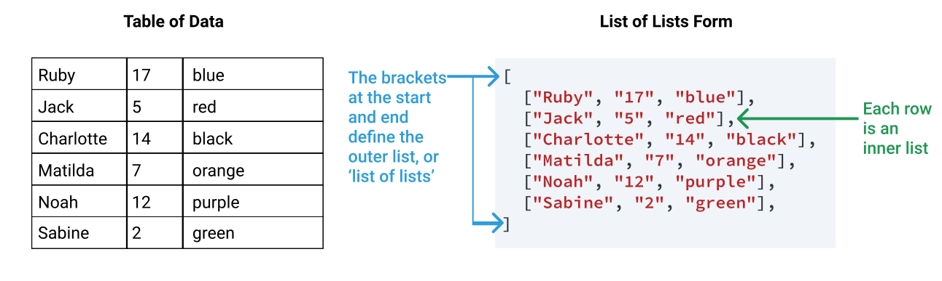
Each row of our data is represented by a list, with each item in that list representing an item from the row. Each "row list" is stored in one single outer list — which is why we call this format a list of lists. The diagram above shows a simple table of data and its lists of list representation.
If we want to find out how many rows are in our list of lists, we can use the Python built-in function len(). The len() function will tell us how many 'row lists' are in our list of lists:
# the list of lists is stored
# using the variable name `children`
​
num_rows = len(children)
print(num_rows)
Copy
6
Copy
In the code above, we:
- Used len(children) to count how many items (rows) are in the children list of lists.
- Assigned the result of len(children) to a variable called num_rows.
- Used print(num_rows) to display the value of the num_rows variable.
On the right is the script.py code editor where you'll complete your coding exercises in this course. Behind the scenes, we have read in the MoMA dataset into a list of lists format to make it easier for you to get started.
Let's use the len() function to find out how many rows are in our dataset. If you get stuck, you can view a hint by using the "Get Help" menu below.
Instructions

The MoMA dataset is stored in a list of lists with the variable name moma.
- Use the len() function to count how many items (rows) are in the moma list of lists.
- Assign the result to a variable called num_rows.
We going to work with data about the art in the Museum of Modern Art (MoMA). MoMA, a museum in New York City, has one of the largest collections of modern art in the world.

MoMA publishes several datasets in their GitHub repository. We'll work with a version of their artwork dataset that has been prepared for this lesson. We have prepared the data for teaching purposes and sampled the size of the dataset down from over 135,000 rows to a more manageable 17,000 rows.
Each row of the dataset represents a unique piece of art. Let's take a look at the first five rows:
Title | Artist | Nationality | BeginDate | EndDate | Gender | Date | Department
Dress MacLeod from Tartan Sets | Sarah Charlesworth | (American) | (1947) | (2013) | (Female) | 1986 | Prints & Illustrated Books
Duplicate of plate from folio 11 verso (supplementary suite, plate 4) from ARDICIA | Pablo Palazuelo | (Spanish) | (1916) | (2007) | (Male) | 1978 | Prints & Illustrated Books
Tailpiece (page 55) from SAGESSE | Maurice Denis | (French) | (1870) | (1943) | (Male) | 1889-1911 | Prints & Illustrated Books
Headpiece (page 129) from LIVRET DE FOLASTRIES, À JANOT PARISIEN | Aristide Maillol | (French) | (1861) | (1944) | (Male) | 1927-1940 | Prints & Illustrated Books
97 rue du Bac | Eugène Atget | (French) | (1857) | (1927) | (Male) | 1903 | Photography
MoMA doesn't provide a data dictionary for the data, but we have provided an explanation of each column for you:
- Title: The title of the artwork.
- Artist: The name of the artist who created the artwork.
- Nationality: The nationality of the artist.
- BeginDate: The year in which the artist was born.
- EndDate: The year in which the artist died.
- Gender: The gender of the artist.
- Date: The date that the artwork was created.
- Department: The department inside MoMA to which the artwork belongs.
The MoMA data is in a CSV file called artworks.csv. Here's what the first five lines of that file look like:
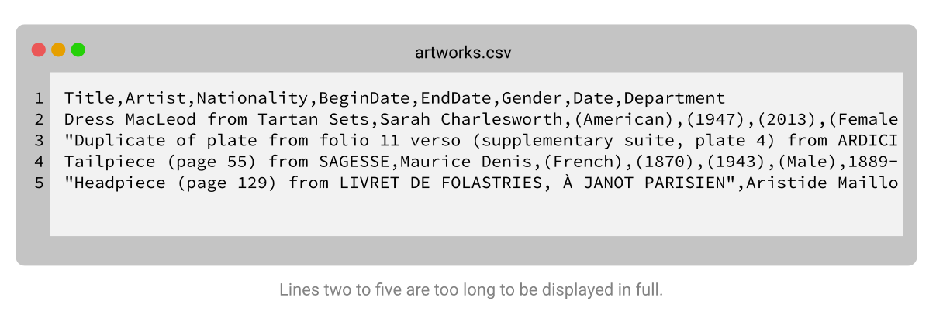
In the previous course, we learned about the built-in csv module, which helps us when working with CSV files. Let's recall how to use the module to open the children.csv file, line-by-line.
First, we start by importing the reader() function from the csv module:
from csv import reader
Copy
Next, we use the Python built-in function open() to open the children.csv file:
opened_file = open('children.csv')
Copy
We then use reader() to parse (or interpret) the opened_file:
read_file = reader(opened_file)
Copy
Once we have parsed the data, we use the list() function to convert the read_file into a list of lists format:
children = list(read_file)
Copy
Remember to close the file:
opened_file.close()
Copy
Finally, we remove the first row of the data, which contains the column names:
children = children[1:]
Copy
The code we just used — which opens the children.csv file as a list of lists — is copied into the code box on the right. Let's use the same technique to open the artworks.csv dataset.
Instructions

- Use the open() function to open the artworks.csv file. Assign the result to opened_file.
- Use the reader() function to parse the data from opened_file. Assign the result to read_file.
- Use list() to convert read_file into a list of lists. Assign the result to moma.
- Close opened_file.
- Use list slicing to remove the column names (the first row) from the moma list of lists.
Often when we're cleaning data, we need to replace parts of strings so our data is consistent.
For example, let's say we have the string "red is my favorite color", but we want to change it to "blue is my favorite color". To do that, we want to replace the "red" part of the string with "blue". When we want to refer to part of a string, we use the term substring.
In order to do this, we'll learn the str.replace() method. The str.replace() method is like a "find and replace" tool for strings. Let's look at the individual steps required to change our string:
- We need to find all instances of the old substring, "red".
- We need to replace each of those instances with the new substring, "blue".
To achieve this using str.replace(), we need to provide two arguments:
- old: The substring we want to find and replace.
- new: The substring we want to replace old with.
Both of these are positional arguments, so we can use them without specifying their names. Let's look at what this looks like in the diagram below:
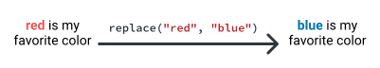
When we use str.replace(), we substitute the str for the variable name of the string we want to modify. Let's look at an example in code:
fav_color = "red is my favorite color"
fav_color = fav_color.replace("red", "blue")
print(fav_color)
Copy
blue is my favorite color
Copy
In the code above, we:
- Created the original string and assigned it to the variable name fav_color.
- Replaced the substring "red" with the substring "blue" by calling fav_color.replace().
- Assigned the result back to the original variable name using the = sign.
- Printed the modified string using the print() function.
One thing to remember when you use str.replace() is that it will replace all instances of the substring it finds. Let's say we wanted to capitalize the start of our sentence, giving us "Red is my favorite color".
We may decide that we can just replace the substring "r" with "R". Let's look at what happens when we do that:
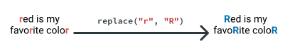
Because the substring "r" was found in the words favorite and color, we have replaced them giving us "favoRite" and "coloR". Be careful where you might have a substring hidden inside other words, and if this happens, just use a longer substring:

Before we practice using str.replace() to place a substring, let's quickly recap what we've learned so far:
- Parts of strings are called substrings.
- We can use the str.replace() method to find and replace substrings.
- str.replace() requires two arguments:
  - old: The substring we want to find and replace.
  - new: The substring we want to replace old with.
- When we use str.replace(), we substitute the str for the variable name of the string we want to modify.
- We need to use = to assign the modified string to a variable name.
If you get stuck, just work through these steps!
Instructions

We have created a variable, age1, containing the string "I am thirty-one years old".
- Use the str.replace() method to create a new string, age2:
  - The new string should have the value "I am thirty-two years old".
Now that we've learned to replace substrings, let's look at where we can use that technique to clean our MoMA dataset. Let's look again at the first few rows of our dataset with only the Title, Artist, Nationality and Gender columns:
Title | Artist | Nationality | Gender
Dress MacLeod from Tartan Sets | Sarah Charlesworth | (American) | (Female)
Duplicate of plate from folio... | Pablo Palazuelo | (Spanish) | (Male)
Tailpiece (page 55) from SAGESSE | Maurice Denis | (French) | (Male)
Headpiece (page 129) from LIVRET... | Aristide Maillol | (French) | (Male)
97 rue du Bac | Eugène Atget | (French) | (Male)
Notice how the Nationality and Gender columns have parentheses (()) at the start and the end of the values. Our task in this screen is to remove those values.
In the previous screen, we learned how to use str.replace() to replace one substring with another. Our task, however, is to remove a substring, not replace it. In order to remove a substring, we use a simple trick: we replace the substring with an empty string: "". Let's look at an example of how that works:
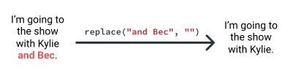
In order to replace characters across our whole moma dataset, we'll need to perform this "replacement" many times. For this, we can use a for loop. Let's look at an example using a small sample of our data:
nationalities = ['(American)', '(Spanish)', '(French)']
​
for n in nationalities:
clean_open = n.replace("(","")
print(clean_open)
Copy
American)
Spanish)
French)
Copy
Our code removed the ( character from the start of each string. In order to remove both, we'll have to perform the str.replace() twice — once for each character:
nationalities = ['(American)', '(Spanish)', '(French)']
​
for n in nationalities:
clean_open = n.replace("(","")
clean_both = clean_open.replace(")","")
print(clean_both)
Copy
American
Spanish
French
Copy
In this code, we:
- Used n.replace() to replace the ( character from each value in our loop.
- Used clean_open.replace() to replace the ) from the result of the previous operation.
If we had used n.replace() both times, we would have lost the result of the first operation and ended up with strings that still had the ( character.
Let's look at how we can adapt this code to work on the whole dataset. We'll start by printing the value from only the Nationalities column (index 2) for three rows in our moma dataset. We'll use the same rows after our loop so we can see how the values changed:
print(moma[300][2])
print(moma[400][2])
print(moma[500][2])
Copy
(American)
(Dutch)
(Swiss)
Copy
Next, we'll loop over each row in the moma dataset. In each row, we'll:
- Assign the Nationality value from index 2 to a variable name.
- Use nationality.replace() to remove all instances of the open parentheses.
- Use nationality.replace() to remove all instances of the close parentheses.
- Assign the cleaned nationality back to row index 2.
for row in moma:
nationality = row[2]
nationality = nationality.replace("(","")
nationality = nationality.replace(")","")
row[2] = nationality
Copy
Let's look at the values of the same three rows after our code:
print(moma[300][2])
print(moma[400][2])
print(moma[500][2])
Copy
American
Dutch
Swiss
Copy
You can see that after using our loop, the parentheses are gone from the values in the Nationalities column.
Now it's your turn — you'll be removing the parentheses from both the Nationality and Gender columns. Remember, if you get stuck, you can click on "Get Help" to view some hints.
Instructions

Use a for loop to loop over the moma list of lists. In each iteration of the loop:
- Clean the Nationality column of the dataset by:
  - Assigning the nationality for each row (found at list index 2 of the row) to a variable.
  - Using the str.replace() method to remove the open parentheses (() character.
  - Using the str.replace() method to remove the close parentheses ()) character.
  - Assigning the cleaned value back to list index 2 of the row.
- Clean the Gender column of the dataset (found at index 5 of the row) by repeating the same technique you used for the Nationality column.
The Gender column in our dataset contains four unique values:
- "" (an empty string)
- "Male"
- "Female"
- "male"
There are two different capitalizations in use in our dataset for "male." This sort of inconsistency is often caused when there is manual data entry and different people use different capitalizations when they enter words.
There are a few ways we could handle this using what we know so far:
- We could use str.replace() to replace m with M, but then we'd end up with instances of FeMale.
- We could use str.replace() to replace male with Male. This would also give us instances of FeMale.
Even if the word "male" wasn't contained in the word "female," both of these techniques wouldn't be good options if we had a column with many different values, like our Nationality column. Instead, we can use a Python string method designed specifically for handling capitalization: the str.title() method.
The str.title() method returns a copy of the string with the first letter of each word transformed to uppercase (also known as title case).
Let's look at an example of this method in action with a simple string:
my_string = "The cool thing about this string is that it has a CoMbInAtIoN of UPPERCASE and lowercase letters!"
​
my_string_title = my_string.title()
print(my_string_title)
Copy
The Cool Thing About This String Is That It Has A Combination Of Uppercase And Lowercase Letters!
Copy
Using title case will give us consistent capitalization for all values in the Gender column.
We have a number of rows containing an empty string ("") for the Gender column. This could mean:
- That the person entering the data didn't know the gender of the artist.
- That the artist is unknown and so the gender is also unknown.
- That the artist's gender is non-binary.
When we correct the capitalization, we'll also take the opportunity to label these with the string "Gender Unknown/Other". The technique we'll use to correct the capitalization is very similar to the technique we used to remove the parentheses:
- Iterate over all of the rows using a for loop.
- Assign the value from the Gender column for each row to a variable.
- Make the changes to the value:
  - Use the str.title() method to make the capitalization uniform.
  - Use an if statement to check if the value is an empty string and, if so, give it a descriptive value.
- Assign the result back to the Gender column for the row.
Let's take a look at what this looks like in code:
for row in moma:
gender = row[5]
​
# convert the gender to title case
gender = gender.title()
​
# if there is no gender, set
# a descriptive value
if not gender:
gender = "Gender Unknown/Other"
row[5] = gender
Copy
Now let's use this technique to make the capitalization of both the Nationality and Gender columns uniform. The Nationality column has 84 unique values, so to help you, we'll provide you with the values that aren't already in title case:
- ''
- 'Nationality unknown'
Instructions

Use a loop to iterate over all rows in the moma list of lists. For each row:
- Clean the Gender column.
  - Assign the value from the Gender column, at index 5, to a variable.
  - Make the changes to the value of that variable.
    - Use the str.title() method to make the capitalization uniform.
    - Use an if statement to check if the value is an empty string. If the value is an empty string, give it the value "Gender Unknown/Other".
  - Assign the modified variable back to list index 5 of the row.
- Clean the Nationality column of the dataset (found at index 2) by repeating the same technique you used for the Gender column.
  - For missing values in the Nationality column, use the string "Nationality Unknown".
Having analyzed the artist nationalities, we'll now look at the BeginDate and EndDate columns. These columns contain the birth and death dates of the artist who created the work. Let's take a look at the contents of the first five rows in each column:
for row in moma[:5]:
birth_date = row[3]
death_date = row[4]
print([birth_date, death_date])
Copy
['(1947)', '(2013)']
['(1916)', '(2007)']
['(1870)', '(1943)']
['(1861)', '(1944)']
['(1857)', '(1927)']
Copy
The values are four-digit years, wrapped in parentheses and stored as strings. To clean these columns, we need to:
- Remove the parentheses from the start and the end of each value.
- Convert the values from the string type to an integer type. This will help us perform calculations with them later.
In the previous two screens, we had to repeat code twice — first when we cleaned the Gender column, and then when we cleaned the Nationality column. Instead of repeating code, we can create a function that performs these operations, then use that function to clean each column.
The function below:
- Takes a single argument
- Uses str.replace() to remove the "(" character
- Uses str.replace() to remove the ")" character
- Uses the int() function to convert the string to an integer
def clean_and_convert(date):
date = date.replace("(", "")
date = date.replace(")", "")
date = int(date)
return date
Copy
Let's use this function to clean and convert the BeginDate value from the first row, '(1947)':
birth_date = '(1947)'
cleaned_date = clean_and_convert(birth_date)
print(cleaned_date)
print(type(cleaned_date))
Copy
1947
class 'int'
Copy
Our function successfully removes the parentheses and converts the value to an integer type. Unfortunately, our function won't work for every value in our dataset. Let's look at the values in the 32nd row:
row_32 = moma[31] # row 32
print(row_32)
Copy
['Untitled', 'Unknown', 'Nationality Unknown', '', '', 'Gender Unknown/Other', 'c. 1925', 'Photography'
Copy
The 4th and 5th values in the list — the artists' birth and death dates — are empty strings. Let's look at what our function does when we pass it an empty string:
birth_date = ''
cleaned_date = clean_and_convert(birth_date)
Copy
---------------------------------------------------------------------------
ValueError Traceback (most recent call last)
<ipython-input-29-5fec733171e0> in <module>()
1 birth_date = ''
----> 2 cleaned_date = clean_and_convert(birth_date)
​
<ipython-input-23-e80fc6338bc3> in clean_and_convert(date)
6 date = date.replace("(", "")
7 date = date.replace(")", "")
----> 8 date = int(date)
9 return date
10
​
ValueError: invalid literal for int() with base 10: ''
Copy
Our code has not completed successfully, instead returning a ValueError. As we learned in the previous course, the name for the error message is called a traceback. The final line of the traceback tells us the underlying error:
ValueError: invalid literal for int() with base 10: ''
Copy
This is Python saying "You asked me to convert the string '' to an int type. I tried to do that, but I couldn't, because I don't know how to represent an empty string as an integer." This tells us that somewhere in one of our date columns, there is a row with a missing date.
One way to handle these scenarios is to use an if statement to make sure we aren't encountering an empty string before we convert our value. Let's look at how we modify our function to include this logic:
def clean_and_convert(date):
# check that we don't have an empty string
if date != "":
# move the rest of the function inside
# the if statement
date = date.replace("(", "")
date = date.replace(")", "")
date = int(date)
return date
​
clean_and_convert("")
Copy
''
Copy
The function leaves any empty strings unchanged. Let's use this modified function inside a for loop to convert all the artist birth and death dates.
Instructions

We have provided the clean_and_convert() that uses the if statement to bypass missing strings.
Use a for loop to iterate over each row in the moma list of lists. In each iteration:
- Assign the BeginDate and EndDate values (at indexes 3 and 4) to variables.
- Use the clean_and_convert() function to clean and convert each value.
- Assign the converted values back to indexes 3 and 4 so the cleaned values are used in the moma list of lists.
In the previous screen, we converted the BeginDate and EndDate columns into numeric values. If we were to combine the data from the BeginDate column — which represents the artist's year of birth — with the data in the Date column — which represents the year in which the piece of art was created — we can calculate the age at which the artist produced the work.
We're going to perform this calculation in this next lesson, but in order to prepare, we need to clean the data in the Date column. Let's start by looking at a sample of the types of values contained in this column:
1912
1929
1913-1923
(1951)
1994
1934
c. 1915
1995
c. 1912
(1988)
2002
1957-1959
c. 1955.
c. 1970's
C. 1990-1999
Copy
This column contains data in many different formats:
- Some years are in parentheses.
- Some years have c. or C. before them, indicating that the year is approximate.
- Some have year ranges, indicated with a dash.
- Some have 's to indicate a decade.
In this screen, our task will be simply to remove all the extra characters so that we're left with either a range or a single year. Then, we'll finish processing the data in the screens that follow. For the two special cases listed above:
- Where there is an 's that signifies a decade, we'll use the year without the 's.
- Where c. or similar indicates an approximate year, we'll remove the c. but keep the year.
To carry out our task, there are lots of characters we'll need to remove. One option is to write an individual str.replace() for each character. A more efficient option is to write a function which iterates over a list of "bad" characters, so our code is easier to understand.
Before we start, let's look at a quick example of how this works. First, let's create a list of sample strings and a list of bad characters we want to remove from those strings:
strings = ["good!", "morn?ing", "good?!", "morniZZZZng"]
bad_chars = ["!", "?", "Z"]
Copy
Next, we'll create a function that uses a for loop to iterate over the bad_chars list, and replaces each of the bad characters with an empty string:
def strip_characters(string):
for char in bad_chars:
string = string.replace(char,"")
return string
Copy
Finally, we'll use a loop to iterate over each string in strings and use our strip_characters() function to remove the bad characters:
cleaned_strings = []
for s in strings:
s = strip_characters(s)
cleaned_strings.append(s)
​
print(cleaned_strings)
Copy
['good', 'morning', 'good', 'morning']
Copy
Let's use this technique to clean the Date column. To make things easier, we've provided two helper variables:
- test_data: This is the list of strings we saw above. This list is representative of the values in the Date column of our dataset, which allows you to see the effect of your code without viewing 17,000 dates.
- bad_chars: This is a list of the characters you'll need to replace. This means you spend your time thinking about the structure of your code, rather than making sure you got every last character.
Instructions

- Create a function called strip_characters(), which accepts a string argument and:
  - Iterates over the bad_chars list, using str.replace() to remove each character.
  - Returns the cleaned string.
- Create an empty list, stripped_test_data.
- Iterate over the strings in test_data, and on each iteration:
  - Use the function you created earlier to clean the string.
  - Append the cleaned string to the stripped_test_data list.
et's look at what our cleaned strings look like now we've removed the "bad" characters:
1912
1929
1913-1923
1951
1994
1934
1915
1995
1912
1988
2002
1957-1959
1955
1970
1990-1999
Copy
There are three different scenarios that we need to cater for when converting these to integers:
- Some are a single year, e.g. 1912.
- Some are ranges of years, e.g. 1913-1923.
When you encounter data like this, you need to make decisions on how you'll proceed. One option might be to discard all approximate years so we know that our calculations are exact. Because we're calculating an artist's age, approximate data is fine — the difference between an artist being 42 and 44 years old, for instance, is more nuanced than we need.
Which way you choose to go with questions like these isn't as important as thinking about your analysis and making sure there is a reason for your decision.
Here are the ways we'll treat the various cases:
- Where there is a single year, we'll keep it.
- Where there is a year range, we'll average the two years.
We want to write code that does the following for each value:
- Checks if the dash character (-) is in the string so we know if it's a range or not.
- If the date is a range:
  - Splits the string into two strings, before and after the dash character.
  - Converts the two numbers to the integer type and then average them by adding them together and dividing by two.
  - Uses the round() function to round the average, so values like 1964.5 become 1964.
- If the date isn't a range:
  - Converts the value to an integer type.
This might look like a complicated set of logic at first, but if you take your time and work through each example, you'll find that they use simple building blocks we're familiar with. There are a few tools and techniques we'll need to learn in order to write the above logic in code.
The first is checking whether a substring exists in a string, so we can check if the year is a range or not by looking for the dash character. To do this, we use the in operator. We've used this operator before to check whether a specific key exists in a dictionary. We can use it in a similar way for strings:
if "car" in "carpet":
print("The substring was found.")
else:
print("The substring was not found.")
Copy
The substring was found.
Copy
if "mike" in "michael":
print("The substring was found.")
else:
print("The substring was not found.")
Copy
The substring was not found.
Copy
We'll also need to know how to split a string into two. For this, we'll use the str.split() method. This method is used to split a string into a list of strings. A quick example of how this method works is below, but if you need more help, you can use the documentation link above.
three_peat = "1991-1993"
print(three_peat.split("-"))
Copy
["1991", "1993"]
Copy
As with the previous screen, you'll build a function that will perform these steps on each date, and then iterate over the list of lists and call the function. We have again given you test data, since it will be much easier for you to troubleshoot your function and see any errors you make on this smaller dataset.
When you have everything working on this test data, you can use the function on the full data moma set. The dataset does not contain any missing data or any other cases that would cause your function to fail on the full data if it successfully works on the test data.
Instructions

The stripped_test_data list, strip_characters() function and bad_chars list are provided for you so you don't have to toggle between screens to remember what they look like.
- Create a function called process_date() which accepts a string, and follows the logic we outlined above:
  - Checks if the dash character (-) is in the string so we know if it's a range or not.
  - If it is a range:
    - Splits the string into two strings, before and after the dash character.
    - Converts the two numbers to the integer type and then average them by adding them together and dividing by two.
    - Uses the round() function to round the average, so values like 1964.5 become 1964.
  - If it isn't a range:
    - Converts the value to an integer type.
  - Finally, returns the value.
- Create an empty list processed_test_data.
- Loop over the stripped_test_data list using your process_date() function. Process the dates and append each processed date back to the processed_test_data list.
- Once your code works with the test data, you can then iterate over the moma list of lists. In each iteration:
  - Assign the value from the Date column (index 6) to a variable.
  - Use the strip_characters() function to remove any bad characters.
  - Use the process_date() to convert the date.
  - Assign the stripped and processed value back to the row.
Another common application of strings is displaying output in an easy-to-read form. One example might be if we wanted to insert a list of values into a sentence. Let's say we have some data about one of our friend's favorite numbers:
name = "Kylie"
num = 8
Copy
And we wanted to print output like the following.
Kylie's favorite number is 8
Copy
Using what we know, we could use the + operator to combine the values, using str() to convert the integer:
output = name + "'s favorite number is " + str(num)
print(output)
Copy
Kylie's favorite number is 8
Copy
As you can see, there is a lot of work required for what seems like a simple task! Luckily, there is a much easier way.
The str.format() method is a powerful tool that helps us write easy-to-read code while combining strings with other variables.
There are also extra things that str.format() can do with formatting numbers, but for now we'll focus on inserting values into strings.
We use the method with a string — which acts as a template — using the brace characters ({}) to signify where we want any variables to be inserted. We then pass those variables as arguments to the method. Let's look at a few examples:
output = "{}'s favorite number is {}".format("Kylie", 8)
print(output)
Copy
Kylie's favorite number is 8
Copy
As you can see, our code is very easy to understand — str.format() converts the integer to a string for us. The variables are inserted into the {} by the order that we pass them as arguments.
If we want to specify ordering and/or repeat numbers, we can use integers:
output = "{0}'s favorite number is {1}, {1} is {0}'s favorite number".format("Kylie", 8)
print(output)
Copy
Kylie's favorite number is 8, 8 is Kylie's favorite number
Copy
Lastly, if we want to make things clearer, we can give each variable a name — technically called using keyword arguments, which you may remember from learning about functions.
When we use keyword arguments to pass values to str.format(), we can use those names inside our braces. Because our string is becoming long, we're going to create a separate template string, and call the str.format() directly on it:
template = "{name}'s favorite number is {num}, {num} is {name}'s favorite number"
output = template.format(name="Kylie", num="8")
print(output)
Copy
Kylie's favorite number is 8, 8 is Kylie's favorite number
Copy
Choosing which way to use str.format() is largely a matter of taste, but we recommend being mindful of readability. If what you're doing has some complexity, using numbered or names inside the braces definitely makes things easier!
In the exercise below, your job will be to insert an artist's name and birth year into a formatted string. For example, for the artist René Magritte, the format would be:
René Magritte's birth year is 1898
Copy
Instructions

We have provided an artist's name and birth year in the artist and birth_year variables.
- Create a template string to insert the artist and birth_year variables into a string, following the format provided in the Learn section above. You may use your choice of the three techniques you learned for specifying which variables goes where, but follow this string structure:
  - René Magritte's birth year is 1898
- Use str.format() to insert the two variables into your template string. Assign the result to a variable.
- Use the print() function to call that variable.
On the previous screen, we learned how to insert variables into strings using the str.format() method. One other powerful usage of the method is its ability to help us apply formatting to numbers as they are inserted into the string. This can make our data more readable, especially in the case of long decimal numbers. Let's look at a quick example:
num = 32.554865
print("I own {pct}% of the company".format(pct=num))
Copy
I own 32.554865% of the company
Copy
For most cases, having six numbers after the decimal point — also called precision — is unnecessary. One approach might be that instead of a precision of 6, we only want to show a precision of 2:
I own 32.55% of the company
Copy
We specify number formatting, including things like precision, by adding one of various format specifications inside the braces ({}) of our string. There are many different parts to this format specification part of the documentation, but because the complexity makes it hard to understand, we're going to just focus on the most common ones you'll need.
To indicate the precision of two, we specify :.2f after the name or position of our argument:
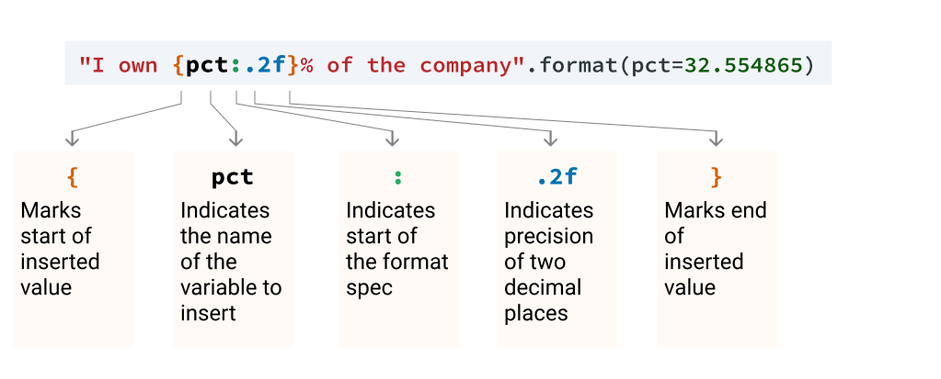
If you are not specifying named/positional argument, you just leave that part out:
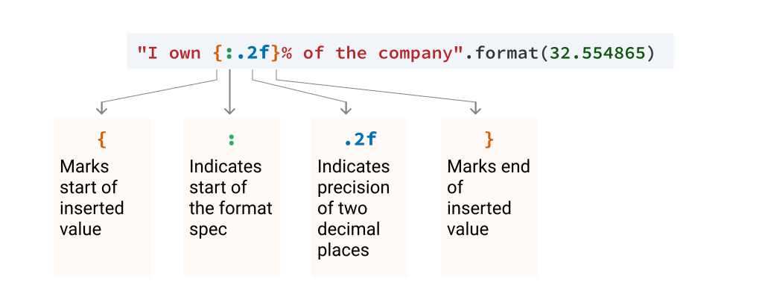
Another useful format specification is to add a comma as a thousands separator, which prevents large numbers from being hard to read, like in the example below:
print("The approximate population of {0} is {1}".format("India",1324000000))
Copy
The approximate population of India is 1324000000
Copy
To add a comma, you would use the syntax :, inside the brackets, after the number or name of the variable you're inserting:
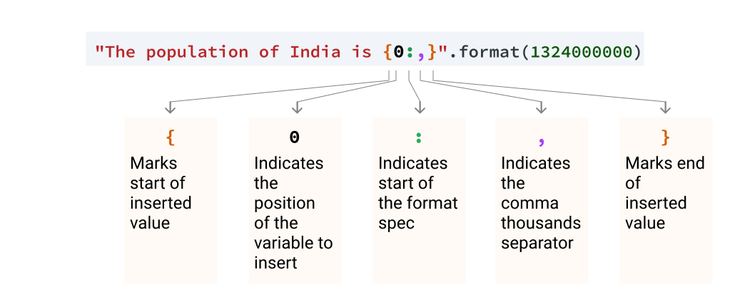
The output of this code is below:
The approximate population of India is 1,324,000,000
Copy
As you can see, this is much easier to read! We can also combine the thousands separator and the precision by specifying them in this order:
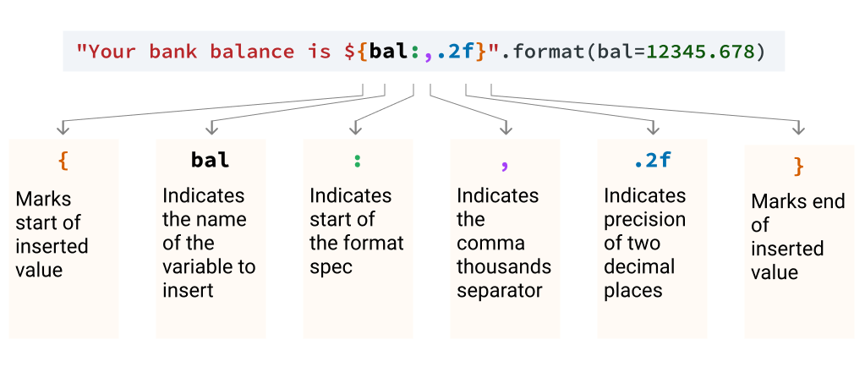
The output of this code is below:
Your bank balance is $12,345.68
Copy
Note that there is a specific order required – If we don't follow this order, our code will return a ValueError:
- The name or position of the of the variable
- A colon (:) to start the format spec
- The thousands separator
- The precision
The easy way to remember this order is that in a number like 3,412.69, the comma comes before the decimal point in the same way the thousands separator comes before the precision.
We'll use this technique on some MoMA data on the next screen, but for now we'll keep things simple and practice using some data on world populations. For each country, you'll need to display data that conforms to the following format:
The population of China is 1,379.30 million
Copy
Instructions

- Create a template string that will insert the country name and population as shown in the example above.
  - The country population should have a precision of two and use a comma separator.
- Use a for loop to iterate over the pop_millions list of lists and in each iteration:
  - Assign the country name and population to two variables.
  - Use str.format() to insert the two variables into your template string.
  - Use the print() function to display the result of your str.format() call.

