Before we get started, let's learn a little about databases. Don't worry: you'll start practicing in the next screen.
When we work with data stored on our computers, we load the data from files like spreadsheets (and text files in several different formats). Working with files solely on our computer is fine most of the time, but we run into problems when we consider a few questions:
- What if the data is too big to fit into a single spreadsheet file?
- What if you share the data with team members and keep it updated?
- What if there's sensitive information in your data that needs protection?
Thankfully, these problems already have a solution: the database. A database structures data just like a spreadsheet by organizing data in different tables, which are comprised of rows and columns. In the example below, we see a table in a spreadsheet where each row represents a chess player and each column gives information about the player.
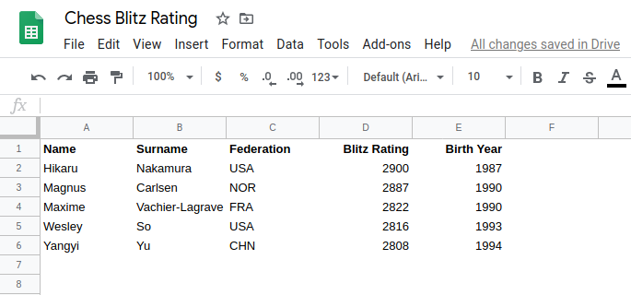
A database can store much more data more securely than a spreadsheet or a text file. Unlike simply opening a spreadsheet, we actually have to "ask" for data from the database.
We primarily interact with a database using a database management system (DBMS) — a computer program to help users interact with data by giving the computer instructions through the DBMS.
We'll begin learning SQL with the DBMS SQLite. SQLite is a lightweight DBMS, and it is the most popular database in the world. Move on to the next screen to start learning some SQL code!
In this course, we'll explore data from the American Community Survey on job outcome statistics based on college majors that we loaded into a SQLite database.
Here are its first three rows:
index | Rank | Major_code | Major | Major_category | Total | Sample_size | Men | Women | ShareWomen | Employed | Full_time | Part_time | Full_time_year_round | Unemployed | Unemployment_rate | Median | P25th | P75th | College_jobs | Non_college_jobs | Low_wage_jobs
0 | 1 | 2419 | PETROLEUM ENGINEERING | Engineering | 2339 | 36 | 2057 | 282 | 0.120564344 | 1976 | 1849 | 270 | 1207 | 37 | 0.018380527 | 110000 | 95000 | 125000 | 1534 | 364 | 193
1 | 2 | 2416 | MINING AND MINERAL ENGINEERING | Engineering | 756 | 7 | 679 | 77 | 0.10185185199999999 | 640 | 556 | 170 | 388 | 85 | 0.117241379 | 75000 | 55000 | 90000 | 350 | 257 | 50
2 | 3 | 2415 | METALLURGICAL ENGINEERING | Engineering | 856 | 3 | 725 | 131 | 0.153037383 | 648 | 558 | 133 | 340 | 16 | 0.024096386 | 73000 | 50000 | 105000 | 456 | 176 | 0
In this table, each row represents a major, and each column gives us some information about that major. Head to the dataset page to become familiar with what each column represents.
We provide a database, jobs.db, loaded with this data into a single table named recent_grads (in the next course, we'll learn how to work with a database containing multiple tables.)
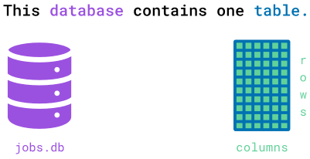
In this screen's exercise we'll ask you to submit the SQL instruction (usually called a query) below. This query selects all columns from the recent_grads table.
SELECT *
FROM recent_grads;
Copy
To run the query above in our interface, type the query in the code editor to the right and click Run Code. This will run the query against the database and display the results.
To submit your answer and get feedback, click Submit Answer. This will run the query against the database, display the results, and give feedback on your answer. If your answer is correct, you'll hear a sound and a Next Screen button will appear, allowing you to proceed to the following screen.
Instructions

- Type the query provided above, and submit it.
- Explore the output.
Congratulations on running your first SQL query in this course! The output was the entirety of the recent_grads table.
The process you used to visualize recent_grads breaks down into two steps:
- Write a SQL query that expresses the request "fetch all the data in the table."
- Ask the SQLite DBMS software to run the code and display the results.
The query you ran is an example of computer code. Writing computer code is called programming.
SQL is one of many programming languages, and just like spoken languages, code in SQL has to follow a defined structure and vocabulary. To display recent_grads, you ran the following SQL query:
SELECT *
FROM recent_grads;
Copy
In the query above, we specified the following:
- The columns we wanted using SELECT * — the symbol * selects all the columns.
- The table we wanted to query using FROM recent_grads.
The order of the different words in this query and the space between SELECT, *, FROM, and recent_grads are crucial features of SQL syntax. If we don't follow the syntax, the database will probably not return the information we want.
The ; character signals the end of the query, but it isn't mandatory.
Here's a visual breakdown of the different components of the query:
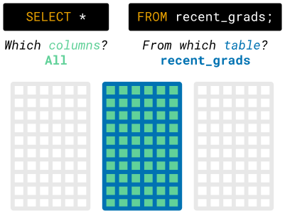
You may have noticed that SELECT and FROM use uppercase letters. This isn't required, but it makes your code easier to read.
Since we often read code more often than we write it, it's common for coders to follow certain conventions, so that programs written by different people look the same, reducing the amount of work it takes to read them.
A couple of other elements that aren't required are the line change and indentation right before FROM. The reason why we changed lines and indented this query is the same as above: stylistic conventions.
You may also have noticed that some words are highlighted. This happens because they are reserved words, (i.e., they are words that serve a particular purpose, so you can't or shouldn't use them for anything else).
In these courses, we'll be following this SQL Style Guide. We suggest that you explore it as you progress through the course.
Let's confirm that lines changes, capitalization, and indentation aren't crucial for the query to run.
Instructions

- Below the displayed query, write the same query without line changes and in all lowercase letters
You may have noticed that in the last screen, despite the fact that we wrote two queries, we only saw the result of the second one.
This isn't because the queries are the same. It's a quirk of the SQLite database that only the last query will display visually. If we want to see the results of multiple queries, we can run each query by itself.
You may also have noticed that this table has 173 rows and over 20 columns. For a computer, this isn't much information. For a human, however, it's difficult to make sense of this much data.
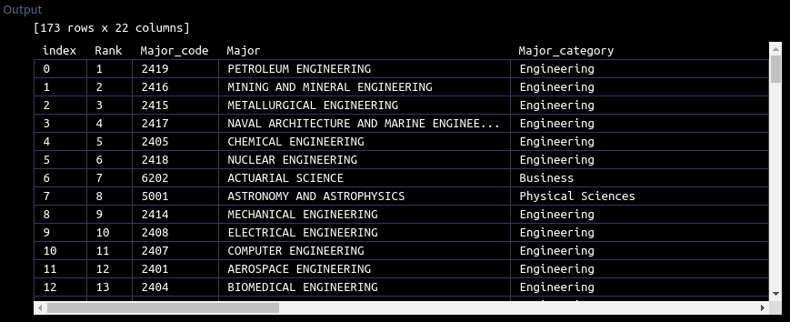
In the following lessons and in the next course, we'll learn how to make sense of large amounts of data using SQL. For now, we'll focus on how we can preview a table without displaying it completely.
In practice, you will often need to access a database without any documentation. In this situation, you'll have to rely on the surrounding context of the database and on your own exploration.
Some tables have millions and millions of rows, so a task as simple as displaying a table can take a very long time, and if you're just trying to explore the table, it isn't really useful to see all of it.
Fortunately, SQL allows us to limit the number of rows we see by using the LIMIT clause. Move on to the next screen to learn how.
Think of a clause as an optional reserved word that doesn't need to be in the code for the query to execute successfully.
Here's how we can use it to retrieve the first three rows (that we saw in a previous screen).
SELECT *
FROM recent_grads
LIMIT 3;
Copy
In the following animation, we see all the columns being selected, and then we see only the first three rows being included.

SQL is a database-dependent language. This means that the SQL that you're learning here (for SQLite) isn't the same as SQL for other DBMSs, like PostgreSQL or Oracle.
However, the different versions of SQL (also called dialects, or flavors) are more alike than they are different.
Although LIMIT functions with all SQL dialects, it sometimes needs a different reserved word. For example, in T-SQL (Microsoft's SQL flavor), we would write the query above like this:
SELECT TOP 3, *
FROM recent_grads;
Copy
Pay attention to these differences when switching between DBMSs.
Now, let's practice LIMIT!
Instructions

- Write a SQL query that returns the first five rows from recent_grads.
So far, we wrote some queries to display the entirety of the recent_grads table, or the limit by the number of rows. Here's the result of the previous exercise:
index | Rank | Major_code | Major | Major_category | Total | Sample_size | Men | Women | ShareWomen | Employed | Full_time | Part_time | Full_time_year_round | Unemployed | Unemployment_rate | Median | P25th | P75th | College_jobs | Non_college_jobs | Low_wage_jobs
0 | 1 | 2419 | PETROLEUM ENGINEERING | Engineering | 2339 | 36 | 2057 | 282 | 0.120564344 | 1976 | 1849 | 270 | 1207 | 37 | 0.018380527 | 110000 | 95000 | 125000 | 1534 | 364 | 193
1 | 2 | 2416 | MINING AND MINERAL ENGINEERING | Engineering | 756 | 7 | 679 | 77 | 0.10185185199999999 | 640 | 556 | 170 | 388 | 85 | 0.117241379 | 75000 | 55000 | 90000 | 350 | 257 | 50
2 | 3 | 2415 | METALLURGICAL ENGINEERING | Engineering | 856 | 3 | 725 | 131 | 0.153037383 | 648 | 558 | 133 | 340 | 16 | 0.024096386 | 73000 | 50000 | 105000 | 456 | 176 | 0
3 | 4 | 2417 | NAVAL ARCHITECTURE AND MARINE ENGINEERING | Engineering | 1258 | 16 | 1123 | 135 | 0.107313196 | 758 | 1069 | 150 | 692 | 40 | 0.050125313 | 70000 | 43000 | 80000 | 529 | 102 | 0
4 | 5 | 2405 | CHEMICAL ENGINEERING | Engineering | 32260 | 289 | 21239 | 11021 | 0.341630502 | 25694 | 23170 | 5180 | 16697 | 1672 | 0.061097712 | 65000 | 50000 | 75000 | 18314 | 4440 | 972
Often, we'll only want to look at data from specific columns. To return only the Major column, we need to add the specific column name in the SELECT statement part of the query (instead of using the * character to return all columns):
SELECT Major
FROM recent_grads;
Copy
This will return all of the values in the Major column. Here's an animation illustrating the process of running this query:
We can specify multiple columns this way, and the results table will preserve the order of the columns:
SELECT Major, Major_category
FROM recent_grads;
Copy
Notice that we use commas to separate column names, and after the last column name there is no comma. When SQL finds a comma, it expects a column to follow, so we need to make sure we don't include a comma after the last column. Here's a visual breakdown of this query:
SQLite accepts the columns with any choice of case; however, for answer-checking purposes — and also for style and consistency — in the remainder of the SQLite content you should specify the column names as we do in the instructions.
Let's practice next.
Instructions

- Write a SQL query that returns only the Major and ShareWomen columns (in that order).
Next, let's use SQL to answer a more specific question: which majors had students who were mostly women?
The SQL workflow translates the question we want to answer to the subset of data we want from the database. To determine which majors had mostly students who were women, we want the following subset:
- Only the Major columns
- Only the rows where ShareWomen is greater than 0.5 (corresponding to 50%)
To filter rows by specific criteria, we can use the WHERE statement. A WHERE statement commonly uses three things:
- The column we want the database to filter on: ShareWomen
- A comparison operator that specifies how we want to compare a value in a column: >=
- The value against which we want the database to compare each value: 0.5
Here are the comparison operators we can use:
- Less than: <
- Less than or equal to: <=
- Greater than: >
- Greater than or equal to: >=
- Equal to: =
- Not equal to: != or <>
To return only the values where ShareWomen is greater than or equal to 0.5, we can use the following WHERE clause:
SELECT Major
FROM recent_grads
WHERE ShareWomen >= 0.5;
Copy
Running this query will return the following results table (the first five results only):
Major
ACTUARIAL SCIENCE
COMPUTER SCIENCE
ENVIRONMENTAL ENGINEERING
NURSING
INDUSTRIAL PRODUCTION TECHNOLOGIES
Here's a breakdown of the different components:
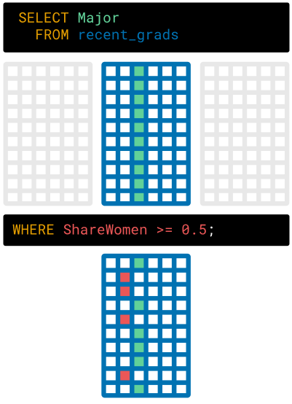
We express the specific column we want in the SELECT part of the query and the specific rows we want in the WHERE part. Note that most database systems require that the SELECT and FROM statements come first, before WHERE or any other statements.
Instructions

- Write a SQL query that returns the majors in the recent_grads table where students who were men outnumbered students who were women.
  - Only return the Major and ShareWomen columns (in that order).
  - Return only the values where ShareWomen is less than 0.5.
  - Don't limit the number of rows returned.
In the previous exercise, we wrote a query to return majors where students who were men outnumbered students who were women:
SELECT Major, ShareWomen
FROM recent_grads
WHERE ShareWomen < 0.5;
Copy
The comparison value after the < operator must be either text or a number, depending on the field. Because ShareWomen is a numeric column, we just write the number 0.5.
For text values, we need to enclose the value in quotes. For example, if we wanted to select only the rows where the Major_category equaled Engineering, we would write the following:
SELECT Major
FROM recent_grads
WHERE Major_category = 'Engineering';
Copy
We can also use the AND operator to combine multiple filter criteria. For example, to determine which engineering majors had a majority of female students, we specify two filtering criteria:
SELECT Major
FROM recent_grads
WHERE Major_category = 'Engineering'
AND ShareWomen > 0.5;
Copy
Major
ENVIRONMENTAL ENGINEERING
INDUSTRIAL PRODUCTION TECHNOLOGIES
Above, we can confirm that only two majors met these criteria!
Instructions

- Write a SQL query that returns all majors that had a majority of female students and a median salary greater than 50000.
  - Only include the following columns in the results and in this order:
    - Major
    - Major_category
    - Median
    - ShareWomen
  - Return only the values where ShareWomen is greater than 0.5 and Median is greater than 50000.
We used the AND operator to specify that our filter needs to pass two Boolean conditions. Both of the conditions had to evaluate to True for the record to appear in the result set. If we wanted to specify a filter that meets either of the conditions instead, we would use the OR operator.
SELECT [column1, column2,...]
FROM [table1]
WHERE [condition1]
OR [condition2];
Copy
We won't go into more detail regarding OR because we use the OR and AND operators in similar ways.
One other important feature is that we don't need to compare a column with a value, but we can also compare columns to other columns.
For example, we've been using the condition WHERE ShareWomen > 0.5. We can obtain an equivalent condition by using WHERE Men < Women.
Instructions

- Write a SQL query that returns the first 20 majors that either:
  - Have a Median salary greater than or equal to 10,000, or
  - Have more men than women
  - Only include the following columns in the results and in this order:
    - Major
    - Median
    - Unemployed
There's a certain class of questions that we can't answer using only the techniques we learned so far. For example, if we wanted to write a query that returned all Engineering majors that either had mostly female graduates or an unemployment rate below 5.1%, we would need to use parentheses to express this more complex logic.
The three raw conditions we'll need are the following:
Major_category = 'Engineering'
ShareWomen >= 0.5
Unemployment_rate < 0.051
Copy
What the SQL query looks like using parentheses:
SELECT Major, Major_category, ShareWomen, Unemployment_rate
FROM recent_grads
WHERE (Major_category = 'Engineering')
AND (ShareWomen > 0.5 OR Unemployment_rate < 0.051);
Copy
You may notice that we have enclosed the logic we want to evaluate together in parentheses. This is very similar to how we group mathematical calculations together in a particular order. The parentheses make it clear to the database that we want all of the rows where both of the expressions in the statements evaluate to True:
(Major_category = 'Engineering') -> True or False
(ShareWomen > 0.5 OR Unemployment_rate < 0.051) -> True or False
Copy
If we had written the WHERE statement without any parentheses, the database would guess what our intentions are, and it would actually execute the following query instead:
WHERE (Major_category = 'Engineering' AND ShareWomen > 0.5) OR (Unemployment_rate < 0.051)
Copy
Leaving the parentheses out implies that we want the calculation to happen from left to right in the order we wrote the logic, so we wouldn't get the data we want. Now let's run our intended query and see the results!
Instructions

- Run the query we explored above, which returns all majors that meet these criteria:
  - Fell under the category of Engineering and either
    - The majority of the graduates were women
    - Or had an unemployment rate below 5.1%, which was the rate in August 2015
  - Only include the following columns in the results and in this order:
    - Major
    - Major_category
    - ShareWomen
    - Unemployment_rate
The results of every query we've written so far have returned in order according to the Rank column. Early in the lesson, we wrote a query that returned all of the columns and didn't filter rows according to any specific criteria (SELECT * FROM recent_grads LIMIT 5):
index | Rank | Major_code | Major | Major_category | Total | Sample_size | Men | Women | ShareWomen | Employed | Full_time | Part_time | Full_time_year_round | Unemployed | Unemployment_rate | Median | P25th | P75th | College_jobs | Non_college_jobs | Low_wage_jobs
0 | 1 | 2419 | PETROLEUM ENGINEERING | Engineering | 2339 | 36 | 2057 | 282 | 0.120564344 | 1976 | 1849 | 270 | 1207 | 37 | 0.018380527 | 110000 | 95000 | 125000 | 1534 | 364 | 193
1 | 2 | 2416 | MINING AND MINERAL ENGINEERING | Engineering | 756 | 7 | 679 | 77 | 0.10185185199999999 | 640 | 556 | 170 | 388 | 85 | 0.117241379 | 75000 | 55000 | 90000 | 350 | 257 | 50
2 | 3 | 2415 | METALLURGICAL ENGINEERING | Engineering | 856 | 3 | 725 | 131 | 0.153037383 | 648 | 558 | 133 | 340 | 16 | 0.024096386 | 73000 | 50000 | 105000 | 456 | 176 | 0
3 | 4 | 2417 | NAVAL ARCHITECTURE AND MARINE ENGINEERING | Engineering | 1258 | 16 | 1123 | 135 | 0.107313196 | 758 | 1069 | 150 | 692 | 40 | 0.050125313 | 70000 | 43000 | 80000 | 529 | 102 | 0
4 | 5 | 2405 | CHEMICAL ENGINEERING | Engineering | 32260 | 289 | 21239 | 11021 | 0.341630502 | 25694 | 23170 | 5180 | 16697 | 1672 | 0.061097712 | 65000 | 50000 | 75000 | 18314 | 4440 | 972
If we modify the query from the last screen to include the Rank column, the results are ordered by the Rank column as well:
Rank | Major | Major_category | ShareWomen | Unemployment_rate
1 | PETROLEUM ENGINEERING | Engineering | 0.120564344 | 0.018380527
3 | METALLURGICAL ENGINEERING | Engineering | 0.153037383 | 0.024096386
4 | NAVAL ARCHITECTURE AND MARINE ENGINEERING | Engineering | 0.107313196 | 0.050125313
14 | MATERIALS SCIENCE | Engineering | 0.310820285 | 0.023042836
15 | ENGINEERING MECHANICS PHYSICS AND SCIENCE | Engineering | 0.183985189 | 0.006334343
17 | INDUSTRIAL AND MANUFACTURING ENGINEERING | Engineering | 0.34347321799999997 | 0.042875544
24 | MATERIALS ENGINEERING AND MATERIALS SCIENCE | Engineering | 0.292607004 | 0.027788805
31 | ENVIRONMENTAL ENGINEERING | Engineering | 0.558548009 | 0.093588575
39 | INDUSTRIAL PRODUCTION TECHNOLOGIES | Engineering | 0.75047259 | 0.028308097
51 | ENGINEERING AND INDUSTRIAL MANAGEMENT | Engineering | 0.174122505 | 0.03365166
As the questions we want to answer get more complex, we want more control over the ordering of the results. We can specify the order using the ORDER BY clause. For example, we may want to understand which majors that met the criteria in the WHERE statement had the lowest unemployment rate:
SELECT Rank, Major, Major_category, ShareWomen, Unemployment_rate
FROM recent_grads
WHERE (Major_category = 'Engineering')
AND (ShareWomen > 0.5 OR Unemployment_rate < 0.051)
ORDER BY Unemployment_rate;
Copy
This will return the results in ascending order (increasing) by the Unemployment_rate column:
Rank | Major | Major_category | ShareWomen | Unemployment_rate
15 | ENGINEERING MECHANICS PHYSICS AND SCIENCE | Engineering | 0.183985189 | 0.006334343
1 | PETROLEUM ENGINEERING | Engineering | 0.120564344 | 0.018380527
14 | MATERIALS SCIENCE | Engineering | 0.310820285 | 0.023042836
3 | METALLURGICAL ENGINEERING | Engineering | 0.153037383 | 0.024096386
24 | MATERIALS ENGINEERING AND MATERIALS SCIENCE | Engineering | 0.292607004 | 0.027788805
39 | INDUSTRIAL PRODUCTION TECHNOLOGIES | Engineering | 0.75047259 | 0.028308097
51 | ENGINEERING AND INDUSTRIAL MANAGEMENT | Engineering | 0.174122505 | 0.03365166
17 | INDUSTRIAL AND MANUFACTURING ENGINEERING | Engineering | 0.34347321799999997 | 0.042875544
4 | NAVAL ARCHITECTURE AND MARINE ENGINEERING | Engineering | 0.107313196 | 0.050125313
31 | ENVIRONMENTAL ENGINEERING | Engineering | 0.558548009 | 0.093588575
If we instead want the results ordered by the same column but in descending order, we can add the DESC keyword:
SELECT Rank, Major, Major_category, ShareWomen, Unemployment_rate
FROM recent_grads
WHERE (Major_category = 'Engineering')
AND (ShareWomen > 0.5 OR Unemployment_rate < 0.051)
ORDER BY Unemployment_rate DESC;
Copy
Here's the result of that query:
Rank | Major | Major_category | ShareWomen | Unemployment_rate
31 | ENVIRONMENTAL ENGINEERING | Engineering | 0.558548009 | 0.093588575
4 | NAVAL ARCHITECTURE AND MARINE ENGINEERING | Engineering | 0.107313196 | 0.050125313
17 | INDUSTRIAL AND MANUFACTURING ENGINEERING | Engineering | 0.34347321799999997 | 0.042875544
51 | ENGINEERING AND INDUSTRIAL MANAGEMENT | Engineering | 0.174122505 | 0.03365166
39 | INDUSTRIAL PRODUCTION TECHNOLOGIES | Engineering | 0.75047259 | 0.028308097
24 | MATERIALS ENGINEERING AND MATERIALS SCIENCE | Engineering | 0.292607004 | 0.027788805
3 | METALLURGICAL ENGINEERING | Engineering | 0.153037383 | 0.024096386
14 | MATERIALS SCIENCE | Engineering | 0.310820285 | 0.023042836
1 | PETROLEUM ENGINEERING | Engineering | 0.120564344 | 0.018380527
15 | ENGINEERING MECHANICS PHYSICS AND SCIENCE | Engineering | 0.183985189 | 0.006334343
Instructions

- Write a query that returns all majors that meet the following criteria:
  - ShareWomen is greater than 0.3
  - And Unemployment_rate is less than .1
  - Only include the following columns in the results and in this order:
    - Major,
    - ShareWomen,
    - Unemployment_rate
  - Order the results in descending order by the ShareWomen column.
In this step, you'll practice going from question to answer using the SQL workflow. You'll focus on one of the questions we posed early in this lesson:
- Which engineering majors had the highest full time employment rates?
Instructions

- Write a query that returns the Engineering or Physical Sciences category, the major, and unemployment rate, listed in ascending order of unemployment rate.
  - The results should only contain the Major_category, Major, and Unemployment_rate columns, in that order.
  - Remember to list the results in ascending order of unemployment rate.
In this lesson, we became familiar with a dataset stored in a SQLite table by learning how to craft basic SQL queries. The kind of queries we learned here and that we'll keep studying for the next few courses are one of four types of SQL commands we can give:
- Data query language
- Data definition language
- Data control language
- Data manipulation language
In this course and the next, we'll focus on data query language (DQL). DQL is the part of SQL that allows users to extract data from databases. Data engineers use the remaining types of instructions to create and maintain databases.
Here are a few things to note:
- We rarely linked to SQLite documentation, because it's a bit challenging to understand when you're just beginning. Sites like W3 Schools and SQL ZOO are more friendly for looking up SQL commands.
- We learned about clauses, statements, keywords, and operators in SQL. Here's a diagram describing the difference between each term:
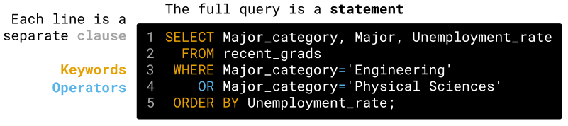
The ability to quickly iterate on queries as you think of new questions is the appeal of SQL. The SQL workflow lets data professionals focus on asking and answering questions, instead of lower-level programming concepts. There's a clear separation of concerns between the engine that stores, organizes, and retrieves the data and the language that lets people interface with the data without worrying about the underlying mechanics.
As the scale of data has increased, engineers have maintained the SQL interface while changing the database engine. This allows people who need to ask and answer questions easily transfer their SQL experience, even as database technologies change. For example, the Presto project lets you query using SQL but use data from database systems like MySQL, from a distributed file system like HDFS, and more.
In the next lesson, we'll learn how to compute summary statistics and perform reductions on the same data in SQL.
In "Introduction to SQL," we wrote queries that filtered rows and columns in a database table. Each of the queries we ran returned multiple rows of values. In this lesson, we'll go over how to calculate the sum, average, minimum, or maximum of these results.
We'll also learn how to calculate summary statistics on subsets of a database table by working with data on job outcomes, compiled by FiveThirtyEight.
Here's how the first 5 rows of the data look:
index | Rank | Major_code | Major | Major_category | Total | Sample_size | Men | Women | ShareWomen | Employed | Full_time | Part_time | Full_time_year_round | Unemployed | Unemployment_rate | Median | P25th | P75th | College_jobs | Non_college_jobs | Low_wage_jobs
0 | 1 | 2419 | PETROLEUM ENGINEERING | Engineering | 2339 | 36 | 2057 | 282 | 0.120564344 | 1976 | 1849 | 270 | 1207 | 37 | 0.018380527 | 110000 | 95000 | 125000 | 1534 | 364 | 193
1 | 2 | 2416 | MINING AND MINERAL ENGINEERING | Engineering | 756 | 7 | 679 | 77 | 0.10185185199999999 | 640 | 556 | 170 | 388 | 85 | 0.117241379 | 75000 | 55000 | 90000 | 350 | 257 | 50
2 | 3 | 2415 | METALLURGICAL ENGINEERING | Engineering | 856 | 3 | 725 | 131 | 0.153037383 | 648 | 558 | 133 | 340 | 16 | 0.024096386 | 73000 | 50000 | 105000 | 456 | 176 | 0
3 | 4 | 2417 | NAVAL ARCHITECTURE AND MARINE ENGINEERING | Engineering | 1258 | 16 | 1123 | 135 | 0.107313196 | 758 | 1069 | 150 | 692 | 40 | 0.050125313 | 70000 | 43000 | 80000 | 529 | 102 | 0
4 | 5 | 2405 | CHEMICAL ENGINEERING | Engineering | 32260 | 289 | 21239 | 11021 | 0.341630502 | 25694 | 23170 | 5180 | 16697 | 1672 | 0.061097712 | 65000 | 50000 | 75000 | 18314 | 4440 | 972
Let's start with some questions about how the data breaks down:
- How many majors had a higher representation among women? How many had a higher representation among men? What proportion of majors had the highest representation among women?
- Which category of majors had the lowest unemployment rates? Which category of majors had the highest representation among women?
- Which majors had the largest spread (difference) between the 25th and 75th percentile starting salaries?
Let's move on to the next screen to start learning!
Before we begin working on our questions, let's start with this: What is the lowest proportion of women on the recent_grads table?
One of way of thinking about this question is that we want to "determine the minimum value of ShareWomen" — recall that ShareWomen gives us the proportion of women graduates. To address this question, we'll focus on the three majors with the three lowest proportion of graduates who are women, seen below. (Scroll to the ShareWomen column.)
index | Rank | Major_code | Major | Major_category | Total | Sample_size | Men | Women | ShareWomen | Employed | Full_time | Part_time | Full_time_year_round | Unemployed | Unemployment_rate | Median | P25th | P75th | College_jobs | Non_college_jobs | Low_wage_jobs
31 | 32 | 2500 | ENGINEERING TECHNOLOGIES | Engineering | 3600 | 39 | 16820 | 1678 | 0.090713 | 2799 | 2257 | 689 | 1723 | 163 | 0.055030 | 50000 | 43000 | 60000 | 1017 | 1269 | 142
61 | 62 | 3603 | MOLECULAR BIOLOGY | Biology & Life Science | 18300 | 90 | 4419 | 371 | 0.077453 | 11581 | 9441 | 4590 | 6183 | 1067 | 0.084361 | 40000 | 29000 | 47000 | 7225 | 3145 | 1168
65 | 66 | 2599 | MISCELLANEOUS ENGINEERING TECHNOLOGIES | Engineering | 8804 | 125 | 124 | 0 | 0.000000 | 7502 | 7001 | 1240 | 5825 | 416 | 0.052539 | 40000 | 30400 | 56000 | 2446 | 3896 | 386
Looking at the sample above, we see that the three lowest ShareWomen values are roughly 0.09, 0.07 and 0, so the minimum is 0. Here's how we can use SQL to answer this question:
SELECT MIN(ShareWomen)
FROM recent_grads;
Copy
Try running this (without submitting your answer) in the code editor. You should see the following result.
MIN(ShareWomen)
0
We can see that there is at least one major that didn't include any women.
It doesn't actually tell us what those majors are — we only know them because we singled out the three majors with fewer women than men. In a typical table, there are too many rows to find an answer just by looking.
We'll learn how to determine to which rows the lowest value correspond later in the course.
Note that instead of just returning a single value, SQLite returned a table with a column (MIN(ShareWomen)) and the lowest value of ShareWomen as a row in that column (0).
A key idea in SQL is that every result is a table. This is a common visual representation that makes SQL approachable for more users. However, this means that users must convert datasets and calculations that aren't well suited for this representation in a SQL environment.
Let's practice!
Instructions

- Write a query that returns the lowest unemployment rate.
  - For answer-checking purposes, make sure the aggregate function is all uppercase, and that you spell the column name exactly like this: Unemployment_rate.
On the last screen, we used MIN(ShareWomen) to compute the minimum value in the ShareWomen column. We introduced the syntax MIN(column_name). This is an example of the broader syntax of functions. A function takes in input and produces the output of the function.
In MIN(ShareWomen), we saw the following:
- The input ShareWomen
- The function MIN
- The output 0.0
Here's an animation depicting this operation:
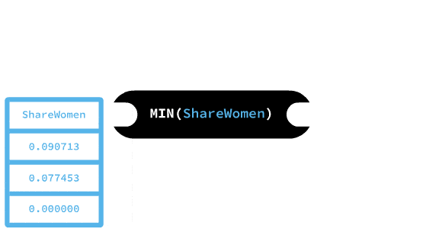
We call this function an aggregate function. Aggregate functions apply over columns of values and return a single value. The MIN and MAX functions, for example, calculate and return the minimum and maximum values in a column.
Some other commonly used aggregate functions include the following:
- AVG — returns the mean of its input.
- COUNT — counts the number of values in its input.
- SUM — sums the values in its input.
Note the use of capital letters for the functions' names. This isn't necessary to run the query, but it's a common convention that functions (just like other reserved words) should be uppercase. You should also use uppercase letters so the answer-checker can correctly validate your answer.
Instructions

- Write a query that computes the sum of the Total column.
  - For answer-checking purposes, make sure to write the aggregate function in all uppercase letters, and spell the column name exactly like this: Total.
In the beginning of this lesson, we posed two questions:
- How many majors included mostly women?
- How many majors included mostly men?
On this screen, we'll answer those questions.
In "Introduction to SQL," we learned how to return all majors with a majority of women:
SELECT Major
FROM recent_grads
WHERE ShareWomen > 0.5;
Copy
To answer the first question above, we'd like to count the students. On the last screen, we learned that there is an aggregate function that counts the number of values in the input: COUNT.
A query could answer the question:
SELECT COUNT(Major)
FROM recent_grads
WHERE ShareWomen > 0.5;
Copy
But does it really work? You may be wondering if COUNT(Major) counts the rows before or after the WHERE clause executes.
The answer is that it runs after! So this query will find the answer. Here's the result:
COUNT(Major)
97
Let's quickly summarize what a query looks like using all the clauses we've learned so far:
SELECT *
FROM some_table
WHERE some_condition
ORDER BY some_column
LIMIT some_limit;
Copy
Here is the order in which the clauses run:
- FROM
- WHERE
- SELECT
- ORDER BY
- LIMIT
Since aggregate functions are part of SELECT, the calculation happens after WHERE acts.
Instructions

- Write a query that returns the number of majors that include mostly men.
  - For answer-checking purposes, make sure you type the aggregate function using all uppercase letters, and make sure that you spell the column name exactly like this: Major.
Sometimes, for various reasons, tables don't contain values in certain cells (a cell is an intersection of a row and a column in a table).
When this happens, we make any of the following statements (or variations of them):
- The value is missing.
- It's a missing value.
- The value is NULL.
  - NULL is a special entity in SQL that exists to capture the concept of missing value.
This is important when using aggregate functions because most of them ignore missing values.
For example, if we were to select COUNT(Primes) in the table below, the result would be 3 due to the missing value in the third row.
Primes
2
3
7
Here's an animation depicting this operation:
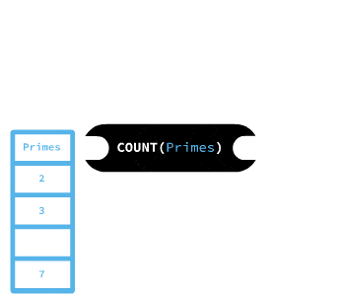
So we must know we don't have null values in a column before we can use it to count the numbers of rows.
To avoid this, we can resort to the * and pass it into COUNT as if it were a column name. So, in the table above, we'd use COUNT(*) instead of COUNT(Primes).
In this screen's exercise we will ask you to use COUNT to find a column with at least a missing value. You can do this by running the query below, replacing <column_name> with the name of the columns in recent_grads until you find a suspicious result. Here's the query:
SELECT COUNT(<column_name>)
FROM recent_grads;
Copy
For your convenience, here are the names of all the columns: Rank, Major_code, Major, Major_category, Total, Sample_size, Men, Women, ShareWomen, Employed, Full_time_year_round, Unemployed, Unemployment_rate, Median, P25th, P75th, College_jobs, Non_college_jobs, Low_wage_jobs.
Instructions

- Use the query above to find a column that has at least one missing value.
  - Here's a hint: it's one of the columns with a value between 0 and 1.
  - Make sure you don't submit an answer while experimenting.
- Write a query that counts the number of rows in recent_grads, followed by the number of rows in the column you determined in 1.
  - For answer-checking purposes, make sure you write the aggregate functions using all uppercase letters, and make sure you spell the column name exactly as it appears in the output of the query above.
Instead of writing an individual query for specific question we want to answer, we can actually write queries that answer multiple questions at once. Let's consider the following questions:
- What's the lowest median salary?
- What's the highest median salary?
- What's the total number of students?
We can select multiple columns by including their names with commas, like this:
SELECT Major, Major_category
FROM recent_grads;
Copy
We can use the same principle to combine multiple aggregation functions into a single query:
SELECT MIN(Median), MAX(Median), SUM(Total)
FROM recent_grads;
Copy
min(Median) | max(Median) | sum(Total)
22000 | 110000 | 6776015
Instructions

- Write a query that calculates the average of the Total column, the minimum of the Men column, and the maximum of the Women column, in that order.
  - For answer-checking purposes, make sure you type the aggregate functions using only uppercase letters, and make sure that you spell all column names exactly as above.
All of the queries we've written so far have had somewhat unpleasant column names in the results, like AVG(Total) and MIN(Men).
Many companies use SQL environments and tools that can run your query, turn the results into a plot of your choosing, and then create a PDF report containing multiple plots (and some additional explanation from the user).
Since others may interpret the results of your SQL queries, it's helpful to specify custom names for the columns in our results.
We can do that using AS:
SELECT SUM(Total) AS num_students
FROM recent_grads;
Copy
This is known as an alias, and it is restricted to only our results table (the table in the database won't be renamed)
If we use certain characters, like spaces, we need to surround the alias with quotes. We can specify an arbitrary phrase as a string using quotation marks:
SELECT SUM(Total) AS 'Total Students'
FROM recent_grads;
Copy
We can drop AS entirely and just add the name next to the original column:
SElECT SUM(Total) 'Total Students'
FROM recent_grads;
Copy
(We'll keep using it, though because it's a matter of style.) Lastly, we can reference renamed columns when writing longer queries to make our code more compact:
SELECT Major AS m, Major_category AS mc, Unemployment_rate AS ur
FROM recent_grads
WHERE (mc = 'Engineering') AND (ur > 0.04 and ur < 0.08)
ORDER BY ur DESC
Copy
Later we'll learn how to use aliases for both database tables and results tables!
Instructions

- Write a query that returns the following in this order:
  - The number of rows as Number of Majors
  - The maximum value of Unemployment_rate as Highest Unemployment Rate
Major_category is a column with only a few unique values. What if we want to get a list with repetitions of the values in this column? Or what if we want to determine how many distinct values there are in this column?
We can return all of the unique values in a column using the DISTINCT statement.
SELECT DISTINCT Major_category
FROM recent_grads;
Copy
Major_category
Engineering
Business
Physical Sciences
Law & Public Policy
Computers & Mathematics
Agriculture & Natural Resources
Industrial Arts & Consumer Services
Arts
Health
Social Science
Biology & Life Science
Education
Humanities & Liberal Arts
Psychology & Social Work
Communications & Journalism
Interdisciplinary
As with the other SQL clauses we've learned, we can use the DISTINCT statement with multiple columns to return unique pairings of those columns:
SELECT DISTINCT Major, Major_category
FROM recent_grads
LIMIT 5;
Copy
Major | Major_category
PETROLEUM ENGINEERING | Engineering
MINING AND MINERAL ENGINEERING | Engineering
METALLURGICAL ENGINEERING | Engineering
NAVAL ARCHITECTURE AND MARINE ENGINEERING | Engineering
CHEMICAL ENGINEERING | Engineering
Lastly, we can count the number of unique values in a column by nesting the COUNT() function with the DISTINCT clause:
SELECT COUNT(DISTINCT Major_category) AS unique_major_categories
FROM recent_grads;
Copy
unique_major_categories
16
Instructions

- Write a query that returns the number of unique values in the Major, Major_category, and Major_code columns. Use the following aliases in this order:
  - For the unique value count of the Major column, use the alias unique_majors.
  - For the unique value count of the Major_category column, use the alias unique_major_categories.
  - For the unique value count of the Major_code column, use the alias unique_major_codes.
Let's run a query and look at the result.
SELECT Major, Total, Men, Women, Unemployment_rate
FROM recent_grads
ORDER BY Unemployment_rate DESC
LIMIT 3;
Copy
Major | Total | Men | Women | Unemployment_rate
NUCLEAR ENGINEERING | 2573 | 2200 | 373 | 0.177226407
PUBLIC ADMINISTRATION | 5629 | 2947 | 2682 | 0.15949059999999998
COMPUTER NETWORKING AND TELECOMMUNICATIONS | 7613 | 5291 | 2322 | 0.151849807
Let's consider the different kinds of values we got:
- In the Major column, we see text.
- In the Total, Men, and Women columns, we see integers.
- In the Unemployment_rate column, we see decimal numbers.
Each of the above is a data type. Each column has exactly one type of value; it can't be mixed.
You can read more about the SQLite data types here. We'll explore them from the point of view of the database when we learn how to create tables.
For now, we'll focus on some of the things we can do with different data types.
Previously, we learned about aggregate functions. Aggregate functions take a column as input and return one value for the column. Now, we'll learn about functions that, when we pass them a column as input, return (a transformation of the input) another column. The values of text columns are typically called strings.
We'll start with the LENGTH function. Given a text column, the LENGTH function returns the number of characters in the input strings

Let's build on the query we saw on the previous screen to see it action.
SELECT Major,
Total, Men, Women, Unemployment_rate,
LENGTH(Major) AS Length_of_name
FROM recent_grads
ORDER BY Unemployment_rate DESC
LIMIT 3;
Copy
Major | Total | Men | Women | Unemployment_rate | Length_of_name
NUCLEAR ENGINEERING | 2573 | 2200 | 373 | 0.177226 | 19
PUBLIC ADMINISTRATION | 5629 | 2947 | 2682 | 0.159491 | 21
COMPUTER NETWORKING AND TELECOMMUNICATIONS | 7613 | 5291 | 2322 | 0.151850 | 42
We can also concatenate strings by using the || operator. Here's an example:z
SELECT 'Data' || 'quest' as 'e-learning';
Copy
e-learning
Dataquest
We signaled the use of strings by using single quotes ('), double quotes ("); however, double quotes also work. Other databases more universally accept single quotes rather than double quotes, so it's a good habit to form.
In the same way that we can compare columns with both constant numbers and other columns in WHERE clauses, we can also mix columns and constant strings when concatenating. For example:
SELECT 'Cat: ' || Major_category
FROM recent_grads
LIMIT 2;
Copy
'Cat: ' || Major_category
Cat: Engineering
Cat: Engineering
In the following exercise, you'll use the LOWER function to replace the Major column with one where all values appear in lowercase letters. We use this just like the LENGTH function. Here's how the output of the exercise should look:
Major | Total | Men | Women | Unemployment_rate | Length_of_name
Major: nuclear engineering | 2573 | 2200 | 373 | 0.177226 | 19
Major: public administration | 5629 | 2947 | 2682 | 0.159491 | 21
Major: computer networking and telecommunications | 7613 | 5291 | 2322 | 0.151850 | 42
This one is difficult, so try it a few times if it doesn't work at first.
Instructions

To save yourself some typing, copy and paste the query at the top of the screen.
- Write a query that does the following:
  - Selects in order
    - The values in the Major column in lowercase, preceded by the string 'Major: '. Use the alias Major.
    - Total.
    - Men.
    - Women.
    - Unemployment_rate.
    - LENGTH(Major) as Length_of_name.
  - Orders in descending order by the unemployment rate.
Let's revisit one of the questions from the beginning of the lesson:
- Which majors had the largest spread (difference) between the 25th and 75th percentile starting salaries?
In the same way that we can use string functions and operators, we can also perform arithmetic on the columns in a table. SQL supports the standard arithmetic operators: *, +, -, and /, and we can use them like any other operator:
SELECT P75th - P25th AS quartile_spread
FROM recent_grads
LIMIT 10;
Copy
quartile_spread
30000
35000
55000
37000
25000
52000
19000
77500
22000
27000
You can also add, subtract, multiply, or divide columns by individual values:
SELECT ShareWomen * 100 percent_female
FROM recent_grads
LIMIT 10;
Copy
percent_female
12.0564344
10.1851852
15.3037383
10.731319599999999
34.1630502
14.4966965
53.571428600000004
44.135557299999995
13.979280099999999
43.7846874
One thing to note is that multiplying or dividing columns with a floating point value (or a column with floating point values) will result in floating point values:
- Two floats — returns a float.
  - SELECT 100.0 / 100.0 returns 1.0.
- A float and an integer — returns a float
  - SELECT 100 / 1.0 returns 100.0.
- Two integers — returns an integer
  - SELECT 100 / 10 returns 10
Instructions

- Write a query that computes the difference between the 25th and 75th percentiles of salaries for all majors.
  - Return the Major column first, using the default column name.
  - Return the Major_category column second, using the default column name.
  - Return the compute difference between the 25th and 75th percentiles third, using the alias quartile_spread.
  - Order the results from lowest to highest and only return the first 20 results.
In the "Summary Statistics" lesson, we computed summary statistics across columns using SQL. Often, however, we will want even more information, which we can get by computing summary statistics per group to answer questions like the following:
- What is the total number of graduates by major category?
- What major category pays the most?
- How does the sample size vary by major category?
In this lesson, we'll answer questions like these by learning how to calculate summary statistics for groups.
We'll continue working with the recent_grads table of jobs.db. Recall that each row represents a single college major, and it contains information about post-graduation employment of students who studied the major. Here are some descriptions for just a few of the 21 total columns:
- Rank — the major's rank according to median earnings.
- Major — the name of the major.
- Major_category — the broader category to which the major belongs.
- Total — the total number of people who graduated with the major.
- Sample_size — the size of the sample.
- Men — the number of graduates who are men.
- Women — the number of graduates who are women.
- ShareWomen — women as a proportion of the total number of graduates (a number ranging from 0 to 1).
- Employed — the number of employed graduates.
Here are the first few rows and columns in the dataset:
Rank | Major | Major_category | Total | Sample_size | Men | Women | ShareWomen | Employed
1 | PETROLEUM ENGINEERING | Engineering | 2339 | 36 | 2057 | 282 | 0.120564 | 1976
2 | MINING AND MINERAL ENGINEERING | Engineering | 756 | 7 | 679 | 77 | 0.101852 | 640
3 | METALLURGICAL ENGINEERING | Engineering | 856 | 3 | 725 | 131 | 0.153037 | 648
4 | NAVAL ARCHITECTURE AND MARINE ENGINEERING | Engineering | 1258 | 16 | 1123 | 135 | 0.107313 | 758
5 | CHEMICAL ENGINEERING | Engineering | 32260 | 289 | 21239 | 11021 | 0.341631 | 25694
Let's begin by learning how to code if/then logic in SQL.
It is common to create new columns according to rules based on other columns. For example, to quickly identify the top 10 majors (per the rank column), we may want to create a column that indicates whether or not the value on rank for each row is greater than 10.

We can do this using the CASE clause in SQL. We'll program the following logic:
- If the row corresponds to a top 10 major, assign the value Top 10.
- If the row corresponds to a top 20 major that isn't a top 10 major, assign the value Top 20.
- Otherwise let it be a missing value.
We can do this using the following syntax:
SELECT CASE
WHEN rank <= 10 THEN 'Top 10'
WHEN rank <= 20 THEN 'Top 20'
ELSE NULL
END AS rank_category
FROM recent_grads;
Copy
A more general syntax looks like this:
CASE
WHEN <condition_1> THEN <value_1>
WHEN <condition_2> THEN <value_2>
ELSE <value_3>
END AS <new_column_name>
Copy
Let's look at a few rows of the result of the following query:
SELECT Major, Rank,
CASE
WHEN rank <= 10 THEN 'Top 10'
WHEN rank <= 20 THEN 'Top 20'
ELSE NULL
END AS rank_category
FROM recent_grads;
Copy
Major | Rank | rank_category
MECHANICAL ENGINEERING | 9 | Top 10
ELECTRICAL ENGINEERING | 10 | Top 10
COMPUTER ENGINEERING | 11 | Top 20
ARCHITECTURAL ENGINEERING | 19 | Top 20
COURT REPORTING | 20 | Top 20
COMPUTER SCIENCE | 21 | None
We can see that we coded our logic correctly. We'll examine this clause on the next screen.
In this exercise we'll categorize the Sample_size column into three categories: Small, Medium, and Large.
The size of a sample is very important for statistical analysis. (You can learn more about this in the statistics courses.) Now let's practice!
Instructions

- Write a SQL query that displays, with the alias Sample_category, the column with values that are a result of the following rules:
  - Small if Sample_size is smaller than 200.
  - Medium if Sample_size is equal to or higher than 200, and smaller than 1000.
  - Large if Sample_size is equal to or higher than 1000.
Look again at the syntax we saw in the previous screen.
CASE
WHEN <condition_1> THEN <value_1>
WHEN <condition_2> THEN <value_2>
ELSE <value_3>
END AS <new_column_name>
Copy
Note the following:
- It starts with CASE to indicate that we'll be creating values by cases.
- It ends with END to indicate where the CASE clause terminates.
- The reserved word WHEN signals each explicit case.
- The value for each case follows the reserved word THEN
- There is a fallback value indicated by the reserved word ELSE.
Here are some important observations:
- Anything you can use in WHERE for filtering, you can also use in place of the conditions above.
- There can be one or more WHEN lines. We demonstrated this with three, but it works with any number.
- The ELSE line is optional — without it, rows that don't match any WHEN will get a missing value (NULL).
Let's practice some more with a very similar exercise.
Instructions

- Write a SQL query that displays, in this order, Major, Sample_size, and a column named Sample_category with values defined by the following rules:
  - Small if Sample_size is smaller than 200.
  - Medium if Sample_size is equal to or higher than 200, and smaller than 1000.
  - Large if Sample_size is equal to or higher than 1000.
Let's return to calculating summary statistics by group. By group we mean any of the unique values in a column. Typically group statistics only calculate for columns in which the values represent categories (as opposed to measurements, like age, currency, and so on).
The GROUP BY SQL statement allows us to compute summary statistics by group. When we use this statement, SQL creates a group for each unique value in a column or set of columns (the same values we get when we use the DISTINCT statement), and then performs the calculations for them.
To demonstrate, we can find the total number of people employed in each major category with the following query:
SELECT SUM(Employed)
FROM recent_grads
GROUP BY Major_category;
Copy
This will give us the total number of employed graduates for each major category. Here's a truncated view of the output:
SUM(Employed)
66943
288114
302797
The output shows aggregate counts of the Employed column for each Major_category. Unfortunately, it doesn't indicate which major category each row refers to. We can fix this by including the Major_category column in our query:
SELECT Major_category, SUM(Employed)
FROM recent_grads
GROUP BY Major_category;
Copy
This makes the output much easier to understand:
Major_category | SUM(Employed)
Agriculture & Natural Resources | 66943
Arts | 288114
Biology & Life Science | 302797
In the next screen, we'll explore how this works. For now, let's jump right into practicing.
One of the questions we asked at beginning of the lesson was What is the total number of graduates by major category? Let's answer it.
Use capital letters when typing the aggregate functions so the answer-checker can validate your answer correctly.
Instructions

- Write a SQL query that, for each major category, displays the following:
  - The major category
  - The total number of graduates for Major_category with the alias Total_graduates
Here's the query from the example on the previous screen.
SELECT Major_category, SUM(Employed)
FROM recent_grads
GROUP BY Major_category;
Copy
Here are the first three rows of the output:
Major_category | SUM(Employed)
Agriculture & Natural Resources | 66943
Arts | 288114
Biology & Life Science | 302797
Here's how the query works. The GROUP BY statement divides the Major_category column into groups (one group for each unique major category), then calculates the sum for each group. The following diagram shows how GROUP BY divides the data (the diagram uses a small sample from the recent_grads table):
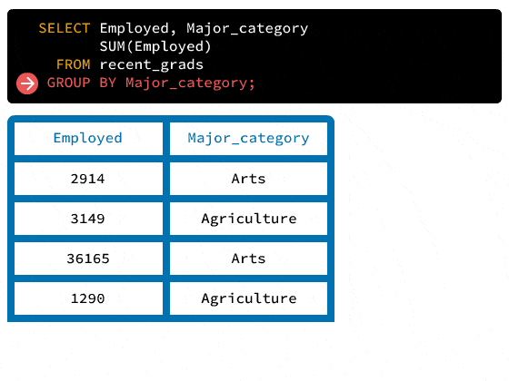
For each group, the GROUP BY statement queries each column and runs all of the aggregation functions we include in the query after the SELECT statement:
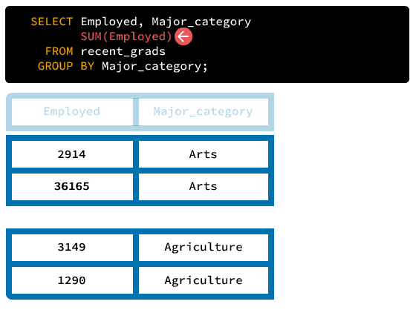
The SQL engine will use the last value for a selected column in the group. The SQL engine will also compute the value for a selected aggregation function across the group.
The query in the diagram will give us the following result:
Employed | Major_category | SUM(Employed)
1290 | Agriculture | 4439
36165 | Arts | 39075
Now let's try using a different aggregate function.
Instructions

- Write a SQL query that, for each major category, displays the following:
  - The major category
  - The average share of women with the alias Average_women.
In addition to computing multiple summary statistics for the whole table, as we did in the "Summary Statistics" lesson, we can also compute multiple summary statistics by groups.
Working from the same example, here's a query that for each major category finds the following:
- The total number of employed graduates
- The average number of employed graduates
- The maximum number of employed graduates in a major
- The minimum number of employed graduates in a major
SELECT Major_category,
SUM(Employed), AVG(Employed), MAX(Employed), MIN(Employed)
FROM recent_grads
GROUP BY Major_category;
Copy
Here are the first three rows of the output:
Major_category | SUM(Employed) | AVG(Employed) | MAX(Employed) | MIN(Employed)
Agriculture & Natural Resources | 66943 | 6694.300000 | 17112 | 613
Arts | 288114 | 36014.250000 | 83483 | 2914
Biology & Life Science | 302797 | 21628.357143 | 182295 | 1010
We can also perform calculations using the resulting columns, much like we did before. Here's a query that computes the difference between the maximum and the minimum number of employed graduates:
SELECT Major_category,
SUM(Employed), AVG(Employed), MAX(Employed) - MIN(Employed) as range_employed
FROM recent_grads
GROUP BY Major_category;
Copy
Major_category | SUM(Employed) | AVG(Employed) | range_employed
Agriculture & Natural Resources | 66943 | 6694.300000 | 16499
Arts | 288114 | 36014.250000 | 80569
Biology & Life Science | 302797 | 21628.357143 | 181285
Note that we used an alias for the result without any problems. You can use aliases the same way you did before.
Now that we have a better understanding of the GROUP BY statement, let's practice using it by computing summary statistics by group for the recent_grads table. On the first screen of this lesson, you can find the list of the column names and what they represent.
Instructions

- Write a query that, for each major category, displays the following in this order:
  - The major category
  - The total number of women with the alias Total_women
  - The average proportion of women with the alias Mean_women
  - The result of multiplying the total number of graduates by the average proportion of women with the alias Estimate_women.
So far we've only grouped by one column (Major_category), but it's also possible to group by multiple columns.
Let's demonstrate this with the following table called fruit. This table isn't in the database that we're using here, so you won't be able to experiment with it.
fruit | color | sourness | weight | price
Orange | Orange | Sour | 131 | 4
Banana | Yellow | Sweet | 150 | 4
Papaya | Orange | Sweet | 450 | 2
Lime | Green | Sour | 44 | 1
Strawberry | Red | Sweet | 12 | 3
Grapefruit | Orange | Sour | 236 | 1
Cherry | Red | Sour | 12 | 3
Red apple | Red | Sweet | 180 | 5
Green apple | Green | Sour | 170 | 2
We see that we have the groups in color and in sourness.
We've ran queries like the one below, which yields the mean weight and price.
SELECT color,
AVG(weight),
AVG(price)
FROM fruit
GROUP BY color;
Copy
color | AVG(weight) | AVG(price)
Green | 107.0 | 1.5
Orange | 272.333333 | 2.333333
Red | 68.0 | 3.666667
Yellow | 150.0 | 4.0
If we want the mean weight and price for the group of sweet red fruits, or more generally, the mean weight and price for all the combinations of groups of color and sourness, we can use GROUP BY. Here's an example:
SELECT color, sourness,
AVG(weight), AVG(price), MIN(weight), MIN(price)
FROM fruit
GROUP BY color, sourness;
Copy
color | sourness | AVG(weight) | AVG(price) | MIN(weight) | MIN(price)
Green | Sour | 107.0 | 1.5 | 44 | 1
Orange | Sour | 183.5 | 2.5 | 131 | 1
Orange | Sweet | 450.0 | 2.0 | 450 | 2
Red | Sour | 12.0 | 3.0 | 12 | 3
Red | Sweet | 96.0 | 4.0 | 12 | 3
Yellow | Sweet | 150.0 | 4.0 | 150 | 4
We can easily confirm the minimum values by spot-checking.
Earlier in this lesson, we created a column with values determined by the following rules:
- Small if Sample_size is smaller than 200
- Medium if Sample_size is equal to or higher than 200 and smaller than 1000
- Large if Sample_size is equal to or higher than 1000
We duplicated the recent_grads table and added that column to a new table. It's called new_grads, and we'll use it for the remainder of this lesson.
Instructions

- Write a query that, for each combination of Major_category and Sample_category, displays the following in this order:
  - The major category
  - The sample category
  - The average proportion of women with the alias Mean_women
  - The sum total of graduates with the alias Total_graduates
Sometimes we want to select a subset of rows after performing a GROUP BY query. On the last screen, for instance, we may have wanted to select only those rows where Mean_women is greater than .8.
We can't use the WHERE clause to do this:
SELECT Major_category, Sample_category,
AVG(ShareWomen) AS Mean_women,
SUM(Total) AS Total_graduates
FROM new_grads
GROUP BY Major_category, Sample_category
WHERE Mean_women > 0.8;
Copy
(sqlite3.OperationalError) near "WHERE": syntax error
[SQL: SELECT Major_category, Sample_category, AVG(ShareWomen) AS Mean_women, SUM(Total) AS Total_graduates FROM new_grads GROUP BY Major_category, Sample_category WHERE Mean_women > 0.8 ;]
(Background on this error at: http://sqlalche.me/e/e3q8)
Copy
We got an error! We'll understand why WHERE doesn't work here in the next screen. For now, let's learn how we would be able to subset the data.
When we want to filter on a column generated by a GROUP BY query, we can use the HAVING statement. Here's an example:
SELECT Major_category, Sample_category,
AVG(ShareWomen) AS Mean_women,
SUM(Total) AS Total_graduates
FROM new_grads
GROUP BY Major_category, Sample_category
HAVING Mean_women > 0.8;
Copy
Note that we used the same column name in the HAVING statement that we originally specified with the AS statement. The statement above will result in the following output:
Major_category | Sample_category | Mean_women | Total_graduates
Education | Large | 0.923745479 | 170862
Health | Large | 0.896018988 | 209394
Psychology & Social Work | Medium | 0.81070414753552 | 53552
Note that the results only include categories where Mean_women is greater than .8. That's because the HAVING statement filters out the other rows.
Instructions

Remember to use the new_grads table.
- Find all of the major categories where the share of graduates with low-wage jobs is greater than .1.
  - Use the SELECT statement to select Major_category and AVG(Low_wage_jobs) / AVG(Total) as Share_low_wage
  - Use the GROUP BY statement to group the query by the Major_category column.
  - Use the HAVING statement to restrict the selection to rows where Share_low_wage is greater than .1.
In the "Summary Statistics" lesson, we learned that when executing a SQL query, the computer runs the clauses in this order:
- FROM
- WHERE
- SELECT
- ORDER BY
- LIMIT
Now we know two more clauses: GROUP BY and HAVING. We can expand our mental model of the general structure of a query:
SELECT column(s)
FROM some_table
WHERE some_condition
GROUP BY column(s)
HAVING some_condition
ORDER BY column(s)
LIMIT some_limit;
Copy
And the order in which SQL runs this is as follows:
- FROM
- WHERE
- GROUP BY
- HAVING
- SELECT
- ORDER BY
- LIMIT
We still haven't looked at using GROUP BY and ORDER BY simultaneously — we'll see an example later.
Note, however, that ORDER BY executes after GROUP BY. One of the main goals of ordering results is functional output, so it makes sense that it should be one of the last clauses to run.
On a previous screen, the percentages in our results were very long and hard to read (e.g., 0.16833085991095678). We can use the SQL ROUND function in our query to round them. Here's an example of what this looks like:
SELECT Major_category,
ROUND(ShareWomen, 2) AS rounded_share_women
FROM new_grads;
Copy
The query will round the ShareWomen column to two decimal places. Here's a truncated view of the results:
Major_category | rounded_share_women
Engineering | 0.12
Engineering | 0.1
By passing different values into the ROUND function, such as ROUND(ShareWomen, 3), we can round to different decimal places.
Instructions

- Write a query with the following features that displays the first 10 results in this order:
- ShareWomen rounded to 4 decimal places with the alias Rounded_women
- Major_category
On an earlier screen, we ran the following query:
SELECT Major_category, Sample_category,
AVG(ShareWomen) AS Mean_women,
SUM(Total) AS Total_graduates
FROM new_grads
GROUP BY Major_category, Sample_category
HAVING Mean_women > 0.8;
Copy
This query returned very long fractional values for Mean_women. We can update our query with the ROUND function to round the results to three decimal places:
SELECT Major_category, Sample_category,
ROUND(AVG(ShareWomen), 3) AS Mean_women,
SUM(Total) AS Total_graduates
FROM new_grads
GROUP BY Major_category, Sample_category
HAVING Mean_women > 0.8;
Copy
This will return the following result:
Major_category | Sample_category | Mean_women | Total_graduates
Education | Large | 0.924 | 170862
Health | Large | 0.896 | 209394
Psychology & Social Work | Medium | 0.811 | 53552
Let's practice nesting functions.
Instructions

- Write a query that does the following:
  - Aggregates by the major's category
  - Displays the following in order:
    - The major's category
    - The ratio AVG(College_jobs) / AVG(Total) rounded to three decimal places with the alias Share_degree_jobs
  - Only keeps the rows where Share_degree_jobs is less than .3
On the last few screens, we used SQL arithmetic to divide float (what we referred to as decimal numbers in an earlier lesson) columns. This resulted in float values that we could round using the ROUND() function.
If we try to divide two integer columns (Women and Total, for instance), SQLite (and most other SQL dialects) will round down and return integer values:
SELECT Women, Total,
Women/Total SW
FROM new_grads
LIMIT 12;
Copy
This query returns the following:
Women | Total | SW
282 | 2339 | 0
77 | 756 | 0
131 | 856 | 0
135 | 1258 | 0
11021 | 32260 | 0
373 | 2573 | 0
960 | 3777 | 0
1667 | 1792 | 0
2105 | 91227 | 0
6548 | 81527 | 0
8284 | 41542 | 0
16016 | 15058 | 1
Notice how every time Women is smaller than Total the result 0 and when Women is larger, the result is 1. The query rounded the ratio.
To get a float value, we can use the CAST() function to transform the columns into a Float type:
SELECT CAST(Women AS Float) / CAST(Total AS Float) AS women_ratio
FROM new_grads
LIMIT 5;
Copy
This returns the results as float values:
women_ratio
0.12056434373663959
0.10185185185185185
0.1530373831775701
0.10731319554848967
0.3416305021698698
Let's practice using CAST.
Instructions

- Write a query that does the following:
  - Divides the sum of the Women column by the sum of the Total column, aliased as SW and as float values.
  - Groups the results by Major_category and orders by SW.
  - Only contains the Major_category and SW columns, in that order.
The other lessons in this course so far have prepared us to answer one question at a time. Often, however, we want to answer questions that involves multiple queries. For example, consider the following:
- Which rows are above the average for the ShareWomen column?
To determine which majors are above average for the ShareWomen column, we need to do the following:
- Determine the average value for the ShareWomen column.
- Select and filter the rows that are greater than the average value.
Simply trying the query below doesn't work.
SELECT *
FROM recent_grads
WHERE ShareWomen > AVG(ShareWomen);
Copy
We get an error.
(sqlite3.OperationalError) misuse of aggregate function AVG()
[SQL: SELECT * FROM recent_grads WHERE ShareWomen > AVG(ShareWomen);]
(Background on this error at: http://sqlalche.me/e/e3q8)
Copy
We can, however, first find AVG(ShareWomen), copy the value manually and replace it in the query above.
SELECT AVG(ShareWomen)
FROM recent_grads;
Copy
avg(sharewomen)
0.5225502029537575
Let's now try to answer the initial question.
Instructions

- Write a query that does the following:
  - Displays, in order, the columns Major and ShareWomen.
  - Displays all rows with a share of women that is higher than average.
Our method in the previous screen lacks flexibility and requires extra work. Fortunately, SQL allows us to answer questions with a single query.
How do we make the computed average value, 0.5225502029537575, dynamic? We can do this by using subqueries. A subquery is a query nested within another query. Here's a template for a SQL statement where the subquery resides in the WHERE clause:
SELECT Major, ShareWomen FROM recent_grads
WHERE ShareWomen > (subquery that returns the average value for ShareWomen)
Copy
The subquery runs first and returns the average value for the ShareWomen column (which happens to be 0.5225502029537575). Based on the result of the subquery, SQL will replace the subquery with this value dynamically.
SQL will ignore the column name (AVG(ShareWomen)) and use the actual row value. Here's a diagram that clarifies the flow:
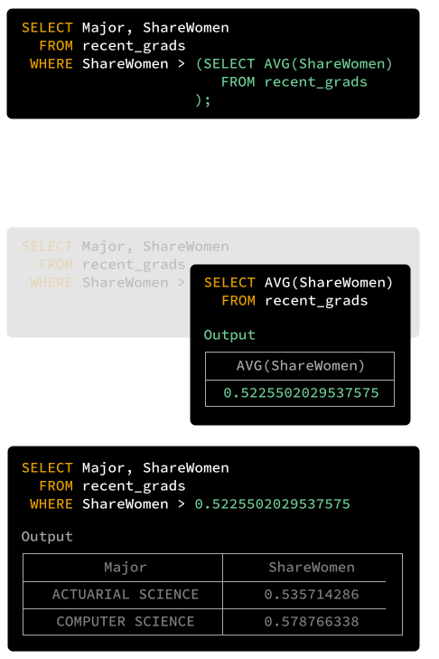
The query that replaces the placeholder subquery needs to be a full query (like the ones we've seen so far).
For this particular example, the inner query should only return a table with a single row and a column because of how it fits within the outer query (... WHERE > ?). If you try to return a table with multiple columns, you will get an error.
Lastly, a subquery must always be inside parentheses (). We get an error if we don't include them in the query above:
(sqlite3.OperationalError) near "SELECT": syntax error
[SQL: SELECT * FROM recent_grads WHERE ShareWomen > SELECT AVG(Sharewomen) FROM recent_grads;]
(Background on this error at: http://sqlalche.me/e/e3q8)
Copy
Let's practice this technique.
Instructions

- Write a query that does the following:
  - Displays, in order, the columns Major and Unemployment_rate.
  - Displays all rows with an unemployment rate below average.
On the previous screen, we wrote SQL statements that used a subquery to express dynamic filter criteria in the WHERE clause. Specifically, we looked for rows that were above or below the average value in a specific column.
What if we wanted to understand the proportion of majors that are above the average for a given column? We'd need to divide the number of rows that met the filter criteria by the total number of rows in the table.
Let's focus on the query from the previous screen:
SELECT Major, ShareWomen
FROM recent_grads
WHERE ShareWomen > (SELECT AVG(ShareWomen)
FROM recent_grads
);
Copy
Using the COUNT aggregate function, we can return the number of rows in the results set:
SELECT COUNT(*)
FROM recent_grads
WHERE ShareWomen > (SELECT AVG(ShareWomen)
FROM recent_grads
);
Copy
COUNT(*)
91
To return the proportion, we need to divide this value by the total number of rows in recent_grads. We can count the number of rows in the table, save the result, and then divide by it. The challenge, however, is to do this dynamically!
To calculate the number of total rows in recent_grads and use it in another SQL statement, we can use a subquery in the SELECT clause:
SELECT COUNT(*),
(SELECT COUNT(*)
FROM recent_grads
)
FROM recent_grads
WHERE ShareWomen > (SELECT AVG(ShareWomen)
FROM recent_grads
);
Copy
COUNT(*) | (SELECT COUNT(*) FROM recent_grads)
91 | 173
Now, extend the SQL statement to compute the actual proportion.
Instructions

- Write a SQL statement that computes the proportion (as a float value) of rows that contain above-average values for ShareWomen.
The results should only return the proportion, aliased as proportion_abv_avg, like this:
proportion_abv_avg
proportion goes here
We've been using operators like < and >. In the SQLite documentation, we see all of the following operators.
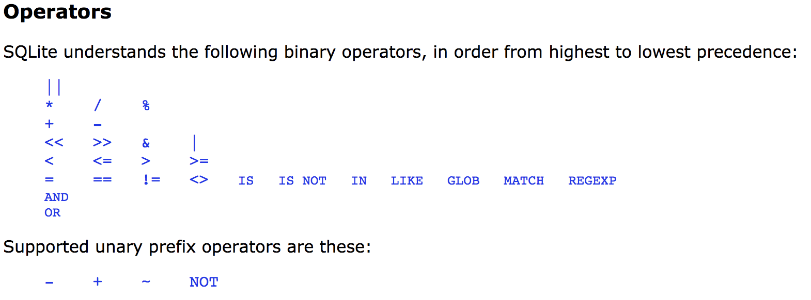
Using the IN operator, we can specify a list of values that we want to match in the WHERE clause. The following query returns the rows where Major_category equals either Business or Engineering:
SELECT Major, Major_category
FROM recent_grads
WHERE Major_category IN ('Business', 'Engineering')
LIMIT 7;
Copy
We've limited the results to just 7 rows, but we encourage you to remove the limit and run the query in our interface:
Major | Major_category
PETROLEUM ENGINEERING | Engineering
MINING AND MINERAL ENGINEERING | Engineering
METALLURGICAL ENGINEERING | Engineering
NAVAL ARCHITECTURE AND MARINE ENGINEERING | Engineering
CHEMICAL ENGINEERING | Engineering
NUCLEAR ENGINEERING | Engineering
ACTUARIAL SCIENCE | Business
Let's practice using IN.
Instructions

- Write a query that displays the following:
  - In order, Major_category and Major
  - All rows in any of the following categories:
    - Business
    - Humanities & Liberal Arts
    - Education
In the previous exercise, we displayed the majors in the categories Business, Humanities & Liberal Arts, and Education.
These are the top three categories with respect to the total number of graduates, as we can see in the query below.
SELECT Major_category, SUM(TOTAL)
FROM recent_grads
GROUP BY Major_category
ORDER BY SUM(TOTAL) DESC;
Copy
Major_category | SUM(TOTAL)
Business | 1302376
Humanities & Liberal Arts | 713468
Education | 559129
Engineering | 537583
Social Science | 529966
Psychology & Social Work | 481007
Health | 463230
Biology & Life Science | 453862
Communications & Journalism | 392601
Arts | 357130
Computers & Mathematics | 299008
Industrial Arts & Consumer Services | 229792
Physical Sciences | 185479
Law & Public Policy | 179107
Agriculture & Natural Resources | 79981
Interdisciplinary | 12296
If we wanted to find the same list of majors as we saw in the previous screen, dynamically (i.e. without first determining the most popular categories and then hard-coding the values into the query), subqueries can help.
Instead of returning just one value, we can make the query return a list of values (disguised as a single column).
In the following exercise, you will display the same results as we saw in the previous screen, only this time you won't manually indicate the categories.
You can use the following code in this screen's exercise.
SELECT Major_category, Major
FROM recent_grads
WHERE Major_category IN (SUBQUERY_GOES_HERE);
Copy
Instructions

- In the code displayed above, replace SUBQUERY_GOES_HERE to create a query that displays the Major_category and Major columns, for the rows where Major_category is one of the three highest group level sums for the Total column.
On the previous few screens, we nested subqueries in the WHERE and the SELECT clauses that underwent evaluation before the outer query.
We can actually nest subqueries within subqueries many times, but this complicates our SQL code and makes it harder to debug. In the next course, we'll explore other techniques for composing SQL statements that simplfify nested logic.
When you need to write a SQL statement that will end up using many subqueries, it can be overwhelming to know how to start.
In general, you want to start with the inner queries first and work your way out. For example, let's consider the ratio of the Sample_size column in relation to the Total column. You can read the dataset documentation if you need a reminder of what these columns represent.
Specifically, let's consider the following:
- Computing this ratio for every major.
- Understanding which majors are above the average for this ratio.
- Understanding how many majors are above the average for this ratio.
We'll start by writing a query that calculates the ratio for every major and then calculates the average of these ratios.
Instructions

- Write a query that returns the average ratio between Sample_size and Total for all of the majors.
Here's the format your query should return:
avg_ratio
average ratio value goes here
Now that we have a subquery that calculates the average ratio (of Sample_size to Total), we can return the rows that exceed this average.
Instructions

- Write a query that does the following:
  - Selects the Major, Major_category, and the computed ratio columns
  - Filters for the rows where ratio is greater than avg_ratio
In the SQL Fundamentals course, we worked exclusively with data that existed in a single table. In the real world, it's much more common for databases to have data in more than one table. If we want to be able to work with that data, we'll have to combine multiple tables within a query. The way we do this in SQL is using joins. As in the SQL Fundamentals course, we'll continue to use SQLite throughout this course.
In this lesson, we're going to be using a version of the CIA World Factbook (Factbook) database from the guided project from the SQL Fundamentals course. To refresh your memory, this database had one table called facts, where each row represented a country from the Factbook. Here are the first 5 rows of the facts table:
id | code | name | area | area_land | area_water | population | population_growth | birth_rate | death_rate | migration_rate
1 | af | Afghanistan | 652230 | 652230 | 0 | 32564342 | 2.32 | 38.57 | 13.89 | 1.51
2 | al | Albania | 28748 | 27398 | 1350 | 3029278 | 0.30 | 12.92 | 6.58 | 3.30
3 | ag | Algeria | 2381741 | 2381741 | 0 | 39542166 | 1.84 | 23.67 | 4.31 | 0.92
4 | an | Andorra | 468 | 468 | 0 | 85580 | 0.12 | 8.13 | 6.96 | 0.00
5 | ao | Angola | 1246700 | 1246700 | 0 | 19625353 | 2.78 | 38.78 | 11.49 | 0.46
In addition to the facts table we've added a new table, called cities which contains information on major urban areas from countries in the Factbook (for the rest of this lesson, we'll use the word 'cities' to mean the same as 'major urban areas'). Let's take a look at the first few rows of this new table and a description of what each column represents:
id | name | population | capital | facts_id
1 | Oranjestad | 37000 | 1 | 216
2 | Saint John'S | 27000 | 1 | 6
3 | Abu Dhabi | 942000 | 1 | 184
4 | Dubai | 1978000 | 0 | 184
5 | Sharjah | 983000 | 0 | 184
- id - A unique ID for each city.
- name - The name of the city.
- population - The population of the city.
- capital - Whether the city is a capital city: 1 if it is, 0 if it isn't.
- facts_id - The ID of the country, from the facts table.
The last column is of particular interest to us, as it is a column of data that also exists in our original facts table. This link between tables is important as it's used to combine the data in our queries. Below is a schema diagram, which shows the two tables in our database, the columns within them and how the two are linked.
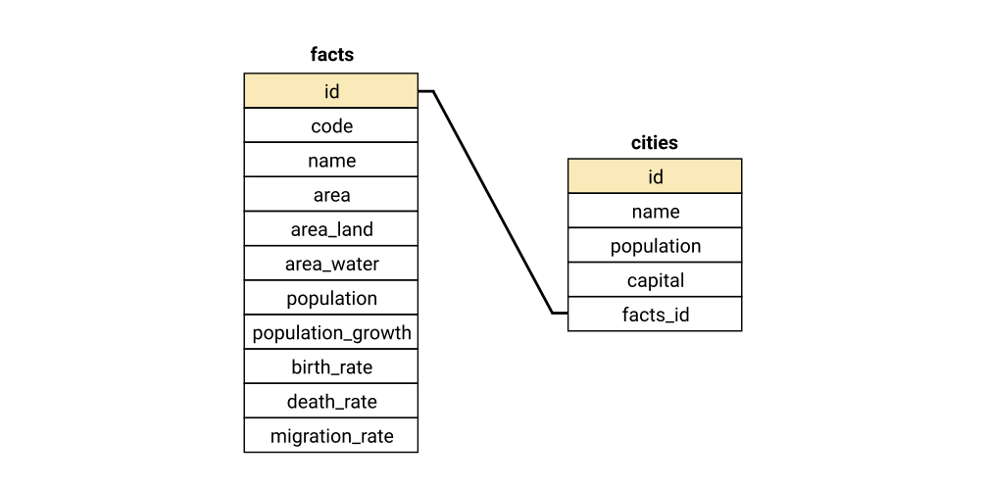
The line in the schema diagram clearly shows the link between the id column in the facts table and the facts_id column in the cities table. You may need to refer back to this schema diagram throughout the lesson.
The most common way to join data using SQL is using an inner join. The syntax for an inner join is:
SELECT [column_names] FROM [table_name_one]
INNER JOIN [table_name_two] ON [join_constraint];
Copy
The inner join clause is made up of two parts:
- INNER JOIN, which tells the SQL engine the name of the table you wish to join in your query, and that you wish to use an inner join.
- ON, which tells the SQL engine what columns to use to join the two tables.
Joins are usually used in a query after the FROM clause. Let's look at a basic inner join where we combine the data from both of our tables.
SELECT * FROM facts
INNER JOIN cities ON cities.facts_id = facts.id
LIMIT 5;
Copy
Let's look at the line of the query with the join in it:
- INNER JOIN cities - This tells the SQL engine that we wish to join the cities table to our query using an inner join.
- ON cities.facts_id = facts.id - This tells the SQL engine which columns to use when joining the data, following the syntax table_name.column_name.
You might presume that SELECT * FROM facts will mean that the query returns only columns from the facts table, however the * wildcard when used with a join will give you all columns from both tables. Here is the result of this query:
id | code | name | area | area_land | area_water | population | population_growth | birth_rate | death_rate | migration_rate | id | name | population | capital | facts_id
216 | aa | Aruba | 180 | 180 | 0 | 112162 | 1.33 | 12.56 | 8.18 | 8.92 | 1 | Oranjestad | 37000 | 1 | 216
6 | ac | Antigua and Barbuda | 442 | 442 | 0 | 92436 | 1.24 | 15.85 | 5.69 | 2.21 | 2 | Saint John'S | 27000 | 1 | 6
184 | ae | United Arab Emirates | 83600 | 83600 | 0 | 5779760 | 2.58 | 15.43 | 1.97 | 12.36 | 3 | Abu Dhabi | 942000 | 1 | 184
184 | ae | United Arab Emirates | 83600 | 83600 | 0 | 5779760 | 2.58 | 15.43 | 1.97 | 12.36 | 4 | Dubai | 1978000 | 0 | 184
184 | ae | United Arab Emirates | 83600 | 83600 | 0 | 5779760 | 2.58 | 15.43 | 1.97 | 12.36 | 5 | Sharjah | 983000 | 0 | 184
This query gives us all columns from both tables and every row where there is a match between the id column from facts and the facts_id from cities, limited to the first 5 rows. We'll look at how the join itself works in detail in a moment, but first let's practice writing our first join.
Instructions

- Write a query that returns all columns from the facts and cities tables.
  - Use an INNER JOIN to join the cities table to the facts table.
  - Join the tables on the values where facts.id and cities.facts_id are equal.
  - Limit the query to the first 10 rows.
We've now joined the two tables to give us extra information about each row in cities. Let's take a closer look at how this inner join works.
An inner join works by including only rows from each table that have a match as specified using the ON clause. Let's look at a diagram of how our join from the previous screen works. We have included a selection of rows which best illustrate the join:
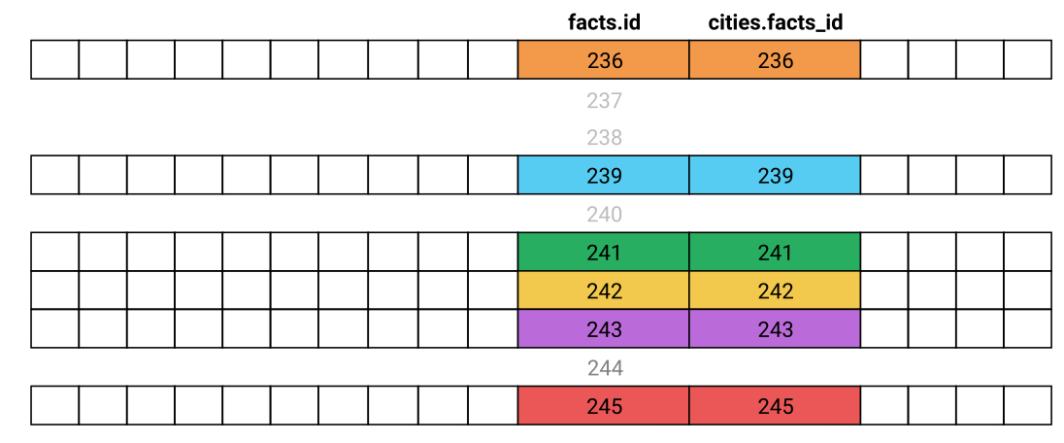
Our inner join will include:
- Rows from the cities table that have a cities.facts_id that matches a facts.id from facts.
Our inner join will not include:
- Rows from the cities table that have a cities.facts_id that doesn't match any facts.id from facts.
- Rows from the facts table that have a facts.id that doesn't match any cities.facts_id from cities.
You can see this represented as a Venn diagram:
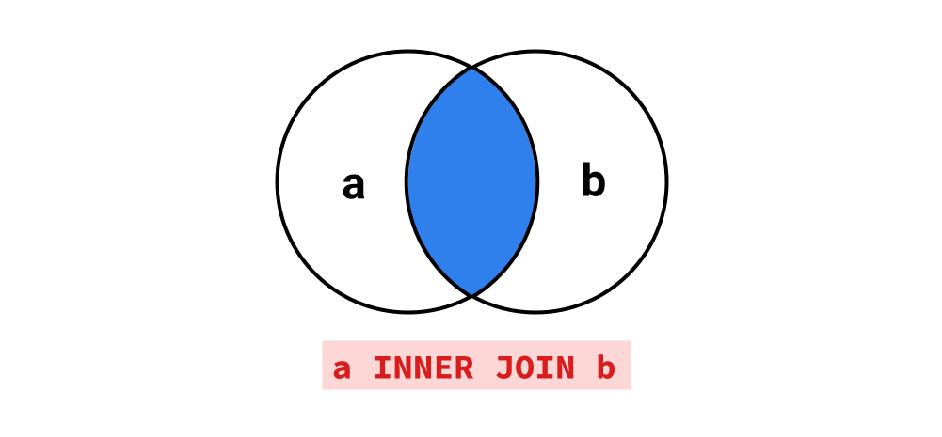
In the SQL fundamentals course, we learned how to use aliases to specify custom names for columns, eg:
SELECT AVG(population) AS AVERAGE_POPULATION
Copy
We can also create aliases for table names, which makes queries with joins easier to both read and write. Instead of:
SELECT * FROM facts
INNER JOIN cities ON cities.facts_id = facts.id
Copy
We can write:
SELECT * FROM facts AS f
INNER JOIN cities AS c ON c.facts_id = f.id
Copy
Just like with column names, using AS is optional. We can get the same result by writing:
SELECT * FROM facts f
INNER JOIN cities c ON c.facts_id = f.id
Copy
We can also combine aliases with wildcards - for instance, using the aliases created above, c.* would give us all columns from the table cities.
While our query from the previous screen included both columns from the ON clause, we don't need to use either column from our ON clause in our final list of columns. This is useful as it means we can show only the information we're interested in, rather than having to include the two join columns every time.
Let's use what we've learned to build on our original query.
Instructions

- Write a query that:
  - Joins cities to facts using an INNER JOIN.
  - Uses aliases for table names.
  - Includes, in order:
    - All columns from cities.
    - The name column from facts aliased to country_name.
  - Includes only the first 5 rows.
Let's practice writing a query to answer a question from our database using an inner join. Say we want to produce a table of countries and their capital cities from our database using what we've learned so far. Our first step is to think about what columns we'll need in our final query. We'll need:
- The name column from facts
- The name column from cities
Given that we've identified that we need data from two tables, we need to think about how to join them. The schema diagram from earlier indicated that there is only one column in each table that links them together, so we can use an inner join with those columns to join the data.
So far, thinking through our question we can already write most of our query:
SELECT f.name, c.name FROM cities c
INNER JOIN facts f ON f.id = c.facts_id
Copy
The last part of our process is to make sure we have the correct rows. From the previous two screens we know that a query like this will return all rows from cities that have a corresponding match from facts in the facts_id column. We're only interested in the capital cities from the cities table, so we'll need to use a WHERE clause on the capital column, which has a value of 1 if the city is a capital, and 0 if it isn't:
WHERE c.capital = 1
Copy
We can now put this all together to write a query that answers our question.
Instructions

- Write a query that uses an INNER JOIN to join the two tables in your query and returns, in order:
  - A column of country names, called country.
  - A column of each country's capital city, called capital_city.
As we mentioned earlier, an inner join will not include any rows where there is not a mutual match from both tables. This means there could be information we are not seeing in our query where rows don't match.
We can use some SQL queries to explore this:
SELECT COUNT(DISTINCT(name)) FROM facts;
Copy
count
261
SELECT COUNT(DISTINCT(facts_id)) FROM cities;
Copy
count
210
By running these two queries, we can see that there are some countries in the facts table that don't have corresponding cities in the cities table, which indicates we may have some incomplete data.
Let's look at how we can create a query to explore the missing data using a new type of join— the left join.
A left join includes all the rows that an inner join will select, plus any rows from the first (or left) table that don't have a match in the second table. We can see this represented as a Venn diagram.
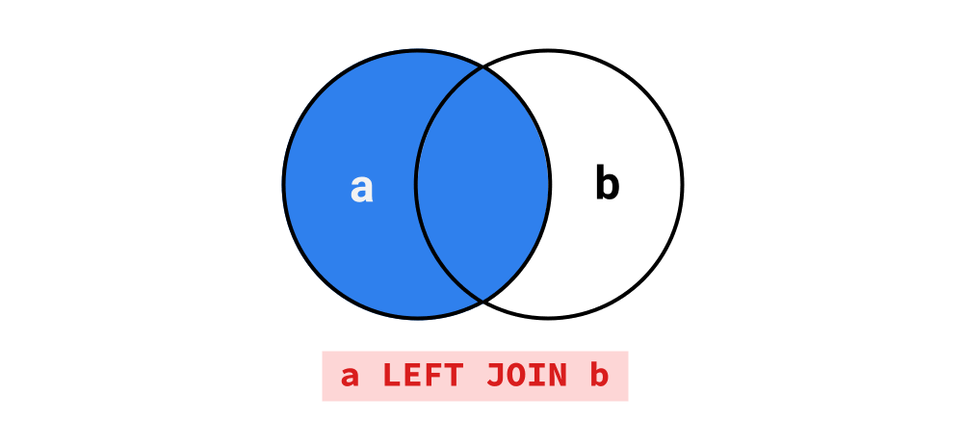
Let's look at an example by replacing INNER JOIN with LEFT JOIN from the first query we wrote, and looking at the same selection of rows from our earlier diagram
SELECT * FROM facts
LEFT JOIN cities ON cities.facts_id = facts.id
Copy
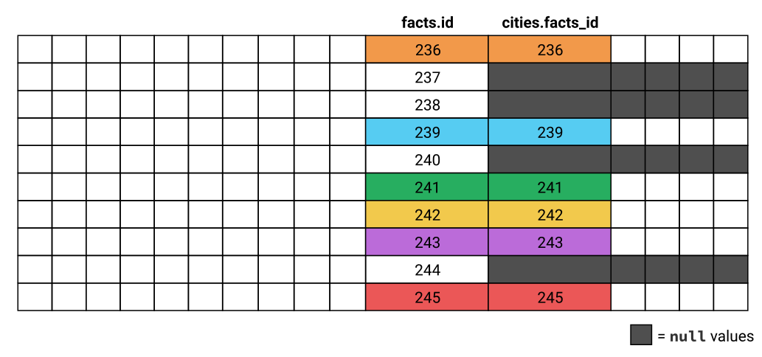
Here we can see that for the rows where facts.id doesn't match any values in cities.facts_id (237, 238, 240, and 244), the rows are still included in the results. When this happens, all of the columns from the cities table are populated with null values.
We can use these null values to filter our results to just the countries that don't exist in cities with a WHERE clause. When making a comparison to null in SQL, we use the IS keyword, rather than the = sign. If we want to select rows where a column is null we can write:
WHERE column_name IS NULL
Copy
If we want to select rows where a column name isn't null, we use:
WHERE column_name IS NOT NULL
Copy
Let's use a left join to explore the countries that don't exist in the cities table.
Instructions

- Write a query that returns the countries that don't exist in cities:
  - Your query should return two columns:
    - The country names, with the alias country.
    - The country population.
  - Use a LEFT JOIN to join cities to facts.
  - Include only the countries from facts that don't have a corresponding value in cities.
Looking through the results of the query we wrote in the previous screen, we can see a number of different reasons that countries don't have corresponding values in cities:
- Countries with small populations and/or no major urban areas (which are defined as having populations of over 750,000), eg San Marino, Kosovo, and Nauru.
- City-states, such as Monaco and Singapore.
- Territories that are not themselves countries, such as Hong Kong, Gibraltar, and the Cook Islands.
- Regions & Oceans that aren't countries, such as the European Union and the Pacific Ocean.
- Genuine cases of missing data, such as Taiwan.
It's important whenever you use inner joins to be mindful that you might be excluding important data, especially if you are joining based on columns that aren't linked in the database schema.
There are two less-common join types SQLite does not support that you should be aware of. The first is a right join. A right join, as the name indicates, is exactly the opposite of a left join. While the left join includes all rows in the table before the JOIN clause, the right join includes all rows in the new table in the JOIN clause. We can see a right join in the Venn diagram below:

The following two queries, one using a left join and one using a right join, produce identical results.
SELECT f.name country, c.name city
FROM facts f
LEFT JOIN cities c ON c.facts_id = f.id
LIMIT 5;
Copy
SELECT f.name country, c.name city
FROM cities c
RIGHT JOIN facts f ON f.id = c.facts_id
LIMIT 5;
Copy
The main reason a right join would be used is when you are joining more than two tables. In these cases, using a right join is preferable because it can avoid restructuring your whole query to join one table. Outside of this, right joins are used reasonably rarely, so for simple joins it's better to use a left join than a right as it will be easier for your query to be read and understood by others.
The other join type not supported by SQLite is a full outer join. A full outer join will include all rows from the tables on both sides of the join. We can see a full outer join in the Venn diagram below:

Like right joins, full outer joins are reasonably uncommon, and similar results can be achieved using a union clause (which we will teach in the next lesson). The standard SQL syntax for a full outer join is:
SELECT f.name country, c.name city
FROM cities c
FULL OUTER JOIN facts f ON f.id = c.facts_id
LIMIT 5;
Copy
When joining cities and facts with a full outer join, the result will be be the same as our left and right joins above, because there are no values in cities.facts_id that don't exist in facts.id.
Let's look at the Venn diagrams of each join type side by side, which should help you compare the differences of each of the four joins we've discussed so far.
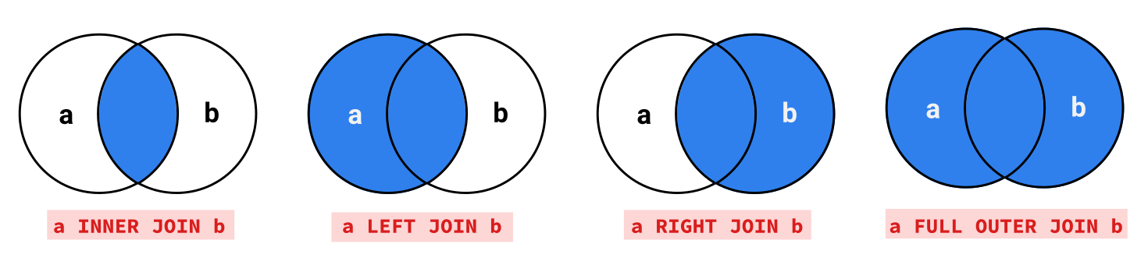
Next, let's practice using joins to answer some questions about our data.
Previously, we've used column names when specifying order for our query results, like so:
SELECT name, migration_rate FROM FACTS
ORDER BY migration_rate desc;
Copy
There is a handy shortcut we can use in our queries which lets us skip the column names, and instead use the order in which the columns appear in the SELECT clause. In this instance, migration_rate is the second column in our SELECT clause so we can just use 2 instead of the column name:
SELECT name, migration_rate FROM FACTS
ORDER BY 2 desc;
Copy
You can use this shortcut in either the ORDER BY or GROUP BY clauses. Be mindful that you want to ensure your queries are still readable, so typing the full column name may be better for more complex queries.
Let's use what we've learned to produce a list of the top 10 capital cities by population. Remember that capital is a boolean column containing 1 or 0, depending on whether a city is a capital or not. We won't specify which join type you should use - you will need to think about what results you require and select an appropriate join type.
Instructions

- Write a query that returns the 10 capital cities with the highest population ranked from biggest to smallest population.
  - You should include the following columns, in order:
    - capital_city, the name of the city.
    - country, the name of the country the city is from.
    - population, the population of the city.
As we learned in the SQL fundamentals course, subqueries can be used to substitute parts of queries, allowing us to find the answers to more complex questions. We can also join to the result of a subquery, just like we could a table.
Here's an example of a using a join and a subquery to produce a table of countries and their capital cities, like we did earlier in the lesson.
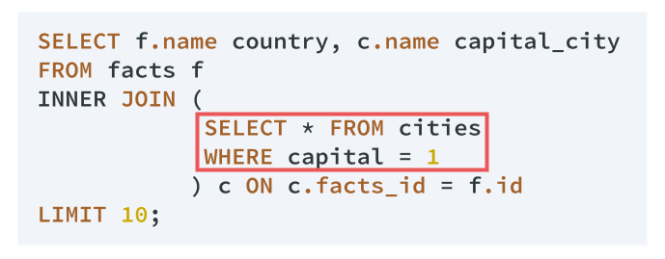
Reading subqueries can be overwhelming at first, so we'll break down what happens in this example in several steps. The important thing to remember is that the result of any subquery is always calculated first, so we read from the inside out.
- The subquery, in the red box, is calculated first. This simple query selects all columns from cities, filtering rows that are marked as capital cities by having a value for capital of 1.
- The INNER JOIN joins the subquery result, aliased as c, to the facts table based on the ON clause.
- Two columns are selected from the results of the join:
  - f.name, aliased as country.
  - c.name, aliased as capital_city.
- The results are limited to the first 10 rows.
Below is the output of this query:
country | capital_city
Aruba | Oranjestad
Antigua and Barbuda | Saint John'S
United Arab Emirates | Abu Dhabi
Afghanistan | Kabul
Algeria | Algiers
Azerbaijan | Baku
Albania | Tirana
Armenia | Yerevan
Andorra | Andorra La Vella
Angola | Luanda
Using this example as a model, we'll write a similar query to find the capital cities with populations of over 10 million.
Instructions

- Using a join and a subquery, write a query that returns capital cities with populations of over 10 million ordered from largest to smallest. Include the following columns:
  - capital_city - the name of the city.
  - country - the name of the country the city is the capital of.
  - population - the population of the city.
Let's take everything we've learned before and use it to write a more complex query. It's not uncommon to find that 'thinking in SQL' takes a bit of getting used to, so don't be discouraged if this challenge takes you a while. It will get easier with practice!
When you're writing complex queries with joins and subqueries, it helps to follow this process:
- Think about what data you need in your final output
- Work out which tables you'll need to join, and whether you will need to join to a subquery.
  - If you need to join to a subquery, write the subquery first.
- Then start writing your SELECT clause, followed by the join and any other clauses you will need.
- Don't be afraid to write your query in steps, running it as you go— for instance you can run your subquery as a 'stand alone' query first to make sure it looks like you want before writing the outer query.
We will be writing a query to find the countries where the urban center (city) population is more than half of the country's total population. Our final results will look like this. For expected results, we rounded to six decimal places; however, when running your query, don't worry about rounding the urban_pct column.
country | urban_pop | total_pop | urban_pct
Uruguay | 1672000 | 3341893 | 0.500315
Congo, Republic of the | 2445000 | 4755097 | 0.514185
Brunei | 241000 | 429646 | 0.560927
New Caledonia | 157000 | 271615 | 0.578024
Virgin Islands | 60000 | 103574 | 0.579296
Falkland Islands (Islas Malvinas) | 2000 | 3361 | 0.595061
Djibouti | 496000 | 828324 | 0.598800
Australia | 13789000 | 22751014 | 0.606083
Iceland | 206000 | 331918 | 0.620635
Israel | 5226000 | 8049314 | 0.649248
United Arab Emirates | 3903000 | 5779760 | 0.675288
Puerto Rico | 2475000 | 3598357 | 0.687814
Bahamas, The | 254000 | 324597 | 0.782509
Kuwait | 2406000 | 2788534 | 0.862819
Saint Pierre and Miquelon | 5000 | 5657 | 0.883861
Guam | 169000 | 161785 | 1.044596
Northern Mariana Islands | 56000 | 52344 | 1.069846
American Samoa | 64000 | 54343 | 1.177705
To help you out, the query you will write will include:
- A join to a subquery.
- A subquery to make a calculation.
- An aggregate function.
- A WHERE clause.
- A CAST expression.
Remember that there are multiple ways to write this query, and the list above is based on the approach we took in our solution.
Instructions

- Write a query that generates output as shown above. The query should include:
  - The following columns, in order:
    - country, the name of the country.
    - urban_pop, the sum of the population in major urban areas belonging to that country.
    - total_pop, the total population of the country.
    - urban_pct, the percentage of the population within urban areas, calculated by dividing urban_pop by total_pop.
  - Only countries that have an urban_pct greater than 0.5.
  - Rows should be sorted by urban_pct in ascending order.
In the previous lesson we learned how to use joins to combine data from two tables within a database. In reality, most databases have more than 2 tables, so we'll need strategies to be able to write queries to combine data from 3 or more tables.
In this lesson we'll learn some new techniques to work with the sort of databases that most businesses will use. We'll be working with a modified version of a database called Chinook. The Chinook database contains information about a fictional digital music shop - kind of like a mini-iTunes store.
The Chinook database contains information about the artists, songs, and albums from the music shop, as well as information on the shop's employees, customers, and the customers purchases. This information is contained in eleven tables. Like with our Factbook database, a schema diagram will help us understand the available columns and the structure of the data. Here's a schema diagram for the Chinook database:
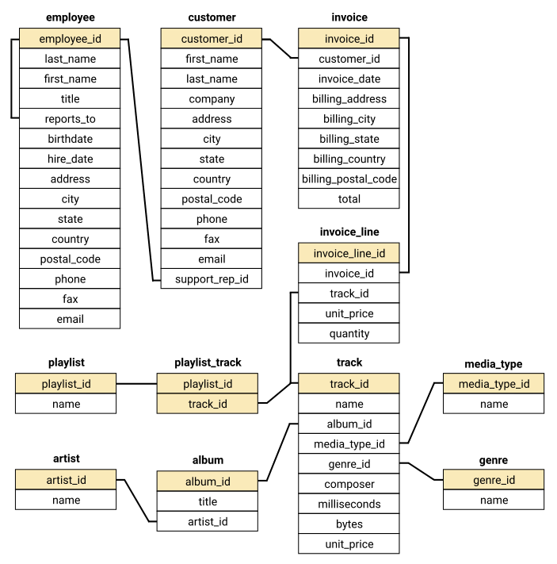
Looking at all those tables can be overwhelming at first, but generally speaking we will only need to think about the specific tables that have the data we require and their connections. Before we look at some specific tables, let's take a moment to understand the different parts of the schema diagram.
- Tables names are shown in bold, with the columns in each table listed below.
- Each table has one or more columns with shading, which indicates those columns are a primary key. We'll learn more about primary keys in a later lesson, but for now all you need to know is that each row's primary key must be unique.
- Relationships between tables are shown using lines between the tables. The lines indicate which columns are related. You may notice that at least one 'end' of the relationship will be a primary key.
As you work through this lesson, you may need to refer back to the schema diagram. This is normal, so don't be bothered when that happens. It can also be helpful to write a simple query to check the column names and some example data from any of the tables, for instance:
SELECT * FROM album LIMIT 3;
Copy
album_id | title | artist_id
1 | For Those About To Rock We Salute You | 1
2 | Balls to the Wall | 2
3 | Restless and Wild | 2
Our first task is to gather some information on a specific purchase. For one single purchase (invoice_id) we want to know, for each track purchased:
- The id of the track.
- The name of the track.
- The name of media type of the track.
- The price that the customer paid for the track.
- The quantity of the track that was purchased.
To gather this information, we will need to write a query that joins 3 tables: invoice_line, track, and media_type. To make this easier, a schema diagram of just these three tables is below:
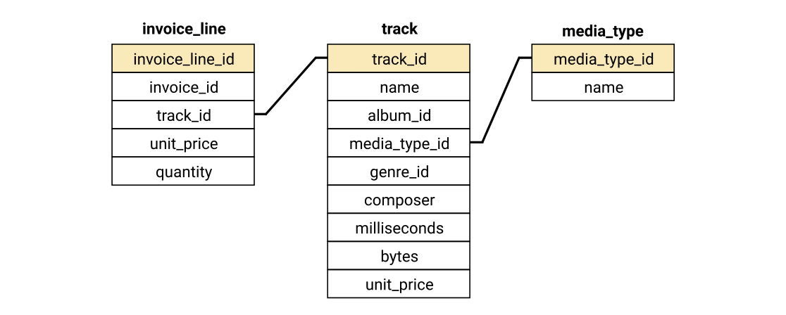
If you didn't explore these 3 tables in the previous screen, take a moment now to explore them:
- For each of invoice_line, track, and media_type:
  - Write a simple query to view the first few rows of each of these tables.
  - Look at the result of the query to become familiar with the columns and what sort of data we are working with.
Now that you're familiar with the data, we can look at the syntax for joining data from more than 2 tables.
SELECT [column_names] FROM [table_name_one]
[join_type] JOIN [table_name_two] ON [join_constraint]
[join_type] JOIN [table_name_three] ON [join_constraint];
Copy
Joining multiple tables is as simple as adding an extra JOIN clause. The SQL engine interprets joins in order, so the first join will be executed, and then the second join will be executed against the result of the first join. Because of this, we can first build our query in steps:
- with 0 joins.
- with 1 join.
- with 2 joins.
We will use the invoice_line table in our FROM clause, since it contains 3 of the 5 columns we want in our final query. You don't have to follow this pattern but if you're not sure, it's a good place to start. Since our task involves looking for information about a specific invoice_id, let's choose an invoice_id value of 3. Selecting all lines from invoice_line with an invoice_id is straightforward:
SELECT * FROM invoice_line
WHERE invoice_id = 3;
Copy
invoice_line_id | invoice_id | track_id | unit_price | quantity
27 | 3 | 2516 | 0.99 | 1
28 | 3 | 2646 | 0.99 | 1
Now we can use an inner join to add the data from the track table.
SELECT * FROM invoice_line il
INNER JOIN track t ON t.track_id = il.track_id
WHERE invoice_id = 3;
Copy
invoice_line_id | invoice_id | track_id | unit_price | quantity | track_id | name | album_id | media_type_id | genre_id | composer | milliseconds | bytes | unit_price
27 | 3 | 2516 | 0.99 | 1 | 2516 | Black Hole Sun | 203 | 1 | 1 | Soundgarden | 320365 | 10425229 | 0.99
28 | 3 | 2646 | 0.99 | 1 | 2646 | I Looked At You | 214 | 1 | 1 | Robby Krieger, Ray Manzarek, John Densmore, Ji... | 142080 | 4663988 | 0.99
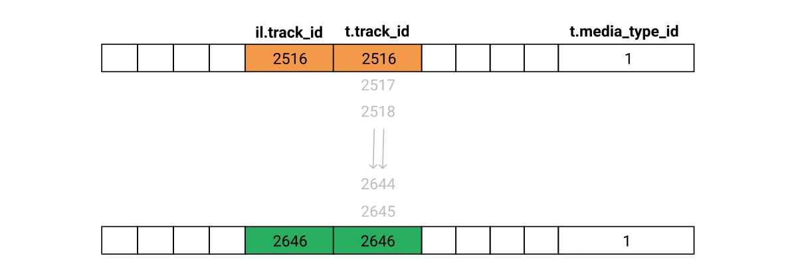
Next, we add our second join to add the data from the media_type table.
SELECT * FROM invoice_line il
INNER JOIN track t ON t.track_id = il.track_id
INNER JOIN media_type mt ON mt.media_type_id = t.media_type_id
WHERE invoice_id = 3;
Copy
invoice_line_id | invoice_id | track_id | unit_price | quantity | track_id | name | album_id | media_type_id | genre_id | composer | milliseconds | bytes | unit_price | media_type_id | name
27 | 3 | 2516 | 0.99 | 1 | 2516 | Black Hole Sun | 203 | 1 | 1 | Soundgarden | 320365 | 10425229 | 0.99 | 1 | MPEG audio file
28 | 3 | 2646 | 0.99 | 1 | 2646 | I Looked At You | 214 | 1 | 1 | Robby Krieger, Ray Manzarek, John Densmore, Ji... | 142080 | 4663988 | 0.99 | 1 | MPEG audio file
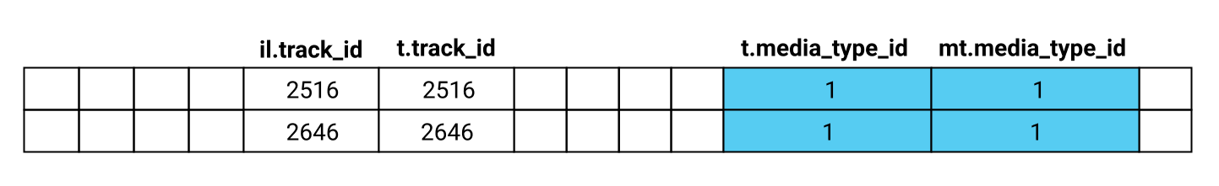
The last step is to alter the SELECT clause to include only the columns we require - let's do that now with a different order.
Instructions

- Write a query that gathers data about the invoice with an invoice_id of 4. Include the following columns in order:
  - The id of the track, track_id.
  - The name of the track, track_name.
  - The name of media type of the track, track_type.
  - The price that the customer paid for the track, unit_price.
  - The quantity of the track that was purchased, quantity.
Let's extend the query we wrote in the previous screen by adding the artist for each track. If you examine the schema, you'll notice that the data for the artist's name is not directly connected to the track table.
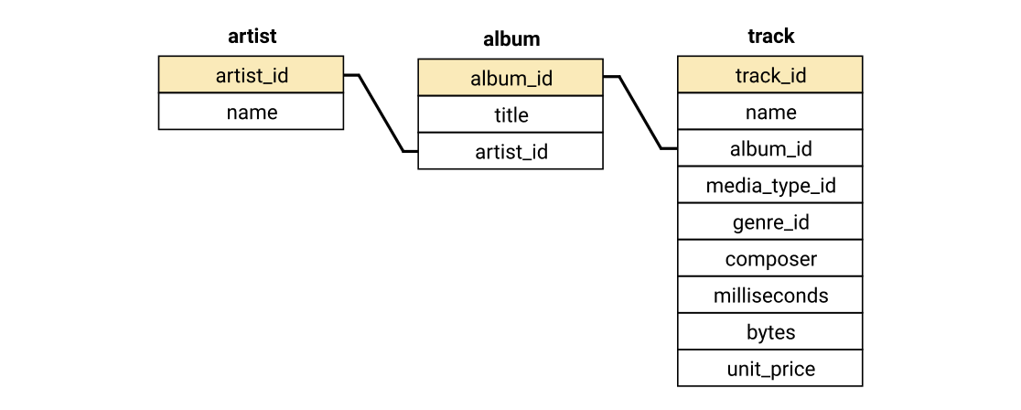
In this case, we will need to join two new tables to our existing query:
- artist, which contains the artist name data that we need
- album, which has a column common to each of the artist and track tables which allows us to join those two tables.
Our select clause won't actually use any of the columns from the album table. This is quite common when writing more complex queries because it will let you join to another table.
The query from the previous screen is included here:
SELECT
il.track_id,
t.name track_name,
mt.name track_type,
il.unit_price,
il.quantity
FROM invoice_line il
INNER JOIN track t ON t.track_id = il.track_id
INNER JOIN media_type mt ON mt.media_type_id = t.media_type_id
WHERE il.invoice_id = 4;
Copy
Instructions

- Add a column containing the artists name to the query from the previous screen.
  - The column should be called artist_name
  - The column should be placed between track_name and track_type
Because the invoice_line table contains each individual song from each customer purchase, it contains information about which songs are purchased the most. We can use the table to find out which artists are purchased the most. Specifically, what we want to produce is a query that lists the top 10 artists, calculated by the number of times a track by that artist has been purchased.
We'll need to use a GROUP BY clause to get the number of tracks purchased from each artist, but before we do we'll have to join a few tables. As we start thinking about how we will write this query, we can look at the database schema from the first screen of this lesson and think about what tables we will need to include.
Writing our query would be a lot easier if we had one table that contained both the track.track_id and the artist.name columns. We can write a subquery that creates this table for us, and then use that subquery to calculate our answer. This means our process will be:
- Write a subquery that produces a table with track.track_id and artist.name,
- Join that subquery to the invoice_line table,
- Use a GROUP BY statement to calculate the number of times each artist has had a track purchased, and find the top 10.
We can write our subquery by joining album to track and then artist to album, just like we did in the previous screen. We'll add an ORDER BY and LIMIT to our query so we're only looking at manageable sample of the data, but we'll remove it when we move to the next step.
SELECT
t.track_id,
ar.name artist_name
FROM track t
INNER JOIN album al ON al.album_id = t.album_id
INNER JOIN artist ar ON ar.artist_id = al.artist_id
ORDER BY 1 LIMIT 5;
Copy
track_id | artist_name
1 | AC/DC
2 | Accept
3 | Accept
4 | Accept
5 | Accept
Next, we need to join this subquery to our invoice_line table. We'll give our subquery an alias ta for 'track artist' to make it easier to refer to. Again, we'll add an ORDER BY and LIMIT statement to this step so our output is more manageable.
SELECT
il.invoice_line_id,
il.track_id,
ta.artist_name
FROM invoice_line il
INNER JOIN (
SELECT
t.track_id,
ar.name artist_name
FROM track t
INNER JOIN album al ON al.album_id = t.album_id
INNER JOIN artist ar ON ar.artist_id = al.artist_id
) ta
ON ta.track_id = il.track_id
ORDER BY 1 LIMIT 5;
Copy
il.invoice_line_id | il.track_id | ta.artist_name
1 | 1158 | Guns N' Roses
2 | 1159 | Guns N' Roses
3 | 1160 | Guns N' Roses
4 | 1161 | Guns N' Roses
5 | 1162 | Guns N' Roses
At first it might look like we've done something wrong, because the artist for all rows is Guns N' Roses, but that's because the very first order in our table is a customer who purchased an entire Guns N' Roses album! All that remains now is for us to add our GROUP BY clause, remove the extra columns and use ORDER BY and LIMIT clauses to select the 10 most popular artists.
SELECT
ta.artist_name artist,
COUNT(*) tracks_purchased
FROM invoice_line il
INNER JOIN (
SELECT
t.track_id,
ar.name artist_name
FROM track t
INNER JOIN album al ON al.album_id = t.album_id
INNER JOIN artist ar ON ar.artist_id = al.artist_id
) ta
ON ta.track_id = il.track_id
GROUP BY 1
ORDER BY 2 DESC LIMIT 10;
Copy
artist | tracks_purchased
Queen | 192
Jimi Hendrix | 187
Nirvana | 130
Red Hot Chili Peppers | 130
Pearl Jam | 129
AC/DC | 124
Guns N' Roses | 124
Foo Fighters | 121
The Rolling Stones | 117
Metallica | 106
You can use a similar technique to work out from which albums the most songs have been purchased.
Instructions

- Write a query that returns the top 5 albums, as calculated by the number of times a track from that album has been purchased. Your query should be sorted from most tracks purchased to least tracks purchased and return the following columns, in order:
  - album, the title of the album
  - artist, the artist who produced the album
  - tracks_purchased the total number of tracks purchased from that album
In some cases, there can be a relation between two columns within the same table. We can see that in our employee table, where there is a reports_to column that has a relation to the employee_id column within the same table.
The reports_to column identifies each employee's supervisor. If we wanted to create a report of each employee and their supervisor's name, we would need some way of joining a table to itself. Doing this is called a recursive join.
Technically, a recursive join will use one of the other standard joins— usually an INNER JOIN or LEFT JOIN since these are the most commonly used joins— and aliases to distinguish between the table on each side of the join. Here's a simple example of a recursive join in action:
SELECT
e1.employee_id,
e2.employee_id supervisor_id
FROM employee e1
INNER JOIN employee e2 on e1.reports_to = e2.employee_id
LIMIT 4;
Copy
This query produces the following table:
employee_id | supervisor_id
2 | 1
6 | 1
3 | 2
4 | 2
To make our report more meaningful, we'll need to add some extra columns. One thing that would be nice is being able to combine the first_name and last_name columns into a single column. We can do that using the concatenate operator: ||.
You can explore how the concatenate operator works by writing a simple query:
SELECT ("this" || "is" || "my" || "string");
Copy
thisismystring
Copy
Here are a few different examples of using concatenation, this time with columns from the album table:
SELECT
album_id,
artist_id,
"album id is" || album_id col_1,
"artist id is" || artist_id col2,
album_id || artist_id col3
FROM album LIMIT 3;
Copy
album_id | artist_id | col_1 | col2 | col3
1 | 1 | album id is1 | artist id is1 | 11
4 | 1 | album id is4 | artist id is1 | 41
2 | 2 | album id is2 | artist id is2 | 22
You'll notice that the SQL engine will concatenate multiple columns, columns with a string, and that the SQL engine handles converting different types where needed.
Let's use what we've learned about recursive joins and the concatenation operator to create a report about employees and their supervisors.
Instructions

- Write a query that returns information about each employee and their supervisor.
  - The report should include employees even if they do not report to another employee.
  - The report should be sorted alphabetically by the employee_name column.
  - Your query should return the following columns, in order:
    - employee_name - containing the first_name and last_name columns separated by a space, eg Luke Skywalker
    - employee_title - the title of that employee
    - supervisor_name - the first and last name of the person the employee reports to, in the same format as employee_name
    - supervisor_title - the title of the person the employee reports to
Let's say you're working as a sales support agent for Chinook, and you get back from lunch and see that one of your colleagues has left a phone message on your desk: "Call Jen". Writing a query to get this information out of the database might seem simple at first:
SELECT
first_name,
last_name,
phone
FROM customer
WHERE first_name = "Jen";
Copy
first_name | last_name | phone
No rows were returned by your query! Suddenly you realize— the name in the database might not be exactly "Jen", it might be Jenny, Jennifer, Jenna, or something else. Rather than having to keep trying different combinations, we can use the LIKE operator to find pattern matches. The syntax for LIKE is as follows:
WHERE [column_name] LIKE "[pattern]"
Copy
Your pattern should be the substring you want to match for, and one or more % characters:
- %Jen - will match Jen at the end of a string, eg Sarah-Jen
- Jen% - will match Jen at the start of a string, eg Jenny
- %Jen% - will match Jen anywhere within the string, eg Kris Jenner
We'll use the last pattern to give ourselves the best chance of a match:
SELECT
first_name,
last_name,
phone
FROM customer
WHERE first_name LIKE "%Jen%";
Copy
first_name | last_name | phone
Jennifer | Peterson | +1 (604) 688-2255
Perfect - we have found one match and have Jennifer's number so we can return her call.
Keep in mind that in SQLite LIKE is case insensitive, so LIKE "%jen%" will match Jen and JEN and JeN. Other flavors of SQL may be case sensitive, so you may need to use the LOWER() function to get a case insensitive match.
Let's use LIKE to find a different customer from our database.
Instructions

You have just returned from lunch to see another phone message on your desk: "Call Belle."
- Write a query that finds the contact details of a customer with a first_name containing Belle from the database. Your query should include the following columns, in order:
  - first_name
  - last_name
  - phone
Sometimes, you'll want to add some sort of categorization to your query. Let's say we wanted to generate a report summarizing each customer's purchases. It might be nice to create a column that puts each customer into a category:
- small spender - If the customer's total purchases are less than $40.
- big spender - If the customer's total purchases are greater than $100.
- regular - If the customer's total purchases are between $40 and $100 (inclusive).
To achieve this, we'll need to use the case statement. The case statement acts like a series of if/then options for a new column. The syntax for CASE is:
CASE
WHEN [comparison_1] THEN [value_1]
WHEN [comparison_2] THEN [value_2]
ELSE [value_3]
END
AS [new_column_name]
Copy
There can be 1 or more WHEN lines, and the ELSE line is optional— without it, rows that don't match any WHEN will be assigned a null value. Let's start by looking at a simple example. The media_type table contains the name of five different media types:
SELECT * FROM media_type;
Copy
media_type_id | name
1 | MPEG audio file
2 | Protected AAC audio file
3 | Protected MPEG-4 video file
4 | Purchased AAC audio file
5 | AAC audio file
Let's look at how we can use CASE to add a new column protected, which indicates whether each media type is protected.
SELECT
media_type_id,
name,
CASE
WHEN name LIKE '%Protected%' THEN 1
ELSE 0
END
AS protected
FROM media_type;
Copy
media_type_id | name | protected
1 | MPEG audio file | 0
2 | Protected AAC audio file | 1
3 | Protected MPEG-4 video file | 1
4 | Purchased AAC audio file | 0
5 | AAC audio file | 0
In this example, our CASE statement has a single WHEN which looks for a partial match of the string Protected in the name column. Any rows with a match get a value of 1; all other rows get 0.
Let's now put CASE into practice using our initial scenario, where we want to categorize customers by their purchase history.
You'll need to know that you can't use aliases in the WHEN line, so when writing a CASE statement that deals with aggregate functions, you will need to include the aggregate function in each WHEN line.
Instructions

- Write a query that summarizes the purchases of each customer. For the purposes of this exercise, we do not have any two customers with the same name.
  - Your query should include the following columns, in order:
    - customer_name - containing the first_name and last_name columns separated by a space, eg Luke Skywalker.
    - number_of_purchases, counting the number of purchases made by each customer.
    - total_spent - the total sum of money spent by each customer.
    - customer_category - a column that categorizes the customer based on their total purchases. The column should contain the following values:
      - small spender - If the customer's total purchases are less than $40.
      - big spender - If the customer's total purchases are greater than $100.
      - regular - If the customer's total purchases are between $40 and $100 (inclusive).
  - Order your results by the customer_name column.
In the previous two lessons, we've learned a lot about joining data. We've gone from creating basic joins between two tables to making complex joins using multiple tables, subqueries, unusual join types and aggregate functions.
In this lesson, we're going to continue to practice constructing complex joins, while also learning how to:
- Build and format your queries for readability
- Creating named subqueries and views
- Combining data using set operations.
Just like the previous lesson, we'll be working with the Chinook database. So you can easily refer to it, the schema for the Chinook database is provided again below.
"Code is read much more often than it is written, so plan accordingly.
"Even if you don't intend anybody else to read your code, there's still a very good chance that somebody will have to stare at your code and figure out what it does: That person is probably going to be you, twelve months from now."
—Raymond Chen
Often quoted and paraphrased, this philosophy is especially important when writing SQL, where queries can quickly get visually complex. Taking the time to write your queries to be more easily understood will take a little extra time now, but will save you time when you come back to old queries that you have written, and help your colleagues when you're working in a data team.
One obvious area when it comes to writing queries is the use of capitalization and whitespace. Because white space doesn't have any meaning in SQL, it can be used to help convey meaning in a complex query. Let's compare the same query written twice— first without whitespace and capitalization:
select ta.artist_name artist, count(*) tracks_sold from invoice_line il
inner join (select t.track_id, ar.name artist_name from track t
inner join album al on al.album_id = t.album_id
inner join artist ar on ar.artist_id = al.artist_id) ta
on ta.track_id = il.track_id group by 1 order by 2 desc limit 10;
Copy
And now, with whitespace and capitalization:
SELECT
ta.artist_name artist,
COUNT(*) tracks_sold
FROM invoice_line il
INNER JOIN (
SELECT
t.track_id,
ar.name artist_name
FROM track t
INNER JOIN album al ON al.album_id = t.album_id
INNER JOIN artist ar ON ar.artist_id = al.artist_id
) ta
ON ta.track_id = il.track_id
GROUP BY 1
ORDER BY 2 DESC LIMIT 10;
Copy
As you can see, a little time put into whitespace and capitalization pays off. A few tips to help make your queries more readable:
- If a select statement has more than one column, put each on a new line, indented from the select statement.
- Always capitalize SQL function names and keywords
- Put each clause of your query on a new line.
- Use indenting to make subqueries appear logically separate.
Another important consideration when writing readable queries is the use of alias names and shortcuts. Name aliases should be clear– a common convention is using the first letter of the table name, however if you feel that a query is complex you should consider using more explicit aliases. Similarly, at times lines like GROUP BY 1 can be confusing, and explicitly naming the column will make your query more readable.
If you work in a team, you might consider a SQL style guide— a great guide is available at SQL style guide, but remember that readability is more important than consistency. If you have a complex query and you think breaking the style guide will make it more readable, you should do it.
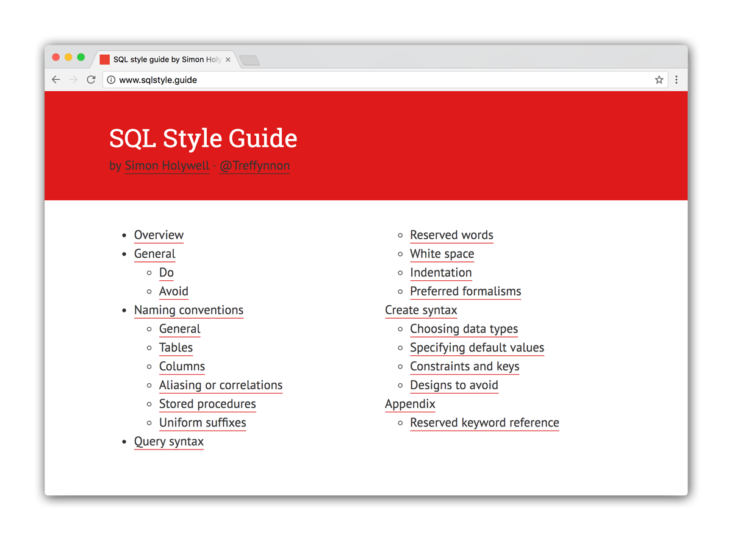
Throughout the rest of our SQL lessons, be mindful of writing queries that are easy to read and understand. While we will continue to check answers based on the results of the queries (rather than taking into account the formatting), practicing this will make your future colleagues (and future self) thank you.
Let's now learn another way to make your queries more readable: named subqueries.
When constructing complex queries, it's useful to create an intermediate table to produce our final results. You can use subqueries to create these intermediate tables. Unfortunately, the way subqueries are written makes it harder to read— the person reading the query needs to find the subquery and read from the inside-out.
One way to alleviate this is to use a with clause. WITH clauses allow you to define one or more named subqueries before the start of the main query. The main query then refers to the subquery by it's alias name, just as if it's a table in the database.
The syntax for the WITH clause is relatively straight-forward.
WITH [alias_name] AS ([subquery])
​
SELECT [main_query]
Copy
Let's look at a simple example, a query designed to gather some info about the tracks from a single album. First, here's our query written with a standard subquery and no WITH clause:
SELECT * FROM
(
SELECT
t.name,
ar.name artist,
al.title album_name,
mt.name media_type,
g.name genre,
t.milliseconds length_milliseconds
FROM track t
INNER JOIN media_type mt ON mt.media_type_id = t.media_type_id
INNER JOIN genre g ON g.genre_id = t.genre_id
INNER JOIN album al ON al.album_id = t.album_id
INNER JOIN artist ar ON ar.artist_id = al.artist_id
)
WHERE album_name = "Jagged Little Pill";
Copy
By moving the subquery before the main query using a WITH clause, the intent of the main query becomes much easier to understand.
WITH track_info AS
(
SELECT
t.name,
ar.name artist,
al.title album_name,
mt.name media_type,
g.name genre,
t.milliseconds length_milliseconds
FROM track t
INNER JOIN media_type mt ON mt.media_type_id = t.media_type_id
INNER JOIN genre g ON g.genre_id = t.genre_id
INNER JOIN album al ON al.album_id = t.album_id
INNER JOIN artist ar ON ar.artist_id = al.artist_id
)
​
SELECT * FROM track_info
WHERE album_name = "Jagged Little Pill";
Copy
While in this example the difference is subtle, using the WITH statement helps a lot when your main query even has some slight complexities. Let's get some practice using WITH in a more complex example.
Instructions

- Create a query that shows summary data for every playlist in the Chinook database:
  - Use a WITH clause to create a named subquery with the following info:
    - The unique ID for the playlist.
    - The name of the playlist.
    - The name of each track from the playlist.
    - The length of each track in seconds.
  - Your final table should have the following columns, in order:
    - playlist_id - the unique ID for the playlist.
    - playlist_name - The name of the playlist.
    - number_of_tracks - A count of the number of tracks in the playlist.
    - length_seconds - The sum of the length of the playlist in seconds.
  - The results should be sorted by playlist_id in ascending order.
When we use the WITH clause, we're creating a temporary named subquery that we can use only within that query. But what if we find ourselves using the same WITH with lots of different queries? It would be nice to permanently define a subquery that we can use again and again.
We do this by creating a view, which we can then use in all future queries. An easy way to think of this is the WITH clause creates a temporary view. The syntax for creating a view is:
CREATE VIEW database.view_name AS
SELECT * FROM database.table;
Copy
We'll be specifying the database name using [database name].[view or table name] syntax in instead of just [view or table name]. You'll need to use this in conjunction with any views because we have manually attached the database. If you're working with SQLite on your local machine, or in one of our Jupyter projects, you don't need to specify the database name like in the following example:
CREATE VIEW view_name AS
SELECT * FROM table;
Copy
Here's an example of how to create a view called customer_2, identical to the existing customer table:
CREATE VIEW chinook.customer_2 AS
SELECT * FROM chinook.customer;
Copy
If we wanted to modify this view, and tried to redefine it, we'd get an error:
CREATE VIEW chinook.customer_2 AS
SELECT
customer_id,
first_name || last_name name,
phone,
email,
support_rep_id
FROM chinook.customer;
Copy
Error: table customer_2 already exists
Copy
If we wish to redefine a view, we first have to delete, or drop the existing view:
DROP VIEW chinook.customer_2;
Copy
We're going to create two views that give us versions of the customer table where the customers in the view have specific criteria. The first is a view of all customers that live in the USA.
CREATE VIEW chinook.customer_usa AS
SELECT * FROM chinook.customer
WHERE country = "USA";
Copy
We have created this view for you - you can query it in the code editor on the right. Once a view is created it acts exactly like a table - you don't need to specify that it's a view when you are querying it, and you can do anything with a view that you could do with a table (keeping in mind that in our interface you'll have to use [database name].[view_name]).
Let's create a second view of customers that have purchased more than $90 from our store.
Instructions

- Create a view called customer_gt_90_dollars:
  - The view should contain the columns from customer, in their original order.
  - The view should contain only customers who have purchased more than $90 in tracks from the store.
- After the SQL query that creates the view, write a second query to display your newly created view: SELECT * FROM chinook.customer_gt_90_dollars;.
  - Make sure you use a semicolon (;) to indicate the end of each query.
NOTE: The query provided in the code editor is required for our answer checking system. Please do not delete this code.
We have now created two views: customer_usa and customer_gt_90_dollars. How can we find customers who are in different permutations of these two views:
- Customers in the USA or have spent more than $90
- Customers in the USA and have spent more than $90
- Customers in the USA and have not spent more than $90
These scenarios require a different type of join as we're wanting to join rows from not tables, and not columns. Let's start by looking at just the first scenario, where we want to combine rows that exist in either view.
Where regular joins are used to join columns, the union operator is used to join rows from tables and/or views.
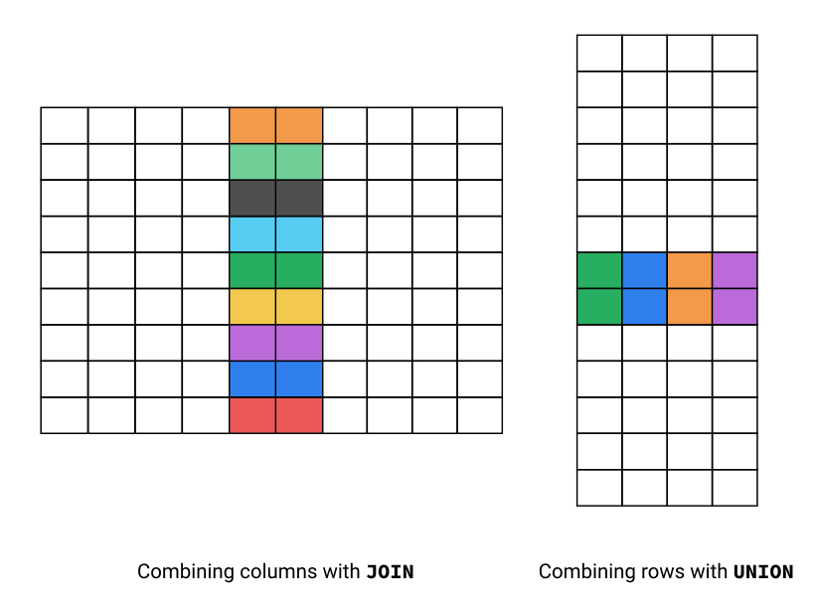
The syntax for the union operator is composed of two or more SELECT statements:
[select_statement_one]
UNION
[select_statement_two]
Copy
Rather than using the ON keyword, the statements before and after UNION must have the same number of columns, with compatible types in order. We'll learn more about types in a later lesson, but as an example, FLOAT and INT are compatible types, but FLOAT and TEXT are not).
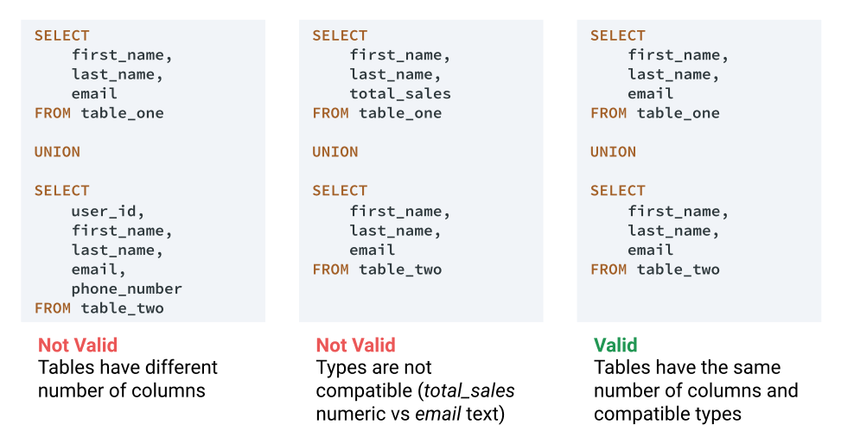
Because we created customer_usa and customer_gt_90_dollars with identical column names, order, and type as customer, we can safely use UNION.
To achieve our first scenario (identify customers who are in the USA or have spent more than $90), the two SELECT statements will be very simple - we can just select all columns and rows from each of the two views.
Instructions

- Use UNION to produce a table of customers in the USA or have spent more than $90, using the customer_usa and customer_gt_90_dollars views:
  - The result should contain the columns from customer, in their original order.
The three scenarios we discussed at the start of the previous screen were:
- Customers who are in the USA or have spent more than $90
- Customers who are in the USA and have spent more than $90
- Customers who are in the USA and have not spent more than $90
We just successfully used UNION for the first, but what about the other two? There are two other operators that will help us with these - intersect and except. Combined, these three operators allow us to perform set operations in SQL. Here's a diagram and explanation of how these compare with union.
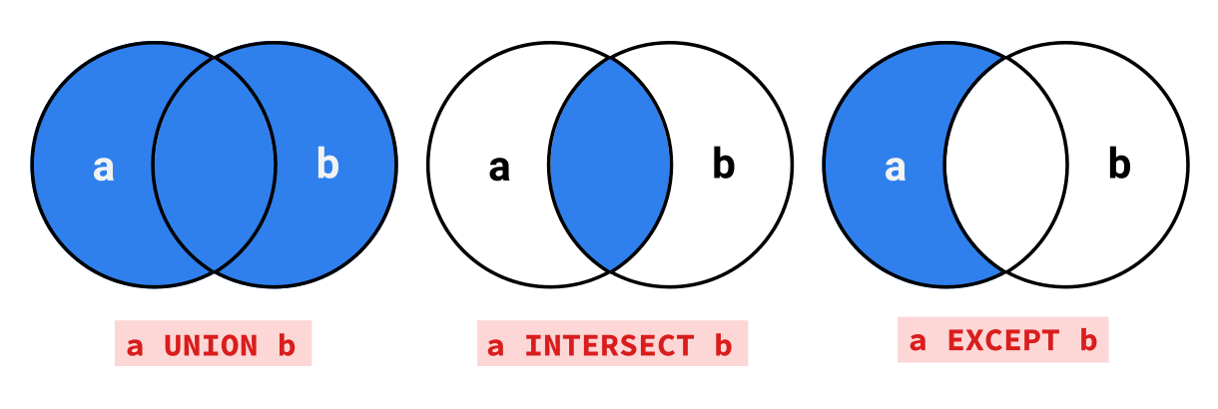
Operator | What it Does | Python Equivalent
UNION | Selects rows that occur in either statement. | or
INTERSECT | Selects rows that occur in both statements. | and
EXCEPT | Selects rows that occur in the first statement, but don't occur in the second statement. | and not
Both the syntax and the rules about column number and ordering of similar types are the same for INTERSECT and EXCEPT as they are for UNION. This means that identifying customers who are in the USA and have spent more than $90 can be done with the following query:
SELECT * from customer_usa
​
INTERSECT
​
SELECT * from customer_gt_90_dollars;
Copy
Identifying customers who are in the USA and have not spent $90 can be done with the following query:
SELECT * from customer_usa
​
EXCEPT
​
SELECT * from customer_gt_90_dollars;
Copy
The results of UNION, INTERSECT and EXCEPT conform to the 'everything in SQL is a table' concept we learned in the SQL fundamentals course. The results of these operations can be used in subqueries and joined to other tables for more complex analysis. Let's look at a scenario where we'll need to join the results of a set operation to another table:
Instructions

- Write a query that works out how many customers that are in the USA and have purchased more than $90 are assigned to each sales support agent. For the purposes of this exercise, no two employees have the same name.
  - Your result should have the following columns, in order:
  - employee_name - The first_name and last_name of the employee separated by a space, eg Luke Skywalker.
  - customers_usa_gt_90 - The number of customers assigned to that employee that are both from the USA and have purchased more than $90 worth of tracks.
  - The result should include all employees with the title "Sales Support Agent", but not employees with any other title.
  - Order your results by the employee_name column.
When we learned about WITH, we said with clauses allow you to define one or more named subqueries, but we didn't show you the syntax for creating more than one named subquery. To do this, you use a single WITH clause and multiple, comma-separated alias/subquery pairs:
WITH
[alias_name] AS ([subquery]),
[alias_name_2] AS ([subquery_2]),
[alias_name_3] AS ([subquery_3])
​
SELECT [main_query]
Copy
While each subquery can be independent, we can actually use the result of the first subquery in subsequent subqueries, and so on. This can be a useful way of building readable complex queries.
Let's look at a simple example where we create three named subqueries that build on each other.
WITH
usa AS
(
SELECT * FROM customer
WHERE country = "USA"
),
last_name_g AS
(
SELECT * FROM usa
WHERE last_name LIKE "G%"
),
state_ca AS
(
SELECT * FROM last_name_g
WHERE state = "CA"
)
​
SELECT
first_name,
last_name,
country,
state
FROM state_ca
Copy
first_name | last_name | country | state
Tim | Goyer | USA | CA
In reality, we'd usually write this as a single query using multiple AND operators in our WHERE clause, but it helps us demonstrate how multiple subqueries can be defined with a single WITH clause. Let's use a more 'real life' example to gather total sales data on customers from India.
Instructions

- Write a query that uses multiple named subqueries in a WITH clause to gather total sales data on customers from India:
  - The first named subquery should return all customers that are from India.
  - The second named subquery should calculate the sum total for every customer.
  - The main query should join the two named subqueries, resulting in the following final columns:
    - customer_name - The first_name and last_name of the customer, separated by a space, eg Luke Skywalker.
    - total_purchases - The total amount spent on purchases by that customer.
  - The results should be sorted by the customer_name column in alphabetical order.
It's time to bring everything we've learned in the course so far to write a complex query. This query will be a bit harder than anything we've written so far, so don't be discouraged if this challenge takes you a while. Write your query in steps, running it as you go to check on your results— this will make troubleshooting much easier.
We will be writing a query to find the customer from each country that has spent the most money at our store. In our database there are no 'ties' for best customer in each country, and we will ignore this case for the exercise.
Our final results will look like this. For expected results, we rounded to two decimal places; however, when running your query, don't worry about rounding the total_purchased column.
country | customer_name | total_purchased
Argentina | Diego Gutiérrez | 39.60
Australia | Mark Taylor | 81.18
Austria | Astrid Gruber | 69.30
Belgium | Daan Peeters | 60.39
Brazil | Luís Gonçalves | 108.90
Canada | François Tremblay | 99.99
Chile | Luis Rojas | 97.02
Czech Republic | František Wichterlová | 144.54
Denmark | Kara Nielsen | 37.62
Finland | Terhi Hämäläinen | 79.20
France | Wyatt Girard | 99.99
Germany | Fynn Zimmermann | 94.05
Hungary | Ladislav Kovács | 78.21
India | Manoj Pareek | 111.87
Ireland | Hugh O'Reilly | 114.84
Italy | Lucas Mancini | 50.49
Netherlands | Johannes Van der Berg | 65.34
Norway | Bjørn Hansen | 72.27
Poland | Stanisław Wójcik | 76.23
Portugal | João Fernandes | 102.96
Spain | Enrique Muñoz | 98.01
Sweden | Joakim Johansson | 75.24
USA | Jack Smith | 98.01
United Kingdom | Phil Hughes | 98.01
To help you out, the query you will write will include:
- One or more named subqueries defined in a WITH clause
- Aggregate functions like SUM() and MAX()
- Several INNER JOINs
- A subquery to define a column
- GROUP BY and ORDER BY clauses
Remember that there are multiple ways to write this query, and the list above is based on the approach we took in our solution.
Instructions

- Create a query to find the customer from each country that has spent the most money at our store, ordered alphabetically by country. Your query should return the following columns, in order:
  - country - The name of each country that we have a customer from.
  - customer_name - The first_name and last_name of the customer from that country with the most total purchases, separated by a space, eg Luke Skywalker.
  - total_purchased - The total dollar amount that customer has purchased.
We'll continue to work with the American Community Survey data on college majors and job outcomes, which looks like this:
Rank | Major_code | Major | Major_category | Total | Sample_size | Men | Women | ShareWomen | Employed
1 | 2419 | PETROLEUM ENGINEERING | Engineering | 2339 | 36 | 2057 | 282 | 0.120564 | 1976
2 | 2416 | MINING AND MINERAL ENGINEERING | Engineering | 756 | 7 | 679 | 77 | 0.101852 | 640
3 | 2415 | METALLURGICAL ENGINEERING | Engineering | 856 | 3 | 725 | 131 | 0.153037 | 648
4 | 2417 | NAVAL ARCHITECTURE AND MARINE ENGINEERING | Engineering | 1258 | 16 | 1123 | 135 | 0.107313 | 758
5 | 2405 | CHEMICAL ENGINEERING | Engineering | 32260 | 289 | 21239 | 11021 | 0.341631 | 25694
The full table has many more columns than the ones we've displayed above (21 to be specific). You can learn about all of them in FiveThirtyEight's GitHub repository.
Here are the descriptions for the columns in the preview:
- Rank: The major's rank by median earnings
- Major_code: The major's code or ID
- Major: The name of the major
- Major_category: The broader category the major belongs to
- Total: The total number of people who studied the major
- Sample_size: The sample size (unweighted) of graduates with full time jobs
- Men: The number of male graduates
- Women: The number of female graduates
- ShareWomen: Women as a proportion of the total number of graduates (a number ranging from 0 to 1)
- Employed: The number of employed graduates
We've loaded a subset of the data into a table named recent_grads in a database. The subset contains the 2010-2012 data for recent college grads only. The database file we'll be working with is called jobs.db.
Python 2.5 and up come with the sqlite module, which means we don't need to install any separate libraries to get started. Specifically, we'll work with the sqlite3 Python module, which was developed to work with SQLite version 3.
We can import it into our environment using this command:
import sqlite3
Copy
Once we import the module, we connect to the database we want to query using the connect() function. This function requires a single parameter, which is the database we want to connect to. Because the database we're working with exists as a file on disk, we need to pass in the file name.
The connect() function returns a Connection instance, which maintains the connection to the database we want to work with. When we're connected to a database, SQLite locks the database file and prevents any other processes from connecting to the database simultaneously. The SQLite team made this design decision to keep the database lightweight, and avoid the complexity that arises when multiple processes interact with the same database.
Instructions

- Import the sqlite3 library into the environment.
- Then, use the sqlite3.connect() function to connect to jobs.db, and assign the Connection instance it returns to conn.
Before we can execute a query, we need to express our SQL query as a string. While we use the Connection class to represent the database we're working with, we use the Cursor class to:
- Run a query against the database
- Parse the results from the database
- Convert the results to native Python objects
- Store the results within the Cursor instance as a local variable
After running a query and converting the results to a list of tuples, the Cursor instance stores the list as a local variable. Before diving into the syntax of querying the database, let's revise some of what we previously learned about tuples.
A tuple is a core data structure that Python uses to represent a sequence of values, similar to a list. Unlike lists, tuples are immutable, which means we can't modify existing ones. Python represents each row in the results set as a tuple.
To create an empty tuple, assign a pair of empty parentheses to a variable:
t = ()
Copy
Python indexes Tuples from 0 to n-1, just like it does with lists. We access the values in a tuple using bracket notation.
t = ('Apple', 'Banana')
apple = t[0]
banana = t[1]
Copy
Tuples are faster than lists, so they're helpful with larger databases and larger results sets.
Next, let's dive into how to use the Cursor instance to query the database.

We need to use the Connection instance method cursor() to return a Cursor instance corresponding to the database we want to query.
cursor = conn.cursor()
Copy
In the following code block, we:
- Write a basic select query that will return all of the values from the recent_grads table, and store this query as a string named query.
- Use the Cursor method execute() to run the query against our database.
- Return the full results set and store it as results.
- Print the first three tuples in the list results.
# SQL Query as a string
query = "select * from recent_grads;"
# Execute the query, convert the results to tuples, and store as a local variable
cursor.execute(query)
# Fetch the full results set as a list of tuples
results = cursor.fetchall()
# Display the first three results
print(results[0:3])
Copy
Now it's your turn!
Instructions

- Write a query that returns all of the values in the Major column from the recent_grads table.
- Store the full results set (a list of tuples) in majors.
- Then, print the first three tuples in majors.
So far, we've run queries by creating a Cursor instance, and then calling the execute method on the instance. The SQLite library actually allows us to skip creating a Cursor altogether by using the execute method within the Connection object itself. SQLite will create a Cursor instance for us under the hood and run our query against the database, allowing us to skip a step. Here's what the code looks like:
conn = sqlite3.connect("jobs.db")
query = "select * from recent_grads;"
conn.execute(query).fetchall()
Copy
Notice that we didn't explicitly create a separate Cursor instance ourselves in this code example.
Now let's learn how to fetch a specific number of results after we run a query.
To make it easier to work with large results sets, the Cursor class allows us to control the number of results we want to retrieve at any given time. To return a single result (as a tuple), we use the Cursor method fetchone(). To return n results, we use the Cursor method fetchmany().
Each Cursor instance contains an internal counter that updates every time we retrieve results. When we call the fetchone() method, the Cursor instance will return a single result, and then increment its internal counter by 1. This means that if we call fetchone() again, the Cursor instance will actually return the second tuple in the results set (and increment by 1 again).
The fetchmany() method takes in an integer (n) and returns the corresponding results, starting from the current position. It then increments the Cursor instance's counter by n. In the following code, we return the first two results using the fetchone() method, then the next five results using the fetchmany() method.
first_result = cursor.fetchone()
second_result = cursor.fetchone()
next_five_results = cursor.fetchmany(5)
Copy
Instructions

- Write and run a query that returns the Major and Major_category columns from recent_grads.
- Then, fetch the first five results and store them as five_results.
Because SQLite restricts access to the database file when we're connected to a database, we need to close the connection when we're done working with it. Closing the connection allows other processes to access the database, which is important when you're in a production environment and working with other team members.
To close a connection to a database, use the Connection instance method close(). When we're working with multiple databases and multiple Connection instances, we want to make sure we call the close() method on the correct instance. After closing the connection, attempting to query the database using any linked Cursor instances will return the following error:
ProgrammingError: Cannot operate on a closed database.
Copy
Instructions

- Close the connection to the database using the Connection instance method close().
Now let's practice the entire workflow we've learned so far, from start to finish.
Instructions

- Connect to the database jobs2.db, which contains the same data as jobs.db.
- Write and execute a query that returns all of the majors (Major) in reverse alphabetical order (Z to A).
- Assign the full result set to reverse_alphabetical.
- Finally, close the connection to the database.
So far, we've learned lots of skills to extract data from databases. This lesson will teach the other side of the equation — how to create and modify databases. Rather than working with a SQL editor, in this lesson we'll be working with the SQLite shell — a command-line interface to interact with SQLite.
A command-line interface is a text only program through which users interact with computers by typing text instructions. On the right part of this screen we have a command-line interface. To launch the SQLite shell, we can use the sqlite3 command followed by the name of the database file as an argument.
/home/dq$ sqlite3 chinook.db
Copy
When you launch the SQLite shell, you will be shown the SQLite prompt. Let's see what that looks like when we open our chinook.db file:
/home/dq$ sqlite3 chinook.db
SQLite version 3.21.0 2017-10-24 18:55:49
Enter ".help" for usage hints.
sqlite>
Copy
If you write a query, you'll get the response displayed in your console. If you press enter, the SQLite prompt will change to ...> and you can continue writing your query on multiple lines. As a result, unlike any of the places you've written SQL queries so far, including a semicolon (;) is necessary in the SQLite shell. If you don't use it, the shell will not know if you are finished writing your query. Let's write a query to look at one of our tables from the Chinook database.
sqlite> SELECT
...> track_id,
...> name,
...> album_id
...> FROM track
...> WHERE album_id = 3;
3|Fast As a Shark|3
4|Restless and Wild|3
5|Princess of the Dawn|3
Copy
The first thing you may notice is that we don't have the column names displayed. SQLite has a number of dot commands which you can use to help you work with databases. When you use a dot command, you don't need to use a semicolon. One that you'll want to use often is .headers on, which switches column headers on. Let's see what the output of our query looks like after we turn column headers on:
sqlite> .headers on
sqlite> SELECT
...> track_id,
...> name,
...> album_id
...> FROM track
...> WHERE album_id = 3;
track_id|name|album_id
3|Fast As a Shark|3
4|Restless and Wild|3
5|Princess of the Dawn|3
Copy
The next thing is that it's hard to read down the columns, since they don't line up. There's another dot command, .mode, that will help us out here. The .mode dot command allows us to select from a few different display modes. We'll use .mode column to allow for easier to read outputs. Here's the output of our query after switching to column mode:
sqlite> .mode column
sqlite> SELECT
...> track_id,
...> name,
...> album_id
...> FROM track
...> WHERE album_id = 3;
track_id name album_id
-------- -------------------- --------
3 Fast As a Shark 3
4 Restless and Wild 3
5 Princess of the Dawn 3
Copy
There are several other dot commands you'll use often:
- .help - Displays help text showing all dot commands and their function.
- .tables - Displays a list of all tables and views in the current database.
- .shell [command] - Run a command like ls or clear in the system shell.
- .quit - Quits the SQLite shell.
Instructions

- Launch the SQLite shell, connecting to the chinook.db database file.
- Use .tables to display the tables in the Chinook database.
- Use dot commands to turn headers on, and set the mode to 'column'.
- Write a query on one of the tables in the chinook.db database.
- Display the help text.
- Run .shell clear to see what it does.
- Quit the SQLite shell.
Now that we've learned the basics of the SQLite shell, let's learn how to create a database table. Here's the syntax for CREATE TABLE:
CREATE TABLE [table_name] (
[column1_name] [column1_type],
[column2_name] [column2_type],
[column3_name] [column3_type],
[...]
);
Copy
Each column in SQLite must have a type. While some database systems have as many as 50 distinct data types, SQLite uses only 5 behind the scenes:
- TEXT
- INTEGER
- REAL
- NUMERIC
- BLOB
If you have any experience with other database systems, you might be familiar with other types such as VARCHAR, REAL, and DATETIME. SQLite accepts most common types in a CREATE statement, but behind the scenes will convert them to one of its 5 base types.
The table below shows each of the types, along with examples of data commonly stored in the type, and some 'equivalent' types from other database systems. If you're not familiar with these other types, don't be concerned - we'll cover them in some more detail in a later course.
Type | Commonly Used For | Equivalent Types
TEXT | Names  Email Addresses  Dates and Times  Phone Numbers | CHARACTER  VARCHAR  NCHAR  NVARCHAR  DATETIME
INTEGER | IDs  Quantities | INT  SMALLINT  BIGINT  INT8
REAL | Weights  Averages | DOUBLE  FLOAT
NUMERIC | Prices  Statuses | DECIMAL  BOOLEAN
BLOB | Binary Data | BLOB
Just like with views, if you try to create a table that already exists you will get an error. If you make a mistake when you create a table, you can use the DROP statement to remove the table so you can create it again:
DROP TABLE [table_name];
Copy
You can also use the SQLite dot command .schema [table_name] to view the schema for a table you have just created to check where you might have gone wrong.
To practice, we'll create a new table in a new database file. If you launch the SQLite shell with the argument of a filename that doesn't exist, SQLite will create an empty database with that filename.
Make sure you quit the SQLite shell at the end, as it triggers our answer checking.
Instructions

- Launch the SQLite shell and create a new database file, new_database.db.
- Create a new table, user, with the following columns:
  - user_id, with type INTEGER
  - first_name, with type TEXT
  - last_name, with type TEXT
- Use the .schema dot command to view the schema for your newly created table.
- Quit the SQLite shell.
We have been using schema diagrams to identify the relationships between tables. Below is an excerpt of the schema diagram for the Chinook database which shows the relationship between the invoice and invoice_line tables:
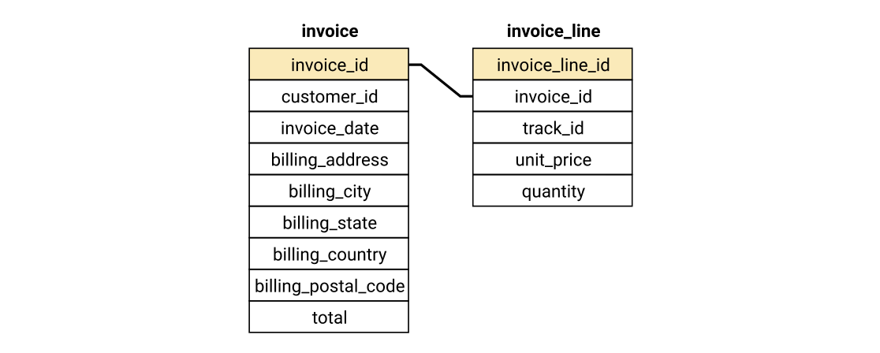
We previously learned that each table has one or more columns shaded in yellow, which indicates they are the primary key. A primary key is a unique identifier for each row - you cannot have two rows in a table with the same value for the primary key column(s).
When two tables have a relation, there will be a column in one table that is a primary key in another table. For example, in the invoice_line table, the invoice_id column is the primary key from the invoice table. This is known as a foreign key. By defining a foreign key, our database engine will prevent us from adding rows where the foreign key value doesn't exist in the other table, which helps to prevent errors in our data (note that by default SQLite doesn't force foreign key constraints, however we have changed the default for this lesson).
Usually, a primary key is specified as part of a create statement. Once the primary key is defined, the database engine will prevent any new rows from being added to the database if they have the same primary key as any existing rows. If we wanted to re-create the table from the previous exercise with a primary key, we would use this syntax:
CREATE TABLE user (
user_id INTEGER PRIMARY KEY,
first_name TEXT,
last_name TEXT
);
Copy
Let's say we wanted to create a new table purchase which tracks basic information about a purchase made by one of our users. Our create statement might look like this:
CREATE TABLE purchase (
purchase_id INTEGER PRIMARY KEY,
user_id INTEGER,
purchase_date TEXT,
total NUMERIC,
FOREIGN KEY (user_id) REFERENCES user(user_id)
);
Copy
By adding a FOREIGN KEY clause, we can define one of our columns as a foreign key and specify the table and column that it references. We're going to use what we've learned about creating tables, primary keys and foreign keys to add new tables to our Chinook database that allow customers to create "wishlists" of tracks they would like to buy.
We'll start by adding a table to store the name of the wishlist and the customer that created the wishlist. The schema is shown below:
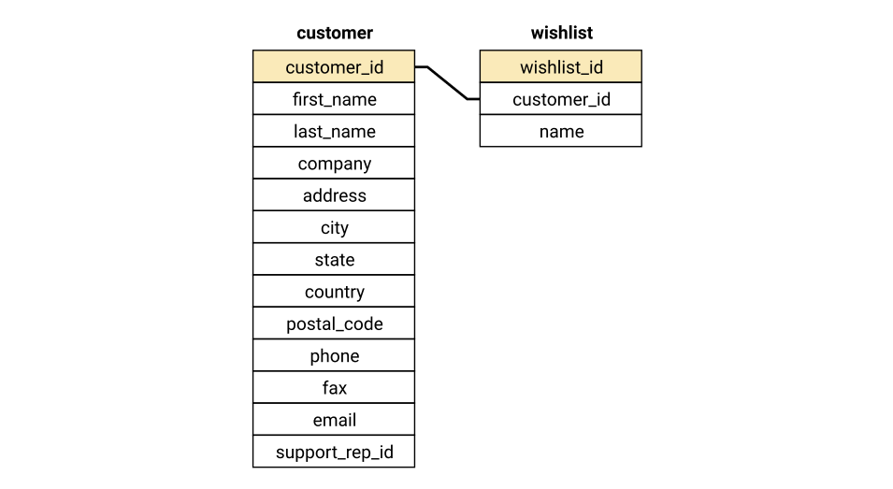
Instructions

- Launch the SQLite shell, connected to the chinook.db database.
- Create a new table, wishlist, with the following columns:
  - wishlist_id, with type INTEGER.
    - This column should be the primary key.
  - customer_id, with type INTEGER.
    - This column should have a foreign key relationship with the customer_id column from the customer table.
  - name, with type TEXT.
- Quit the SQLite shell.
When we created our wishlist table, we didn't include a track_id column to store which tracks are in the users wishlist. To understand why, let's take a look at what the table might look like if we stored all the data in a single table.
wishlist_id | customer_id | name | track_id
1 | 34 | Joao's awesome wishlist | 1158
1 | 34 | Joao's awesome wishlist | 2646
1 | 34 | Joao's awesome wishlist | 1990
2 | 18 | Amy loves pop | 3272
2 | 18 | Amy loves pop | 3470
There are are some drawbacks to storing the data this way:
- Data Duplication - we are storing the name of each wishlist multiple times.
- Data Modification - if we want to change the name of one of the wishlists, we have to modify multiple rows.
- Data Integrity - There is nothing to stop a row being added with the wrong wishlist name, and if that happened we wouldn't know which was the correct name.
The process of optimizing the design of databases to minimize these issues is called database normalization. In database normalization theory, there are several different phases of normalization, known as normal forms. Knowing each normal form is not as important as understanding the goals of normalization, and designing your databases to avoid data duplication and integrity issues. We'll learn more about database normalization in the next lesson, however for now let's look at how we can design our wishlist tables with normalization in mind:
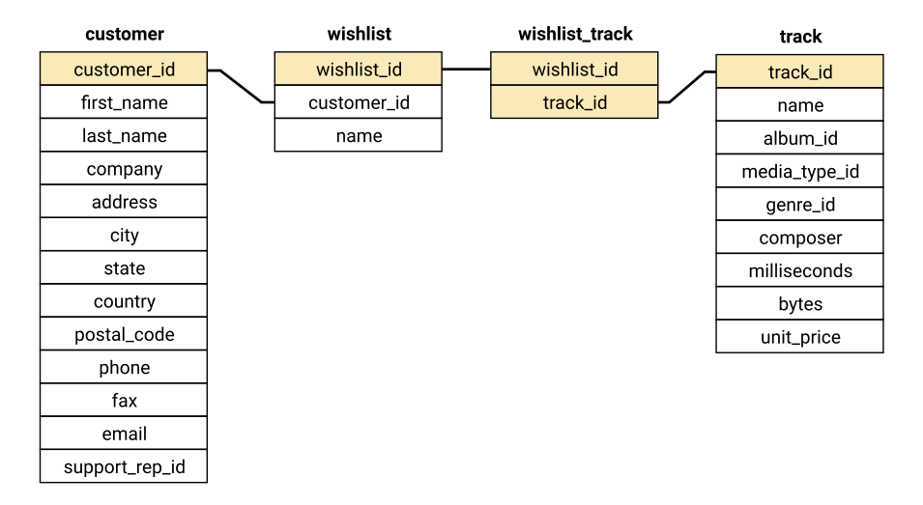
In addition to the wishlist table we made in the previous screen, we have added a new wishlist_track table and shown its relationship to the existing track table. The wishlist_track table has two columns that are both yellow to indicate that they're primary keys, since neither column will uniquely identify each row by itself. When two or more columns combine to form a primary key it is called a compound primary key. To create a compound primary key, you use the PRIMARY KEY clause:
CREATE TABLE [table_name] (
[column_one_name] [column_one_type],
[column_two_name] [column_two_type],
[column_three_name] [column_three_type],
[column_four_name] [column_four_type],
PRIMARY KEY (column_one_name, column_two_name)
);
Copy
Both columns in the wishlist_track table also have lines to indicate that they are foreign keys. To create a table with multiple foreign keys, you simply use multiple FOREIGN KEY clauses.
Instructions

- Launch the SQLite shell, connected to the chinook.db database.
- Create a new table, wishlist_track:
  - The table should have the following columns:
    - wishlist_id, with type INTEGER.
    - track_id, with type INTEGER.
  - A primary key should be specified, composed of both columns from the table.
  - Each of the columns should be designated as a foreign key as indicated in the schema diagram.
- Quit the SQLite shell.
Now that we've created the tables to hold our wishlist data, let's add some rows to those tables. To add rows to a SQL table, we'll use the INSERT statement:
INSERT INTO [table_name] (
[column1_name],
[column2_name],
[column3_name]
) VALUES (
[value1],
[value2],
[value3]
);
Copy
If you are inserting values into every column in a table, you don't need to list the column names:
INSERT INTO [table_name] VALUES ([value1], [value2], [value3]);
Copy
Additionally, you can insert multiple rows in a single statement:
INSERT INTO [table_name]
VALUES
([value1], [value2], [value3]),
([value4], [value5], [value6]),
[...]
Copy
Because of our foreign key constraints, we'll need to start by adding rows to the wishlist table, and then add rows to the wishlist_track table. If we don't, our insert statement will fail. At the end, we want our wishlist table to contain this data:
wishlist_id | customer_id | name
1 | 34 | Joao's awesome wishlist
2 | 18 | Amy loves pop
And our wishlist_track table to contain this data:
wishlist_id | track_id
1 | 1158
1 | 2646
1 | 1990
2 | 3272
2 | 3470
If you make an error while inserting new rows, you'll need to use the DELETE statement to remove all rows:
DELETE FROM [table_name]
Copy
Or use it with a where statement to remove selected rows:
DELETE FROM [table_name]
WHERE [expression];
Copy
Instructions

- Launch the SQLite shell, connected to the chinook.db database.
- Add new rows to the wishlist table, in order, as shown above.
- Add new rows to the wishlist_track table, in order, as shown above.
- Quit the SQLite shell.
We now have two tables to track our wishlist data, and have seeded some data. But what should we do when a customer wants to remove a track from their wishlist? One approach might be just to DELETE the row from wishlist_track. The downside of this approach is that we don't retain any historical data on which tracks were added to wishlists which reduces our ability to analyze this in the future.
A better approach would be to add a column that has a boolean value to show whether the row is active or not, and just change that value if the user wants to delete a track. We can do a similar thing with the wishlists themselves, so users can delete (or technically, deactivate) wishlists they no longer want to use.
We'll need to add a column to each of our tables. We can use the ALTER statement to do this.
ALTER TABLE [table_name]
ADD COLUMN [column_name] [column_type];
Copy
As we learned earlier, SQLite supports only five basic types - the closest thing to a boolean type is NUMERIC, where the values 1 and 0 will represent true and false respectively. Let's create active columns for both of our wishlist tables.
Instructions

- Launch the SQLite shell, connected to the chinook.db database.
- Create a new column, active, in the wishlist table with type NUMERIC.
- Create a new column, active, in the wishlist_track table with type NUMERIC.
- Quit the SQLite shell.
We've added our columns to both wishlist tables, but currently they don't have any data in them. To change values for existing rows, we use the UPDATE statement:
UPDATE [table_name]
SET [column_name] = [expression]
WHERE [expression]
Copy
The WHERE clause is optional, and can contain any expression that would be valid in a SELECT statement.
There are several variations we can use for our SET clause. First we can use a single value:
UPDATE customer
SET phone = "+55 (12) 3921-4464"
WHERE customer_id = 1
Copy
We can use a subquery that returns a single value:
UPDATE track
SET unit_price = (
SELECT AVG(unit_price)
FROM track
)
Copy
We can use a column, or function on an existing column:
UPDATE track
SET unit_price = unit_price * 1.1
Copy
Lastly, we can set more than one column at once:
UPDATE wishlist_track
SET
active = 1,
purchased = 0;
Copy
Because our active columns will store a 1 for true and 0 for false, we'll set the values to 1 for every row.
Instructions

- Launch the SQLite shell, connected to the chinook.db database.
- Set all values for the active column in the wishlist table to 1.
- Set all values for the active column in the wishlist_track table to 1.
- Quit the SQLite shell.
et's put everything we've learned into action with a challenge. Up until now, the Chinook store hasn't had to collect sales tax, but due to some new tax legislation, we will need to charge customers in certain countries taxes on their purchases.
We need to add the following columns to the invoice table:
- subtotal
- tax
We also need to update all existing invoices with data for these two new columns. The value for the tax column will need to be 0 for every row, and the value for the subtotal column will need to be the same as the total column for each row.
Here's what the first five rows of those columns will need to look like when you're done:
sqlite> SELECT
...> invoice_id,
...> subtotal,
...> tax,
...> total
...> FROM invoice
...> LIMIT 5;
invoice_id subtotal tax total
---------- ---------- ---------- ----------
1 15.84 0 15.84
2 9.9 0 9.9
3 1.98 0 1.98
4 7.92 0 7.92
5 16.83 0 16.83
Copy
Instructions

- Launch the SQLite shell, connected to the chinook.db database.
- Add two new columns, with values, to the invoice table:
  - tax, with type NUMERIC.
    - The value for all existing rows should be 0.
  - subtotal, with type NUMERIC.
    - The value for each row should be the same as that row's value for total.
- Quit the SQLite shell.

