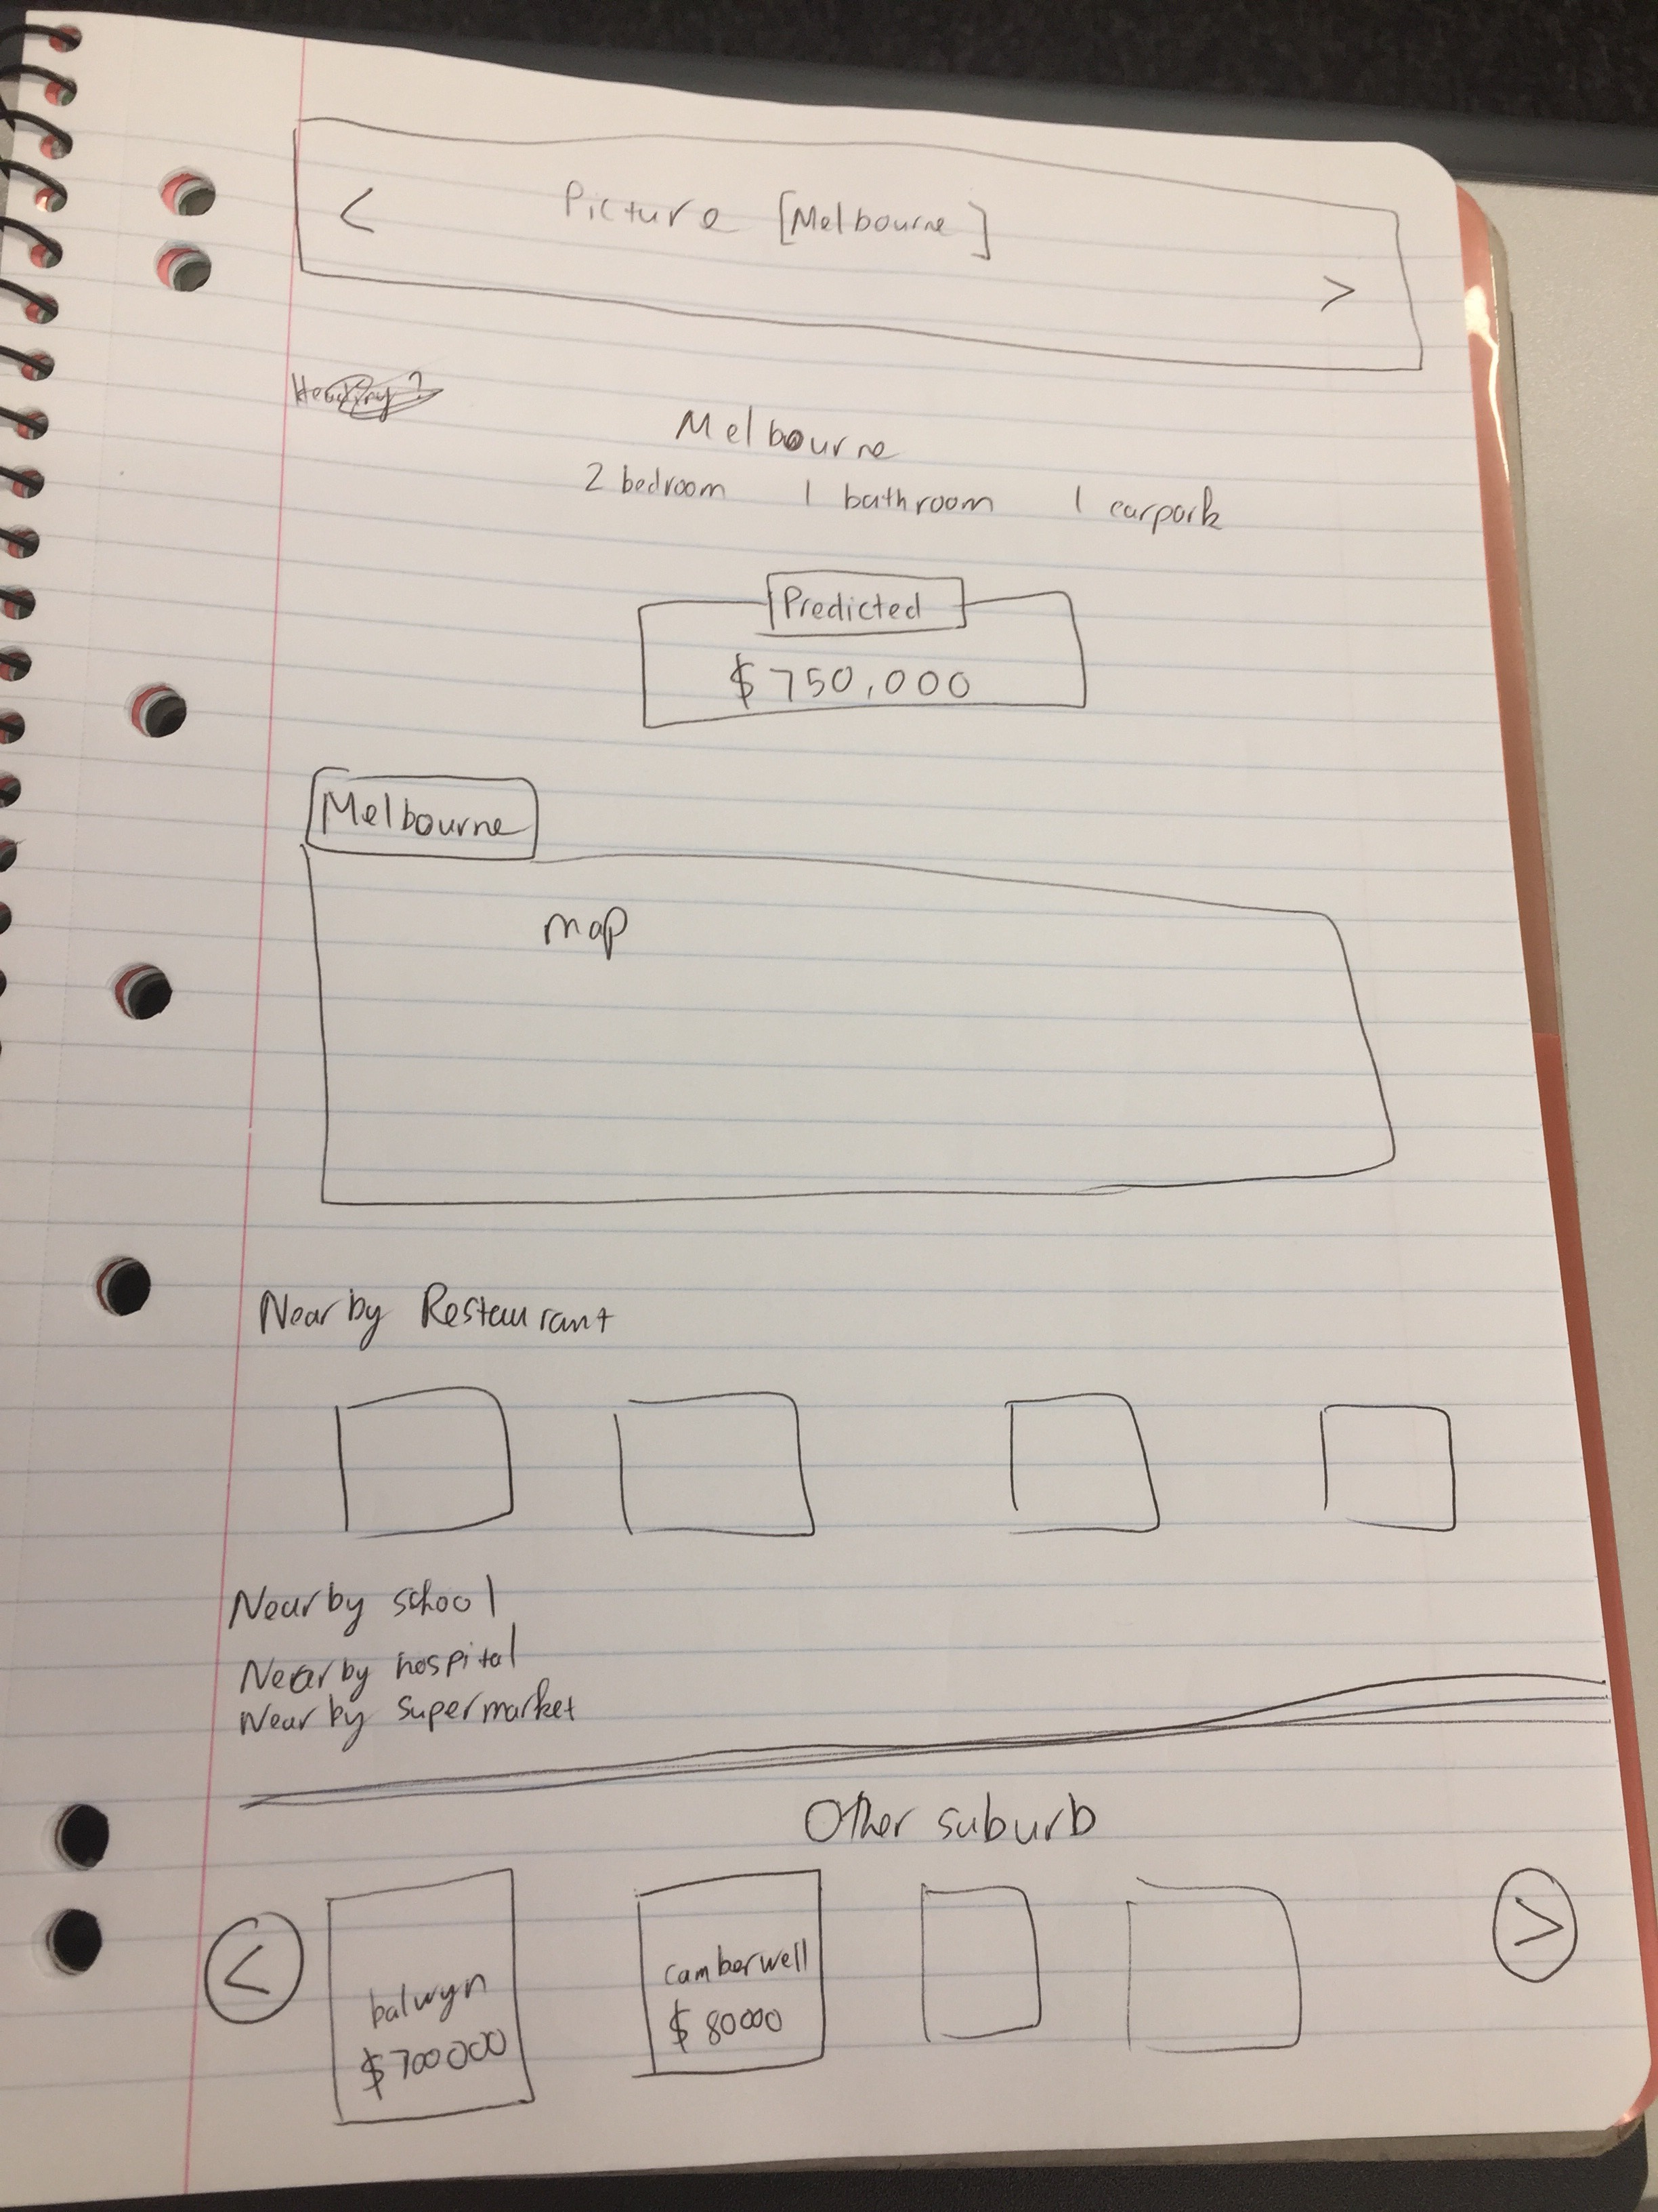

• Restaurant (4 items):

* Remove “$$$”
* Display rating stars in the middle, below address

• School (4 items):

* Same as restaurant

• Supermarket (4items):

* Same as restaurant

• Hospitals (4items):

* Same as restaurant (without star rating)