In the original article, the paired change in ranking analysis (the final paragraph of the Results section, corresponding to Figure 3) contained a statistical error. In this measure, there was a crossover interaction with no main effect: i.e., for non-students, female authors’ change in ranking was more positive than male authors’, whereas for students it was male authors who had a more positive change in ranking than female authors. However, in the original article, a main effect was erroneously reported. This occurred because the data were analyzed using regression with dummy-coding; the coefficient for “Gender” was misinterpreted as representing a main effect of gender, but in dummy-coded regression this coefficient actually only represents the simple effect of gender at the baseline level of student status (i.e., non-students).

The data was re-analysed, at which point three data points with incorrectly assigned genders were also updated (each correction made the patterns more extreme). Re-analyzing the data using deviation-coded regression, in which the coefficients correspond to main effects, reveals that there is neither a main effect of gender (p = 0.80) nor of student status (p = 0.73). Only the interaction between gender and student status is significant (p = 0.03).

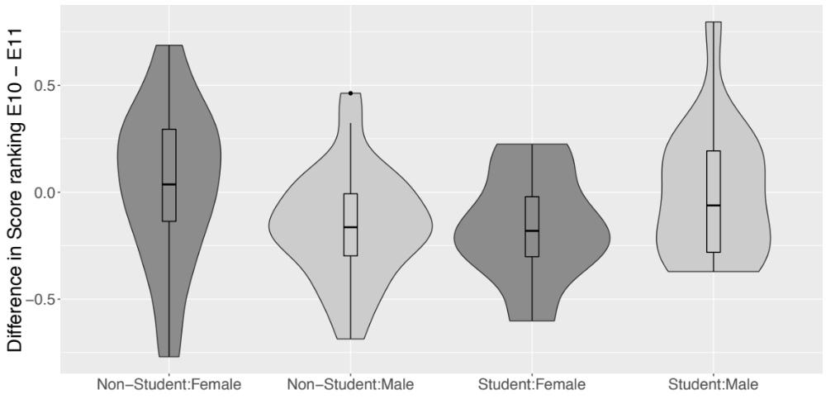

Because the distributions are skewed, we also performed a permutation test. We found that, for non-students, female authored papers improved in their ranking compared to male authored papers (z = 1.952 , p = 0.03). But there was no significant effect for student authors (z = -1.024 , p = 0.84).

The interaction is still puzzling to us. We were hoping to show that the main result of the paper (female authored papers are ranked better under double-blind review) was not driven by imbalances in the number of submissions or author identities. That’s true for non-students: individual female authors were likely to see their rank improve between the two conferences. But it’s not clear why there would be a difference for students. The R code for this new analysis is available on GitHub.

