Should Travellers Avoid Flying Airlines That Have Had Crashes in the Past?
DS406 Topics in Data Analytics - Group 1
Raphael Brena · Cillian Hegarty · Grace Loughrey · Seán O’Leary

1. Introduction
High-profile aviation disasters often trigger swift public responses: passengers avoid the airlines involved, treating past incidents as a signal of future risk. In his 2014 article “Should Travelers Avoid Flying Airlines That Have Had Crashes in the Past?”, Nate Silver assessed whether an airline’s historical safety record reliably predicts its future safety performance. This project conducts an independent, data-driven reanalysis of that question using the same publicly available dataset.
Three research questions structure the analysis. First, is an airline’s past incident rate a statistically significant predictor of its future incident rate? Second, is Silver’s composite safety score a defensible and reproducible statistical construction? Third, does a country’s GDP per capita explain airline safety better than the airline’s own historical record? Together, these questions allow us both to replicate and to critically interrogate Silver’s central claims.

2. Methods

2.1 Data
The primary dataset (AirlineSafety.csv, sourced from the Aviation Safety Network via FiveThirtyEight) contains safety metrics for 56 major commercial airlines across two 15-year periods: 1985–1999 and 2000–2014. Key variables are available seat kilometres per week (ASK, a measure of airline size), and counts of incidents, fatal accidents, and fatalities in each period. For the GDP analysis, country-level GDP per capita data were obtained from the World Bank and merged with the airline dataset via a manually constructed country lookup table, yielding 55 matched observations after Taiwan was dropped due to absence from the World Bank dataset.

2.2 Research Question 1 - Past vs. Future Incident Rate
Incident counts were normalised by ASK to produce comparable rates across airlines of differing sizes. A Pearson correlation and OLS regression of future rate on past rate provided a baseline. Because incident counts are non-negative integers, a Poisson GLM with log(ASK) as an offset was then fitted as the principled count-data model, with past incident count as predictor and future incident count as outcome. Overdispersion was assessed via the residual deviance-to-df ratio and a formal dispersion test (AER package). Given significant overdispersion (ratio ≈ 3.03, p = 0.025), a negative binomial GLM was fitted as the preferred model. Robustness to influential observations was evaluated by refitting OLS after removing the three highest-leverage airlines (Aeroflot, Pakistan International, Ethiopian Airlines).

2.3 Research Question 2 - Validity of the Composite Safety Score
Silver’s composite score was reconstructed over the full 30-year period (1985–2014): total incident, fatal accident, and fatality counts were divided by ASK; each rate was subtracted from the fleet-wide mean, multiplied by √ASK, standardised to a Z-score, and the three Z-scores averaged. The defensibility of aggregating these components was assessed via their pairwise correlation matrix and a principal component analysis (PCA) on the standardised components.

2.4 Research Question 3 - GDP per Capita vs. Historical Record
The composite safety score was regressed on the natural logarithm of 1999 GDP per capita (log transformation applied to address right skew). Explanatory power was compared directly against the past incident rate model using R².

3. Results

3.1 Defensibility of the Composite Safety Score
The pairwise correlation matrix of the three standardised safety components shows uniformly positive relationships: incidents and fatal accidents are strongly correlated (r = 0.876), fatal accidents and fatalities moderately so (r = 0.667), and incidents and fatalities less strongly (r = 0.470). All three metrics move together, indicating they reflect a common underlying dimension of safety. PCA confirms this: PC1 accounts for 78.5% of total variance, with PC2 and PC3 contributing 18.5% and 3.0% respectively. A single latent safety factor dominates the data, providing strong statistical justification for Silver’s composite construction. The top and bottom 10 airlines by composite score are shown in Figure 1.

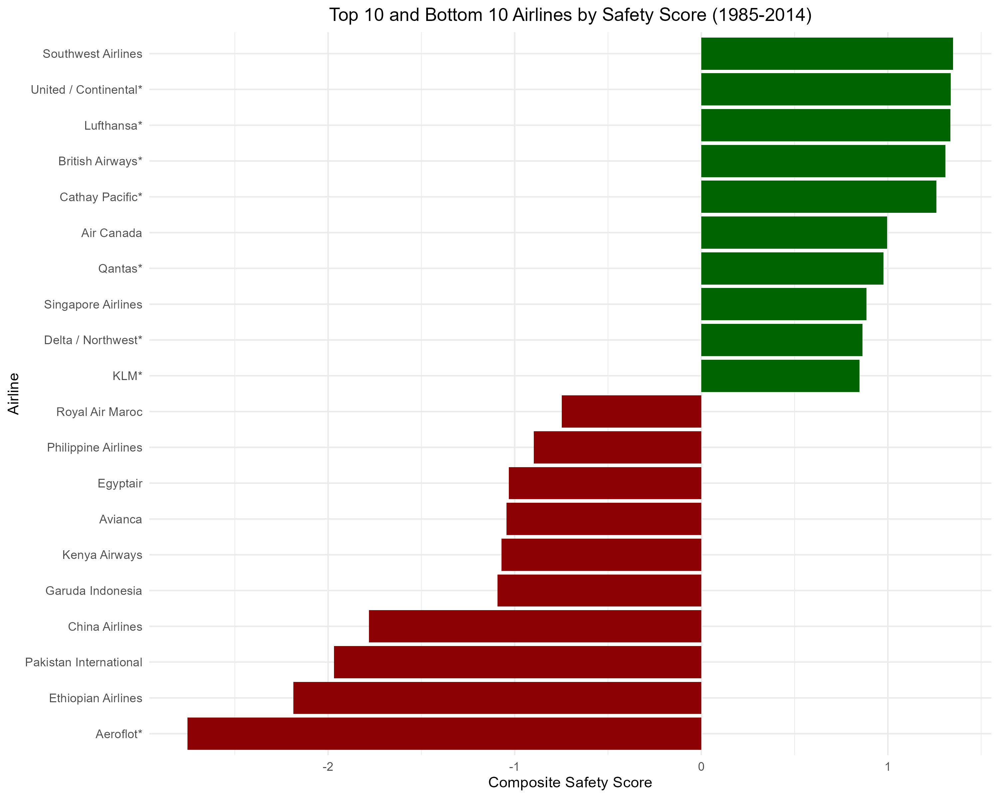
Figure 1. Top 10 and bottom 10 airlines by composite safety score (1985–2014). Green bars indicate above-average safety; red bars below-average. Score is the average of three ASK-weighted, standardised Z-scores (incidents, fatal accidents, fatalities).

3.2 Past vs. Future Incident Rates
The OLS regression of future incident rate on past incident rate yields r = 0.369 (95% CI: 0.118–0.576), R² = 0.136, β = 0.155 (p = 0.005; Figure 2). The relationship is statistically significant but weak: past rates explain only 13.6% of variation in future rates. This finding is robust to outliers: removing Aeroflot, Pakistan International, and Ethiopian Airlines reduces the correlation only marginally, from r = 0.369 to r = 0.353, with both remaining significant.
The Poisson GLM with log(ASK) offset yields β = 0.010 (p = 0.033), appearing to confirm significance. However, the residual deviance-to-df ratio of 3.03 (formal dispersion test: p = 0.025) establishes that the Poisson equidispersion assumption is violated. Refitting with a negative binomial GLM (θ = 1.714) corrects for this: the coefficient for past incidents becomes β = 0.011 (p = 0.303), which is not statistically significant. Under the appropriate count-data model, past incident history carries no significant predictive signal for future incident counts. Figure 3 illustrates the difference in fitted values between the two count models.
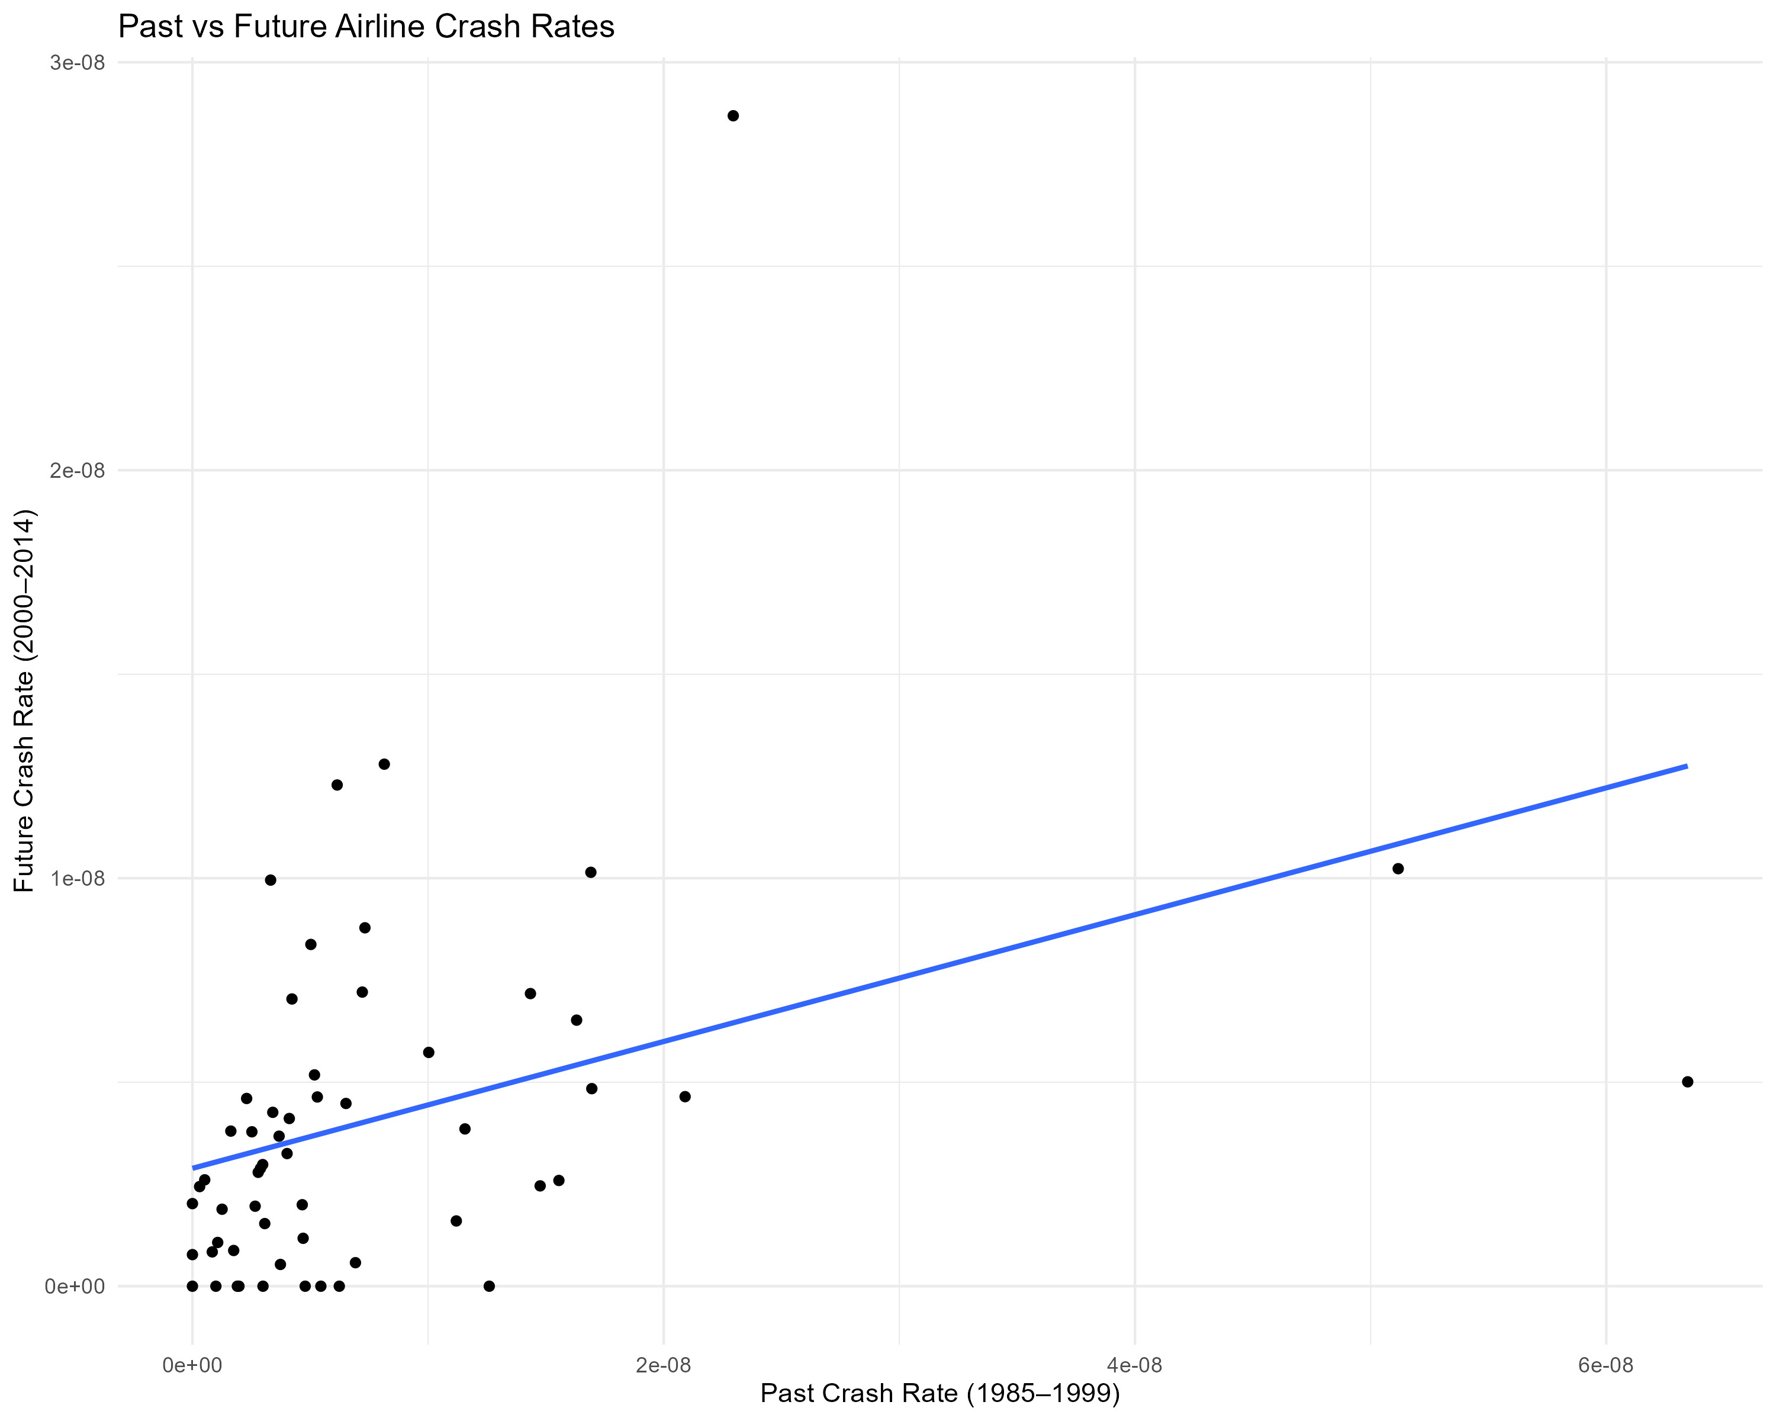
Figure 2. Past (1985–1999) vs. future (2000–2014) airline incident rates per ASK with OLS regression line (r = 0.369, p = 0.005, R² = 0.136).

3.3 GDP per Capita as a Predictor of Safety
Regressing the composite safety score on log(GDP per capita) produces r = 0.690, R² = 0.477, β = 0.570 (p = 5.5 × 10⁻⁹; Figure 4). GDP per capita explains approximately 47.7% of the variance in safety outcomes - more than three times the explanatory power of the past incident rate model (R² = 0.136). This result closely reproduces Silver’s reported correlation of approximately 0.70. Table 1 summarises all key model results.
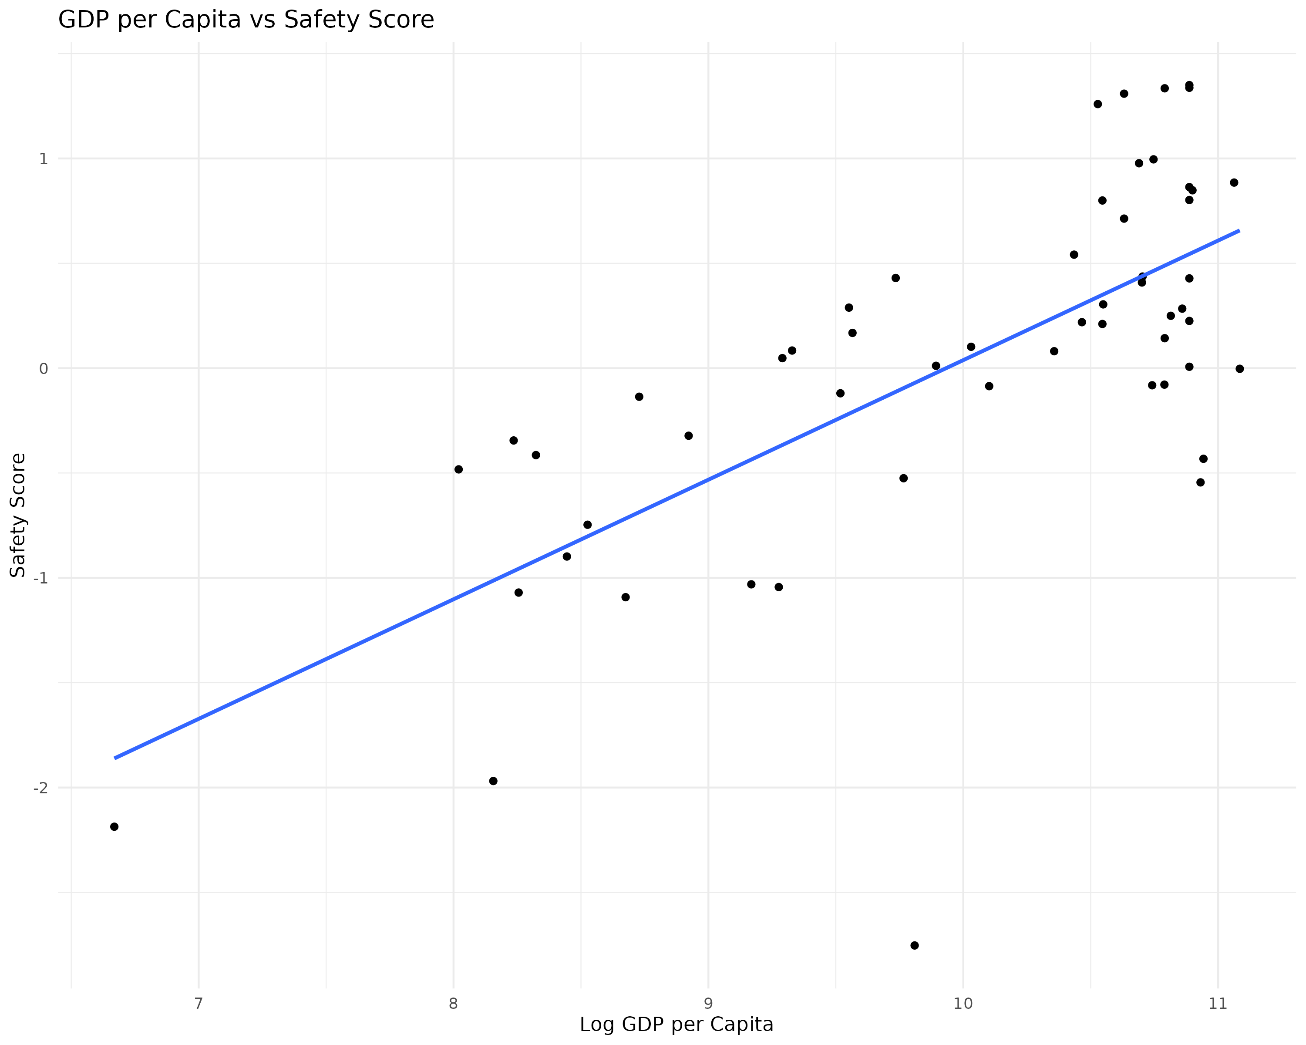

Figure 4. Log GDP per capita (1999) vs. composite safety score (n = 55, r = 0.690, R² = 0.477, p = 5.5×10⁻⁹).

Model | Predictor | Outcome | r | R² / p-value
OLS (rates) | Past rate | Future rate | 0.369 | R²=0.136; p=0.005
Poisson GLM | Past counts | Future counts | - | p=0.033*
Neg. Binomial | Past counts | Future counts | - | p=0.303
OLS (GDP) | log(GDP p.c.) | Safety score | 0.690 | R²=0.477; p=5.5×10⁻⁹
Table 1. Summary of regression models fitted for Q1 and Q3. *Poisson p-value is unreliable due to significant overdispersion (ratio ≈ 3.03, p = 0.025); the negative binomial is the preferred model.

4. Discussion
The central question - whether travellers should avoid airlines with past crashes - receives a nuanced answer. Under OLS on normalised rates, there is a statistically significant but weak positive association between past and future incident rates (r = 0.369, p = 0.005), replicating Silver’s direction of effect. However, the more principled count-data analysis tells a different story: once overdispersion is properly accounted for via a negative binomial GLM, past incident counts are no longer a significant predictor of future counts (p = 0.303). The OLS result overstates the predictive signal by treating count data as continuous and ignoring the variance structure of the outcome. The finding is robust: removing the three most influential airlines barely changes the OLS correlation (r drops from 0.369 to 0.353), confirming the weak association is not an artefact of a small number of high-incident carriers.
The composite safety score analysis validates Silver’s methodological choice. The PCA result - PC1 capturing 78.5% of variance - demonstrates that a single latent safety factor underlies all three metrics. The score is both statistically justified and reproducible from the published methodology.
The GDP analysis is the most practically significant finding. A country’s wealth explains nearly half the variance in airline safety (R² = 0.477), compared to just 13.6% for past incident rates. Wealthier nations are better positioned to fund aviation authorities, enforce compliance, and retire ageing aircraft - structural advantages that persist across time periods and are largely invisible in an individual airline’s incident history.
Two limitations warrant acknowledgement. First, 1999 GDP values are used as a static proxy, time-averaged or period-matched GDP might better capture the economic context across both safety periods. Second, the GDP safety relationship is correlational, unmeasured confounders such as regulatory regime, fleet composition, and geography could account for part of the association. Despite these caveats, the convergence of our result with Silver’s (r = 0.69 vs. 0.70) strengthens confidence in the finding.
In summary, the data do not support using an airline’s past crash record as a meaningful guide for travel decisions. Structural economic factors are substantially better predictors of safety outcomes, and the apparent predictive value of past incidents diminishes under rigorous count-data modelling.

5. References
1.) Silver, N. (2014). Should travelers avoid flying airlines that have had crashes in the past? FiveThirtyEight.
2.) Aviation Safety Network / FiveThirtyEight. (2014). 1AirlineSafety.csv [Dataset]. https://github.com/fivethirtyeight/data/tree/master/airline-safety
3.) World Bank. (2023). GDP per capita (current US$) [Dataset]. Via Our World in Data. https://ourworldindata.org/grapher/gdp-per-capita-worldbank

Additional plots/tables.

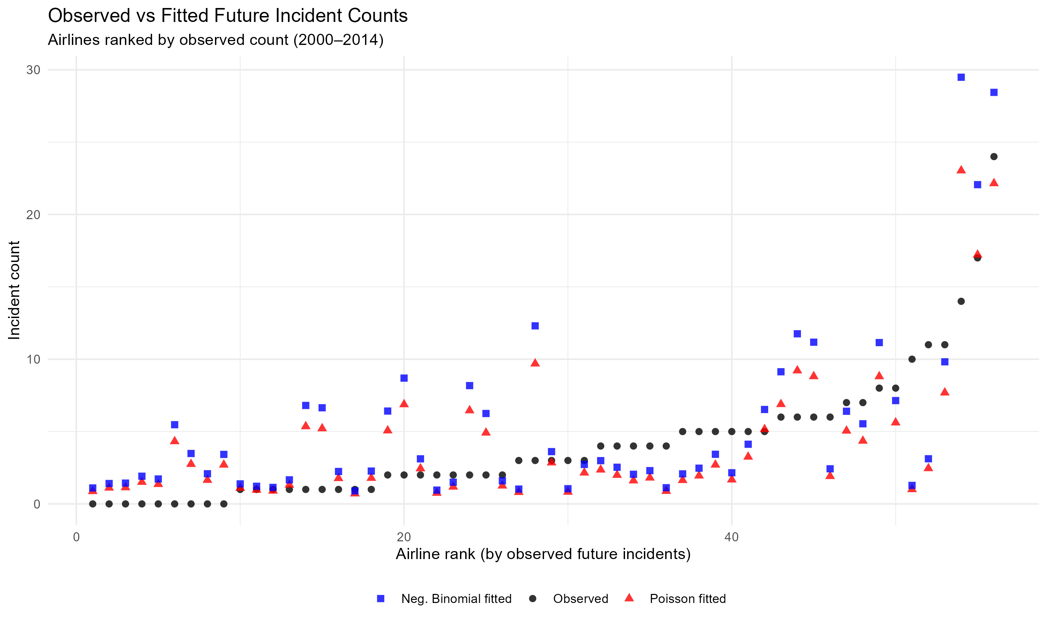

Figure 3. Observed vs. fitted future incident counts under Poisson and negative binomial GLMs. The NB model (blue squares) produces systematically higher fitted values than Poisson (red triangles), absorbing the excess variance that inflated significance under the Poisson assumption.

