1. Clone repo
2. Make sure you have git, node, yarn, ts-node installed
3. In config.json file, make sure to replace “solTreasuryAccount” with your wallet’s public key
4. In config.json file, make sure to change “storage” from arweave to arweave-sol (since our image is >10mb)
5. If you wish to add more sample assets in examples-assets file, make sure to follow the format when typing the metadata, and save image as .png file. Also, update “number” in config.json file to match the number of sample assets in examples-assets file.
6. Then go to your phantom wallet, switch to Devnet, copy your wallet’s public key, go to <https://solfaucet.com>, and send 1sol to your wallet (for gas fee, creating candy machine, uploading to arweave, and opening token accounts)
7. Then follow these steps:

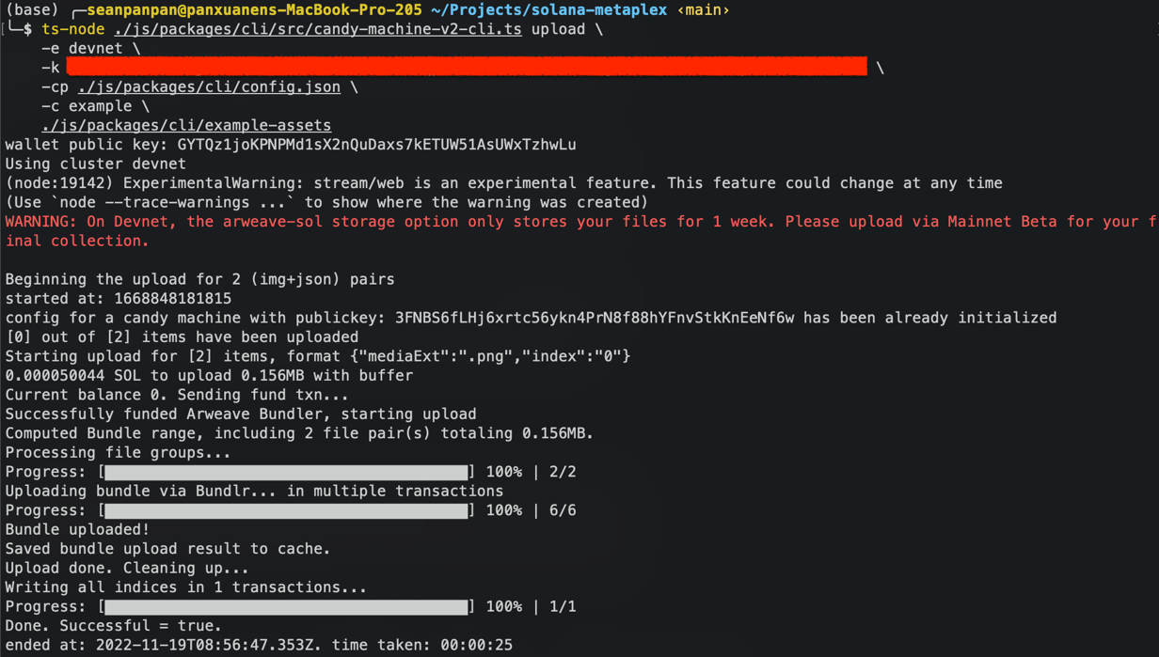

Note: use my commands instead of the ones in metaplex documentation, I have modified the path so the v2 candy machine, cuz v2 is supposedly deprecated according to the official documentation. And double check all paths are correct. For the part that I censored, you may use the keypair generation command to get the private key, store it in a json file, then access it by putting the path in. Or simply go to your phantom wallet’s settings/security & privacy/export private key, enter your password then copy and paste it in the command line.

1. After step 7a 7b, you should see a .cache folder created, in the devnet-example.json file, you get all the links to the metadata and image that is uploaded to arweave. You will also be able to see the “smart contract” of the created candy machine. You can go to the link and double check that everything is correct. The json file that is stored on arweave should look like the screenshot below.

Note: I believe arweave storage on devnet only lasts for one week

1. After 7c, you may check your wallet to see if the transaction went through and whether the nft has been minted.

