# **Appendix**

**A. Code Repository** :All code is available in the attached Jupyter notebook - [AAI_521FinalProject.ipynb](https://github.com/seanpaz478/USDAAI521Team1FinalProject/blob/main/AAI_521FinalProject.ipynb)

**B. Loss and Accuracy Plots for Training vs. Validation**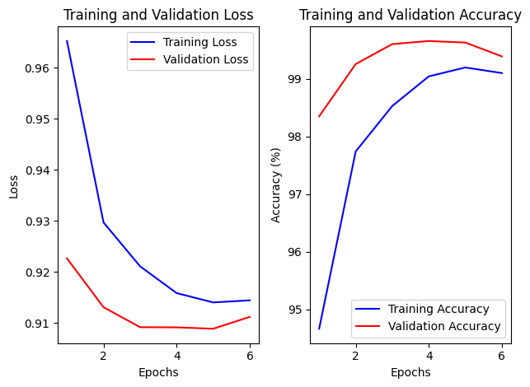

**C. Visualizing the samples with Grad-CAM**

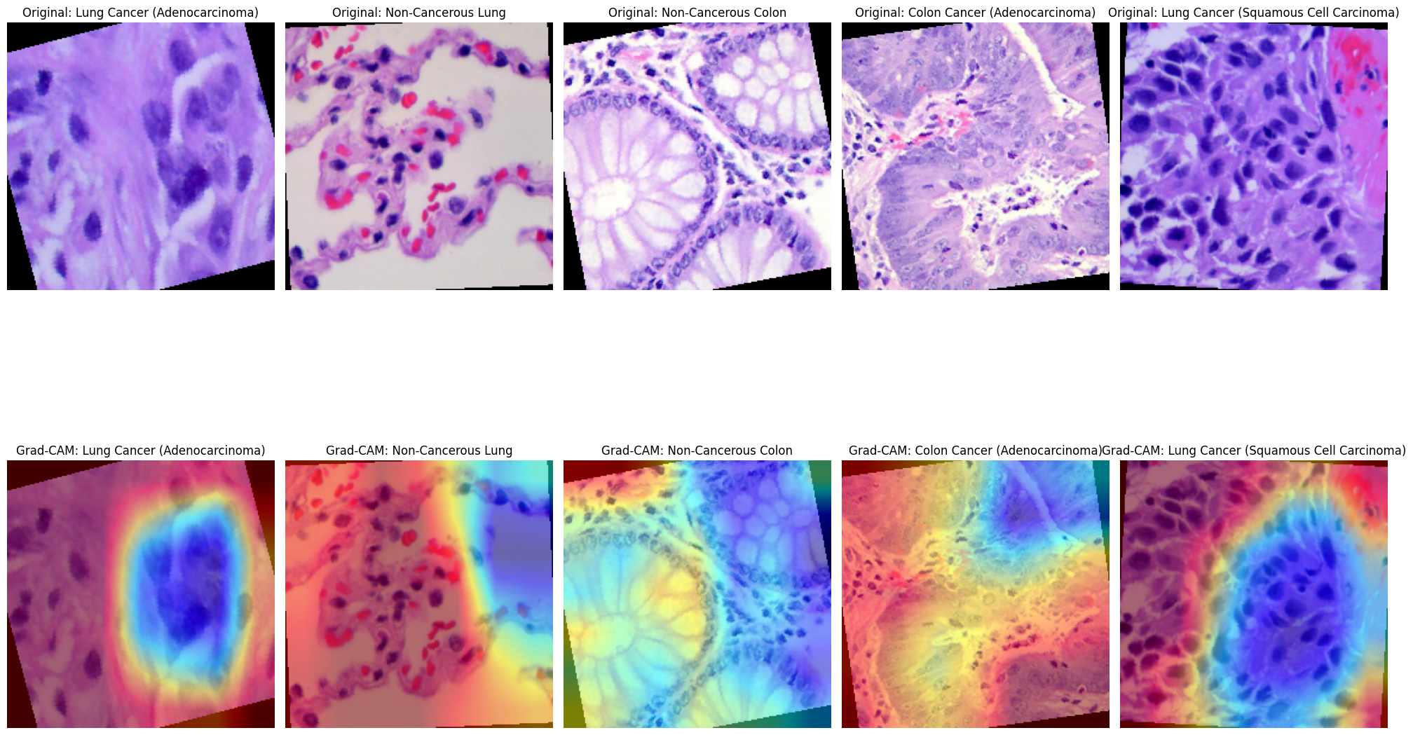

**D. Dataset Information:** <https://www.kaggle.com/datasets/andrewmvd/lung-and-colon-cancer-histopathological-images/data>