Apple iOS battery documentation

This document goes over general documentation of my experience with battery performance and activity while using various versions of Apple iOS (version 4 to version 6) across several iPod Touch devices (4th and 5th generation) (from 2009 <month><day> to 2015 Unknown date) Data is not able to be backed up yet, as can no longer retrieve new data, as I have not had a functional Apple device since 2015.

- iOS had an OK battery life when using it
- iOS puts out a low battery warning at 20% battery, and an extremely low battery warning at either 10 or 5% (I can’t remember which)
- The battery on all Apple devices cannot be easily replaced, and can not be swapped out easily like early Android devices
- Like Android, you have to manually enable showing the battery percentage of the device in the settings
- Early versions of IOS made a battery sound, and had really cool graphics when charging the device (it looked like this when plugged in):
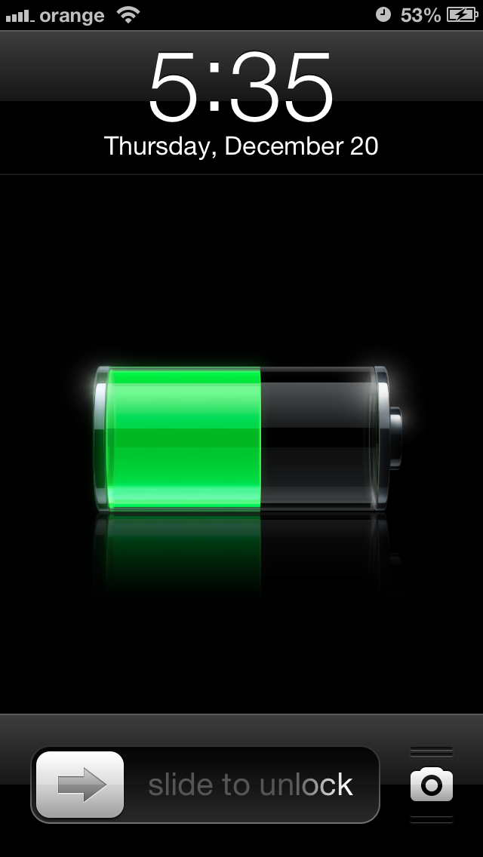
And it looked like this when shut down:
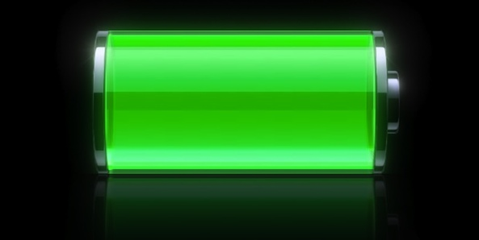
- The above graphics never had a red variant for low battery
- Later versions of iOS also have a yellow battery icon for when your device is between 21% and (I think) 65%
- iPhoneOS 1, 2, & 3 had the same graphics as iOS 4, 5, and 6 (I am not entirely sure on this)
- No other documentation available

Other important battery advice

For Lithium Ion batteries
- Lithium batteries degrade over time. Do not buy a replacement battery while your current battery is in perfect health, as the backup battery will degrade/rot in storage, then by the time you need to use it, it will not work very well/at all.
- Based on general advice, it is recommended to not let your battery drop below 20% and not charge above 80% this is best for the batteries health. If you can’t follow the step of stopping every charge at 80%, you can at least plug your device in when it gets low (for example: lately, always plug mine in at 23-29% battery)
- MacOS 11.0 (Big Sur) and subsequent versions (MacOS 12.0 Monterey) have a built-in feature to limit battery discharge at 20% and battery charge at 80%. I don’t know of any other operating system that forces this rule (Ubuntu says it does, but it actually doesn’t, as I have used my device with less than 11% battery before)

General battery advice
DO NOT use your phone while it is plugged into a cable charger. Take it from me. I have destroyed the charging port on 6 different devices by using it while plugged in in less than 6 months per device. Also, be careful using a cable charger as well. I prefer wireless charging when available, and nowadays, it is mandatory for my cellular devices, as my Samsung Galaxy S20 FE 5G got a destroyed charging port in less than 4 months.
DO NOT hard power cycle your device UNLESS completely necessary (completely unresponsive, softlocked) (hard power cycle means holding the power button down for 10 seconds, or removing the battery while the device is running) as this damages the software running and can cause corruption.
No other info available at the moment
This document was last updated on 2021 Sunday, December 12th at 3:41 pm

File info
File type: OpenDocument Format (*.odt)
File version: 1 (2021, Sunday, December 11th at 3:41 pm)
Page count: 4 (according to LibreOffice Writer, it may differ depending on what program you are using to read this document.)
Article language: English (US) with basic Rich Text Formatting, a numbered list, and 2 image files
Word count: 0,624
Character count: 3,469

