Windows 10 laptop battery documentation

This document goes over general documentation of my experience with battery performance and activity while using Windows 10 across 2+ different laptops (from 2016 <month><day> to 2020 July 8th) excluding 2 defective laptops. This data is not able to be backed up yet, and I can no longer retrieve new data, as I have not used Windows 10 since 2020 July 9th (when I switched to Ubuntu 20.04)

- The battery saver can be enabled at 100% battery, and can last all the way down to the beginning with little tweaking (typically, you can only start it at 95% or lower automatically, but manually, you can start it at any time)
- The battery can act sporadic and give ridiculous estimates, like this:

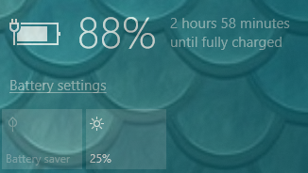

or this:
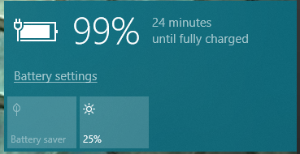

Both images came from an unstable day in 2018.
3) I can’t remember how long it took for Windows 10 to go from 99% to 100% battery right now
4) Windows 10 becomes extremely unstable once it reaches 25% battery, and starts dropping sporadically. It can go from 24% battery to 5% battery in just a matter of minutes
5) Battery saver cannot be enabled when the device is plugged in
6) Depending on the outlet power source, it is normal for the battery to suddenly rise from 95% to 100% instantly, and immediately drop to 95% battery upon unplugging
7) No other notes

Other important battery advice

For Lithium Ion batteries
- Lithium batteries degrade over time. Do not buy a replacement battery while your current battery is in perfect health, as the backup battery will degrade/rot in storage, then by the time you need to use it, it will not work very well/at all.
- Based on general advice, it is recommended to not let your battery drop below 20% and not charge above 80% this is best for the batteries health. If you can’t follow the step of stopping every charge at 80%, you can at least plug your device in when it gets low (for example: lately, always plug mine in at 23-29% battery)
- MacOS 11.0 (Big Sur) and subsequent versions (MacOS 12.0 Monterey) have a built-in feature to limit battery discharge at 20% and battery charge at 80%. I don’t know of any other operating system that forces this rule (Ubuntu says it does, but it actually doesn’t, as I have used my device with less than 11% battery before)
This document was last updated on 2021 Saturday, December 11th at 9:54 pm

File info
File type: OpenDocument Format (*.odt)
File version: 1 (2021, Saturday, December 11th at 9:54 pm)
Page count: 2 (according to LibreOffice Writer, it may differ depending on what program you are using to read this document.)
Article language: English (US) with basic Rich Text Formatting, a numbered list, and 2 image files
Word count: 479
Character count: 2,680

