Mila Myrick (July 16th 2007 2007-September 18th 2020)

Index
0. Title
1. Index
2. General info
3. Previous life
4. Good life
5. Death
6. Memories and farewell
7. Preservation of memory
8. Conclusion

General info
Mila was born on July 16th 2007 in California. She was a black mini chihuahua mix (her paperwork identified her as a terrier/mix, this was off) At the time we adopted her from the Blue Mountain Humane society, she was 8 years, 0 months, and 20 days old. She was a very small dog, but she always thought she was much bigger than she actually was. When we got her, she only weighed 6.5 pounds, as her previous owners were very neglectful of her. We gave her a good life for the 5+ years we had her.
Other info from her adoption:
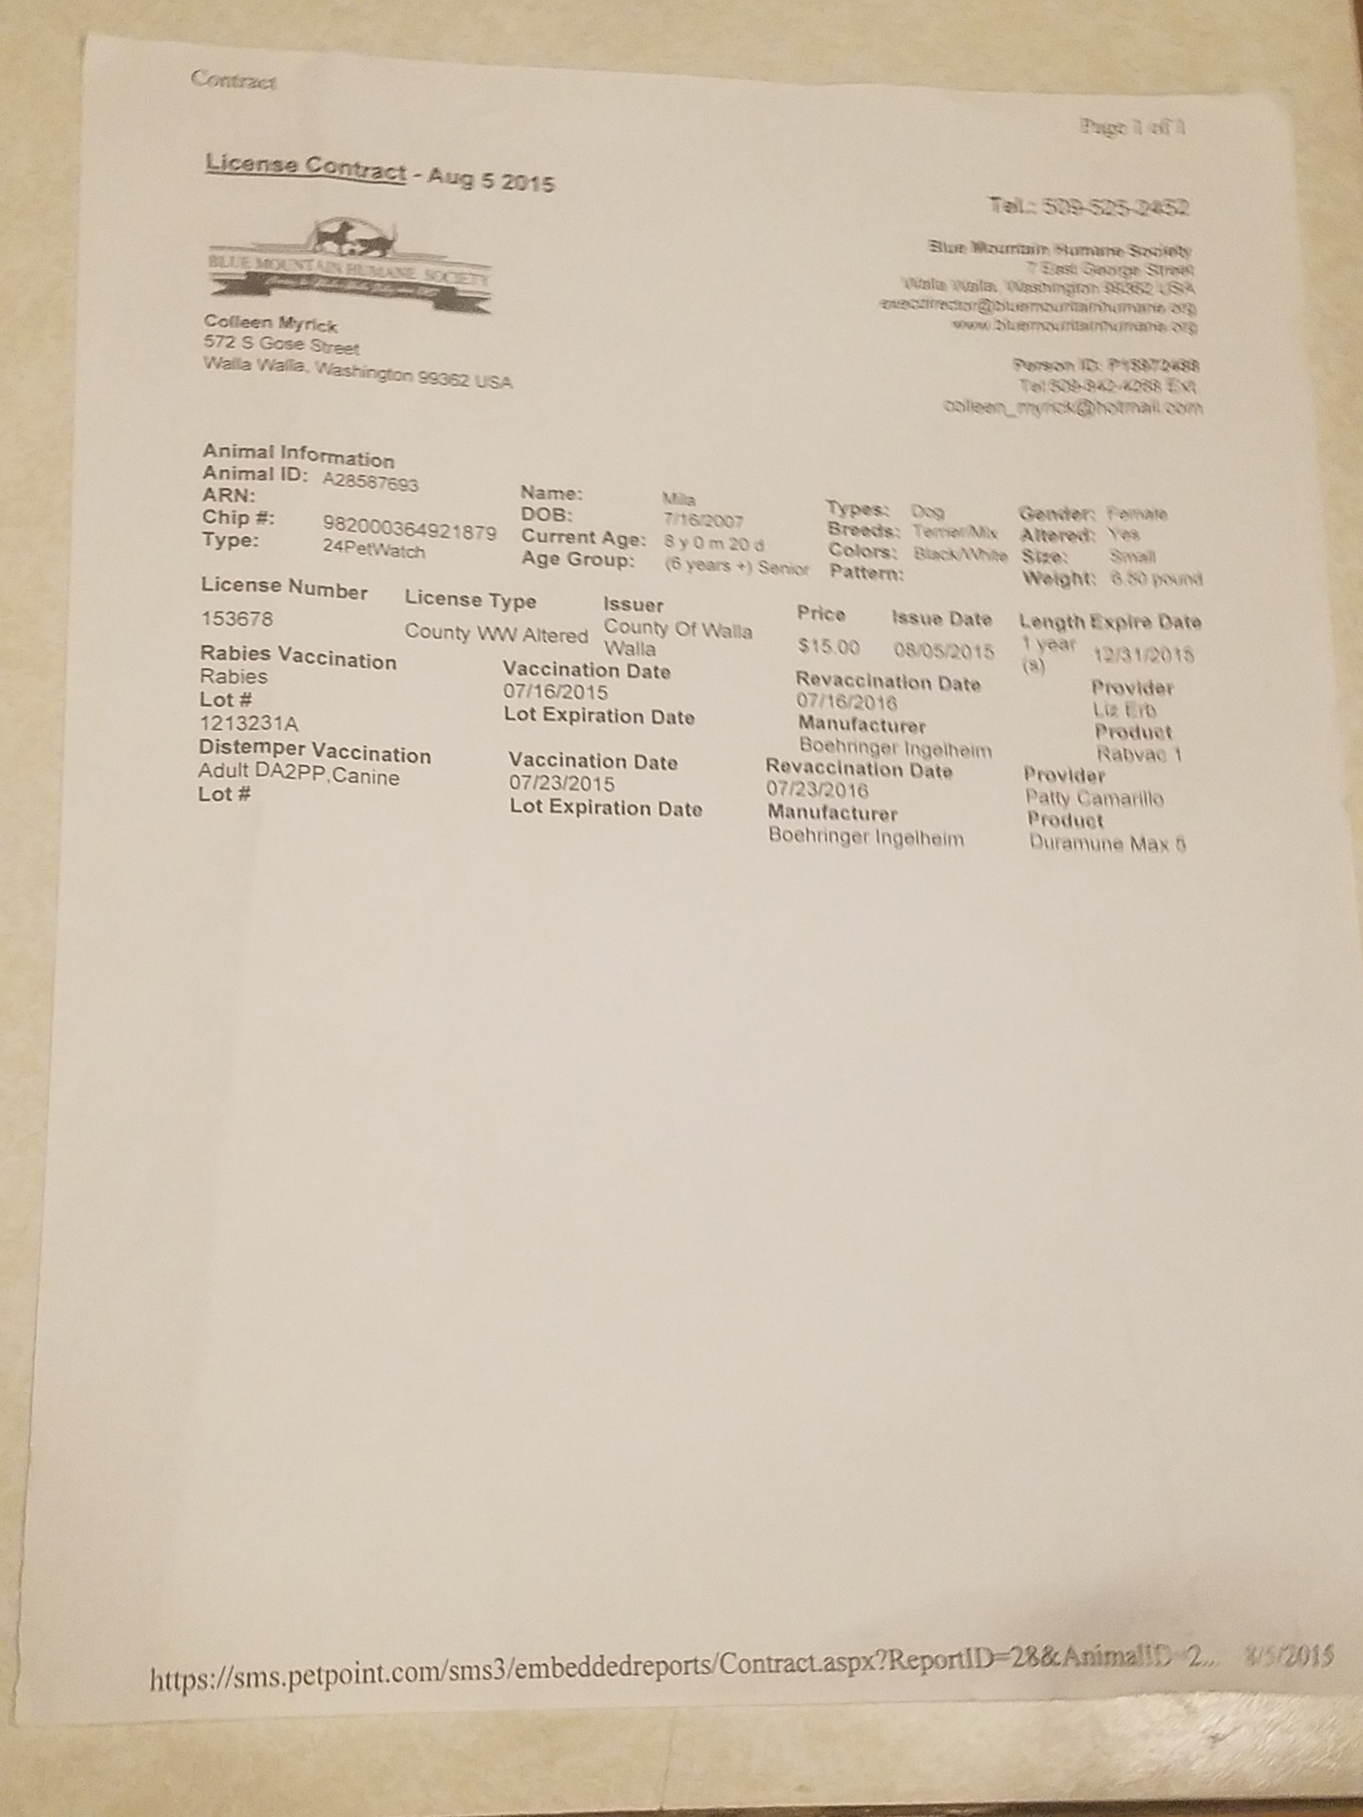

Previous life
Mila had a series of abusive and neglectful owners before we got her from the humane society. One aspect that helped us pick her out was that she was jumping up and making a praying motion at the gates, telling us that she didn’t want to be at the humane society anymore. So we took her home, as a test trial. Sean became attached with her very quickly, and we ended up keeping her.

Good life
We gave Mila a good ending to her life, and made a good chunk of her life better. She was a very energetic dog at the time, but she was still traumatized.
Over the years, Mila developed dementia. She constantly started barking at everything. She even bit Milly on the ears and got her ears infected. She constantly got into fights, and over time, became blind as well. She would later get sprayed by a spray bottle in her final months when she started barking. She would always go outside with the rest of the family, but then either go to the front door or the garage door barking to get back in immediately. When she started going blind, she was tripping over everything, barking at the wall to get in (instead of the door) and she became very aggressive. She did not go with us on our 2020 Cannon Beach vacation due to this and other problems. Meme expected Mila to die by the time we got back. When we got back, she was still doing fine, but later did worse.

Death
On September 16th 2020, Mila was refusing to eat or drink. She has been deteriorating for a long time. She developed Dementia in the last 2 years of her life, and on September 16th 2020, she did not do well. Sean was not fully aware of this at the time. She slept in my area, something she never did before.
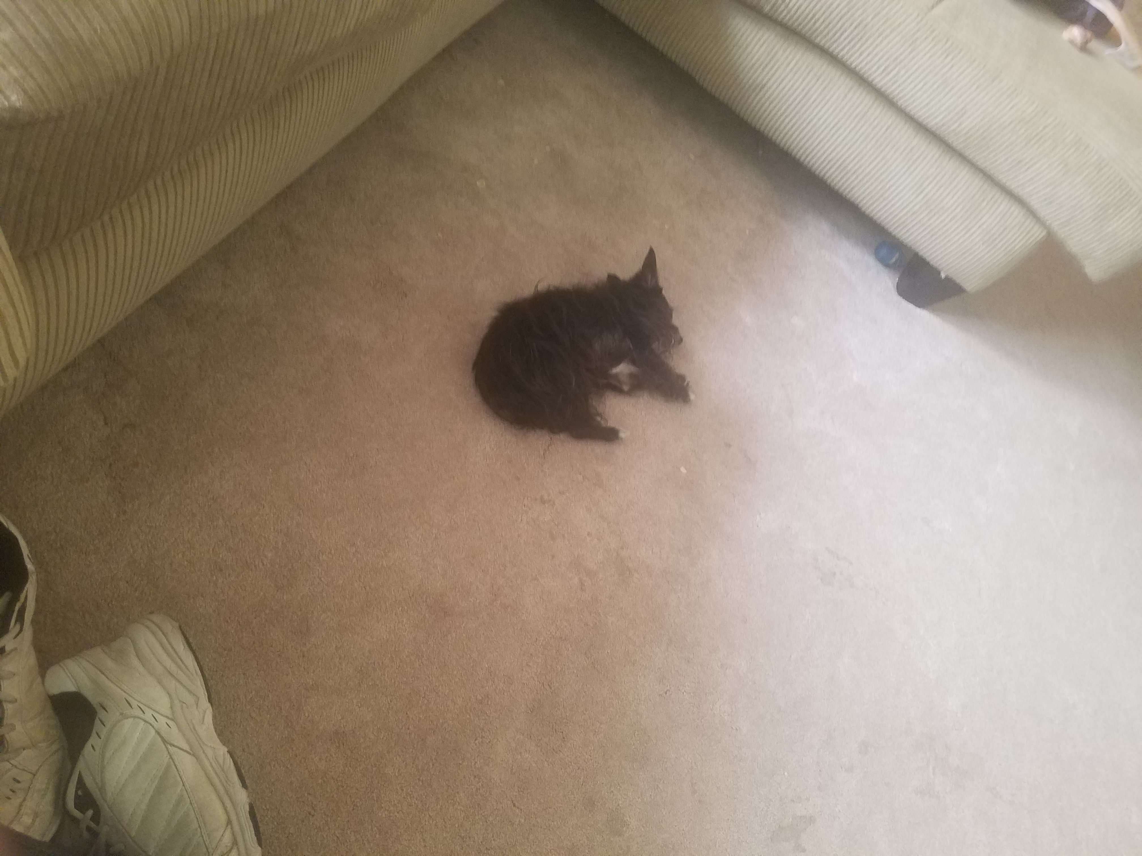
Angle 2:
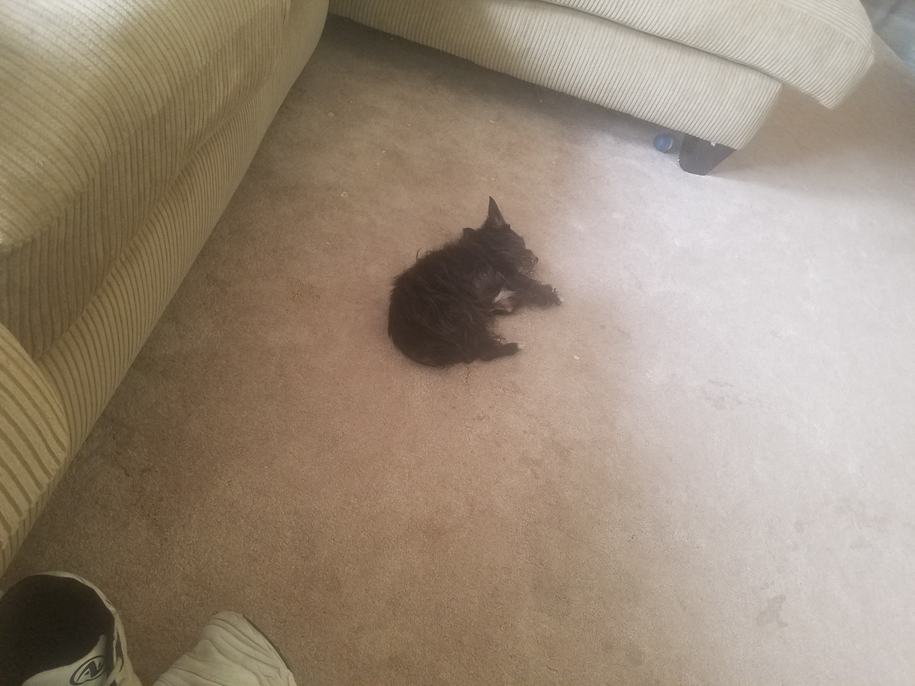
On September 17th 2020, Mila started to get worse. She wandered around a bit outside with meme, she was almost completely blind, and was lost.
Video here (unfortunately, no office editor supports video at the moment)
She was taken in the house. She laid down, and Sean began to grieve her. She was not going to make it much longer. I tried to make an impression on her, so that she would remember me when she died. I left her alone after a while, as that is what she wanted. She was in a familiar area in her bed.
Later that night, as I was finishing up my work, at 10:40 pm, I began to hear a screaming sound. I grabbed my phone and went and used the flashlight. It was Mila, she was yelping in pain. I went and got meme, and we pet her a bit. She got better, but meme said that when she makes it through the night, she will have to be euthanized tomorrow. She was experiencing organ failure tonight. She has had problems with her heart for years, and had to take medication for it. None of us want to see her suffer, she doesn’t deserve to suffer. She was better through the night, and she continued to sleep.
On September 18th 2020, Mila was alive. She made it through the night, but she was suffering too much to be alive. We called the vet clinic to get her euthanized. The appointment was at 10:00 am. In the time leading up to this, she was mostly asleep, but at one point she began to have heart problems and she started yelping repeatedly. We pet her a bit, then let her relax in the quiet of her area, as that is what she wanted. We later took her out to the car in her bed. She was reeking due to going to the bathroom on herself. We took her to the vet clinic, and got 2 final pictures of her:
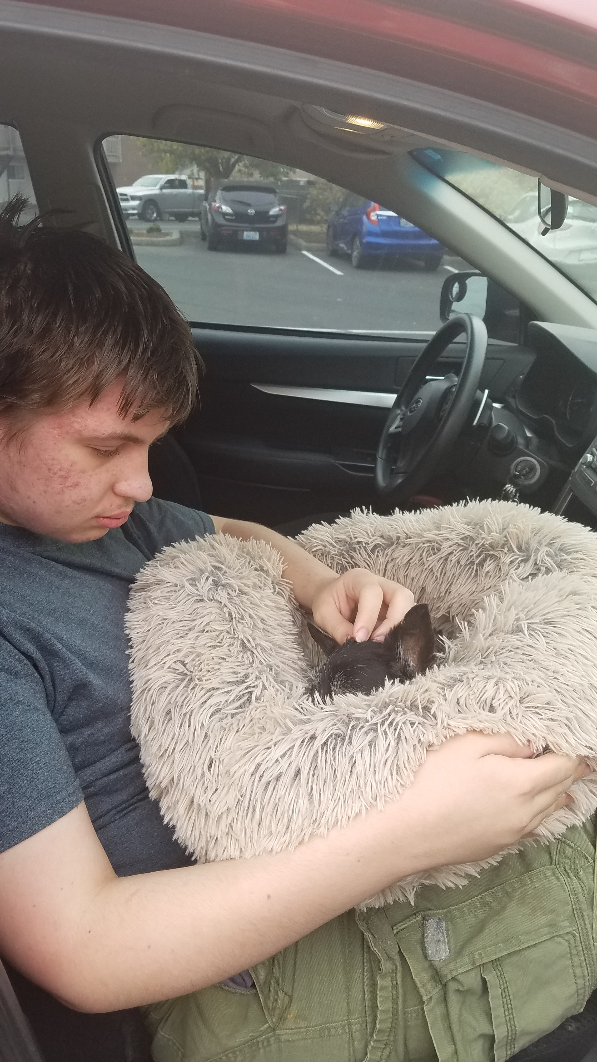
The last picture of Mila, ever:
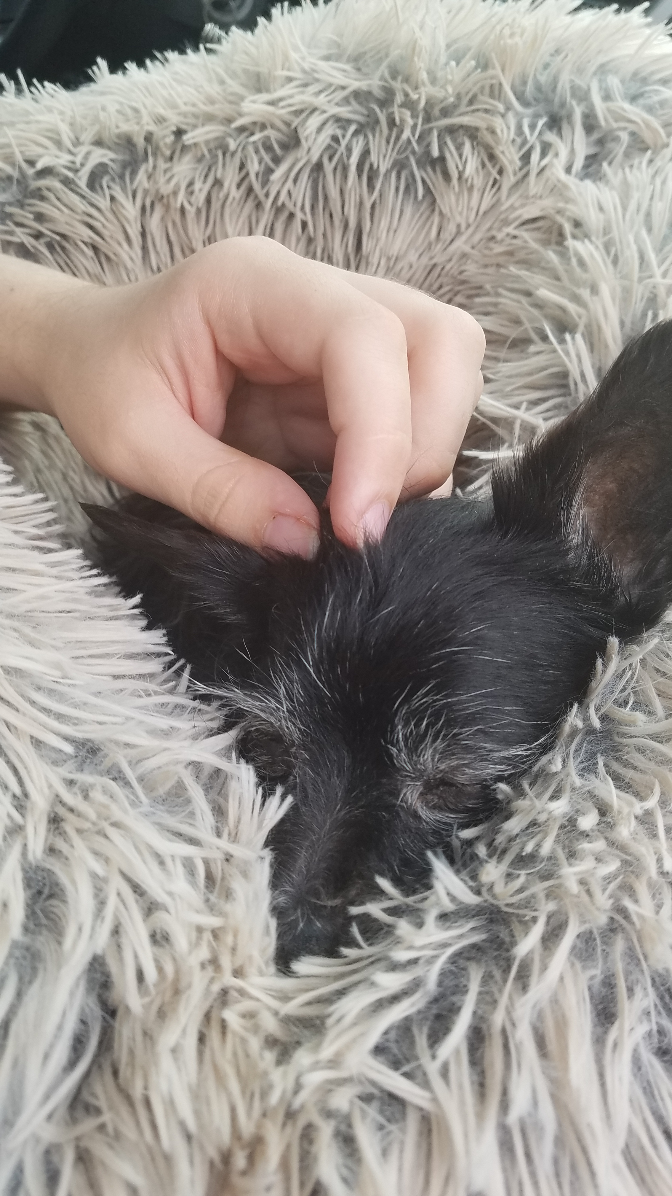
Mila began to get put down. She was already asleep. Meme kept whispering in her ear “good girl Mila” and then she received the final dose, and died quickly and painlessly. At 10:14 am, on Friday, September 18th 2020, Mila died. There was a lot of grievance for the rest of the day. We have lost a member of our family. The moments with Mila have ended. We will never be able to see her again.

Memories and farewell
“On the cold winter days and nights, I used to lay by Mila next to the Fireplace when it was on, she would lay right next to it, and I wouldn’t touch her, as she would get scared off. This was the only time where I could chill with her” - Chris M
“She was really a fighter. She would keep going and going, and she made it really far” – Chris M
“Thanks for letting us know Sean. So sad to hear the news about Mila. She was a cute little dog who had a lot of heart and was pretty fiesty for being so small.” - Lindsay M
“Today, I feel sad every time I go into the areas Mila used to go to. I began to go into tears when I noticed her bed wasn’t where it normally was (by the fireplace) and I knew she would never get to lie down in it again. I even miss the things like her barking, and coughing, and her little pray she does. This is an incredibly hard day for me. I wish I could have spent more time with her, but she didn’t deserve to live in pain, and we did the right thing.“ - SeanPM

Preservation and memory
In the final 4 months of Milas life, Sean was working on a project to preserve Milas caricature by making content of her on a green screen, so that she could be edited into future video. Sean planned to do this for the other dogs as well. Unfortunately, I never figured out how to do it properly, and it was too late by the time I was near ready.
Her memory will live on with me. We also have some video of her, and possibly an audio sample, so hopefully in the future, technology will be good enough to easily crop out everything but her without a green screen, and also rebuild her voice based off a vocal sample. This will never replace her, we will still miss her greatly

R.I.P

Mila Myrick

July 16th 2007-September 18th 2020

Document info
File type: OpenDocument (*.odt)
Page count: 13
Word count: 1,459
Character count: 7,632
Exported into: *.pdf *.epub *.rtf *.doc *.docx *.uot *.txt

Version history
Version 1 (Early afternoon, September 18th 2020)
Changes:
1. Started the document
2. Added the title
3. Added the index
4. Added the general info section chapter
5. Added the previous life section chapter
6. Added the good life section chapter
7. Added the death section chapter
8. Added the memories section chapter
9. Added the conclusion section
10. No other changes in version 1
Version 2 (Evening, September 18th 2020)
Changes:
1. Updated the index
2. Renamed and updated the memories section (now memories and farewell)
3. Added some more images
4. Updated the general info section
5. Updated the previous life section
6. Updated the good life section
7. Updated the death section
8. Added the preservation of memory section
9. Finalized the conclusion section
10. No other changes in version 2
Version 3 (Nighttime, September 18th 2020)
Changes:
1. Updated the index
2. Added the file info section
3. Added the file history section
4. Updated some section titles and headers to include the full birth date
5. Updated the death section
6. Updated the memories and farewell section
7. No other changes in version 3
Version 4 (Coming soon)
Changes:
1. Coming soon
2. No other changes in version 4

