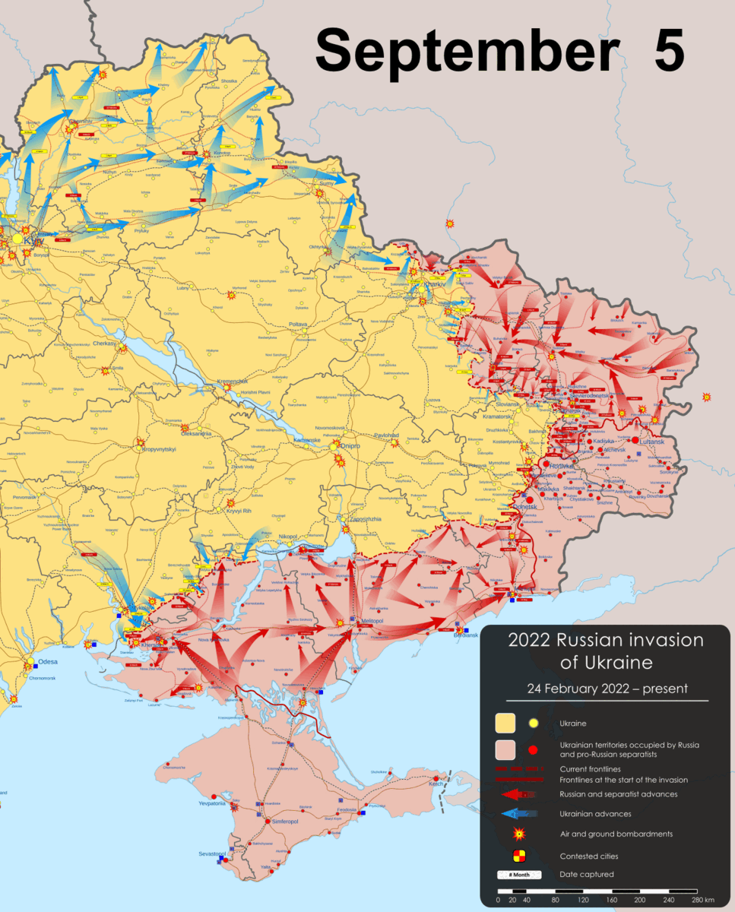
🇺🇦️: Я перебуваю в 100 метрах від вашого місця розташування і стрімко наближаюся. Почніть бігати
English: I am 100 meters from your location and rapidly approaching. Start running

Commentary
Context: (in reference to an image that was originally used instead of an animated GIF, still mostly applies here) this occupation map picture comes directly before Ukraine came in and made the Russians surrender a claimed 6000 square kilometers of land back to Ukraine. I find it really fitting, as the Russians really did run here.

Inspired by a meme of Scout (Team Fortress 2) saying “I am 100 meters from your location and rapidly approaching. Start running” it was a meme that I discovered long after it lost relevancy, I wanted to use it for this joke, as I just discovered it, and despite it being a “dead meme” now, it is funny and relevant.

Taken from the 2022 September 22nd Seanpm2001 Life Archive daily article

